RAM ISTP
Your Trading Cockpit — a Plain-English Guide
How to read each page, understand the numbers, and decide a Buy or Sell for yourself.
The one idea to remember. This portal is a co-pilot, not an auto-pilot. It shows you the edge, the statistics, and the caveats — then you make the call. It never shouts “BUY!” and it never places an order on your account.

1. What this portal is (and is not)
RAM ISTP scans liquid NSE stocks, backtests trading rules on years of price history, and surfaces the setups that have a measurable edge right now. Think of it as a research desk that did the homework for you and shows its working.
It DOES | It does NOT | So your job is
Show edges + the stats behind them | Tell you “buy this now” | Read the evidence
Size the trade to your risk | Place / modify any order | Decide & place orders yourself
Flag risks (liquidity, circuits, news) | Promise a win | Respect the caveats

Two honesty truths that drive the whole app:
1) Confidence vs Conviction. “Confidence” = is the edge real? (how trustworthy the backtest is). “Conviction” = is today a good day to take it? (live conditions). Two different numbers, never merged — and neither is a probability that you will win.
2) Be skeptical of pure day-trading. After real brokerage + slippage, the intraday edge is roughly zero or negative. The one validated, positive edge in this system is the multi-day Swing. The portal says this out loud on the Intraday page.

2. Opening the portal
Start the server once, then use it all day in your browser:
./target/debug/ram_istp serve 30min
Then open: http://127.0.0.1:8787
First launch warms up for ~2 minutes (it scans the universe), then it’s instant. Every page shares the same top menu: Live signals · Intraday · Desk · Journal · Portfolio · Add stock.

3. The six pages at a glance
Page | What it answers | Reach for it when…
Live Signals | “What are today’s sharpest setups, and what fits my money?” | You want the day’s shortlist + an honest basket.
Intraday | “Tell me everything about ONE stock.” Deep-dive + scanner + finder. | You’re vetting a specific name before acting.
Desk | Control room: risk brakes, staging, scorecards, holdings risk. | You want guardrails + to track results.
Journal | “Log my real trades (paste P&L or upload a report).” | You want your record to power the analytics.
Portfolio | “What is my portfolio really doing — keep, trim, rotate?” | You want a plain read of what you own.
Add stock | Bring a new NSE name into the system + test it for an edge. | A stock you like isn’t in the list yet.

4. Page-by-page

4.1 Live Signals (the home page)
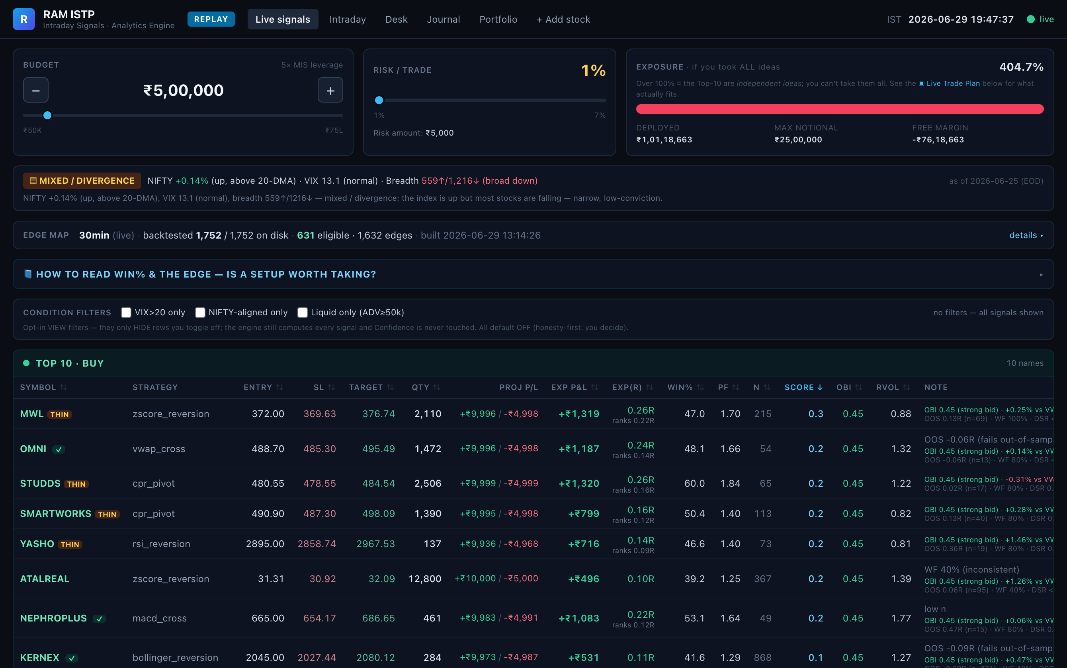
The home board: budget/risk, market-regime banner, edge-map freshness, then the ranked Top-10 with every stat and the live OBI/RVOL read.
- Freshness banner. How recent the data is and how much of the universe it covers — so a stale or partial scan is never mistaken for “everything.”
- The Top-10 board. The best setups, ranked by a live Score. Each row has Entry, Stop-loss, Target, a ready-made share quantity, and the stats (glossary in §6). Coloured tags warn you instantly:
Tag | Meaning — and what to do
⛔ NO-MIS | Cannot be intraday-traded (T2T / ASM / GSM surveillance). Avoid for intraday.
THIN | Low liquidity — your order may move the price. Trade small or skip.
₹LOW | Very low-priced / penny-ish — extra caution.
green ✓ | Clean on the tradability checks.

- ★ Sharpest setups + ▣ Live Trade Plan. “Sharpest setups” = top 2 Buy + 2 Sell via an 8-point checklist. “Live Trade Plan” = the realistic basket that actually fits your budget, 5× leverage cap, a total-risk ceiling and diversification (the Top-10 are 10 separate ideas you can’t all take).

4.2 Intraday (deep-dive on one stock)
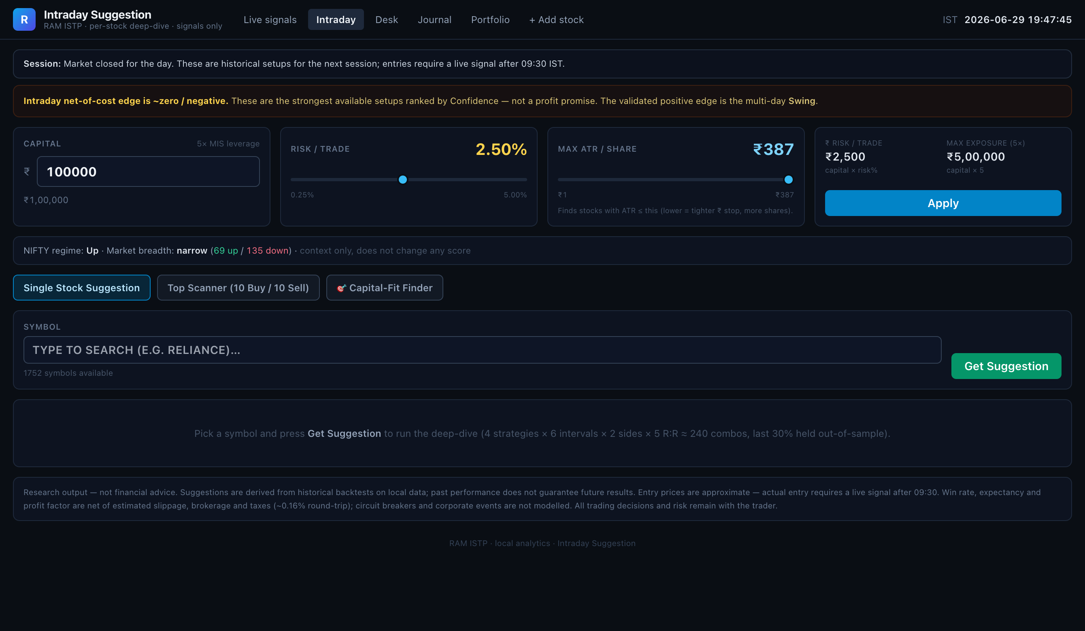
The Intraday page: honest “intraday edge ≈ zero net of cost” note up top, your capital/risk inputs, and the Scanner / Capital-Fit Finder tabs.
- Deep-dive. Type a symbol → the full file: Confidence /100 (is the edge real), Conviction /100 (is now a good time), expectancy, win%, profit factor, sample size, robustness (out-of-sample, walk-forward, overfitting probability), worst-pain-before-profit, plus Fundamentals (context only), pivots and sector momentum. A red ⛔ STAY AWAY banner shows for surveillance-blocked names.
- Top Scanner. The 10 best Buy and 10 best Sell candidates, each with ATR, SL, Target, Qty and ₹ profit/loss.
- 🎯 Capital-Fit Finder. “Which edged stocks fit my wallet?” Give it your capital and the most ATR (₹ risk/share) you’ll take.

4.3 Desk (your control room)
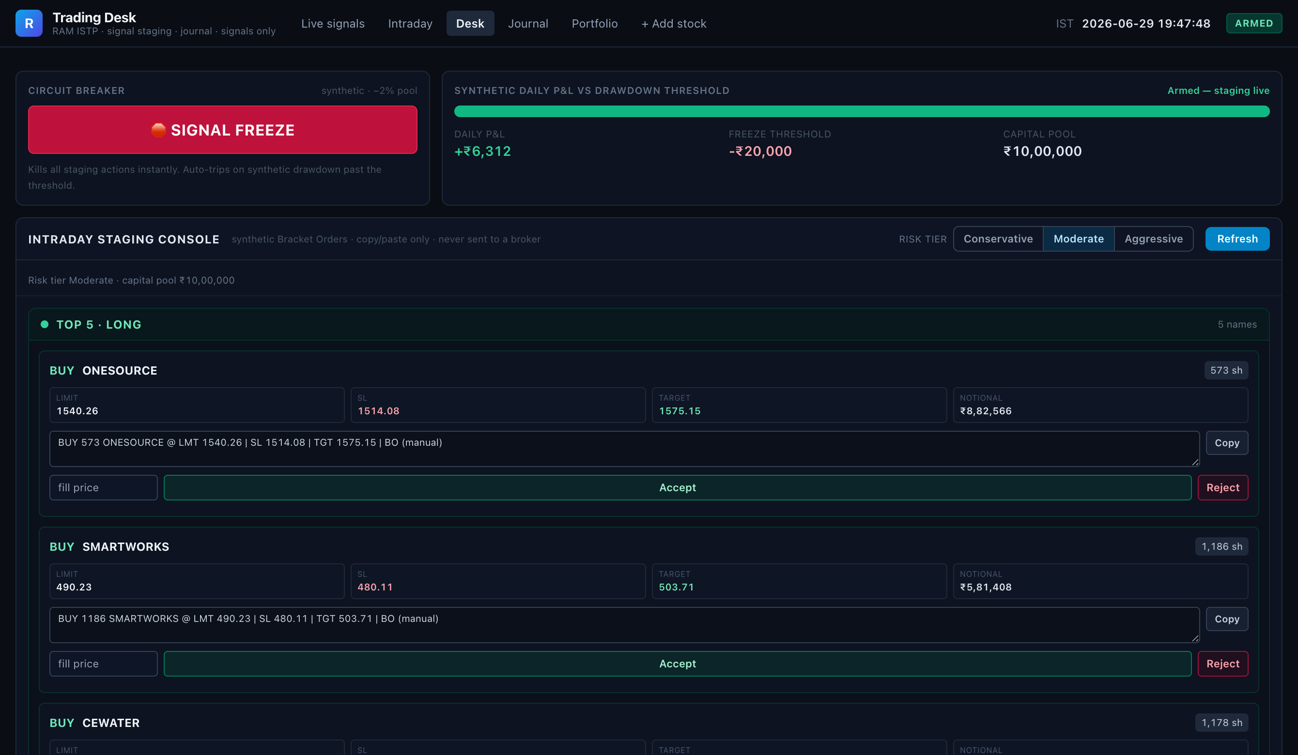
The Desk: a Circuit-Breaker stop switch, the daily-P&L-vs-drawdown meter, and the Intraday Staging Console (Top-5 Long / Short).
- Circuit Breaker + Signal Freeze. A red “stop” switch and a daily-loss meter — hit your threshold and it freezes new staging.
- Staging Console + Swing Ledger. Line up the top Long/Short ideas by risk tier; track multi-day swings.
- Calibration Scorecard + Portfolio Analytics. Did the model’s predicted win% hold up in your trades? Plus your record (win%, profit factor, Sharpe, drawdown, equity curve). These light up from the Journal — the more you log, the sharper they get.

4.4 Trade Journal (log your real trades) — NEW
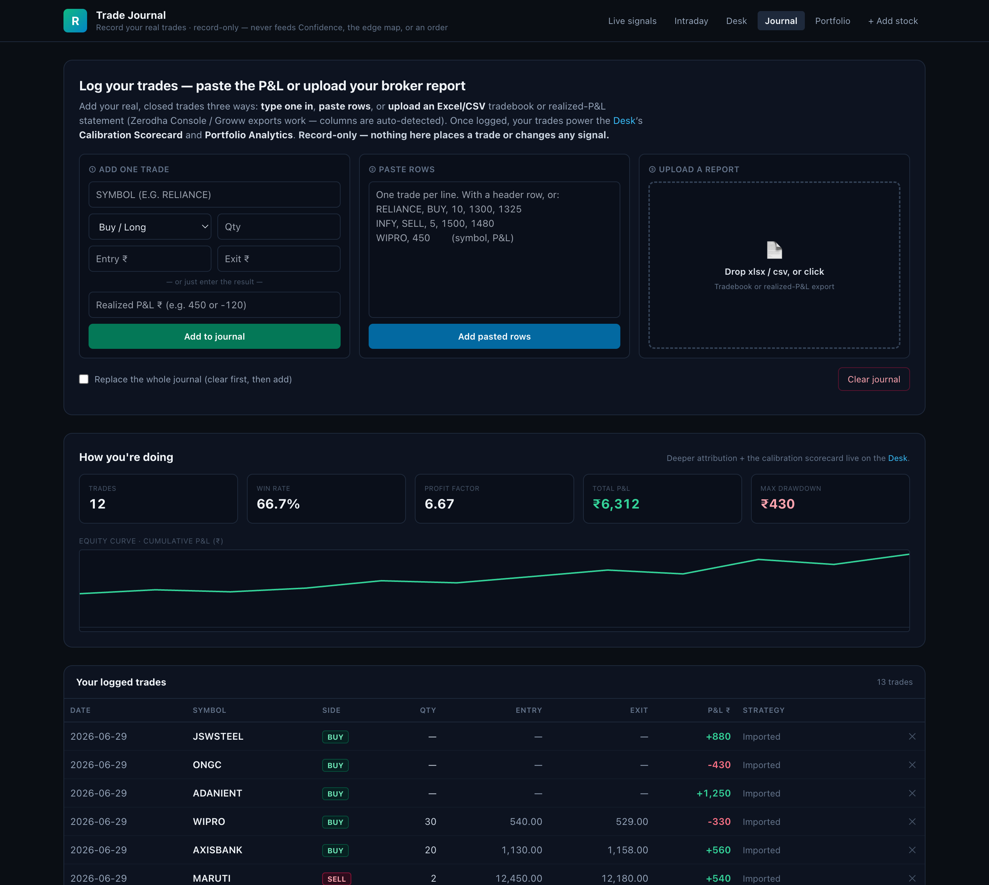
The new Trade Journal: ① add one trade, ② paste rows, or ③ upload an xlsx/csv — then your live win-rate, profit factor, P&L and equity curve, and the trades table.
Record every real, closed trade so the analytics reflect your results, not just the backtest. Three ways — use whichever is handy:
- Add one trade. Type Symbol, Side, Qty, Entry, Exit — or just the Symbol and the realized P&L ₹. (It works out profit/loss for you.)
- Paste rows. Paste straight from a sheet: one trade per line, with a header row or as symbol, side, qty, entry, exit (or symbol, P&L).
- Upload a report. Drop your broker’s Excel / CSV tradebook or realized-P&L statement (Zerodha Console / Groww exports work — columns are auto-detected).
- What you get back. Live Trades / Win-rate / Profit-factor / Total-P&L / Max-drawdown, an equity curve, and a trades table you can prune. Re-uploading the same report is safe — duplicates are skipped automatically.
- Record-only, by design. The journal never feeds Confidence, the edge map, ranking, or an order. It only powers the backward-looking Calibration Scorecard + Portfolio Analytics on the Desk.

4.5 Portfolio (plain-English review of what you own)
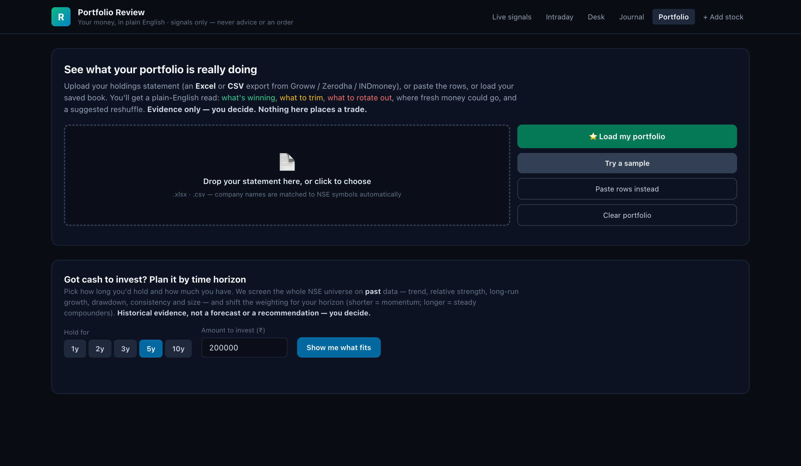
Portfolio Review: paste or upload your holdings statement to see concentration, keep/trim/rotate calls, and a realistic growth range.
Paste rows from your broker statement (or upload it) and it explains, in everyday terms:
- How spread out your money is (over-concentrated in one name or sector?).
- Which stocks to keep, trim, or rotate — by trend and relative strength.
- Where fresh cash could go, a suggested reshuffle, and a realistic growth range — plus a plan for new money by time horizon.

4.6 Add stock (bring in a new NSE name)
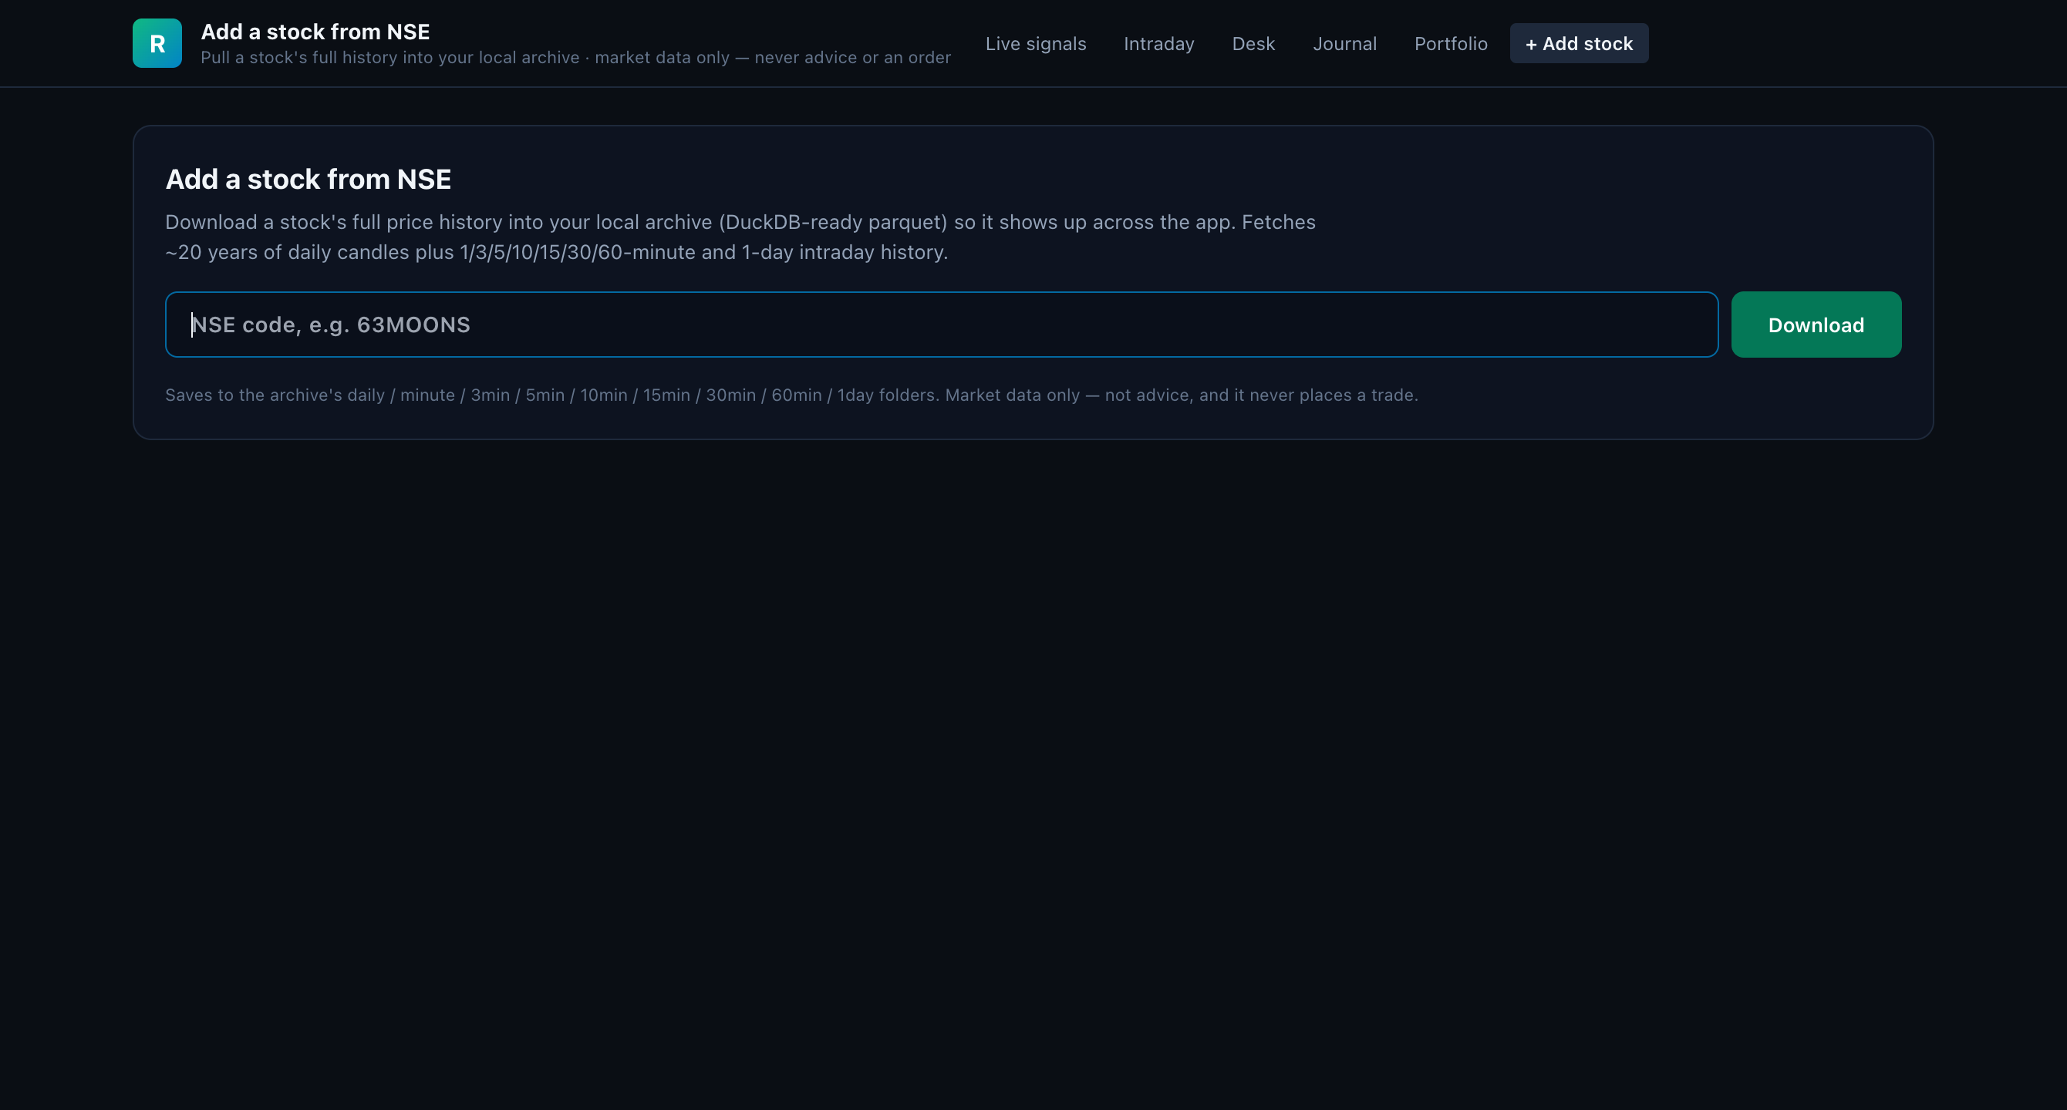
Add a stock: type an NSE code → it downloads the candles, backtests every rule, and tells you (honestly) whether it has an edge.
Type an NSE code (e.g. 63MOONS). It downloads the candles, auto-onboards the stock (backtests + merges), shows the edge validation per timeframe, and fills in company details. No edge? It tells you — not every stock has one.

5. How to read the numbers (quick glossary)
Term | Plain meaning
Entry / SL / Target | Where to get in, where to bail if wrong (stop-loss), where to take profit. Entry→SL gap = your risk = “1R.”
Qty | Shares, auto-sized so a stop-out loses only your chosen risk amount (budget × risk%). Bigger stop → fewer shares.
exp(R) | Expectancy in risk-units. +0.5R = you net half your risk per trade on average. The core “is there an edge?” number — net of cost.
Win% | Of the last n times this fired in the backtest, the share that hit Target before SL. Historical, not a promise.
PF | Profit Factor = ₹ won ÷ ₹ lost in the backtest. Above 1 = profitable; 2.0 = won twice what it lost.
n | How many backtested trades the stats rest on. Bigger = more trustworthy. Small n (say <30) — caution.
Score | The live ranking the board sorts by (small-sample-shrunk expectancy × live confirmation). A ranking, not a probability.
Confidence | 0–100: how real / robust the edge is. Display-only — never inflates the trade.
Conviction | 0–100: how favourable conditions are right now. Also display-only.
OBI / RVOL | OBI: more buyers or sellers in the book right now (supports a Buy if positive). RVOL: busier than usual (>1 = more conviction/liquidity).
OOS / WF / DSR / PBO | Robustness: did the edge hold out-of-sample (OOS) and across time windows (WF)? PBO = probability the backtest was luck — lower is better, >50% is a red flag.

6. Deciding a Buy or a Sell
Each row is already a Buy or Sell idea (a “Buy” row = a long; a “Sell” row = a short). Your job: decide whether this one clears your bar. Run it through five gates, in order — fail an early gate and you stop.
- Is it even tradeable? No ⛔ NO-MIS / STAY-AWAY, not THIN, not ₹LOW. Blocked → done, move on.
- Is the edge real? High Confidence, n ≥ ~30 (ideally 50+), PF ≥ ~1.5, exp(R) clearly positive (net of cost), OOS positive, PBO low. Weak/tiny-sample? Pass.
- Is today a good day? Conviction healthy, OBI leans your way, RVOL > 1, sector momentum agrees, no fresh news against the trade.
- Does it fit my money? Take the quantity from the Live Trade Plan (not the raw Top-10 sum). It already respects your risk%, the 5× cap, and diversification.
- Final live checks, then you act. Before entering, verify on your broker: tight spread, price not pinned to a circuit band, enough time before the ~15:20 IST square-off. Then you place the order — the app never does.

Green lights — lean in | Red flags — step back
Big sample (n high) + PF ≥ 1.5 | Tiny sample (n < 30) or PF near 1
OOS positive, PBO low, WF consistent | PBO > 50% — likely just luck
Conviction + OBI/RVOL agree with the side | News / today’s move fights the signal
Clean tradability (green ✓) | NO-MIS / THIN / ₹LOW tag present
Fits the Live Trade Plan basket | You’d have to ignore the risk cap to take it

7. Worked example — choosing on multiple parameters
Two Buy setups are on the board. Both show a green Projected P&L. But P&L colour isn’t the decision — the parameters together are. Read each across the five gates:
Parameter | A — TATASTEEL · Buy | B — a low-liquidity name · Buy
Tradeable? | ✓ green — MIS-ok, liquid | ✗ THIN tag — order would move price
Edge real? | n=180, PF 1.9, exp(R) +0.42R, OOS +ve, PBO 8% | n=22, PF 1.25, exp(R) +0.18R, OOS ≈0, PBO 58%
Confidence | 74/100 | 51/100
Today good? | Conviction 68 · OBI +0.35 · RVOL 1.6 · sector +ve | Conviction 60 · OBI −0.1 · RVOL 0.8 · flat sector
Fits money? | Yes — in the Live Trade Plan basket, qty 40, risk ₹500 | Only if you breach the risk cap
Verdict | TAKE — small, wait for the live trigger | SKIP — edge not trustworthy, can’t fill

Why B loses despite green P&L. Its sample is tiny (n=22) and PBO 58% says the backtest is more likely luck than edge; it’s THIN so you can’t get filled at the shown price; and OBI/RVOL don’t support the move today. Any one of those is a stop. A green “Projected P&L” only tells you the reward-if-it-works — never whether the edge is real or takeable.
The habit: scan the board left-to-right — tradability tag first, then n and PF, then exp(R), then Score for ranking, then OBI/RVOL for the live read. If the early gates fail, the pretty P&L doesn’t matter.

8. Golden rules (read once a week)
- You decide, always. The numbers are evidence to size a bet, never a “sure shot,” recommendation, or order.
- Prefer Swing over pure intraday. Net of costs, the validated positive edge is multi-day. Day-trade only with eyes open.
- Respect the stop-loss. Never widen an SL to avoid a loss. The Qty was sized on that exact stop.
- Trust big samples, doubt small ones. n and PBO tell you how much to trust the rest.
- Re-check tradability live. Surveillance, spread and circuit bands change intraday — verify on the broker before you act.
- Log every trade in the Journal. The Calibration Scorecard only gets honest about your results once you feed it real outcomes.

Bottom line. Read the freshness banner, pick from the board, vet it on the Intraday deep-dive, size it with the Live Trade Plan, do your live checks — then make your call, and log it in the Journal. The portal did the homework; the decision, and the risk, are yours.

