# Transmitter Integration Test Plan

CSMA/CD Transmitter Bus Using Unipolar Return to Zero (RZ) Encoding

Bus Idle 0V, 1000bps transmission rate

The Unit Under Test (UUT) is the message exchange node being tested (Implemented on the Cypress PSoC board), and should be properly powered up and configured prior to beginning the test.

Required Hardware:

Oscilloscope

Computer with RealTerm software capable of sending data through a serial connection (USB)

USB Cable

Collision Generator Circuit (See Appendix A)

Begin Test

1. Connect the UUT ground to the ground on the collision generator circuit. Connect the scope ground to the circuit ground on the collision generator circuit.   
     
   Connect the UUT transmit pin (P3_6 on the Cypress PSoC board) to TX Input as shown in Appendix A (pin 4 on the 74LS125).   
     
   Connect the UUT receive pin (P0_7 on the Cypress PSoC board) to the RX Output as shown in Appendix A (this is the network bus).  
     
   Verify all circuits have proper power and ground signals.   
     
   Start the Realterm software and verify a baud rate of 57600 on the port the UUT is connected to. Verify the correct port is being used.
2. Verify that the UUT indicates that it is in the IDLE state. Pass/Fail: _____________
3. Set the scope to trigger on channel 1. Without generating a collision, and without transmitting, verify that the network bus idles at 0V. Pass/Fail: _____________
4. Enable the collision generator circuit, while the UUT is not transmitting any data. This acts as if there is another node transmitting on the network. Verify the UUT indicates that the line is in the BUSY state. Pass/Fail: _____________
5. With the UUT in the IDLE state, begin a transmission from Realterm of 5 characters in length. This is most easily done by going to the send tab of Realterm, and entering a string of characters as shown in figure 1 below. Send ASCII would then send the string to the UUT.  
     
   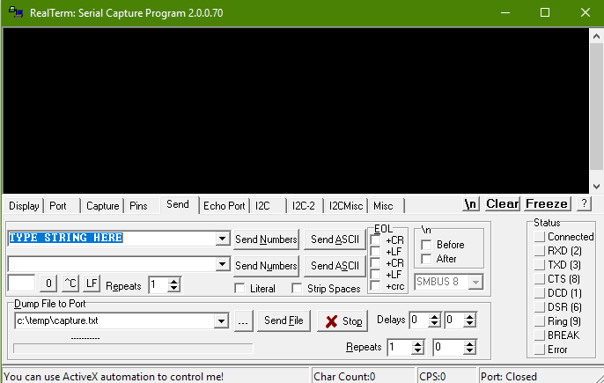

Figure : String entry into Realterm.

Enter a string of any 5 characters into Realterm. Verify the UUT indicates that it is in the BUSY  
state. This indication may be very brief. It may be advantageous to use a scope to verify the LED has a voltage across it for about least 5ms (since each bit takes 1/1000th of a second or 1ms to transmit). Pass/Fail: _____________

1. While the collision generator circuit is generating a signal, attempt to send 0x00 to the bus. Verify the data stream from the collision generator circuit is not interrupted by the transmission. There should be no steady stream of 0 bits shown on the scope. Pass/Fail: _____________

# Appendix A: Collision Generator Circuit

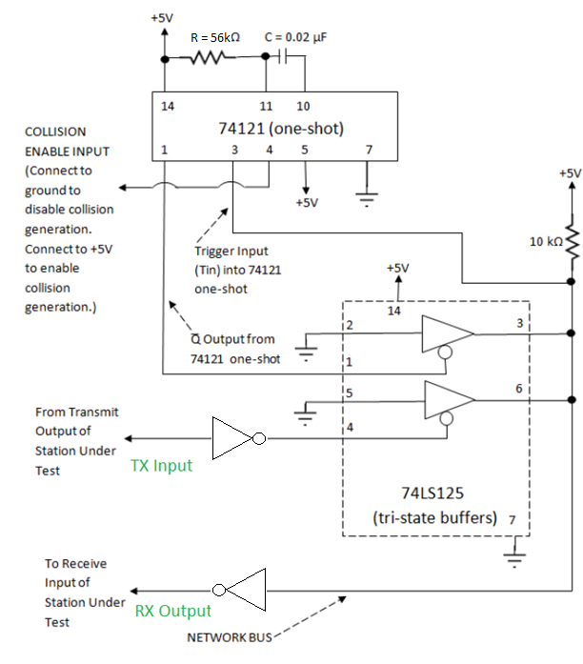

Figure : Collection generator circuit diagram. Provided courtesy of Dr. Darrin Rothe   
and Dr. Edward Chandler of Milwaukee School of Engineering.