***Spring batch***

======================

What is Spring batch

======================

- The application which process bulk record of data( 10k.50k...)is called batch operation.

- Spring Batch is an open source framework for batch processing. It is a lightweight,

comprehensive solution designed to enable the development of robust batch applications.

Ex:

- sending monthly salary to employee.

- Generating monthly paySlip.

- Sending monthly account statement to account holder.

**either source can customer --> DB or DB --> customer**

process process

CSV file =====================> DB ================> CSV file

Spring Batch terminology

========================

ItemReader - It is responsible for reading data from source ( DB or CSV file )

ItemProcessor - Here we can write the business logic while process data

ItemWritter - It responsible for write the data to ( DB or CSV file )

Step - Here we can create step to process the data, we can create multiple steps.

Here we configure all reader processor and writer

Job - Here we can config all steps.

JobLauncher - It is responsible for the execute the hob what ever assign to JobLauncher.

JobReposiory - All the terminology is maintain in JobRepository

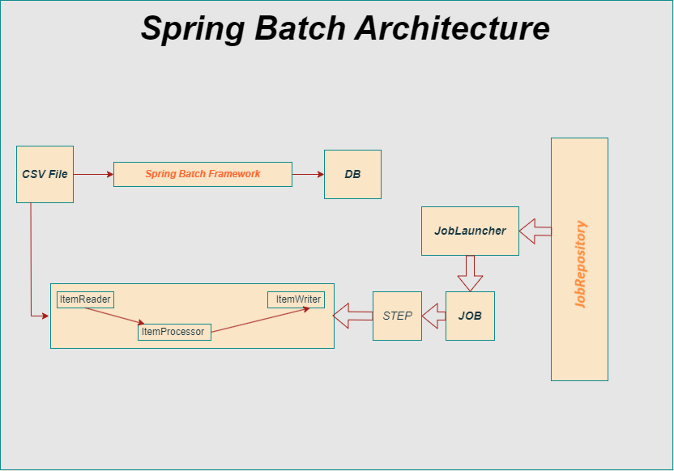

Create a project with Spring batch

===================================

- create a spring boot stater project <https://start.spring.io>

