**What is Performance Testing ?**

Performance testing is the process of determining the speed or effectiveness of a computer, network, software program or device. This process can involve quantitative tests done in a lab, such as measuring the response time or the number of MIPS (millions of instructions per second) at which a system functions.

Performance testing encompasses a range of different tests which enable analysis of various aspects of the system. One of the simplest ways to test the performance of a website is through load testing. This provides information about the behavior of the system when handling specific loads of users, who might be providing a number of transactions simultaneously on the same application.

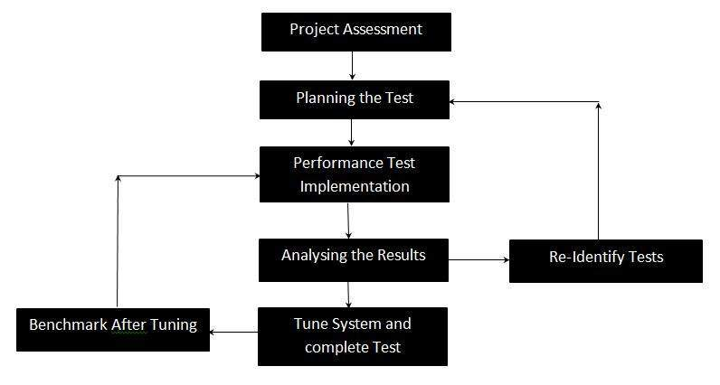

Why performance testing:

When it comes to understanding and improving a website system, whether it be a personal project, a business venture or otherwise, it’s vital a web application is tested for its responsiveness in terms of its stability, how well it can handle a particular workload. Businesses can also find out a lot about their website system through software performance testing, which can build performance into the design and structure of the system, prior to any coding taking place.

Performance testing encompasses a range of different tests which enable analysis of various aspects of the system. One of the simplest ways to test the performance of a website is through load testing. This provides information about the behavior of the system when handling specific loads of users, who might be providing a number of transactions simultaneously on the same application.

How is performance testing is used:

Software performance testing is a means of quality assurance (QA). It involves testing software applications to ensure they will perform well under their expected workload.

Features and Functionality supported by a software system is not the only concern. A software application's performance like its response time, do matter. The goal of performance testing is not to find bugs but to eliminate performance bottlenecks

The focus of Performance testing is checking a software program's

* Speed - Determines whether the application responds quickly
* Scalability - Determines maximum user load the software application can handle.
* Stability - Determines if the application is stable under varying loads.

Performance testing is done to provide stakeholders with information about their application regarding speed, stability and scalability. More importantly, performance testing uncovers what needs to be improved before the product goes to market. Without performance testing, software is likely to suffer from issues such as: running slow while several users use it simultaneously, inconsistencies across different operating systems and poor usability. Performance testing will determine whether or not their software meets speed, scalability and stability requirements under expected workloads. Applications sent to market with poor performance metrics due to non-existent or poor performance testing are likely to gain a bad reputation and fail to meet expected sales goals. Also, mission critical applications like space launch programs or life saving medical equipment’s should be performance tested to ensure that they run for a long period of time without deviations.