**JMeter Installation Guide**

In previous article we have learned about basic “**Introduction to Apache JMeter**” and what all features to be supported in Apache JMeter. In today’s article, we will get to know about how to download and install JMeter on local Windows Machine.

JMeter is a pure Java desktop application, that’s why it runs on any system which supports Java. So before installing JMeter, first get to know the basic requirement of JMeter to run on local windows machine.

**JMeter requirements according to the Operating System**

Before installing JMeter, your system should fulfill with below requirements.

|  |  |  |
| --- | --- | --- |
| **Operating system** | **Java Virtual Machine** | **Architecture** |
| Free BSD 9.0 | Open JDK 6 | amd64 |
| Linux 2.4, 2.6, 3.1 | Sun JDK 5, 6, 7 and Open JDK 6 | i386, amd64 |
| Mac OS | JDK6 |  |
| Window XP | Sun JDK6, Sun JDK 7 | 32/64 bits |
| Window 7 | Sun JDK 5, 6, 7. | 32 bits |

### How to set Path for Java in Windows

For setting the path for Java, you need to follow these steps:

* Go to MyComputer properties -> advanced tab -> environment variables -> new tab of user variable -> write path in variable name -> write path of bin folder in variable value -> ok -> ok -> ok

### For Example:

|  |
| --- |
| **1)Go to My Computer properties** |
| how to set path in java |
| **2) click on advanced tab** |
| how to set path in java |
| **3) click on environment variables** |
| how to set path in java |
| **4)click on new tab of user variables** |
| how to set path in java |
| **5)write path in variable name** |
| how to set path in java |
| **6)Copy the path of bin folder** |
| how to set path in java |
| **7)paste path of bin folder in variable value** |
| how to set path in java |
| **8)click on ok button** |
| how to set path in java |
| **9)click on ok button** |
| how to set path in java |

Now your path is set. You can now run your Jmeter.bat file from any drive.

**Check for Java has been installed on your Windows**

In this Document you will get to know how to download and install JMeter on Window operating. These are the steps involved in downloading and installing JMeter.

Before installing JMeter***,***just check your system is supporting Java or not, if not then install it because JMeter is a pure Java desktop application. You can verify that java is already installed in your windows machine or not using bellow given command in your command prompt. You can use the following procedure to check whether Java JDK is installed successfully in your system.

In Window/Linux – Just go to Terminal or click on start and type**“**command prompt”

Open the “command prompt” and type command **“java –version”.**

If Java run-time environment is installed successfully, you will see the output as figure below,

[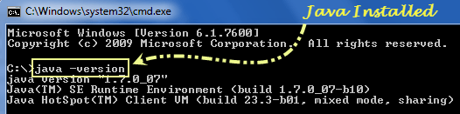](http://i1.wp.com/www.softwaretestingclass.com/wp-content/uploads/2014/02/jmeter-check-java-version.png)

If Java run-time environment is not installed successfully, you will see the output as figure below,

[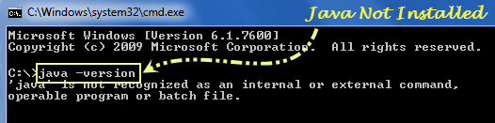](http://i1.wp.com/www.softwaretestingclass.com/wp-content/uploads/2014/02/jmeter-java-not-installed.png)

You can get the latest version of Java SE Development Kit in the site: http://www.oracle.com/technetwork/java/javase/downloads/index.html, using this site download and install the latest version of Java SE Development Kit. After installation, just check java is installed successfully or not using command “Java – Version” in the command prompt.

**Download and installation process of JMeter**

**Step 1: Download process of v2.13 JMeter**

After checking Java, just download JMeter through the site:

**http://jmeter.apache.org/download_jmeter.cgi**The latest version of JMeter is v2.13, go to the site and choose the Binaries file (either zip or tgz) to download as shown in figure below.

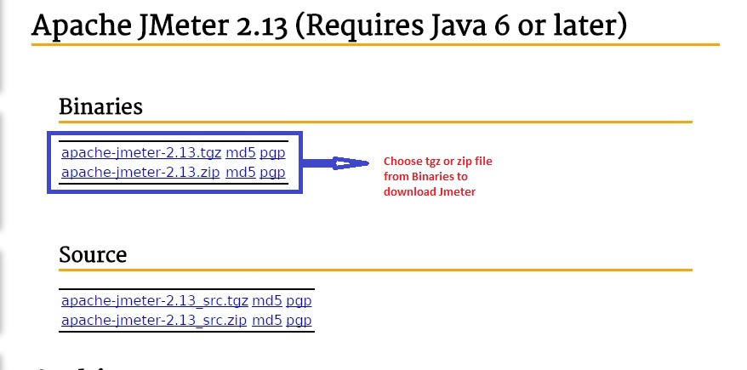

**Step 2: Installation process of v2.13 JMeter**

It is very simple and easy to install JMeter, just download the **“.zip”** or **”.tgz”** file and unzip JMeter file into the directory where you want to install JMeter. A very simple and easy installation process and it’s done. After unzip process is done, the directory will look like the given below figure,

[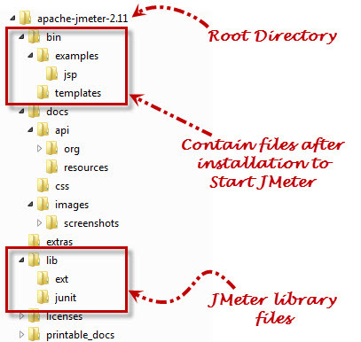](http://i2.wp.com/www.softwaretestingclass.com/wp-content/uploads/2014/02/jmeter-directory-structure1.jpg)

Files and directory which generate after installation of JMeter are given below,

**/bin**: Containsscript file which comes after installation of JMeter to start JMeter

**/docs**: Contains JMeter documentation files

**/extras**: ant connectedadditional files

**/lib/**: Contains Java library files of JMeter

**/lib/ext**: Contains protocols and core jar files for JMeter

**/lib/junit**: Contains JUnit library files of JMeter

To check, it got installed or not on Windows, go to the directory where did you unzip the .zip of .tgz file, open Apache-JMeter-2.13 folder, click on bin folder, and then click on JMeter.bat file will open v2.13 JMeter application. In UNIX machine type ./bin/JMeter on command prompt to open JMeter.

# ****Start JMeter in three modes****

You can open JMeter using two modes – GUI Mode, Server Mode and Command Line Mode

## 1) In GUI Mode: JMeter runs on client computer

In Windows – First, open Apache-JMeter-2.13 folder, click on bin folder, and then click on **JMeter.bat** file will open v2.13 JMeter application. Shown in figure below,

[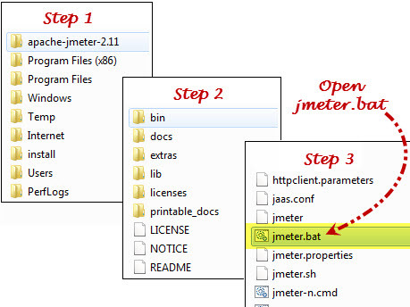](http://i0.wp.com/www.softwaretestingclass.com/wp-content/uploads/2014/02/jmeter-runs-on-client-computer1.jpg)  
   
Once you click on JMeter.bat, it opens JMeter – 2.13, shown in figure below,

[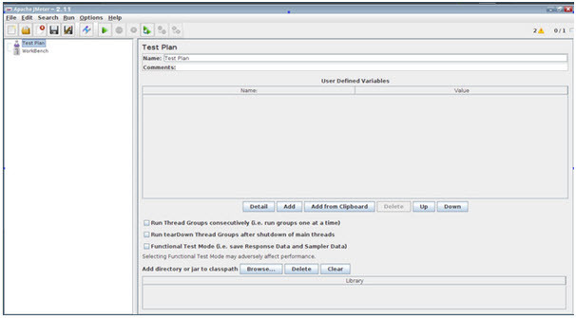](http://i1.wp.com/www.softwaretestingclass.com/wp-content/uploads/2014/02/jmeter-open-first-time.jpg)

**2) JMeter in Command line mode:**

If we open JMeter in GUI mode, it takes more computer memory to open it.  If you don’t want your computer should consume more resources to run JMeter, open JMeter in command line mode.

**Type this command in command line:**

**“JMeter -n -t testPlan.jmx – l log.jtl -H 127.0.0.1 -P 8000”**to open JMeter, shown in the figure below,

Where,

**JMeter–n:**Shows that JMeter will run on command line mode

**-t testPlan.jmx:**Name of file contains the Test plan

**– llog.jtl:**Shows the log files which contain the test result

**-H 127.0.0.1 -P 8000:**Proxy server host name and port

[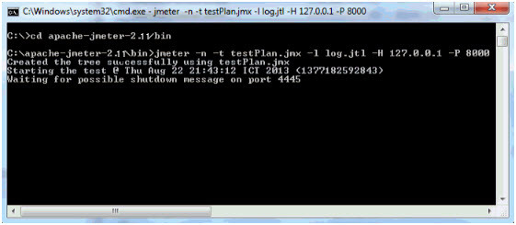](http://i0.wp.com/www.softwaretestingclass.com/wp-content/uploads/2014/02/jmeter-in-command-line-mode.jpg)