Datatable:

A DataTable, similar to Microsoft Excel helps testers to create data driven test cases that can be used to run an Action multiple times. There are two types of Datatables.

**Local Data Table -**Each action has its own private data table also known as local data table which is can also be accessed across actions.

**Global Data Table -**Each test has one global data sheet that is accessible across actions.

The Data sheet can be accessed from the "Data" Tab of QTP as shown below:

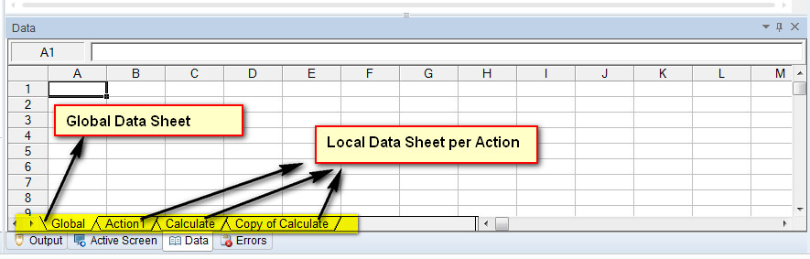

To execute a test case for some specified number of iterations, one can set the iterations of global data table in the Test Settings dialog, that can be accessed using File -> Settings -> Run (Tab) as shown below:

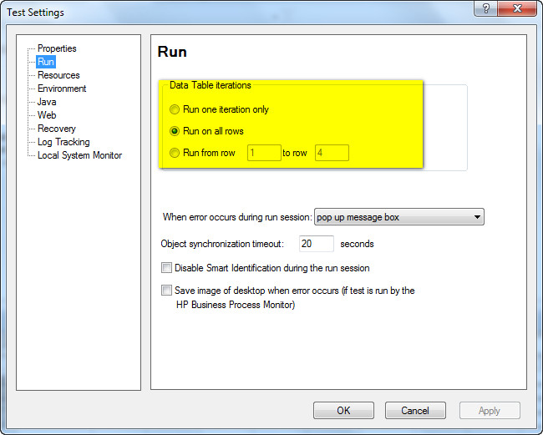

Example:

For Instance, if user wants to parameterize "compound Interest" of "http://easycalculation.com/" that can be accessed using "http://easycalculation.com/compound-interest.php". The Parameters can be created as shown below. Most of the functionalities of Excel can be used in Data table as well.

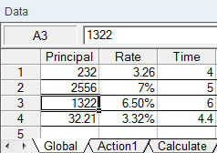

Data Table Methods:

|  |  |  |
| --- | --- | --- |
| **Method Name** | **Description** | **Syntax** |
| AddSheet | Adds the specified sheet to the run-time data table | DataTable.AddSheet(SheetName) |
| DeleteSheet | Deletes the specified sheet from the run-time data table | DataTable.DeleteSheet SheetID |
| Export | Exports the Datatable to a new file in the specified location | DataTable.Export(FileName) |
| ExportSheet | Exports a Specific Sheet of the Datatable in run-time | DataTable.ExportSheet(FileName,SheetName) |
| GetCurrentRow | Returns the active row of the run-time data table of global sheet | DataTable.GetCurrentRow |
| GetParameterCount | Returns the number of columns in the run-time data Table of Global Sheet | DataTable.GetParameterCount |
| GetRowCount | Returns the number of rows in the run-time data table of Global Sheet | DataTable.GetRowCount |
| GetSheet | Returns the specified sheet from the run-time data table. | DataTable.GetSheet(SheetID) |
| GetSheetCount | Returns the total number of sheets in the run-time data table. | DataTable.GetSheetCount |
| Import | Imports a specific external Excel file to the run-time data table. | DataTable.Import(FileName) |
| ImportSheet | Imports the specified sheet of the specific excel file to the destination sheet. | DataTable.ImportSheet(FileName, SheetSource, SheetDest) |
| SetCurrentRow | Sets the Focus of the Current row to the Specified Row Number | DataTable.SetCurrentRow(RowNumber) |
| SetNextRow | Sets the focus of the next row in the run-time data table | DataTable.SetNextRow |
| SetPreviousRow | Sets the focus of the previous row in the run-time data Table | DataTable.SetPrevRow |

Data Table Properties:

|  |  |  |
| --- | --- | --- |
| **Property Name** | **Description** | **Syntax** |
| GlobalSheet | Returns the first sheet of the run-time data table. | DataTable.GlobalSheet |
| LocalSheet | Returns the Active local sheet of the run-time data table. | DataTable.LocalSheet |
| RawValue | Retrieves the raw value of the cell | DataTable.RawValue ParameterID, [SheetID] |
| Value | Retrieves the value of the cell in the specified parameter. | DataTable.Value(ParameterID, [SheetID]) |