-🡪Create function in function library and call in to new test.

First Open new test in qtp

Open quick test Start🡪All programs🡪Quick test professional🡪

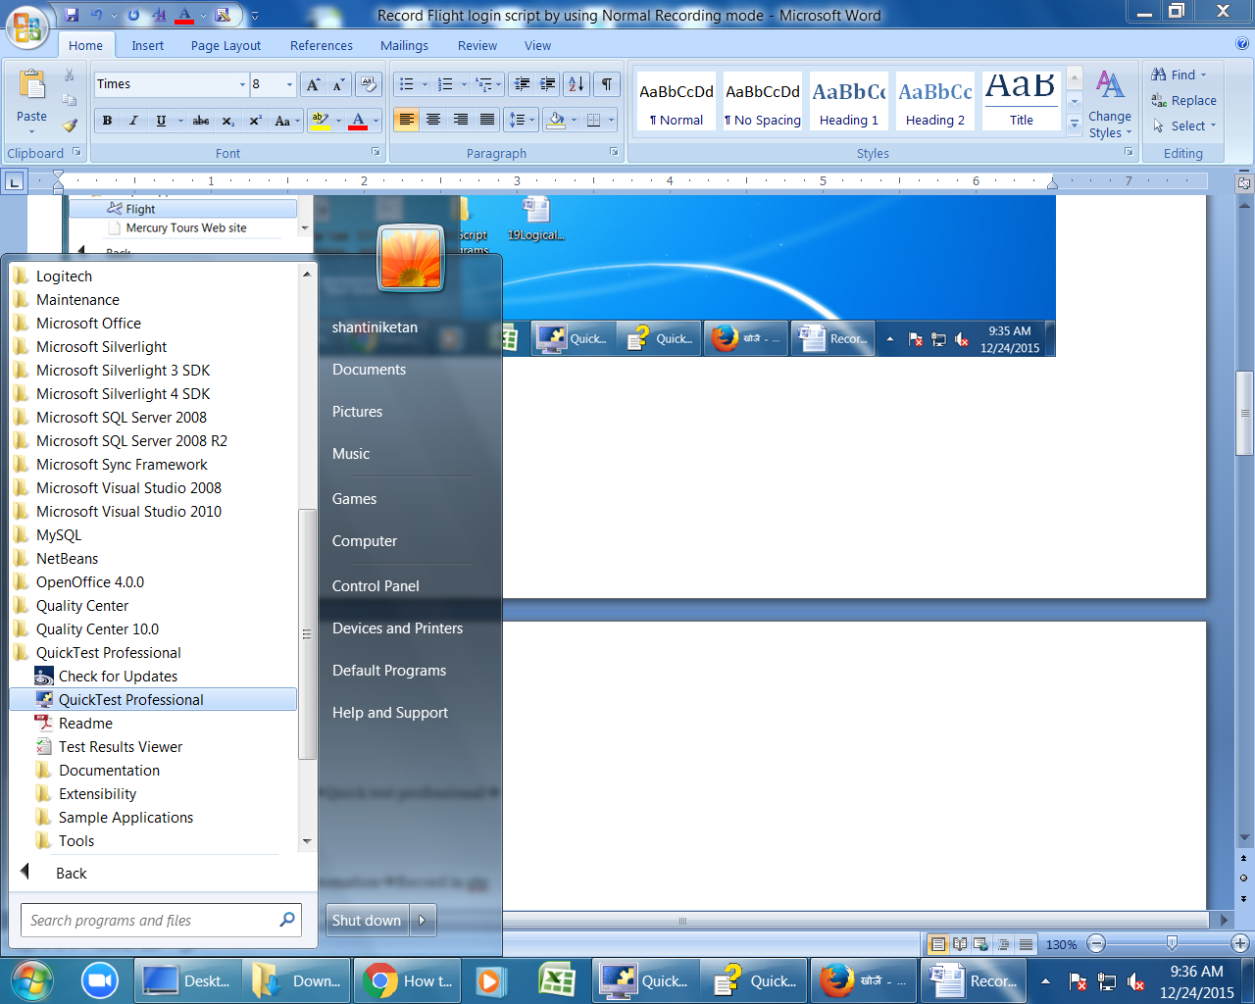

click on file🡪new🡪Test

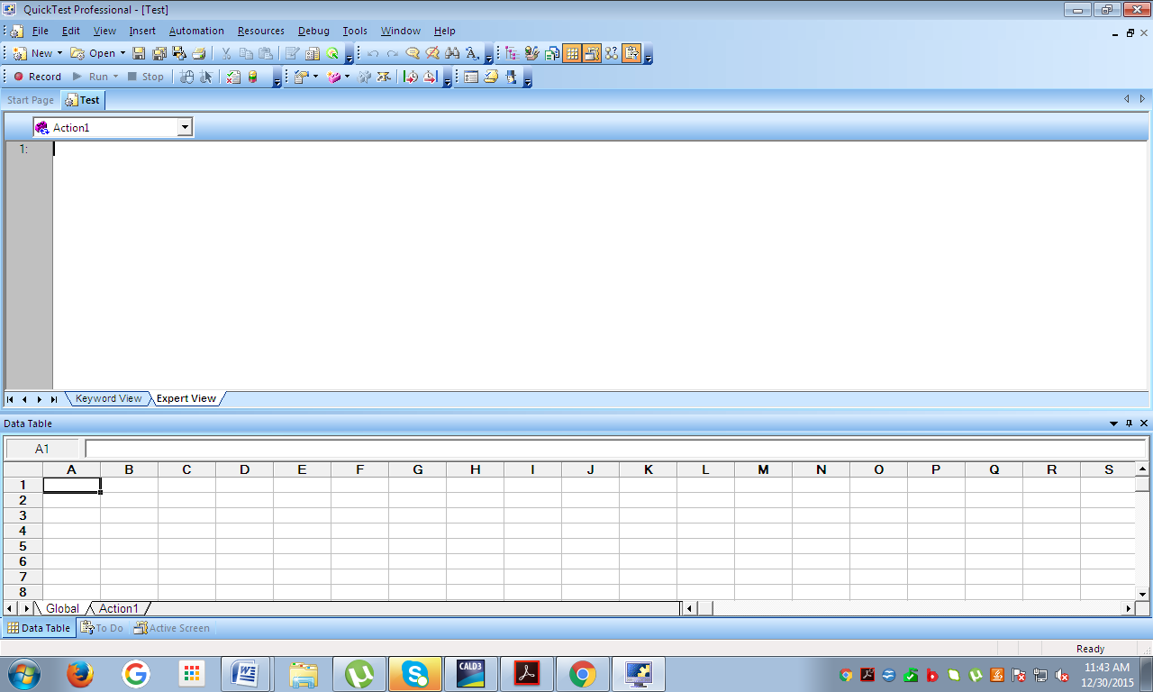

Open new function library(File🡪New🡪Function Library)/Ctrl+Alt+N

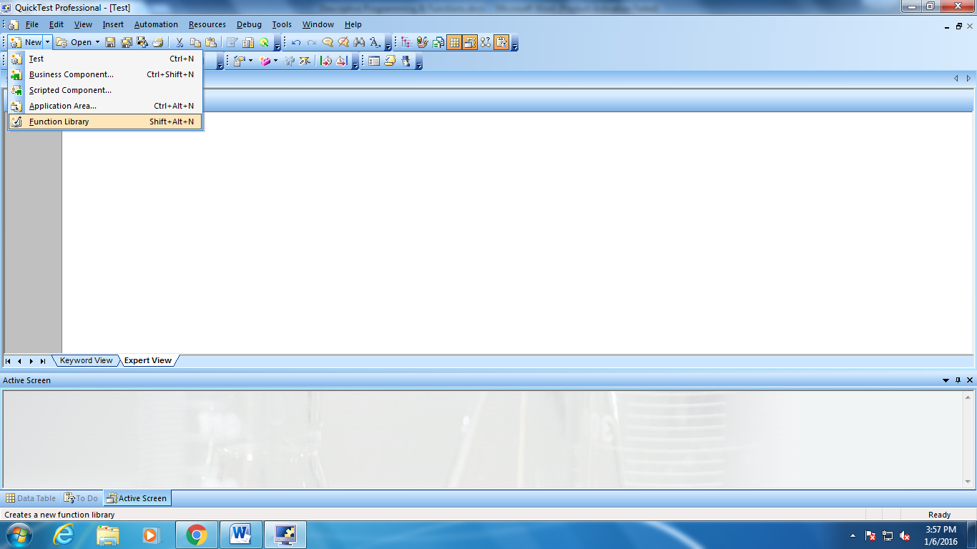

Create Function

Ex: Sum of two numbers

Function sum(a,b)

a=10

b=20

c=a+b

msgbox c

end function

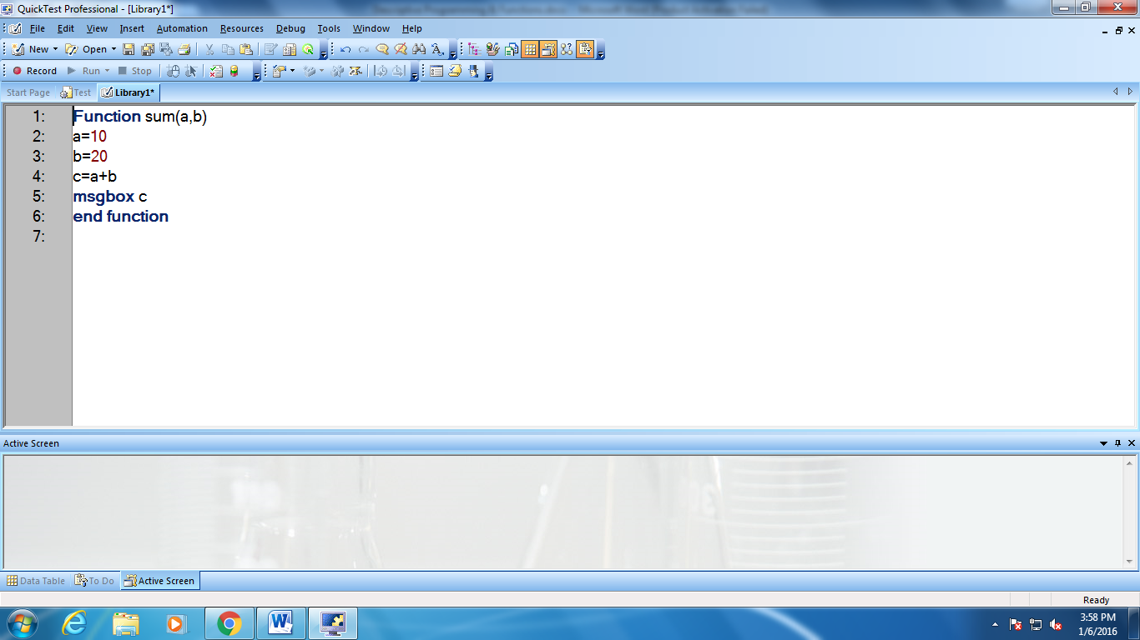

save function (file🡪save)

To call saved function in to new test:

First Open new test in qtp

Open quick test Start🡪All programs🡪Quick test professional🡪



click on file🡪new🡪Test



To call saved function first associate in to the test.

Select file🡪Settings🡪Resources🡪Click on +🡪Click on Browse button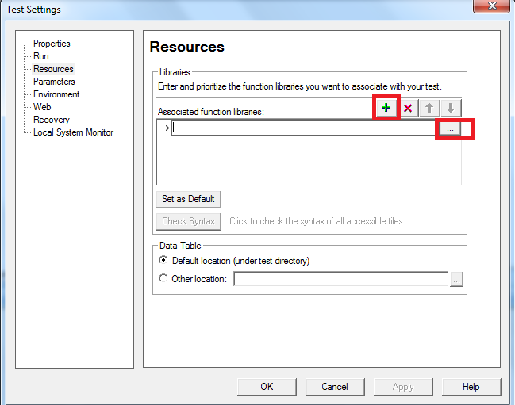

select saved function library file🡪Click on open button

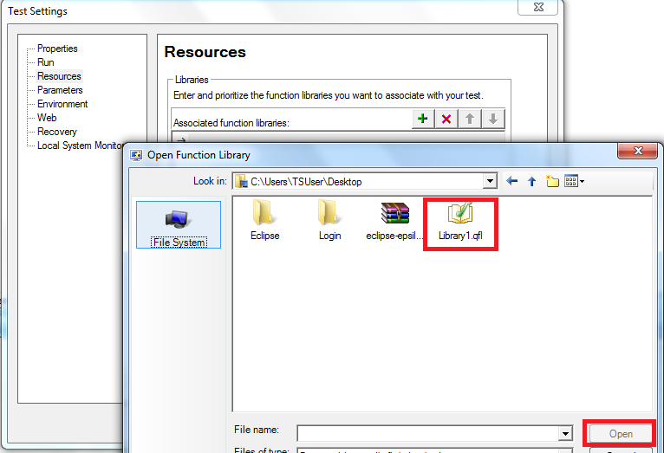

Click on NO button

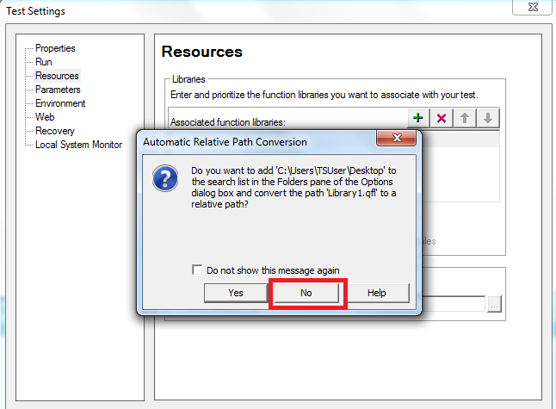

Click on ok button

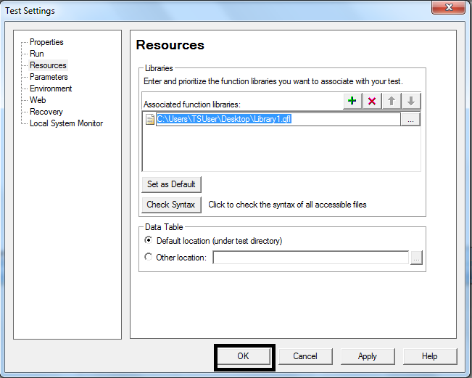

After Associating function in to the new test & call the function

To call function in expert-view write

call name of the function(arguments)

Call sum(9,9)

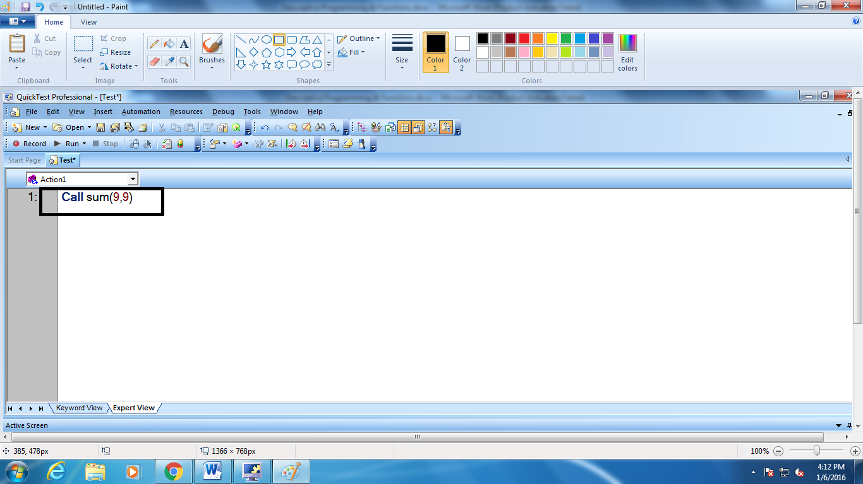

Click on run button or F5 then result will be displayed as per function.

