1. Write script for flight login by using Descriptive programming

Syn: Class("Property Name:=Property Value").method"input Value"

steps for Login

1)Activate flight login window

2) Enter Valid Agent Name in Agent name field

3) Enter Valid Password in Password field

4) Press Ok button

Before writing descriptive programme for login , First open Flight login window

Start🡪All programs🡪Quick test professional🡪Sample application🡪Flight

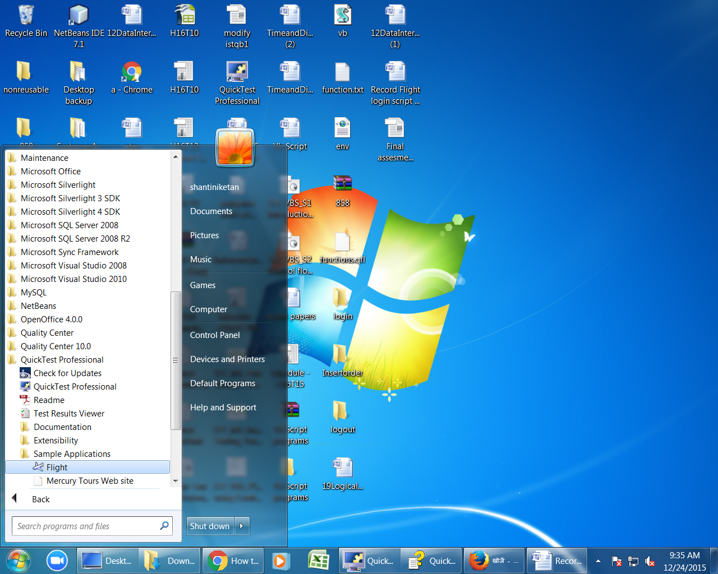

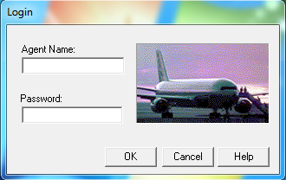

Here login window is one object it contain other objects like ( Agent name, password, Ok, cancel and help) so we have to find out each object class, unique property,value.

To find any object class, property and value we use Object spy.

Ex: To find Agent name field class, Property and values

First Open new test in qtp

Open quick test Start🡪All programs🡪Quick test professional🡪

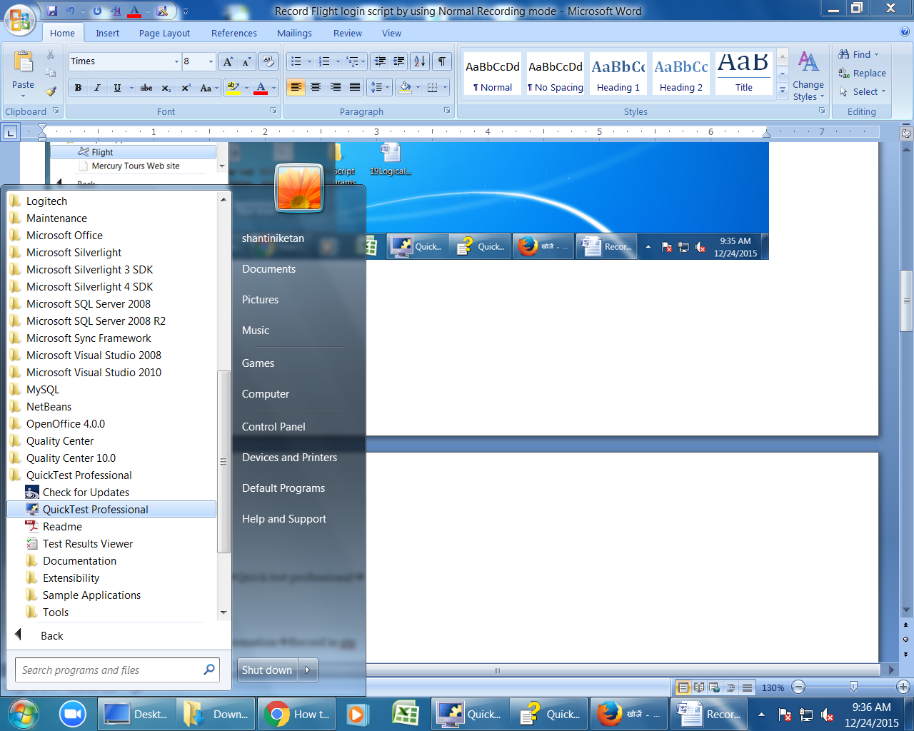

click on file🡪new🡪Test

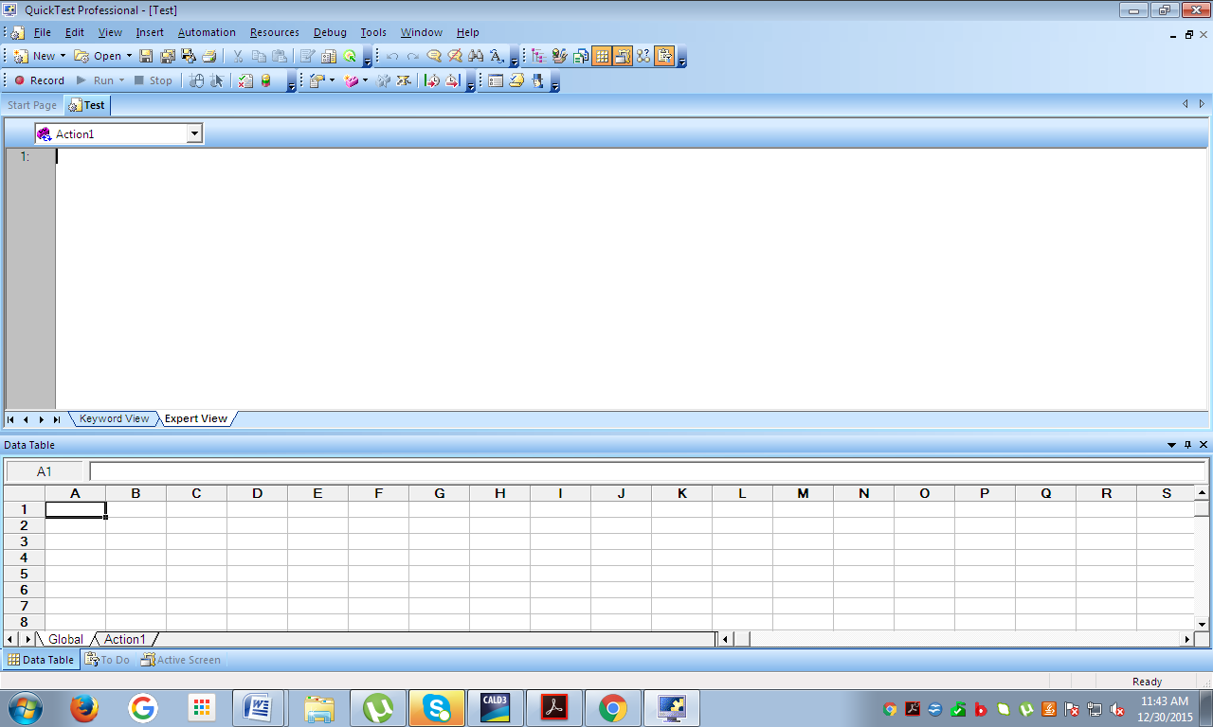

select tools🡪object spy

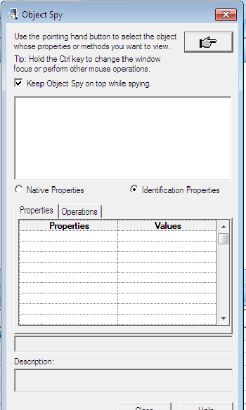

Click on Hand Icon button & select required object (Agent name filed) in flight login window.

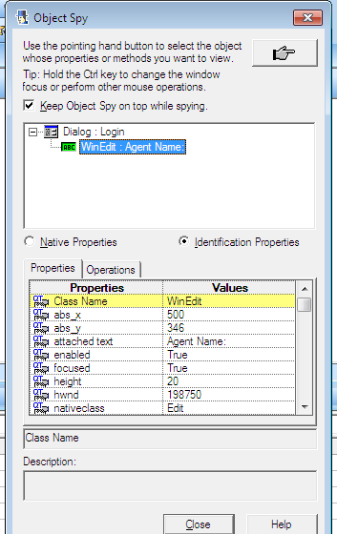

Note down class of agent name field , property and value.

Class=Winedit,

Property=Attached text

Value= Agent Name:

Like this we can find any object information.

After gathering objects information for login.

Write descriptive programme as mentioned below

1. To activate login window

Dialog(“text:=Login”).active

1. To enter agent name

Dialog(“text:=Login”).winedit(“Attached Text:=Agent Name:”).set”Talentsprint”

(Here Login window is parent object and agent name is child object so that first write script for parent object and then write child object.)

1. To enter Password

Dialog(“text:=Login”).winedit(“Attached Text:=Password:”).set”mercury”

1. To click on Ok button
2. Dialog(“text:=Login”).winbutton(“Text:=Ok”).click