## 4. Create flight login script by using copy Action:

To create copy a Action first need create new action and save then copy, as needed.

First create a new action for Flight Reservation Login:

1. Select **Insert > Call to New Action** or click the **Insert Call to New Action** button on the **Insert** toolbar.

The Insert Call to New Action dialog box opens.

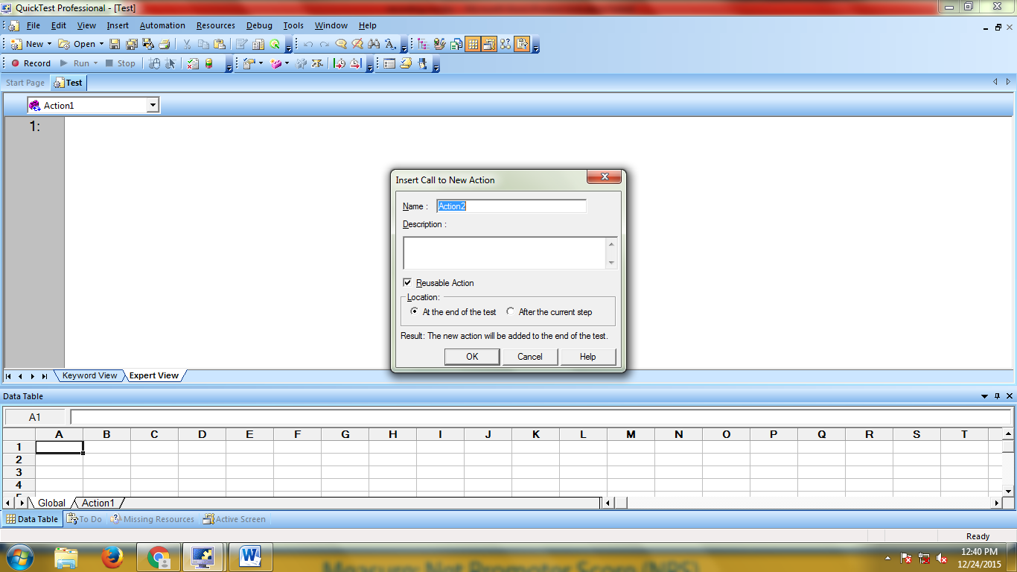

2.In the **Name** box, type a new action name as “Flight login”

3.In the **Description** box, add a description of the action

4. Select **At the end of the test option**

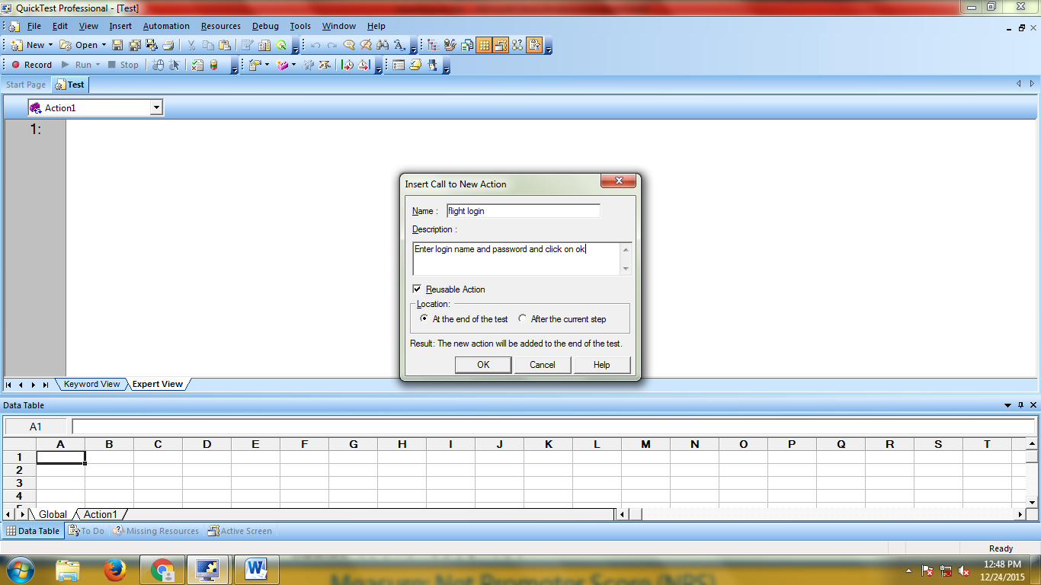

5.Click **OK**.

A new action is stored with in test.

6. Open flight login window

Start🡪All programs🡪Quick test professional🡪Sample application🡪Flight

7. Click the **Record** button to begin a recording session in qtp

8. Record login script in this action.

9.Enter Agent name

10. Enter password

11. Click on ok

12. Close the flight reservation window

Quick Test inserts script in expert view in Flight login Action .

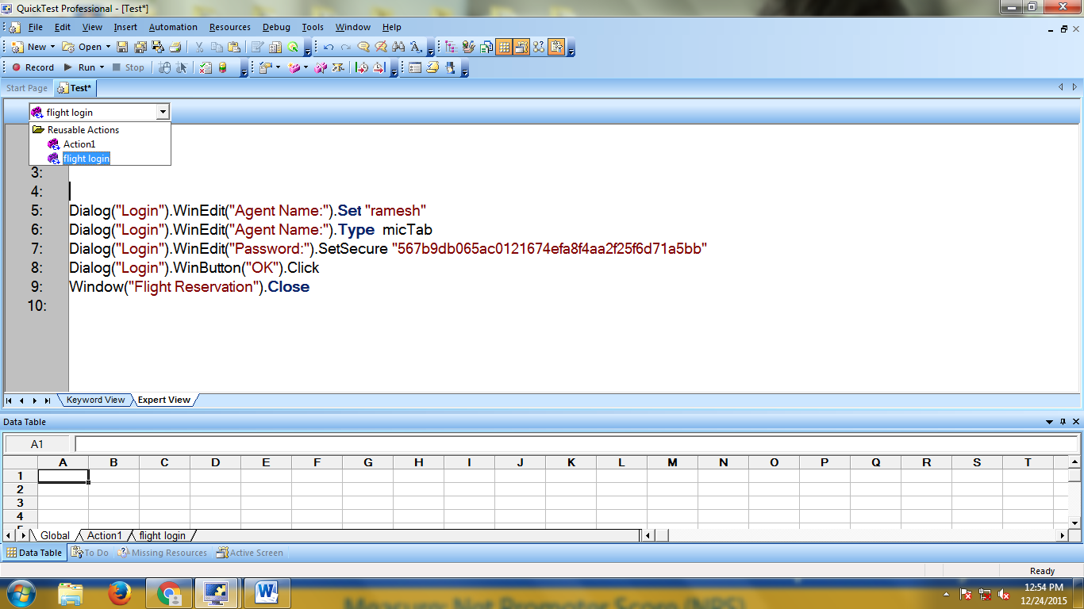

13. Save action file🡪save.

14. Open new test in qtp (File-->New🡪Test or Ctrl+n)

Copy the saved (existing)action i.e Flight Login

15. Select **Insert >** click the **Insert Call to Copy Action** button on the **Insert** toolbar.

16. Click on browse button

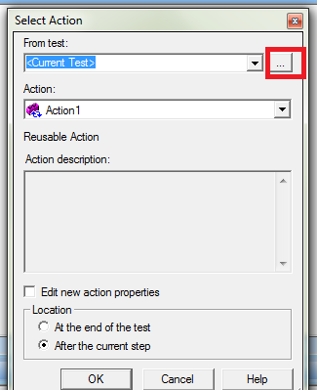

17. Select copied action from external location

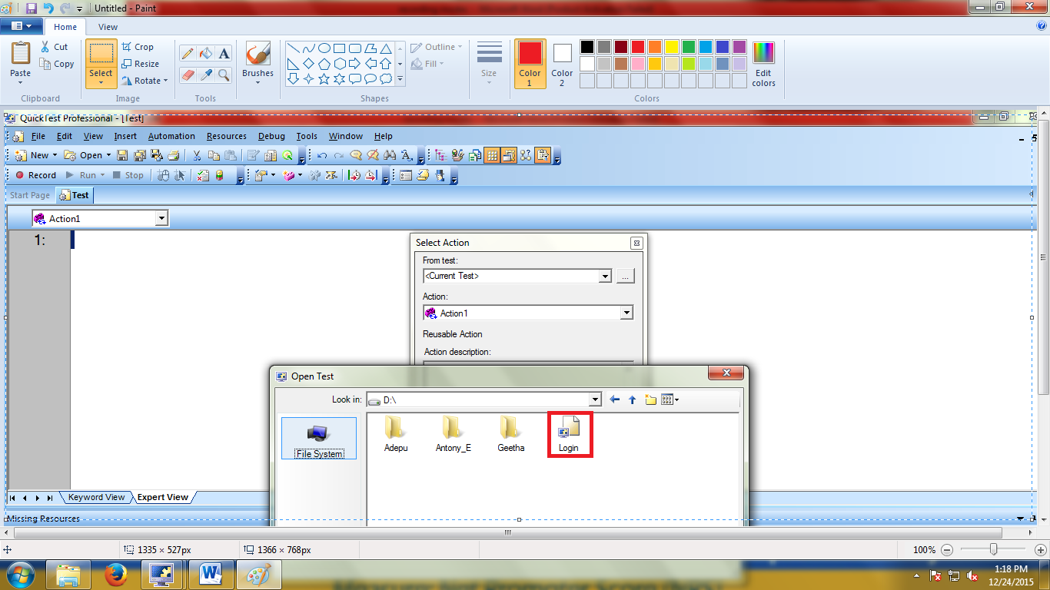

18. Select “flight Login” action from Action listbox

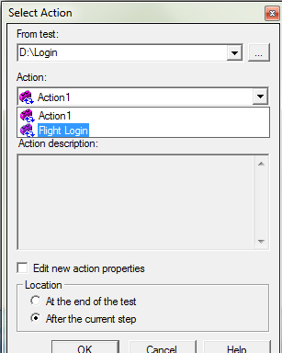

19. Click on ‘ok’ button

Below script generated in "Expert View" in QTP

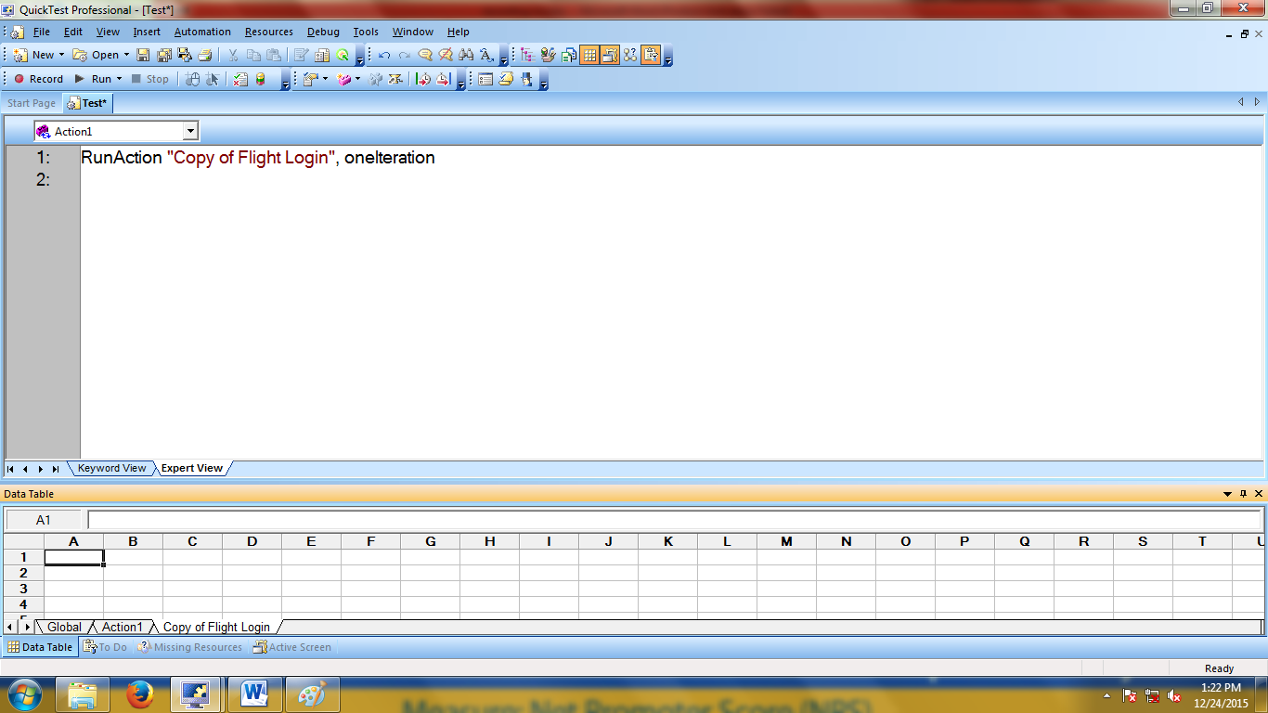

20. copied script we can see in expertview by selecing copy of flight login in Action list box

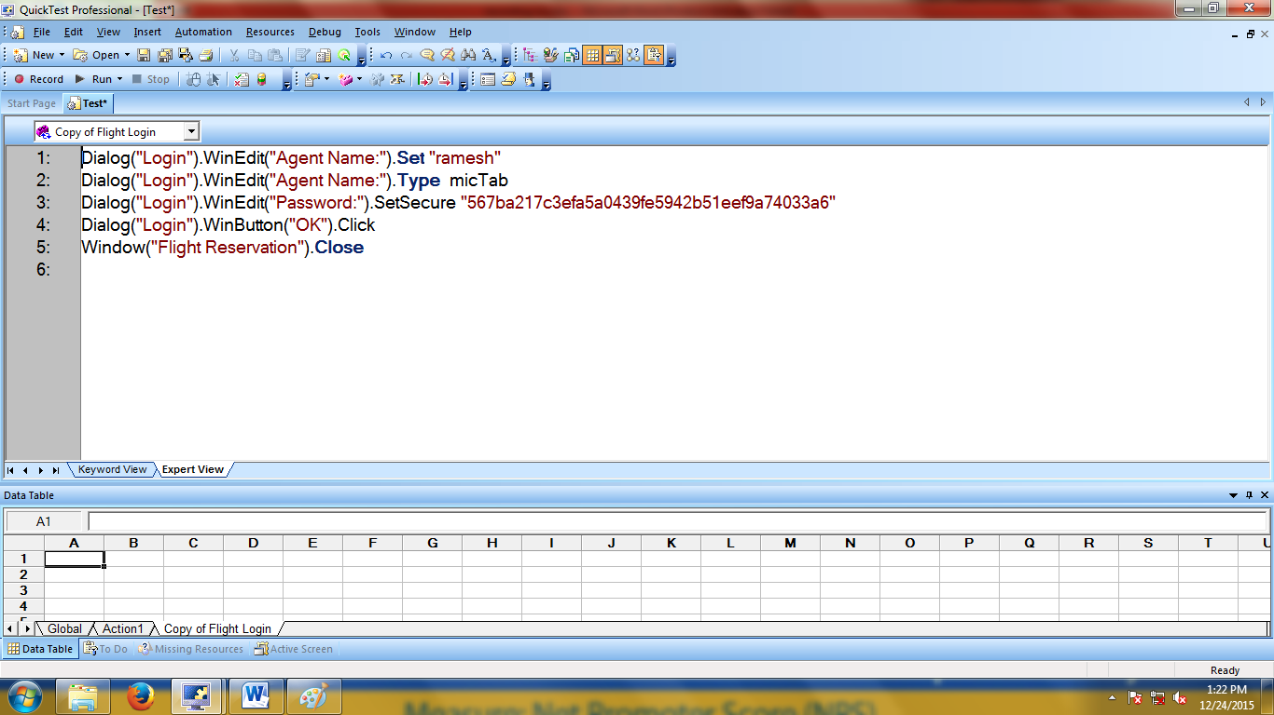

## 5.Create Flight login script by using Call Action:

To create call Action, first need create new action and save then call, as needed.

First create a new action for Flight Reservation Login:

1. Select **Insert > Call to New Action** or click the **Insert Call to New Action** button on the **Insert** toolbar.

The Insert Call to New Action dialog box opens.



2.In the **Name** box, type a new action name as “Flight login”

3.In the **Description** box, add a description of the action

4. Select **At the end of the test option**



5.Click **OK**.

A new action is stored with in test.

6. Open flight login window

Start🡪All programs🡪Quick test professional🡪Sample application🡪Flight

7. Click the **Record** button to begin a recording session in qtp

8. Record login script in this action.

9.Enter Agent name

10. Enter password

11. Click on ok

12. Close the flight reservation window

Quick Test inserts script in expert view in Flight login Action .



13. Save action file🡪save.

14. Open new test in qtp (File-->New🡪Test or Ctrl+n)

Copy the saved (existing)action i.e Flight Login

15. Select **Insert >** click the **Insert Call to Existing Action** button on the **Insert** toolbar.

16. Click on browse button



17. Select copied action from external location



18. Select “flight Login” action from Action listbox



19. Click on ‘ok’ button

Below script generated in "Expert View" in QTP

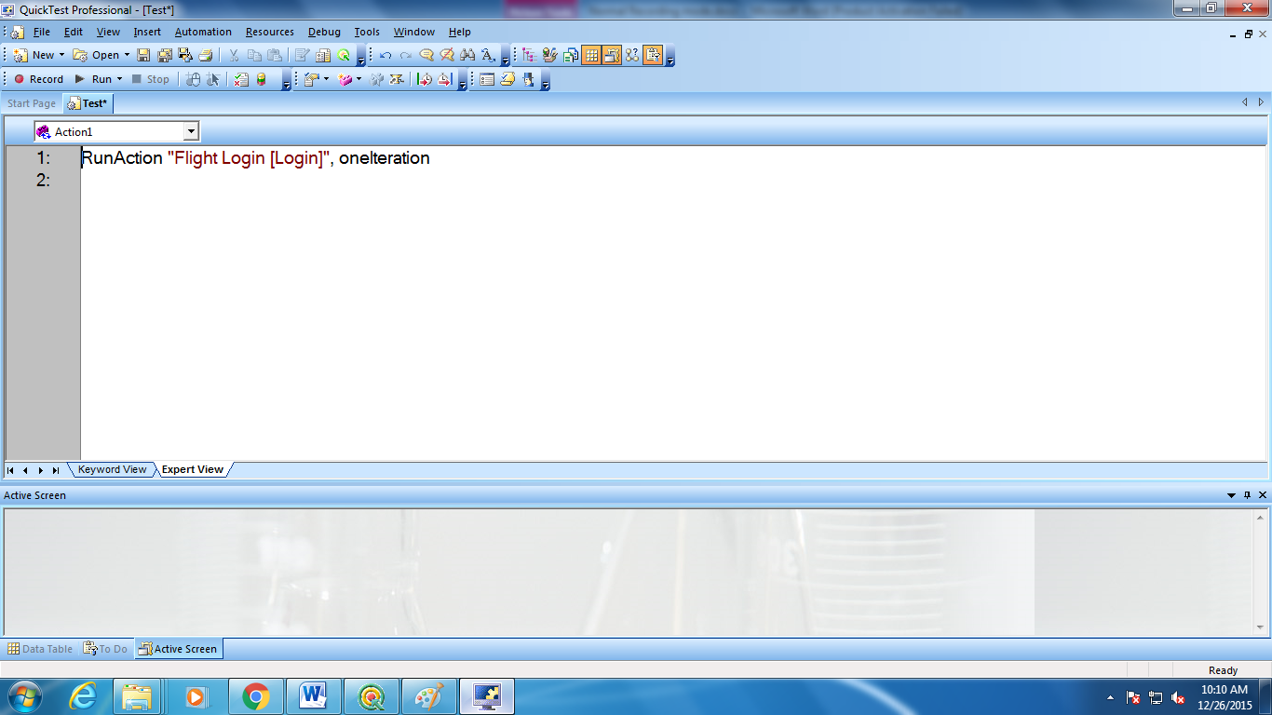

20. called script we can see in expert view 