- Behavioral Design Pattern
- Encapsulate your request in an object (or called here as command). This is all about how the requests are made between various objects.
- Supports undo operation for all of the commands
- The commands are saved in a queue
- Parameterization - where the various command objects can be passed around. Creating a set/list/collection of commands which get executed by execution of a single individual command.
- A command can wrap multiple actions in itself.
- Advantage: Decoupling actions from the end objects. Instead of hard-coding what a button press does you make it programmable by detaching or decoupling the actions from the end object (here a remote).
Following is an example of using the command pattern to program a remote control with 2 buttons.

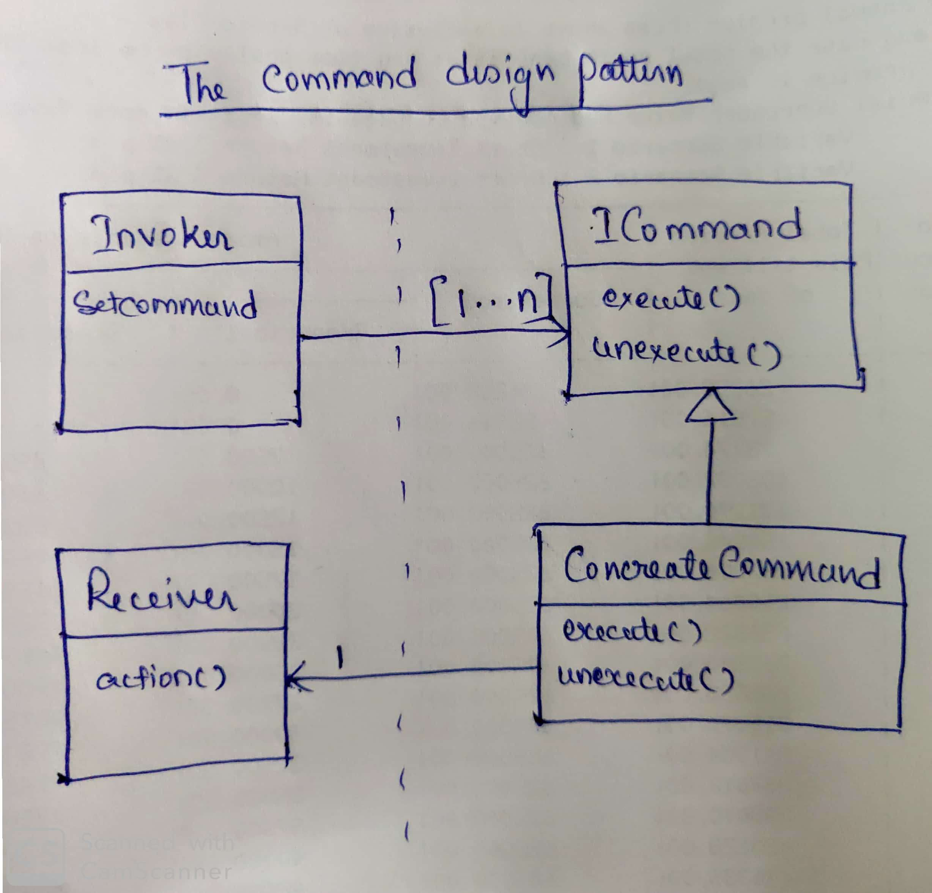
Image 1: The UML for command design pattern
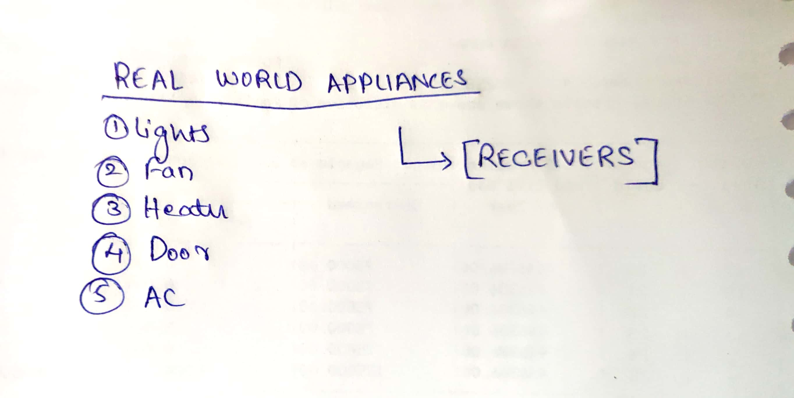
Image 2: Receiver objects of the example

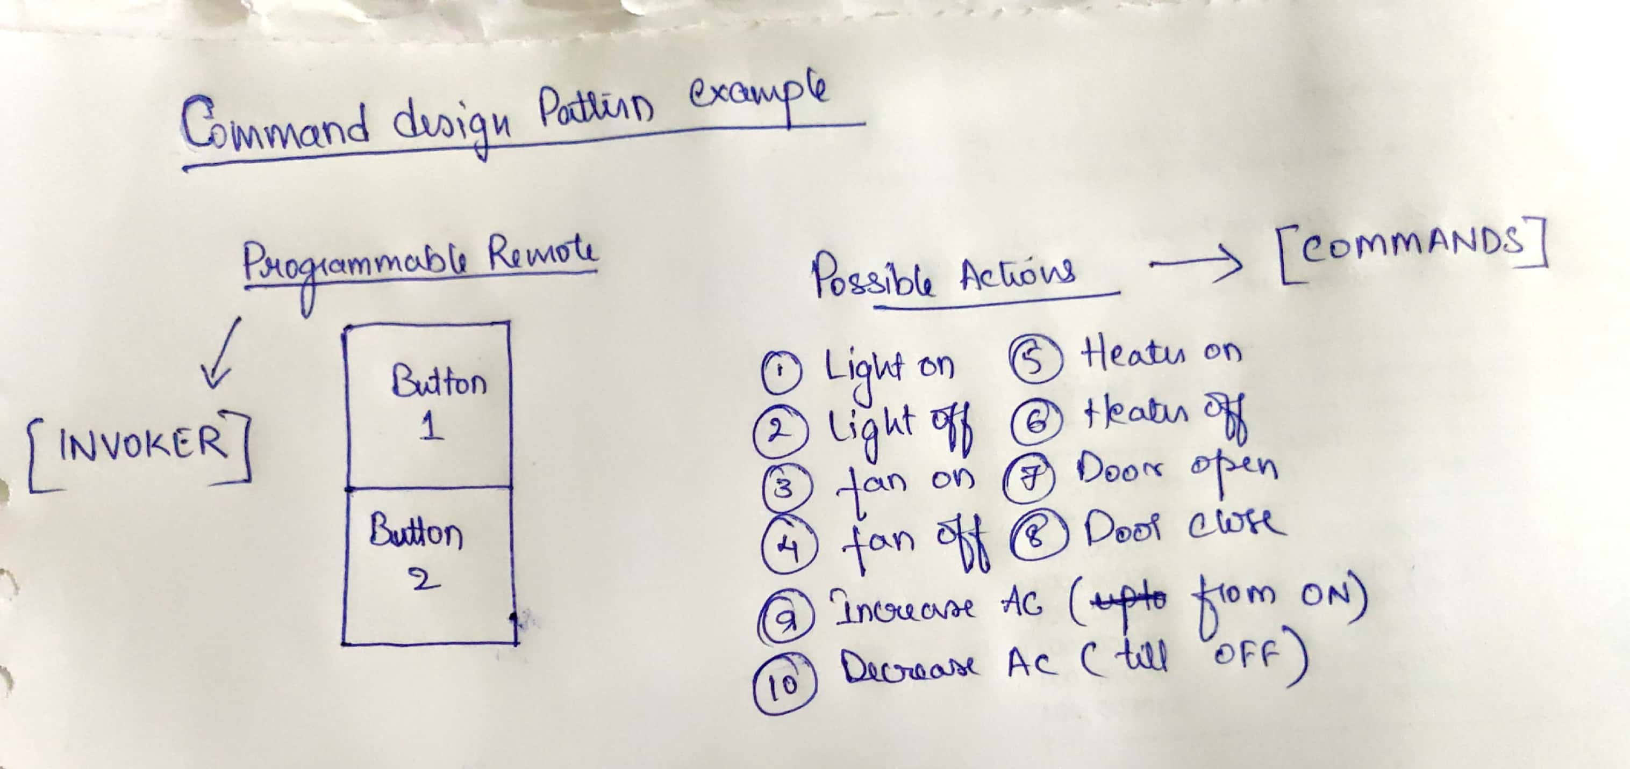
Image 3: Invoker and command objects for the example
