Lab # 1:

Douglas Oak

Info 1112

Section 12

Student Number: 100356690

Instructor: Warren Edwards Ph.D

C1.1 Coding assignment source code:

/\*

File: lab1.cpp

PROGRAMMER: Douglas Oak

INFO 1112 Section 12

PURPOSE: Display a User's nickname and hours worked

\*/

#include <iostream> //for cin and cout

#include <iomanip> //formatting decimal numbers

#include <string> //for using string data types

using namespace std; //for later versions of c++

int main()

{

//local data...

char letter1, letter2, letter3; //input: three letters to display

double hoursPerDay, hoursPerWeek; //hours per day and hours per week

int numDays, complete;

string name;

//enter name and initials, the hours per day

//and the number of days

cout << "Please enter your first name: ";

cin >> name; //entering more than one name causes errors

cout << "Enter three initials for your name: ";

cin >> letter1 >> letter2 >> letter3;

cout << "Enter the hours you work in a day: ";

cin >> hoursPerDay;

cout << "Enter the number of days you work in a week: ";

cin >> numDays;

hoursPerWeek = hoursPerDay \* numDays; //calculate hours worked per week

//Output a message formatting the hours to one decimal place

cout << fixed << showpoint << setprecision(1);

cout << endl;

cout << "Hello " << name << endl;

cout << "Your initials are: " << letter1 << "." << letter2 << "." << letter3 <<

".\n";

cout << "I hope you enjoy studying C++ for " << hoursPerWeek << " hours each

week!" << endl << endl;

cout << "Written by: Douglas Oak INFO 1112 Section 12 " << endl;

cout << endl;

cout << "Press any key to continue";

cin >> complete;

return 0;

Output Image: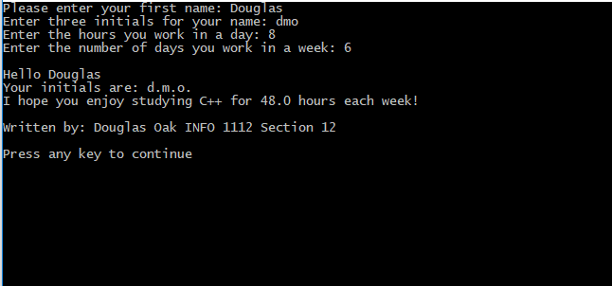

Review Exercises:

R1.1

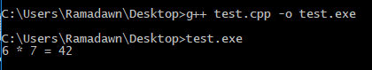

6 \* 7 = 42

R1.2



HelloWorld

R1.3

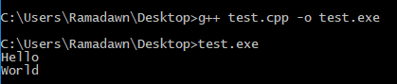

Hello

World

R1.4 Pseudo Code Account Balance Program:

If the is a current balance stored:

Assign current balance to starting balance

Else:

Prompt user to input Starting balance(SB)

Store input into starting balance

Prompt user to input Total dollar amount of deposits made(dept)

Store input into deposits

Prompt user to input Total dollar amount of withdrawals made(with)

Store input into withdrawals

If program is connected to interest rate database:

Query database for current interest rates

Assign database query to IR

Else:

Prompt user to input interest rate(IR)

Assign input to IR

Prompt user to input transaction time period (TTP) in days

Divide TTP by 365

Final balance before interest(FBBI) = Starting balance – with + dept

Final balance after interest = FBBI + (FBBI \* e ^ (IR \* TTP)

Store final balance as current balance

Print out current balance