Course Name: Cloud Computing
Course Code: 22IT102003
Program: B.Tech VI Semester
Faculty: Mr. P. Yogendra Prasad
Student Name: Vempadapu Rama
Roll Number: 23102A020090
Branch & Section: Cyber Security-2
Task Number & Title: 8- Cloud Business Proposal
9- Cloud For Disaster Alert System

Assignment Title: Lab Task- 8- Cloud Business Proposal

1. Student Details
- Name: Vempadapu Rama
- Register Number: 23102A020090
- Branch & Section: Cyber security-2
- Task Number & Title: 8- Cloud Business Proposal
- Date of Submission: 09-02-2026
2. Objective
The objective of this task is to study how cloud computing can solve real-world business problems such as server crashes, data loss, and high infrastructure costs. The task focuses on selecting suitable cloud service models (IaaS, PaaS, SaaS) and deployment models based on business needs, scalability, cost efficiency, and security.
3. Tools & Resources Used
AI Tools Used
- ChatGPT / Gemini – Used to structure the cloud business proposal, justify service models, and explain cost–benefit analysis.
Web Resources
- AWS and Google Cloud official documentation
- Cloud pricing calculators for pay-as-you-go analysis
- General cloud architecture learning resources

4. Theory / Background
Cloud computing provides on-demand access to computing resources such as servers, storage, databases, and networking over the internet with a pay-as-you-go pricing model.
I. Cloud Deployment Models
- Public Cloud: Shared infrastructure accessible over the internet (AWS, Azure, GCP).
- Private Cloud: Dedicated infrastructure for a single organization.
- Hybrid Cloud: Combination of public and private cloud for flexibility and control.
II. Cloud Service Models (SPI Model)
- IaaS: Provides virtual machines, storage, and networking.
- PaaS: Provides a ready-to-use platform for application development and deployment.
- SaaS: Delivers complete software applications over the internet.
III. Business Drivers
- Scalability & Elasticity
- High Availability & Fault Tolerance
- CapEx to OpEx Cost Model
5. Practical / Activity Performed
Step 1: Business Problem Identification
- The business uses a single on-premise server to host its application and database.
- Problems identified:
  - Risk of complete data loss due to hardware failure
  - Poor performance during peak usage hours
  - No automated backup or disaster recovery
  - High upfront hardware and maintenance costs
Step 2: Proposed Cloud Solution
- Cloud Type: Public Cloud
- Service Model: Platform as a Service (PaaS)
Justification:
PaaS allows the business to focus on application development without managing servers, OS updates, or hardware maintenance.
Step 3: Architecture Design
- Load balancer distributes user traffic
- Auto-scaling application servers
- Managed database with automated backups
- Multi-Availability Zone deployment
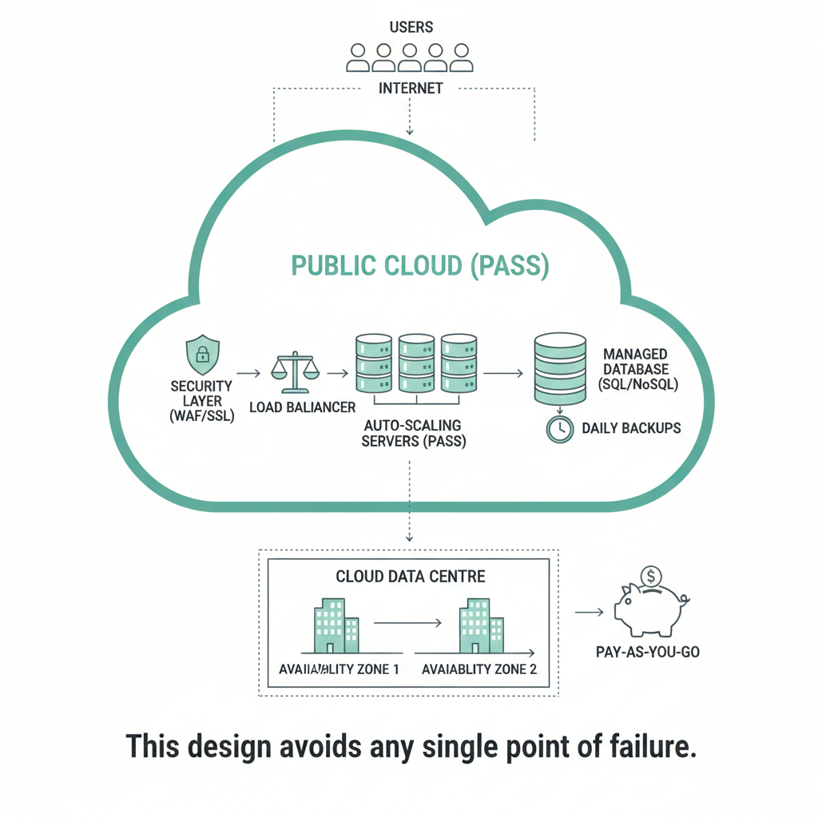
Step 4: Cost & Benefit Analysis
- Pay-only-for-usage pricing model
- Reduced hardware and electricity costs
- Automatic scaling during peak hours
- No manual maintenance required
Step 5: Risk & Security Considerations
- Data encryption at rest and in transit
- Firewall and security group configuration
- Automated backups across regions
- High availability using Multi-AZ architecture
6. Observations & Results
- Improved application performance during peak load
- Reduced infrastructure cost
- High system reliability and uptime
Key Learnings
- Importance of scalability and elasticity
- Cloud-based disaster recovery techniques
- Cost optimization using cloud services
7. Real-Time Use Case
Popular platforms like Swiggy, Zomato, and Uber use cloud computing to handle millions of users, dynamically scale resources, and ensure uninterrupted service.
8. Conclusion
Cloud computing enables businesses to replace unreliable physical servers with scalable, secure, and cost-efficient infrastructure. The adoption of PaaS on a public cloud helps startups reduce operational burden and focus on growth.
9. AI Reflection
AI tools helped in structuring the proposal, explaining cloud concepts clearly, and aligning the solution with real-world business scenarios. The final report maintains a professional and technical tone suitable for academic submission.
10. References
- AWS Official Documentation
- Google Cloud Architecture Center
- Microsoft Azure Learn
- NIST Cloud Computing Standards
- GeeksforGeeks Cloud Tutorials

Assignment Title: Lab Task- 9: CLOUD FOR DISASTER ALERT SYSTEM

1. Student Details
- Name: Vempadapu Rama
- Register Number: 23102A020090
- Branch & Section: Cyber security-2
- Task Number & Title: 9: CLOUD FOR DISASTER ALERT SYSTEM
- Date of Submission: 09-02-2026
2. Objective
The objective of this lab task is to understand how cloud computing is used to design a real-time disaster alert system.
The task focuses on how cloud services collect data from multiple sources, analyze it using AI, and send alerts instantly to millions of people during disasters such as floods, earthquakes, and cyclones.
This task also highlights how cloud computing avoids system failure, ensures 24/7 availability, and supports large-scale emergency communication using a pay-as-you-go cost model.
3.Tools & Resources Used
AI Tools
ChatGPT / Perplexity AI
Used to design the cloud architecture, explain data flow, identify services, and describe scalability and security features.
Web Resources
Disaster management portals (NDMA, GDACS)
Cloud provider documentation (AWS, Google Cloud, Azure)
General cloud computing learning resources

4. Theory / Background
Cloud Computing in Disaster Management
Traditional disaster alert systems depend on physical servers located at one place. These systems often fail during disasters due to power loss, hardware damage, or overload.
Cloud computing overcomes these issues by providing:
- Elastic resources
- High availability
- Global communication
- Real-time data processing
Key Cloud Concepts Used
- Real-Time Streaming: Continuous flow of sensor data to cloud servers.
- High Availability: Multiple backup servers ensure uninterrupted service.
- Auto-Scaling: Resources automatically increase or decrease based on demand.
- Multi-Region Deployment: System runs from multiple geographic locations.

5. Practical / Activity Performed
Step 1: Identification of Data Sources
A disaster alert system depends on accurate and real-time data from multiple sources:
- Weather Sensors
  - Measure rainfall, wind speed, temperature, and pressure.
  - Help predict cyclones, heavy rainfall, and heat waves.
- River Level Sensors
  - Installed near rivers and dams.
  - Monitor water level rise to detect flood risks early.
- Seismic Sensors
  - Detect ground vibrations and earthquake intensity.
  - Trigger early warnings for earthquakes and tsunamis.
- Satellite Data
  - Provide large-scale weather images and flood mapping.
  - Help confirm disasters across wide geographic areas.
- Government APIs
  - Official data from IMD, NDMA, and global seismic agencies.
  - Improve accuracy and trustworthiness of alerts.

Step 2: Real-Time Data Flow Design
- Sensors continuously collect disaster-related data.
- Data is transmitted to the cloud through secure IoT gateways.
- Streaming services receive and queue incoming data.
- AI models analyze patterns and detect threats.
- Alert messages are generated based on risk level.
- Alerts are sent instantly via SMS, mobile apps, TV, and web portals.
This entire process happens within seconds to ensure timely warnings.
Step 3: Cloud Services Required (Detailed)
Cloud Service | Role in System | Explanation
Compute | Data processing | Runs AI models and alert logic
Storage | Data archive | Stores historical disaster data
Database | Structured data | Stores user location and region info
Networking | Alert delivery | Ensures fast and global communication
Serverless | Event handling | Automatically runs when data arrives
Why serverless is important:
During normal days, costs are low. During disasters, thousands of cloud functions run instantly without manual setup.
Step 4: Architecture Design
- Sensors → IoT Gateway → Cloud Ingestion
- Load balancer distributes data traffic
- AI engines analyze incoming streams
- Alerts stored and pushed to users
- Backup systems replicate data across regions
This design avoids any single point of failure.

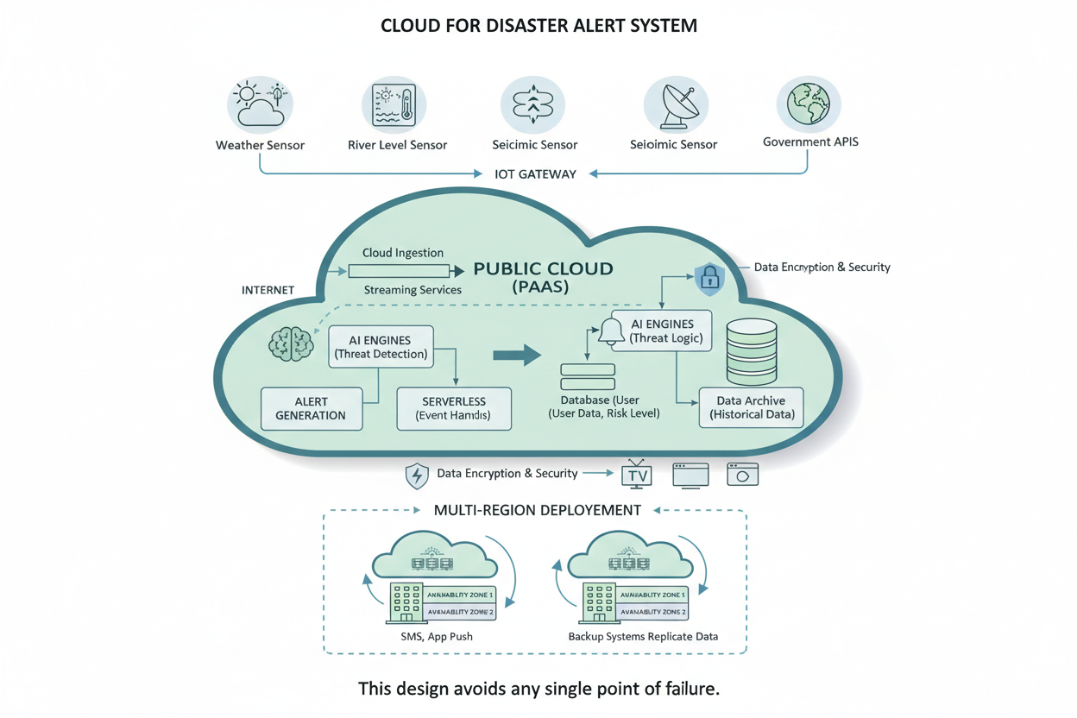
Step 5: Scalability & Reliability
Scalability
- Cloud automatically increases compute power during disasters.
- Supports millions of users simultaneously.
- No performance degradation during peak usage.
Reliability
- Multi-Availability Zones ensure backup systems.
- Multi-Region deployment protects against regional failures.
- System continues even if one data center fails.

6.Observations
Data Encryption
- Protects sensor data during transmission and storage.
Authentication
- Only verified sensors and systems can send data.
Digital Signatures
- Prevent fake alerts and data tampering.
Access Control
- Restricts system access to authorized government agencies.

7. Real-Time Use Case
Government Systems
- India’s NDMA SACHET
- Global GDACS platform
Daily Life Applications
- Flood alerts via SMS
- Earthquake warnings on mobile apps
- Cyclone alerts on TV and radio

8. Conclusion
Cloud-based disaster alert systems provide fast, reliable, and scalable solutions for emergency management.
They ensure real-time alerts, prevent data loss, and support millions of users without system failure.
Cloud computing plays a critical role in saving lives during natural disasters.
9. AI Reflection (Mandatory)
AI tools helped in designing the complete cloud architecture, explaining each layer clearly, and maintaining a professional academic structure.
The use of AI reduced design time and improved clarity and organization of the system.
10. References
Websites / Tutorials / Docs
- GDACS Global Disaster Platform
- AWS Disaster Recovery Whitepapers
- Google Cloud Disaster Architecture
- NIST Cloud Computing Standards

