Course Name : Cloud Computing
Course Code : 22IT102003
Program : B.Tech VI Semester Faculty : P. Yogendra Prasad
Student Name : Vempadapu Rama
Roll Number : 23102A020090
Branch & Section : Cyber Security & CS - 2
Task Number & Title : Task- 11: Multi-Cloud Architecture for Disaster Recovery & High Availability

Task- 11: Multi-Cloud Architecture for Disaster Recovery & High Availability
- Student Details
  - Name: Vempadapu Rama
  - Register Number: 23102A020090
  - Branch & Section: Cyber Security & CS - 2
  - Task Number & Title: Task-11 & Multi-Cloud Architecture for Disaster Recovery & High Availability
  - Date of Submission: 23-02-2026
2.Problem Statement:
Modern enterprises rely heavily on cloud infrastructure to run mission-critical applications. Downtime caused by infrastructure failures, cyberattacks, natural disasters, or service outages can result in financial loss, reputational damage, and compliance violations.
This project designs a production-grade Multi-Cloud Disaster Recovery (DR) architecture using Amazon Web Services and Microsoft Azure to ensure high availability, business continuity, minimal Recovery Time Objective (RTO), and minimal Recovery Point Objective (RPO)**.
The proposed solution ensures cross-region replication, automated failover, data backup, secure connectivity, and cost-efficient standby infrastructure.
3. Requirements Analysis
3.1 Functional Requirements
- Automatic data replication across regions and clouds
- Failover within minutes in case of primary cloud outage
- Real-time database synchronization
- Backup automation and recovery testing
- Centralized monitoring and alerting
- Secure encrypted communication between clouds

3.2 Non-Functional Requirements

Category | Target | Rationale
Availability | 99.99% uptime | Critical enterprise applications
RTO | < 15 minutes | Fast recovery during outages
RPO | < 5 minutes | Minimal data loss
Scalability | 0–50,000 users | Traffic surge handling
Security | ISO 27001 / GDPR | Regulatory compliance
Cost Efficiency | 35% lower than full-active dual cloud | Use warm standby model
3.3 Compute Requirements
Workloads are categorized into application compute, database compute, and recovery compute.
Primary Cloud Compute
• Auto Scaling Groups for application servers
• Kubernetes clusters for container workloads
• Multi-AZ virtual machines
• Managed database services

Secondary Cloud Compute
• Warm standby virtual machines
• Pre-configured Kubernetes clusters
• Scaled-down database replicas
• Automated scaling upon failover

Recovery Compute
Recovery compute remains minimal during normal operations and scales automatically during disaster events.
4. Storage for Datasets
4.1 Storage Architecture Overview
A tiered cross-cloud storage strategy ensures redundancy and cost efficiency.
Tier | Service | Use Case | Replication
Hot (Active) | Object Storage (S3 / Blob / GCS) | Active application data | Cross-cloud sync
Warm (Active) | Block Storage | Database snapshots | Scheduled replication
Cold Archive | Archive Storage | Backup & logs | Long-term retention

4.2 Cross-Cloud Replication Strategy
• Database replication using logical replication or read replicas
• Daily full backups stored in alternate cloud
• Hourly incremental backups
• Encrypted storage with customer-managed keys
• Snapshot replication between regions
All data in transit is secured using TLS encryption.

4.3 Data Lifecycle Management
• Automated lifecycle rules move old backups to cold storage
• Retention policies based on compliance requirements
• Periodic disaster recovery testing
• Backup integrity verification

5. Cloud Model Selection
5.1 Justification for AWS
A multi-cloud strategy is selected to:
• Eliminate single point of failure
• Reduce vendor lock-in risk
• Improve regional coverage
• Strengthen regulatory compliance
• Enhance resilience against cloud-wide outages
Using multiple providers increases system reliability compared to relying on a single vendor.
5.2 Deployment Model: Public Cloud (Managed Services)
The deployment follows a public multi-cloud managed-services model.
Primary environment runs on AWS.
Secondary disaster recovery environment runs on Azure.
Optional tertiary backup can be configured on GCP.
Interconnectivity is established using VPN or dedicated private links.

6. Architecture Diagram
Architecture Scope
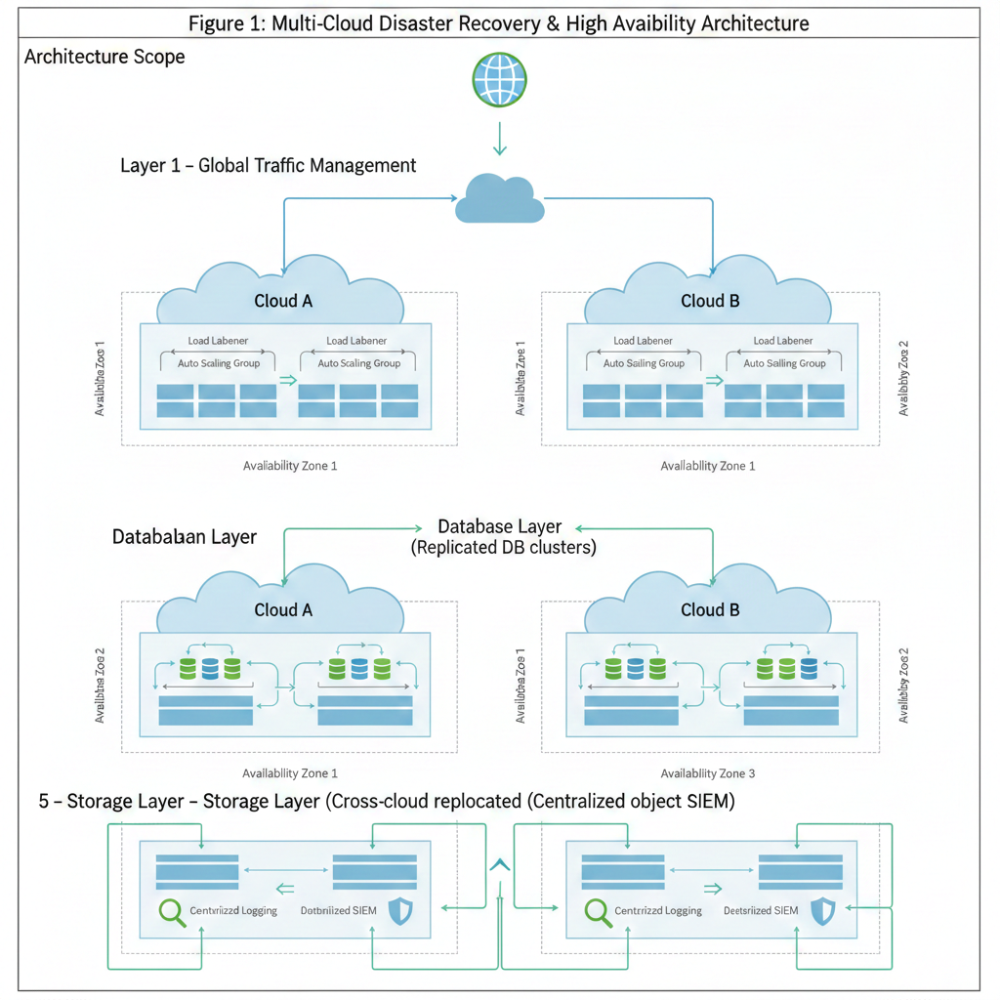
Figure 1: Multi-Cloud Disaster Recovery & High Availability Architecture
7. Explanation & Justification
7.1 Traffic Management Layer
Global DNS routing is configured using:
• Amazon Route 53
• Azure Traffic Manager
Health checks continuously monitor endpoints. If the primary cloud becomes unavailable, DNS automatically redirects traffic to the secondary cloud.
7.2 Application Layer
Application servers are deployed in multiple Availability Zones. Auto Scaling ensures performance during traffic spikes. Containers are orchestrated using Kubernetes clusters in each cloud.
Stateless microservices architecture allows seamless failover without session loss.

7.3 Database Layer
Primary database operates in Multi-AZ mode.
Secondary cloud maintains:
• Read replica
• Continuous replication
• Automated promotion during failover
This ensures RPO < 5 minutes
7.4 Monitoring & Automation Layer
• Centralized logging
• Health monitoring dashboards
• Automated failover scripts
• Alert notifications
Infrastructure is deployed using Terraform to maintain consistency across clouds.
7.5 Security Architecture
• Network isolation using VPCs
• IAM-based access control
• Encryption at rest and in transit
• Web Application Firewall
• Audit logging
• Threat detection systems
Security policies are standardized across clouds.

8. Cost Implications
8.1 Cost Breakdown by Layer
Component | Est. Monthly | Optimisation Strategy
Primary Cloud Infra | ~$2,800 | Reserved instances
Secondary Standby | ~$300 | Minimal active compute
Cross-Cloud Replication | ~$700 | Scheduled sync
Networking | ~$1,150 | Private endpoints
TOTAL ESTIMATE | ~$7,100/mo | Optimized Active-Passive

8.2 Cost Optimisation Strategies
• Active–Passive model reduces compute cost
• Auto-scale only during failover
• Archive old backups
• Use reserved capacity in primary cloud
• Automated shutdown of unused resources
• Periodic cost monitoring and anomaly detection
9. Benefits & Challenges
Benefits
• Near-zero downtime
• Business continuity
• Improved resilience
• Reduced vendor dependency
• Enhanced global performance
Challenges
• Increased complexity
• Higher operational cost
• Cross-cloud latency
• Skilled resource requirement
• Monitoring overhead
9. Conclusion
This project presents a secure, scalable, and resilient Multi-Cloud Disaster Recovery and High Availability architecture across AWS, Azure, and GCP.
The solution ensures minimal downtime, rapid recovery, and strong security controls. By combining cross-cloud replication, global DNS failover, and automated monitoring, enterprises can achieve enterprise-grade resilience and regulatory compliance.
The architecture is future-ready and can integrate advanced technologies such as AI-based failure prediction and automated disaster recovery orchestration.
10. References
- Amazon Web Services – Disaster Recovery Whitepaper
- Microsoft Azure Architecture Center – Multi-Cloud Strategy
- Google Cloud Architecture Framework – Reliability Guide
- NIST Cloud Computing Guidelines
- Gartner Research – Multi-Cloud Strategy 2025

11. AI Usage Disclosure
Disclosure Statement — Use of AI Tools
AI-assisted tools were used in preparing this document in accordance with academic integrity guidelines. AI supported content drafting and structuring. All architectural decisions and validations were performed by the student, who takes full responsibility for the accuracy and integrity of the work.

