Flowchart Quiz 2

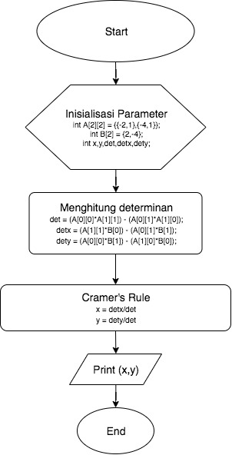Sarah Alyaa Tsaabitah / 13218011