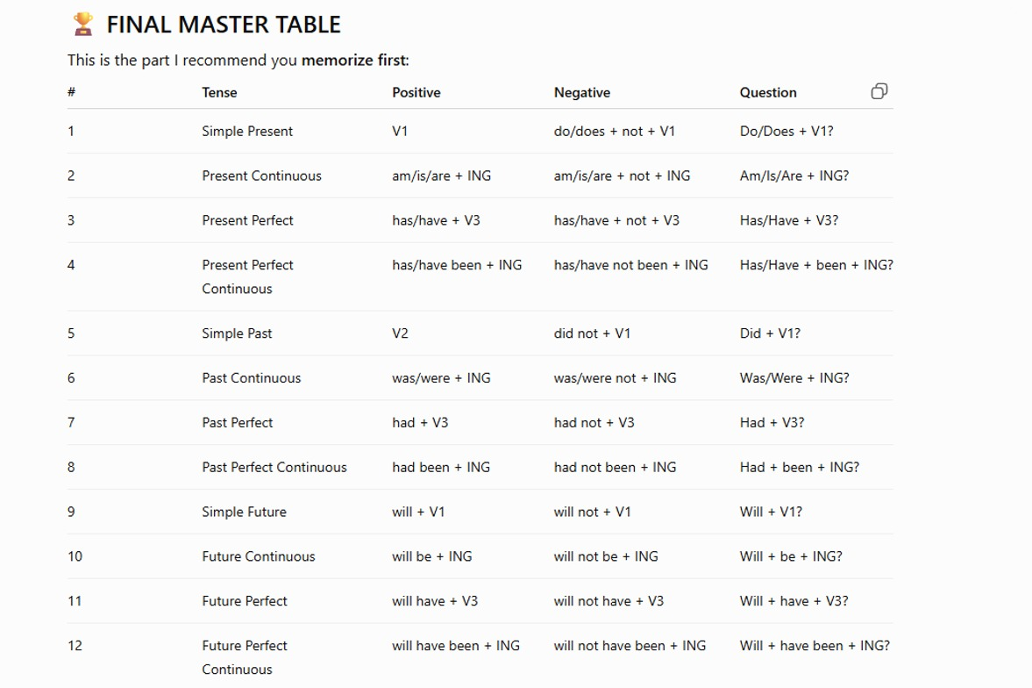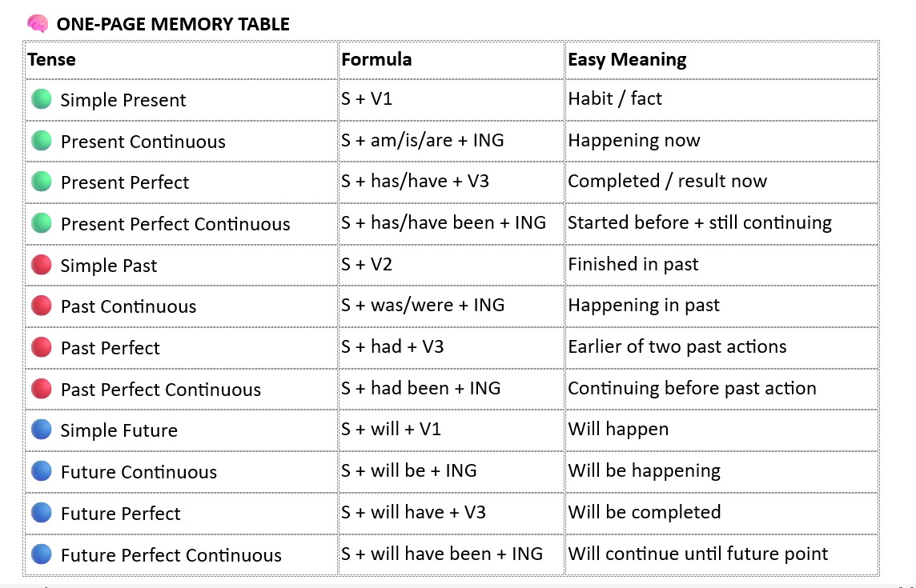

Can
Could

I am not able to join.
I was not able to join.

I have seen this movie;
I saw this movie yesterday.

I have read this book;
I read this book, when I was child/ was in UG;

Have you brought milk?
Did you bring milk?

Yes I have brought the milk;
Yes I brought the milk 10 mins ago;

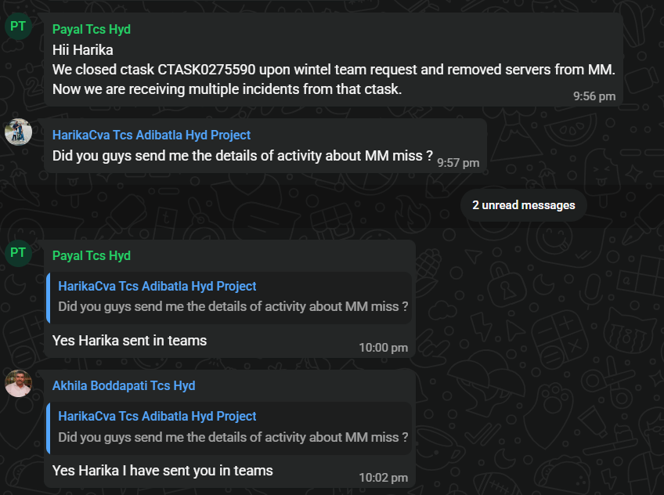
When you came, I was eating;
I was sleeping at that;

Present perfect continuous;
Past present;

Sorry I was eating, when you called me;

Simple Future;

yest. I was at aditya’s room;
today I woke up at 6:30 AM;
then I went to railways station to see off my friend;
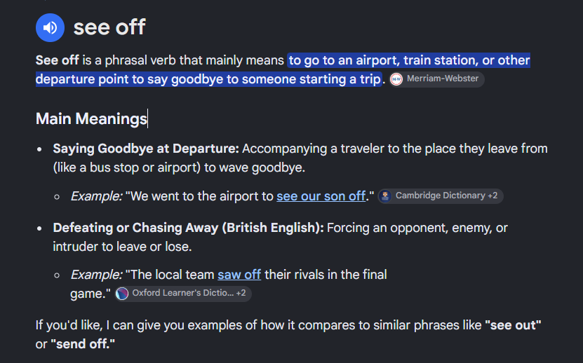
then I returned to my home at 7:15 am;
then I freshened up myself and brushed;
then I started using mobile phone, and used for 30 min.
2 day, 3 day for
1st Jan since;

I went to adityas room to give his scooty;
After that I went to the hotel to eat breakfast; (to + v1)
Then bought chicken for lunch, and I reached at home at 10:30 am;
After that read/studied current affair and history for 90 min.
Then I started preparing lunch
I completed/had/took my bath.
I finished/ate/had/took my lunch;
The curry was so spicy;
I put extra masala, so that it became spicy;
He put/used/added more masala in the curry;
After that what I did?
I think I started listening song for 45 min, then I slept for 90 mins.
Again I got/woke up at 5:30 pm;
Then started studying math for 30 min.
Suddenly the mobile started ringing and then I saw it was dibya;
He told/informed me that his uncles house is empty;
Then he told me, that if you want to visit the house. You can come and visit;
If you want you can eat rice;

Then I went to his uncles house and visited that, saw those rooms.
And I liked the balcony; and we discussed about the room and its rent;
With that we started gossiping for 30 min.
Then I came/returned to my room;
At that time it was 8:00 pm;
Then I started talking with my parents for 30 min.
And there I discussed with my father about the construction site;
And he said, everything is going good;
And he told me, You come tomorrow;
You come tomorrow, we will do that;
You will come tomorrow;
Ram you come tomorrow, we will go there;
I heated the food;
Heat, heated, heated;
I heated up the food; and I completed my dinner and after that I took the skin care routing, and then washed my Used dishes / Leftover dishes / Utensils;
Then I waited for the meeting. And I joined the meeting;
Right now, I am here;
we are in the meeting, and discussing about English;
And we have been discussing for 30mins.

I woke/got up at 7 am;
Then I brushed my teeth;
After that I freshened up / went to fresh up / had a fresh up;
Then I went to worship;
Then I started studying python for 2 hours;
Then I went to hotel to get some breakfast;
I went to hotel to eat breakfast, and I ate/took/had puri upma there;
After that I came to my home and started talking with my friend;
After that I had a little conversion with Rama;
Then I went to have/eat lunch.
And I ate lunch;
Then I went to library and started studying excel for 2 hours;
Then I saw kapil sharma show for 45 min;
After that I read English for 1 hours;
Then Dhiren and me;
Mu I
Mote me
Dhiren and I went to uncles house to see the rooms;
We saw the rooms;
Then after returned/came back from uncles house we discussed.
Then I went to library, then I saw cricket match;

VK scored 100/ a century;
India won the match;

Present(V1) Past(v2) Past participle (v3) Present participle(V-ing)
Do did done doing

Question:
When did you do/eat your lunch/dinner?
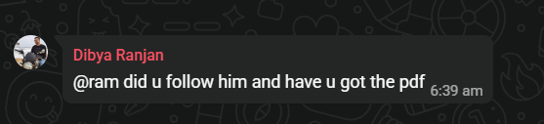
Have you got/gotten the pdf?
Did you get the pdf, that I sent this morning?

Did you follow him?
Do you follow him?

Did you go to play TT today?
Did not you go to office?

How was your day?
How did your day go?
How has your day been?

How have you been?
How are you?

He has been fantastic;
He has been a good student
Has he been ill for 2 days?

Past present
How have you been?
Past- Present-

Did you drink coffee in the eve?
Do you drink soda?
Did you drink soda today?
Have you ever tested soda?

How many hours do you study? 4

How many hours have you studied?
How many hours did you study today? 3

Have you used insta?
Did you use insta today?
How long have you been/used in social media today?
How long did you use social media today?

Did you talk with your family?
Yes, I did.
No, I didn’t.
Yes, I talked;

Why are you behaving like nonsense?
Why do you think too much? bhaba
Why did you think so much. Bhabila

Daily why do you think about her?
Today why did you think about her like Devdas?

It will take time;
My-TL: Rama, why don’t you mix up with people?
What was your answer on that question?
- It will take time;

How is the construction work?
What is the update on the work?
How the work is going on?

What did the misty say?
What did the misty tell you?

Will stop here, and will discuss it tomorrow/further?
That is it, will discuss further;

we will stop here today,
Casual / Everyday Options (Best for friends or close coworkers):
- "That's all for today, we'll discuss the rest tomorrow."
- "Let's call it a day, we'll talk about it tomorrow."
- "That's it for today, we can discuss it tomorrow."
Formal / Professional Options (Best for official business meetings):
- "That concludes our discussion for today; we will resume tomorrow."
- "Let's wrap up for today and pick this back up tomorrow."

I will go to my village on nation duty, I will not be available, I will be available;

Start
Stop
Avoid
Keep

Order
Request
State of Being:
State of possession:

State of Action:
Present simple
Present Continuous
Present perfect
Present perfect continuous

Past simple
Past Continuous

Future simple

Imperative sentence
Order and request;

