CREDITFAIR: ACCURATE, CALIBRATED AND FAIR CREDIT-RISK SCORING WITH EXPLAINABLE DECISIONS
A Project Based Learning Report Submitted in partial fulfilment of the requirements for the award of the degree
of
Bachelor of Technology
in The Department of Computer Science and Engineering
Course: Machine Learning
Submitted by
2510030213 : Rama Gayathri
2510030376 : Chandana
2510030258 : Chakrika
2510030109 : Srivalli
Under the guidance of
Dr. Sai Sudha

Department of Computer Science and Engineering
Koneru Lakshmaiah Education Foundation, Aziz Nagar
Aziz Nagar – 500075
OCT - 2026.
Abstract
Credit decisions shape people's lives, and a credit model that is accurate but biased can systematically deny opportunity to protected groups while regulators demand that every decline be explainable. This project presents CreditFair, an end-to-end credit-risk system that predicts 12-month default probability and loss given default, sets risk-based credit limits, produces adverse-action reason codes and audits its own decisions for group fairness. Following a 12-week build plan, we construct a leakage-safe pipeline on a 40,000-application loan portfolio and climb a ladder of models: OLS with gradient descent, ridge and lasso, logistic regression, an interpretable tree, a random forest and a gradient-boosting champion, tuned with cross-validation, the one-standard-error rule and early stopping. Probabilities are calibrated, borrowers are segmented with k-means, DBSCAN and PCA, and decisions are made at a cost-optimal threshold.
The calibrated champion reached an AUC of 0.797 against a theoretical ceiling of 0.814, matched the incumbent logistic baseline within statistical noise while improving PR-AUC and log-loss, and cut expected cost per applicant to ₹14,419 from ₹22,959 when approving everyone. The fairness audit exposed a hidden bias that rank accuracy missed: the model over-predicted the risk of women (13.3% predicted against 12.1% observed). Group-specific thresholds combined with reweighing raised the disparate-impact ratio from 0.928 to 0.996 without raising cost. The packaged artefact scores an application with reason codes in a P99 of 34.9 ms, and a PSI-plus-calibration guard flagged simulated drift in month 8. The portfolio is synthetic, so absolute figures are illustrative, but the methodology is directly transferable.
Keywords: credit risk, probability of default, loss given default, fairness, calibration, interpretability, reason codes, gradient boosting, population stability index, machine learning.
List of Figures
Fig. 1. High-level architecture of the CreditFair risk-scoring system. 7
Fig. 2. The 12-week build plan of CreditFair. 12
Fig. 3. Default rate by bureau-score decile, utilisation band and loan purpose. 13
Fig. 4. Missing values and the effect of winsorising income. 13
Fig. 5. Correlation of key numeric features with each other and with default. 13
Fig. 6. Gradient descent converges to the OLS optimum (cost and distance to the closed-form solution). 15
Fig. 7. Cross-validation for ridge and lasso with the one-standard-error choice, and the lasso coefficient path. 15
Fig. 8. ROC and precision-recall curves of the four PD models on the test split. 16
Fig. 9. Random forest: (a) OOB error versus number of trees; (b) permutation importance (drop in validation AUC). 17
Fig. 10. Model selection: (a) cross-validated log-loss versus logistic C with the 1-SE choice; (b) boosting learning curve with the early-stopping point. 17
Fig. 11. Reliability diagram: observed default rate against predicted PD by decile. 18
Fig. 12. Top two levels of the interpretable credit tree (full tree has 14 leaves; features in model units). 18
Fig. 13. Champion attributions: (a) global mean absolute effect; (b) one declined applicant. 19
Fig. 14. Choosing k: inertia (elbow) and silhouette score for k-means. 19
Fig. 15. PCA variance, k-means segments on the first two components, and DBSCAN noise points. 20
Fig. 16. Expected cost per applicant as the approval threshold varies (test split). 20
Fig. 17. Bootstrap distributions of the AUC difference and of the cost saving. 21
Fig. 18. Calibration by gender: predicted PD against observed default rate. 22
Fig. 19. Effect of mitigation on the disparate-impact ratio, the equal-opportunity gap and the cost. 22
Fig. 20. Mean limit as a share of the request by PD band, and the limit curve for three LGD levels. 23
Fig. 21. Twelve-month drift simulation: score PSI and calibration error against their trigger levels. 24
Fig. 22. Distribution of end-to-end scoring latency over 1,200 requests. 25
List of Tables
Table 1. Applicant attributes in the CreditFair dataset. 7
Table 2. Performance metrics used in the project. 8
Table 3. Models used for each target. 9
Table 4. Mapping from attributes to adverse-action statements (excerpt). 10
Table 5. Software environment used for development and experiments. 11
Table 6. Week-wise execution log. 12
Table 7. Validation test cases and observed behaviour. 14
Table 8. LGD regression results on the test split (987 defaulted loans). 15
Table 9. PD classification results on the test split (8,000 applications). 16
Table 10. Calibration comparison on the test split. 17
Table 11. Selected leaves of the depth-4 credit tree (training split). 18
Table 12. Profile of the four k-means risk segments (training split). 19
Table 13. Expected monetary cost per applicant on the test split. 20
Table 14. Paired bootstrap comparison, champion minus incumbent (1,000 resamples). 21
Table 15. Fairness audit by gender at the cost-optimal threshold (test split). 21
Table 16. Comparison of fairness mitigations (female versus male). 22
Table 17. Risk-based limits by calibrated PD band (test split). 23
Table 18. Population Stability Index by scenario. 23
Table 19. Scoring latency of the packaged artefact. 24
Table 20. Summary of key findings. 25
Table 21. Files delivered with the project. 30
Table of Contents
1. INTRODUCTION 5
1.1 Background 5
1.2 Problem Statement 5
1.3 Objectives 5
1.4 Scope and Limitations 6
1.5 Literature Survey 6
1.6 Organization of the Report 6
2. METHODOLOGY 7
2.1 System Overview and Architecture 7
2.2 Data Model: Loan Applications and Repayment Records 7
2.3 Prediction Targets, Irreducible Error and Metrics 8
2.4 Leakage-Safe Preprocessing Pipeline 9
2.5 The Model Ladder 9
2.6 Calibration and Reason Codes 10
2.7 Borrower Segmentation 10
2.8 Cost-Sensitive Decision and Fair Credit Limits 10
2.9 Fairness Audit and Mitigation 11
2.10 Packaging, Drift Guard and Serving 11
3. EXPERIMENTS 11
3.1 Experimental Set-up 11
3.2 Dataset and Exploratory Analysis 12
3.3 Validation Test Cases 14
4. RESULTS 14
4.1 Loss Given Default 14
4.2 Default Prediction 15
4.3 Calibration 17
4.4 Interpretability and Reason Codes 18
4.5 Borrower Segments 19
4.6 Cost-Based Decisions and Significance Tests 20
4.7 Fairness Audit 21
4.8 Fair, Risk-Based Credit Limits 23
4.9 Drift Monitoring and Serving 23
4.10 Discussion 25
4.11 Limitations of the Present Work 25
5. CONCLUSION AND FUTURE WORK 26
REFERENCES 27
APPENDIX A: SOURCE CODE (EXCERPTS) 28
APPENDIX B: HOW TO RUN AND EXAMPLE API RESPONSES 30

1. INTRODUCTION

1.1 Background
Lending is one of the most consequential decisions a financial institution makes about a person. A home-improvement loan, a vehicle loan or a small-business loan can change a household's prospects, and a refusal can close a door that stays closed for years. Banks and non-banking lenders therefore build credit-risk models that estimate, at the moment of application, how likely a borrower is to repay. Two quantities are central to the Basel-style view of credit risk [13]: the probability of default (PD), the chance that the borrower fails to repay within a horizon (here 12 months), and the loss given default (LGD), the fraction of the exposure that is lost if default occurs. Together with the exposure at default (EAD), they give the expected loss, EL = PD × LGD × EAD, which is the quantity a lender must price, provision for and cap.
Machine learning has steadily improved the accuracy of these estimates [8], but accuracy alone is not enough in lending. First, a model that is accurate on average can still be biased against a protected group: it may deny qualified applicants more often because a feature it relies on is itself a distorted measurement of that group's behaviour. Second, regulators expect every adverse decision to be explainable: in the United States, Regulation B requires a lender to state the principal reasons for a decline [14], and digital-lending guidance in India stresses transparency and fairness toward borrowers [20]. Third, probabilities used to set prices and limits must be calibrated: a predicted 10% default risk must correspond to about 10 defaults per 100 such loans, otherwise limits and provisions are mis-sized. Credit scoring is therefore the place where machine learning meets ethics and regulation, and getting risk right and fair at the same time is the entire challenge.
This project, CreditFair, builds an end-to-end credit-risk system that treats these requirements as first-class objectives rather than afterthoughts. It predicts default and loss, converts them into a fair, risk-based credit limit, produces adverse-action reason codes, audits every decision for group fairness, and is packaged as a versioned scoring service with a drift guard. The work follows a 12-week plan, from framing the two prediction targets in Week 1 to serving and monitoring in Week 12.

1.2 Problem Statement
Lenders need a credit model that is simultaneously accurate, calibrated, interpretable and fair. Existing practice often optimises one of these at the expense of the others: a black-box model may rank borrowers well but cannot justify a decline, and a simple scorecard may be explainable but leaves accuracy on the table. The problem addressed in this project is to design, build and evaluate a credit-risk system that models 12-month default and expected loss accurately, while auditing and controlling for fairness across protected groups, and that produces calibrated, interpretable, regulation-ready outputs through a low-latency scoring endpoint.

1.3 Objectives
- To frame two prediction targets, 12-month loan default (classification) and loss given default (regression), and to estimate the irreducible-error floor that no model can beat.
- To build a leakage-safe data pipeline for loan-application and repayment records, with documented handling of missing values and outliers.
- To develop a ladder of models, from linear and logistic baselines through an interpretable tree and a random forest to a gradient-boosting champion, and to tune them with cross-validation and the one-standard-error rule.
- To produce human-readable adverse-action reason codes from a tree and from per-applicant attributions.
- To calibrate predicted probabilities and to derive cost-optimal decisions and risk-based fair credit limits.
- To segment borrowers with k-means, DBSCAN and PCA and to test whether segment labels improve prediction.
- To audit the model for group fairness, apply mitigation, and quantify the accuracy and cost of fairness.
- To package the champion as a versioned artefact with a PSI drift guard and to verify a sub-100 ms P99 latency budget with a retraining trigger.

1.4 Scope and Limitations
The study uses a synthetic but realistic loan portfolio of 40,000 applications that we generated with a documented data-generating process. Real lending data are confidential and cannot be shared for coursework, and a synthetic portfolio has a decisive advantage for a fairness study: the true default probability of every applicant is known, so we can compute the theoretical accuracy ceiling and verify that an injected bias is actually detected. The consequence is that absolute numbers (for example the AUC) describe this simulated portfolio and must not be read as expected performance on a real book. The relative findings, such as which model wins, how much calibration helps and which mitigation closes the fairness gap, are the transferable part of the work.
Two implementation notes are stated openly. The gradient-boosting champion is implemented with scikit-learn's histogram-based gradient-boosted trees, which belong to the same algorithm family as XGBoost [3] and support the same early-stopping workflow; and per-applicant explanations use a baseline-substitution attribution rather than the SHAP library [4], because neither package was available in the build environment. Section 2.6 explains the method, and Section 5 notes that XGBoost and TreeSHAP are drop-in replacements for the same interfaces.

1.5 Literature Survey
Statistical credit scoring began with logistic-regression scorecards, which remain the industry reference because they are transparent and easy to audit [9][12]. Lessmann et al. benchmarked dozens of classifiers on credit data and found that ensembles of trees generally outperform single models, although the margin over well-tuned logistic regression is often modest [8]; this is exactly the pattern observed later in this report. Random forests [2] reduce the variance of deep trees by averaging bootstrap-trained trees, and gradient boosting, popularised at scale by XGBoost [3], builds trees sequentially to correct earlier errors. Regularisation methods such as the lasso [11] and ridge regression shrink coefficients to control over-fitting [1].
Predicted probabilities from many classifiers are poorly calibrated, and Niculescu-Mizil and Caruana showed that Platt scaling and isotonic regression repair this [7]. Explanations for individual predictions are commonly produced with Shapley-value methods [4], and permutation importance gives a model-agnostic global ranking. For fairness, Hardt, Price and Srebro formalised equality of opportunity and a post-processing remedy based on group-specific thresholds [5], while Kamiran and Calders proposed reweighing the training data [6]; Barocas, Hardt and Narayanan give a textbook treatment of the trade-offs [15]. Cost-sensitive decision-making sets the threshold from the ratio of misclassification costs [19]. For monitoring, the Population Stability Index is the standard drift measure in credit-risk practice [12]. Unsupervised segmentation relies on k-means [17] and DBSCAN [16]. This project combines these established ingredients into one audited, deployable pipeline.

1.6 Organization of the Report
Section 2 presents the methodology: architecture, data model, targets and metrics, the leakage-safe pipeline, the model ladder, calibration and reason codes, segmentation, cost-based decisions, the fairness audit, and packaging and monitoring. Section 3 describes the experimental set-up, exploratory analysis, the 12-week execution log and the validation tests. Section 4 reports and discusses results. Section 5 concludes and proposes future work. Source code excerpts and run instructions are given in the appendices.

2. METHODOLOGY

2.1 System Overview and Architecture
CreditFair is organised as a pipeline (Fig. 1). Application and repayment records are ingested, validated and split before any statistic is learned, so that no information from the test period leaks into training. A single, shared feature module produces model inputs for training and for serving, which removes the classic training/serving skew. Two supervised models run on those features: a PD model (classification) and an LGD model (regression). PD is calibrated and multiplied by the predicted LGD and the loan amount to give the expected loss. Expected loss drives a risk-based credit limit, and PD drives the approve/decline decision through a cost-optimal threshold. In parallel, the system produces reason codes for each decision and a fairness audit of the outcomes, and a monitoring layer watches the incoming population and the calibration of the scores.
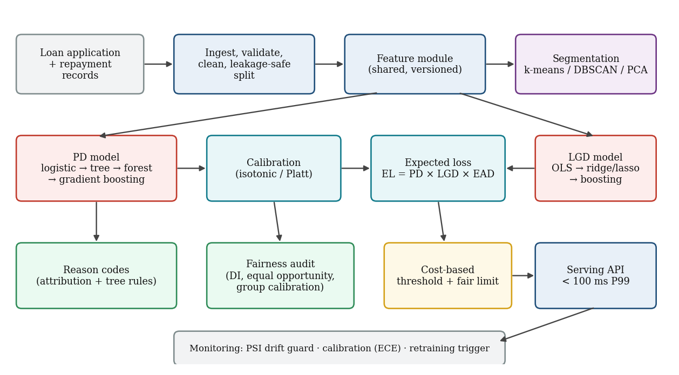
Fig. 1. High-level architecture of the CreditFair risk-scoring system.
Every component is a plain Python object with a fit/transform or fit/predict interface, so the whole system is serialised as a single versioned artefact (Section 2.10). Segmentation is deliberately placed beside, not inside, the prediction path: its label is fed back to the PD model only as an optional extra feature, which lets us test its value rather than assume it.

2.2 Data Model: Loan Applications and Repayment Records
Each record describes one loan application and its 12-month outcome. The attributes (Table 1) cover the four groups named in the project brief: income, credit history, utilisation and bureau data, plus loan characteristics. Gender and age are recorded for auditing only and are never given to the model (fairness through unawareness is used as a starting point, and the audit then tests whether it is sufficient, which in general it is not, because other features can act as proxies).
Table 1. Applicant attributes in the CreditFair dataset.
Attribute | Type | Meaning
income | numeric | Annual income (₹); 3.4% missing; a few entry errors
emp_years | numeric | Years in current employment; 5.9% missing
loan_amount, term | numeric | Requested amount (₹, also the exposure at default) and tenure in months
dti | numeric | Debt-to-income ratio including the new instalment
utilisation | numeric | Share of existing revolving credit in use (0 to 1)
history_years | numeric | Length of credit history
bureau_score | numeric | Credit-bureau score (300 to 850); 2.9% missing (thin files)
delinq_2y, inquiries_6m, open_accounts | numeric | Delinquencies in 2 years, recent credit inquiries, open accounts
home, purpose, region | categorical | Housing status, loan purpose (6 levels), region (4 levels)
default (target 1) | binary | Default within 12 months
lgd (target 2) | numeric | Loss given default, observed only for defaulters (0.05 to 1)
gender, age | audit only | Protected attributes; excluded from model inputs

Data-generating process. Incomes are log-normal with a modest historical gap by gender. Default risk depends non-linearly on bureau score, utilisation, debt-to-income, delinquencies, income, loan-to-income and tenure, with interaction effects (for example high utilisation together with high debt-to-income) and thresholds (a bureau score below 600). The intercept is calibrated so that the portfolio default rate is about 12%. Loss given default depends on loan purpose (secured purposes such as vehicle loans lose less), housing status, tenure and loan size, with random noise of standard deviation 0.12. Finally, we inject a measurement bias: the bureau score recorded for women is on average 22 points lower than the score their repayment behaviour would earn, a stylised version of the thin-file effect documented in credit-bureau data. True default risk depends on behaviour, not on this distortion, so the bias is real, hidden and detectable only by an audit.

2.3 Prediction Targets, Irreducible Error and Metrics
Target 1 (classification) is default within 12 months. Target 2 (regression) is loss given default, learned on defaulted loans only, because LGD is only observed after a default. The expected-loss rate of an applicant is PD × LGD. Before modelling, Week 1 asks how well any model could possibly do. Because the true default probability of every simulated applicant is known, the ceiling for ranking accuracy is the AUC of the true probabilities, 0.814 on the test split; no model can honestly exceed it. For LGD, the noise standard deviation of 0.12 sets an RMSE floor of about 0.12 before clipping to the valid range. On real data these floors are estimated indirectly, for example from the plateau of learning curves or from near-duplicate applicants; here we can compare every model with the true floor.
Table 2. Performance metrics used in the project.
Metric | Used for | Why it is used
AUC (ROC) | PD ranking | Threshold-free ranking quality; compared with the ceiling
PR-AUC (average precision) | PD ranking | More informative than AUC when defaults are rare (12%)
KS statistic | PD ranking | Maximum separation of good and bad score distributions; industry standard
Brier score, log-loss | PD probabilities | Proper scoring rules; penalise over-confident probabilities
ECE (expected calibration error) | PD calibration | Gap between predicted and observed default rate by decile
RMSE, MAE, R² | LGD | Error of the loss-severity regression
Expected cost per applicant (₹) | Decision | Monetary cost of wrong approvals and wrong declines
Disparate-impact ratio, equal-opportunity gap | Fairness | Approval-rate ratio; approval gap among good borrowers
PSI | Drift | Population shift: below 0.10 stable, 0.10 to 0.25 watch, above 0.25 act

2.4 Leakage-Safe Preprocessing Pipeline
The data are split once, stratified by default status, into 60% training (24,000), 20% validation (8,000) and 20% test (8,000) records. A Prep object is fitted on the training split only and then applied unchanged to validation, test and live traffic. It performs, in order: (i) winsorising income at the 0.5th and 99.5th training percentiles, which neutralises the 98 entry errors where income is inflated twenty-fold; (ii) imputation of missing numeric values with training medians, together with explicit missingness indicators for income, employment length and bureau score, because a missing bureau score marks a thin file and is itself informative; (iii) feature engineering: log-income, log-loan, loan-to-income, instalment-to-income, the utilisation × debt-to-income interaction and a has-delinquency flag; (iv) one-hot encoding of the three categorical attributes with unseen categories mapped to all zeros; and (v) standardisation. The result is a 31-dimensional feature vector. Threshold, calibration and hyper-parameter choices are made on the validation split, and the test split is touched once for the final report.

2.5 The Model Ladder
Models are introduced in a deliberate order, each answering a question the previous one raises (Table 3). Linear models set an honest baseline; the tree adds interpretability; the forest trades interpretability for variance reduction; boosting is the accuracy champion.
Table 3. Models used for each target.
Week | Model | Target | Key technique
3 | OLS and gradient descent | LGD | Closed form versus batch gradient descent written from scratch
4–5 | Ridge, lasso; logistic regression | LGD; PD | 5-fold cross-validation and the one-standard-error rule
6 | Decision tree (depth 4) | PD | Readable rules; regulatory reason codes
7 | Random forest (300 trees) | PD, LGD | Out-of-bag error, permutation importance
8 | Gradient boosting (champion) | PD, LGD | Early stopping, random-search tuning, attributions

Linear baselines. The LGD baseline is ordinary least squares (OLS), solved both in closed form and by batch gradient descent with learning rate 0.05 for 400 iterations, which shows that the iterative optimiser converges to the analytical optimum. Ridge (L2) and lasso (L1) penalties are then added, with the penalty chosen by 5-fold cross-validation. The one-standard-error rule selects the strongest penalty whose cross-validated error is within one standard error of the minimum; it prefers the simpler model when the data cannot distinguish the two. The PD baseline is an L2-regularised logistic regression, tuned the same way.
Tree, forest and boosting. A decision tree of depth 4 with at least 300 applicants per leaf yields a small set of readable rules. A random forest of 300 trees (leaf size 20, square-root feature sampling) averages away the instability of single trees, and its out-of-bag (OOB) predictions provide a free validation estimate. The champion is a gradient-boosted ensemble of shallow trees, tuned by random search over learning rate, depth, L2 penalty and leaf size (12 trials), with early stopping on a held-out slice of the training data so that the number of boosting rounds is learned rather than guessed.

2.6 Calibration and Reason Codes
Boosted trees optimise log-loss and are usually close to calibrated, but not exactly. We compare the raw scores with Platt scaling (a logistic fit on the logit of the score) and isotonic regression (a monotone step function), both fitted on the validation split, and select by validation Brier score. Calibration matters because the credit limit, the expected loss and the cost threshold all treat the output as a true probability.
Reason codes answer the regulator's question, "why was this applicant declined?" Two complementary mechanisms are used. First, the interpretable tree gives a global rulebook (Section 4.4). Second, for the champion we compute a per-applicant attribution by baseline substitution: each of the 14 raw attributes is in turn replaced by its training median (or mode), the calibrated PD is recomputed, and the drop in PD is that attribute's contribution. Attributes whose contribution is positive, meaning they pushed the risk up, are ranked, and the top four are mapped to plain-language statements (Table 4). All 15 evaluations (the applicant plus 14 substitutions) go through the model in one batch, so the cost is small. Unlike SHAP, this attribution is not guaranteed to be additive across features; it is nevertheless transparent, deterministic and cheap, and it can be replaced by TreeSHAP without changing the interface.
Table 4. Mapping from attributes to adverse-action statements (excerpt).
Attribute | Reason statement shown to the applicant
bureau_score | Bureau credit score is low
utilisation | Credit utilisation is high
dti | Debt obligations are high relative to income
delinq_2y | Recent delinquencies on credit accounts
income | Income is insufficient for the amount requested
inquiries_6m | Too many recent credit inquiries
history_years | Length of credit history is short

2.7 Borrower Segmentation
Week 9 looks for structure that supervised models might miss. Nine behavioural variables (log-income, employment length, debt-to-income, utilisation, history, bureau score, delinquencies, inquiries and instalment-to-income) are standardised, and k-means [17] is run for k = 2 to 8, comparing inertia (the elbow) and silhouette score. PCA shows how much of the variation is captured by a few components and gives a two-dimensional map. DBSCAN [16] is run on the first three principal components to find unusual applicants: points that belong to no dense region are labelled noise. The chosen k-means label is one-hot encoded and fed back to the PD model as an extra feature, and the model is retrained with identical settings to measure the gain.

2.8 Cost-Sensitive Decision and Fair Credit Limits
A decline is not free. Approving a borrower who defaults costs the loss given default times the exposure; declining a borrower who would have repaid costs the margin forgone, which we set to 9% of the loan. With calibrated PD p and mean loss rate LGD, approving is worthwhile when p × LGD < (1 − p) × margin, which gives the theoretical threshold t* = margin / (margin + LGD) = 0.155. We nevertheless sweep the threshold on the validation split and choose the empirical minimum, then report the cost on the test split. A rule of thumb that depends on costs, not on a convention such as 0.5, is what makes the decision defensible.
The risk-based limit caps the expected-loss rate: limit = requested amount × min(1, b / (PD × LGD)), with budget b = 5%. Applicants whose expected-loss rate is below the budget receive the full amount, and riskier approved applicants receive proportionally less. Because the limit is a smooth function of calibrated PD and LGD, two applicants with the same risk always receive the same limit, which is the sense in which the limit is fair; calibration by group (Section 4.7) is what makes this claim checkable.

2.9 Fairness Audit and Mitigation
Fairness is audited on the held-out test split for gender and, as a secondary check, age band (below 30, 30 to 45, above 45). Four quantities are reported per group: the approval rate; the disparate-impact ratio (approval rate of the group divided by that of the reference group, with 0.80 as the customary red line); the equal-opportunity gap, defined here as the difference in approval rate among borrowers who in fact repay [5]; and calibration by group, the mean predicted PD against the observed default rate. Calibration by group is the key diagnostic for hidden measurement bias: if a group's predicted risk systematically exceeds its observed risk, the model is penalising that group for something other than its behaviour.
Two mitigations are compared. Reweighing [6] gives each (group, outcome) cell a training weight equal to its expected over observed frequency, so that group and outcome look statistically independent in the training data. Group-specific thresholds [5] choose a separate approval cut-off for each group on the validation split so that good borrowers are approved at the same rate in both groups. The two can be combined. Each variant is judged on fairness, AUC and monetary cost, so that the price of fairness is explicit.

2.10 Packaging, Drift Guard and Serving
The champion is saved as one versioned artefact (creditfair-1.0.0, 0.18 MB) containing the fitted preprocessing object, the PD model, the calibrator, the LGD model, the decision threshold, the expected-loss budget, the reference values used for attributions and the training score distribution used by the drift guard. A single score_one function returns the PD, LGD, expected loss, decision, limit and reason codes for one application. The PSI drift guard compares the distribution of each feature and of the score in live traffic with the training reference (ten bins at reference deciles). The retraining trigger fires when the score PSI exceeds 0.25 or when the expected calibration error of the most recent matured cohort exceeds 0.03. Latency is measured end to end on single applications, including all reason-code evaluations, against a P99 budget of 100 ms.

3. EXPERIMENTS

3.1 Experimental Set-up
All experiments were run in Python on a single CPU core without a GPU. The random seed is fixed in every stage, so the reported numbers are reproducible, and each stage logs its parameters and metrics to a results file in the spirit of an MLflow run log. Table 5 lists the software environment.
Table 5. Software environment used for development and experiments.
Component | Version / role
Python | 3.12, single process
scikit-learn | 1.8.0: models, cross-validation, clustering, PCA, metrics
NumPy, pandas, SciPy | Numerical computing, data frames, statistical tests
Matplotlib | All figures in this report
joblib | Serialisation of the versioned artefact
Hardware | CPU only; latency measured on the same machine as training

The work followed the 12-week plan of the brief (Fig. 2). The first two weeks fix the problem, the data and the pipeline; Weeks 3 to 8 climb the model ladder; Week 9 adds unsupervised structure; Week 10 turns scores into decisions and audits fairness; and Weeks 11 and 12 make the system deployable and monitorable. Table 6 summarises what was produced in each week.
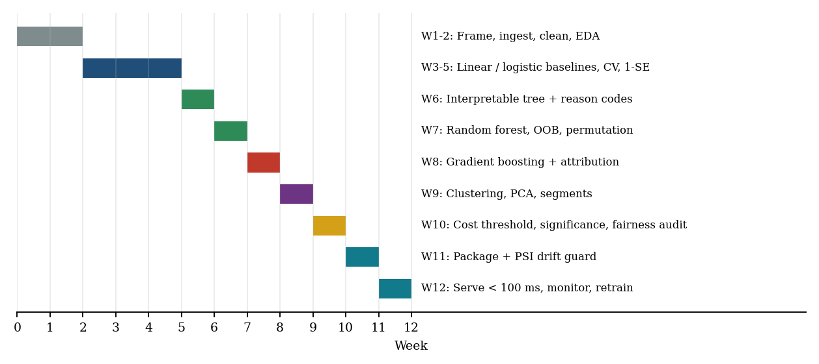
Fig. 2. The 12-week build plan of CreditFair.
Table 6. Week-wise execution log.
Week | Work carried out | Output
1 | Framed targets; computed accuracy ceiling; first look at data | AUC ceiling 0.814; LGD floor ≈ 0.12
2 | Ingestion, validation, cleaning, EDA, leakage-safe split | 31 features; 98 outliers capped
3 | OLS and gradient-descent baseline for LGD | RMSE 0.1155; GD matches OLS
4 | Ridge, lasso, logistic regression, feature engineering | Lasso keeps 9 of 31 features
5 | Cross-validation and one-SE rule; baseline milestone | Logistic AUC 0.792
6 | Interpretable tree and reason codes | Tree AUC 0.762; 14 rules
7 | Random forest, OOB error, permutation importance | AUC 0.794; OOB 0.788
8 | Gradient-boosting champion with early stopping | AUC 0.797 after 195 rounds
9 | k-means, DBSCAN, PCA; segment feature | 4 risk segments; DBSCAN flags 3.4% as noise
10 | PR-AUC, cost threshold, significance, fairness audit | Threshold 0.12; DI 0.928 → 0.996
11 | Versioned artefact, shared features, PSI guard | 0.18 MB artefact; PSI wired in
12 | Latency test, drift simulation, retraining trigger | P99 34.9 ms; trigger in month 8

3.2 Dataset and Exploratory Analysis
The portfolio has 40,000 applications, of which 12.3% default within 12 months, and 4,934 defaulted loans have an observed loss rate averaging 49.2%. Women are 46% of applicants, and their median income is ₹6,25,100 against ₹7,02,400 for men, an 11% gap. Fig. 3 shows the first exploratory signals: default risk falls steeply with bureau score (from 46.5% in the lowest decile to 3% in the highest) and rises sharply with utilisation (from 4.9% below 20% utilisation to 48.2% above 80%). Business loans are the riskiest purpose (15.6%).
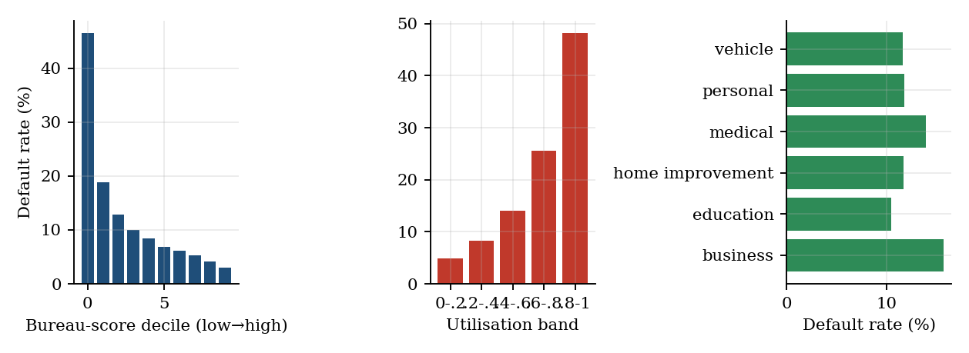
Fig. 3. Default rate by bureau-score decile, utilisation band and loan purpose.
Data quality work is shown in Fig. 4. Income is missing for 3.44% of records (more often for business loans), employment length for 5.94% and bureau score for 2.92%. Because the missing bureau scores correspond to thin files, whose risk is higher, the missingness indicator is kept as a feature rather than discarded. The raw income histogram has a long right tail caused by entry errors; winsorising restores a clean, roughly log-normal shape. The correlation map (Fig. 5) shows that bureau score and utilisation are the strongest single correlates of default (-0.33 and 0.24), and that instalment-to-income is strongly related to debt-to-income and tenure, a reminder that linear coefficients on correlated features should be interpreted with care.
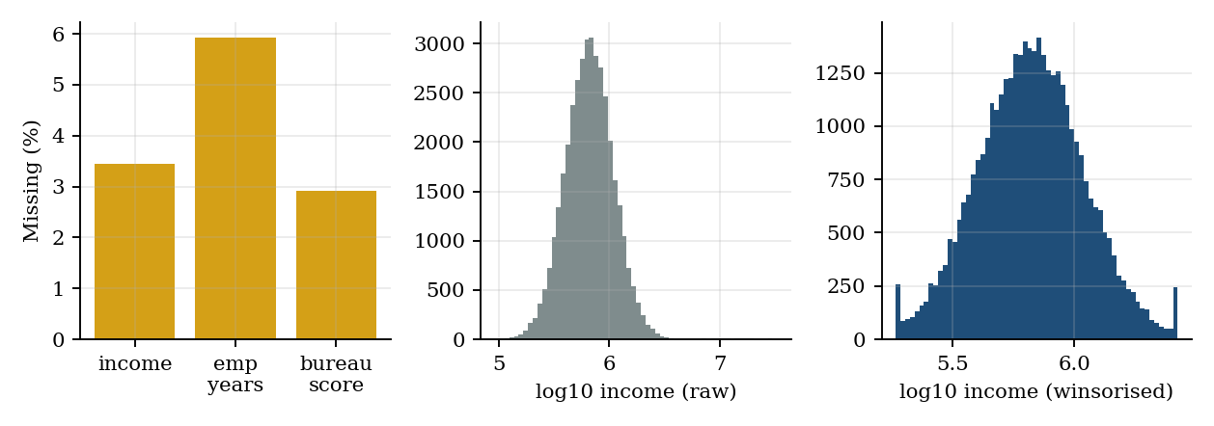
Fig. 4. Missing values and the effect of winsorising income.
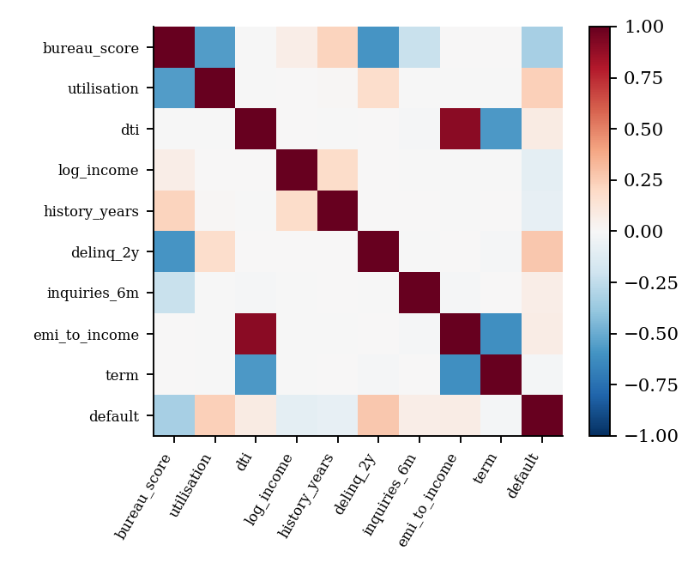
Fig. 5. Correlation of key numeric features with each other and with default.

3.3 Validation Test Cases
Beyond accuracy metrics, fourteen behavioural tests check that the pipeline is safe to deploy (Table 7). They cover data hygiene (splits, missing values, outliers, unseen categories), model sanity (monotonic response to utilisation and bureau score, valid probabilities), decision rules (limit bounds, reason-code coverage), governance (protected attributes excluded, determinism) and packaging (artefact round-trip). All 14 tests were executed against the final artefact, and 14 of 14 passed.
Table 7. Validation test cases and observed behaviour.
ID | Test | Observed behaviour | Result
T1 | Stratified split: Train/val/test default rates equal | 0.1233 / 0.1234 / 0.1234 | Pass
T2 | Train-only statistics: Imputation medians come from the training split, not full data | Max median difference vs full data = 4500.0 (so statistics were not peeked) | Pass
T3 | Single vs batch transform: Same applicant gives identical features alone or in a batch | max |diff| = 0.0e+00 | Pass
T4 | Missing income: NaN income is imputed and flagged | No NaN in output; income_missing indicator = 1 | Pass
T5 | Income outlier: Entry error (₹50 crore) is winsorised | log-income capped at 14.79 (cap ₹2,652,867) | Pass
T6 | Unseen category: Unknown loan purpose does not crash scoring | All purpose dummies = 0; PD = 0.374 | Pass
T7 | Monotonic in utilisation: Raising utilisation never lowers PD (sample of 500) | 100.0% of applicants non-decreasing | Pass
T8 | Monotonic in bureau score: Raising bureau score never raises PD (sample of 500) | 98.6% of applicants non-increasing | Pass
T9 | Calibrator range & order: Calibrated PD stays in [0,1] and is non-decreasing | min 0.0001, max 0.9999 | Pass
T10 | Limit bounds: 0 ≤ limit ≤ requested; declined → 0 | 77.7% approved; max limit/request = 1.00 | Pass
T11 | Reason-code coverage: Every declined applicant gets ≥ 1 reason (max 4 reported) | 300/300 declined applicants have ≥ 1 positive reason | Pass
T12 | Determinism: Same input → identical output | Outputs bit-identical on 50 applicants | Pass
T13 | Protected attributes excluded: Gender and age are not model inputs | Feature list contains no gender/age column (31 features) | Pass
T14 | Artefact round-trip: Reloaded artefact reproduces scores | max |diff| = 0.0e+00; version creditfair-1.0.0 | Pass

The monotonicity tests pass for 100.0% of applicants for utilisation and 98.6% for bureau score. The few exceptions are not a defect: tree ensembles are piecewise constant and can have small local non-monotonicities, which is why a deployment that must guarantee monotonic behaviour for regulatory reasons would add monotonic constraints to the booster (Section 5).

4. RESULTS

4.1 Loss Given Default
Table 8 reports test-set performance for the LGD models on the 987 defaulted test loans. Predicting the training mean gives an RMSE of 0.1627. OLS reduces this to 0.1155 (R² = 0.495), and the hand-written gradient descent reaches the same solution to four decimals (Fig. 6), confirming that the optimiser is correct; its parameter vector is within 0.009 of the OLS solution after 400 iterations. The RMSE of about 0.116 is slightly below the nominal floor of 0.12 because clipping losses to the interval [0.05, 1] reduces the noise that remains.
Table 8. LGD regression results on the test split (987 defaulted loans).
Model | RMSE | MAE | R²
Training-mean baseline | 0.1627 | – | 0.000
OLS (closed form) | 0.1155 | 0.0934 | 0.495
OLS (gradient descent, 400 iterations) | 0.1155 | 0.0934 | 0.496
Ridge (α = 373, 1-SE) | 0.1162 | 0.0937 | 0.490
Lasso (α = 0.0045, 1-SE, 9/31 features) | 0.1162 | 0.0938 | 0.489
Random forest (300 trees) | 0.1195 | 0.0967 | 0.460
Gradient boosting (211 rounds) | 0.1181 | 0.0950 | 0.473

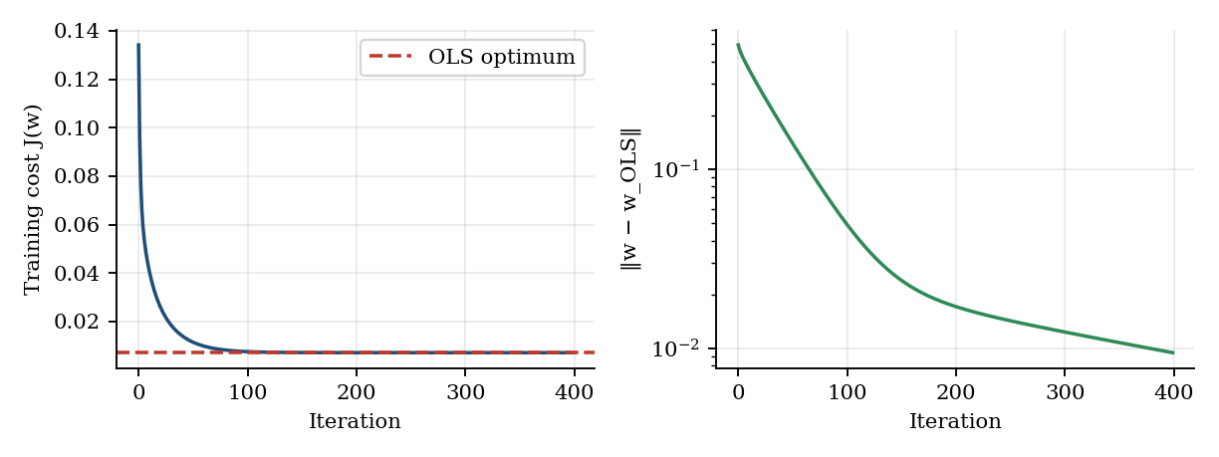
Fig. 6. Gradient descent converges to the OLS optimum (cost and distance to the closed-form solution).
Regularisation behaves as the one-standard-error rule predicts (Fig. 7). The cross-validated error is flat over a wide range of penalties, so the rule selects a much stronger penalty than the minimum (ridge α = 373 instead of 100; lasso α = 0.0045 instead of 0.0013) at essentially no loss in accuracy (cross-validated ridge RMSE 0.1212 against 0.1207). The lasso retains only 9 of 31 features, led by loan purpose (personal and medical loans lose more, vehicle and home-improvement loans lose less), housing status and tenure, which agrees with how the data were generated. Notably, no non-linear model beats the regularised linear models on LGD: forest and boosting are no better than OLS, because the loss-severity signal is essentially additive and the remaining error is the irreducible noise.
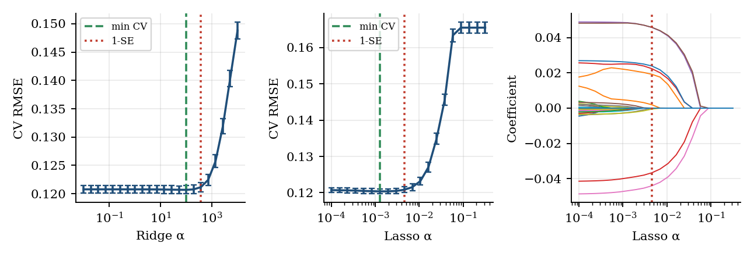
Fig. 7. Cross-validation for ridge and lasso with the one-standard-error choice, and the lasso coefficient path.

4.2 Default Prediction
Table 9 and Fig. 8 compare the PD models on the untouched test split. The regularised logistic regression is a strong baseline (AUC 0.792, chosen at C = 0.0014 by the one-SE rule). A depth-4 tree is clearly weaker (0.762) but readable. The random forest reaches 0.794 and the boosted champion 0.797, which is 0.017 AUC below the ceiling of 0.814; the remaining gap reflects estimation error and the unavoidable noise in the 12-month outcome. The champion is also best on PR-AUC (0.452), log-loss (0.298) and Brier score (0.0864). The ranking of the models is the same on every metric except KS, where the forest is marginally ahead.
Table 9. PD classification results on the test split (8,000 applications).
Model | AUC | PR-AUC | KS | Brier | Log-loss
Logistic (1-SE) | 0.792 | 0.441 | 0.436 | 0.0885 | 0.303
Decision tree (d=4) | 0.762 | 0.371 | 0.401 | 0.0905 | 0.313
Random forest | 0.794 | 0.445 | 0.455 | 0.0873 | 0.301
Gradient boosting | 0.797 | 0.452 | 0.453 | 0.0864 | 0.298
GB + segment feature | 0.797 | 0.456 | 0.453 | 0.0862 | 0.298
GB calibrated (champion) | 0.795 | 0.431 | 0.444 | 0.0868 | 0.302

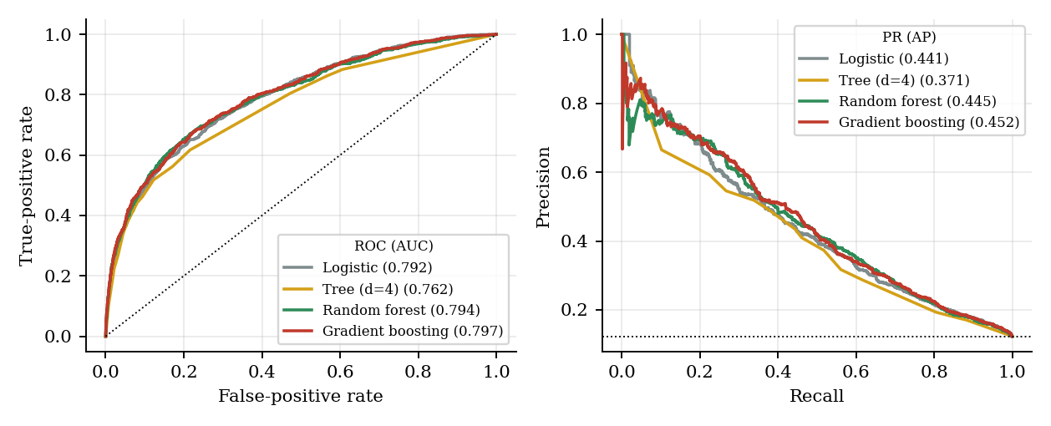
Fig. 8. ROC and precision-recall curves of the four PD models on the test split.
Three further observations matter. Variance reduction: an unpruned tree has a test AUC of only 0.645, far below the depth-4 tree (0.762) and the forest (0.794); the forest's out-of-bag AUC (0.788) tracks its test AUC (0.794) closely and levels off after about 200 trees (Fig. 9a), so OOB error is a trustworthy substitute for a validation set. Importance: permutation importance on the validation split ranks the bureau score first by a wide margin (AUC drops by 0.047 when it is shuffled), followed by income, utilisation, the utilisation × debt-to-income interaction and delinquencies (Fig. 9b). Early stopping: the boosting search selected a shallow ensemble (depth 3, learning rate 0.06, L2 = 5) that stopped after 195 rounds, where the validation loss flattens while training loss keeps falling (Fig. 10b); the logistic penalty selection is shown in Fig. 10a.
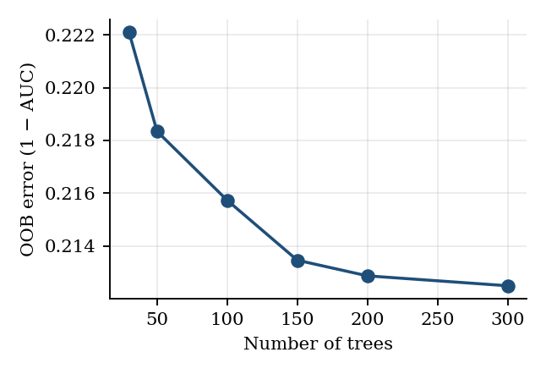 | 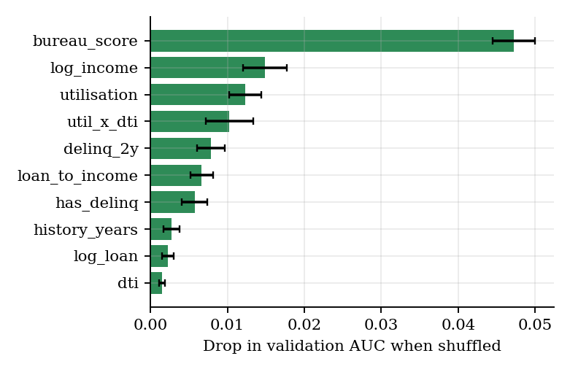
Fig. 9. Random forest: (a) OOB error versus number of trees; (b) permutation importance (drop in validation AUC).
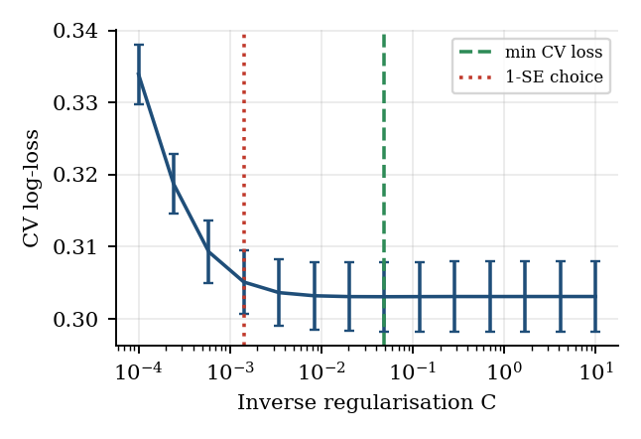 | 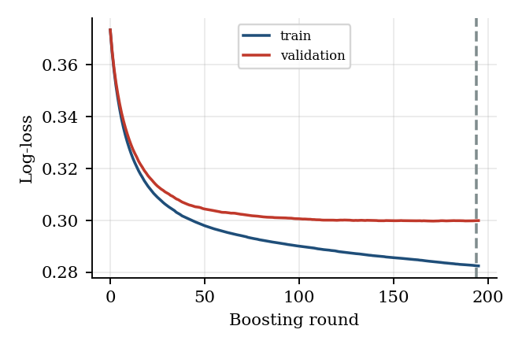
Fig. 10. Model selection: (a) cross-validated log-loss versus logistic C with the 1-SE choice; (b) boosting learning curve with the early-stopping point.
Segment feature. Feeding the k-means segment label to the booster raises AUC from 0.7967 to 0.7972, a gain of 0.0005 that is far inside the sampling noise (Section 4.6 shows the noise level is about ±0.005). Segmentation is therefore valuable for portfolio strategy and communication (Section 4.5) but adds no predictive power here, which is the expected result when the segments are derived from the same variables the model already sees.

4.3 Calibration
Table 10 and Fig. 11 show calibration on the test split. The boosted model is already well calibrated (ECE 0.0079), and the random forest is visibly worse (0.0117) because averaging pushes its probabilities toward the middle; Platt scaling cuts the forest's ECE almost in half (to 0.0064). For the champion, isotonic regression had the lowest validation Brier score (0.0859 against 0.0869 raw) and was selected; it lowers ECE from 0.0079 to 0.0069 but costs 0.0016 AUC through tied scores, and the test Brier score is within noise of the raw value. The honest conclusion is that calibration is a small refinement for a log-loss booster and a large one for a forest; the discipline of checking it is what matters, because every downstream quantity (cost, limit, provision) assumes it.
Table 10. Calibration comparison on the test split.
Scores | Brier | ECE | AUC
GB raw | 0.0864 | 0.0079 | 0.7967
GB + Platt | 0.0864 | 0.0078 | 0.7967
GB + Isotonic (selected) | 0.0868 | 0.0069 | 0.7950
RF raw | 0.0873 | 0.0117 | 0.7936
RF + Platt | 0.0869 | 0.0064 | 0.7936
Logistic | 0.0885 | 0.0133 | 0.7918

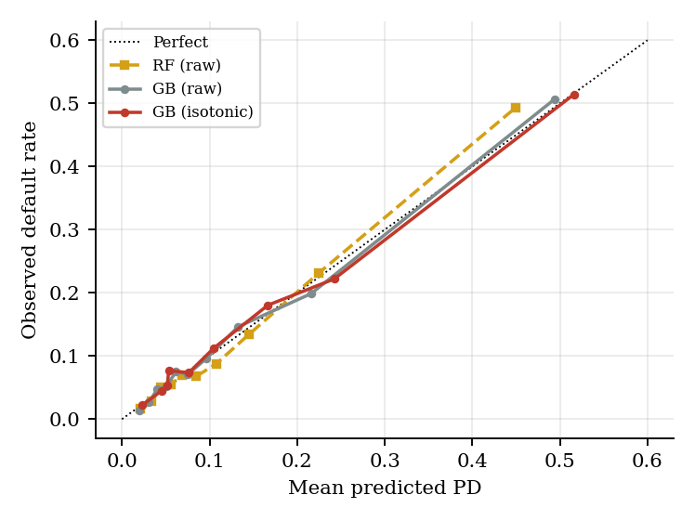
Fig. 11. Reliability diagram: observed default rate against predicted PD by decile.

4.4 Interpretability and Reason Codes
The depth-4 tree is the regulatory backbone of the model. Its first split is the bureau score at about 600, and its leaves (Fig. 12 shows the top levels; Table 11 the extreme leaves) read as sentences a credit officer can check. The riskiest leaf, an applicant with a bureau score of 578 or below and utilisation above 72%, has a default rate of 70.9% among 413 training applicants, while the safest large leaf, bureau score above 641 with a low utilisation × debt-to-income product and income above ₹4.4 lakh, defaults 3.9% of the time among 8,706 applicants.
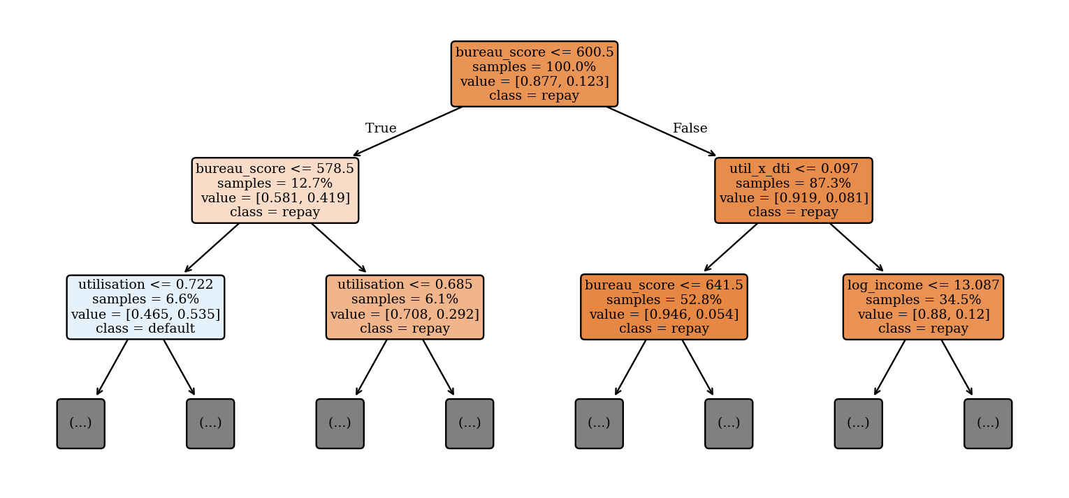
Fig. 12. Top two levels of the interpretable credit tree (full tree has 14 leaves; features in model units).
Table 11. Selected leaves of the depth-4 credit tree (training split).
Rule | Default rate | Applicants
bureau_score ≤ 578.50 and utilisation > 0.72 | 70.9% | 413
bureau_score ≤ 578.50 and utilisation ≤ 0.72 and util_x_dti > 0.11 | 54.3% | 679
578.50 < bureau_score ≤ 600.50 and utilisation > 0.69 | 43.6% | 312
600.50 < bureau_score ≤ 641.50 and util_x_dti ≤ 0.10 and income > 6.8 lakh | 5.5% | 813
bureau_score > 641.50 and util_x_dti ≤ 0.10 and income > 4.4 lakh | 3.9% | 8,706

For the champion, the mean absolute change in PD from substituting each attribute (600 test applicants) is largest for bureau score, utilisation and income (Fig. 13a), and the grouped permutation importances agree closely with it (Spearman rank correlation 0.91 across the 14 attributes), a useful consistency check between two independent explanation methods. Fig. 13b shows one declined applicant: a business-loan applicant with a bureau score of 559, utilisation of 75%, a debt-to-income ratio of 49% and three delinquencies. The calibrated PD is 78.3%, and the three positive contributions are the bureau score (+0.41), utilisation (+0.38) and debt-to-income (+0.17), which become the three adverse-action reasons in Section 4.9.
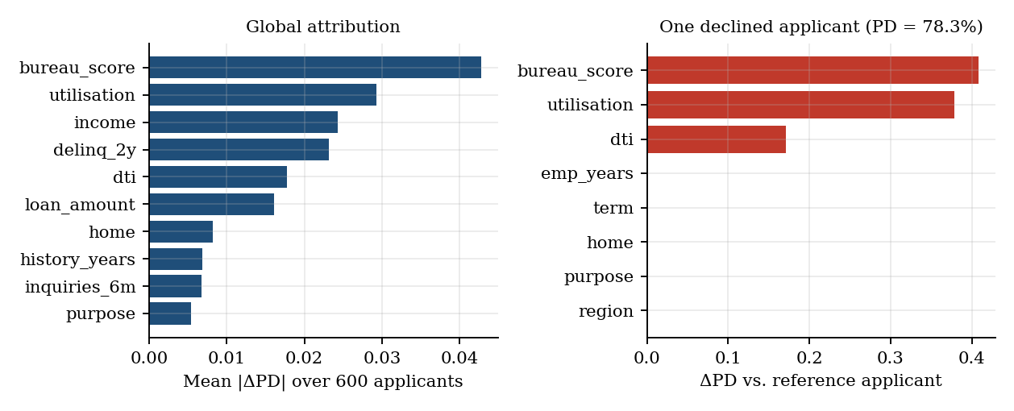
Fig. 13. Champion attributions: (a) global mean absolute effect; (b) one declined applicant.

4.5 Borrower Segments
The silhouette score is highest at k = 3 (0.162) and only slightly lower at k = 4 (0.148) (Fig. 14); the low absolute values (about 0.15) say that borrowers form a continuum rather than sharply separated clusters, which is typical of credit data. We chose k = 4 because it yields four commercially useful risk tiers (Table 12): Prime (default 4.9%), Near-prime (6.7%), Stretched (16.1%), driven by a very high debt-to-income ratio of 0.56, and High-risk (27.1%), characterised by low bureau scores, high utilisation and about 1.2 delinquencies per borrower. The Stretched segment is a notable finding: its bureau score looks ordinary, so a bureau-only policy would mis-price it.
Table 12. Profile of the four k-means risk segments (training split).
Segment | Share | Default | Median income | Utilisation | Bureau | DTI | Delinq.
Prime | 25% | 4.9% | ₹8,12,100 | 0.35 | 689 | 0.24 | 0.29
Near-prime | 40% | 6.7% | ₹6,00,100 | 0.30 | 681 | 0.23 | 0.18
Stretched | 9% | 16.1% | ₹6,64,400 | 0.37 | 664 | 0.56 | 0.42
High-risk | 26% | 27.1% | ₹6,46,500 | 0.54 | 601 | 0.24 | 1.18

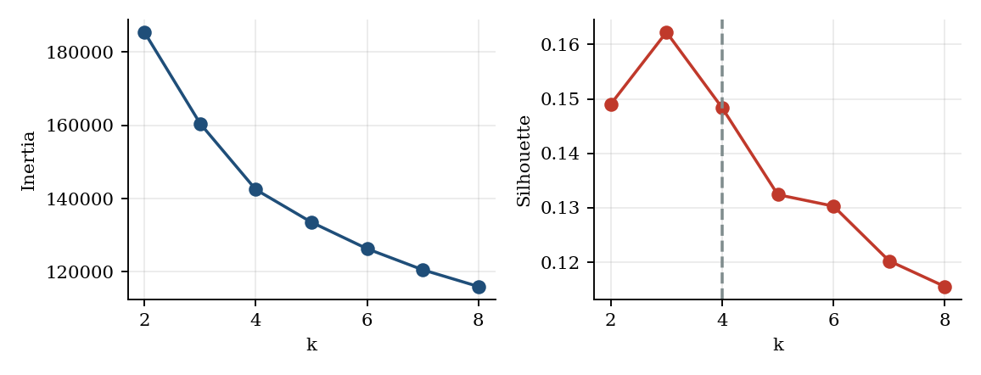
Fig. 14. Choosing k: inertia (elbow) and silhouette score for k-means.
The first three principal components explain 61.5% of the variance (Fig. 15a), so no single dominant direction exists; the PCA map separates the high-risk segment from the prime segment along the first two components (Fig. 15b). DBSCAN (eps = 0.73, 10 minimum points) finds a single dense region and labels 3.4% of applicants as noise (Fig. 15c). These outliers are not harmless: their default rate is 30.6% against 11.9% in the dense core, so density-based outlier detection is a cheap, label-free early-warning signal that can route unusual applications to manual review.
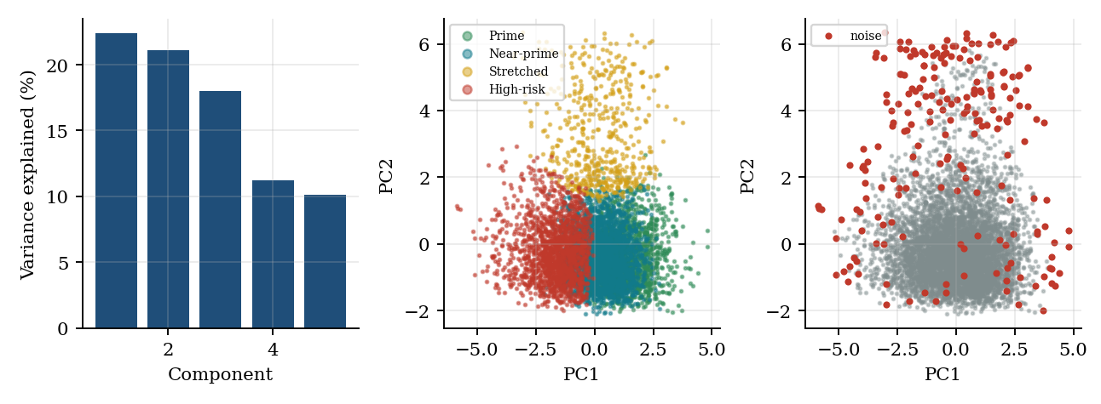
Fig. 15. PCA variance, k-means segments on the first two components, and DBSCAN noise points.

4.6 Cost-Based Decisions and Significance Tests
The cost curves of Fig. 16 have a clear minimum near the theoretical threshold of 0.155; validation selected 0.155 for the logistic baseline and 0.120 for the calibrated champion. Table 13 shows the monetary result. Approving everyone costs ₹22,959 per applicant, rejecting everyone costs ₹30,934, the logistic baseline ₹14,781, and the champion ₹14,419, a saving of 37% against approve-all and ₹362 per applicant against the incumbent. The champion also approves more applicants (77.1% against 74.7%).
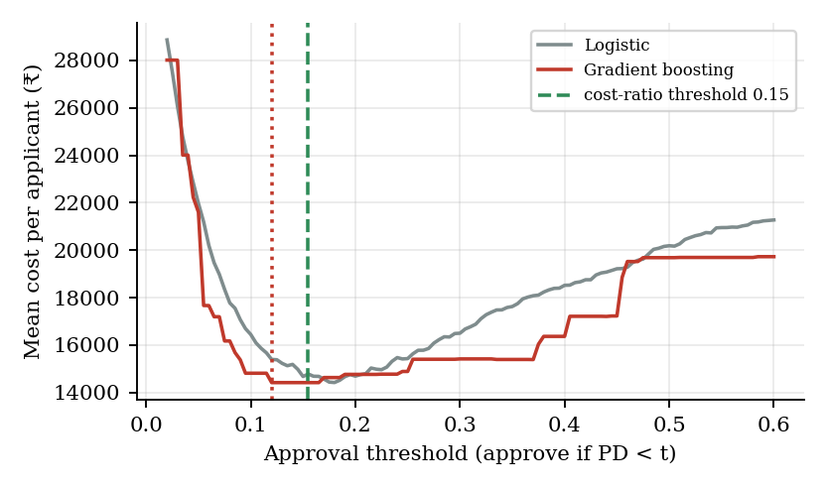
Fig. 16. Expected cost per applicant as the approval threshold varies (test split).
Table 13. Expected monetary cost per applicant on the test split.
Policy | Threshold | Approval rate | Cost per applicant
Approve everyone | – | 100.0% | ₹22,959
Reject everyone | – | 0.0% | ₹30,934
Incumbent: logistic regression | 0.155 | 74.7% | ₹14,781
Champion: calibrated boosting | 0.120 | 77.1% | ₹14,419

Is the improvement real? A paired bootstrap with 1,000 resamples of the test set (Fig. 17, Table 14) gives a mean AUC difference of +0.0032 with a 95% interval of [-0.0025, +0.0089], and a mean saving of ₹352 per applicant with interval [−₹274, ₹972]. Both intervals include zero (one-sided bootstrap p-values 0.15 and 0.12). The champion is therefore directionally better than the incumbent but not significantly so at the 5% level on 8,000 test applications. A McNemar-type count of decisions favours the champion (415 applicants decided correctly only by the champion against 252 only by the incumbent), but because the two policies use different thresholds that test partly measures the threshold difference and should not be over-read. The practical reading is that a boosted model is justified by consistent gains across PR-AUC, log-loss, KS and cost, but not by a decisive AUC gap; a real lender would confirm the gain on a larger out-of-time sample before replacing a scorecard.
Table 14. Paired bootstrap comparison, champion minus incumbent (1,000 resamples).
Quantity | Mean difference | 95% interval | One-sided p
AUC | +0.0032 | [-0.0025, +0.0089] | 0.150
Cost saving per applicant | ₹352 | [−₹274, ₹972] | 0.124

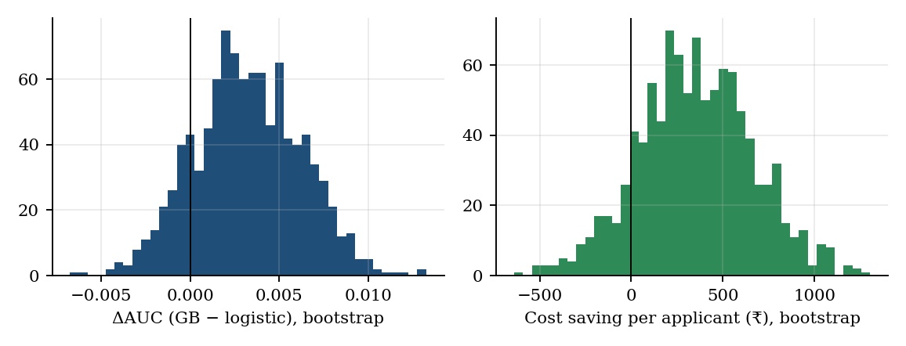
Fig. 17. Bootstrap distributions of the AUC difference and of the cost saving.

4.7 Fairness Audit
The audit finds a real problem. At the cost-optimal threshold the model approves 79.8% of male and 74.0% of female applicants, a disparate-impact ratio of 0.928. This passes the 0.80 rule but conceals a larger equal-opportunity gap: among borrowers who actually repay, 85.2% of men and 79.4% of women are approved, a gap of 5.7 percentage points (Table 15). The cause is visible in calibration by group (Fig. 18): the model predicts a mean PD of 13.3% for women but only 12.1% actually default, while for men it predicts 11.2% against 12.5% observed. Women are over-predicted and men under-predicted, exactly the signature of the injected bureau-score measurement bias. The model's AUC is nearly identical for both groups (0.796 and 0.797), which shows why rank accuracy alone cannot reveal this kind of unfairness. The age audit shows a larger spread (disparate-impact ratio 0.88 for applicants below 30), but here predicted and observed risk agree (15.4% against 15.3%), so the gap reflects genuine differences in credit-history length rather than a miscalibrated penalty and needs business, not statistical, justification.
Table 15. Fairness audit by gender at the cost-optimal threshold (test split).
Group | Applicants | Approval rate | Good-borrower approval | Mean PD | Observed default | AUC
Female | 3,659 | 74.0% | 79.4% | 13.3% | 12.1% | 0.796
Male | 4,341 | 79.8% | 85.2% | 11.2% | 12.5% | 0.797

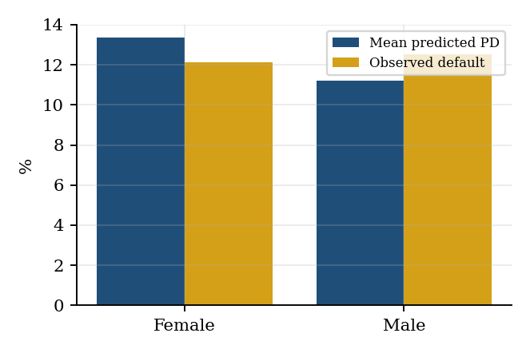
Fig. 18. Calibration by gender: predicted PD against observed default rate.
Table 16 and Fig. 19 compare the mitigations. Reweighing barely helps (disparate-impact ratio 0.932, equal-opportunity gap 5.3 points): it rebalances group and outcome frequencies in the training data, but the bias here lives in a feature (a distorted bureau score), not in the group-outcome balance of the labels. Group-specific thresholds work much better: with a PD cut-off of 0.189 for women and 0.142 for men, the disparate-impact ratio rises to 0.980 and the gap falls to 1.6 points, and the cost per applicant actually falls slightly (₹14,419 to ₹14,354), because the threshold shift undoes a systematic error rather than trading accuracy for fairness. Combining both brings the ratio to 0.996 and the gap to 0.1 points at ₹14,252 per applicant. In this setting, fairness was therefore not in conflict with profit; this should not be assumed in general, because on real data the true effect of a biased feature is unknown.
Table 16. Comparison of fairness mitigations (female versus male).
Variant | DI ratio | Approval gap (pp) | Good-borrower gap (pp) | AUC | Cost per applicant
Baseline (calibrated GB) | 0.928 | 5.7 | 5.7 | 0.7950 | ₹14,419
Reweighing | 0.932 | 5.5 | 5.3 | 0.7934 | ₹14,513
Group thresholds | 0.980 | 1.6 | 1.6 | 0.7950 | ₹14,354
Reweighing + thresholds | 0.996 | 0.3 | 0.1 | 0.7934 | ₹14,252

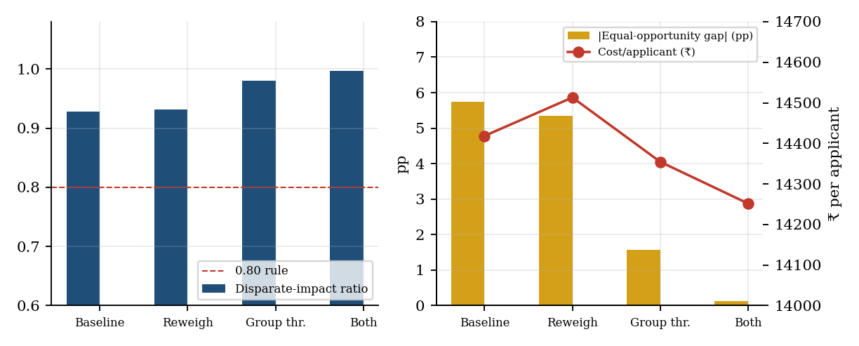
Fig. 19. Effect of mitigation on the disparate-impact ratio, the equal-opportunity gap and the cost.
A caution is essential. Group-specific thresholds are a form of explicit group-aware treatment, which many jurisdictions restrict in lending; they are used here to demonstrate and quantify the problem, and in production would be a decision for compliance and legal teams. The cleaner long-term remedy is to fix the biased measurement itself (for example by re-scoring thin-file borrowers with alternative data or by removing the distorted feature), and to keep this audit as a standing control that runs on every retraining.

4.8 Fair, Risk-Based Credit Limits
The limit rule caps the expected-loss rate at 5% of the requested amount (Fig. 20). Among approved applicants 87.6% receive the full amount, because their expected-loss rate (PD × LGD) is below the budget, and the average approved limit is 97.9% of the request (Table 17). Limits shrink smoothly in the 10 to 15% PD band (mean 86% of the request) and reach zero beyond the approval threshold. Calibration supports the whole chain: the sum of predicted expected losses over the test portfolio is ₹17.76 crore against ₹18.37 crore realised, a ratio of 0.967, i.e. a 3.3% under-estimate, small enough for provisioning purposes. Among approved applicants the mean limit ratio is 97.6% for women and 98.1% for men, so the limit rule itself adds almost no further disparity; the remaining difference arises at the approve/decline decision, which Section 4.7 addresses.
Table 17. Risk-based limits by calibrated PD band (test split).
PD band | Applicants | Mean PD | Observed default | Mean EL rate | Approved | Mean limit / request
<5% | 2,540 | 3.1% | 3.0% | 1.5% | 100% | 100%
5-10% | 2,965 | 6.8% | 7.4% | 3.4% | 100% | 99%
10-15% | 666 | 11.6% | 13.1% | 5.7% | 100% | 86%
15-25% | 1,001 | 20.4% | 19.0% | 9.9% | 0% | –
>25% | 828 | 49.9% | 50.1% | 24.4% | 0% | –

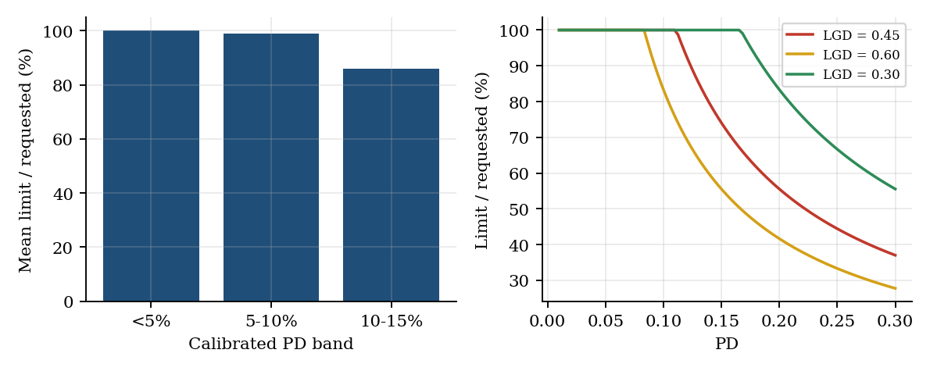
Fig. 20. Mean limit as a share of the request by PD band, and the limit curve for three LGD levels.

4.9 Drift Monitoring and Serving
Table 19 shows PSI for the score and four key features in three situations: the held-out test population (no drift), a mild drift (income down, utilisation up, more inquiries, slight macro stress) and a severe drift. With no drift every PSI is about 0.002. Under mild drift the score PSI is 0.17 (the watch band) and the largest feature shifts are in utilisation (0.23) and bureau score (0.21); under severe drift the score PSI reaches 1.16. Debt-to-income does not move (PSI 0.001), which shows why monitoring features individually is more informative than watching the score alone.
Table 18. Population Stability Index by scenario.
Scenario | Score | Income | Utilisation | Bureau score | Inquiries | DTI
No drift (test) | 0.002 | 0.002 | 0.001 | 0.001 | 0.000 | 0.001
Mild drift | 0.169 | 0.016 | 0.231 | 0.213 | 0.121 | 0.001
Severe drift | 1.156 | 0.126 | 2.135 | 1.463 | 0.635 | 0.001

A twelve-month simulation (Fig. 21) lets the population drift gradually from month 5. The score PSI crosses the watch level of 0.10 in month 6 (0.122) and the retraining level of 0.25 in month 8 (0.431), the same month in which the calibration error passes its limit of 0.03 (0.042). Retraining on the drifted data with extra weight on recent cases lowers the calibration error on a fresh cohort from 0.094 to 0.033 and the under-prediction of risk shrinks (mean PD 33.2% before and 39.4% after, against 42.6% observed), while AUC is unchanged at about 0.82. Thus ranking quality survives the shift, but the probabilities, which price risk and size limits, do not, and that is precisely what the two-part trigger (PSI plus calibration) is designed to catch.
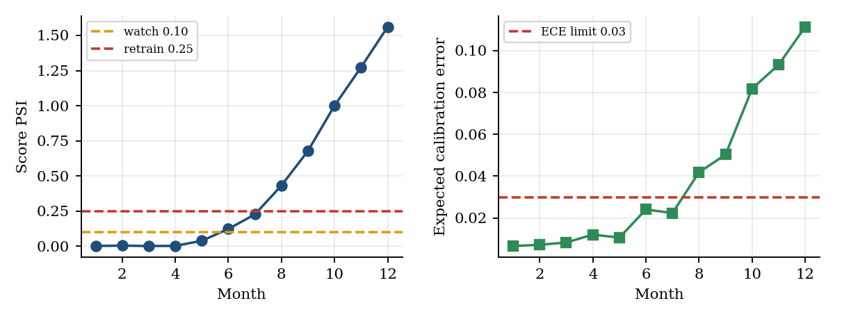
Fig. 21. Twelve-month drift simulation: score PSI and calibration error against their trigger levels.
Serving. The packaged artefact scores one application end to end, including preprocessing, PD, calibration, LGD, expected loss, limit and reason codes (15 batched model evaluations), in a median of 20.9 ms. Over 1,200 requests the 95th percentile is 27.2 ms and the 99th percentile is 34.9 ms, about one third of the 100 ms budget (Table 20, Fig. 22). The slowest single request took 169 ms, a rare cold-path outlier of the kind that a production service would absorb with warm-up and a worker pool. These are single-process, CPU-only timings without network overhead, so they are an upper bound on compute, not a promise about end-to-end service latency.
Table 19. Scoring latency of the packaged artefact.
Statistic | Latency (ms)
Mean | 22.1
Median (P50) | 20.9
P95 | 27.2
P99 | 34.9
Maximum | 168.7
Budget (P99) | 100.0

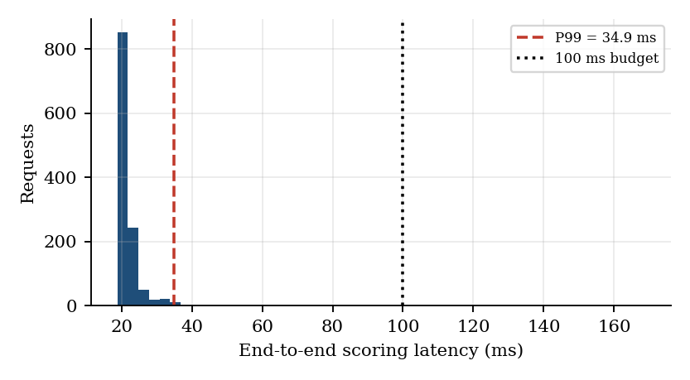
Fig. 22. Distribution of end-to-end scoring latency over 1,200 requests.
Two example responses (Appendix B) show the output. The declined applicant above receives a decision of decline with reason codes for bureau score, utilisation and debt-to-income. An approved applicant (PD 5.2%, expected-loss rate 2.5%) receives the full requested amount of ₹7,26,000, because the expected-loss rate is below the 5% budget; the reasons returned for an approved applicant are informational, not adverse.

4.10 Discussion
Table 21 summarises the main findings. Four stand out. First, the ladder of models behaves as theory predicts, with diminishing returns: AUC rises from 0.762 (tree) to 0.792 (logistic) to 0.797 (boosting) against a ceiling of 0.814, and for LGD the simple linear model is already at the noise floor. A boosted model should be adopted only for the accuracy it demonstrably adds. Second, explainability need not cost accuracy at the point of decision: the tree supplies global rules and the attribution supplies per-applicant reasons, and the two agree on what matters. Third, fairness failures are invisible to accuracy metrics; only calibration by group exposed the biased feature. Fourth, monitoring must watch calibration as well as population shift, because drift can leave rankings intact while corrupting probabilities.
Table 20. Summary of key findings.
Area | Finding
Accuracy ceiling | Best achievable AUC 0.814; champion 0.797; logistic 0.792
LGD | Linear models reach the noise floor (RMSE 0.116); trees add nothing
Calibration | Boosting nearly calibrated (ECE 0.0079); forest needs Platt (0.0117 to 0.0064)
Interpretability | Tree rules and attributions agree (rank correlation 0.91)
Segments | Four tiers, default 4.9% to 27.1%; no AUC gain; DBSCAN noise defaults 30.6%
Decision value | Cost ₹14,419 versus ₹22,959 approve-all; gain over incumbent not significant
Fairness | DI 0.928 to 0.996; good-borrower gap 5.7 to 0.1 points; cost does not rise
Operations | P99 34.9 ms; drift trigger in month 8; calibration restored by retraining

4.11 Limitations of the Present Work
- Synthetic data. All results describe a simulated portfolio; absolute metrics must be re-established on real data, and real bias is rarely as cleanly isolated as the injected bureau-score distortion.
- Implementation substitutions. scikit-learn boosting stands in for XGBoost, and baseline-substitution attribution stands in for SHAP; additivity and consistency guarantees of SHAP are not claimed.
- Single time window. Splits are random, not out-of-time, so temporal drift is simulated rather than observed; LGD is learned only on defaulters, ignoring selection effects.
- Fairness scope. Only gender and age were audited, with group-specific thresholds raising legal questions; intersectional groups and counterfactual fairness were not studied.
- Cost model. A single flat margin and exposure at default equal to the loan amount; real pricing, partial repayments and recoveries timing are not modelled.

5. CONCLUSION AND FUTURE WORK
CreditFair demonstrates that accuracy, calibration, interpretability and fairness can be engineered together in one auditable pipeline. On a 40,000-application simulated portfolio, a calibrated gradient-boosting model reached an AUC of 0.797 against a theoretical ceiling of 0.814, cut the expected cost per applicant by 37% relative to approving everyone, and matched the incumbent logistic scorecard within statistical noise while improving PR-AUC, KS and log-loss. A depth-4 tree and per-applicant attributions supplied regulation-style reason codes. The fairness audit uncovered a hidden measurement bias that accuracy metrics missed, and a combination of reweighing and group-specific thresholds raised the disparate-impact ratio from 0.928 to 0.996 without raising cost. The packaged artefact scored an application in a P99 of 34.9 ms, and a PSI-plus-calibration guard flagged simulated drift in month 8.
The project also yields two cautionary lessons. A flexible model should earn its place against a good baseline, and here it earned it narrowly; and a model can look fair on rank metrics while treating a group unfairly, which only calibration by group revealed.
Future work. (1) Replace the scikit-learn booster with XGBoost and the attribution with TreeSHAP, and add monotonic constraints on bureau score and utilisation for regulatory guarantees. (2) Validate on real, out-of-time lending data and add survival models to estimate default timing. (3) Remove, not just compensate, the biased feature through thin-file rescoring and test intersectional and counterfactual fairness. (4) Model recovery cash-flows and loan pricing to replace the flat margin. (5) Containerise the scoring service, add authentication, request logging for audit, a champion-challenger shadow mode, and an automated retraining pipeline governed by the PSI and calibration triggers.

REFERENCES
[1] T. Hastie, R. Tibshirani and J. Friedman, The Elements of Statistical Learning, 2nd ed. New York: Springer, 2009.
[2] L. Breiman, "Random forests," Machine Learning, vol. 45, no. 1, pp. 5–32, 2001.
[3] T. Chen and C. Guestrin, "XGBoost: A scalable tree boosting system," in Proc. 22nd ACM SIGKDD Int. Conf. Knowledge Discovery and Data Mining, 2016.
[4] S. M. Lundberg and S.-I. Lee, "A unified approach to interpreting model predictions," in Advances in Neural Information Processing Systems 30, 2017.
[5] M. Hardt, E. Price and N. Srebro, "Equality of opportunity in supervised learning," in Advances in Neural Information Processing Systems 29, 2016.
[6] F. Kamiran and T. Calders, "Data preprocessing techniques for classification without discrimination," Knowledge and Information Systems, vol. 33, no. 1, pp. 1–33, 2012.
[7] A. Niculescu-Mizil and R. Caruana, "Predicting good probabilities with supervised learning," in Proc. 22nd Int. Conf. Machine Learning, 2005.
[8] S. Lessmann, B. Baesens, H.-V. Seow and L. C. Thomas, "Benchmarking state-of-the-art classification algorithms for credit scoring: An update of research," European Journal of Operational Research, vol. 247, no. 1, pp. 124–136, 2015.
[9] L. C. Thomas, D. B. Edelman and J. N. Crook, Credit Scoring and Its Applications. Philadelphia: SIAM, 2002.
[10] F. Pedregosa et al., "Scikit-learn: Machine learning in Python," Journal of Machine Learning Research, vol. 12, pp. 2825–2830, 2011.
[11] R. Tibshirani, "Regression shrinkage and selection via the lasso," Journal of the Royal Statistical Society, Series B, vol. 58, no. 1, pp. 267–288, 1996.
[12] N. Siddiqi, Credit Risk Scorecards: Developing and Implementing Intelligent Credit Scoring. Hoboken: Wiley, 2006.
[13] Basel Committee on Banking Supervision, International Convergence of Capital Measurement and Capital Standards: A Revised Framework, Bank for International Settlements, 2006.
[14] Consumer Financial Protection Bureau, "Regulation B (Equal Credit Opportunity Act), 12 CFR Part 1002," United States.
[15] S. Barocas, M. Hardt and A. Narayanan, Fairness and Machine Learning: Limitations and Opportunities. MIT Press, 2023.
[16] M. Ester, H.-P. Kriegel, J. Sander and X. Xu, "A density-based algorithm for discovering clusters in large spatial databases with noise," in Proc. 2nd Int. Conf. Knowledge Discovery and Data Mining (KDD), 1996.
[17] S. P. Lloyd, "Least squares quantization in PCM," IEEE Transactions on Information Theory, vol. 28, no. 2, pp. 129–137, 1982.
[18] B. Efron and R. J. Tibshirani, An Introduction to the Bootstrap. New York: Chapman & Hall, 1993.
[19] C. Elkan, "The foundations of cost-sensitive learning," in Proc. 17th Int. Joint Conf. Artificial Intelligence (IJCAI), 2001.
[20] Reserve Bank of India, "Guidelines on Digital Lending," 2022.

APPENDIX A: SOURCE CODE (EXCERPTS)
The listing below reproduces the core of the implementation: calibration, the leakage-safe preprocessing class, the PSI drift measure, training of the champion with its cost threshold, and the scoring function used by the endpoint. Data generation, experiments and plotting scripts (creditfair_core.py, run_experiments.py, run_tests.py) accompany the report.
# ---- creditfair_core.py (excerpt): calibration, leakage-safe preprocessing, drift guard
import numpy as np, pandas as pd
from sklearn.linear_model import LogisticRegression

class Platt:
"""Sigmoid (Platt) calibration on the logit of the raw score."""
def fit(self, p, y):
from sklearn.linear_model import LogisticRegression
z = np.log(np.clip(p, 1e-6, 1 - 1e-6) / (1 - np.clip(p, 1e-6, 1 - 1e-6))).reshape(-1, 1)
self.m = LogisticRegression(C=1e6).fit(z, y); return self
def predict(self, p):
p = np.clip(p, 1e-6, 1 - 1e-6); return self.m.predict_proba(np.log(p / (1 - p)).reshape(-1, 1))[:, 1]

class Prep:
"""Leakage-safe preprocessing: every statistic is learned on the training split only."""
def fit(self, df):
self.inc_lo, self.inc_hi = df["income"].quantile([0.005, 0.995])
self.med = df[NUM].median()
self.cats = {c: sorted(df[c].unique()) for c in CAT}
X = self._raw(df)
self.mu, self.sd = X.mean(), X.std().replace(0, 1)
self.names = list(X.columns)
return self

def _raw(self, df):
d = df.copy()
miss = {f"{c}_missing": d[c].isna().astype(float) for c in ["income", "emp_years", "bureau_score"]}
d["income"] = d["income"].clip(self.inc_lo, self.inc_hi)
d = d[NUM + CAT].copy()
d[NUM] = d[NUM].fillna(self.med)
out = pd.DataFrame(index=d.index)
out["log_income"] = np.log(d["income"])
out["log_loan"] = np.log(d["loan_amount"])
for c in ["emp_years", "term", "dti", "utilisation", "history_years", "bureau_score",
"delinq_2y", "inquiries_6m", "open_accounts"]:
out[c] = d[c]
out["loan_to_income"] = d["loan_amount"] / d["income"]
out["emi_to_income"] = d["loan_amount"] / d["term"] / (d["income"] / 12)
out["util_x_dti"] = d["utilisation"] * d["dti"]
out["has_delinq"] = (d["delinq_2y"] > 0).astype(float)
for k, v in miss.items(): out[k] = v
for c in CAT:
for lv in self.cats[c]:
out[f"{c}={lv}"] = (d[c] == lv).astype(float)
return out

def transform(self, df):
X = self._raw(df)
return ((X - self.mu) / self.sd).values

def feature_names(self): return self.names

def psi(expected, actual, bins=10):
"""Population Stability Index with bin edges from the reference (expected) sample."""
edges = np.unique(np.quantile(expected, np.linspace(0, 1, bins + 1)))
edges[0], edges[-1] = -np.inf, np.inf
e = np.histogram(expected, edges)[0] / len(expected)
a = np.histogram(actual, edges)[0] / len(actual)
e, a = np.clip(e, 1e-4, None), np.clip(a, 1e-4, None)
return float(np.sum((a - e) * np.log(a / e)))

# ---- train_champion.py (excerpt): boosting champion, calibration, cost threshold
from sklearn.ensemble import HistGradientBoostingClassifier
from sklearn.isotonic import IsotonicRegression

prep = Prep().fit(df.iloc[train_idx]) # statistics from TRAIN only
Xtr, Xva = prep.transform(df.iloc[train_idx]), prep.transform(df.iloc[val_idx])
gb = HistGradientBoostingClassifier(learning_rate=0.06, max_depth=3, l2_regularization=5.0,
min_samples_leaf=60, max_iter=800, early_stopping=True,
validation_fraction=0.15, n_iter_no_change=25, random_state=0).fit(Xtr, y_train)
cal = IsotonicRegression(out_of_bounds="clip", y_min=1e-4, y_max=1-1e-4).fit(
gb.predict_proba(Xva)[:, 1], y_val) # calibrate on validation split
MARGIN = 0.09 # net margin lost on a rejected good loan
def cost(p, idx, t):
approve = p < t; d = y[idx] == 1
return np.where(approve & d, lgd[idx] * loan[idx], # approved defaulter: LGD x EAD
np.where(~approve & ~d, MARGIN * loan[idx], 0)).mean()
t_star = min(np.linspace(0.02, 0.6, 117), key=lambda t: cost(cal.predict(p_val), val_idx, t))

# ---- serve.py (excerpt): risk score + fair limit + adverse-action reasons
def score_one(row, art):
prep, gb, cal, gbr = art["prep"], art["pd_model"], art["calibrator"], art["lgd_model"]
variants = [row] # row 0 = applicant as submitted
for f in FEATURE_GROUPS: # baseline-substitution attribution
v = row.copy(); v[f] = art["ref"][f]; variants.append(v)
X = prep.transform(pd.concat(variants))
p = cal.predict(gb.predict_proba(X)[:, 1]) # one batched call, 15 rows
pd_, contrib = p[0], p[0] - p[1:] # positive = pushes PD up
lgd_ = float(np.clip(gbr.predict(X[:1])[0], 0.05, 1.0))
el = pd_ * lgd_ # expected-loss rate
frac = min(1.0, art["el_budget"] / max(el, 1e-9)) # exposure cap: EL <= 5% of amount
approve = pd_ < art["thr"]
top = np.argsort(-contrib)[:4]
return dict(pd=pd_, lgd=lgd_, decision="approve" if approve else "decline",
limit=row.loan_amount.iloc[0] * frac if approve else 0.0,
reasons=[FEATURE_GROUPS[i] for i in top if contrib[i] > 0])

APPENDIX B: HOW TO RUN AND EXAMPLE API RESPONSES
Running the pipeline. The three scripts are run in order from one directory; the second writes the figures, the results file and the versioned artefact, and the third executes the validation tests against that artefact.
pip install numpy pandas scipy scikit-learn matplotlib joblib
python run_experiments.py # data, models, audit, drift, latency -> results.json, figs/, artefact
python run_tests.py # 14 validation tests -> tests.json

Example 1: declined application. The request carries the 14 applicant attributes; the response contains the calibrated PD, LGD, decision and reason codes.
POST /score { "income": 1092900, "loan_amount": 517000, "term": 12, "dti": 0.487,
"utilisation": 0.751, "bureau_score": 559, "delinq_2y": 3, "purpose": "business", ... }
200 OK { "version": "creditfair-1.0.0", "decision": "decline", "pd": 0.783, "lgd": 0.426,
"expected_loss_rate": 0.333, "limit": 0,
"reasons": ["bureau_score", "utilisation", "dti"] }
-> "Bureau credit score is low"; "Credit utilisation is high";
"Debt obligations are high relative to income"

Example 2: approved application.
POST /score { "income": 946100, "loan_amount": 726000, "term": 36, "dti": 0.348,
"utilisation": 0.203, "bureau_score": 646, "delinq_2y": 0, "purpose": "education", ... }
200 OK { "version": "creditfair-1.0.0", "decision": "approve", "pd": 0.052, "lgd": 0.481,
"expected_loss_rate": 0.025, "limit": 726000 }

Table 21. Files delivered with the project.
File | Purpose
creditfair_core.py | Data generator, preprocessing, calibration class, PSI, reason-code dictionary
run_experiments.py | Weeks 1 to 12: all models, audit, drift and latency experiments; saves the artefact
run_tests.py | Fourteen validation tests executed against the artefact
creditfair_artefact.joblib | Versioned champion artefact (creditfair-1.0.0)

