IEEE Yachay Tech University Student Branch
Rebuilding the Branch Website
IEEE Yachay Tech University Student Branch — ieee@yachaytech.edu.ec
Andrés Aveiga (Web Master) — andres.aveiga@yachaytech.edu.ec
Ismael Cifuentes (Chair) — ismaelcifuentes@ieee.org

A student branch website usually dies the moment its author graduates. This article describes how the IEEE Yachay Tech University Student Branch (Urcuquí, Ecuador) rebuilt its web presence around that problem. The site, public at ramaieeeyt.github.io, is organized around the questions a student actually arrives with: what the branch is, who to write to, what IEEE membership costs and what it opens, which IEEE tools a member can use today, and where to fit in. It presents six 2026 officers each with a direct contact, eight concrete routes into IEEE, six IEEE tools, ten chapters and affinity groups with their official lockups, and ten milestones, all ten traceable to a public source. It was built with plain HTML, CSS and JavaScript: no framework, no build step, no cookies, no third-party request. Every piece of content that changes between administrations lives in one file, and the repository belongs to the branch's GitHub organization rather than to a person, so the site can be handed over instead of inherited. Sourcing the timeline surfaced and corrected three errors in the branch's own record.
Keywords — Student Branch, website, IEEE branding, accessibility, sustainability, R9.

I.Introduction
The IEEE Yachay Tech University Student Branch was constituted before IEEE in late 2019, enrolling fifty-one members that December [1]. Since then it has organized national congresses, competed in IEEEXtreme, founded a Women in Engineering affinity group, and won the branch fair at the 2023 National Student Branch Meeting [2]. Almost none of that was visible online, and the page a search engine returned was three administrations out of date.
The failure is common and it is not a design failure. Student branch websites are built by one enthusiastic volunteer, hosted on a personal account, and abandoned when that volunteer graduates; what they contain ages badly because updating it requires the original author. A student looking for the branch finds either nothing or something wrong, and a wrong page is worse than no page: it tells a prospective member the branch is inactive.
Our objective was therefore narrower and more demanding than "make a website". We set out to build a site that (i) presents the branch and its officers accurately, (ii) makes the concrete opportunities of IEEE membership visible to students who do not know they exist, and states what membership costs, (iii) records the branch's history so that any reader can verify it independently, and (iv) can be maintained and handed over by people who did not build it. The deliverable is a public, responsive site at https://ramaieeeyt.github.io, described in Section IV.
II.Methodology
The work followed four stages.
What the page owes a visitor. Before writing any code we listed the questions students actually ask the branch — what is this, who do I talk to, what do I get, what does it cost, where do I fit, what have you done — and made each question a section. Nothing was added that did not answer one of them, which is why there is no news feed and no blog: we had no sustainable way to keep either honest.
Source gathering. Content was drawn from the branch's membership guide, its Instagram account (@ramaieeeyt), the IEEE Ecuador Section, IEEE vTools Events records, and the branch's page on edu.ieee.org. Photographs of the 2026 officers come from the branch's own published carousel, re-cropped to a uniform 4:5 frame so that every portrait shares the same head size and eye line.
Brand compliance. Colour, typography and logo usage follow the IEEE Brand Identity Guidelines, Q1 2025 [3]. The IEEE palette is declared as CSS variables with the exact hexadecimal values from the guidelines, anchored on IEEE Blue (#00629B). Open Sans is used as IEEE's preferred web typeface, and Adobe Caslon Pro — IEEE's secondary typeface, permitted for headlines — in italic accents and drop caps. The official branch lockup identifies the header, and each chapter carries its own official lockup.
Verification and implementation. Every historical claim was checked against a public source before publication, and the source recorded beside the data in the code, so the next editor sees the evidence and not only the assertion. Every outbound link was opened and read, not merely pinged. The site was built with plain HTML, CSS and JavaScript, with no framework and no build step, deliberately: a successor needs a text editor and a browser, nothing else.
III. Implementation
Four problems dominated the execution phase.
Verification was harder than expected. The branch's recollection of its own history did not survive contact with the sources, and three errors were corrected. The 2025 National Student Branch Meeting had been recorded as ours; the IEEE vTools record shows it was held 26–28 September 2025 at Universidad Técnica del Norte [4], with our branch participating. The confusion had a traceable cause: a separate vTools entry is a participation report filed by our own chapter, and its "host organization" field names whoever wrote the report, not whoever organized the event. An enrolment of fifty-one members had been attributed to 2023; the record dates it to December 2019 [1]. A claim about a university mentoring programme had no traceable source and was removed. We consider finding these a result of the project rather than an obstacle to it.
Typography over the file system. The site is designed to open directly from disk, without a server, so that any officer can review a change before it is published. Browsers refuse to load font files over the file:// protocol, which replaced the entire typographic system with fallbacks — silently, which is the difficult part, because the page still looked finished. The Latin subsets are therefore embedded in the stylesheet as base64 data URIs, which always resolve, and the rendered text was measured to confirm the real typefaces were in use.
Imagery and intellectual property. Illustrating the Opportunities section, the obvious approach was to reuse the preview image each destination page publishes. Inspecting those images showed why it was the wrong one: the IEEE Foundation page exposes a photograph of identifiable award recipients, and the IEEE WIE page a licensed stock photograph. Republishing either would have meant hosting third-party material we have no right to redistribute. We adopted a narrower rule — official IEEE programme marks, which an IEEE organizational unit may legitimately display, and photographs the branch owns. Seven cards use official marks, one our own photograph, and none reuses third-party imagery. For the same reason the Archive keeps its images as files in the repository rather than linking to Instagram, whose image URLs are signed and expire within days.
Weight, measured rather than assumed. The animated background was the obvious suspect and the wrong one: a frame costs about 1.3 ms at eleven frames per second — roughly one per cent of a processor core — and it stops when off screen. The weight was in the images. The chapter lockups were stored at 900 px and displayed at 124 px, or at 42 px on the home page: three megabytes for marks a few pixels tall. Rescaled to the size they are actually shown at, the set fell from 3.0 MB to 216 kB — a factor of 13.7 — with no difference visible side by side at twice their displayed size. Two font preloads were also removed: they pointed at files no font rule uses, costing 58 kB per visit for nothing. The measurement came first in each case, and it moved the effort from what looked expensive to what was.
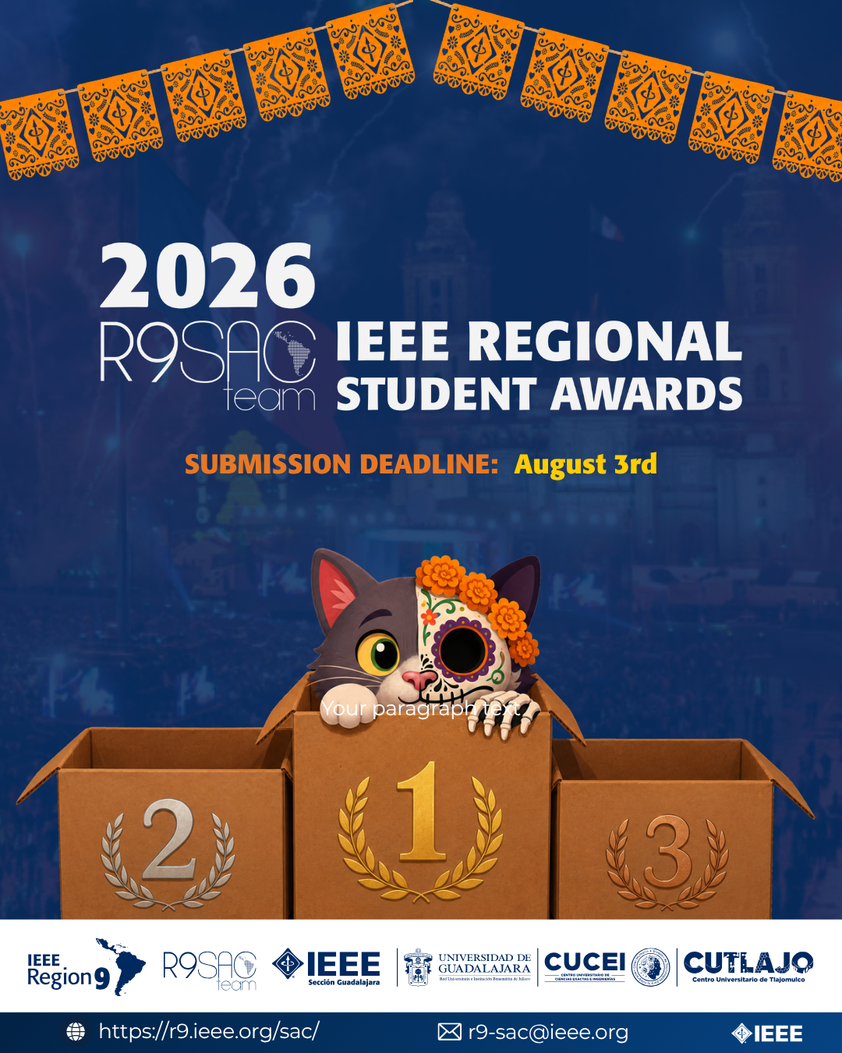
Figure 1. Home page, showing the official branch lockup and IEEE Blue as the anchor colour.
IV. Results
The site is public at https://ramaieeeyt.github.io [5]. One scrolling page carries nine blocks and a dedicated page carries the chapters. Each block exists to answer one question, and this section reports what each one contains.
Who we are, and who to write to. An identity block states the branch's mission, and a fact panel carries university, location, IEEE Region and branch code without scrolling or searching. The Board section presents all six 2026 officers — Chair, Vice Chair, Secretary, Treasurer, Web Master and Membership — each with a photograph, a personal statement and a direct email address. A visitor reaches the person responsible for what they need instead of a generic inbox, which is the difference between an answer in a day and no answer at all.
What membership opens, and what it costs. Opportunities is the section we consider most important, and it opens with the number a student actually wants: membership costs roughly USD 28 a year, about half that when enrolling after March, plus USD 1 to 13 for each technical society. The figures are attributed to the branch's membership guide and linked to IEEE for the current rate. Eight concrete routes follow — IEEEXtreme, IEEE Foundation scholarships, IEEE WIE travel grants, student membership benefits, the R9 SAC contests, IEEE Day, volunteering inside the branch's chapters, and the National Student Branch Meeting — each carrying the official mark of the programme and linking to its IEEE page. The section states plainly that most of what it lists requires membership, because a student who discovers that after applying does not come back.
What a member can use today. Opportunities and Resources answer two different questions and the site keeps them apart: Opportunities is what a student applies to, Resources is what a member already uses — IEEE Xplore, IEEE Spectrum, Collabratec, IEEE Standards, IEEE Access and the IEEE conference calendar, with membership requirements marked per item.
Where a student fits. A dedicated page presents the ten units working inside the branch: eight technical chapters — Computer Society, EMBS, Electronics Packaging, Circuits and Systems, Robotics and Automation, Geoscience and Remote Sensing, Computational Intelligence and the Nanotechnology Council — and two affinity groups, Women in Engineering and SIGHT, each with its official lockup and a link to its society. This page alone answers the question every first-year student asks. Joining is then reduced to three actions in one place: obtain an IEEE membership, read the branch's membership guide, or write to the branch.
What the branch has done. The Timeline records ten milestones from 2019 to 2026, tagged as award, milestone or meeting, among them first place nationally at IEEEXtreme 13.0. Ten of ten are traceable to a named public source, recorded in the code beside the entry. An Archive of published pieces accompanies it.
Navigation. Section links and page links were separated once the menu outgrew a single bar. Links that move within the page live in a fixed spine along the left edge, folded to a strip of marks that expands on hover, keyboard focus or tap; links that lead elsewhere stay in the top bar. The spine doubles as a position indicator, marking the section in view.
Checking produced corrections. Every outbound link was opened, and one resource was dropped: the IEEE Learning Network answers HTTP 200 while serving a login wall, which to a non-member reads as a dead link. Labels set at 42 % ink measured 2.76:1 against paper, below the 4.5:1 WCAG AA asks of small text, and were raised to a measured 5.23:1. Officer statements lived only in a hover state and were therefore invisible on every phone; they now show by default where there is no pointer. Between 861 and 1099 px the layout offered neither the spine nor the hamburger menu and eight links spilled off the right edge — exactly where a tablet in landscape lands; the two thresholds now meet.
The initial load transfers about 350 kB from a single origin, with photographs fetched only as the reader reaches them. The site sets no cookies, uses no local storage and makes no request to any third party — no analytics, no CDN, no embedded widgets — verified in production. It is responsive from 320 px upward with no horizontal overflow at any width. Accessibility measures include alternative text on images, ARIA attributes on the menu, lightbox and spine, full keyboard navigation, visible focus states, touch targets sized for a finger, and prefers-reduced-motion, which disables every animation for readers who ask for it. The site is written in Spanish because its readers are Ecuadorian undergraduates, with IEEE programme names kept in their official English form.
Table 1

Criteria | What the site provides
Content Strategy and Relevance (40) | 8 opportunities with official marks and links, 6 IEEE tools, 10 chapters and affinity groups, 6 officers, 10 sourced milestones, membership cost stated up front
Branding and IEEE Identity (20) | IEEE Brand Identity Guidelines Q1 2025: exact palette on IEEE Blue #00629B, Open Sans, Adobe Caslon Pro, official branch and chapter lockups
Information Accessibility and Navigation (15) | Fixed section spine with position indicator, separate page links, full keyboard navigation, contrast measured at 5.23:1
Member Engagement and Recruitment (15) | Price before the pitch, three ways to join in one place, a named contact for every officer
Technical Quality and Accessibility (10) | ~350 kB from a single origin, responsive from 320 px, no cookies and no third-party request, prefers-reduced-motion honoured
Evaluation criteria and the site's response to each.
V. Closing Remarks
Replicability was a design requirement, not an afterthought, and it is the part of this project most worth copying.
Ownership. The site is hosted on GitHub Pages under a GitHub organization owned by the branch rather than by an individual. Officers are added as owners, so access transfers with the role. This addresses the failure described in Section I directly: there is no personal account to lose.
Editability. All content that changes between administrations — officers, opportunities, resources, timeline entries, archive items — is defined in a single JavaScript object at the top of one file. Changing a name or adding a milestone means editing one line, and it can be done from a browser through GitHub's web editor: no software installed, no build to run, from any computer. A successor does not need to understand the site in order to update it.
Documentation. The repository includes a maintenance guide in Spanish covering how to change photographs, add timeline entries, publish and regenerate assets, written for someone who did not build the site. A second document records the decisions that are not visible in the code, together with the mistakes made during development, so a successor does not repeat them.
Maintenance record. Because the repository is public, its commit history is the maintenance record: every change dated, described and attributable, open to inspection at github.com/ramaieeeyt/ramaieeeyt.github.io. No separate reporting had to be invented, and none can fall out of date.
Cost. The project used no budget: hosting, domain and every tool involved are free. That matters for replication — any student branch in the Region can reproduce this arrangement without asking its section for funding.
VI. Conclusions
The objectives set out in Section I were met. The site presents the branch and its six officers accurately, each with a direct contact; it makes eight IEEE opportunities visible with links to official pages and states what membership costs before asking for a decision; it lists six resources a member can open today and ten chapters and affinity groups to join; it records ten milestones, all ten traceable to a public source; and it is owned, structured and documented so that people who did not build it can maintain it.
The most valuable outcome was unplanned. Requiring a public source for every historical claim surfaced three errors in the branch's own record, one of which credited us with an event organized by another university. A student branch website is, in practice, the public memory of the organizational unit, and holding it to the evidentiary standard expected of an IEEE publication seems to us the correct bar — the alternative is a page that repeats its own mistakes to every future reader.
The same discipline governed the technical work: the number, not the impression, decided what to do. What looked expensive was cheap, the images nobody suspected were not, a link returning HTTP 200 was a login wall, and a contrast that looked fine measured 2.76:1.
For the next edition we intend to add published records of branch activities to the Archive as they occur, keep the officer section current with each incoming administration, and automate the Archive's synchronization with the branch's Instagram account — the workflow is written and waits only on an access token. These extend the site; they are not required for it to serve its readers today.

References
[1] IEEE vTools Events, "Inscripción de nuevos miembros a la Rama Estudiantil Yachay Tech", 2019. [Online]. Available: https://events.vtools.ieee.org/m/216744 [Accessed: August 15, 2026].
[2] IEEE Ecuador Section, "Reunión Nacional de Ramas Estudiantiles IEEE 2023", 2023. [Online]. Available: https://r9.ieee.org/ecuador/reunion-nacional-de-ramas-estudiantiles-ieee-2023/ [Accessed: August 15, 2026].
[3] IEEE, "IEEE Brand Identity Guidelines", Q1 2025. [Online]. Available: https://brand-experience.ieee.org/ [Accessed: August 15, 2026].
[4] IEEE vTools Events, "RNR IBARRA 2025", 2025. [Online]. Available: https://events.vtools.ieee.org/m/497568 [Accessed: August 15, 2026].
[5] IEEE Yachay Tech University Student Branch, "Sitio web de la Rama", 2026. [Online]. Available: https://ramaieeeyt.github.io [Accessed: August 15, 2026].

