IEEE Yachay Tech University Student Branch
Rebuilding the Branch Website
IEEE Yachay Tech University Student Branch — ieee@yachaytech.edu.ec
Andrés Aveiga (Web Master) — andres.aveiga@yachaytech.edu.ec
Ismael Cifuentes (Chair) — ismaelcifuentes@ieee.org

A student branch website usually dies the moment its author graduates. This article describes how the IEEE Yachay Tech University Student Branch (Urcuquí, Ecuador) rebuilt its web presence around that problem. The site, public at ramaieeeyt.github.io, is organized around the questions a student actually arrives with, and presents six 2026 officers each with a direct contact, eight routes into IEEE covering scholarships, travel grants, competitions, events, volunteering and IEEE programmes, six IEEE tools, ten chapters and affinity groups with their official lockups, and ten milestones all traceable to a public source. It follows the IEEE Brand Identity Guidelines, was built with plain HTML, CSS and JavaScript with no framework and no third-party request, keeps every editable item in a single file, and belongs to the branch's GitHub organization rather than to a person, so it can be handed over instead of inherited. Sourcing the timeline corrected three errors in the branch's own record.
Keywords — Student Branch, website, IEEE branding, accessibility, sustainability, R9.

I.Introduction
The IEEE Yachay Tech University Student Branch was constituted before IEEE in late 2019, enrolling fifty-one members that December [1]. Since then it has organized national congresses, competed in IEEEXtreme, founded a Women in Engineering affinity group, and won the branch fair at the 2023 National Student Branch Meeting [2]. Almost none of that was visible online, and the page a search engine returned was three administrations out of date. The failure is common and it is not a design failure: branch websites are built by one volunteer, hosted on a personal account, and abandoned at graduation. A wrong page is worse than none, because it tells a prospective member the branch is inactive.
Overview. The deliverable is a public, responsive site at https://ramaieeeyt.github.io: one scrolling page with nine sections and a dedicated page for the branch's chapters and affinity groups, in Spanish for Ecuadorian undergraduates, with IEEE programme names kept in their official English form.
Objectives. The site had to (i) present the branch and its officers accurately, with a direct way to reach each of them; (ii) make the concrete opportunities of IEEE membership visible to students who do not know they exist, and state what membership costs; (iii) record the branch's history so that any reader can verify it independently; and (iv) be maintainable and transferable by people who did not build it.
II.Methodology
The work followed four stages.
What the page owes a visitor. Before writing any code we listed the questions students actually ask the branch — what is this, who do I talk to, what do I get, what does it cost, where do I fit, what have you done — and made each question a section. Nothing was added that did not answer one of them, which is why there is no news feed and no blog: we had no sustainable way to keep either honest.
Source gathering. Content was drawn from the branch's membership guide, its Instagram account, the IEEE Ecuador Section, IEEE vTools Events records and the branch's page on edu.ieee.org. Officer photographs come from the branch's own published carousel, re-cropped to a uniform frame.
Branding and communication strategy. Colour, typography and logo usage follow the IEEE Brand Identity Guidelines, Q1 2025 [3]: the palette is declared as CSS variables with the exact hexadecimal values from the guidelines, anchored on IEEE Blue (#00629B), and Open Sans is used as IEEE's preferred web typeface. The official branch lockup identifies the site and each chapter carries its own official lockup, so a visitor can tell at a glance that this is an IEEE organizational unit. Communication is deliberately many-doored rather than centralized: every officer publishes a direct address next to their role, the branch address and its Instagram account close the page, and each opportunity links to the official IEEE page that owns it, so the site routes people onward instead of becoming a bottleneck.
Verification and implementation. Every historical claim was checked against a public source before publication, and the source recorded beside the data in the code, so the next editor sees the evidence and not only the assertion. Every outbound link was opened and read, not merely pinged. The site was built with plain HTML, CSS and JavaScript, with no framework and no build step: a successor needs a text editor and a browser, nothing else.
III. Implementation
Three problems dominated the execution phase.
Verification was harder than expected. The branch's recollection of its own history did not survive contact with the sources, and three errors were corrected: the 2025 National Student Branch Meeting had been recorded as ours when the vTools record shows it was hosted by Universidad Técnica del Norte with our branch participating [4]; an enrolment of fifty-one members had been dated to 2023 instead of December 2019 [1]; and a claim about a mentoring programme had no traceable source and was removed. We consider finding these a result of the project rather than an obstacle to it.
Imagery and intellectual property. Illustrating the opportunities, the obvious approach was to reuse the preview image each destination page publishes. Inspecting them showed why it was wrong: one exposes a photograph of identifiable award recipients, another a licensed stock photograph, and republishing either would have meant hosting third-party material we have no right to redistribute. We adopted a narrower rule — official IEEE programme marks, which an organizational unit may legitimately display, and photographs the branch owns.
Weight, measured rather than assumed. The animated background looked like the expensive part and costs about one per cent of a processor core. The weight was in the images: chapter lockups stored at 900 px and displayed at 124 px, which rescaled to their real size fell from 3.0 MB to 216 kB with no visible difference.
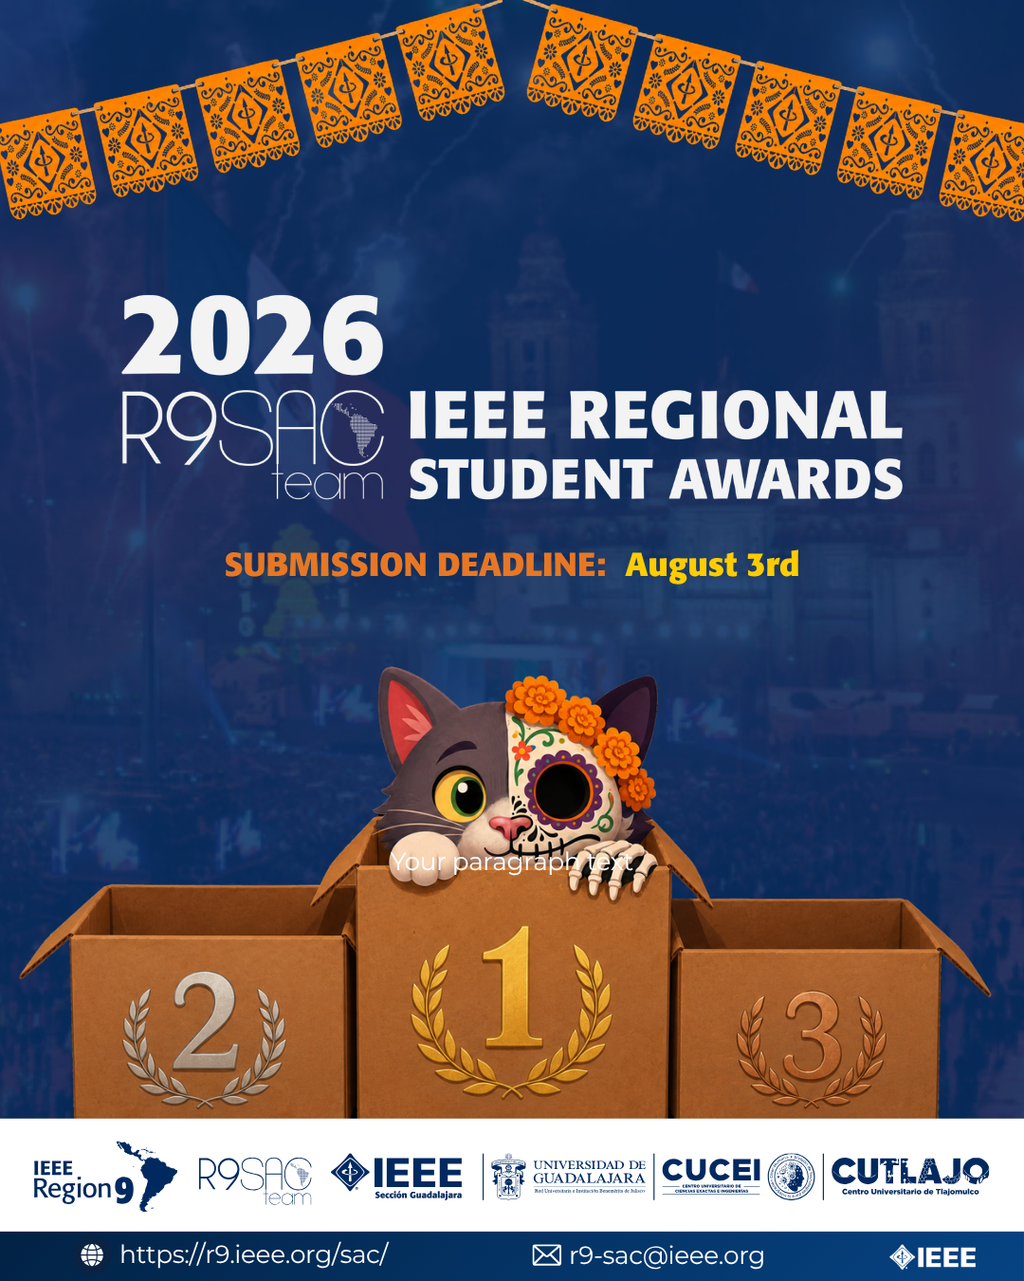
Figure 1. Home page, showing the official branch lockup and IEEE Blue as the anchor colour.
IV. Results
Main sections and resources. The site is public at https://ramaieeeyt.github.io [5]. An identity block states the mission and carries university, location, IEEE Region and branch code without scrolling. The Board section presents all six 2026 officers — Chair, Vice Chair, Secretary, Treasurer, Web Master and Membership — each with a photograph, a personal statement and a direct email address, so a visitor reaches the person responsible instead of a generic inbox. Resources lists six IEEE tools a member can open today: IEEE Xplore, IEEE Spectrum, Collabratec, IEEE Standards, IEEE Access and the conference calendar, with membership requirements marked per item. A dedicated page presents the ten units working inside the branch — eight technical chapters and the Women in Engineering and SIGHT affinity groups — each with its official lockup and a link to its society. The Timeline records ten milestones from 2019 to 2026, among them first place nationally at IEEEXtreme 13.0, all traceable to a named public source. An Archive of published pieces and a Join section close the page.
Content strategy. Opportunities is the section we consider most important, and it opens with the number a student actually wants: membership costs roughly USD 28 a year, about half that when enrolling after March, plus USD 1 to 13 per technical society, attributed to the branch's membership guide and linked to IEEE for the current rate. Eight routes follow, and between them they cover every category the contest names: scholarships (IEEE Foundation), travel grants (IEEE WIE), competitions (IEEEXtreme and the R9 SAC contests), events (IEEE Day and the National Student Branch Meeting), volunteer opportunities (the branch's own chapters) and IEEE programmes (student membership benefits). Each card carries the official mark of the programme and links to its IEEE page. The section states plainly that most of what it lists requires membership, because a student who discovers that after applying does not come back. Opportunities and Resources answer two different questions and the site keeps them apart: one is what you apply to, the other what you already use. Joining is then reduced to three actions in one place — obtain an IEEE membership, read the branch's membership guide, or write to the branch.
Navigation and accessibility. Section links live in a fixed spine along the left edge that doubles as a position indicator; links leading elsewhere stay in the top bar. Checking produced corrections: one resource was dropped because it answers HTTP 200 while serving a login wall, labels measuring 2.76:1 against paper were raised to 5.23:1, and officer statements that lived only in a hover state — invisible on every phone — now show by default where there is no pointer.
Technical results. The initial load transfers about 350 kB from a single origin, with photographs fetched only as the reader reaches them. The site sets no cookies, uses no local storage and makes no request to any third party — no analytics, no CDN, no embedded widgets — verified in production. It is responsive from 320 px upward with no horizontal overflow at any width, and carries alternative text, ARIA attributes, visible focus states and prefers-reduced-motion support.
Table 1

Criteria | What the site provides
Content and Opportunities (40) | 8 opportunities covering all six categories the contest names, 6 IEEE tools, 10 chapters and affinity groups, 6 officers, 10 sourced milestones, membership cost stated up front
Branding and IEEE Identity (20) | IEEE Brand Identity Guidelines Q1 2025: exact palette on IEEE Blue #00629B, Open Sans, official branch and chapter lockups
Information Accessibility and Navigation (15) | Fixed section spine with position indicator, separate page links, full keyboard navigation, contrast measured at 5.23:1
Member Engagement and Recruitment (15) | Price before the pitch, three ways to join in one place, a named contact for every officer
Technical Quality and Accessibility (10) | ~350 kB from a single origin, responsive from 320 px, no cookies and no third-party request, prefers-reduced-motion honoured
Website evaluation criteria and the site's response to each.
V. Closing Remarks
Maintenance and sustainability were design requirements, not afterthoughts, and they are the part of this project most worth copying.
Ownership. The site is hosted on GitHub Pages under a GitHub organization owned by the branch rather than by an individual. Officers are added as owners, so access transfers with the role. There is no personal account to lose, which addresses the failure described in Section I directly.
Editability. All content that changes between administrations — officers, opportunities, resources, timeline entries, archive items — is defined in a single object at the top of one file. Changing a name or adding a milestone means editing one line, and it can be done from a browser through GitHub's web editor: no software installed, no build to run, from any computer. A successor does not need to understand the site in order to update it.
Documentation. The repository includes a maintenance guide in Spanish covering how to change photographs, add entries, publish and regenerate assets, written for someone who did not build the site, together with a record of the decisions that are not visible in the code and of the mistakes made during development.
Maintenance record. Because the repository is public, its commit history is the maintenance record: every change dated, described and attributable, open to inspection at github.com/ramaieeeyt/ramaieeeyt.github.io. No separate reporting had to be invented, and none can fall out of date. The project also used no budget, which matters for replication: any branch in the Region can reproduce it without asking its section for funding.
Future improvements. Three are planned. Published records of branch activities will be added to the Archive as they occur. An upcoming-events section will be generated from the branch's own IEEE vTools Events records by a scheduled job, so that it stays current without anyone remembering to update it — and renders nothing when there is nothing to show, rather than displaying an empty calendar. Synchronization of the Archive with the branch's Instagram account is written and waits only on an access token.
VI. Conclusions
The objectives of Section I were met. The site presents the branch and its six officers accurately, each with a direct contact; it makes eight IEEE opportunities visible with links to official pages and states what membership costs before asking for a decision; it lists six resources and ten units to join; it records ten milestones, all traceable to a public source; and it is owned, structured and documented so that people who did not build it can maintain it.
The most valuable outcome was unplanned. Requiring a public source for every historical claim surfaced three errors in the branch's own record, one of which credited us with an event organized by another university. A student branch website is the public memory of the organizational unit, and holding it to the evidentiary standard expected of an IEEE publication seems to us the correct bar: the alternative is a page that repeats its own mistakes to every future reader. The same discipline governed the technical work, where the number and not the impression decided what to do.

References
[1] IEEE vTools Events, "Inscripción de nuevos miembros a la Rama Estudiantil Yachay Tech", 2019. [Online]. Available: https://events.vtools.ieee.org/m/216744 [Accessed: August 15, 2026].
[2] IEEE Ecuador Section, "Reunión Nacional de Ramas Estudiantiles IEEE 2023", 2023. [Online]. Available: https://r9.ieee.org/ecuador/reunion-nacional-de-ramas-estudiantiles-ieee-2023/ [Accessed: August 15, 2026].
[3] IEEE, "IEEE Brand Identity Guidelines", Q1 2025. [Online]. Available: https://brand-experience.ieee.org/ [Accessed: August 15, 2026].
[4] IEEE vTools Events, "RNR IBARRA 2025", 2025. [Online]. Available: https://events.vtools.ieee.org/m/497568 [Accessed: August 15, 2026].
[5] IEEE Yachay Tech University Student Branch, "Sitio web de la Rama", 2026. [Online]. Available: https://ramaieeeyt.github.io [Accessed: August 15, 2026].

