=========================================================

TOPIC: JOINS AND SET OPERATIONS
=========================================================
Dr.Y Subbarayudu ,Department CSE ,KL University Bachupally Hyderabad
=========================================================
PART 1: CROSS JOIN
=========================================================

STEP 1: CREATE TABLES
---------------------------------------------------------

CREATE TABLE class (
id INT,
name VARCHAR(30)
);

CREATE TABLE class_info (
id INT,
address VARCHAR(30)
);
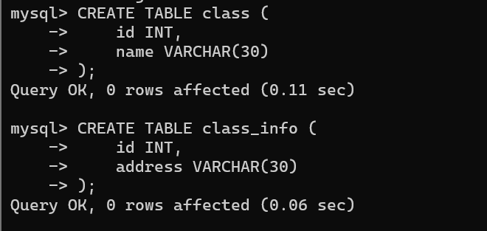
=========================================================
STEP 2: INSERT DATA
=========================================================

INSERT INTO class VALUES
(1,'abhi'),
(2,'adam'),
(4,'alex');

INSERT INTO class_info VALUES
(1,'DELHI'),
(2,'MUMBAI'),
(3,'CHENNAI');
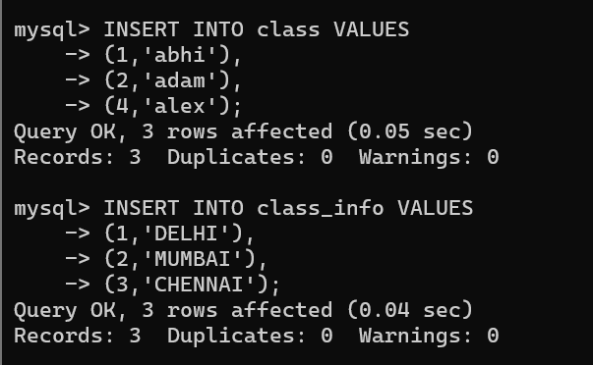
=========================================================
QUESTION 1 - CROSS JOIN
=========================================================

SCENARIO:
School administration wants every student to be paired
with every available city for survey analysis.

QUERY:

SELECT *
FROM class
CROSS JOIN class_info;

OUTPUT:

id name id address
-----------------------
1 abhi 1 DELHI
2 adam 1 DELHI
4 alex 1 DELHI
1 abhi 2 MUMBAI
2 adam 2 MUMBAI
4 alex 2 MUMBAI
1 abhi 3 CHENNAI
2 adam 3 CHENNAI
4 alex 3 CHENNAI
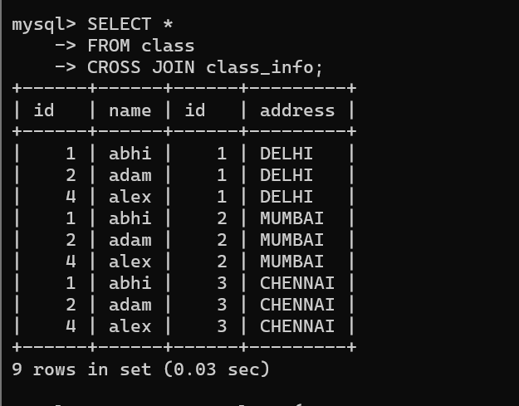
=========================================================
PART 2: INNER JOIN
=========================================================

CREATE TABLE class (
id INT,
name VARCHAR(30)
);

CREATE TABLE class_info (
id INT,
address VARCHAR(30)
);

INSERT INTO class VALUES
(1,'abhi'),
(2,'adam'),
(3,'alex'),
(4,'anu');

INSERT INTO class_info VALUES
(1,'DELHI'),
(2,'MUMBAI'),
(3,'CHENNAI');
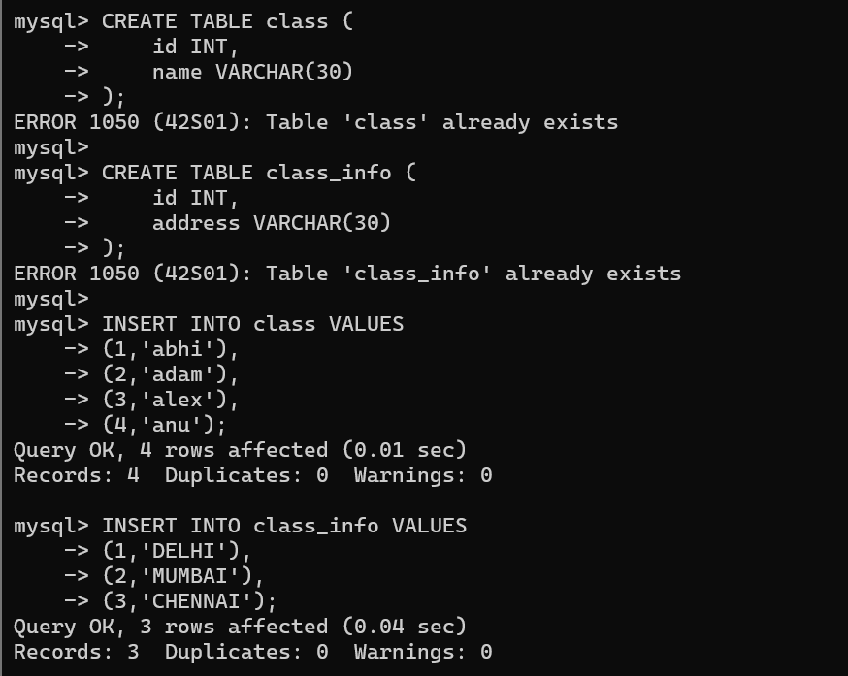
=========================================================
QUESTION 2 - INNER JOIN
=========================================================

SCENARIO:
Management wants only students whose address details
are available in both tables.

QUERY:

SELECT *
FROM class
INNER JOIN class_info
ON class.id = class_info.id;

OUTPUT:

id name id address
-----------------------
1 abhi 1 DELHI
2 adam 2 MUMBAI
3 alex 3 CHENNAI
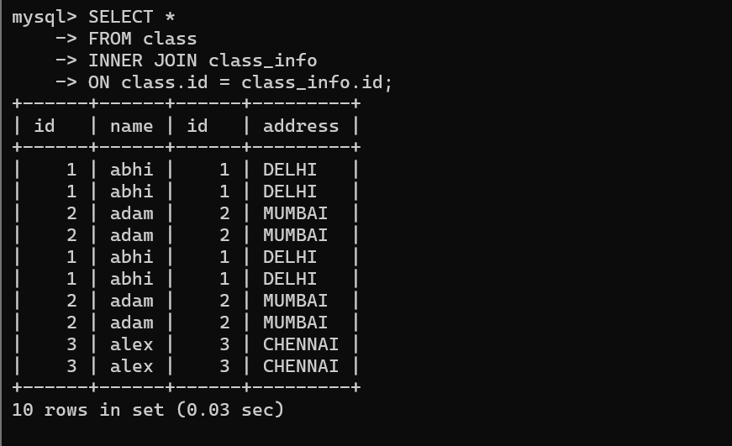
=========================================================
QUESTION 3 - INNER JOIN
=========================================================

SCENARIO:
Find student names and addresses for registered students.

QUERY:

SELECT class.name,
class_info.address
FROM class
INNER JOIN class_info
ON class.id=class_info.id;

OUTPUT:

abhi DELHI
adam MUMBAI
alex CHENNAI
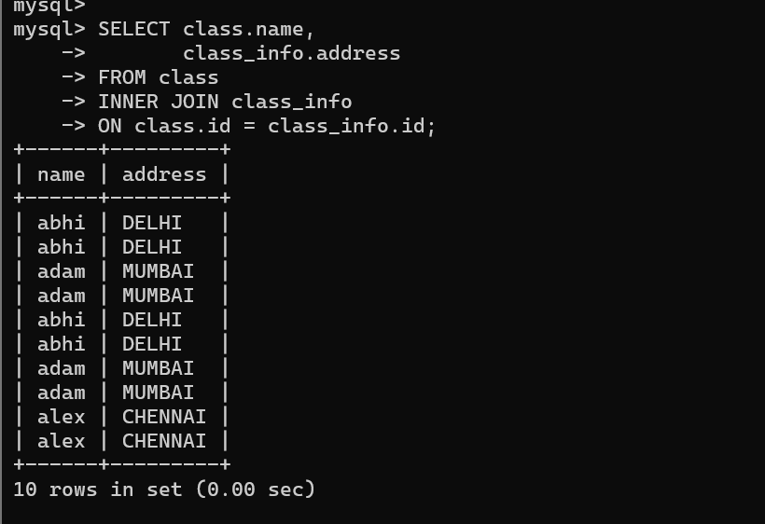
=========================================================
PART 3: NATURAL JOIN
=========================================================

QUESTION 4 - NATURAL JOIN
=========================================================

SCENARIO:
The database administrator wants matching records
automatically joined using common columns.

QUERY:

SELECT *
FROM class
NATURAL JOIN class_info;

OUTPUT:

id name address
------------------
1 abhi DELHI
2 adam MUMBAI
3 alex CHENNAI
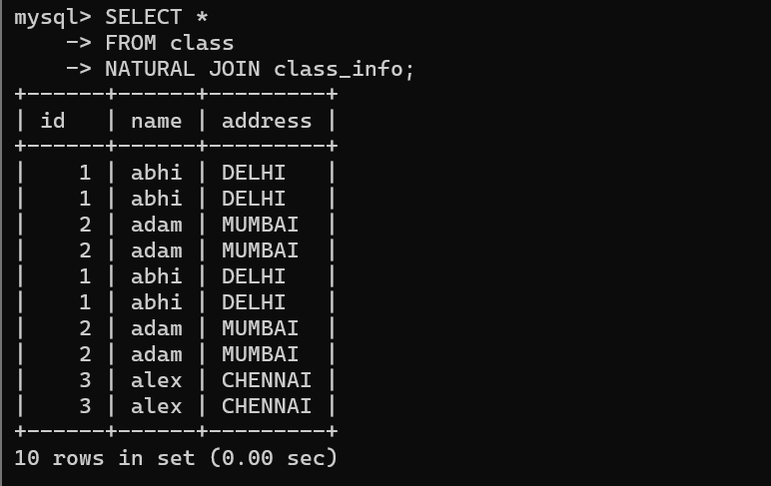
=========================================================
PART 4: LEFT OUTER JOIN
=========================================================

INSERT INTO class VALUES
(5,'ashish');

INSERT INTO class_info VALUES
(7,'NOIDA'),
(8,'PANIPAT'); 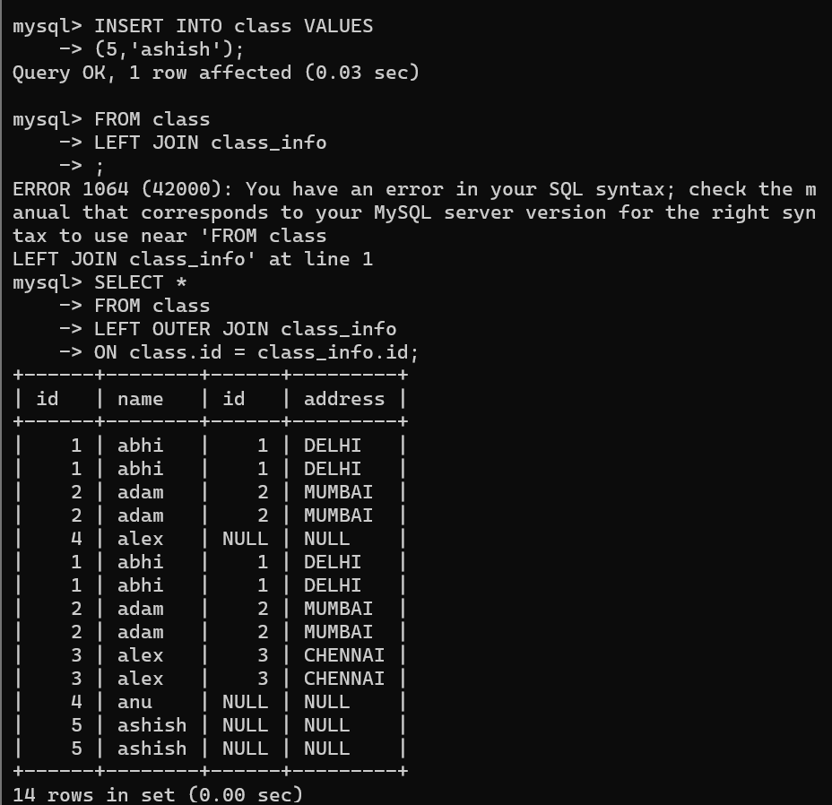

=========================================================
QUESTION 5 - LEFT JOIN
=========================================================

SCENARIO:
School wants all students even if address information
is not available.

QUERY:

SELECT *
FROM class
LEFT OUTER JOIN class_info
ON class.id=class_info.id;

OUTPUT:

1 abhi 1 DELHI
2 adam 2 MUMBAI
3 alex 3 CHENNAI
4 anu NULL NULL
5 ashish NULL NULL
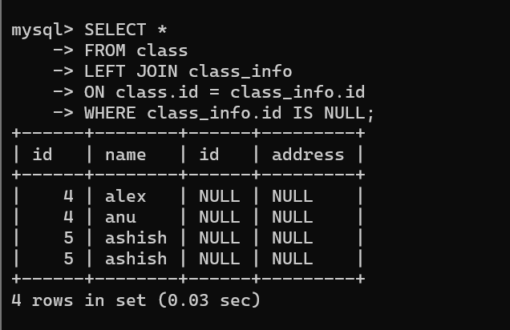
=========================================================
QUESTION 6 - LEFT JOIN
=========================================================

SCENARIO:
Find students who do not have address records.

QUERY:

SELECT *
FROM class
LEFT JOIN class_info
ON class.id=class_info.id
WHERE class_info.id IS NULL;

OUTPUT:

4 anu
5 ashish
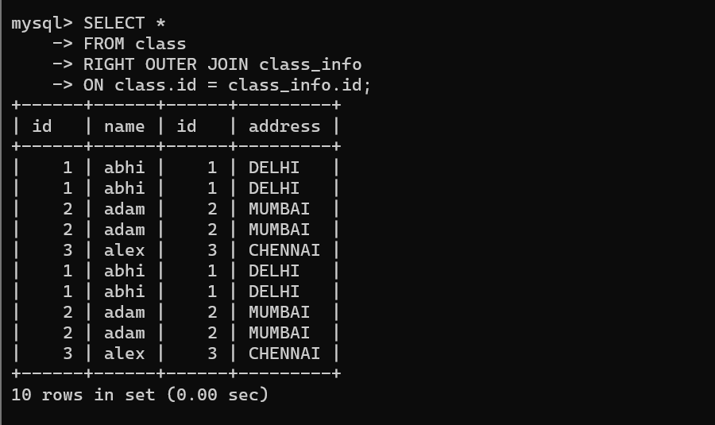
=========================================================
PART 5: RIGHT OUTER JOIN
=========================================================

QUESTION 7 - RIGHT JOIN
=========================================================

SCENARIO:
Administration wants all address records even if
students are missing.

QUERY:

SELECT *
FROM class
RIGHT OUTER JOIN class_info
ON class.id=class_info.id;

OUTPUT:

1 abhi 1 DELHI
2 adam 2 MUMBAI
3 alex 3 CHENNAI
NULL NULL 7 NOIDA
NULL NULL 8 PANIPAT
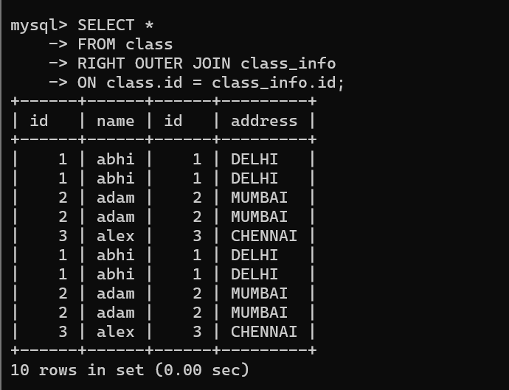
=========================================================
QUESTION 8 - RIGHT JOIN
=========================================================

SCENARIO:
Find address records that do not belong to any student.

QUERY:

SELECT *
FROM class
RIGHT JOIN class_info
ON class.id=class_info.id
WHERE class.id IS NULL;

OUTPUT:

7 NOIDA
8 PANIPAT
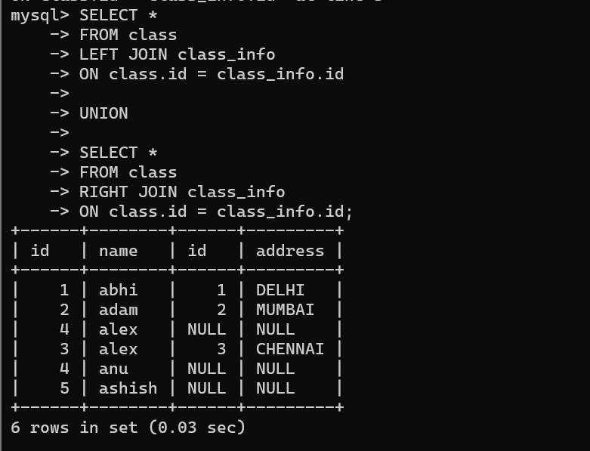
=========================================================
PART 6: FULL OUTER JOIN
=========================================================

QUESTION 9 - FULL OUTER JOIN
=========================================================

SCENARIO:
Management wants all records from both tables,
matched and unmatched.

QUERY:

SELECT *
FROM class
FULL OUTER JOIN class_info
ON class.id=class_info.id;

OUTPUT:

1 abhi 1 DELHI
2 adam 2 MUMBAI
3 alex 3 CHENNAI
4 anu NULL NULL
5 ashish NULL NULL
NULL NULL 7 NOIDA
NULL NULL 8 PANIPAT
=========================================================
QUESTION 10 - FULL OUTER JOIN
=========================================================

SCENARIO:
Audit team wants unmatched records from both tables.

QUERY:

SELECT *
FROM class
FULL OUTER JOIN class_info
ON class.id=class_info.id
WHERE class.id IS NULL
OR class_info.id IS NULL;

OUTPUT:

4 anu
5 ashish
7 NOIDA
8 PANIPAT
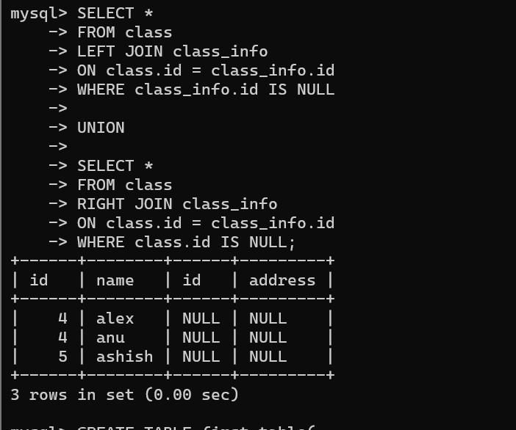
=========================================================
PART 7: UNION
=========================================================

CREATE TABLE first_table(
id INT,
name VARCHAR(30)
);

CREATE TABLE second_table(
id INT,
name VARCHAR(30)
);

INSERT INTO first_table VALUES
(1,'abhi'),
(2,'adam');

INSERT INTO second_table VALUES
(2,'adam'),
(3,'chester');
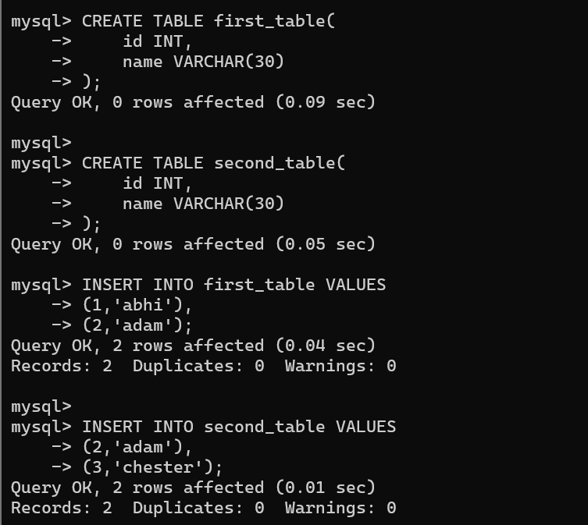
=========================================================
QUESTION 11 - UNION
=========================================================

SCENARIO:
Management wants a combined list without duplicates.

QUERY:

SELECT * FROM first_table
UNION
SELECT * FROM second_table;

OUTPUT:

1 abhi
2 adam
3 chester
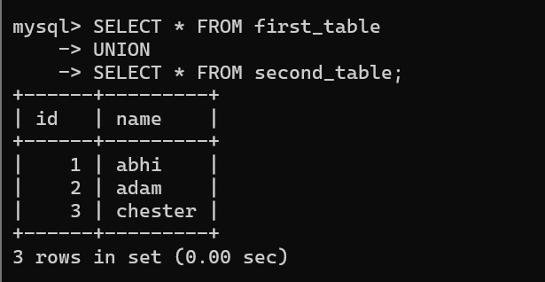=========================================================
QUESTION 12 - UNION
=========================================================

SCENARIO:
Generate a master student list from two branches.

QUERY:

SELECT name FROM first_table
UNION
SELECT name FROM second_table;

OUTPUT:

abhi
adam
chester
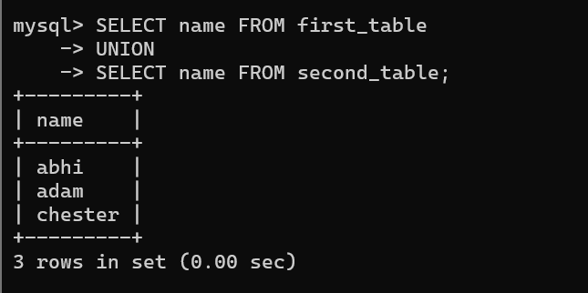
=========================================================
PART 8: UNION ALL
=========================================================

QUESTION 13 - UNION ALL
=========================================================

SCENARIO:
Management wants all records including duplicates.

QUERY:

SELECT * FROM first_table
UNION ALL
SELECT * FROM second_table;

OUTPUT:

1 abhi
2 adam
2 adam
3 chester
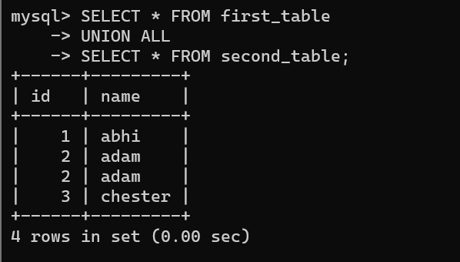
=========================================================
QUESTION 14 - UNION ALL
=========================================================

SCENARIO:
Count total records from both branches.

QUERY:

SELECT COUNT(*)
FROM
(
SELECT * FROM first_table
UNION ALL
SELECT * FROM second_table
) A;

OUTPUT:

4
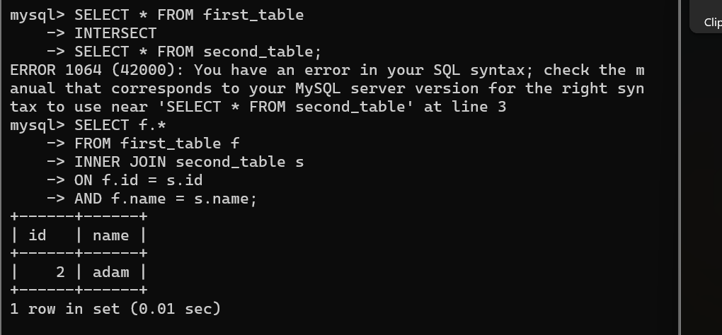
=========================================================
PART 9: INTERSECT
=========================================================

QUESTION 15 - INTERSECT
=========================================================

SCENARIO:
Find students present in both branches.

QUERY:

SELECT * FROM first_table
INTERSECT
SELECT * FROM second_table;

OUTPUT:

2 adam
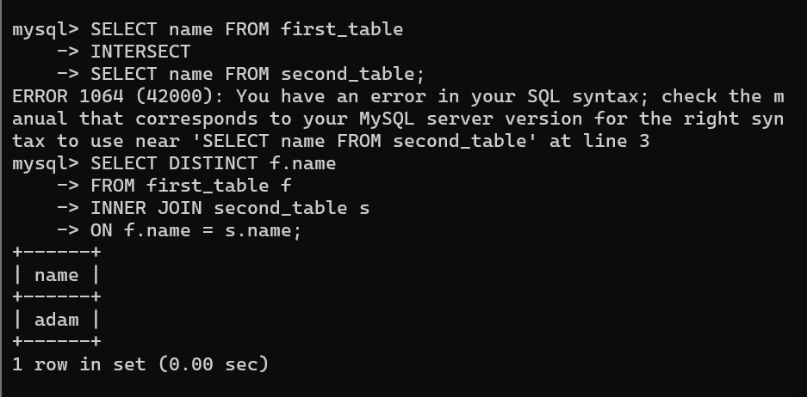
=========================================================
QUESTION 16 - INTERSECT
=========================================================

SCENARIO:
Find common student names.

QUERY:

SELECT name FROM first_table
INTERSECT
SELECT name FROM second_table;

OUTPUT:

adam
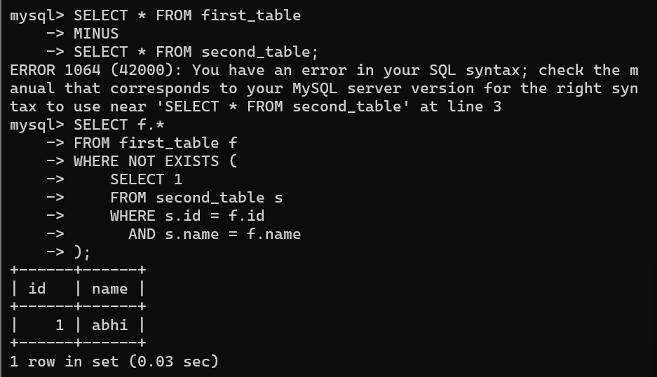
=========================================================
PART 10: MINUS
=========================================================

QUESTION 17 - MINUS
=========================================================

SCENARIO:
Find students present only in the first branch.

QUERY:

SELECT * FROM first_table
MINUS
SELECT * FROM second_table;

OUTPUT:

1 abhi
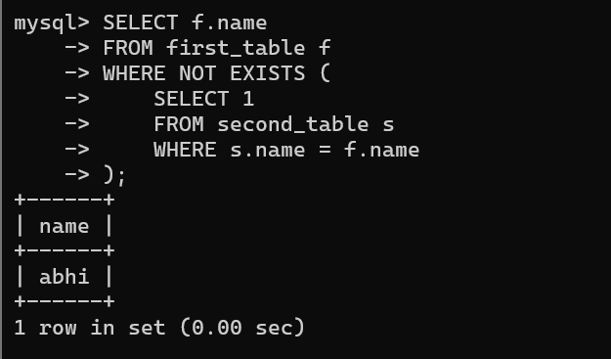

=========================================================
QUESTION 18 - MINUS
=========================================================

SCENARIO:
Find names that exist only in first_table.

QUERY:

SELECT name FROM first_table
MINUS
SELECT name FROM second_table;

OUTPUT:

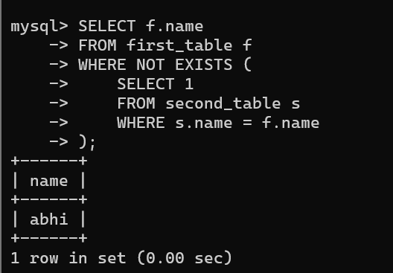

=========================================================
ADVANCED INTERVIEW QUESTIONS
=========================================================

QUESTION 19

SCENARIO:
Find students having matching addresses.

QUERY:

SELECT c.id,c.name,ci.address
FROM class c
INNER JOIN class_info ci
ON c.id=ci.id;
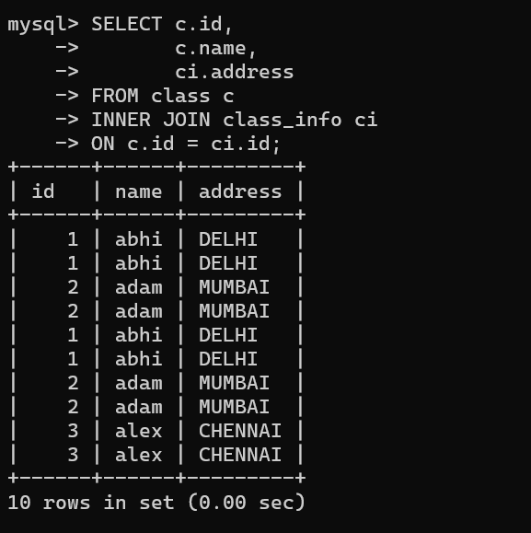
=========================================================

QUESTION 20

SCENARIO:
Generate a report showing all students and address
availability status.

QUERY:

SELECT c.id,
c.name,
CASE
WHEN ci.address IS NULL
THEN 'Address Missing'
ELSE 'Address Available'
END AS Status
FROM class c
LEFT JOIN class_info ci
ON c.id=ci.id;

OUTPUT:

1 abhi Address Available
2 adam Address Available
3 alex Address Available
4 anu Address Missing
5 ashish Address Missing
