show dbs // list databases
use myDatabase // switch/create database
db // show current database
db.dropDatabase() // delete current database

show collections
db.createCollection("users")
db.users.drop()
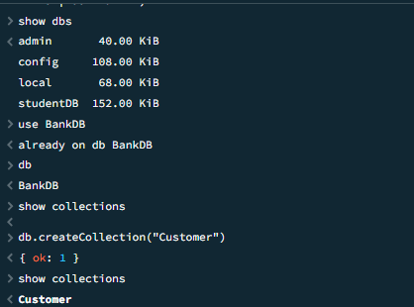
db.users.insertOne({ name: "Alice", age: 25 })

db.users.insertMany([
{ name: "Bob", age: 30 },
{ name: "Carol", age: 28 }
])
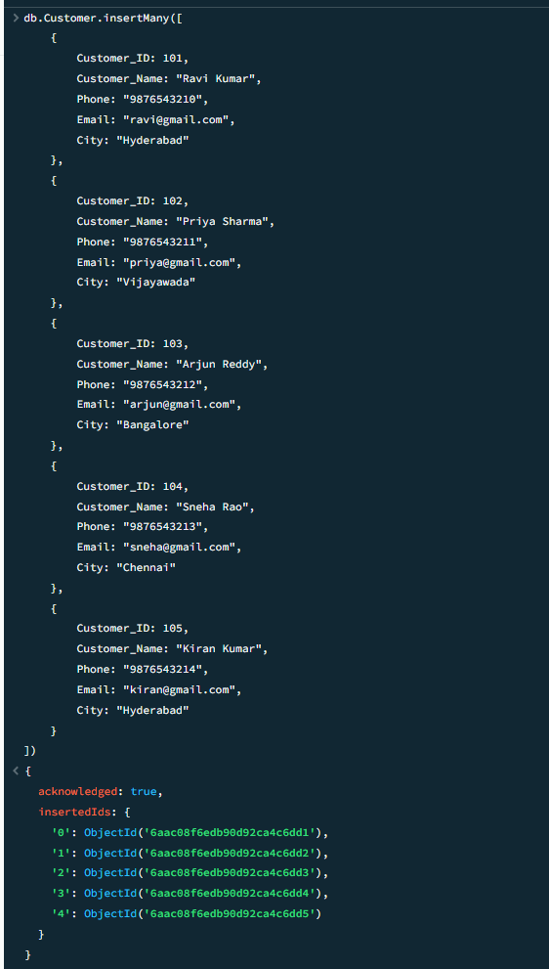

db.users.find() // all documents
db.users.findOne({ name: "Alice" })

db.users.find({ age: { $gt: 25 } }) // age > 25

db.users.find(
{ age: { $gte: 25 } },
{ name: 1, _id: 0 } // projection
)
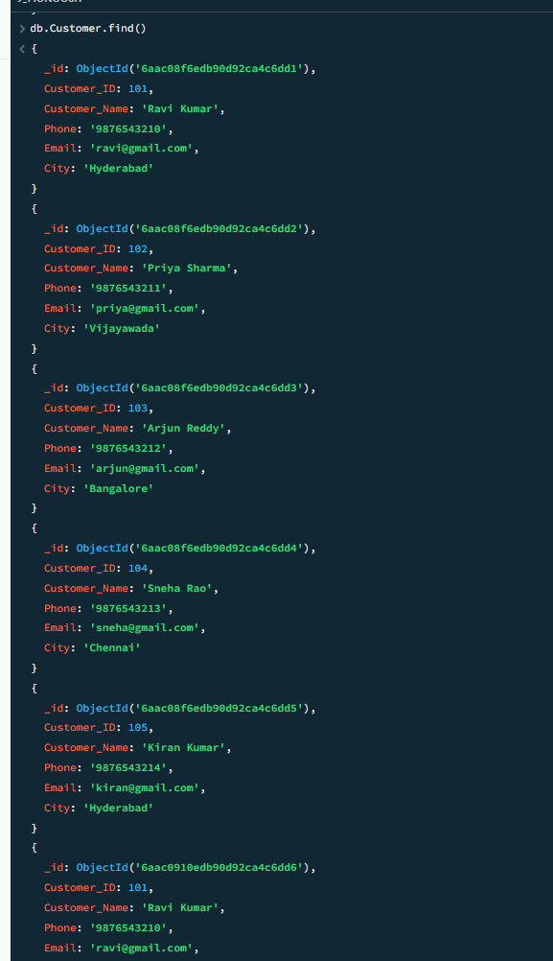
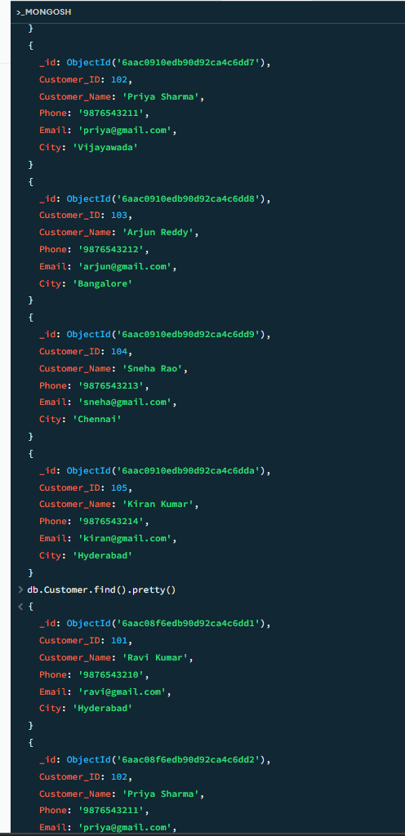
db.users.updateOne(
{ name: "Alice" },
{ $set: { age: 26 } }
)

db.users.updateMany(
{ age: { $lt: 30 } },
{ $inc: { age: 1 } }
)

db.users.deleteOne({ name: "Bob" })
db.users.deleteMany({ age: { $gt: 100 } })

db.users.countDocuments()
db.users.countDocuments({ age: { $gte: 25 } })

db.users.find().sort({ age: 1 }) // 1 = asc, -1 = desc
db.users.find().limit(5)
db.users.find().skip(10)
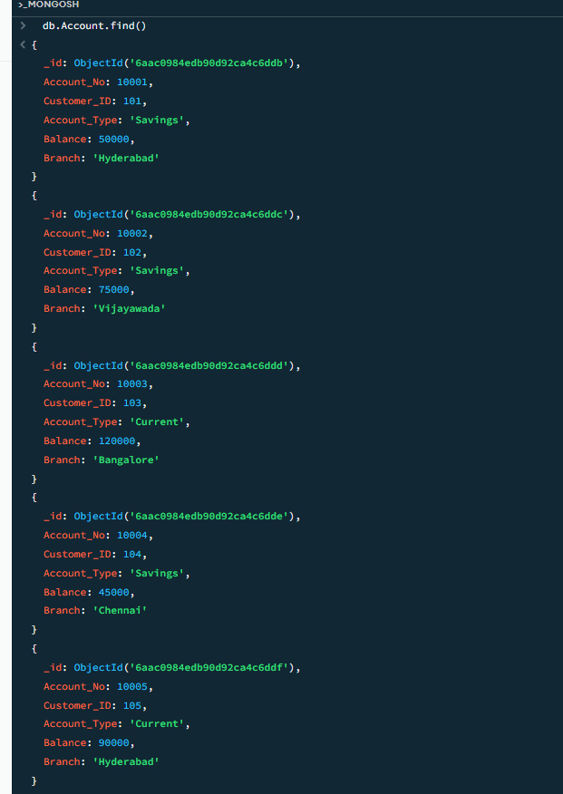
db.users.aggregate([
{ $match: { age: { $gte: 25 } } },
{ $group: { _id: "$age", total: { $sum: 1 } } }
])

db.users.createIndex({ name: 1 })
db.users.getIndexes()
db.users.dropIndex({ name: 1 })
CRUD Operations in MongoDB
CRUD = Create, Read, Update, Delete
We’ll use a collection called users.

🟢 CREATE (Insert Data)
Insert one document
db.users.insertOne({
name: "Alice",
age: 25,
email: "alice@gmail.com"
})
Insert multiple documents
db.users.insertMany([
{ name: "Bob", age: 30, email: "bob@gmail.com" },
{ name: "Carol", age: 28, email: "carol@gmail.com" }
])
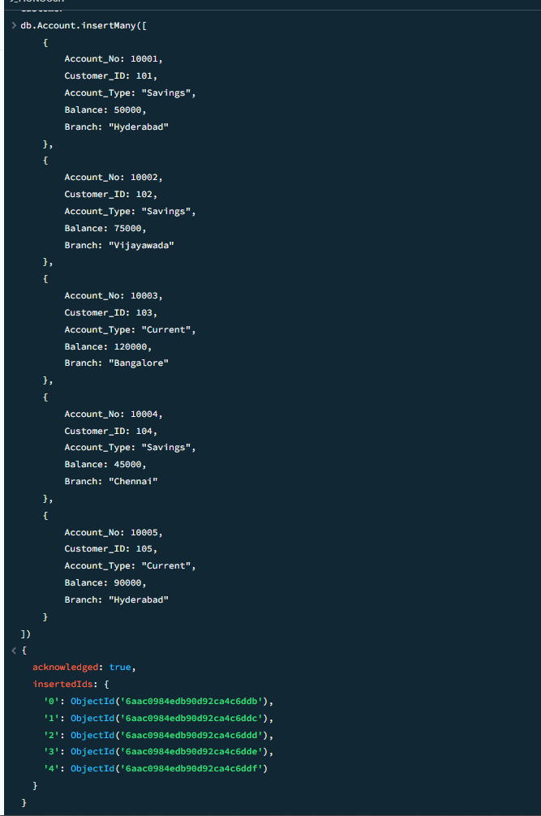
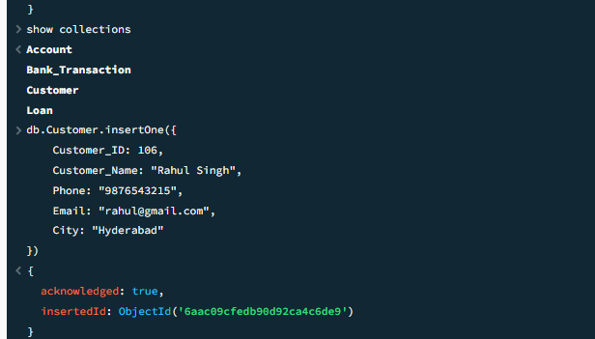

🔵 READ (Retrieve Data)
Find all documents
db.users.find()
Find specific document
db.users.findOne({ name: "Alice" })
Conditional query
db.users.find({ age: { $gt: 25 } })
Select specific fields (Projection)
db.users.find(
{ age: { $gte: 25 } },
{ name: 1, email: 1, _id: 0 }
)
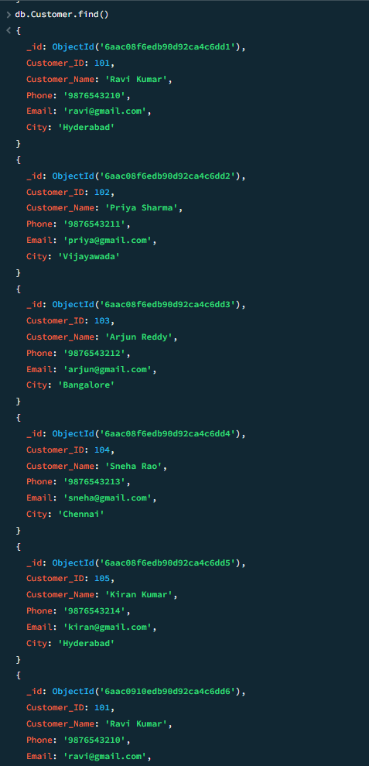
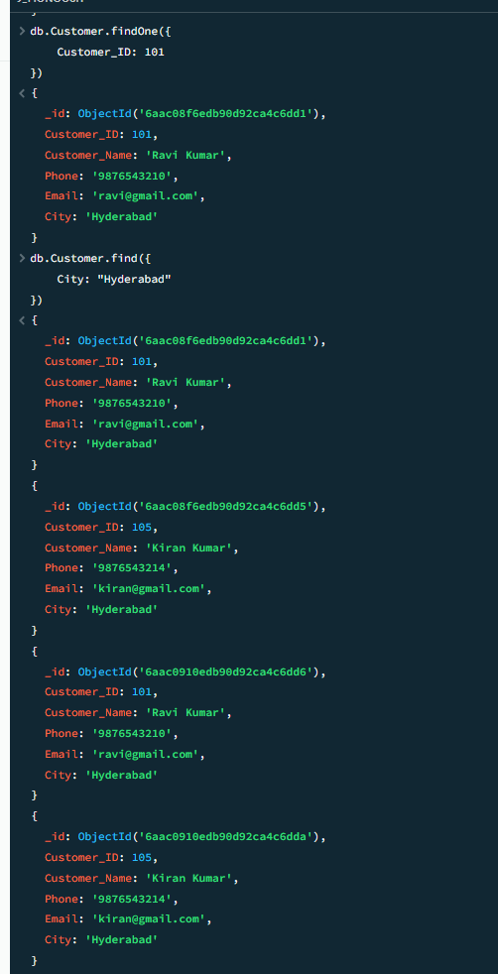
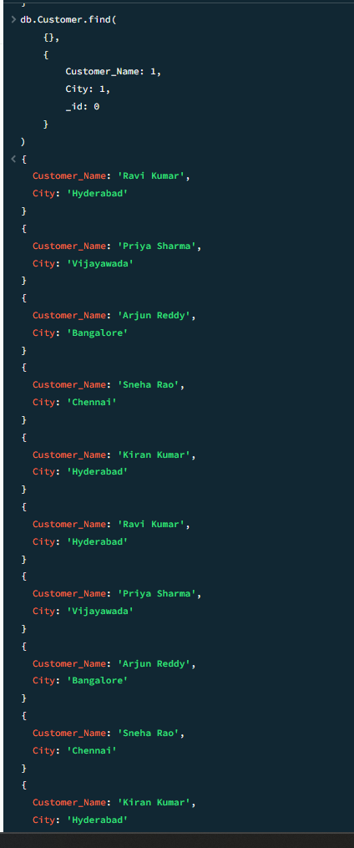

🟡 UPDATE (Modify Data)
Update one document
db.users.updateOne(
{ name: "Alice" },
{ $set: { age: 26 } }
)
Update multiple documents
db.users.updateMany(
{ age: { $lt: 30 } },
{ $inc: { age: 1 } }
)
Replace entire document
db.users.replaceOne(
{ name: "Bob" },
{ name: "Bob", age: 31, email: "bob@gmail.com", active: true }
)
Upsert (Update or Insert)
db.users.updateOne(
{ name: "David" },
{ $set: { age: 29 } },
{ upsert: true }
)
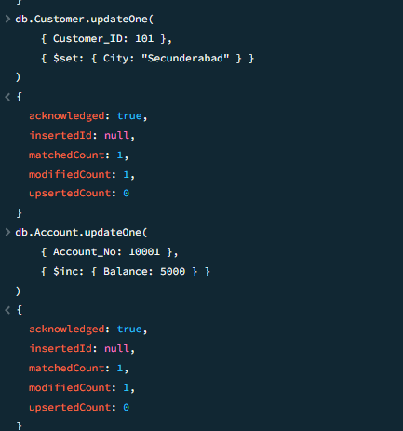

🔴 DELETE (Remove Data)
Delete one document
db.users.deleteOne({ name: "Carol" })
Delete multiple documents
db.users.deleteMany({ age: { $gt: 60 } })
Delete all documents (⚠ careful)
db.users.deleteMany({})
