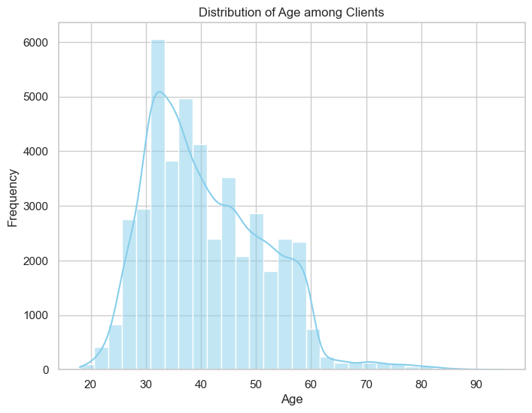

**Findings and Insights**

1. **Age Distribution**
   * The majority of clients are between **30 to 50 years**, suggesting that this age group forms the core customer base.
   * Younger and older age groups are underrepresented, potentially indicating untapped market segments.
2. **Job Type**
   * Clients are predominantly employed in sectors like **management**, **technicians**, and **blue-collar jobs**.
   * Minimal representation in categories like **unemployed** or **students** suggests a focus on financially stable demographics.
3. **Marital Status**
   * A significant proportion of clients are **married** (~60%), followed by **single** clients (~30%).
   * Strategies can be developed to better engage single clients who may have different financial needs.
4. **Education Level**
   * Most clients have at least a **secondary education**, with a notable segment holding **tertiary qualifications**.
   * Higher education levels correlate with greater financial awareness and product adoption.
5. **Credit in Default**
   * Only a small proportion (~2%) of clients have **credit in default**, indicating a largely creditworthy client base.
   * Defaulting clients may require closer monitoring and tailored financial solutions.
6. **Yearly Balance Distribution**
   * The average yearly balance distribution is highly skewed, with a majority having **balances under €5,000**.
   * High-balance clients could be targeted for premium financial services.
7. **Housing Loans**
   * Around **55%** of clients have **housing loans**, signifying the importance of housing-related financial products.
8. **Personal Loans**
   * A smaller portion (~20%) of clients have **personal loans**, indicating room for expansion in this product category.
9. **Communication Types**
   * The most common communication method is **cellular calls**, followed by **telephone landlines**.
   * Email and other digital methods are underutilized, presenting an opportunity for digital engagement.
10. **Last Contact Day of the Month**
    * Most client interactions occur in the **middle of the month**, suggesting a strategic scheduling pattern.
11. **Last Contact Month**
    * The majority of contacts were made in **May**, followed by **August**.
    * Off-peak months could be leveraged for additional campaigns.
12. **Duration of Last Contact**
    * Longer call durations generally correlate with better client engagement.
    * Calls under **3 minutes** often result in lower conversion rates.
13. **Campaign Contacts**
    * Most clients were contacted **1-3 times** during the campaign.
    * High-frequency contacts (>5) show diminishing returns, indicating a need for more targeted outreach.
14. **Days Since Last Contact**
    * A significant number of clients had not been contacted for over **100 days**, highlighting the need for regular follow-ups.
15. **Previous Contacts**
    * Clients with multiple previous contacts exhibit a higher likelihood of conversion.
16. **Outcomes of Previous Campaigns**
    * The most frequent outcomes were **non-subscription** and **no response**, pointing to potential areas for process improvement.
17. **Term Deposit Subscription**
    * Around **12%** of clients subscribed to term deposits, leaving significant room for growth in this product category.
18. **Correlations with Subscription**
    * Positive correlations: **Call duration**, **higher balance**, and **previous campaign success**.
    * Negative correlations: **High frequency of contacts** and **default status**.