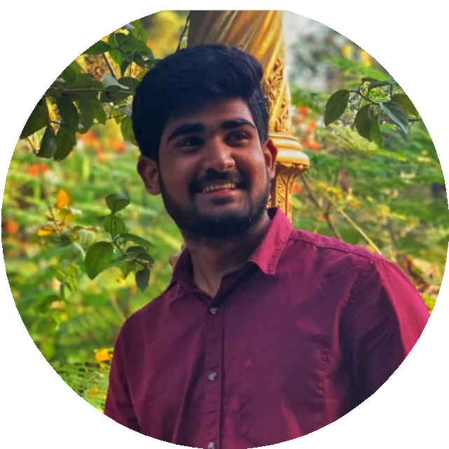DEVIDI RAMAKANTH

+91 70932 19094

[ramakanthreddy709@gmail.com](mailto:ramakanthreddy709@gmail.com)

[linkedin.com/in/ramakanth-reddy](https://www.linkedin.com/in/ramakanth-reddy-801715212/) [github.com/ramakanthdevidi](https://github.com/ramakanthdevidi)

# CAREER OBJECTIVE

A self-motivated undergrad with enthusiasm to learn new things and looking forward to expanding knowledge across different technologies. Actively looking for an opportunity where I can make the best of my potential and contribute to the organization’s growth.

# EDUCATION

|  |  |
| --- | --- |
| **Information Technology** | 2019 – 2023 |
| Gokaraju Rangaraju Institute of Engineering and Technology | **GPA 8.4/10** |
| **Intermediate** | 2017 – 2019 |
| Narayana Junior College | **Percentage 97.3** |
| **SSC** | 2016 – 2017 |
| Mary Mother of Hope High School | **GPA 8.7/10** |

WORK EXPERIENCE

**Machine Learning Intern** Jan 2022 – Feb 2022

RINEX

* Handled the Machine Learning project from scratch.
* Worked with Machine Learning using python.

# PROJECTS

**Instagram Reach Analysis and Prediction** *|* ***Machine Learning*** January 2023

* Domain - Technical domain
* In this study, we analyzed Instagram reach by collecting data from a sample of users over a six-month period.
* Our study provides valuable insights into Instagram’s reach and can help individuals and businesses develop strategies to increase their reach.
* The predictive model can help users forecast the reach of their posts and adjust their strategies accordingly.

**Enhanced AI Model for Leather Defect Inspection** *|* ***Machine Learning*** March 2022

* Domain - Industrial domain
* ML model which detects defective leather material using Deep Learning.
* Built using Convolution Neural Networks (CNN) and Dataset containing different leather images classified into defective and non-defective.

# SKILLS

**Languages**: English , Telugu , Hindi

**Programming Languages**: C , Java , Python , CSS , HTML , Javascript , SQL , Agile

**Version Control**: git

# CERTIFICATIONS

**PCAP: Programming Essentials in Python** June 2022 Cisco Networking Academy

**AiML Artificial Intelligence with Machine Learning** Mar - April 2022 Oracle Academy

**Machine Learning Certification** Jan - Feb 2022

RINEX

**Python Programming** Jul - Oct 2021

NPTEL- SWAYAM CENTRAL

# ACHIEVEMENTS

**JNTUH Kabbadi Team**

Selected as a Player in JNTUH Kabaddi Team

**47th Senior Inter District Kabbadi Championship** January 2021 Selected as a Player in 47th Senior Inter District Kabbadi Championship - 2021

**46th Junior Inter District Kabbadi Championship** January 2020 Selected as a Player in 46th Junior Inter District Kabbadi Championship - 2020

# INTERESTS

* Travelling
* Cooking
* Video Gaming
* Playing Kabbadi