**MY ONLINE SHOPPING STORE**

We have a physical shopping store, which is doing well in terms of revenue and margin. We want to increase the business by extending the availability of our products through online mechanisms. Quick time-to-market is the main criteria;

we are adding some features:

1) Home Page

2) Product Search facility

3) Product Detail Page

4) Add to Cart

5) Place Order

**Use Case Diagram-Online Shopping Website:**

The use case diagram are usually referred to as behavior diagram used to describe the actions of all user in a system.

All user describe in use case are actors and the functionality as action of system.

**Use case for online shopping website:**

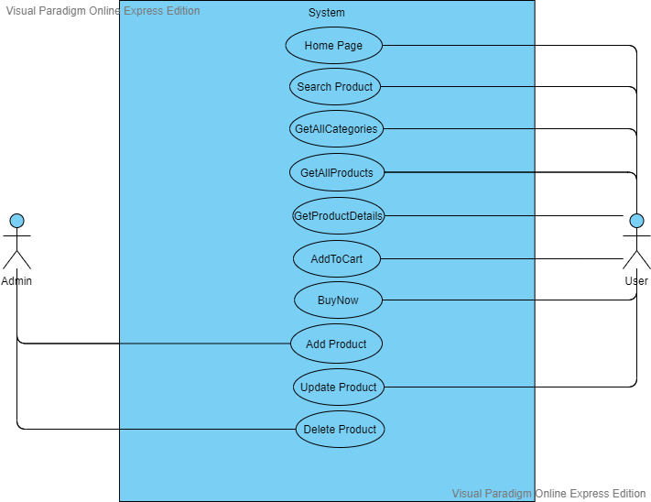

## Specification of Use Cases:

### **Use Case Home page**

| Home Page | |
| --- | --- |
| Element | Details |
| Actor | User |
| Trigger | With or without authentication |
| Pre Conditions | Various Categories of the items are displayed |
| Post Conditions | On clicking the each category, various sub items are to displayed |
| Normal course | 1. On hovering various categories are displayed 2. On each Category, the sub categories are displayed |

### **Use Case Search Product**

| Search Product | |
| --- | --- |
| Element | Details |
| Actor | User |
| Trigger | On clicking the search bar for the item to be searched. |
| Pre Conditions | User can check the items he needed |
| Post Conditions | The various items of the searched product are displayed |
| Normal course | 1. User enters the Product name or product category 2. The various items of the product are displayed |

### **Use Case GetAllProducts**

| GetAllProducts | |
| --- | --- |
| Element | Details |
| Actor | User |
| Trigger | With or without authentication |
| Pre Conditions | User needs to enter a product name |
| Post Conditions | The sub list of all the items should be displayed. |
| Normal course | 1. The various products should be displayed varying in different perspectives |

### **Use Case GetProductDetails**

| Get Product Details | |
| --- | --- |
| Element | Details |
| Actor | User |
| Trigger | On clicking a particular item the info about the product is to be displayed. |
| Pre Conditions | The user needs to enter the product name or category |
| Post Conditions | The total info regarding the product is to be displayed |
| Normal course | 1. User enters the Product name and then submits 2. The fetching records will be displayed |

### **Use Case AddProduct**

| Add Product | |
| --- | --- |
| Element | Details |
| Actor | Admin |
| Trigger | When the User Quantity is not available |
| Pre Conditions | Checks whether the searched item is available in the inventory or not |
| Post Conditions | The user can search for the prescribed item |
| Normal course | 1. Admin checks in the inventory stock 2. During the period of offers or when the inventory is not available to the users , he adds in the database. |

### **Use Case Delete Product**

| Delete Product | |
| --- | --- |
| Element | Details |
| Actor | Admin |
| Trigger | When the offer period is completed |
| Pre Conditions | Refactoring the product as per the daily market price |
| Post Conditions | The product is not available after the deletion. |
| Normal course | 1. Admin login using his credentials 2. Search for the product to be deleted 3. Deletes the particular products |

### **Use Case Edit Product**

| Edit Product | |
| --- | --- |
| Element | Details |
| Actor | Admin |
| Trigger | When the product needs to be updated during the season sale |
| Pre Conditions | The product may vary in its cost and delivery |
| Post Conditions | The product has been updated regarding the information |
| Normal course | 1. Admin logins using his credentials 2. Updates the selected products in the inventory. |

### **Use Case Add To Cart**

| Add To Cart | |
| --- | --- |
| Element | Details |
| Actor | User |
| Trigger | When user needs to buy the item in later point of time |
| Pre Conditions | If the user likes a particular product he can choose to buy by clicking the Add To Cart |
|  |  |
| Post Conditions | The selected items are available later ,until the selected product is available |
| Normal course | 1. User selects the particular product 2. He then clicks on Add To Cart. 3. The liked items are available for later usage |

### **Use Case BuyNow**

| BuyNow | |
| --- | --- |
| Element | Details |
| Actor | User |
| Trigger | With authentication |
| Pre Conditions | The total amount should be displayed. |
| Post Conditions | On Clicking the order needs to be placed. |
| Normal course | 1. Click on Buy Now, select the items and then go to payment 2. The order should be placed after payment. |

**Shopping cart System ER Diagram:**

**ER Diagram** stands for Entity Relationship Diagram, also known as ERD is a diagram that displays the relationship of entity sets stored in a database. In other words, ER diagrams help to explain the logical structure of databases. ER diagrams are created based on three basic concepts: entities, attributes and relationships.

ER Diagrams contain different symbols that use rectangles to represent entities, ovals to define attributes and diamond shapes to represent relationships.

The main entities of the Shopping Cart System are Products Category, Customer ,Cart.

### **Shopping Cart System entities and their attributes** :

* Products Entity : Attributes of Products are product id, categoryid ,price quantity ,picture ,Content.
* Category Entity : Attributes of Category are category id, categoryname
* Cart Entity : Attributes of Cart are shopping cart id, price and quantity.

**ER Diagram:**

ProductCategory

Product

CartItem

has

AddedTo

**Flow Chart For Online Shopping system:**

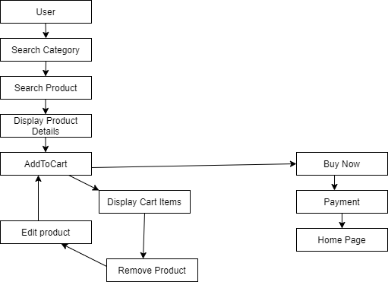

**Database Table Design:**

**ProductCategory:**

|  |  |  |
| --- | --- | --- |
| **Field Name** | **Type** | **Remark** |
| CategoryId | Int | PK |
| CategoryName | Nvarchar(50) |  |

**Products:**

|  |  |  |
| --- | --- | --- |
| **Field Name** | **Type** | **Remark** |
| Id | int | PK |
| CategoryId | int | FK |
| Price | Float |  |
| Quantity | Int |  |
| Description | Nvarchar(Max) |  |
| Picture | Nchar(100) |  |

**CartItem:**

|  |  |  |
| --- | --- | --- |
| **FieldName** | **Type** | **Remark** |
| Id | Int | FK |
| Price | Float |  |
| Quantity | Int |  |

**Appendices**

**HomePage:**

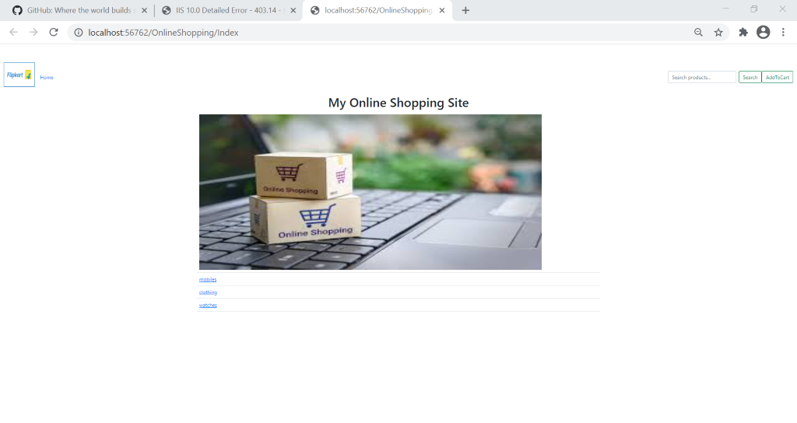

**Search Products Page:**

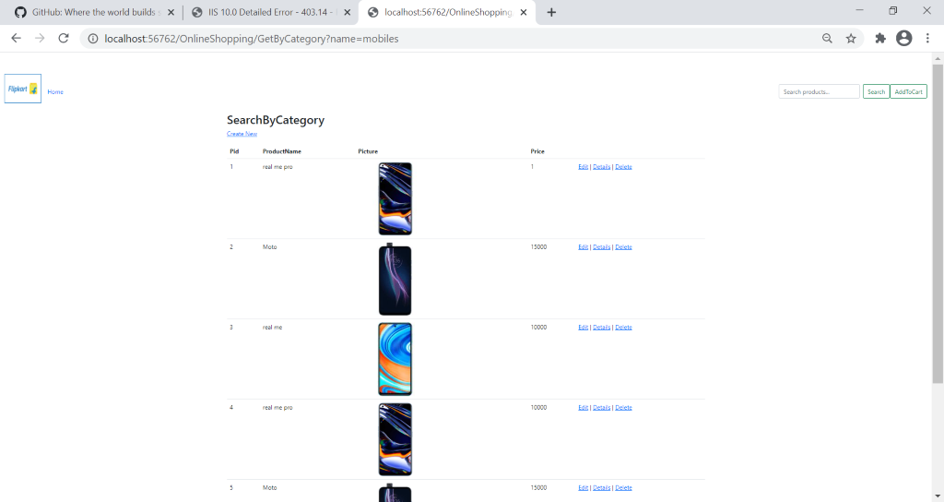

**ProductDetailsPage:**

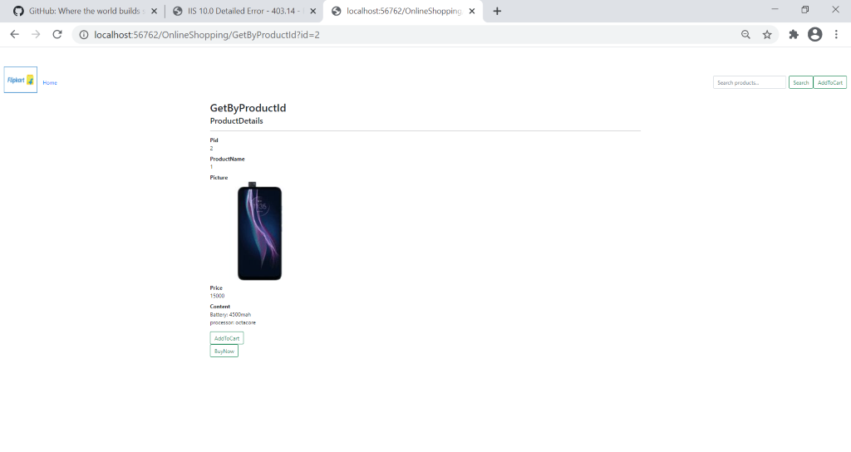

**AddToCart Page:**

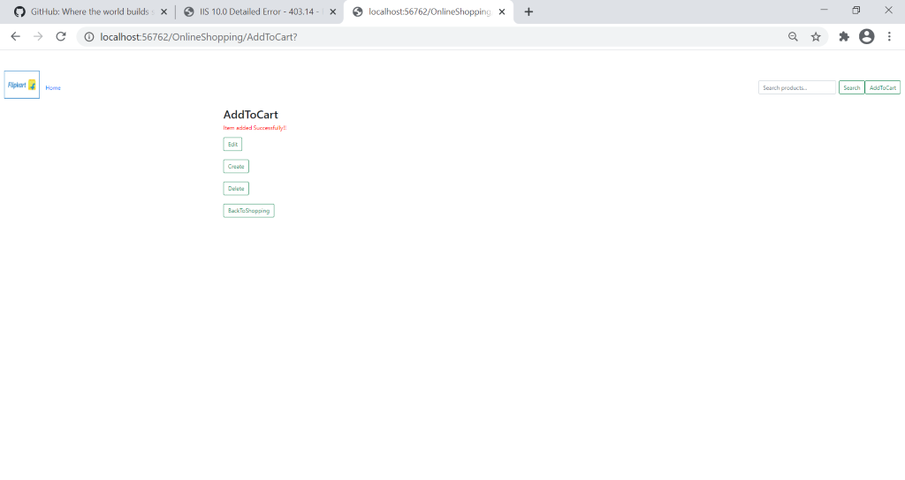

**Confirmation Page:**

