COMPARATIVE FINANCIAL ANALYSIS
OF LEADING INDIAN BANKS
ICICI Bank | HDFC Bank | Axis Bank | State Bank of India
Financial years 2024-25 and 2025-26
________________________________________________________________________________
Executive Summary
This project compares four major Indian banks using profitability, core interest income, asset quality and operating efficiency indicators. The analysis uses FY2024-25 and FY2025-26 standalone figures gathered from bank annual reports, audited results and investor disclosures. Microsoft Excel was used to organize the dataset, calculate year-on-year growth, rank the banks across seven metrics and visualize selected comparisons.
The results show that SBI recorded the highest FY26 net profit and the strongest net-profit growth in the group, while ICICI Bank recorded the highest net interest income (NII) growth. HDFC Bank had the lowest FY26 gross NPA ratio and cost-to-income ratio. ICICI Bank ranked first under the project’s simple equal-weight scoring method, narrowly ahead of HDFC Bank. This score is a learning tool, not a definitive measure of overall bank quality.
HIGHEST PROFIT GROWTH  SBI  12.88% | HIGHEST NII GROWTH  ICICI Bank  8.51%
LOWEST GNPA  HDFC Bank  1.15% | TOP PROJECT SCORE  ICICI Bank  13 points
Prepared as a student finance project | Tool used: Microsoft Excel

1. Objective, Scope and Methodology
Objective. To compare the FY25-FY26 financial performance of ICICI Bank, HDFC Bank, Axis Bank and SBI using a small set of indicators that a beginner can calculate and explain in an internship interview.
Scope. The project focuses on seven metrics across four dimensions: profitability, core interest income, asset quality and operating efficiency. Net profit and NII are compared over two years; ratios are recorded for both years where available. Monetary amounts are in ₹ crore, and ratio figures are percentages.
Method. Raw figures were placed in a dedicated Excel sheet and linked to an Analysis sheet. Growth was calculated as (FY26 value − FY25 value) ÷ FY25 value × 100. The banks were ranked on seven metrics, assigning Rank 1 to the strongest result for each measure. The seven ranks were added to create an overall score, where a lower total is better.
Metrics used
Metric | Meaning | How to interpret
Net Profit | Profit after expenses, provisions and tax; indicates total earnings. | Higher is generally better; absolute totals reflect bank size.
Net Interest Income (NII) | Interest earned minus interest paid. | Higher growth can indicate stronger core interest income.
Return on Assets (ROA) | Profit relative to average assets. | Higher generally indicates stronger asset profitability.
Return on Equity (ROE) | Profit relative to shareholders’ equity. | Higher generally means higher accounting return on equity.
Gross NPA (GNPA) | Gross non-performing loans as a share of gross advances. | Lower generally indicates better asset quality.
Net NPA (NNPA) | Net non-performing loans after relevant provisions and adjustments, relative to net advances. | Lower generally indicates lower residual problem-loan exposure.
Cost-to-Income | Operating costs relative to operating income, as reported by each bank. | Lower generally indicates better operating efficiency.
Data comparability note
The study uses bank-reported standalone figures. Ratio definitions, averaging conventions and presentation can differ between institutions, so cross-bank comparisons should be treated as indicative. The equal-weight ranking is deliberately simple and does not incorporate bank size adjustments, capital adequacy, liquidity, business mix, risk-adjusted returns or market valuation.

2. Financial Performance and Growth
Table 1 compares net profit and net interest income. Growth values are calculated from the FY25 and FY26 values used in the workbook. SBI FY25 NII is ₹1,66,340 crore, matching the FY26 annual report’s comparative figure.
Bank | Net Profit  FY25 | Net Profit  FY26 | NP Growth | NII  FY25 | NII  FY26 | NII Growth
ICICI Bank | 47,227 | 50,147 | 6.18% | 81,165 | 88,075 | 8.51%
HDFC Bank | 67,347.4 | 74,671.3 | 10.87% | 122,670.1 | 128,686.0 | 4.90%
Axis Bank | 26,373 | 24,457 | -7.27% | 54,348 | 56,048 | 3.13%
SBI | 70,901 | 80,032 | 12.88% | 166,340 | 173,120 | 4.08%
Note: Monetary values are ₹ crore. HDFC values retain one decimal place as reported in the project dataset; other displayed figures are rounded to whole crore.
What the growth figures indicate
- SBI had the highest FY26 net profit at ₹80,032 crore and the fastest profit growth at 12.88%.
- ICICI Bank posted the strongest NII growth at 8.51%, increasing from ₹81,165 crore to ₹88,075 crore.
- HDFC Bank’s net profit grew by 10.87%, while NII increased by 4.90%.
- Axis Bank’s NII increased by 3.13%, but net profit declined by 7.27%. The dataset alone does not identify the cause; expenses, provisions, taxes and non-interest income would need further review.
Growth formula
Growth (%) = (FY26 − FY25) ÷ FY25 × 100

3. Ratio Comparison
The table below shows FY25 → FY26 for return, asset-quality and operating-efficiency ratios. Values are percentages as reported in the project dataset.
Bank | ROA (%) | ROE (%) | GNPA (%) | NNPA (%) | Cost-to-Income (%)
ICICI Bank | 2.40 → 2.32 | 17.95 → 15.97 | 1.67 → 1.40 | 0.39 → 0.33 | 38.64 → 39.75
HDFC Bank | 1.91 → 1.94 | 14.56 → 14.30 | 1.33 → 1.15 | 0.43 → 0.38 | 40.50 → 38.00
Axis Bank | 1.74 → 1.45 | 16.52 → 13.15 | 1.28 → 1.23 | 0.33 → 0.37 | 47.10 → 47.90
SBI | 1.10 → 1.12 | 19.87 → 18.57 | 1.82 → 1.49 | 0.47 → 0.39 | 51.64 → 50.11
Arrow shows FY25 → FY26. For GNPA, NNPA and Cost-to-Income, a downward movement is generally favourable; for ROA and ROE, an increase is generally favourable, although context matters.
Interpretation
- ICICI Bank recorded the highest FY26 ROA (2.32%) and the lowest NNPA ratio (0.33%) among the four banks. Its ROA declined from FY25 and its cost-to-income ratio increased, so its results are strong but not uniformly improving.
- HDFC Bank had the lowest FY26 GNPA (1.15%) and cost-to-income ratio (38.00%). Its GNPA, NNPA and cost-to-income ratio all improved year on year in the dataset.
- SBI recorded the highest FY26 ROE (18.57%), but also the lowest ROA (1.12%) and highest GNPA and NNPA ratios in this four-bank sample.
- Axis Bank’s ROA and ROE declined while GNPA improved slightly and NNPA increased. These mixed signals show why several ratios should be read together rather than in isolation.
Why the ratios complement profit growth
Net profit and NII are absolute amounts affected by the size and business mix of a bank. ROA and ROE scale profit against assets and equity; GNPA and NNPA give an indication of credit quality; and cost-to-income gives an operating-efficiency perspective. No single ratio is sufficient to judge a bank.

4. Comparative Charts
The charts summarize the key comparisons in the Excel workbook. Figures are based on the selected standalone FY25-FY26 dataset.
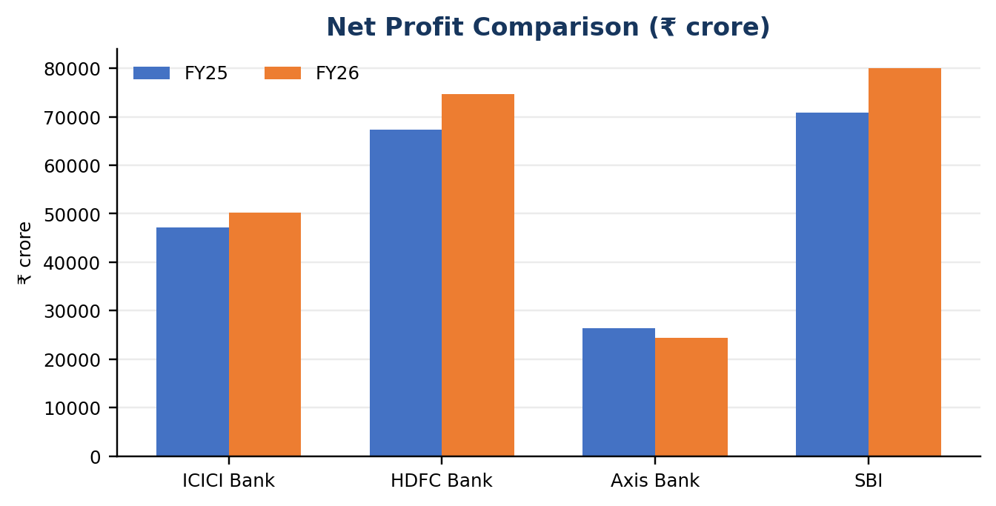 | 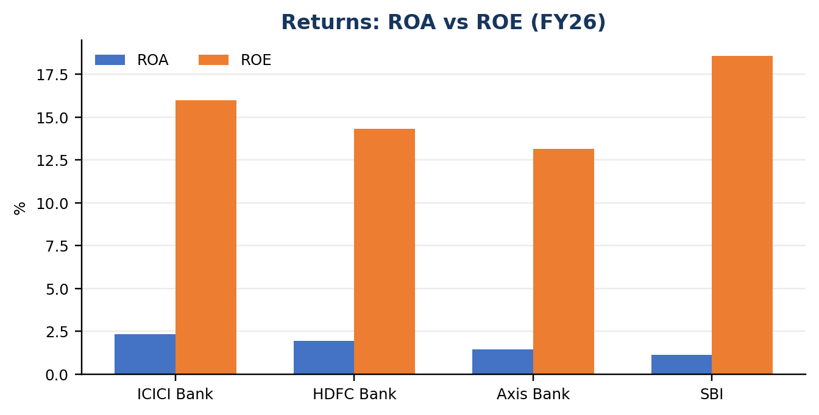
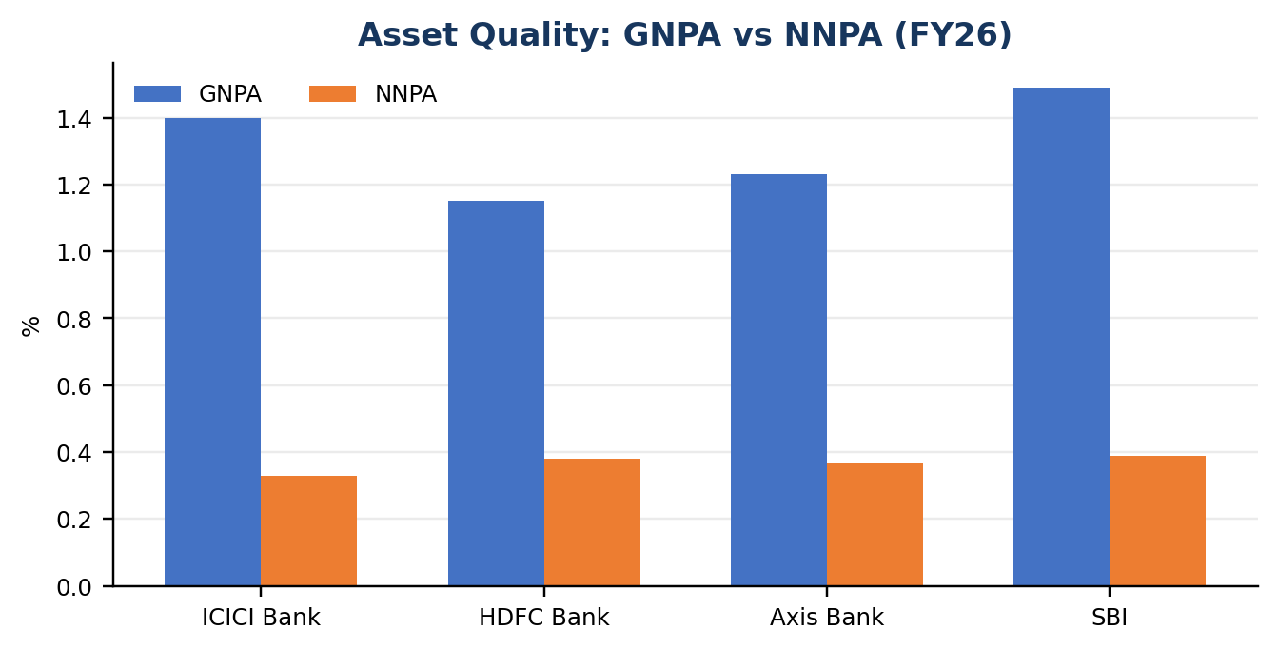 | 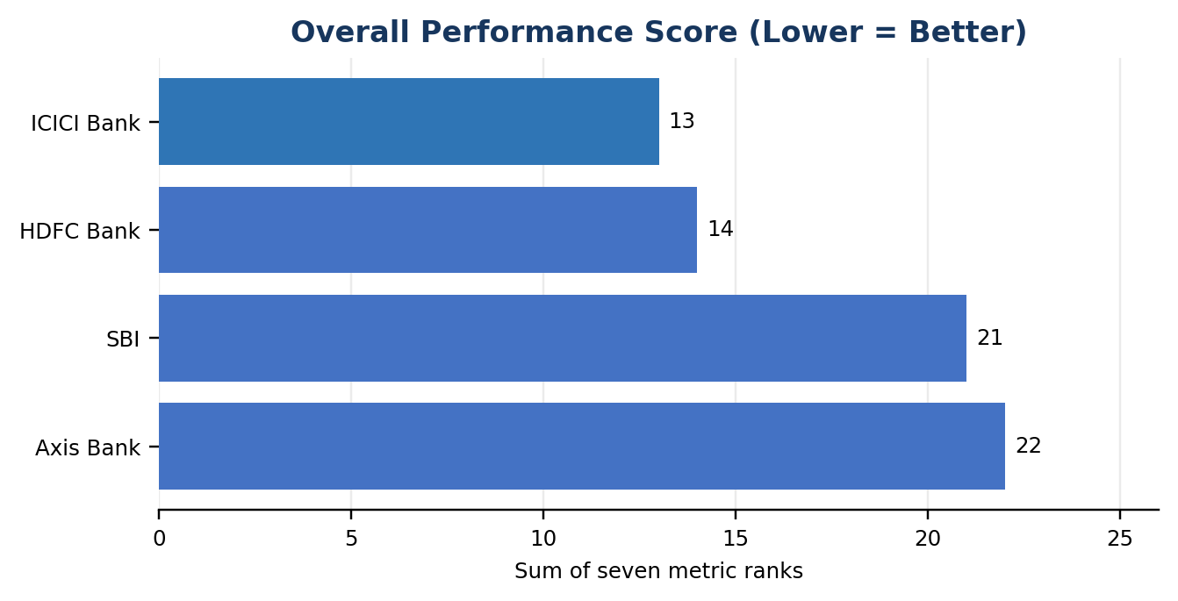
Reading the charts: the net-profit chart compares year-end annual totals; the ROA/ROE chart uses a shared percentage axis, so ROA bars appear smaller; and the score chart is explicitly labelled “Lower = Better.”
Overall ranking score
Rank | Bank | Overall Score
1 | ICICI Bank | 13
2 | HDFC Bank | 14
3 | SBI | 21
4 | Axis Bank | 22
The score is the sum of seven ordinal ranks: ROA, ROE, GNPA, NNPA, cost-to-income, net-profit growth and NII growth. Each metric has equal weight. The result should be interpreted as an exploratory classroom comparison, not a formal credit rating or investment recommendation.

5. Key Findings and Conclusion
1. SBI: profit scale and growth: Highest FY26 net profit (₹80,032 crore) and profit growth (12.88%); weaker FY26 ROA and comparatively higher NPA ratios temper the picture.
2. ICICI: strong core-income growth: Highest NII growth (8.51%), highest ROA (2.32%) and lowest NNPA (0.33%); however, ROA eased and cost-to-income increased versus FY25.
3. HDFC: asset quality and efficiency: Lowest FY26 GNPA (1.15%) and lowest cost-to-income (38.00%); it ranked second overall, only one point behind ICICI.
4. Axis: mixed performance: NII grew 3.13% while net profit fell 7.27%; investigating provisions, operating costs, taxes and other income would be the next analytical step.
5. Composite ranking favoured ICICI: ICICI (13 points) ranked ahead of HDFC (14), SBI (21) and Axis (22) under this project’s equal-weight rank-sum method.
Limitations
This is a small descriptive comparison of four banks over two financial years. It does not assess liquidity, capital adequacy, credit costs in detail, business mix, macroeconomic conditions, risk-adjusted returns or market valuation. Reported ratio definitions may differ. The rank-sum score uses equal weights and can hide differences in the importance of individual measures. Figures were transcribed into the workbook from the bank disclosures listed below; the workbook’s source column should retain the exact report and relevant page/section for every metric.
Conclusion
The comparison illustrates that bank performance has multiple dimensions. SBI was strongest on profit scale and profit growth, ICICI on NII growth and selected return/asset-quality measures, and HDFC on GNPA and cost-to-income. ICICI obtained the lowest total rank score under the project’s chosen method, with HDFC close behind. These findings support a structured peer comparison, while also showing why conclusions should be qualified and supported by consistent definitions and primary-source checks.
Primary sources
• ICICI Bank — FY2026 annual reports and March 2026 performance review — Official report / results; related disclosure
• HDFC Bank — FY2026 annual reports and financial results — Official report / results; related disclosure
• Axis Bank — Integrated Annual Report FY2025-26 — Official report / results
• State Bank of India — Annual Report FY2025-26 and Q4FY26 analyst presentation — Official report / results; related disclosure
Report prepared 10 October 2026. This project is for educational purposes and is not investment advice.

