SIMPLE ONLINE LEAVE SYSTEM
A Project Report
Submitted by
RAMA KRISHNA-AP23110011655
LOKESH-AP23110011576
REDDY BABU-AP23110011579
NAVEEN-AP23110011585

Under the Supervision of
Dr. Rajesh Yelchuri
Assistant Professor
Department of Computer Science and Engineering
SRM University-AP
In partial fulfilment for the requirements of the Web Technology(CSE210) Project
BACHELOR OF TECHNOLOGY
IN
COMPUTER SCIENCE AND ENGINEERING


DEPARTMENT OF COMPUTER SCIENCE AND ENGINEERING
SRM UNIVERSITY-AP
NEERUKONDA
MANAGALAGIRI - 522503
ANDHRA PRADESH, INDIA
APRIL-2025

CERTIFICATE
This is to certify that the project work entitled “SIMPLE ONLINE LEAVE SYSTEM” is a Bonafide record of project work carried out by the following students:
- Mr. RAMAKRISHNA (Roll No.: AP23110011655)
- Mr. LOKESH (Roll No.: AP23110011576)
- Mr. REDDY BABU (Roll No.: AP23110011579)
- Mr. NAVEEN (Roll No.: AP23110011585)

from the Department of Computer Science and Engineering, SRM University-AP. The students conducted this project work under my supervision during the period January 2025 to April 2024.It is further certified that, to the best of my knowledge, this project has not previously formed the basis for the award of any degree or any similar title to this or any other candidate.
This is also to certify that the project work represents the teamwork of the candidates.

Station: Mangalagiri Dr. Rajesh Yelchuri

Date: Assistant Professor
Department of Computer Science & Engineering
SRM University-AP
Andhra Pradesh.

TABLE OF CONTENTS

S. NO. | TITLE | PAGE NO.
1 | Introduction | 4
2 | Problem Definition | 5
3 | Problem Statement | 6
4 | Objectives | 7-8
5 | Software Requirements Specifications | 9-11
6 | Design (DFD Diagram) | 12
7 | Implementation | 13-17
8 | Database Design | 18-19
9 | Output Screenshots | 20-26

Introduction
In the modern digital era, the management of organizational tasks and employee records has significantly shifted from traditional paperwork to automated systems. One of the crucial aspects of human resource management is handling employee leave requests. Manual leave tracking methods are often prone to errors, delays, and lack of transparency, which can hinder productivity and lead to discrepancies in records.
To address these challenges, this Online Leave Management System has been developed using PHP and MySQL. This web-based application provides a streamlined solution that allows users to apply for leaves online and enables administrators to manage these requests with ease. The system is designed to improve operational efficiency, reduce administrative workload, and ensure accurate leave tracking.
The application is structured into two main user roles: User and Admin. Users can submit leave applications by providing essential details such as name, department, leave dates, and reasons. These applications are stored in a centralized database and are displayed in the admin panel for review. Admins have the authority to approve or reject leave requests and can monitor all employee leave records from a single interface.
By automating the leave request and approval workflow, this system not only enhances user experience but also ensures that organizations maintain proper records and transparency. It serves as a scalable solution suitable for institutions of all sizes, paving the way for a more organized and accountable work environment.
With the increasing demand for remote work and decentralized teams, the necessity for such automated systems has grown manifold. An online leave management platform ensures that regardless of the physical location of employees or administrators, the process remains uninterrupted and accessible 24/7. Moreover, by incorporating user-friendly interfaces and real-time updates, the system promotes self-service and empowers employees to take charge of their own leave planning. It also aids administrators in maintaining compliance with organizational policies by providing detailed insights into leave trends, usage statistics, and employee availability—ultimately fostering a more disciplined and transparent work culture.
Problem Definition
In any organization, managing employee leave requests is a recurring and critical administrative task. Traditionally, this process is handled manually through paper-based forms or spreadsheet entries, which often leads to numerous challenges. These methods are time-consuming, inefficient, and error-prone. They lack real-time updates, are difficult to track over time, and make it hard to maintain a reliable history of leave records. Miscommunication, lost forms, and unauthorized leaves are common issues that can disrupt workflow and negatively impact productivity.
Moreover, as organizations scale, the complexity of managing leaves across departments and teams increases. Without a centralized and structured system in place, administrators often struggle to coordinate leave schedules, especially during peak periods or when multiple employees apply for leave simultaneously. This lack of coordination can lead to understaffing, operational delays, and even employee dissatisfaction due to delayed approvals or unclear leave balances.
There is also a lack of transparency and accountability in manual systems. Employees do not always have a clear view of their leave status or history, and managers may not have sufficient data to make informed decisions. Additionally, generating reports or summaries from manual records is a tedious task that requires significant time and effort.
To overcome these issues, there is a pressing need for a robust and user-friendly Online Leave Management System. Such a system should allow employees to apply for leaves online, track their leave history, and view the status of their applications in real time. At the same time, it should empower administrators with tools to review, approve, or reject leave requests, maintain leave records systematically, and generate reports with minimal effort. By digitizing and automating the leave management process, organizations can enhance efficiency, improve transparency, and ensure better resource planning.

Problem Statement
Efficient management of employee leaves is a fundamental aspect of any organization’s human resource operations. However, many organizations, especially small to medium enterprises, still rely on traditional manual methods for handling leave requests. These may include the use of handwritten applications, email threads, or spreadsheet-based tracking systems. While these approaches may seem manageable for a small workforce, they quickly become cumbersome, error-prone, and inefficient as the number of employees increases.
Manual leave management processes are plagued by several critical issues. Firstly, they are time-consuming for both employees and administrators. Employees must physically submit forms or send emails and then follow up for approval updates. Administrators, on the other hand, must manually record, calculate, and update leave balances, leading to a higher risk of miscalculations and data loss. These inefficiencies often result in delays in processing leave requests, which can lead to dissatisfaction among employees and affect overall productivity.
Secondly, traditional systems lack transparency and real-time communication. Employees often do not have access to up-to-date information about their remaining leave balances or the status of their pending applications. This lack of visibility can lead to confusion and conflicts, especially during critical periods like holidays or when multiple team members apply for leave simultaneously. Additionally, managers may find it difficult to assess employee availability or make informed decisions without an accurate, centralized database of leave records.
Moreover, without an automated system, generating reports and analyzing leave patterns becomes a laborious task. Organizations may miss out on valuable insights that could help in strategic planning, such as identifying departments with frequent absenteeism or optimizing staffing during peak workloads.
In light of these challenges, there is a pressing need to design and implement an Online Leave Management System that automates the entire process. The system should allow employees to easily apply for leave through a user-friendly web interface, while providing administrators with powerful tools to manage requests, track leave balances, and maintain accurate records. Such a solution will not only streamline operations and reduce administrative burden but also enhance transparency, accountability, and employee satisfaction across the organization.

Objectives
The primary objective of this project is to develop a web-based Online Leave Management System using PHP and MySQL that simplifies and automates the process of applying for, approving, and managing employee leave requests. The system aims to reduce manual workload, improve accuracy in record-keeping, and enhance transparency within the organization. Below are the detailed objectives that this project seeks to achieve:
1. Automate Leave Application and Approval Workflow
To eliminate the traditional paper-based system by providing an online platform where employees can submit leave requests, and administrators can review, approve, or reject them with ease.
2. Real-Time Leave Status Tracking
To enable employees to check the status of their leave requests (pending, approved, or rejected) in real-time, reducing the need for continuous follow-ups and ensuring transparency.
3. Centralized Leave Records Management
To maintain a secure, centralized database that stores all leave-related data, including employee details, leave types, history of applications, and current balances.
4. Role-Based Access Control
To implement a login system with different roles—Admin and Employee—ensuring that users access only the features and data relevant to their roles.
5. Reduce Administrative Workload
To minimize the manual effort involved in leave tracking, approval, and record maintenance, allowing HR personnel and managers to focus on higher-level tasks.
6. Generate Analytical Reports
To provide the admin with tools to generate reports based on leave data, helping in decision-making, workload planning, and identifying attendance patterns.
7. User-Friendly Interface
To design an intuitive, easy-to-navigate user interface that allows users with minimal technical knowledge to operate the system effectively.
8. Improve Organizational Efficiency
To ensure a smoother workflow across departments by providing clarity on employee availability and reducing conflicts due to overlapping leaves or miscommunication.
9. Ensure Data Integrity and Security
To implement basic security measures that protect sensitive user information and ensure the accuracy and consistency of stored data.
10. Scalability for Future Enhancements
To build the system in a modular fashion so it can be easily extended in the future to include features like notifications (email/SMS), calendar integration, multi-department management, or mobile accessibility.

Software Requirements Specification (SRS)
1. Functional Requirements
- User Authentication
  - Secure login/logout system for Admin and Employee roles.
  - Role-based access to functionalities.
- Leave Application Module (Employee Side)
  - Fill and submit a leave request with fields: name, department, leave dates, and reason.
  - View status of requests (Pending/Approved/Rejected).
  - Access leave history.
- Leave Management Module (Admin Side)
  - Dashboard displaying all submitted leave requests.
  - Option to approve, reject, or mark as pending.
  - Add/edit employee profiles.
  - View and manage leave records for each employee.
- Notification System
  - Basic status update messages on leave request actions.
  - (Optional for future enhancement) Email notification integration.
- Reporting
  - Generate reports for employee leave history.
  - Export leave data for audit or analysis.

2. Non-Functional Requirements
- Usability
  - Clean and responsive UI, minimal training required.
- Performance
  - Response time under 2 seconds per request on standard hardware.
- Security
  - Session-based access control.
  - Basic input validation and SQL injection prevention.
- Maintainability
  - Modular code structure for easy updates and scalability.
- Portability
  - Compatible with major browsers and cross-platform server environments.

3. Software Requirements
Category | Description
Frontend | HTML5, CSS3, JavaScript
Backend | PHP (version 7 or higher)
Database | MySQL (or MariaDB as an alternative)
Web Server | Apache (via XAMPP, WAMP, or LAMP stack)
Operating System | Windows/Linux (any OS supporting Apache-PHP stack)
Browser | Chrome, Firefox, Edge (latest versions)

4. Hardware Requirements
Component | Minimum Specification
Processor | Dual Core 2.0 GHz or higher
RAM |  | 02 GB (4 GB recommended)
Storage | 500 MB available disk space
Display | 1024x768 resolution or higher

5. System Constraints
- Single-department structure (multi-department not supported yet).
- No integration with external calendar or payroll APIs.
- Accessible only within the network or via hosted server.
- No support for mobile optimization in current version.

Design (DFD Diagram)
Here is the Data Flow Diagram (DFD) for the Online Leave Management System project. It outlines the interaction between the Employee, Admin, and the Leave Management System, showing how leave requests are handled, including approval and tracking of leave statuses.

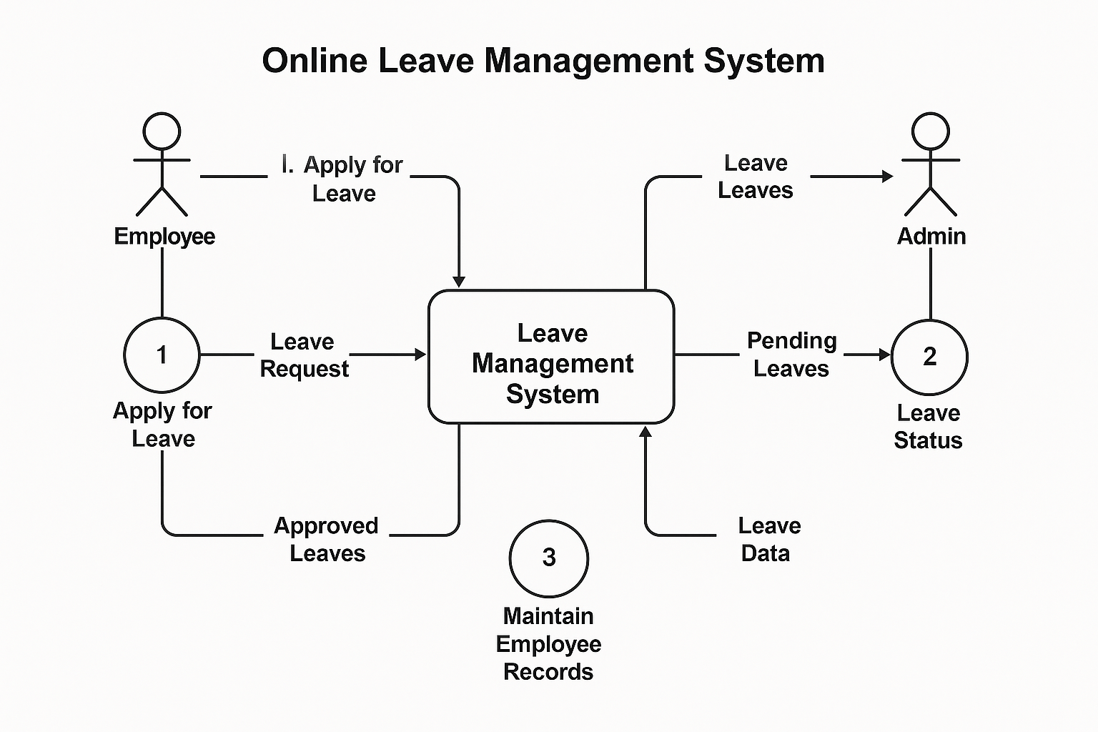

Implementation
providing a clean and functional interface for two user types: Admin and Employee. The system has been developed using PHP and MySQL, with basic frontend technologies such as HTML and CSS for structure and style. Below is a detailed explanation of how each module and component has been implemented.
The implementation of the Simple Online Leave Management System focuses on
1. Database Implementation
The backend data management is handled using MySQL, and the database is named simpleave. It consists of two primary tables:
- users Table
  - Stores login credentials and user roles.
  - Fields: id, email, password, role (admin/employee), name, department.
- leaves Table
  - Stores leave applications submitted by employees.
  - Fields: leave_id, user_id, leave_date, reason, status (Pending, Approved, Rejected), applied_on.
The database is designed to maintain referential integrity, where each leave request is linked to a specific employee via the user_id foreign key.
A ‘.sql ’ file is provided for importing the schema and initial data using phpMyAdmin.

2. Authentication and User Login
Authentication is implemented using PHP Sessions and secure form handling.
- Login Process:
  - A single login form (index.php) allows both Admin and Employee to log in using their credentials.
  - After form submission, the entered email and password are checked against the users table.
  - Based on the user's role (admin or employee), the system redirects the user to the appropriate dashboard.
  - PHP session variables ($_SESSION['user_id'], $_SESSION['role']) are set upon successful login to maintain user state.
- Security Measures:
  - Passwords are stored in plain text for simplicity in this project but can be hashed using password_hash() for production.
  - Input validation is added to prevent SQL injection (via mysqli_real_escape_string or prepared statements).

3. Employee Module Implementation
Once an employee logs in, they are directed to employee-dashboard.php, which displays a welcome message and available options like applying for leave or viewing leave history.
a. Leave Application Form
- Implemented in apply-leave.php.
- The form includes fields for:
  - Name (auto-filled from session)
  - Department (auto-filled)
  - Leave Date (Date input)
  - Reason (Text-area input)
- On submission, the form data is sent to process-leave.php, where:
  - Input validation is performed.
  - A new row is inserted into the leaves table with status set as "Pending".

b. Leave History
- Implemented in view-leaves.php.
- This page queries the database for all leave requests made by the logged-in employee.
- A dynamic table shows:
  - Leave date
  - Reason
  - Status (Pending/Approved/Rejected)
- Statuses are color-coded for better visualization (e.g., green for approved, red for rejected).

4. Admin Module Implementation
Admin users are redirected to admin-dashboard.php after logging in. The admin has elevated privileges to manage leave requests.
a. View Leave Applications
- The admin dashboard lists all leave requests from all employees in a tabular format.
- The table includes:
  - Employee Name
  - Department
  - Leave Date
  - Reason
  - Status
  - Action buttons (Approve/Reject)
b. Manage Requests
- Each row in the admin table contains two buttons: Approve and Reject.
- On clicking either button:
  - A PHP script (update-leave-status.php) is called via a GET or POST request.
  - This script updates the corresponding record in the leaves table by changing the status field.
  - The database is then refreshed and the updated status is shown immediately.
c. Admin Tools
- Admin can filter leave requests by status or employee.
- Future enhancements could include adding/deleting users, department-wise reports, and export functionality.

5. Frontend Interface
The interface has been developed using basic HTML and CSS, ensuring it is lightweight and responsive for various devices.
- Navigation Bar: Appears at the top of each dashboard, showing navigation links and a logout button.
- Forms: Simple and clean layout using standard HTML form elements.
- Tables: Leave records are displayed in HTML tables with border styling and alternating row colors for clarity.
- Status Badges: Custom CSS is used to display the leave status in color-coded badges (e.g., .badge-approved { color: green; }).

6. Database Connectivity
All scripts requiring database interaction use a centralized configuration file: config.php.

Sample Code in config.php:
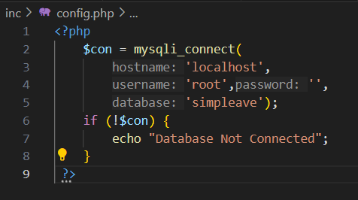
- This file is included at the beginning of every PHP script that interacts with the database.
- Error handling ensures that the application fails gracefully if the database is unreachable.

7. Logout and Session Management
- A logout button is provided on each dashboard.
- When clicked, it triggers logout.php which:
  - Destroys the current session using session_destroy()
  - Redirects the user back to the login page (index.php)

Database Design
Database Name: simpleave
1. Table: admin
Column | Data Type | Description
id | INT (PK, AI) | Unique ID foradmin
name | VARCHAR(255) | Admin's name
email | VARCHAR(255) | Admin email (for login)
password | VARCHAR(255) | Hashed admin password
Primary Key: id
Password hash: Likely MD5 (D00F...)

2. Table: users (Employees)
Column | Data Type | Description
id | INT (PK, AI) | Unique user ID
name | VARCHAR(255) | Employee full name
department | VARCHAR(255) | Department the user belongs to
email | VARCHAR(255) | Employee email (for login)
password | VARCHAR(333) | Hashed password (MD5 used here)
Primary Key: id
Note: All employees have role = employee by default since no explicit role field is present.

3. Table: leaves
Column | Data Type | Description
id | INT (PK, AI) | Unique leave request ID
name | VARCHAR(255) | Name of employee (not normalized)
email | VARCHAR(255) | Email of employee (not normalized)
department | VARCHAR(255) | Department name (duplicate of users)
leavedate | DATE | Date for leave
leavereason | VARCHAR(255) | Reason for leave (stored as HTML)
status | INT(1) | Leave status: 0 = Pending, 1 = Approved
Primary Key: id
Data Redundancy Note: The leaves table duplicates data from users (name, email, department) instead of using a user_id. This design works but is not normalized.

Data Relationships Summary
- admin: Used only for login; no direct connection to leaves.
- users: Each user can have multiple leave requests.
- leaves: Linked by matching name/email with users (but no foreign key is enforced in schema).

Output Screenshots:
Student Login:
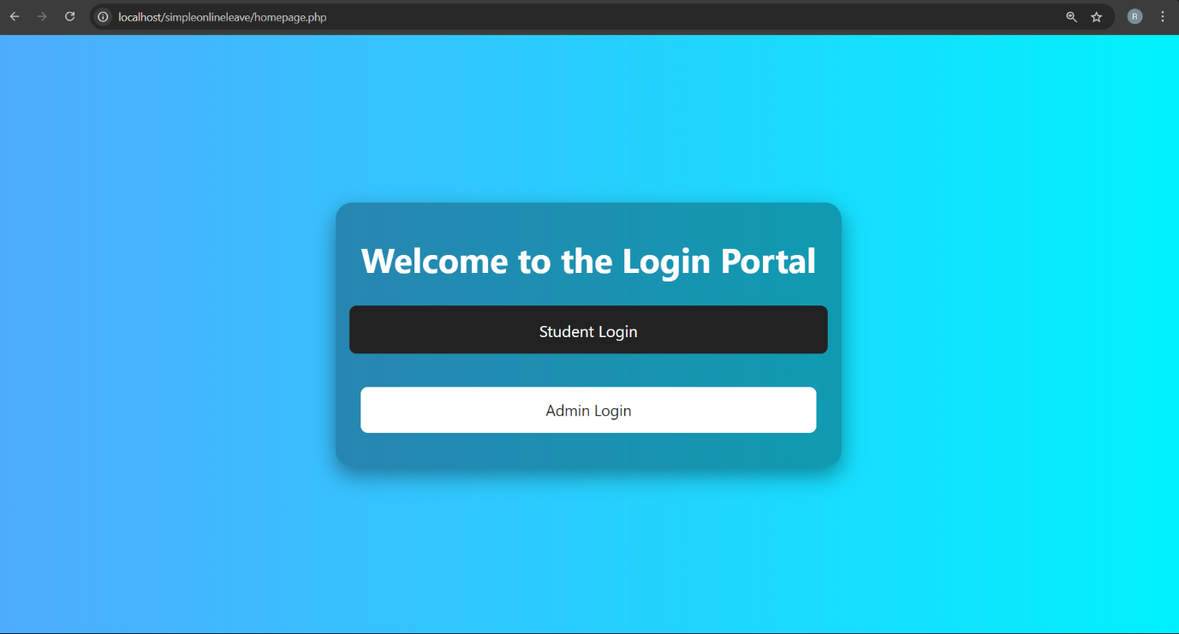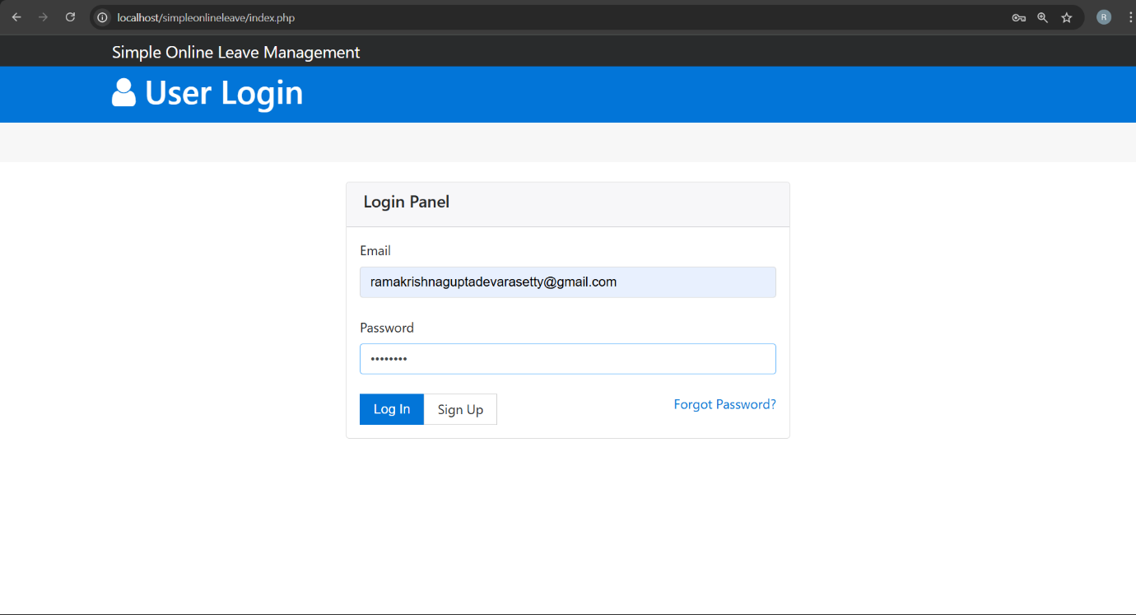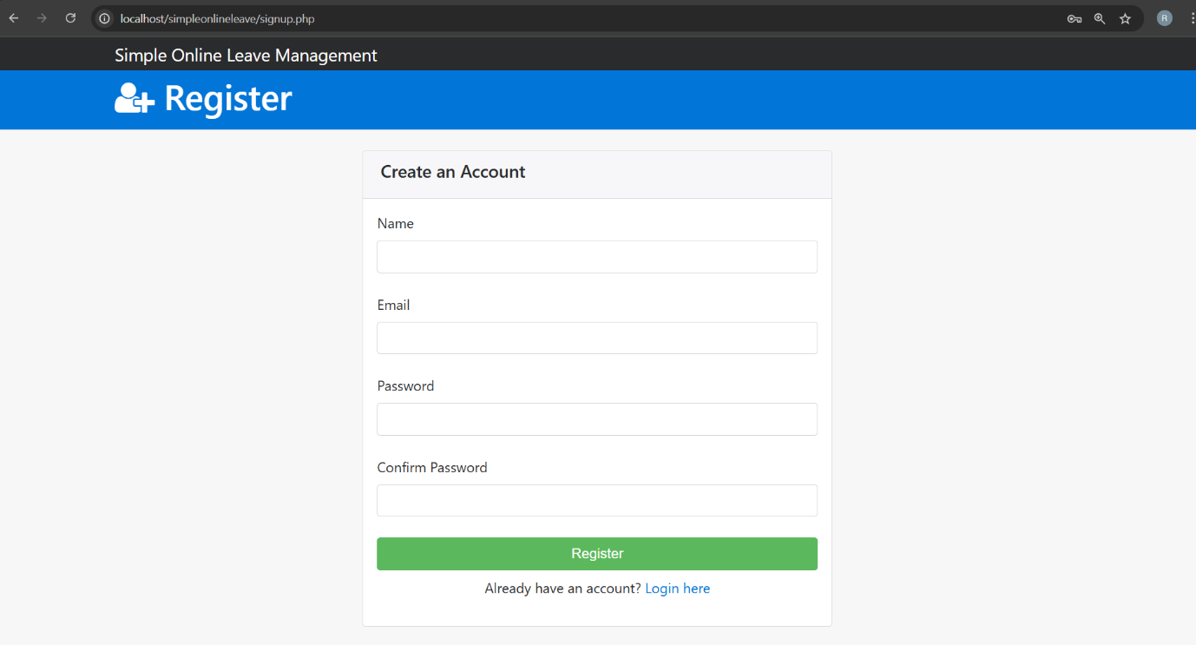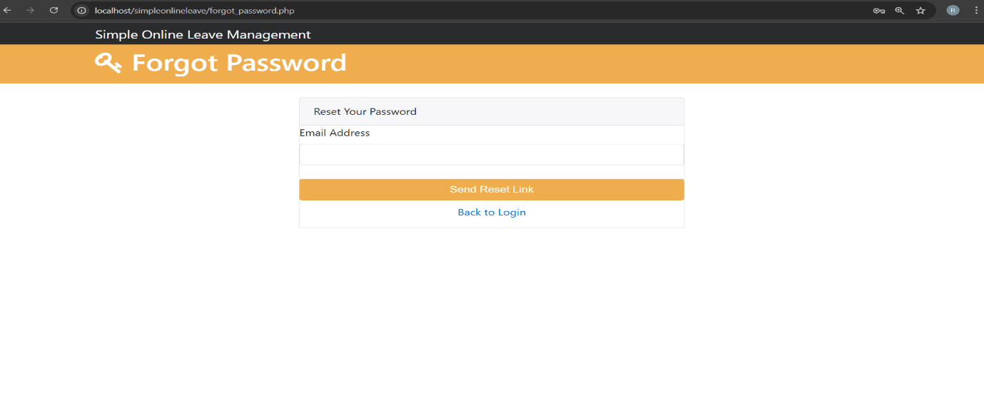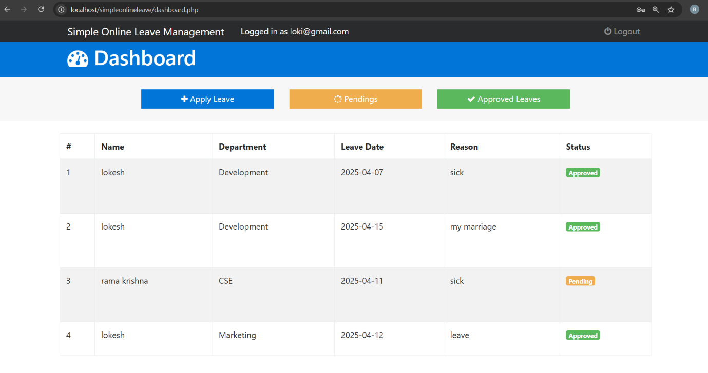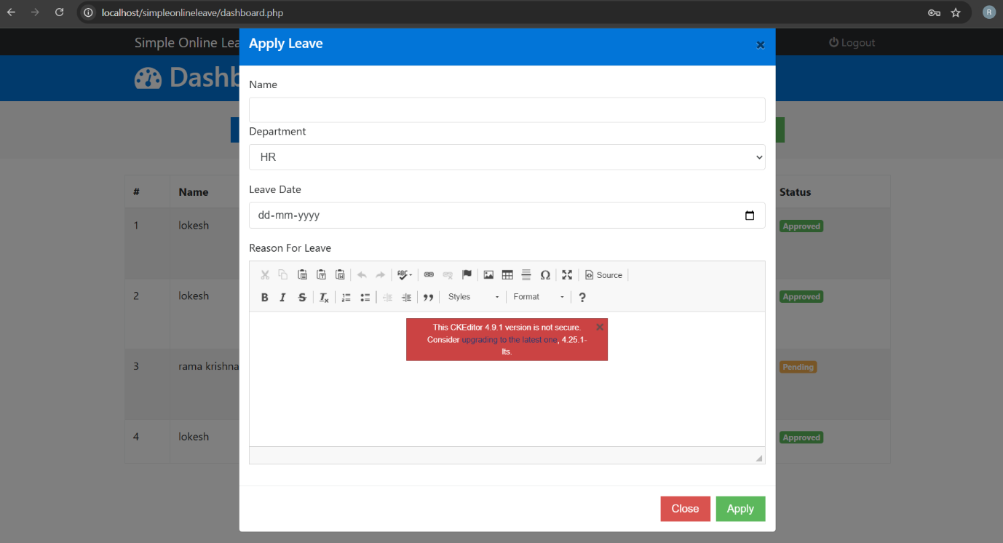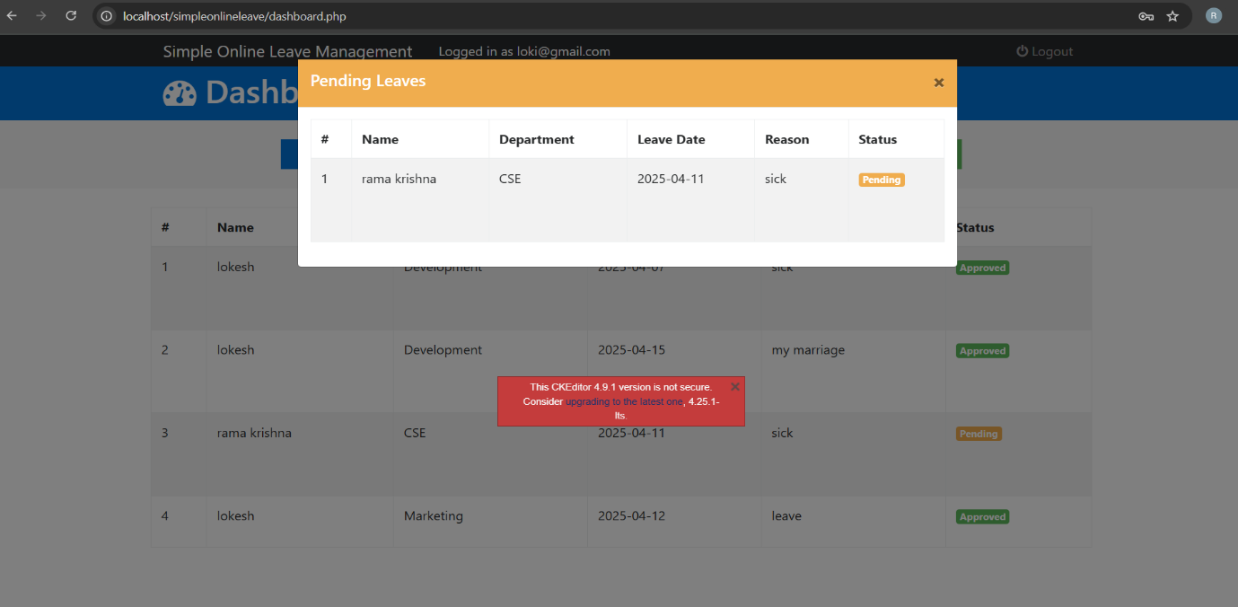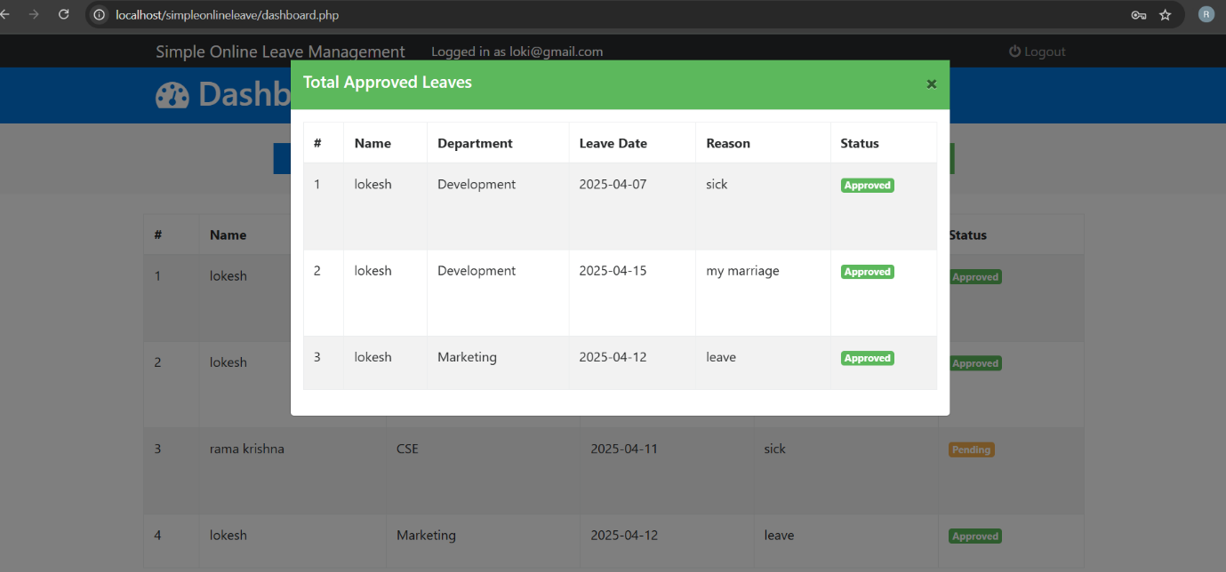
Admin Login:
