**INNOVATION LAB PROJECT REPORT**

**ON**

**Model Calculations Solver**

*A project report submitted in partial fulfilment of the requirement for the award of the degree of*

**BACHELOR OF TECHNOLOGY**

in

**CHEMICAL ENGINEERING**

BY

P. PRANEETH SRINIVAS (19CH10004)

Y. PAVAN KIRAN (19CH10022)

M. VINAY KUMAR (19CH10034)

A.S.L. GANNESH (19CH10036)

M. RAMAKRISHNA (19CH10044)

**UNDER THE GUIDANCE OF**

DR. DIPANKAR PAL



INDIAN INSTITUTE OF PETROLEUM AND ENERGY

VISAKHAPATNAM

SEPTEMBER 2022

**Indian Institute of Petroleum and Energy**,

**Vishakhapatnam**

**Certificate**

Certified that this is a bonafide record of project work entitled “Model Calculations Solver” being submitted by “ASL Gannesh (19CH10036)”, in partial fulfillment for the award of the degree of “Bachelor Of Technology” in CHEMICAL ENGINEERING, Indian Institute of Petroleum and Energy, Vishakhapatnam during the academic year 2019-2023.

Dipankar Pal

Department of Chemical Engineering

**Acknowledgment**

With profound sense of regard and gratitude I would like to thank to my Project mentor Dr. Dipankar Pal for his immense guidance and support throughout the project.

I would also like to thank my team mates M Ramakrishna, Y Pavan Kiran, M Vinay Kumar, P Praneeth Srinivas to their support throughout the project.

|  |  |  |
| --- | --- | --- |
| **S. No** | **Table of contents** | **Page No** |
| **1** | Introduction | **5** |
| **2** | Motivation | **5** |
| **3** | Problem Statement | **5** |
| **4** | Design and Fabrication of Prototype | **6** |
| **5** | Working of Prototype | **6** |
| **6** | Technologies and Software used | **6** |
| **7** | Software Specification | **7-9** |
| **8** | Sample Screenshots | **10-13** |
| **8** | Conclusion and future aspects | **14** |
| **9** | References | **14** |

**1. INTRODUCTION**

We discovered that performing model calculations for at least 5 different readings is time-consuming and inefficient because, after your initial model calculation, you have to repeat the same steps once more. This observation was made while conducting experiments on heat transfer and particle technology in our fifth semester of chemical engineering. Furthermore, it was challenging for us to find a reliable source from which we could compare our results and determine whether they were accurate or not. Therefore, we developed this website so that users may quickly and simply solve all calculations. We did this for certain experiments that were on our syllabus (the names of the experiments are provided below).

**Heat Transfer Experiments:**

1. Emissivity Measurement Apparatus
2. Counter Flow Double Pipe Heat Exchanger
3. Heat Flow Through Composite Wall

**Particulate Technology Experiments:**

1. Sampling
2. Time of Grinding
3. Effectiveness of Trommel

**2. MOTIVATION**

One of our seniors made a website on model computations for laboratory experiments. This concept of developing a website inspired us. Even if MS Excel is available to us, there are some drawbacks to its student usage. Our website was created primarily to meet the needs of lab experiments for students. Free access, a simple design, usability, and accurate results are a few benefits.

**3. PROBLEM STATEMENT**

The main motto of this project is to save time and increase efficiency of results while performing lab calculations.

**3. DESIGN AND FABRICATION OF PROTOTYPE**

**Design:** We have designed our website such that it takes the required inputs from the user and provides valid outputs in the form of tables, graphs and values within few seconds.

**Development:** To structure and design a layout, we utilised HTML and CSS. For computations and to make the webpage interactive, we used JavaScript. Graphs are generated by utilizing CanvasJS API. We used Visual Studio Code to write the code and Git for tracking code changes.

**Implementation**: We have created .html files and .js files for every individual experiment and index.html for home page. A external style sheet (.css) has been created for styling. Each page consists of input elements which take input from the user and upon clicking on “calculate” button, generates the necessary output in the form of tables, graphs and final result. Home page consists of links to every experiment.

**Deployment:** We have deployed the wesbite on github pages.

**Cross Browser Testing:** We have tested it on various devices – (Mobile, Tab, PC) and browsers (Chrome, Firebox and Mozilla).

**Verification:** Using the values from our observation notebook, we tested our website for all of our lab experiments

**4. WORKING OF PROTOTYPE**

We have developed the webpage as per requirements of this project. We have also implemented, executed and tested the webpage on various experimental values and found that the results are accurate enough.

**Testing**

* All field entries must be valid to pass the test.
* The specified link needs to be used to activate the pages.
* Delays on the entering screen, messages, or responses are not acceptable.

**Testable features**

* Check to see that the entries are in the right format.
* Entries that are invalid shouldn't be accepted.
* Each and every link should direct users to the appropriate page.

**Results of the tests**: All of the aforementioned test scenarios were successful. There were no faults found.

**5. TECHNOLOGIES AND SOFTWARE USED**

* HTML, CSS, Bootstrap and JavaScript
* Visual Studio Code, Git & Github

**6. SOFTWARE SPECIFICATION**

1. **HTML (HYPER TEXT MARKUP LANGUAGE)**:

It is a standard markup language used to build web pages. HTML is written in HTML elements, which are simply tags contained in angle brackets, like <html>. HTML tags usually include pairs like "<h1>" and "</h1>" although some tags, like "<img>" represent empty elements and are therefore not paired. The opening tag is the first of a pair of tags, while the closing tag is the end tag (they are also called opening tags and closing tags). It is recommended practise to add a slash to tags that are not linked with a closing tag, while it is not always necessary.

A web browser's job is to read HTML files and merge them into visible or audible appealing web pages. Although the HTML tags are not displayed by the browser, they are used to interpret the page's content. HTML is a markup language rather than a programming language since it provides presentation cues along with semantic descriptions of the structure of a website.

All webpages are constructed using HTML elements. HTML enables the embedding of objects and images, and it can be used to develop interactive forms. It provides a method for creating structured documents by defining structural semantics for text elements including headers, paragraphs, quotes, links and other objects. It has the ability to embed scripts that modify the behaviour of HTML web pages and are written in languages like JavaScript.

1. **CSS (CASCADING STYLE SHEETS):**

It is style sheet language that is used to describe the appearance a document created in a markup language, including formatting. Any type of XML document, including plain XML, SVG, and XUL, can be styled using this language. However, it is most typically used to style HTML and XHTML-based web pages and interfaces.

Most web pages utilise CSS style sheets to describe how they are presented since CSS is a key web specification.

The main purpose of CSS is to make it possible to separate a document's content from its presentation, which includes things like the layout, colours, and fonts. This division can increase the accessibility of the content, give the specification of presentation features greater flexibility and control, allow multiple pages to share formatting, and minimize the complexity and duplication of the structural content.

The same HTML page can also be rendered using several rendering techniques using CSS is accessible in a variety of ways, such as on-screen, in print, verbally (when read out loud by a screen reader or browser with speech recognition), and on Braille-based tactile devices. Additionally, depending on the screen size or viewing device, it can be used to enable the web page to appear differently. Readers can override the style sheet that the author has specified by using a different style sheet, possibly one that is on their own computer, even if the author normally links a document to a CSS file. However, the default style of the browser will be used if the author or reader did not link the document to a specific style sheet.

1. **JAVASCRIPT:**

The Web's primary programming language is JavaScript. JavaScript is used on every modern HTML page. A lightweight programming language is a scripting language. Every type of web browser can run JavaScript code, which may be placed into any HTML page. Learning JavaScript is easy.

**Why JavaScript is useful**

One of the three languages that every web developer should master is JavaScript.

1. Using HTML to specify web page content
2. Using CSS to determine web page layout
3. JavaScript to specify the behavior of web pages

**Example**

x = document.getElementById("result");  //Find the HTML element with id="result"  
x.innerHTML = "This is JavaScript";     //Change the content of the HTML element

document.getElementById() is one of the most commonly used HTML DOM methods.

***Other applications for JavaScript include:***

* Deleting HTML components
* Adding new HTML elements
* Copying HTML elements
* JavaScript is a set of HTML declarations that the web browser can execute.

**7. SAMPLE SCREENSHOTS**

*Sampling*

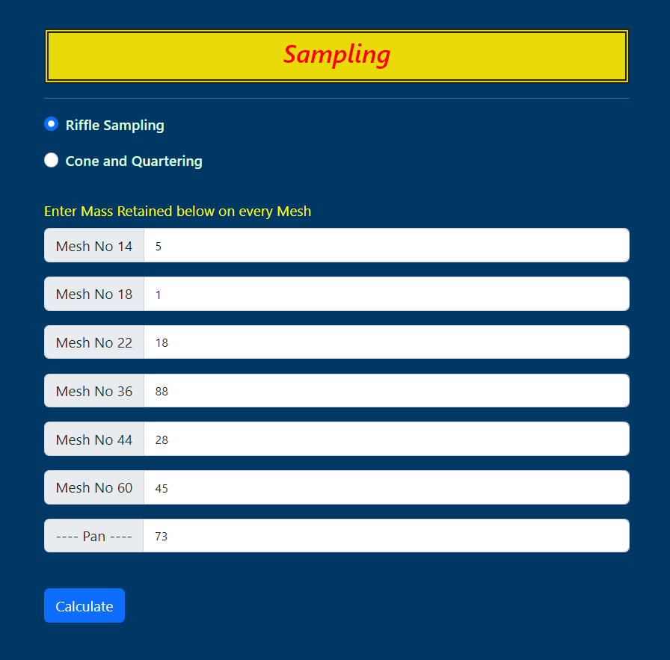

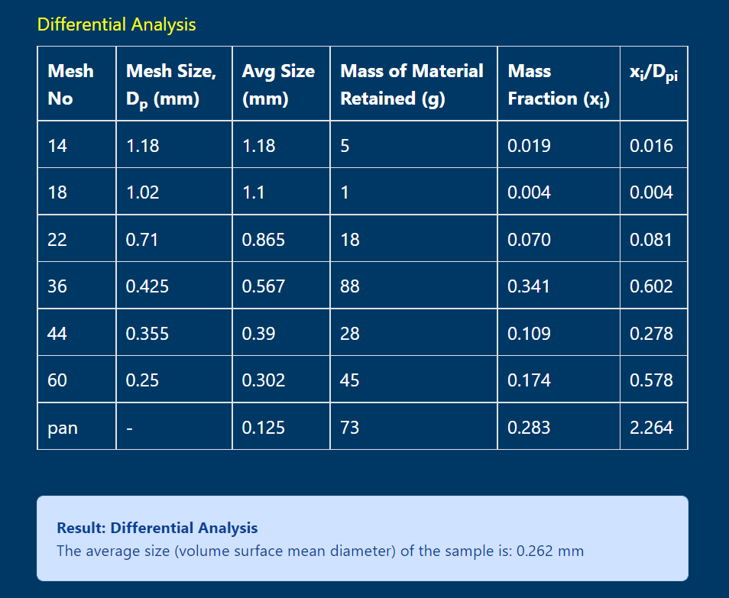

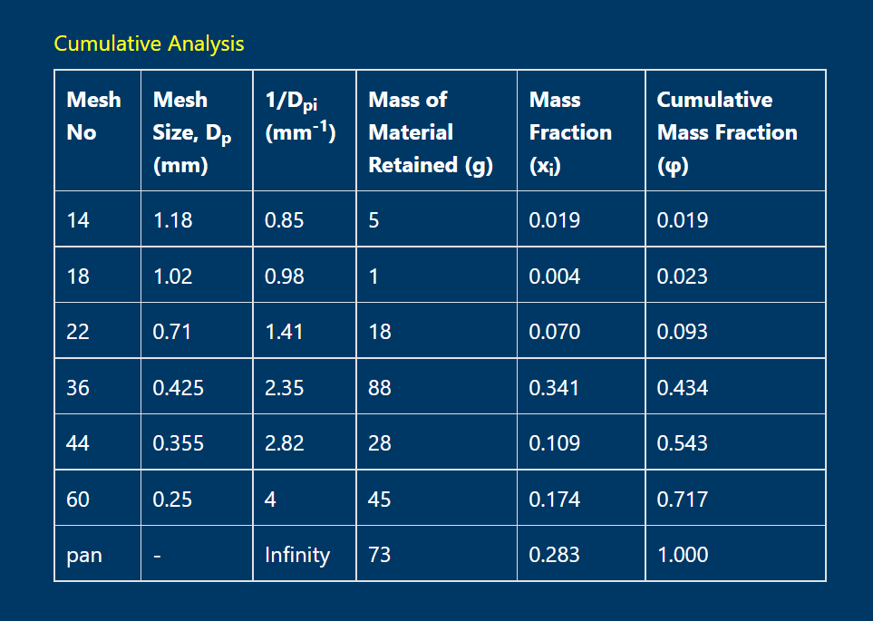

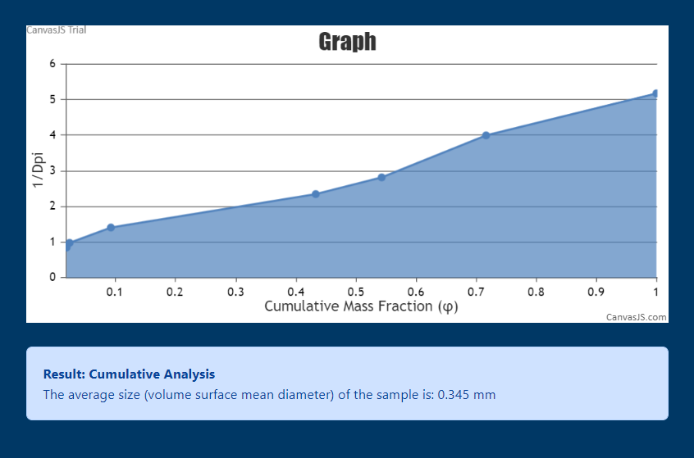

*Counter flow Double Pipe Heat Exchanger*

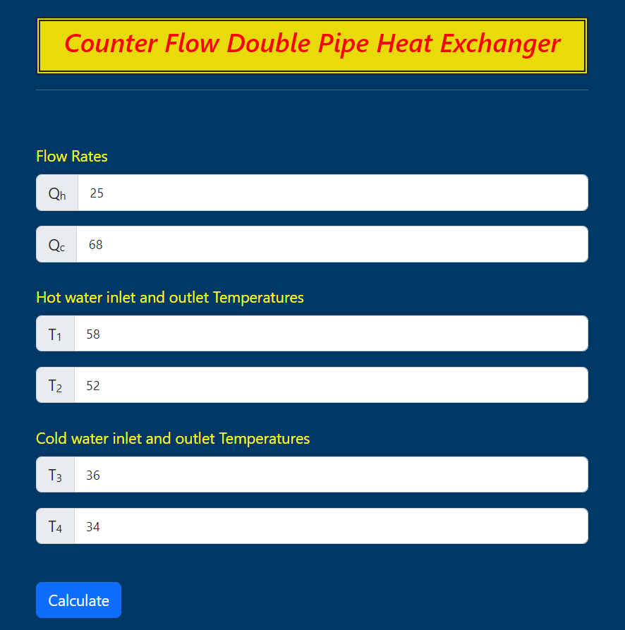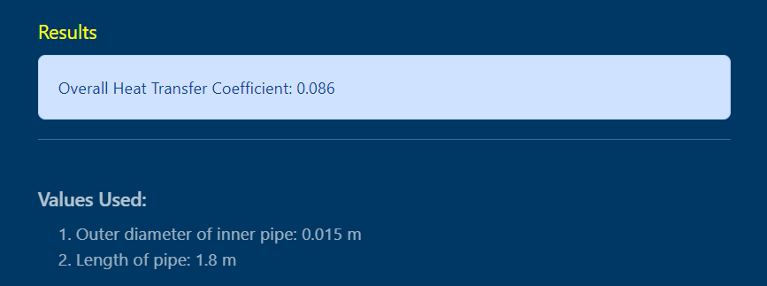

**8. CONCLUSION AND FUTURE ASPECTS**

We are happy to say that our website is working as efficient as we anticipated and generating accurate results for every experiment immediately after entering observation values.

Our senior had initiated the idea of creating a webpage of model calculations with fluid lab experiments. Now we extended this idea by developing the website for Heat Transfer and Particle Technology lab experiments. This website can be further extended for Instrumentation and Process control, Mass transfer, Chemical Reaction Engineering lab experiments.

**9. REFERENCES**

1. <https://github.com/rohit-bindal/FluidLab>/
2. <https://getbootstrap.com/>
3. <https://canvasjs.com/>
4. <https://stackoverflow.com/>­­­