

INT 301 – Open Source Technologies

CA3 Project Report

On

Using any Open-Source Software display advanced information on

internal and external hardware, also display operating system details; save report in a simple text file.

Submitted by

Name: Sathi ST Rama Krishna Reddy

Reg.No: 11903574

Under the Guidance of

Rajeshwar Sharma Sir

School of Computer Science & Engineering,

Lovely Professional University,

Phagwara

(April 2023)

**Index**

1. Introduction

1.1 Objective of the project

1.2 Description of the project

1.3 Scope of the project

1. System Description
   1. Target system description

3. Analysis Report

* 1. System snapshots and full analysis report

1. Bibliography
2. Github Link

Chapter-1

# Introduction

## Objective:

Using any open-source software in Linux for displaying all the information related to hardware and

operating system using command line inputs. The entire output should be saved in a single text file and output should be saved on text file and display it.

## Description:

Open-source software refers to software whose source code is freely available and can be modified and distributed by anyone. Source code always part of software mostly users won’t see it. The programmers who are having the accessibility can only change the source code others can’t. Linux is the first open- source software that was released. Usage of Linux open-source software has many benefits they are

transparency, collaboration, customization, cost-savings, innovation and many more. Linux has become one of the most popular open-source operating systems in the world, with many distributions available to suit different needs and preferences. Some of the most popular Linux distros include Ubuntu, Debian, Fedora, and CentOS.

There are several open-source software programs that can display advanced information on hardware and operating system, providing users with a detailed insight into their computer's specifications and configuration. Here are some examples:

Hwinfo: This open-source software is a comprehensive hardware information and diagnostic tool that provides detailed information about the hardware components in a system. It is available for Linux and other operating systems and is widely used by system administrators, technicians, and power users.

CPU-Z: This open-source software can display detailed information about the CPU, including its clock speed, voltage, and temperature. It can also provide information about the motherboard, memory, and graphics card.

Hardinfo: This open-source system profiler and benchmark tool can provide detailed information on hardware and operating system, including CPU, memory, storage, and network interfaces. It also has a benchmark tool for measuring system performance.

Sysinfo: This open-source software can provide a comprehensive overview of the system, including hardware, software, and network information. It can also display real-time system performance data.

lshw: This open-source command-line tool can provide detailed information on the hardware configuration of the system, including CPU, memory, storage, and network interfaces.

inxi: This open-source command-line tool can display detailed information on the system hardware and software configuration, including CPU, memory, storage, and graphics card.

## Scope:

The scope of open-source software displaying hardware and operating system information is quite broad and encompasses a wide range of tools and applications. Such software can provide a variety of

information about the hardware and software configuration of a computer, including processor information, memory information, storage information, network information, operating system

information and many more. Open-source software for displaying hardware and operating system

information can be useful for a variety of purposes, including system administration, hardware upgrades, troubleshooting, and performance optimization. For example, system administrators can use such software to monitor server performance, identify bottlenecks, and troubleshoot issues. End-users can use them to check system specifications, diagnose hardware problems, and optimize system

performance. Some examples of popular open-source software programs for displaying hardware and operating system information include Hwinfo, Hardinfo, Sysinfo, lshw, inxi, CPU-Z, and hwinfo as

mentioned above. These programs can be run on various operating systems such as Linux, Windows, and macOS.

**Chapter-2**

# System Description

## Target system description:

An open-source software display of hardware and operating system is a system that allows users to view detailed information about the hardware components and operating system of their computer. This type of system typically utilizes open-source software, which means that the source code is freely available and can be modified and redistributed by anyone. The display of hardware information typically includes details about the CPU, RAM, storage devices, and other hardware components installed in the computer. This information can be useful for troubleshooting hardware issues, checking system requirements for software, and determining upgrade options. The display of operating system information typically

includes details about the version of the operating system, installed updates, and system settings. This information can be useful for diagnosing software issues, checking compatibility with other software, and optimizing system performance.

**Chapter-3**

# Analysis Report

## System snapshots and full report:

**3.1.1**

There are many open-source software in Linux for displaying hardware and operating systems but now in this “Hwinfo” is used for objectives.

Hwinfo is a command-line utility that provides detailed information about the hardware components of a computer system. This tool can be very useful for system administrators, IT professionals, and other users who need to know the technical specifications of their hardware. The hwinfo utility can display a

wide range of information about the system's hardware, including the processor, memory, motherboard, storage devices, network interface cards, and more. It can also provide information about the current status and configuration of these hardware components.

To use hwinfo, you first need to install it on your Linux system. On most Linux distributions, you can

install hwinfo using your package manager. For example, on Ubuntu and other Debian-based systems, you can install hwinfo by running the following command in a terminal:

sudo apt-get install hwinfo

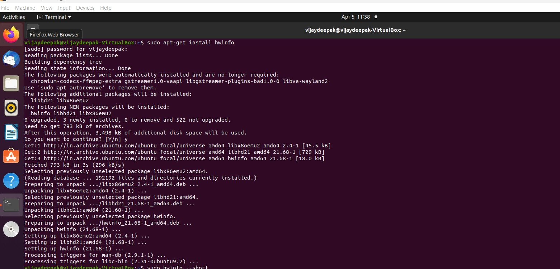

Hwinfo is a popular hardware information and diagnostic tool that can be used in Linux operating systems. It provides a wide range of commands that can be used to gather information about the hardware components of a system. Here are few of the commonly used commands:

hwinfo –cpu hwinfo –disk

hwinfo netcard hwinfo –usb

hwinfo monitor hwinfo –sound hwinfo –all

hwinfo –short

hwinfo –arch and many more.

These are just some of the commands available with hwinfo in Linux. By using these commands, users can gather valuable information about the hardware components of their system, which can be useful for troubleshooting, maintenance, and upgrades.

Now, the command for displaying the information of hardware and operating system: sudo hwinfo –short

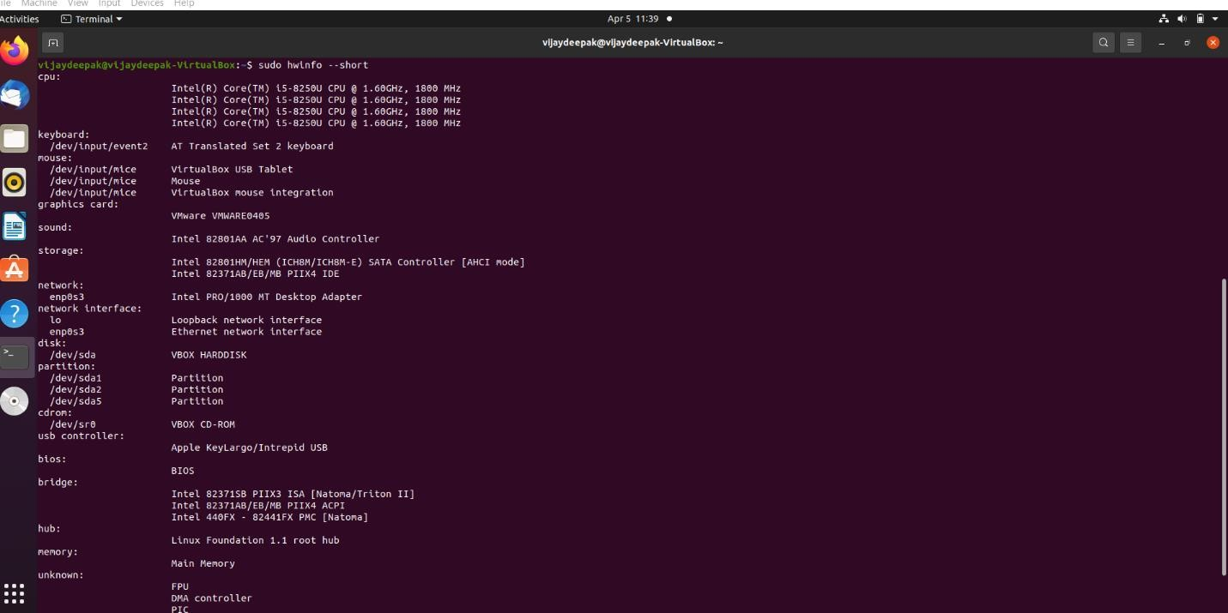

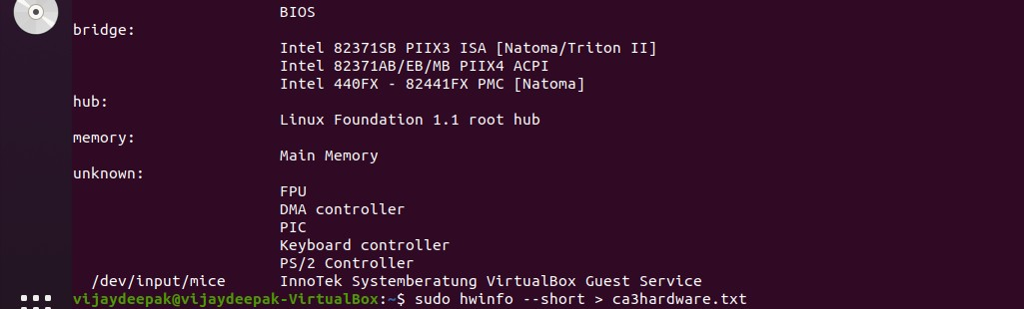

As the information is displayed using on screen using above command in command line prompt. Now for storing entire information into a single text file is “command > filename.txt”. As in above pic the command written to save the output into a text file.

sudo hwinfo –short > ca3hardware.txt

Now, displaying the text file where the information is stored using cat command, gedit command, nano command. Cat command will display the information on command line itself but nano and gedit will open a text file for displaying information.

cat filename

nano filename

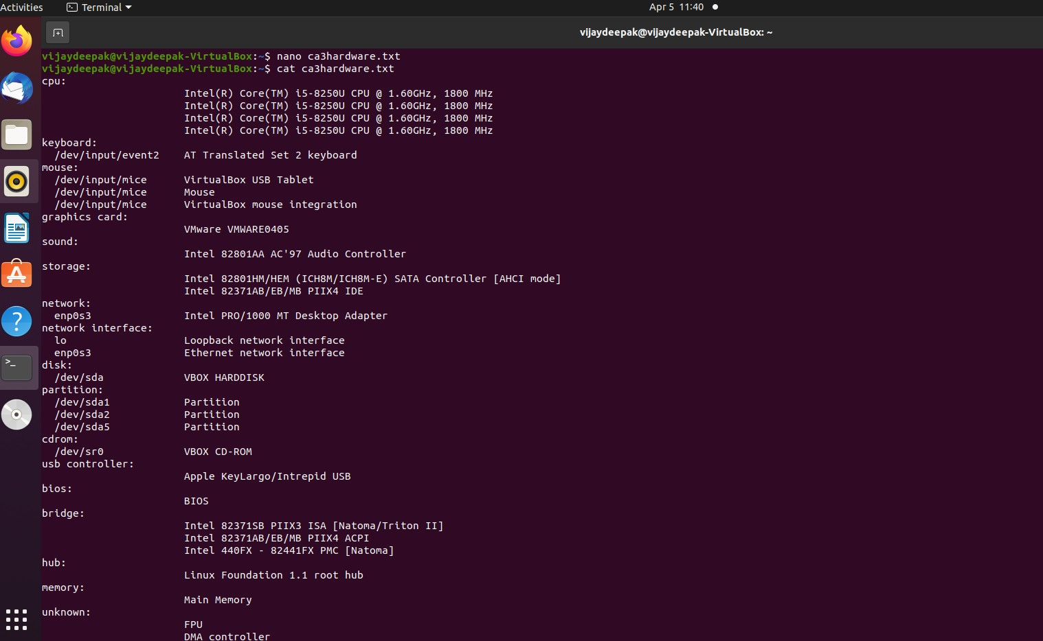

As the command displays same information where we seen in sudo hwinfo –short command.

## 3.1.2

Suppose for example if we see the another open-source software that is “inxi” for displaying the information in Linux.

For install: sudo apt-get install inxi

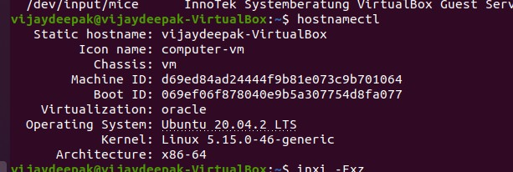

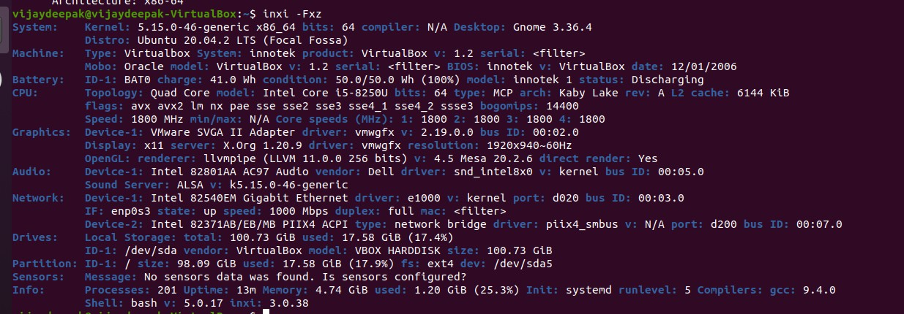

Hostnamectl and inxi -Fxz are used to display the information about hardware and operating system in Linux. As it displays system, machine, battery, cpu, graphics, drives, partition, info and others.

**Chapter-4**

# Bibliography

<https://ostechnix.com/find-linux-system-hardware-information-with-hwinfo/>

<https://opensource.com/resources/what-open-source>

**Chapter-5**

**Github link:** <https://github.com/ramakrishna-sathi/CA-3-INT-301>