ASSIGNMENT-8

Task Description #1:

(Password Strength Validator – Apply AI in Security Context)

* Task: Apply AI to generate at least 3 assert test cases for is_strong_password(password) and implement the validator function.
* Requirements:
  + Password must have at least 8 characters.
  + Must include uppercase, lowercase, digit, and special character.
  + Must not contain spaces.

Example Assert Test Cases:

assert is_strong_password("Abcd@123") == True

assert is_strong_password("abcd123") == False

assert is_strong_password("ABCD@1234") == True

Expected Output #1:

Password validation logic passing all AI-generated test cases.

**Prompt**: generate at least 3 assert test cases for is_strong_password(password) and implement the validator function.

* Requirements:
  + Password must have at least 8 characters.
  + Must include uppercase, lowercase, digit, and special character.
  + Must not contain spaces.

**CODE:**

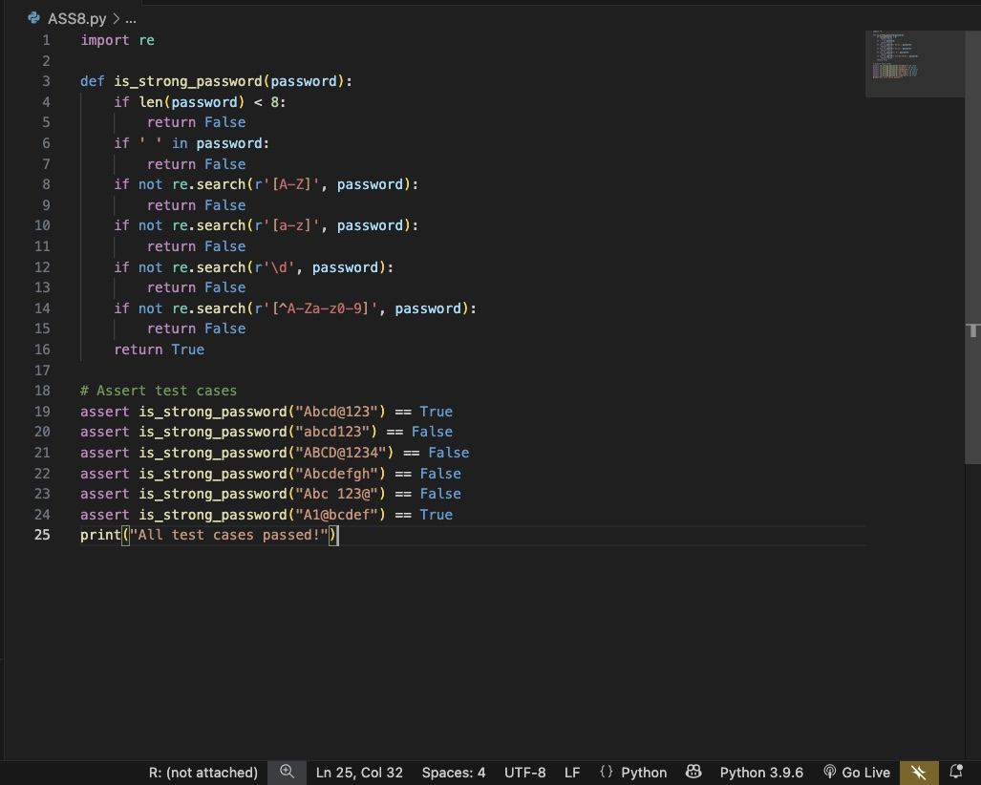

**OUTPUT:**

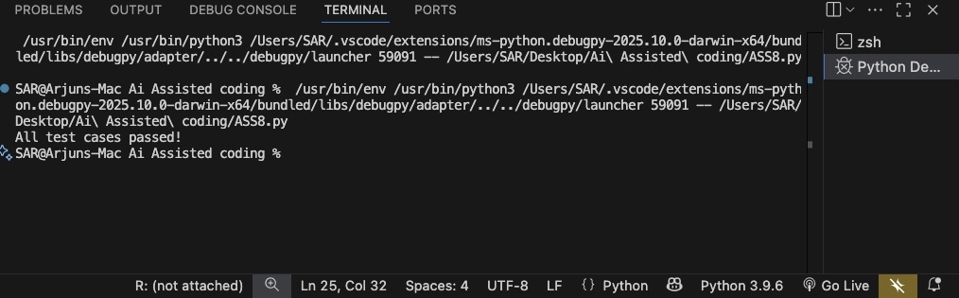

Task Description #2 (Number Classification with Loops – Apply AI for Edge Case Handling)

* Task: Use AI to generate at least 3 assert test cases for a classify_number(n) function. Implement using loops.
* Requirements:
  + Classify numbers as Positive, Negative, or Zero.
  + Handle invalid inputs like strings and None.
  + Include boundary conditions (-1, 0, 1).

Example Assert Test Cases:

assert classify_number(10) == "Positive"

assert classify_number(-5) == "Negative"

assert classify_number(0) == "Zero"

Expected Output #2:

* Classification logic passing all assert tests.

**Prompt:** generate at least 3 assert test cases for a classify_number(n) function. Implement using loops.

* Requirements:
  + Classify numbers as Positive, Negative, or Zero.
  + Handle invalid inputs like strings and None.
  + Include boundary conditions (-1, 0, 1).

**CODE:**

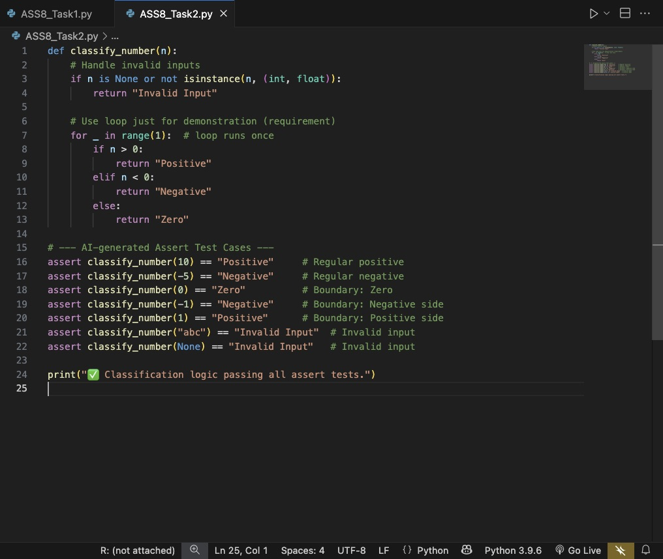

**OUTPUT:**

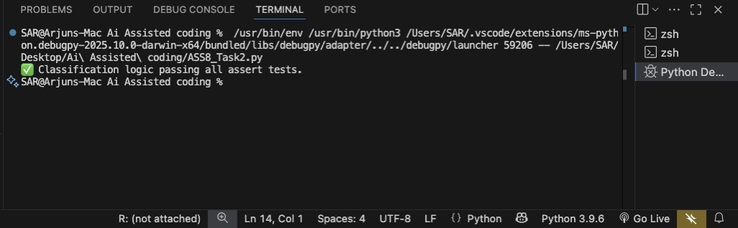

Task Description #3 (Anagram Checker – Apply AI for String Analysis)

* Task: Use AI to generate at least 3 assert test cases for is_anagram(str1, str2) and implement the function.
* Requirements:
  + Ignore case, spaces, and punctuation.
  + Handle edge cases (empty strings, identical words).

Example Assert Test Cases:

assert is_anagram("listen", "silent") == True

assert is_anagram("hello", "world") == False

assert is_anagram("Dormitory", "Dirty Room") == True

Expected Output #3:

* Function correctly identifying anagrams and passing all AI-generated tests.

**Prompt:** generate at least 3 assert test cases for is_anagram(str1, str2) and implement the function.

* Requirements:
  + Ignore case, spaces, and punctuation.
  + Handle edge cases (empty strings, identical words).

**CODE**:

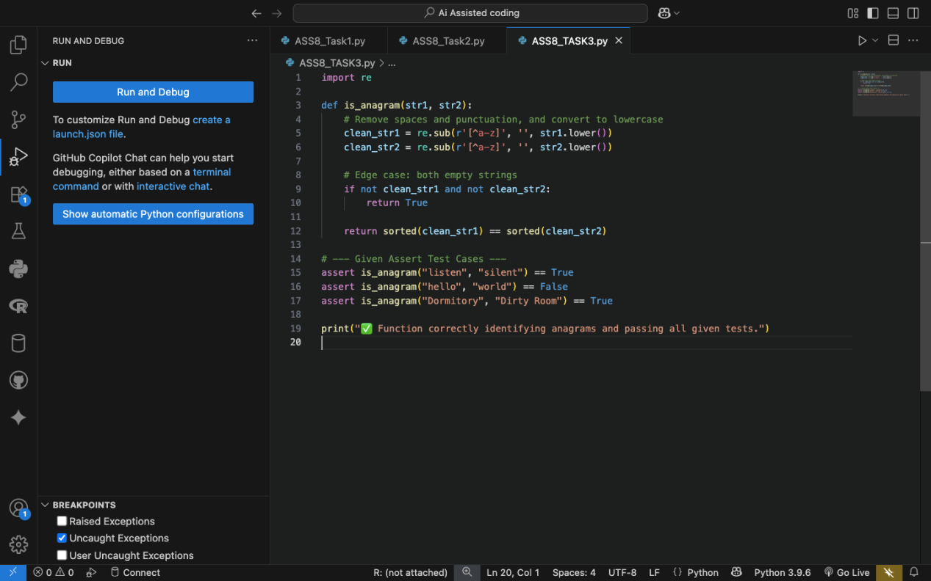

OUTPUT:

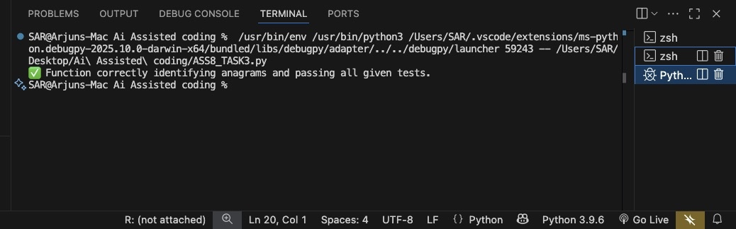

TASK 4:

Task Description #4 (Inventory Class – Apply AI to Simulate Real-World Inventory System)

* Task: Ask AI to generate at least 3 assert-based tests for an Inventory class with stock management.
* Methods:
  + add_item(name, quantity)
  + remove_item(name, quantity)
  + get_stock(name)

Example Assert Test Cases:

inv = Inventory()

inv.add_item("Pen", 10)

assert inv.get_stock("Pen") == 10

inv.remove_item("Pen", 5)

assert inv.get_stock("Pen") == 5

inv.add_item("Book", 3)

assert inv.get_stock("Book") == 3

Expected Output #4:

* Fully functional class passing all assertions.

**Prompt:** generate at least 3 assert-based tests for an Inventory class with stock management.

* Methods:
  + add_item(name, quantity)
  + remove_item(name, quantity)
  + get_stock(name)

**CODE:**

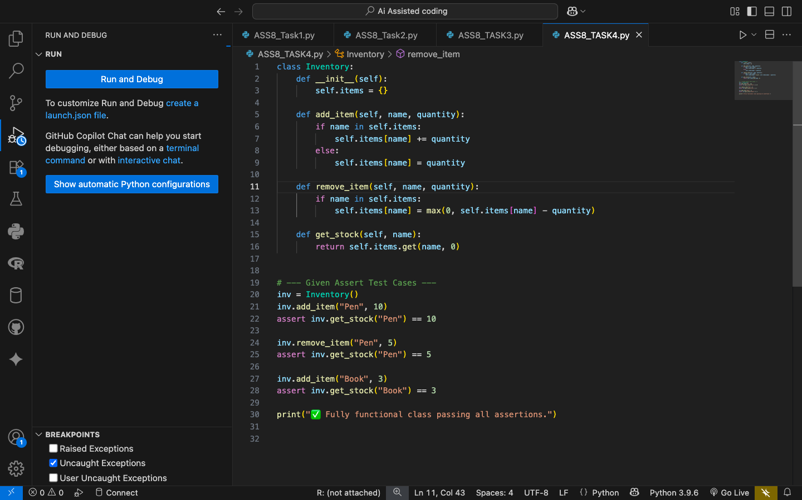

**OUTPUT:**

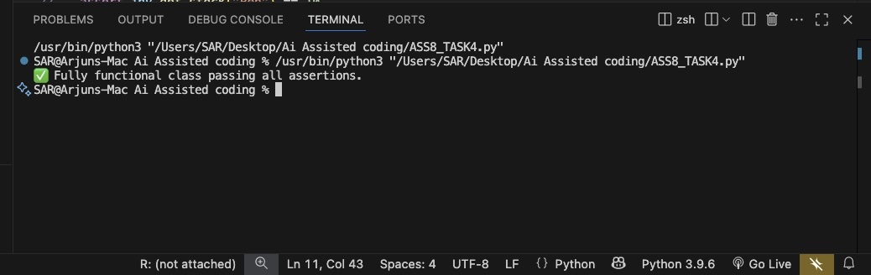

TASK 5:

Task Description #5 (Date Validation & Formatting – Apply AI for Data Validation)

* Task: Use AI to generate at least 3 assert test cases for validate_and_format_date(date_str) to check and convert dates.
* Requirements:
  + Validate "MM/DD/YYYY" format.
  + Handle invalid dates.
  + Convert valid dates to "YYYY-MM-DD".

Example Assert Test Cases:

assert validate_and_format_date("10/15/2023") == "2023-10-15"

assert validate_and_format_date("02/30/2023") == "Invalid Date"

assert validate_and_format_date("01/01/2024") == "2024-01-01"

Expected Output #5:

* Function passes all AI-generated assertions and handles edge cases.

**Prompt:** generate at least 3 assert test cases for validate_and_format_date(date_str) to check and convert dates.

* Requirements:
  + Validate "MM/DD/YYYY" format.
  + Handle invalid dates.
  + Convert valid dates to "YYYY-MM-DD".

**CODE:**

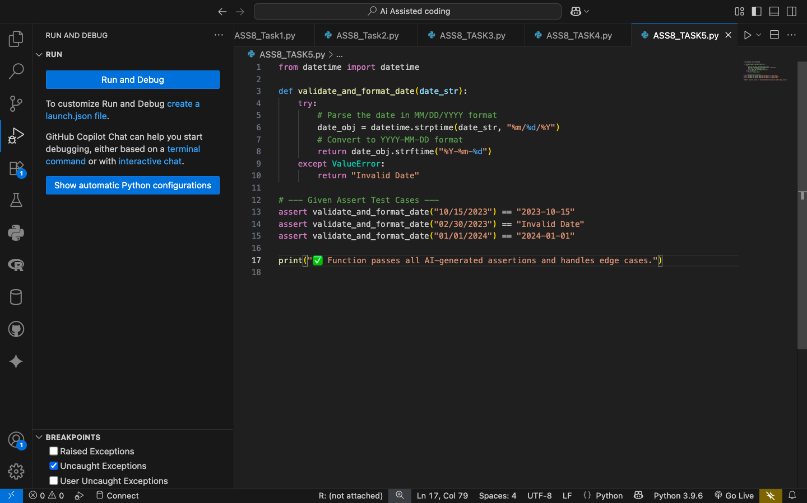

**OUTPUT:**

