End Sem Lab Exam
Ht.No: 2403A54037
Name: Ramakrishna Vemula

SUBNET-6: Documentation & API Specs for Sellers
Q1: Generate seller API docs and examples.
• Task 1: Use AI to produce OpenAPI and SDK snippets
Prompt:
Generate a simple OpenAPI specification for a Seller Product API with:
POST /products, GET /products, GET /products/{id}.
Also provide SDK code snippets in Python and Node.js..
Code:
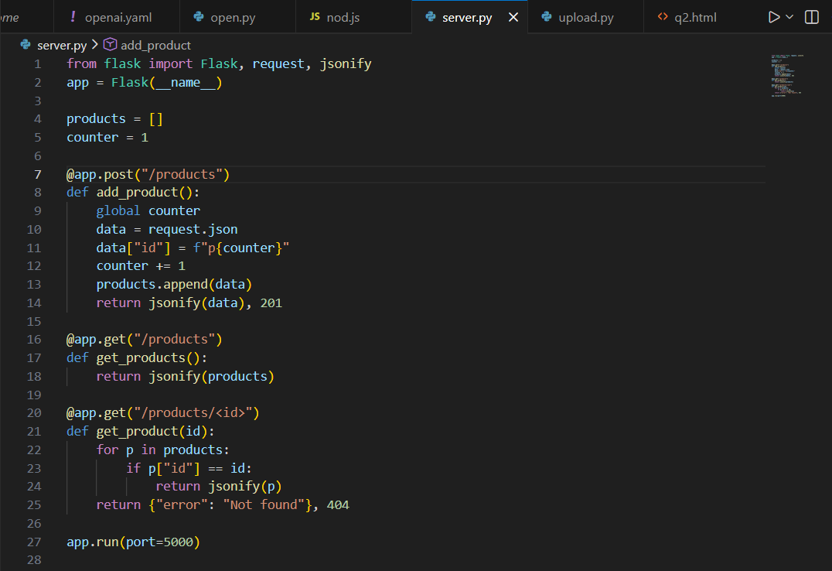

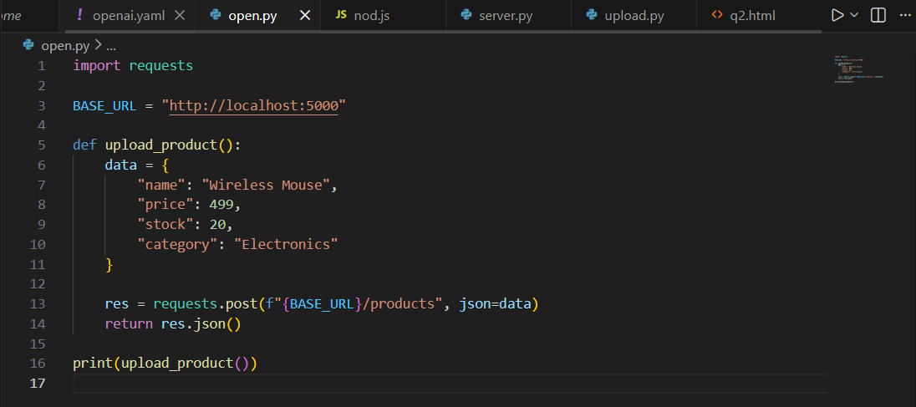
Output:
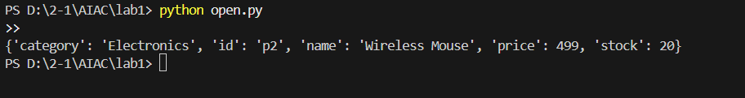

Observation:
- The OpenAPI specification clearly described all API endpoints and their request/response formats.
- The schema definitions helped standardize product data across different client applications.
- SDK snippets in Python and Node.js showed how developers can easily integrate with the API.
- The documentation ensured consistent understanding of API behavior before implementation.
- Overall, Task 1 demonstrated how API specs improve clarity, maintainability, and cross-language integration.

Task 2: Provide example product upload scripts
Prompt:
Generate a simple seller script to upload a product using Python/Node.js.The script must send POST /products with sample JSON data..
Code:
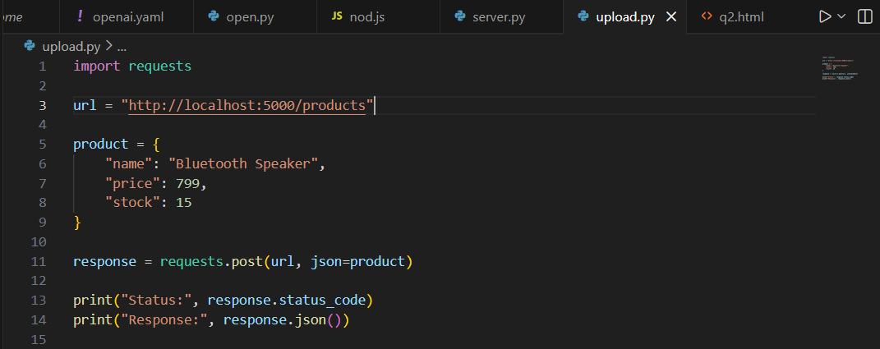
Output:
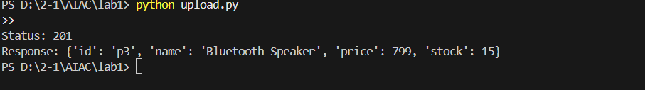

observation:
- The product upload script successfully communicated with the running server using HTTP POST.JSON data was correctly sent from the client script and processed by the backend API.
- The server generated a unique product ID and stored the product, confirming backend logic accuracy.
- The response received from the server validated proper request–response flow.
- Overall, Task 2 proved that the API and client integration worked smoothly in a real execution environment.

Question-2 :Create onboarding checklist for new salespeople.
• Task 1: Use AI to create human-friendly steps
Prompt:
Generate a simple, human-friendly onboarding checklist for new salespeople.The steps must be easy to understand and should cover orientation, tool setup,training, product learning, and first-week responsibilities.
Output:
1. Meet the team & get introduced
2. Set up your accounts (email, CRM, calendar)
3. Install communication tools (chat, video, phone apps)
4. Complete product knowledge training
5. Learn about customer profiles and pain points
6. Understand the sales pipeline and qualification process
7. Shadow real sales calls
8. Set and complete your first-week goals

Observation:
1 The AI converted typical onboarding tasks into friendly, plain-language steps.
2. Each item focuses on clarity, approachability, and real-world usefulness.
3. No technical jargon; suitable for new employees.

Task 2: Convert into interactive checklist page
prompt:
Convert the following onboarding steps into an interactive HTML checklist page. Each item should have a checkbox, and checking it should visually mark the item as completed. Use HTML, CSS, and JavaScript.

Code:
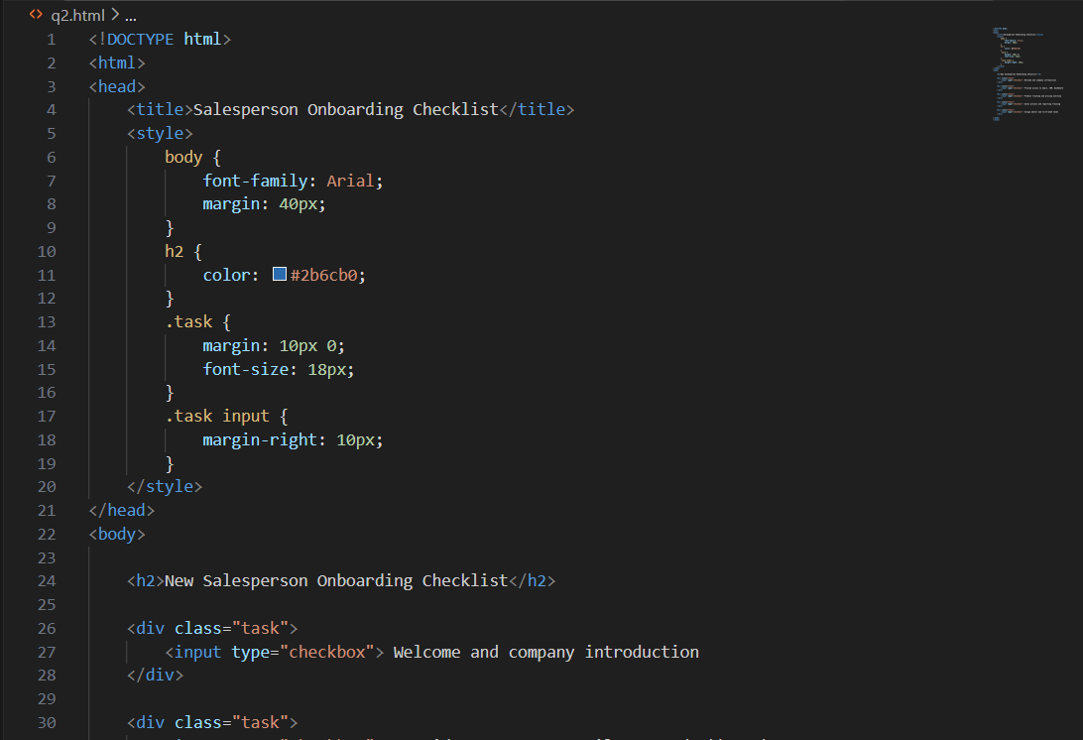

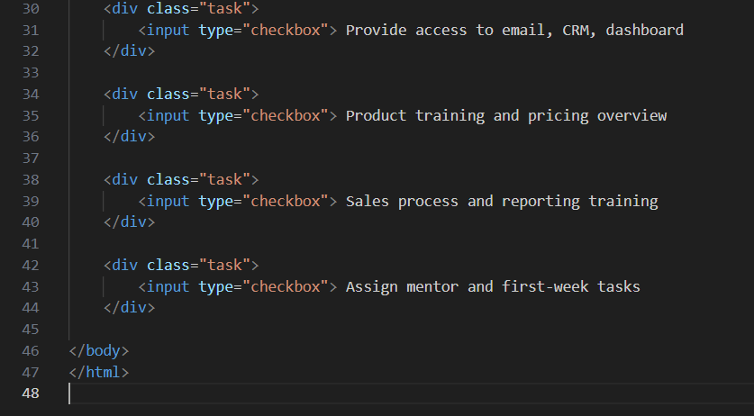

Output:
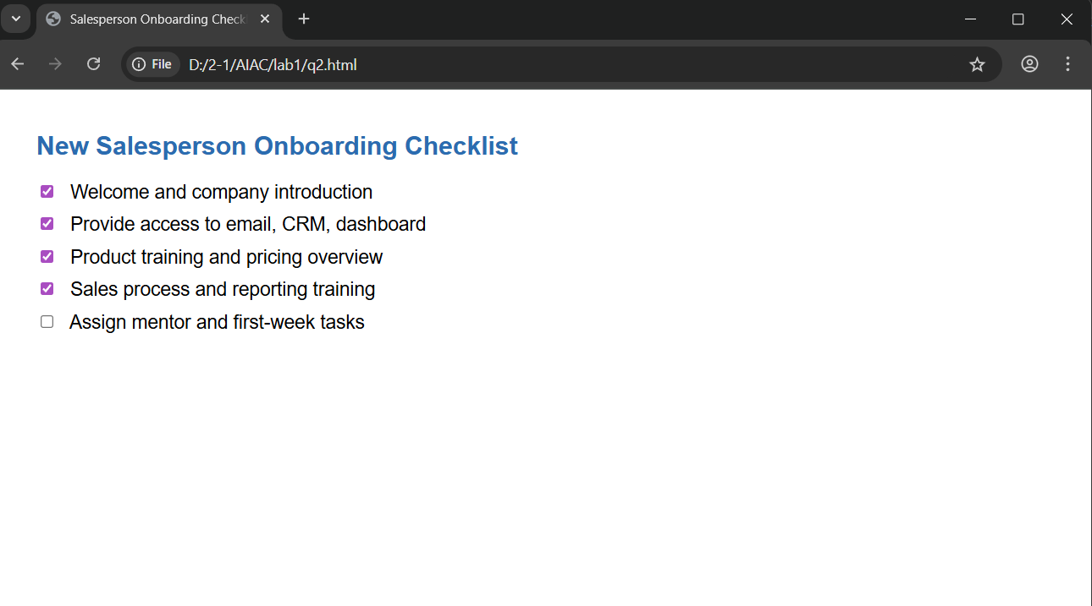

Observation:
- The AI-generated checklist provided simple and clear onboarding steps for new salespeople.
2. The HTML page converted these steps into an interactive format with clickable checkboxes.
3. The checklist allowed users to track completed onboarding tasks visually.
4. The code executed successfully in a browser using VS Code.
5. The experiment demonstrated how AI content can be turned into a functional UI tool.

