STUDENT MANAGEMENT SYSTEM USING SPRINGBOOT , THYMLEAF

Technologies:

Spring Boot , Thymleaf , Spring boot data jpa

Here we have view pages , controller , service interface, service implementation, jpa interface(Dao).

Screen Shots:

Listing of students

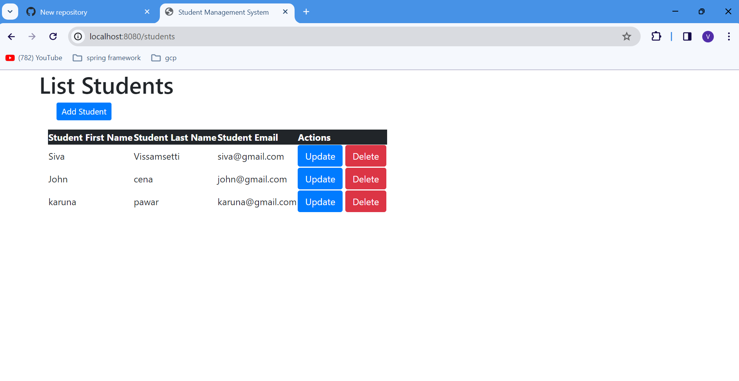

Update of students

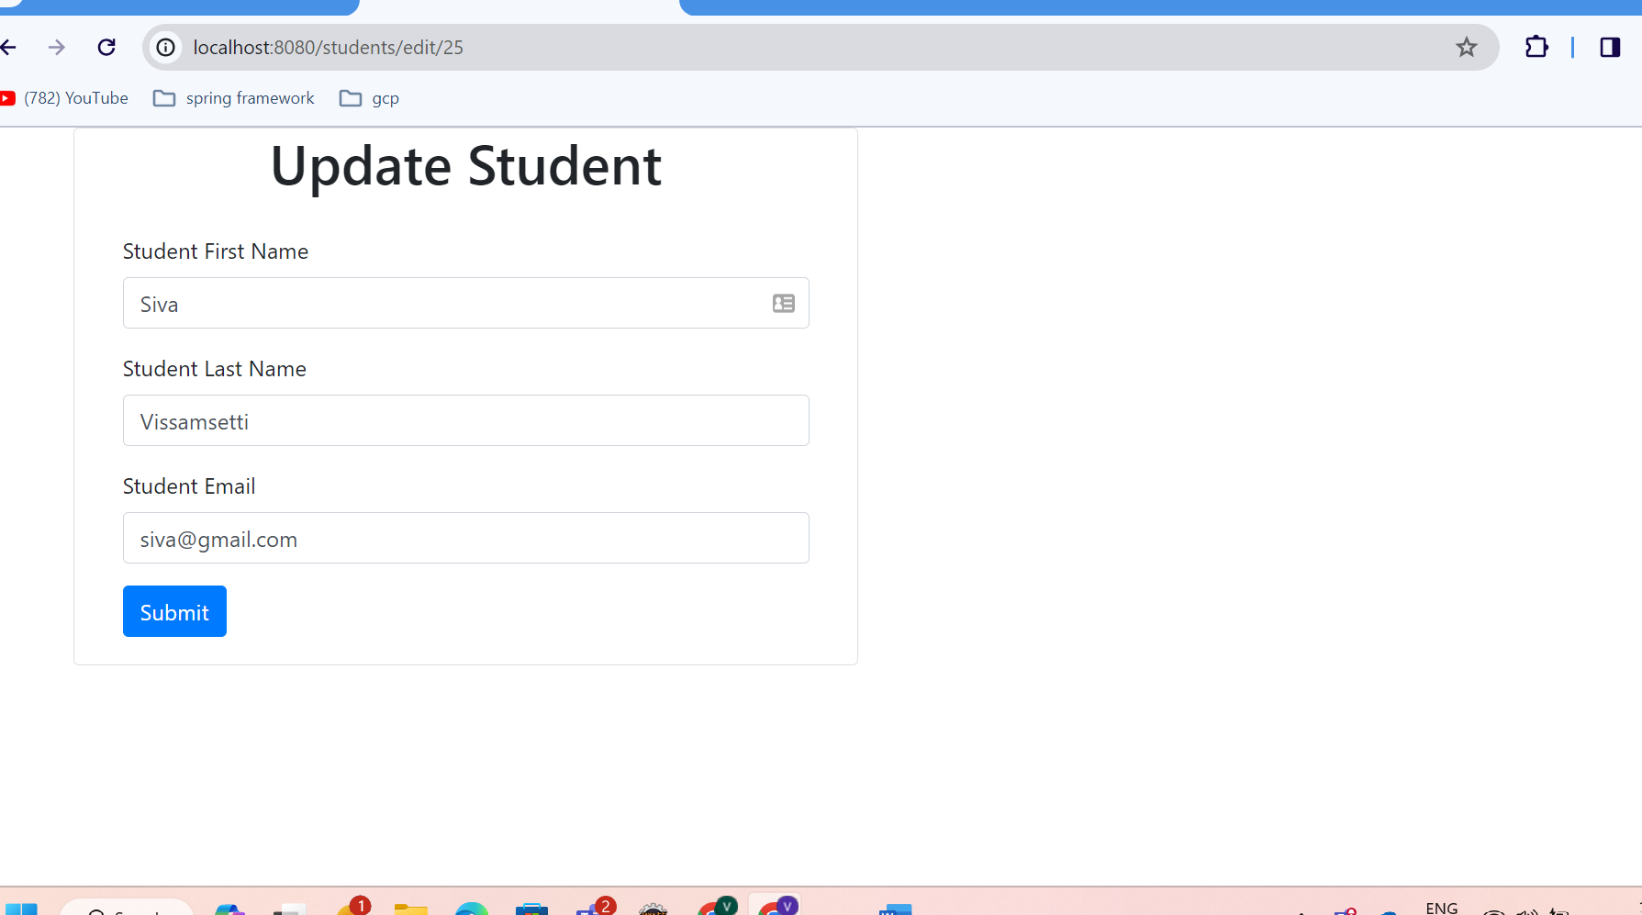

Adding a student:

