Er diagram followed here

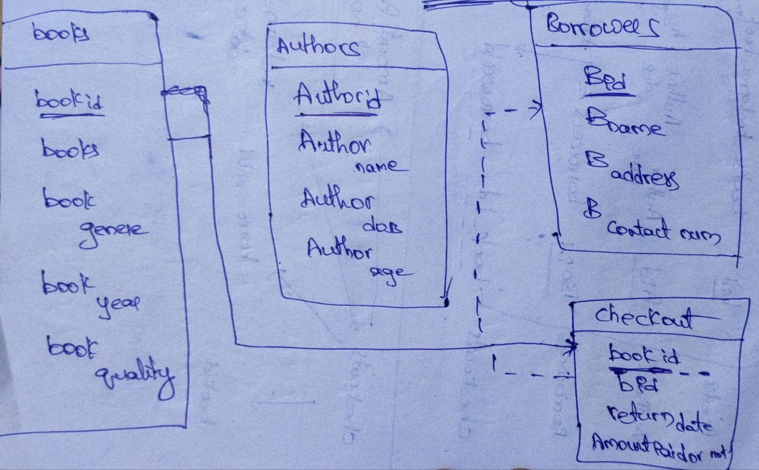
Note - a small change added a table to move across book s greater than 103 and l;ater joined using union operation.

LIBRARY MANAGEMENT SOFTWARE

FOR BOOK TABLE
CREATE TABLE books
(
book_id integer primary key,
b_name varchar2(10)
); —-------------------------------------------------- table created
select * from books —-------------------------------------------- checks columns
alter table books
modify b_name varchar2(100) —-----------------------modified the column size
alter table books
modify b_genre varchar2(100)------------------------ modified the column size
alter table books
add b_genre varchar2(10)------------------ adding another column to table
update books set b_genre ='romantic' where book_id='101'---- updating the value in the column
insert into books values('102','to kill a moacking bord','literary fiction')-- inserting values to th etable
create sequence seq
start with 103
increment by 1 —------- creation of a sequence
insert into books(book_id, b_name, b_genre) values(seq.nextval, 'the book thief', 'Historicalfiction fiction'); — adding values using the sequence

FOR AUTHOR TABLE
create table authors
(
author_id number primary key,
a_name varchar2(10)
); —-------------------------------------------------TABLE CREATED

alter table authors
add age integer—--------------------------------ADDED A COLUMN
select * from authors
select * from books
insert into authors values(1,'James Cameron',68); —--- INSERTED A COLUMN
alter table authors
modify a_name varchar2(100)------ IMPROVED SIZE
drop sequence seq
create sequence seq
start with 2
increment by 1 —---GENERATED A SEQUENCE
insert into authors(author_id, a_name, age) values(seq.nextval, 'markuszusak', '49');
—---- INSERTED VALUES USING SEQUENCE

FOR BORROWERS TABLE
create table borrowers
(
borrower_id number primary key,
b_name varchar2(100),
b_adress varchar2(100),
b_num varchar2(100)
); —---------------------- table creation
insert into borrowers values(1,'ram','rjy','8885895166'); – data insertion
select * from borrowers
create sequence seq1 start with 2 increment by 1;
drop sequence seq1 – sequence creation
insert into borrowers(borrower_id, b_name,b_adress,b_num) values(seq1.nextval, 'LEO', 'chennai',123456789) — data adding into sequence

FOR CHECKOUT TABLE

CREATE TABLE checkout (
book_id INTEGER PRIMARY KEY,
borrower_id NUMBER REFERENCES borrowers (borrower_id),
return_date DATE DEFAULT SYSDATE,
amount_paid CHAR(1) CHECK (amount_paid IN ('Yes', 'No'))
);
—-----------table creation
insert into checkout values(103,3,sysdate,'NO'); -insertion statement

CREATE TABLE books_over_100 (
book_id NUMBER,
borrower_id NUMBER,
return_date DATE,
amount_paid VARCHAR2(255)
);
—-------------------- table creation
INSERT INTO books_over_100 (book_id, borrower_id, return_date, amount_paid)
VALUES (105, 4, sysdate, 'NO'); – insertion statement

select * from checkout
union
select * from books_over_100
-union of 2 tables

