DATA ANALYTICS ASSIGNMENT 3

Ponnada Ramakrishna

2122003050041

III BSc MppCs

Government Degree College Tekkali

DATASET : [Sample - Superstore.xls](https://docs.google.com/spreadsheets/d/1Vmsk3xJ_qp69U0AZzCpNybqX0AP4KSon/edit#gid%3D972120833)



* Define at least two sets based on specific criteria from your dataset (e.g., high-value customers, top-performing products).
* Experiment with combining sets using UNION, INTERSECT, and MINUS operations.
* Create 2 Calculation field using any aggregate function
* Create any 3 visualization using quick Table Calculations

HIGH-VALUE CUSTOMERS BY SALES

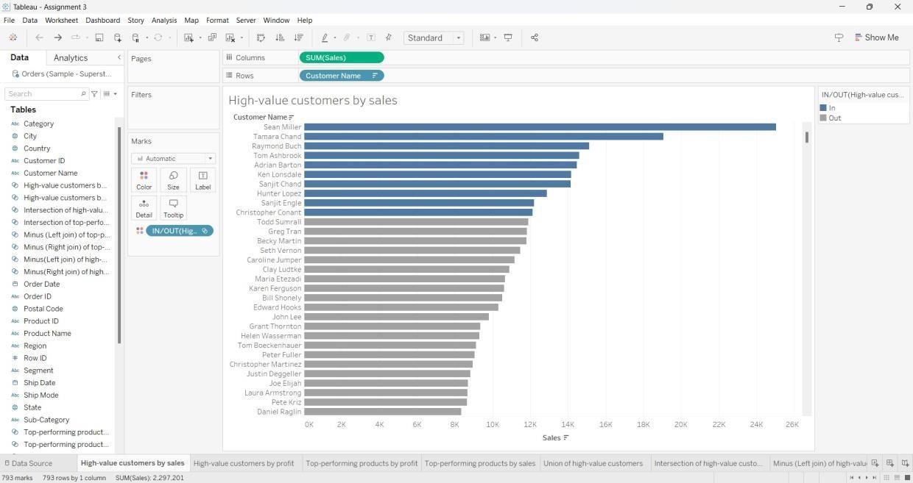

HIGH-VALUE CUSTOMERS BY PROFIT

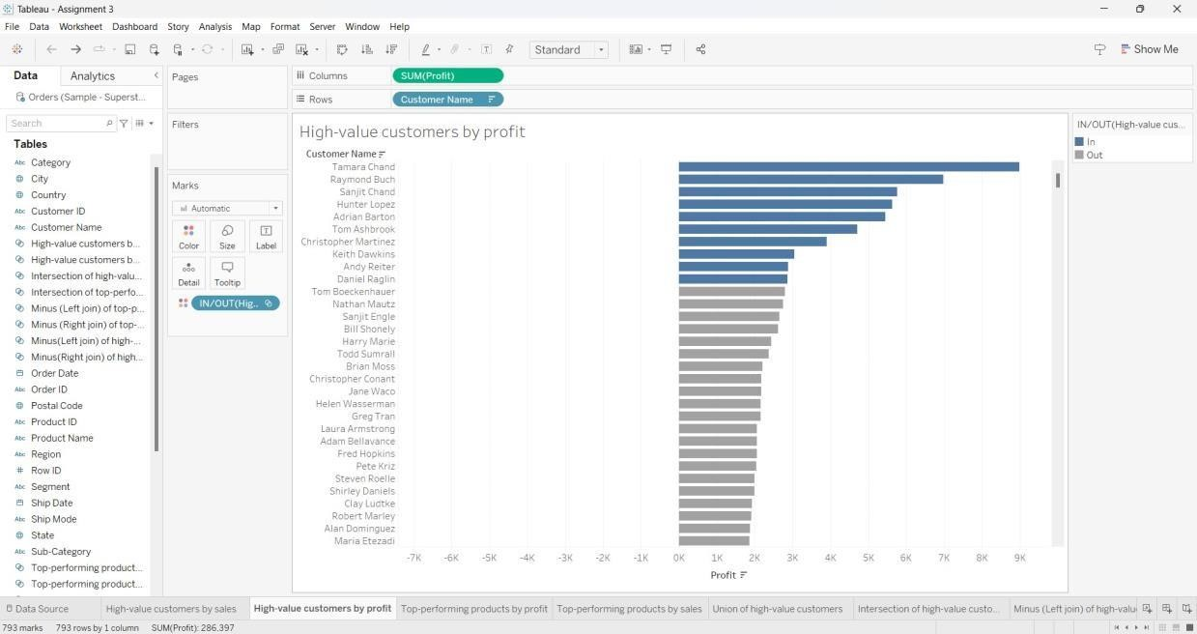

UNION OF HIGH-VALUE CUSTOMERS

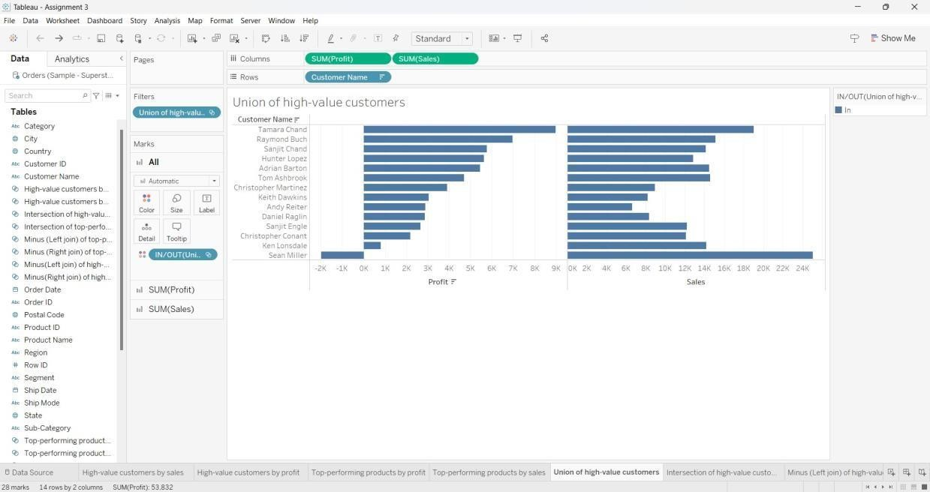

INTERSECTION OF HIGH-VALUE CUSTOMERS

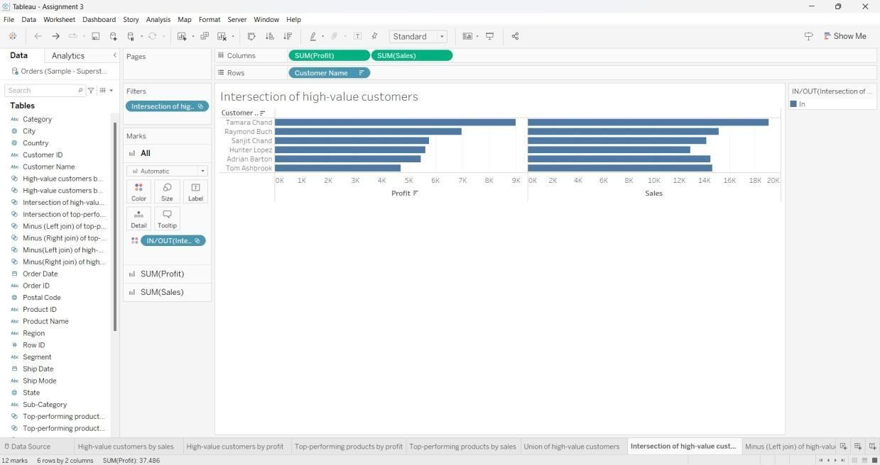

MINUS (LEFT JOIN) OF HIGH-VALUE CUSTOMERS

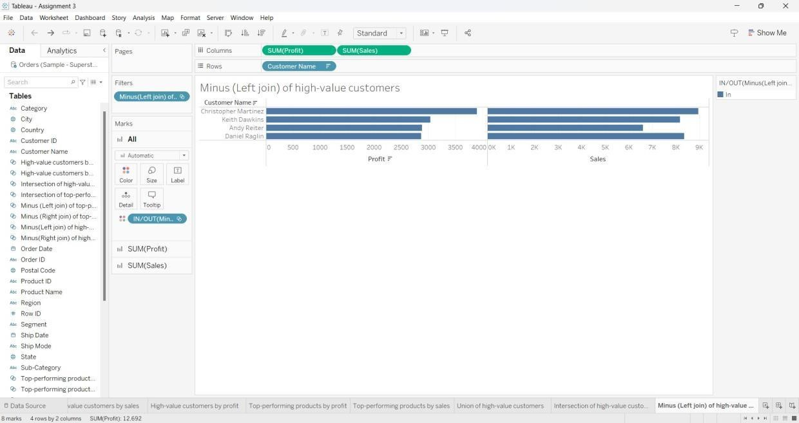

MINUS (RIGHT JOIN) OF HIGH-VALUE CUSTOMERS

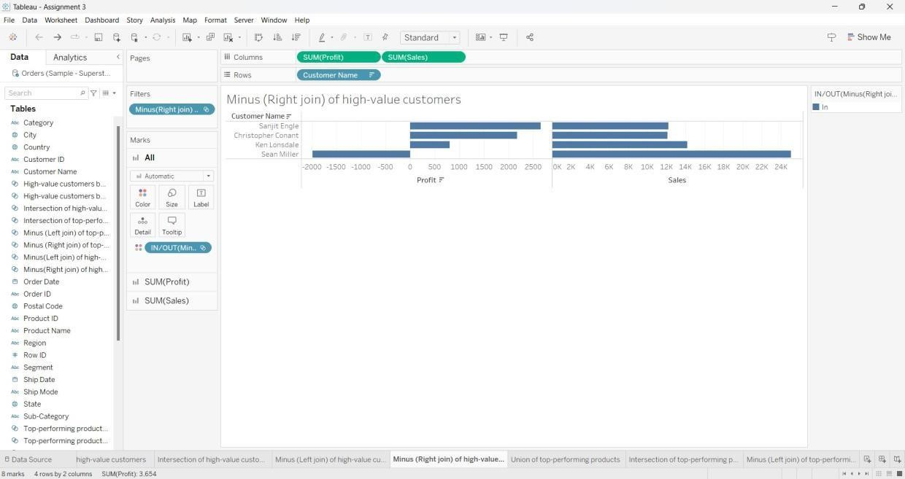

TOP-PERFORMING PRODUCTS BY PROFIT

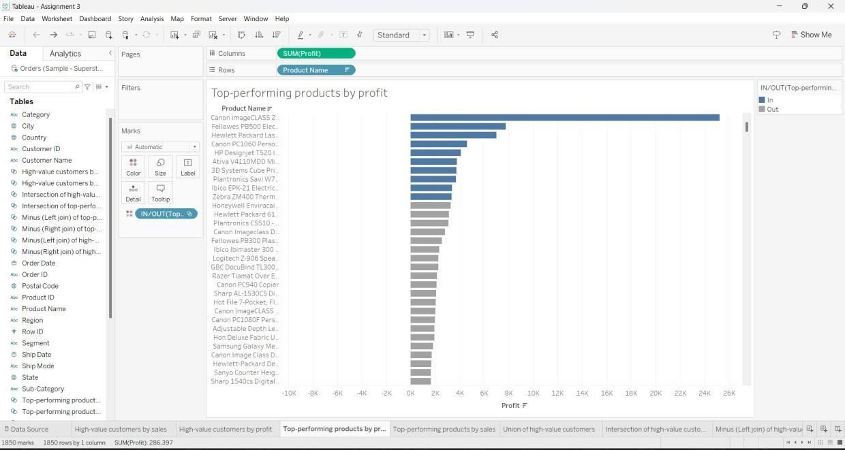

TOP-PERFORMING PRODUCTS BY SALES

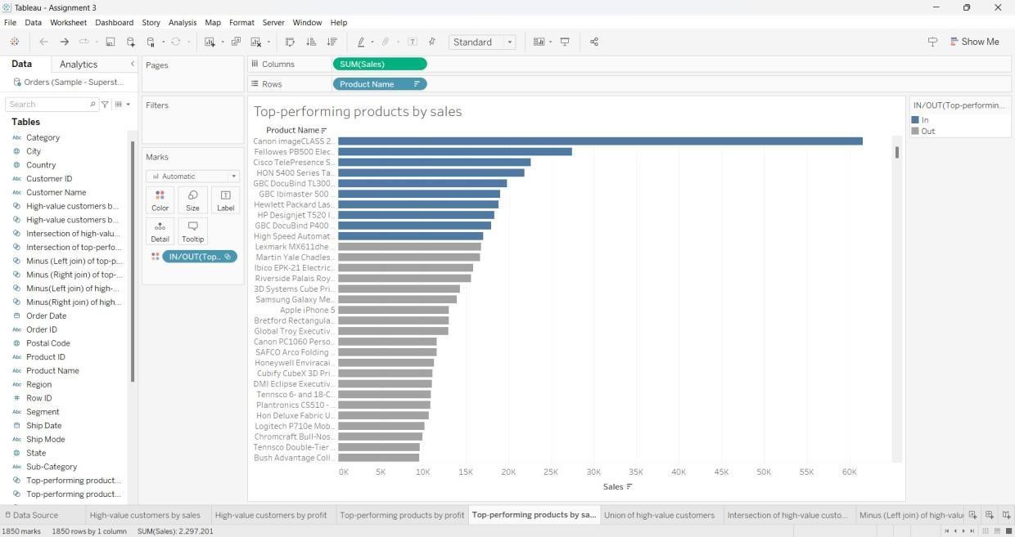

UNION OF TOP-PERFORMING PRODUCTS

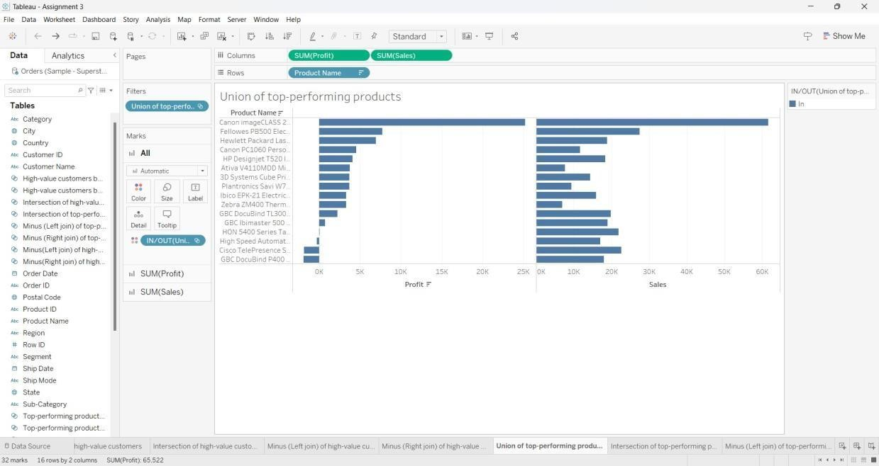

INTERSECTION OF TOP-PERFORMING PRODUCTS

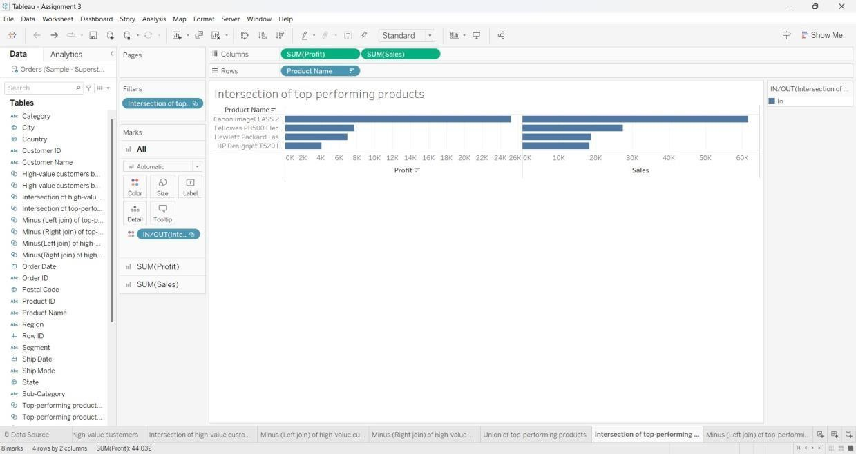

MINUS (LEFT JOIN) OF TOP-PERFORMING PRODUCTS

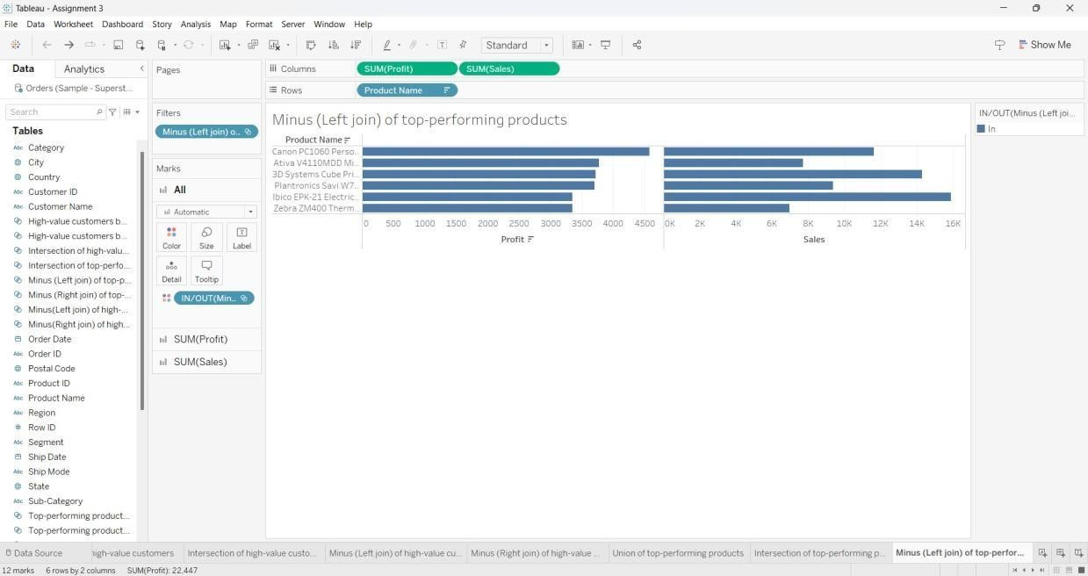

MINUS (RIGHT JOIN) OF TOP-PERFORMING PRODUCTS

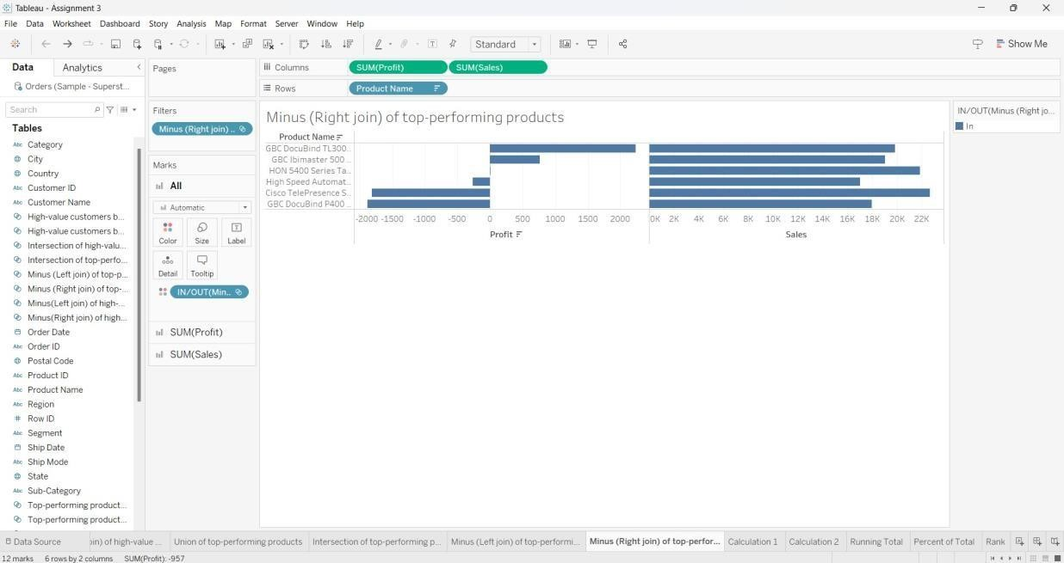

CALCULATED FIELD - 1

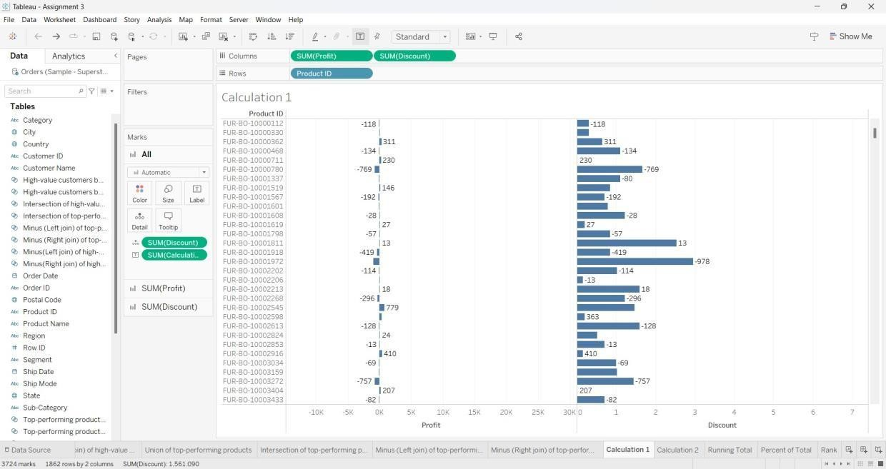

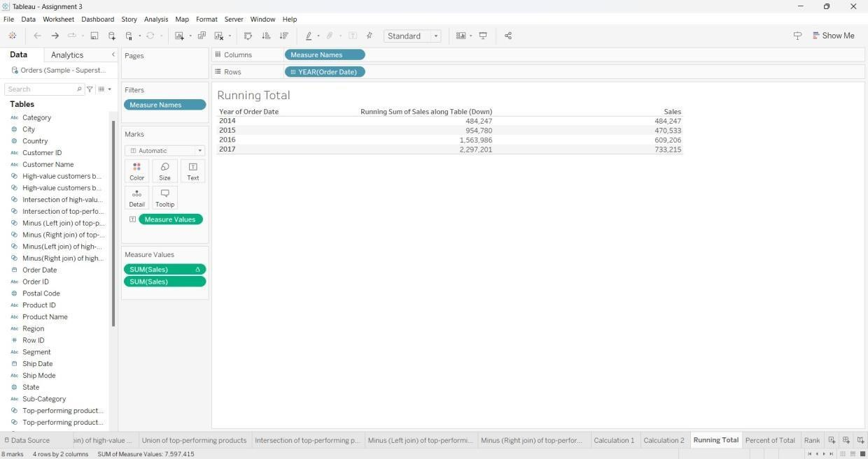CALCULATED FIELD - 2

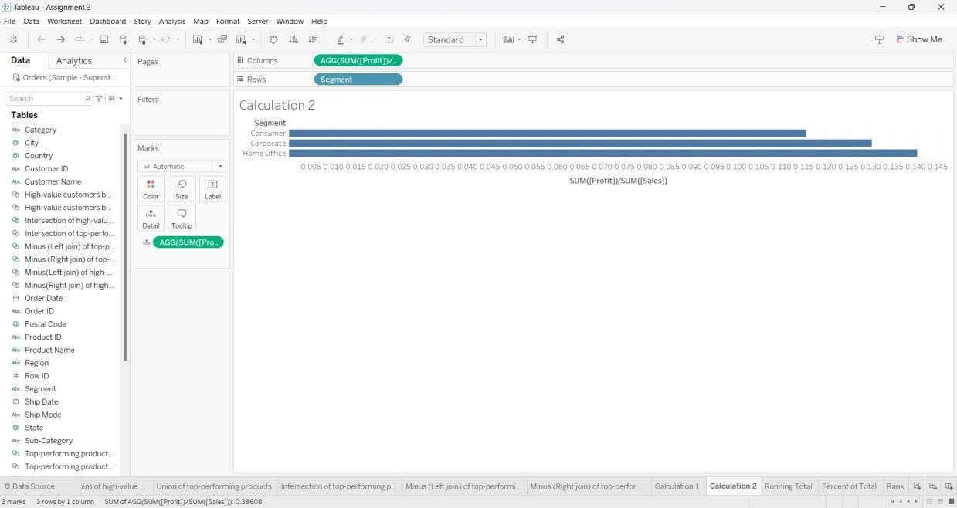

QUICK TABLE CALCULATIONS:

RUNNING TOTAL

PERCENT OF TOTAL

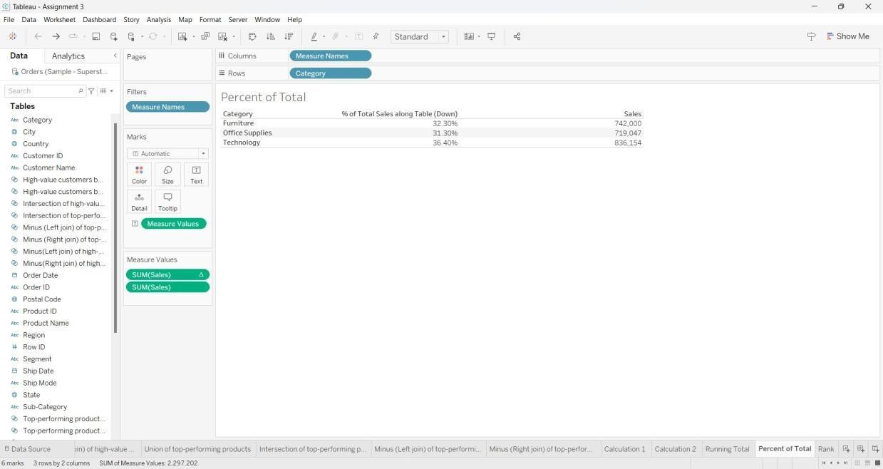

RANK

