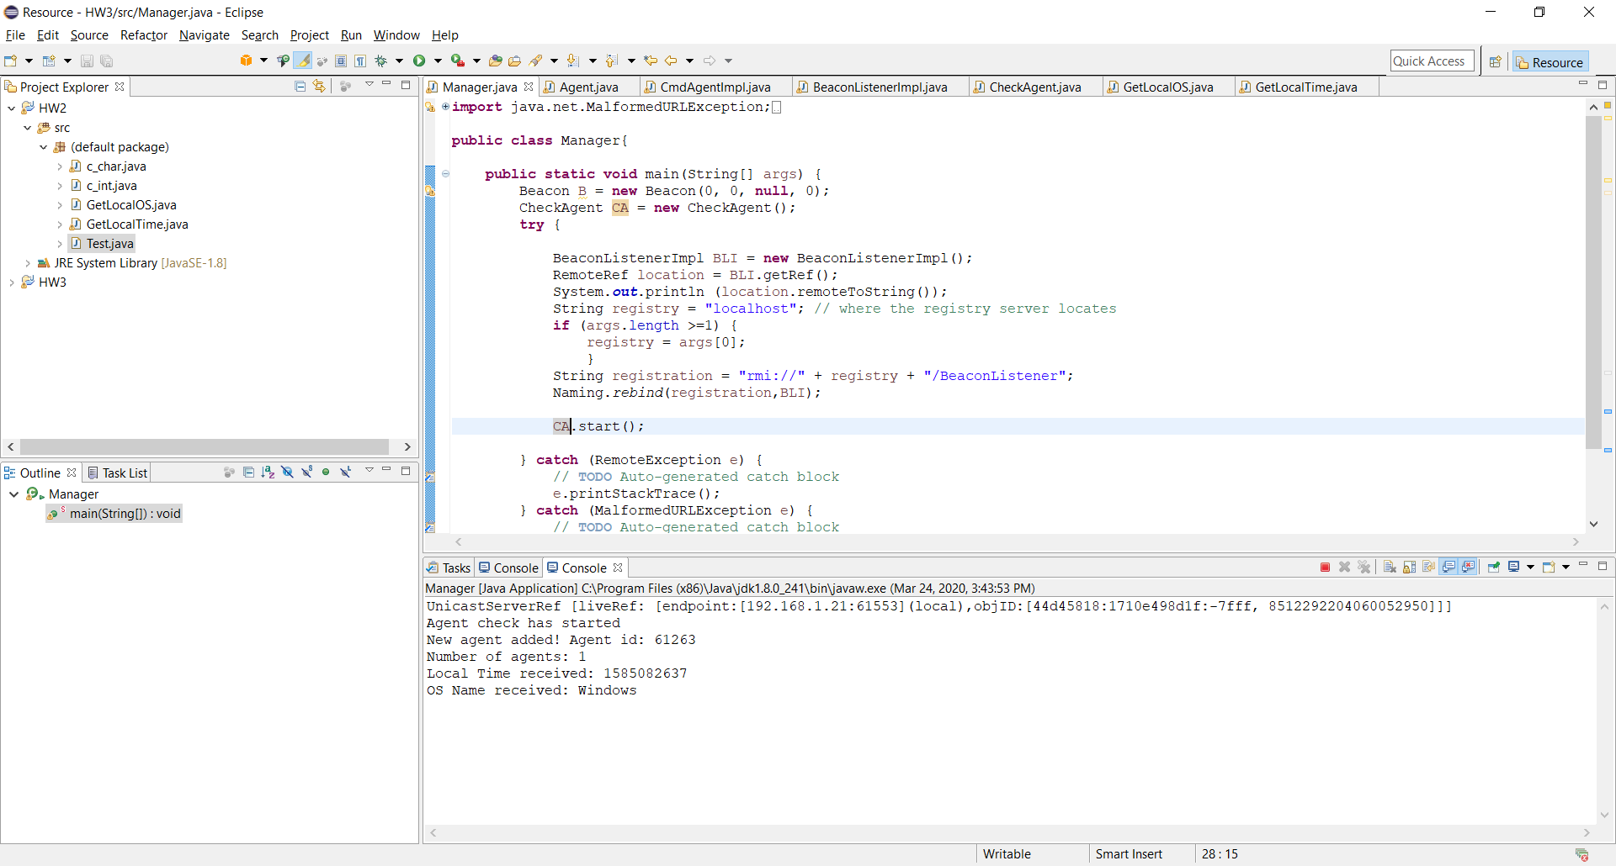



In the screenshot above, both manager and agent have started. The Manager is receiving the beacon from the Agent periodically and adding it to the list. The LocalTime and OS is received from the C function using JNI.

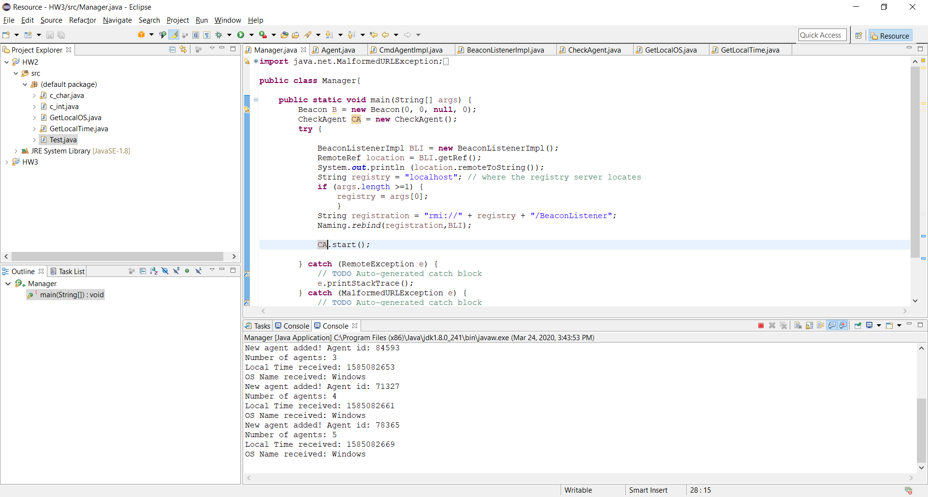



The number of agents has increased and since so far, no agent has died, there have been no deletions from the list. So now there are 5 agents in list. I have an agentCheck method in class CheckAgent which starts running as soon as Manager starts running. I have implemented it as a thread.

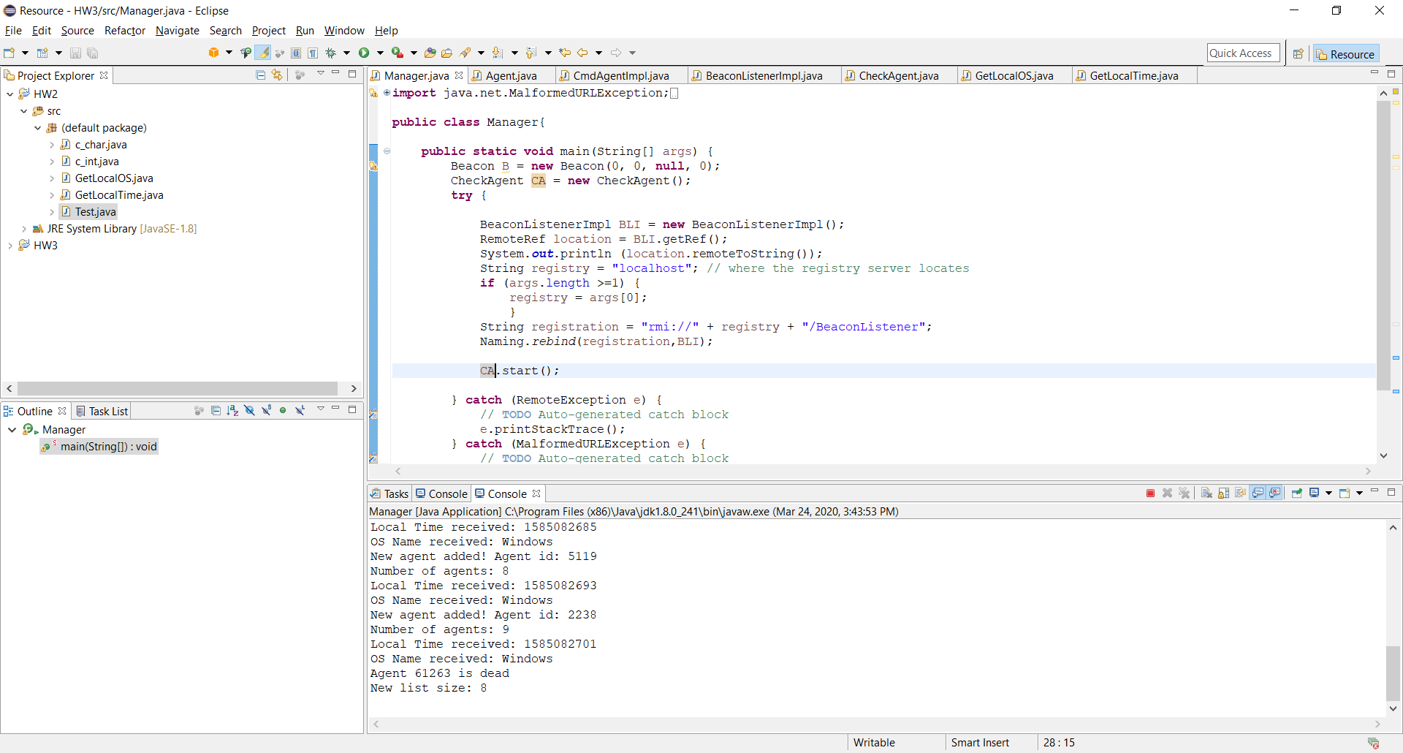



Here, one of the agents has died, and it is removed from the list. The new list size shows how many agents are remaining after the operation.