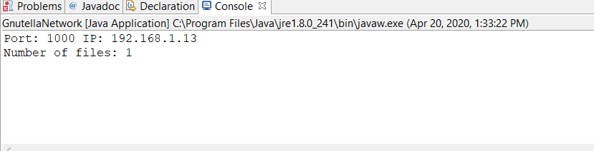

The above screenshots shows that the initial node has started.

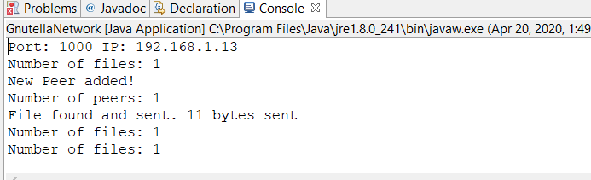

A second node has connected and requested a file. The file was found and sent to the peer. The size of the file is printed.

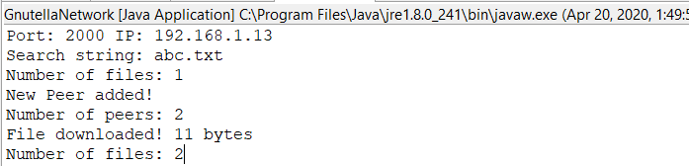

The second node has received the file. The name of requested file was abc.txt. The file was downloaded and the size of file is printed. The number of files has been updated to reflect this change.