1.Sqoop import 13 tables

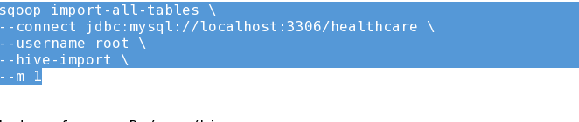

2.sqoop import screenshots

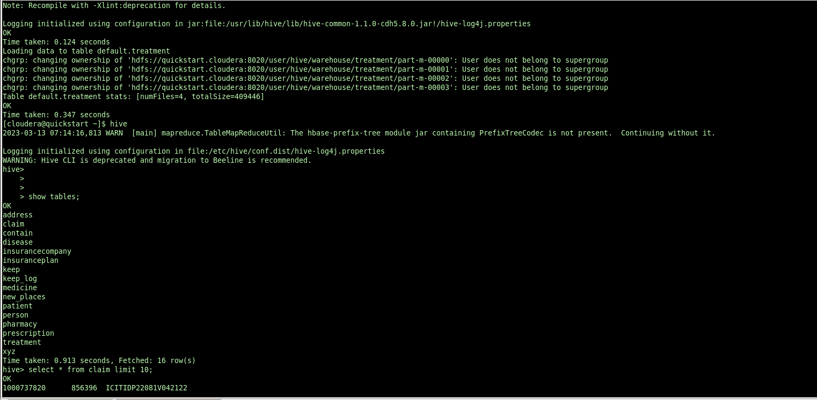

3.external table creation and loading the query output

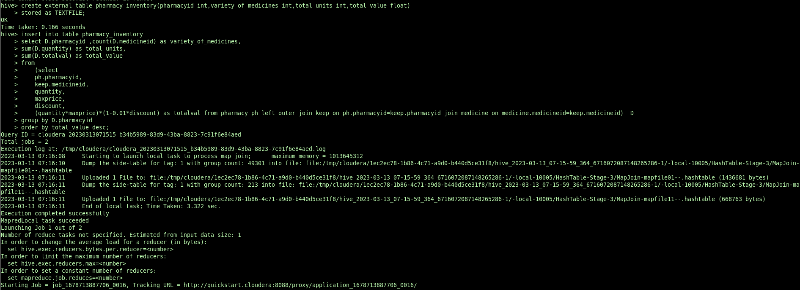

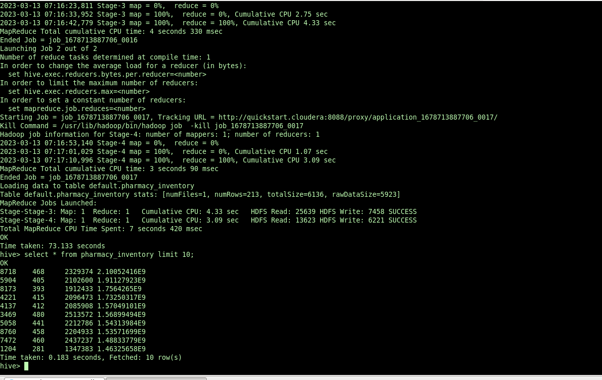

External table data from hdfs location

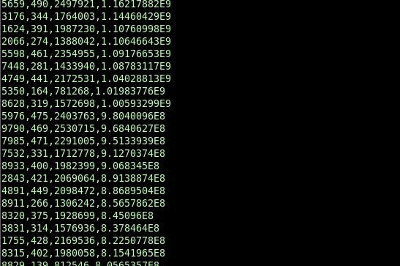

5.Exporting the outputs from external table to MySql database

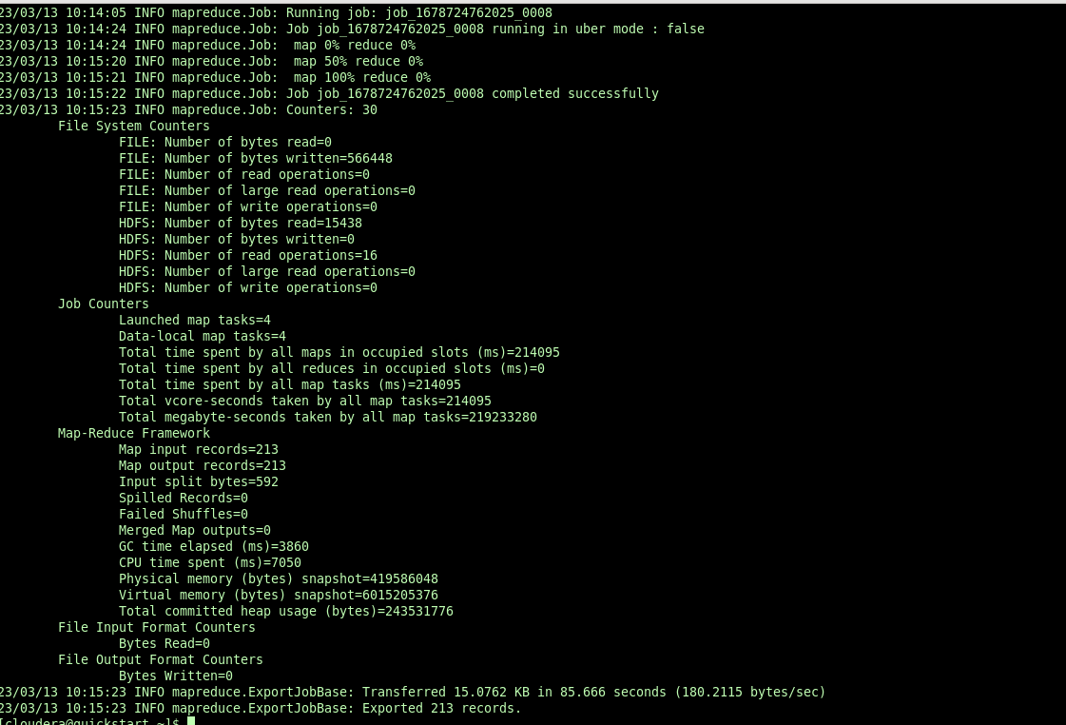

6.displaying the exported data from mysql database

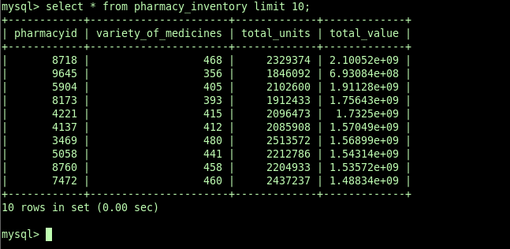

-------------------------------------------------query—2----------------------------------------------

1.creating external table to store query2 output

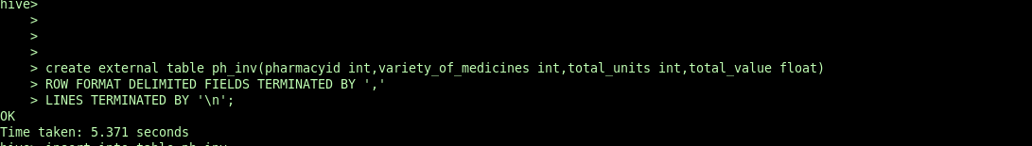

2.inserting query output to external table

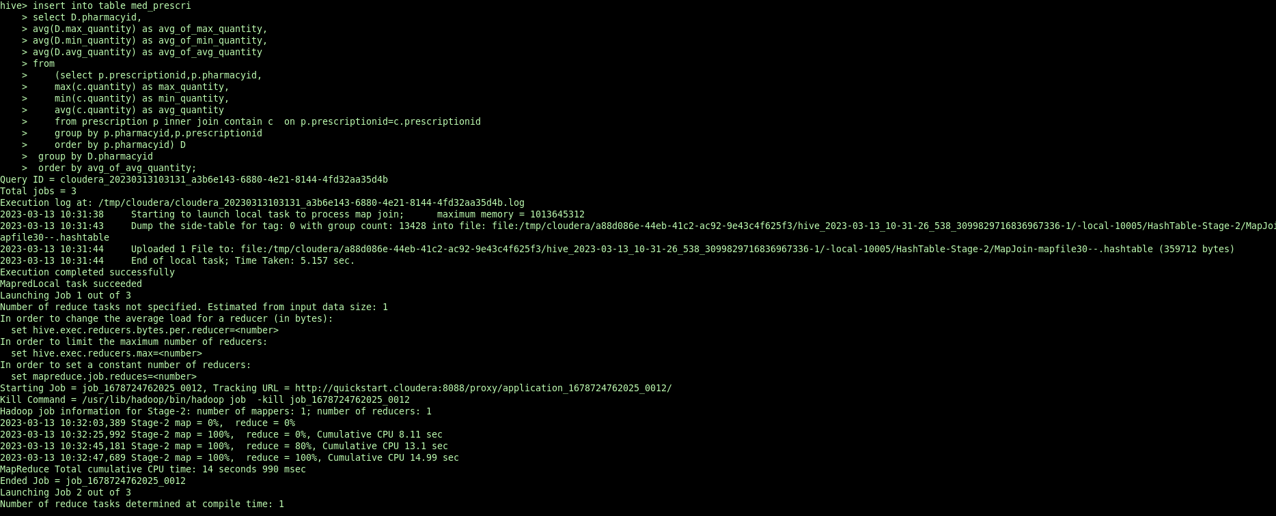

3.exporting external table to mysql db

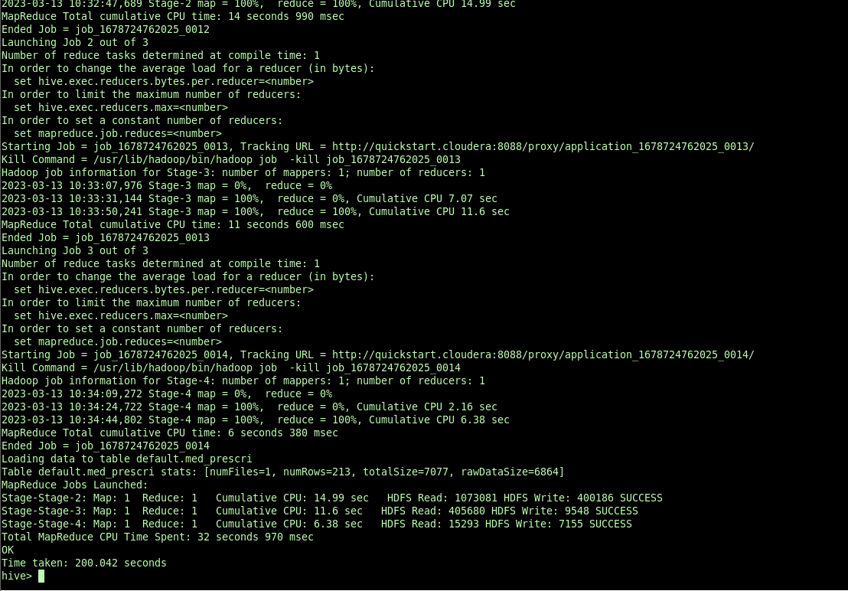

4.displaying exported data from mysql db

