Blink an LED on the Scholar FPGA Board
A first hardware design on a Spartan-3A FPGA trainer, from USB power-up to a blinking LED
By Ramakumar Mayil Dilli Babu

Introduction
In this project, we build the simplest possible FPGA design — a blinking LED — on the Scholar board (Fig. 1), a compact USB-powered FPGA trainer built around a Xilinx Spartan-3A device, designed and manufactured by Addlek Systems, Bengaluru. The exercise looks trivial, but on an FPGA it exercises the entire toolchain — writing a hardware description, constraining it to physical pins, synthesising and routing it into a bitstream, and loading that bitstream onto silicon — before a single LED even flickers.
The Scholar board is deliberately minimal: an FPGA, a small microcontroller that handles USB communication and configuration, an SPI flash to hold the bitstream, an SDRAM for larger designs, and a 20-pin I/O header on each side for prototyping. No JTAG pod, no external power supply, and no separate programmer are needed — the board enumerates over USB, accepts a bitstream from the host, and reconfigures itself. That makes it a reasonable candidate for a first FPGA project.
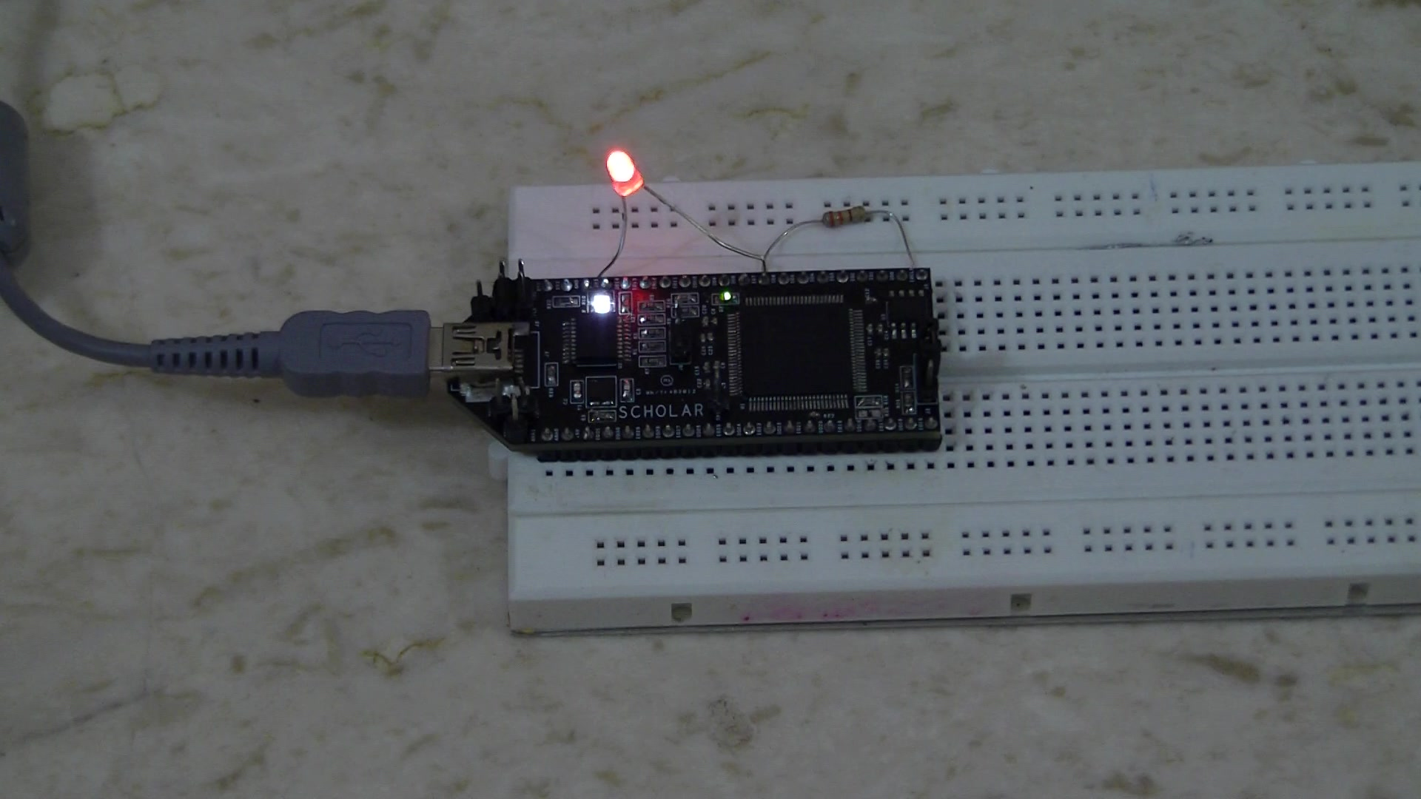
Fig. 1: The finished blinker, caught mid-flash on video — the external red LED lit, alongside the board's own onboard white and green status LEDs. The Xilinx Spartan-3A (XC3S200A) FPGA is the large IC at centre.

Components Required
- Scholar FPGA trainer board — Xilinx XC3S200A-VQG100 Spartan-3A FPGA (Addlek Systems)
- Breadboard
- Red LED (5 mm, through-hole)
- 330 Ω resistor
- Jumper wires
- Mini-USB cable
- PC running Xilinx ISE WebPACK and Addlek's Accelar loader utility

Bill of Materials
Reference | Part | Function
U1 | Xilinx XC3S200A-VQG100 | FPGA — hosts the clock-divider logic
U2 | Microchip PIC18LF14K50-SSOP | USB interface and FPGA configuration control
U3 | Winbond W25X20BV | 2-Mbit SPI flash, stores the bitstream
Y1 | 12 MHz oscillator (ABM8G series) | Sole clock reference, feeds FPGA pin 43
R10 | 330 Ω resistor | Current-limits the external red LED
— | Red LED (external, breadboard) | Visual output for the blinker

Circuit and Working
At the heart of the board is a Xilinx XC3S200A-VQG100 FPGA — a Spartan-3A device in a 100-pin VQFP package with roughly 200,000 system gates, more than enough for a blinker or for considerably more ambitious student designs. Three other ICs round out the board: a Microchip PIC18LF14K50 microcontroller that talks USB to the host and pushes configuration data into the FPGA; a Winbond W25X20BV 2-Mbit SPI flash that holds the bitstream between power cycles; and a Winbond W9812G6JH 8M×16 SDRAM for designs that need external memory. Two low-dropout regulators derived from the 5 V USB rail supply the board's 3.3 V and 1.2 V rails (fitted as AMS1117-package parts on the review unit, footprint-compatible with the ZLDO1117G33TA/ZLDO1117G12TA specified in the design).
A single dedicated 12 MHz oscillator (Y1) is wired directly into one of the FPGA's global clock inputs (GCLK0, physical pin 43) — this is the only clock source on the board, and the microcontroller has no part in generating it. Every FPGA design on this board, including the blinker described here, starts from that same 12 MHz reference and derives whatever timing it needs internally. For this project, the FPGA fabric divides the 12 MHz clock down with a binary counter and drives one bit of that counter out through a second pin, IO_CLK (physical pin 44), which is brought out to the board's I/O header. A 330 Ω resistor in series with a red LED, wired directly across that header pin and an adjacent ground pin, converts the divided clock into a visible blink.
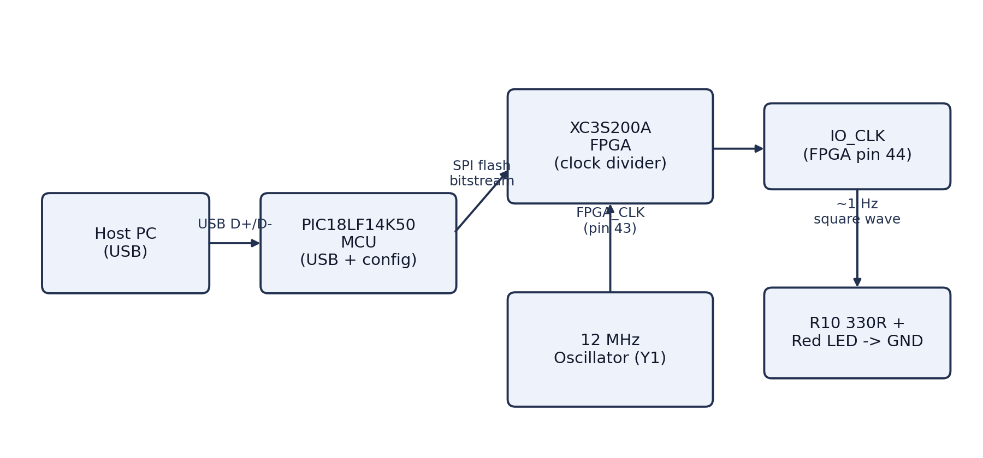
Fig. 2: Signal path for the blinker — the onboard 12 MHz oscillator clocks the FPGA directly; the FPGA divides it internally and drives the IO_CLK header pin, which lights the external LED through a current-limiting resistor.
Configuration works the other way around, from flash to FPGA rather than FPGA to LED. On power-up, the microcontroller pulls its own FLASH-DISABLE line high, then pulses the FPGA's PROG_B pin (physical pin 100) to start configuration. The FPGA then drives the flash's chip-select pin itself and reads out the stored bitstream over the flash's CCLK, MOSI and MISO connections. Because the flash and the SDRAM share some FPGA pins, and the SDRAM's chip-select is permanently asserted, the two memories are never accessed at the same time — SDRAM traffic is simply inactive while the FPGA is not yet configured, so there is no contention.

Connecting Components
Only one connection is external to the board; everything else is fixed onboard wiring that needs no breadboarding:
FPGA Pin | Connects To | Notes
P43 (GCLK0) | Y1, 12 MHz oscillator | Onboard — no external wiring
P44 (IO_CLK header pin) | 330 Ω resistor → red LED → GND | External — wire on breadboard
P100 (PROG_B) | PIC18LF14K50 microcontroller | Onboard — no external wiring

Construction, in other words, is almost entirely a matter of plugging the Scholar board into a breadboard — its two 20-pin headers straddle the centre gap and break out cleanly onto both rails — and then wiring the 330 Ω resistor and red LED in series between the IO_CLK pin and an adjacent ground pin. The board's own mini-USB port takes power and data from the host PC, so there is no separate bench supply to set up.

Blink an LED on the Scholar FPGA Board — Coding
The design was written in Verilog and built with Xilinx ISE WebPACK (free for the Spartan-3A family). The logic itself is a single always block: a 24-bit counter free-runs on every rising edge of the 12 MHz input, and its most significant bit is wired straight to the output pin.
module led_blinker (
input wire clk_in, // 12 MHz, onboard oscillator Y1, FPGA pin 43
output wire led_out // to IO_CLK header pin, FPGA pin 44
);

reg [23:0] counter = 24'd0;

always @(posedge clk_in) begin
counter <= counter + 1'b1;
end

assign led_out = counter[23];

endmodule
Bit 23 of a free-running 12 MHz counter toggles roughly every 0.7 second (2^23 ÷ 12,000,000 ≈ 0.70 s), so the LED cycles fully on and off a little under once a second — close enough for a visual demo, and easy to retune by picking a different bit if an exact 1 Hz is needed. The pins are fixed to the board's hardware in the User Constraints File:
NET "clk_in" LOC = "P43" | IOSTANDARD = LVCMOS33;
NET "led_out" LOC = "P44" | IOSTANDARD = LVCMOS33 | SLEW = SLOW | DRIVE = 8;
After synthesis, translate, map and place-and-route, ISE produces a .bit file — blinker.bit for this design, compiled for the 3s200avq100 target (the tool's own name for the XC3S200A-VQ100). Addlek's Accelar utility, a small Windows application that talks to the onboard PIC18LF14K50 over USB, loads this file: its Load Program screen names the board type (Scholar), the USB port, and the target file, and a Test Board option can confirm the connection first. Clicking Load writes the bitstream into the SPI flash; the microcontroller then resets and reconfigures the FPGA from flash automatically, with no separate JTAG cable involved. A second, faster-blinking variant (fast_blinker.bit) is also commonly kept alongside it for a quick visual check that a board is alive.
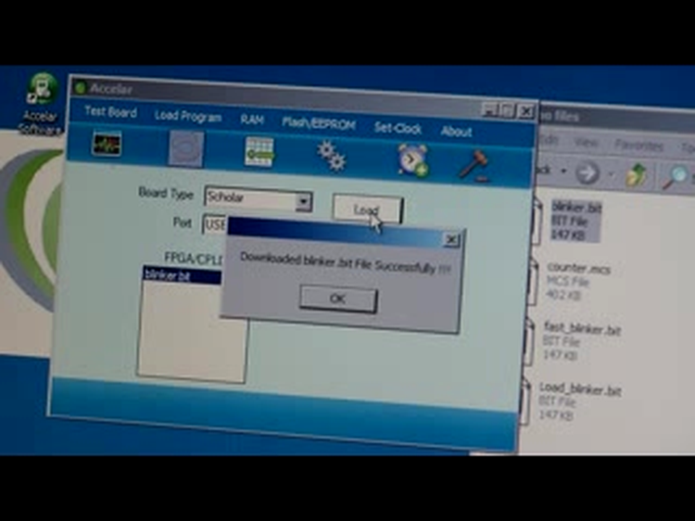
Fig. 3: Accelar's Load Program screen after loading blinker.bit onto the Scholar board over USB — the demo folder alongside it also shows fast_blinker.bit and counter.mcs.

Testing
With the bitstream loaded as described above, the LED begins blinking within a second of the board powering up, and continues as long as USB power is present — unplugging and replugging the board reproduces the same behaviour immediately, since the design persists in the onboard flash rather than a volatile configuration memory. Operation was confirmed on video: the red LED is clearly on in some frames and clearly off in others, at intervals consistent with the roughly 0.7 s toggle computed above. The whole build, from unpacking the board to a blinking LED, took under an hour, most of it spent installing ISE WebPACK rather than wiring the breadboard.
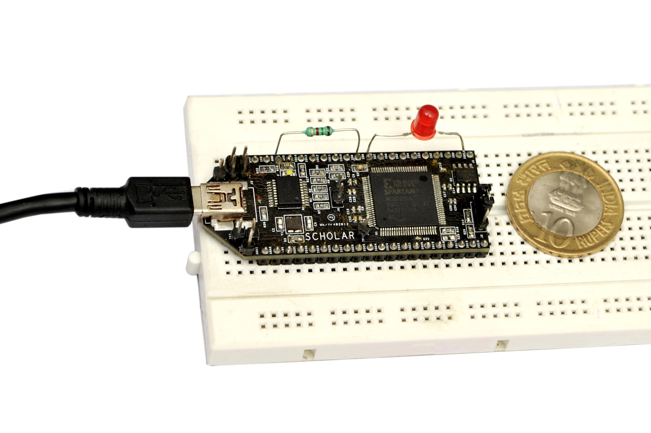
Fig. 4: The Scholar board and its breadboard wiring, shown next to a ₹10 coin for scale.
This is obviously a starting point rather than a destination: the same 20-pin headers that carried IO_CLK here expose 32 general-purpose FPGA I/O pins in total, along with the SDRAM and SPI flash interfaces, which is enough headroom for considerably more involved student projects — a UART, a small state machine, or a soft counter driving a 7-segment display are natural next steps once the toolchain and the pin-out are this well understood.

Author Biography
 | RAMAKUMAR MAYIL DILLI BABU is a Senior Staff Hardware Engineer at Celestica Inc., Texas, USA, where he architects multi-node AI compute rack systems supporting large-scale AI training infrastructure. He has over 23 years of experience in mission-critical hardware design across the aerospace, medical device, networking, and automotive industries, including senior engineering roles at Honeywell Aerospace, Qualcomm, Cisco, Palo Alto Networks, Siemens Healthineers, and GM/Cruise Automation. He is a named co-inventor, among four, of U.S. Patent 11,324,110 B2 (with granted European and Chinese counterparts), covering a temperature-variable circuit-board standoff developed for the Aspire400 satellite data communication unit at Honeywell Aerospace. He is also the founder of Addlek Systems, Bengaluru, maker of the Scholar board used in this article. He holds an M.B.A. from the University of Madras and a B.E. from Bharathidasan University, India, and is a Member of IEEE (ORCID: 0009-0000-1761-4576).

