Laravel mix working, but vite not work.

Need to Downgrade breeze version

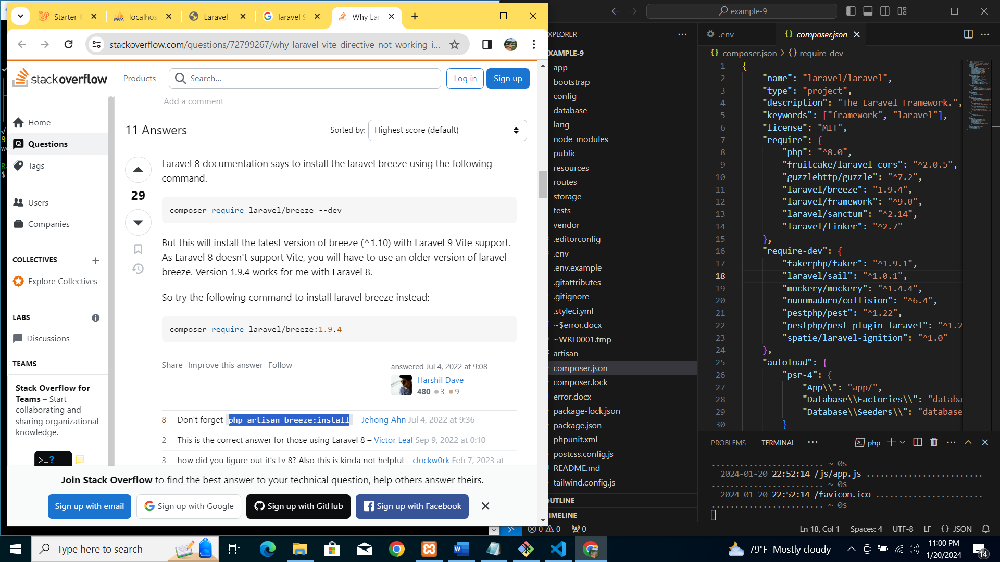

https://stackoverflow.com/questions/72799267/why-laravel-vite-directive-not-working-in-my-project