1. No connection

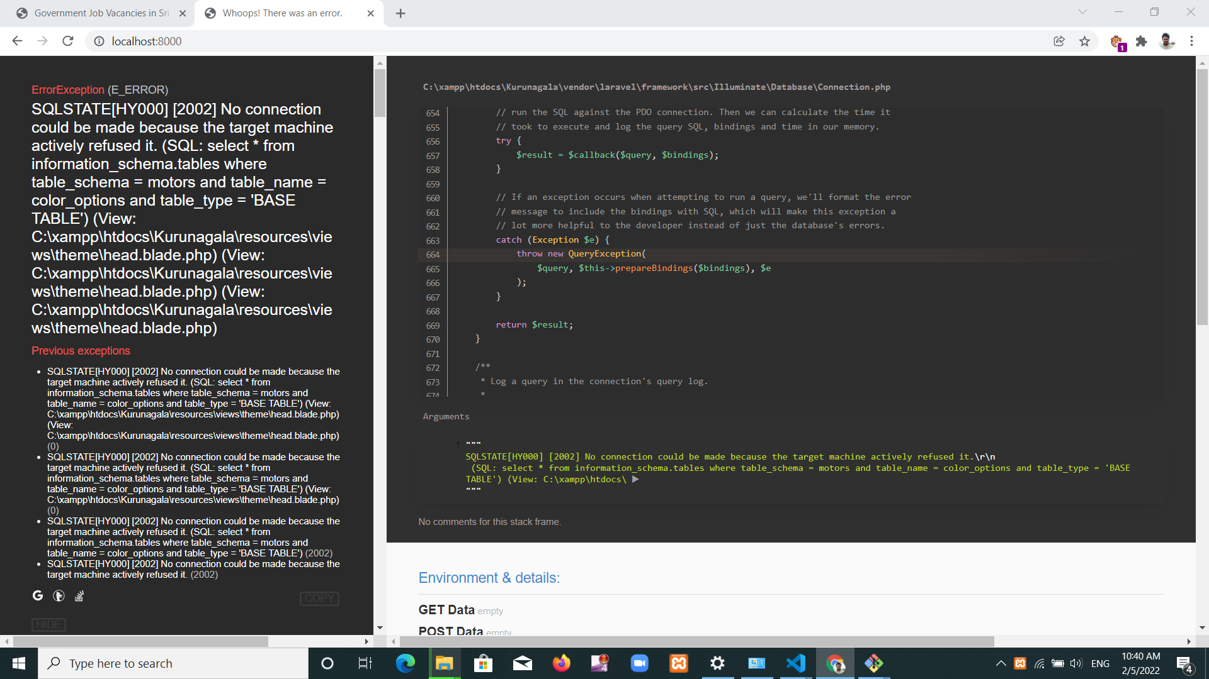

START XAMPP

1. Gsetting

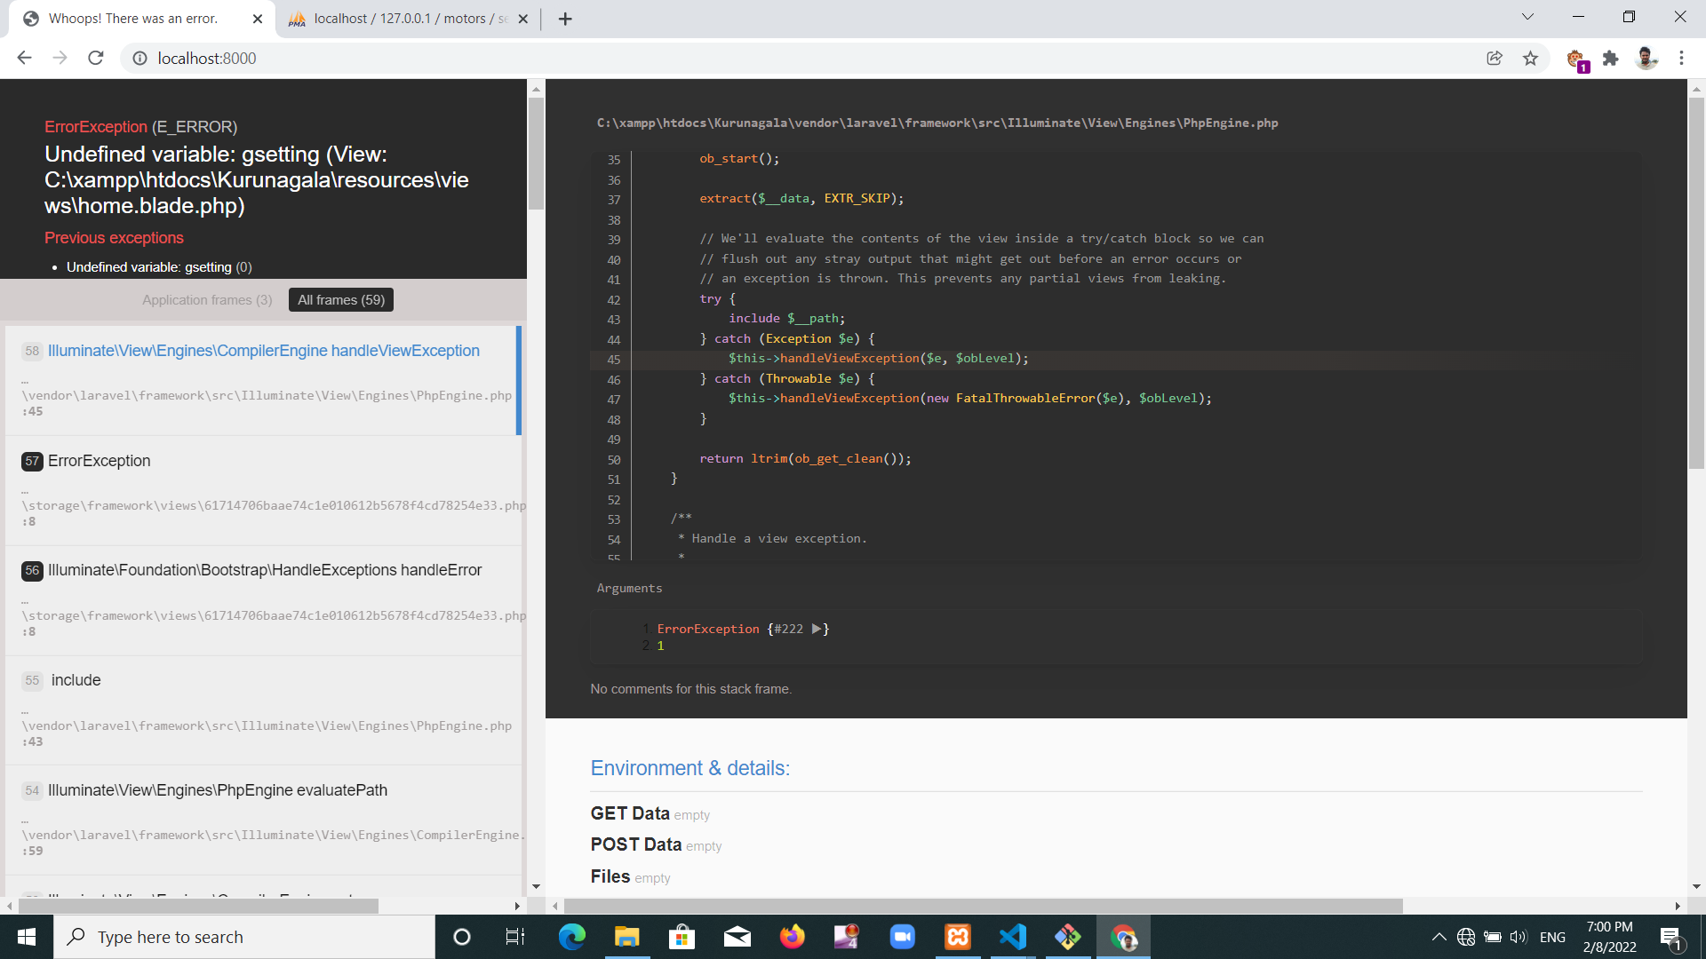

php artisan db:seed

1. Undifine variable

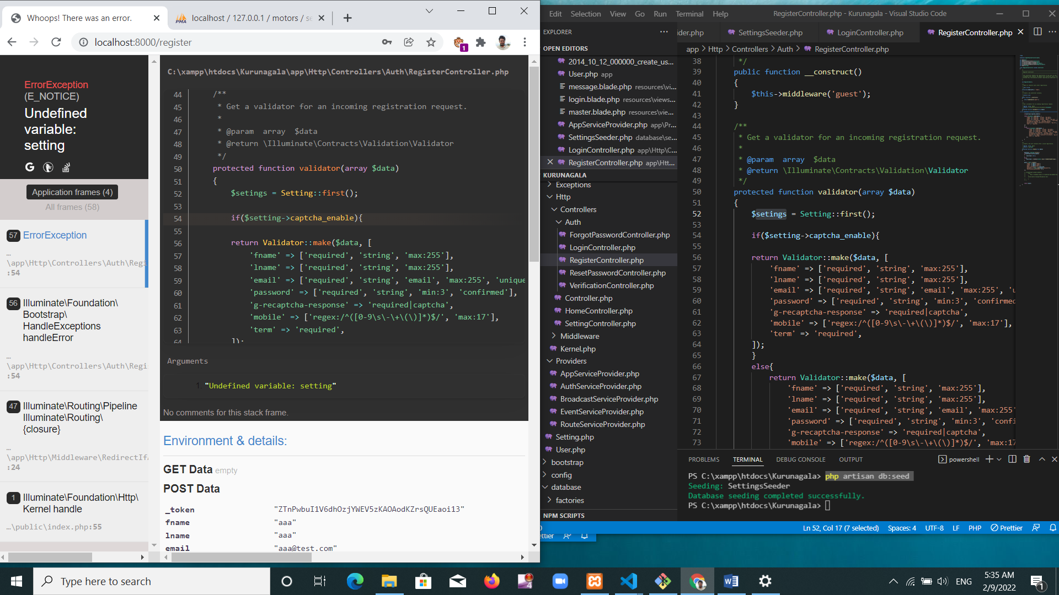

syntax error , seting = setting

1. Seeding error

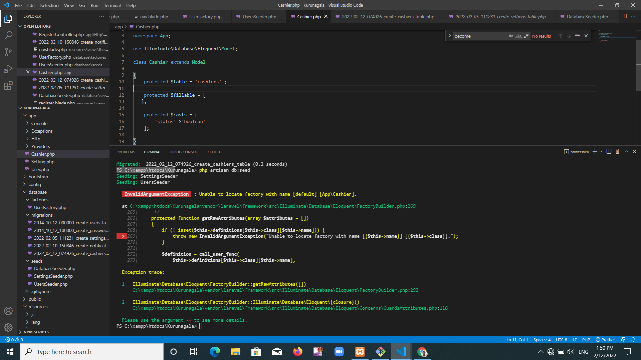

PS C:\xampp\htdocs\Kurunagala> php artisan db:seed

Seeding: SettingsSeeder

Seeding: UsersSeeder

InvalidArgumentException : Unable to locate factory with name [default] [App\Cashier].

at C:\xampp\htdocs\Kurunagala\vendor\laravel\framework\src\Illuminate\Database\Eloquent\FactoryBuilder.php:269

265| */

266| protected function getRawAttributes(array $attributes = [])

267| {

268| if (! isset($this->definitions[$this->class][$this->name])) {

> 269| throw new InvalidArgumentException("Unable to locate factory with name [{$this->name}] [{$this->class}].");

270| }

271|

272| $definition = call_user_func(

273| $this->definitions[$this->class][$this->name],

Exception trace:

1 Illuminate\Database\Eloquent\FactoryBuilder::getRawAttributes([])

C:\xampp\htdocs\Kurunagala\vendor\laravel\framework\src\Illuminate\Database\Eloquent\FactoryBuilder.php:292

2 Illuminate\Database\Eloquent\FactoryBuilder::Illuminate\Database\Eloquent\{closure}()

C:\xampp\htdocs\Kurunagala\vendor\laravel\framework\src\Illuminate\Database\Eloquent\Concerns\GuardsAttributes.php:116 es.php:116

Please use the argument -v to see more details.

1. Route Cashier.index not found

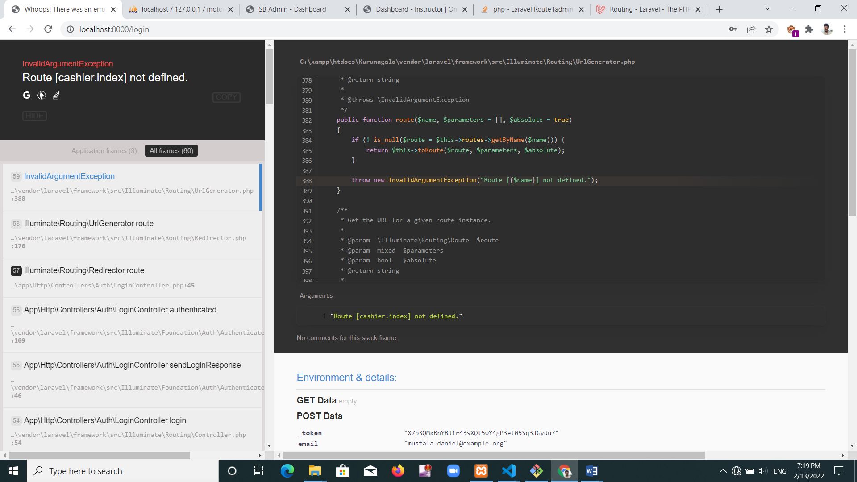

Web.php = php artisan route:list

Need to use same capital, simple letters in web.php and controller

<https://stackoverflow.com/questions/58300968/laravel-route-admin-home-index-not-defined/71101223#71101223>

1. Reset email button not work 404 error

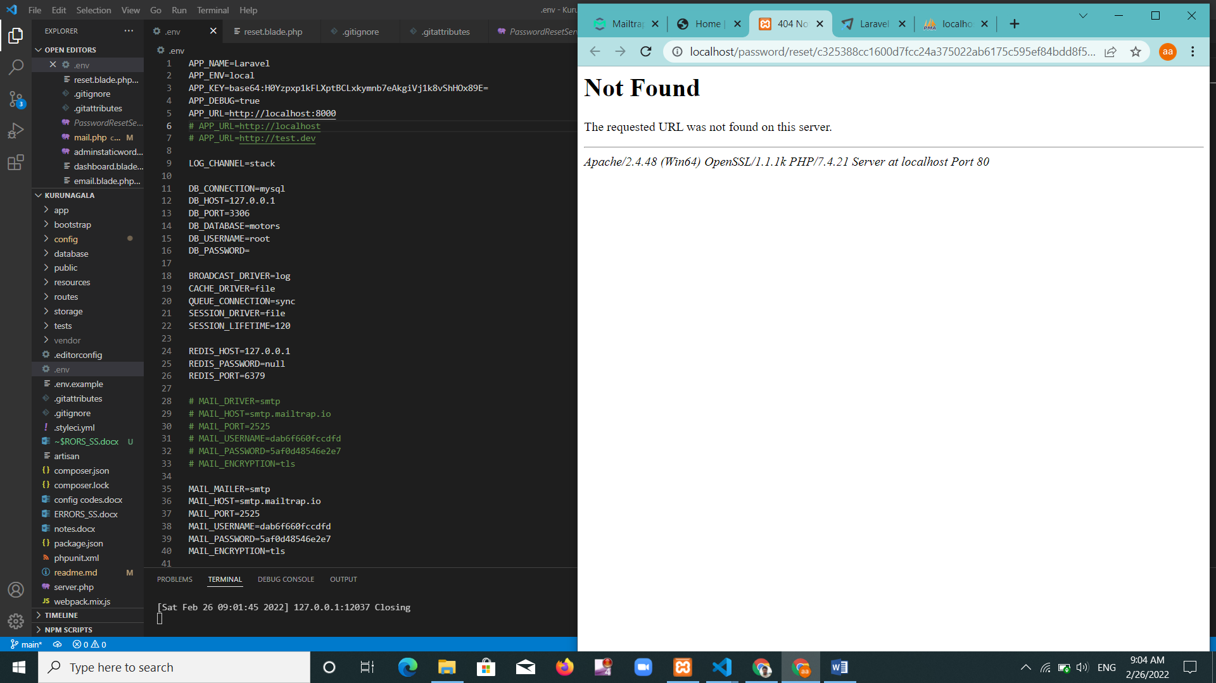not only https//localhost .need “ https//localhost:8000

1. Auth error

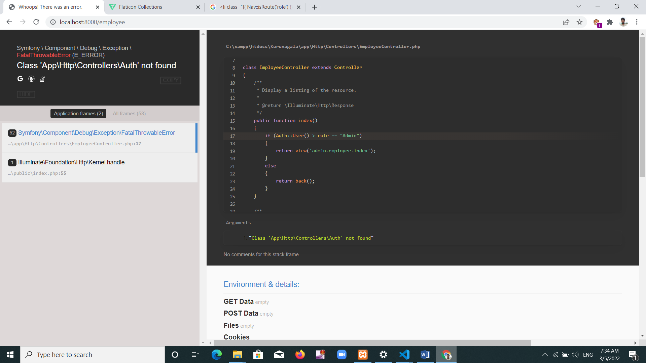

Use Auth ===🡺 AbcdController.php

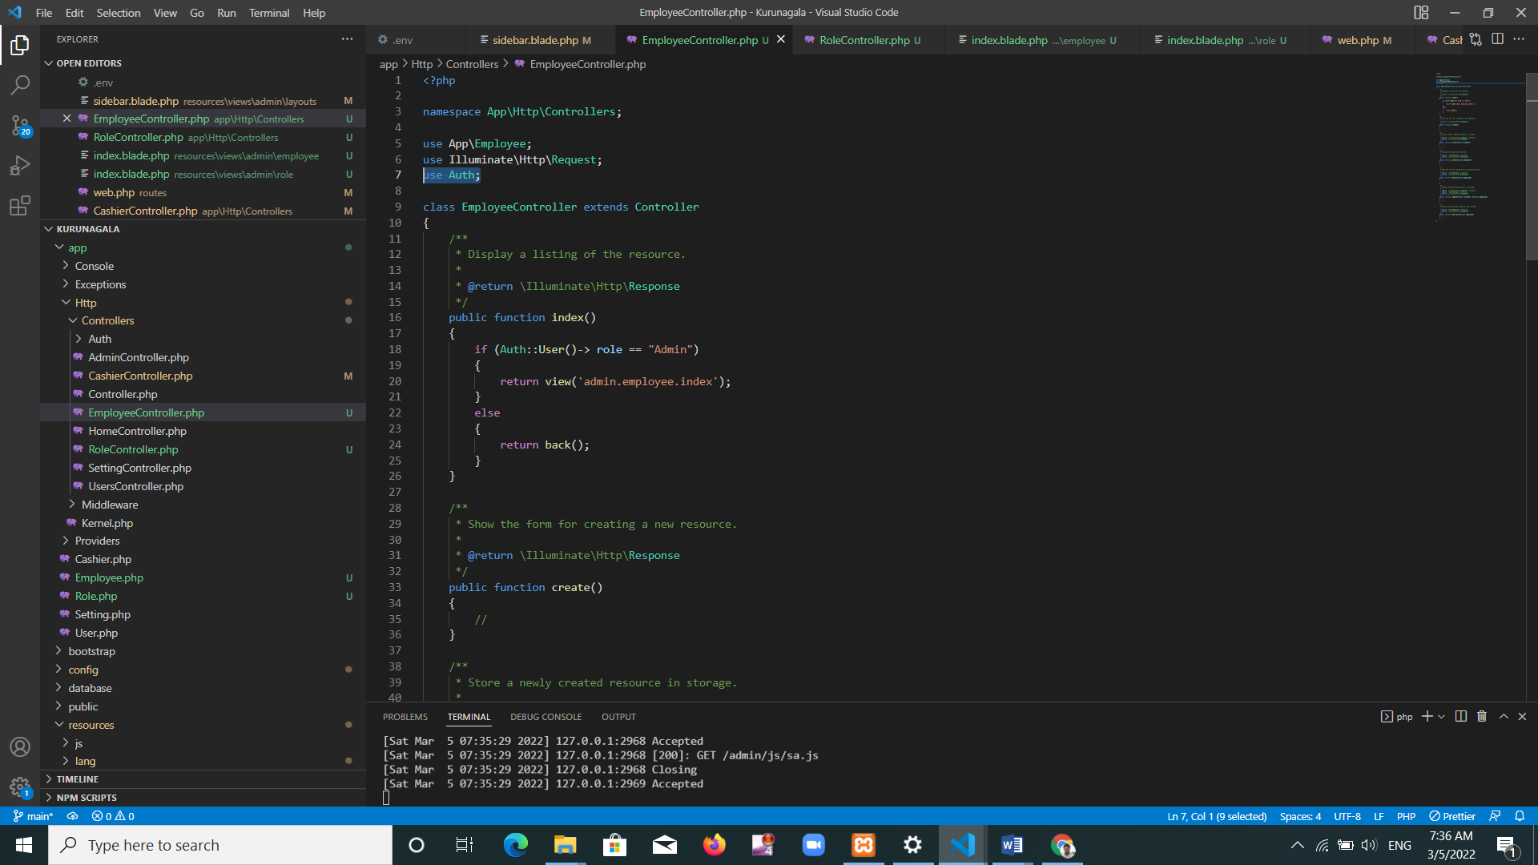

Database mobile null

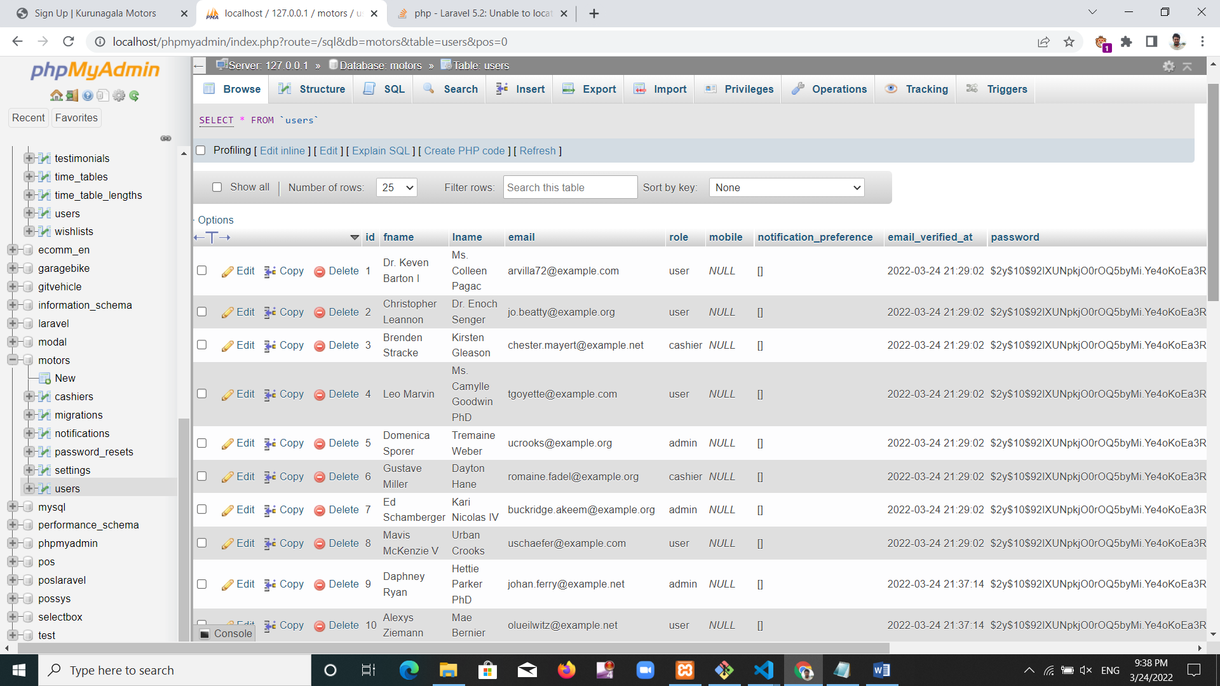

1. Db seed error

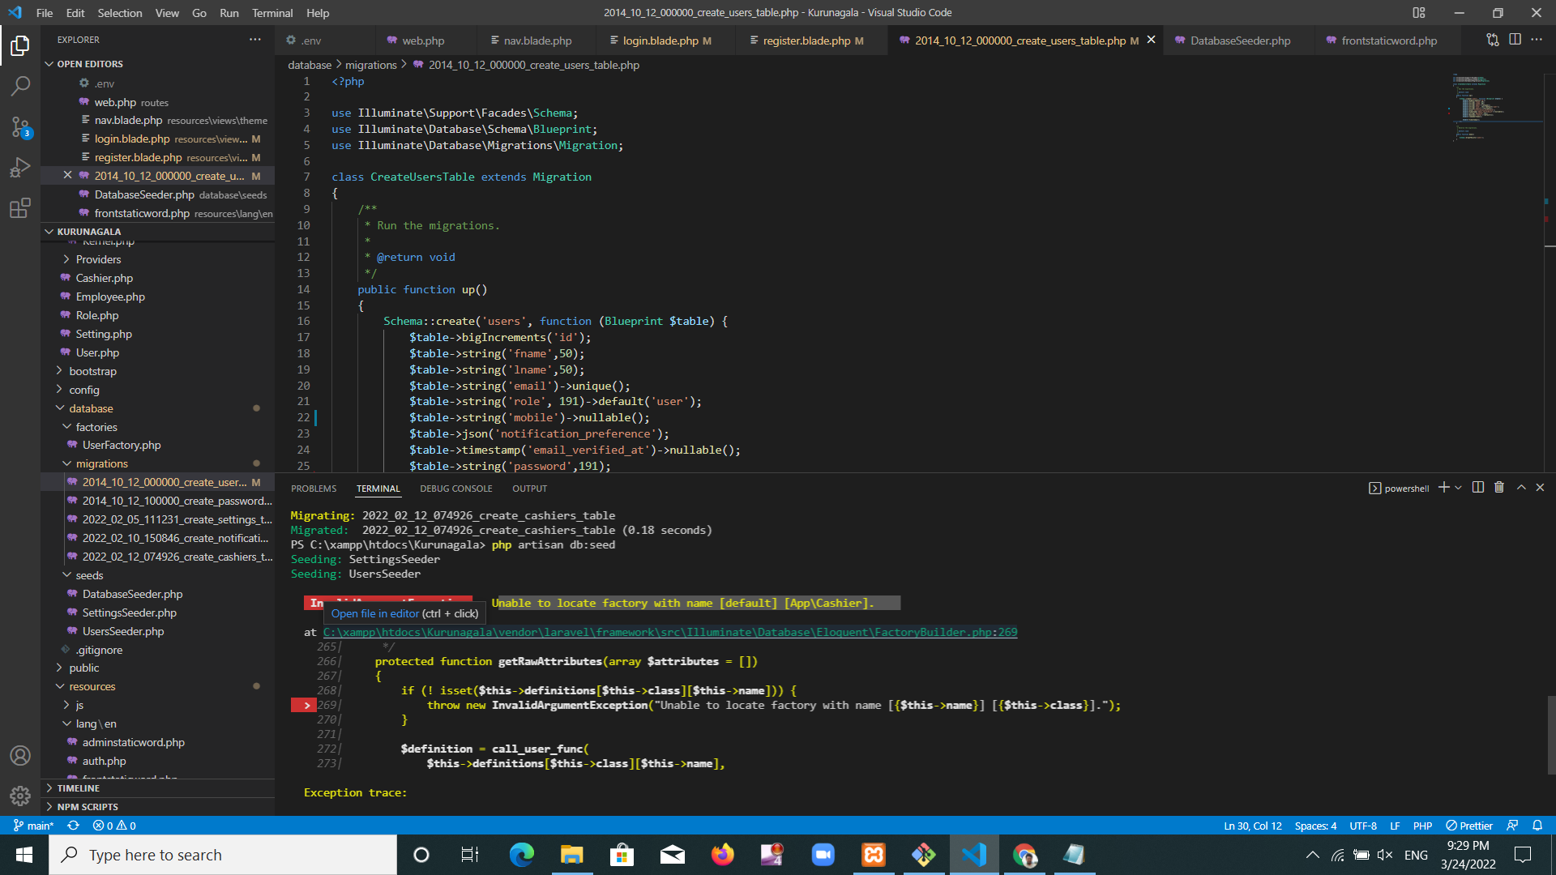

edit employee image . need to add role for role id

