Town(country) & cities conect

Provinces(continent)

[SELECT](http://localhost/phpmyadmin/url.php?url=https://dev.mysql.com/doc/refman/8.0/en/select.html) towns.id AS id, towns.name AS name, towns.image AS image, towns.population AS population, towns.territory AS territory, towns.description AS description, [AVG](http://localhost/phpmyadmin/url.php?url=https://dev.mysql.com/doc/refman/8.0/en/aggregate-functions.html%23function_avg)(cities.price) AS avg_price FROM towns JOIN cities ON towns.id = cities.town_id GROUP BY(cities.town_id);

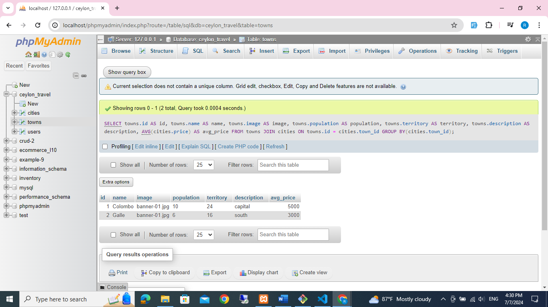

CITY TABLE CONNECT TO BOOKING TABLE

SELECT cities.id AS id, cities.name AS name, cities.image AS image,cities.trip_days AS trip_days, cities.price AS price,

COUNT(bookings.city_id) AS city_id FROM cities

JOIN bookings ON cities.id = bookings.city_id GROUP BY(bookings.city_id);

Count cities bookings

[SELECT](http://localhost/phpmyadmin/url.php?url=https://dev.mysql.com/doc/refman/8.0/en/select.html) [COUNT](http://localhost/phpmyadmin/url.php?url=https://dev.mysql.com/doc/refman/8.0/en/aggregate-functions.html%23function_count)(bookings.city_id) AS count_bookings FROM cities JOIN bookings ON cities.id = bookings.city_id;

