LCG white water rafting

Site Plan

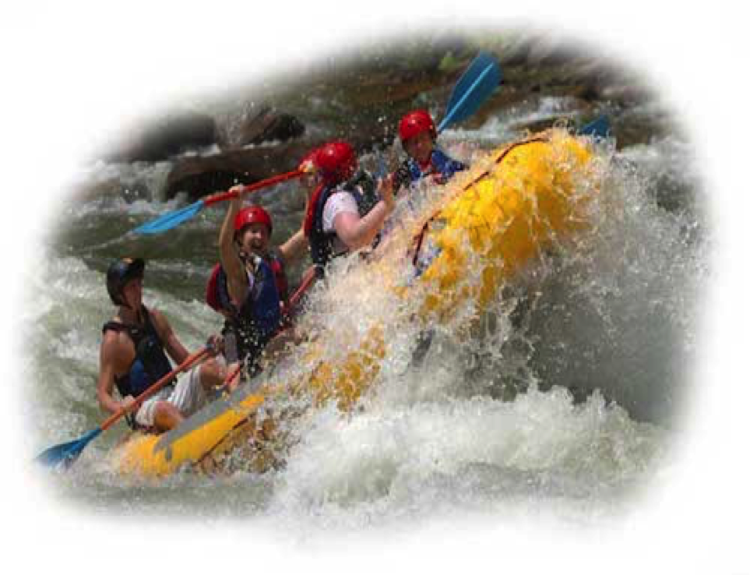

Raul Laredo

WDD100-5

**Overview**

**Site Purpose**

The main purpose for LCG White Water Rafting web page will be to create a digital presence to take advantage of news technologies and opportunities on the Internet. The main purpose of the website will be:

Build revenues for the existing business trying to attract new customers of the new generations, since they are used to surf on Internet and at the same time they are the main market, creating a large percentage of our sales. With a modern design, we want to compete in the rafting market, and that tool will be one of the most important weapons in the company’s digital plans.

**Target Audience**

The audience for our website are young people who want to enjoy life, between eighteen and thirty years old and with job. Normally our target lives with their parents, and this situation allows them to have enough money for the services of the company. They don’t have still either duties or responsibilities. Our audience is used to surf on mobile devices and because of this situation our website must be responsive. They are usually men and enjoy with adrenaline and danger.

## Branding

### Website Logo



Color Palette

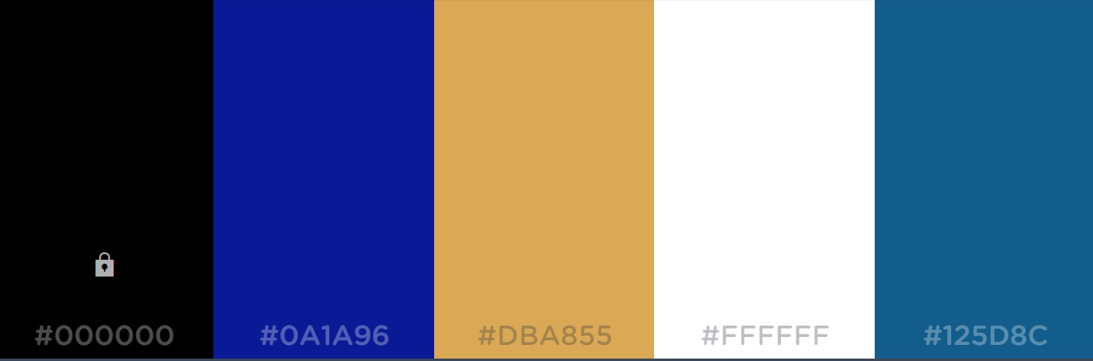

|  |  |  |  |  |
| --- | --- | --- | --- | --- |
| **Primary** | **Secondary** | **Accent** | **Accent** | **Accent** |
| #000000 | #0A1A96 | #DBA855 | #FFFFFF | #125D8C |

## Typography

### Heading Font

#### Robot Bold typography from google fonts.

#### ABCDEFGHIJKLMNOPQRSTUVWXYZ abcdefghijklmnopqrstuvwxyz 1234567890!@#$%^&*()_+

#### This is my Sample Heading

### Body Copy Font

#### Robot Ligth typography from google fonts.

ABCDEFGHIJKLMNOPQRSTUVWXYZ  
abcdefghijklmnopqrstuvwxyz  
1234567890!@#$%^&*()_+

This is an example of my sample paragraph. It will show the color, size and style of a paragraph in my website.

## Navigation

### Main Navigation

|  |  |  |
| --- | --- | --- |
| **Home** | About us | Services |

Link:normal : #396E94

Link:hover : #E7C24F

## HTML Elements (optional)

### Links

Link:normal

Link:hover

## Layout

### Site Map

Home

Rivers

About Us

### Wireframes

