Prepare Query — two defects
Environment: QA — https://qagps.tillipay.com/portal/paymentstats
 | Test case | Defect | Gateways seen on
1 | PS-PQ-05 | Having and Execute never recover after Select is emptied | BillPay, MerchantE
2 | PS-PQ-13 | Execute straight after Cancel queries what the panel no longer shows | BillPay

1. PS-PQ-05 — Having and Execute never recover after Select is emptied
Module: Payment Analytics → Payment Stats → Prepare Query Priority: High Environment: QA — https://qagps.tillipay.com/portal/paymentstats Date observed: 22 September 2026
Summary
Emptying the Select field correctly disables Group, Having and Execute.
Putting the Select fields back does not bring them all back. Group becomes usable again, but Having stays greyed out and Execute stays disabled. From that point the panel cannot be used at all — there is no way to build or run a query without leaving the page.
Steps to reproduce
1. Sign in to the customer portal. 2. Go to Payment Analytics → Payment Stats from the sidebar. 3. Expand Prepare Query. 4. Note that Select and Group are pre-filled and Execute is enabled. 5. Remove every chip from the Select field, one by one, using the small x on each chip. 6. Observe Group, Having and Execute — all three are now disabled. *(This part is correct.)* 7. Add the Select fields back from the dropdown. 8. Observe Having and Execute.
Expected result
Step 6 of the written case: *"Add one Select field back and verify Group becomes usable again."*
The panel should return to a working state. Once Select has fields again, Group, Having and Execute should all be usable, exactly as they were when the panel was opened.
Actual result
Control | After emptying Select | After adding Select fields back
Group | disabled | usable again — correct
Having (3 dropdowns) | disabled | still disabled — wrong
And/Or | disabled | still disabled — wrong
Execute | disabled | still disabled — wrong

Only Group recovers. Having and Execute stay locked, so the query panel is dead until the page is reloaded or the user navigates away and back.
Evidence
Before anything is removed
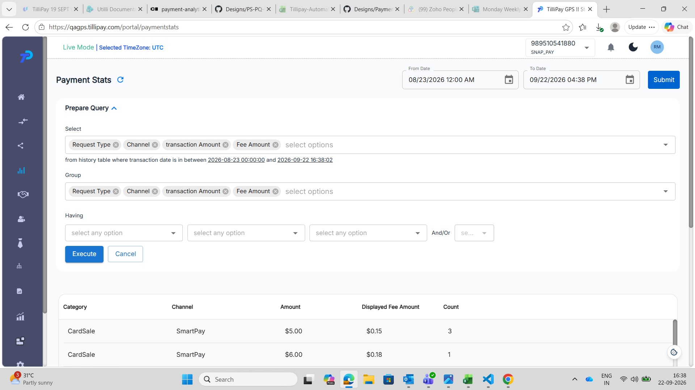
SnapPay (989510541880), 16:38. The panel as it opens. Select and Group each hold all four fields, the three Having dropdowns read "select any option" and are usable, and Execute is blue and clickable. This is the state the panel should return to once Select is refilled.
Select emptied — the intermediate state, which is correct
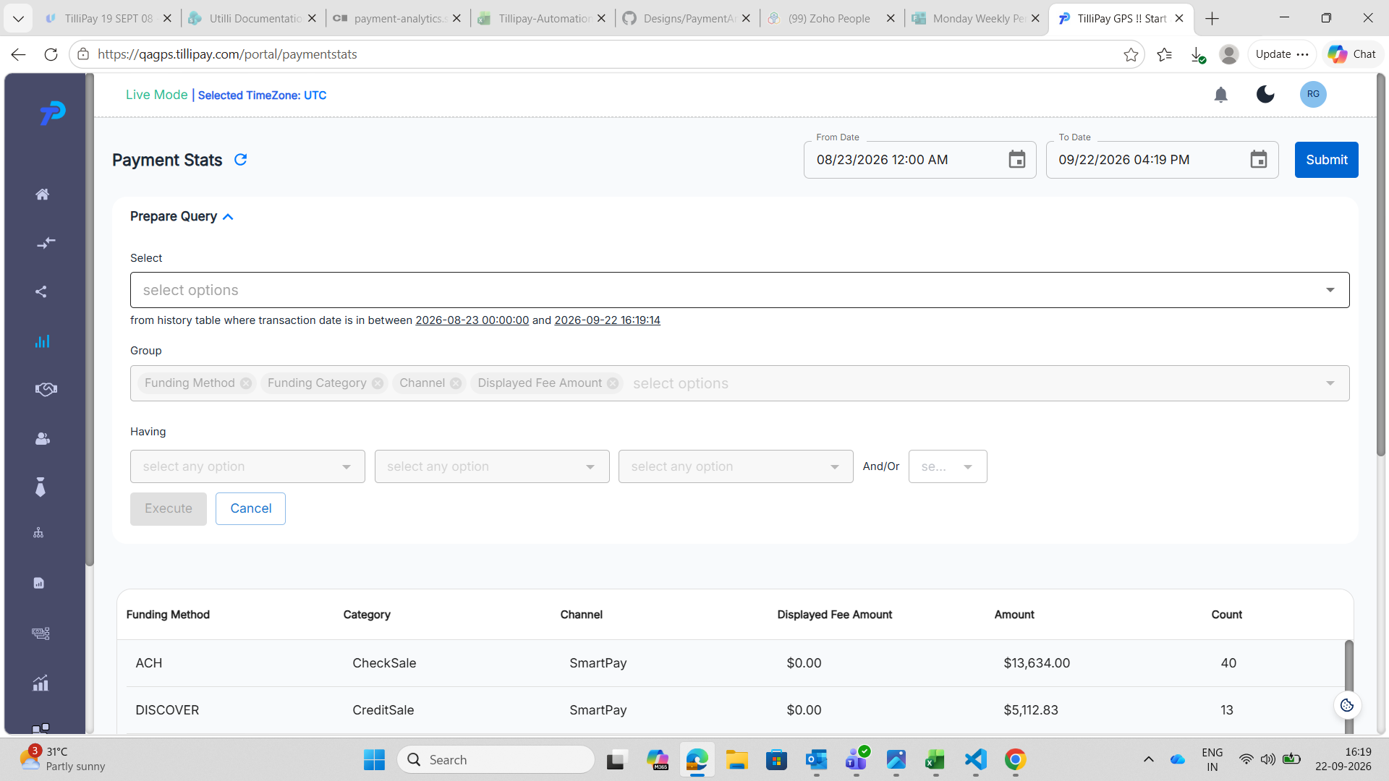
BillPay, 16:19. Select has been emptied and shows only the "select options" placeholder. The Group chips — Funding Method, Funding Category, Channel, Displayed Fee Amount — are greyed, the Having dropdowns are greyed, and Execute is greyed. This is the intermediate state, which is the correct behaviour for an empty Select.
Select refilled — the broken end state
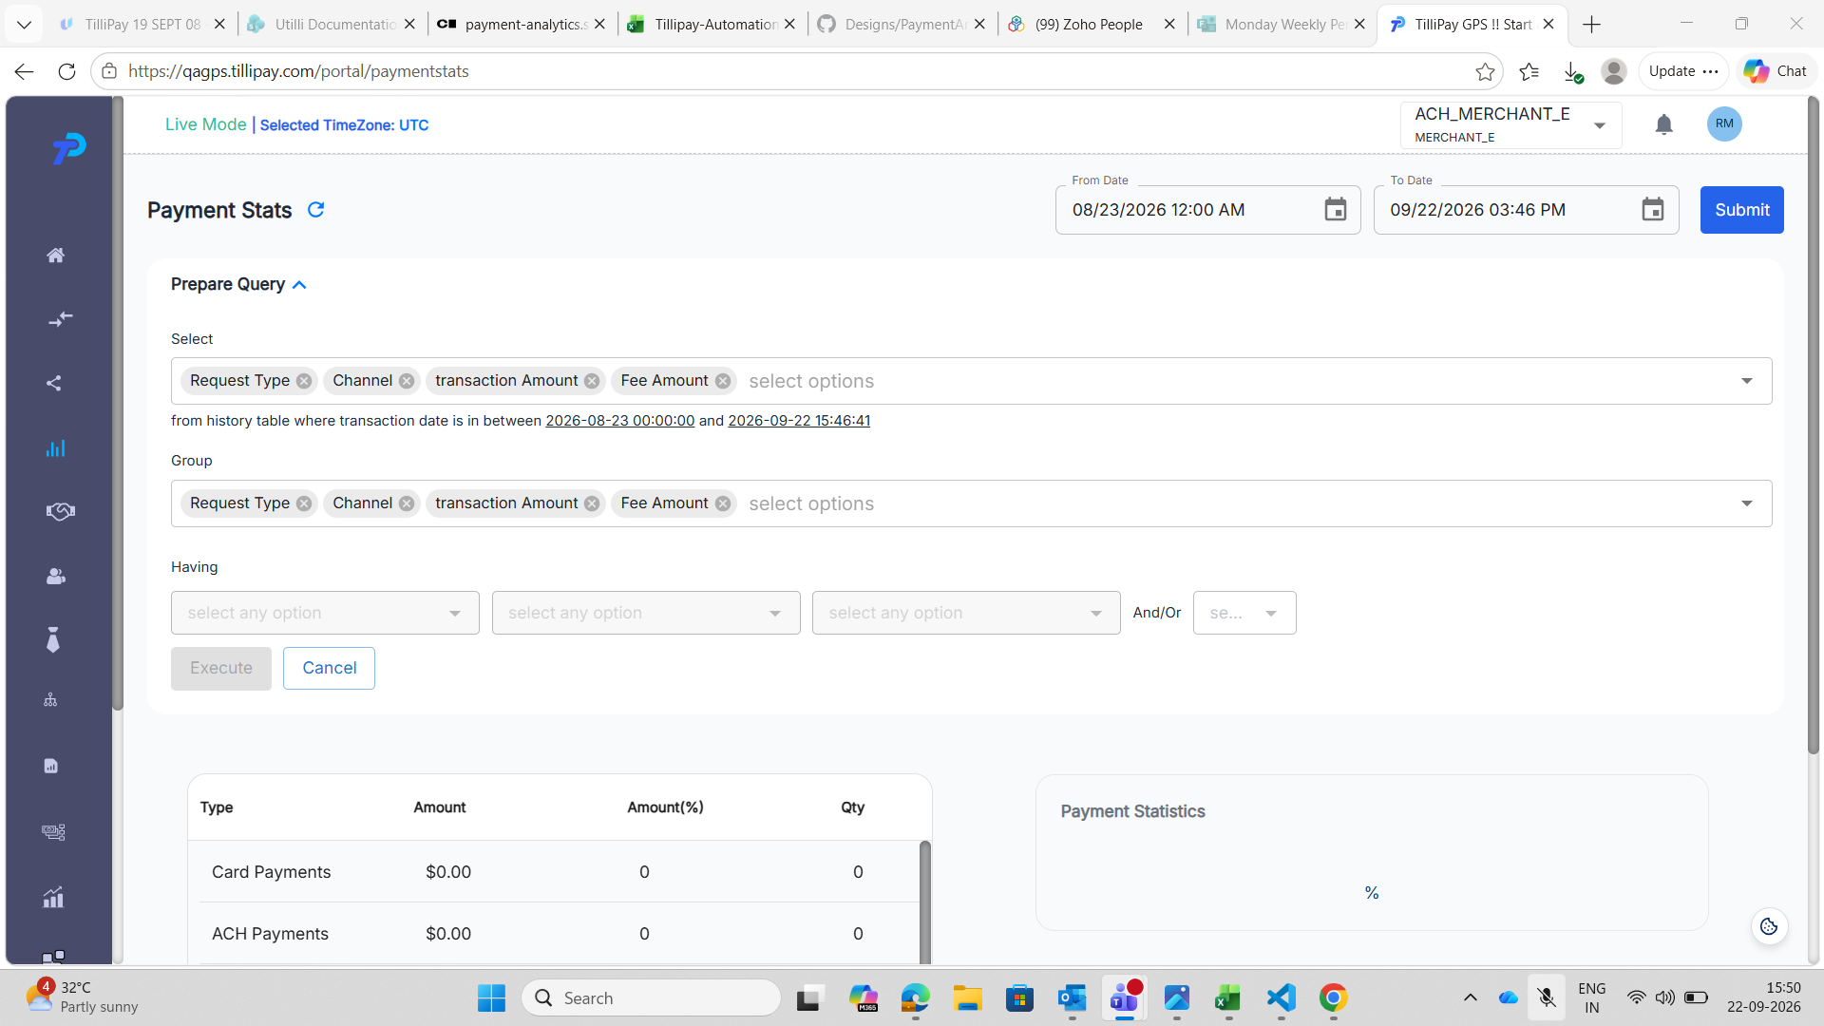
MerchantE (ACH_MERCHANT_E), 15:50. Select holds all four fields — Request Type, Channel, transaction Amount, Fee Amount — and Group holds the same four. Despite the panel being fully populated, all three Having dropdowns and the And/Or dropdown are greyed out, and the Execute button is greyed out while Cancel remains active. This is the state left behind after Select was emptied and refilled.
In every screenshot the date range and the results table below are unaffected, so the page itself is healthy — only the query controls are stuck.
Impact
The Prepare Query panel is the only way a merchant can group or filter their payment statistics. Once this state is reached the feature is unusable for the rest of the visit, and nothing on screen explains why the buttons are dead or how to get them back.
Clearing a field and changing your mind is ordinary behaviour, so this is easy to hit by accident.
Workaround: reload the page, or navigate away and back through the sidebar. The panel opens fresh and works normally.
Notes for the developer
• Group recovering while Having and Execute do not suggests the enable/disable rules for the three controls are evaluated separately, and only Group's is re-checked when Select changes.
• Having and Execute appear to recover only when Group itself is edited, not when Select is.
• Seen on both BillPay and MerchantE, so it is not specific to one gateway's field set.
2. PS-PQ-13 — Execute straight after Cancel queries what the panel no longer shows
Test case: PS-PQ-13 Priority: High Gateway seen on: BillPay Date observed: 23 September 2026
Summary
Cancel restores what is displayed but not the query behind it.
Press Execute straight after Cancel, without touching anything, and the request carries the previous, narrowed field list rather than the one the panel is showing. The table comes back missing a column that the panel still lists as selected.
Steps to reproduce
1. Sign in as the BillPay merchant. 2. Go to Payment Analytics → Payment Stats from the sidebar. 3. Note the column headings in the table. 4. Expand Prepare Query. Select and Group both arrive holding all four fields. 5. Remove one or more chips from Select and press Execute. The table narrows, correctly. 6. Press Cancel. The panel redraws with every field selected again, and the original columns come back. 7. Without changing anything, press Execute.
Expected result
The panel is showing all four fields, so Execute should query all four and the table should match the headings noted in step 3.
Actual result
The request carries only the fields left after step 5. The table drops the column that was removed before Cancel, even though the panel lists it as selected.
 | Select panel shows | select_fields sent
After trimming to two and Execute | 2 chips | funding_method,funding_category — correct
After Cancel | 4 chips | all four — correct
Execute after Cancel | 4 chips | channel,funding_category,funding_method

The last row carries three fields, not four. displayed_fee_amount is missing.
Evidence
Select trimmed — request correct
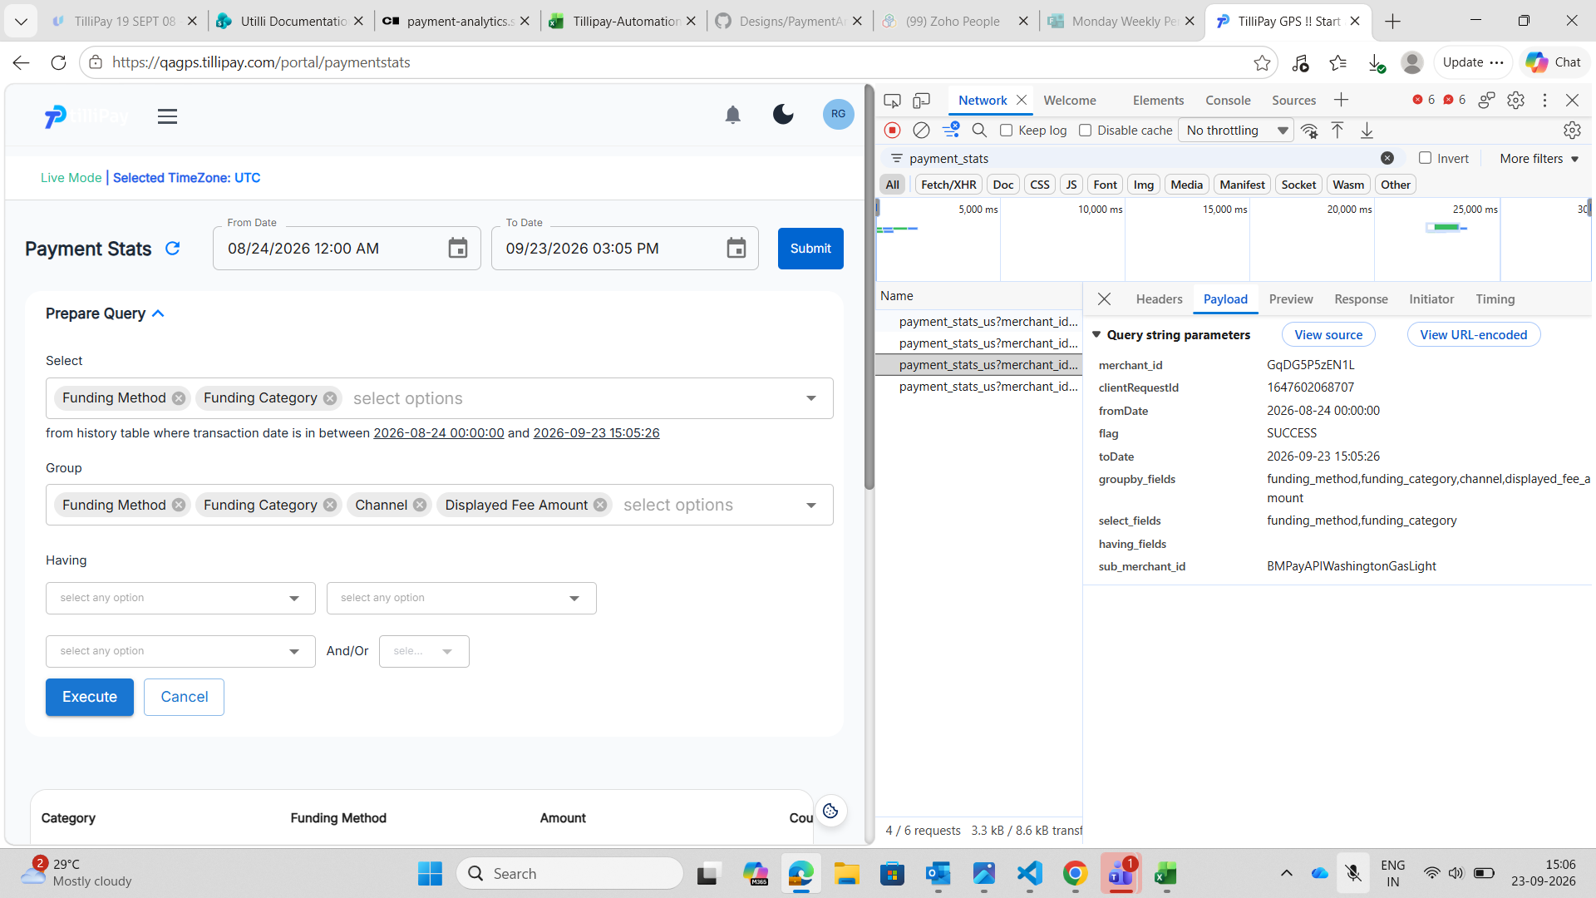
Select trimmed to Funding Method and Funding Category. The request carries exactly those two, and Group still holds four so groupby_fields carries four. Everything matches the panel.
After Cancel — request still correct
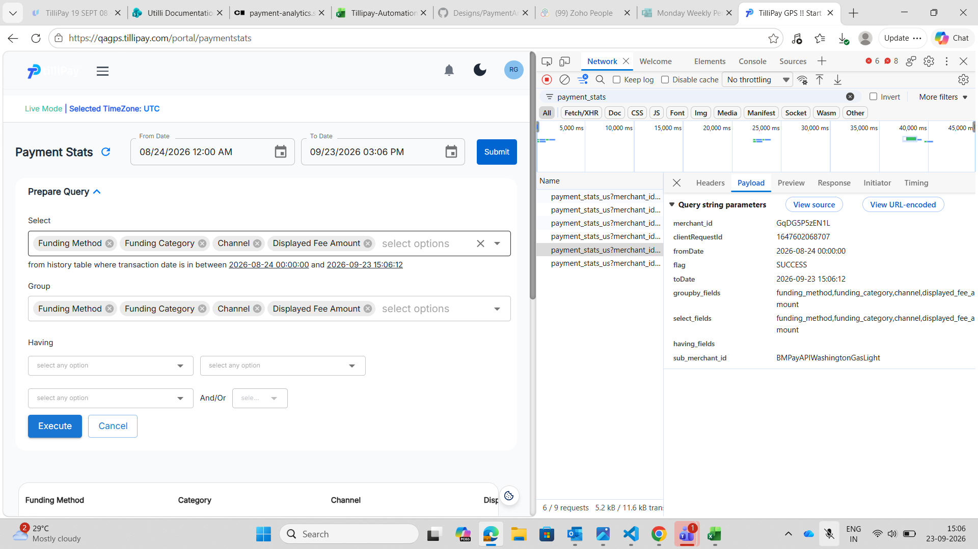
Cancel has restored the panel and the request carries all four fields. Cancel itself is not the problem.
Execute after Cancel — request wrong
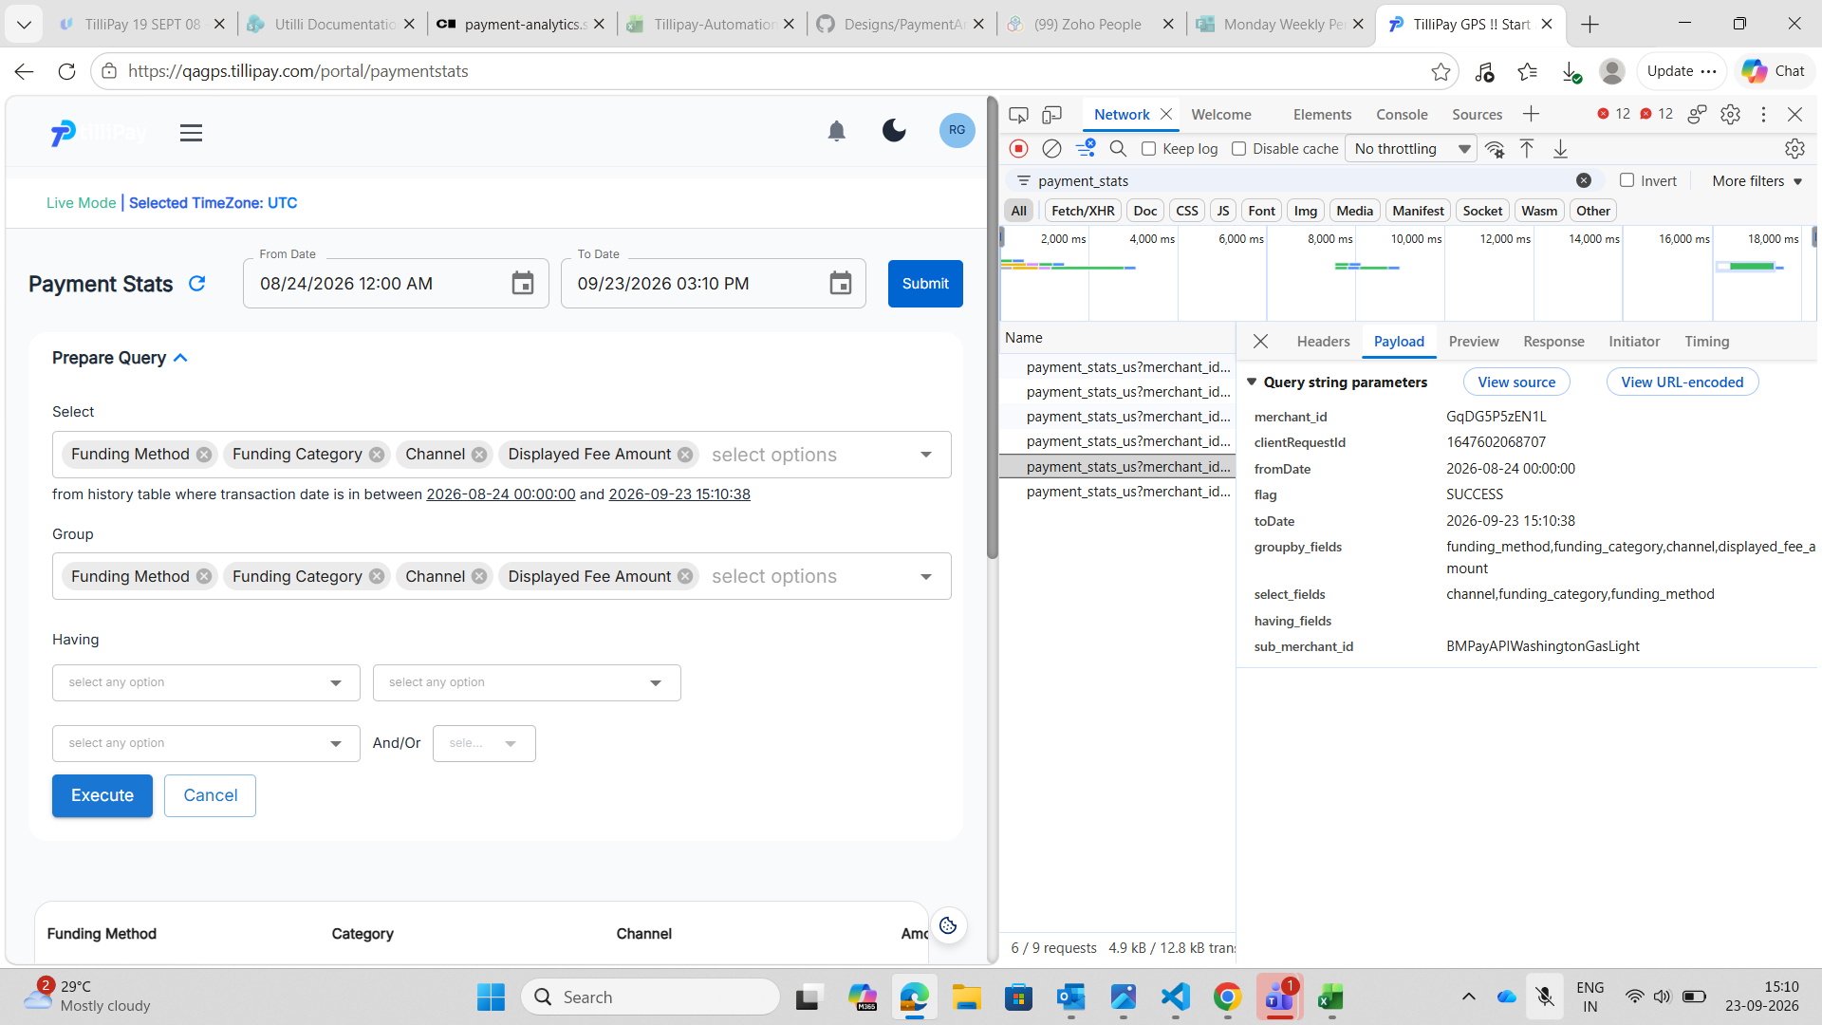
The panel shows all four fields. The request carries three:
select_fields channel,funding_category,funding_method groupby_fields funding_method,funding_category,channel,displayed_fee_amount
displayed_fee_amount is absent from select_fields while still present in groupby_fields, and the table below has lost its Displayed Fee Amount column.
Impact
The merchant is shown a result they did not ask for, with nothing on screen to indicate it. The panel and the table disagree, and the panel is the thing they trust.
Pressing Cancel and then Execute is an ordinary sequence — change your mind, start again — so this is easy to hit without realising.
Workaround: reload the page after Cancel before building a new query.
Notes for the developer
• Cancel redraws the panel and fires a correct default request. The stale state only surfaces on the next Execute, so the fault is in what Execute reads, not in Cancel's own request.
• The returned list is not merely shorter, it is reordered: channel,funding_category,funding_method against the panel's order of Funding Method, Funding Category, Channel, Displayed Fee Amount. A correct request follows the panel order, as the request straight after Cancel does. That points at the field list being rebuilt from some other collection which kept a stale membership and lost the ordering, rather than Cancel failing to clear a flag.
• groupby_fields stays correct throughout. Only select_fields goes stale, which narrows where to look.

