Nudge Dynamic Merge Tags — Gateway Test Cases
Dev test cases proving Payment Link and Payment Reversal merge tags are dynamic across gateways. Each test case: configure tags → trigger → note email (before) → change tag values → trigger again (after). The after email differing — with no code change — proves it is dynamic.

SECTION 1 — Payment Link (per-merchant)
Tags (Tag Name → Tag Value): requestedAmount → amount, tilliPayPaymentUrl → uri, payment_for → payment_for, Customer_Name → customer_name, customer_number → customer_number.

TC-NDT-A1 — IPG
Steps: Admin → Merchants → merchant → Update Merchant Details → Nudge Configuration → Payment Link Request tags → Save. Merchant portal → Share Payment → share link (before). Change tag values → Save → share again (after).
Expected: The After email differs from the Before email (same data, changed mapping) → merge tags are dynamic.
Config — before
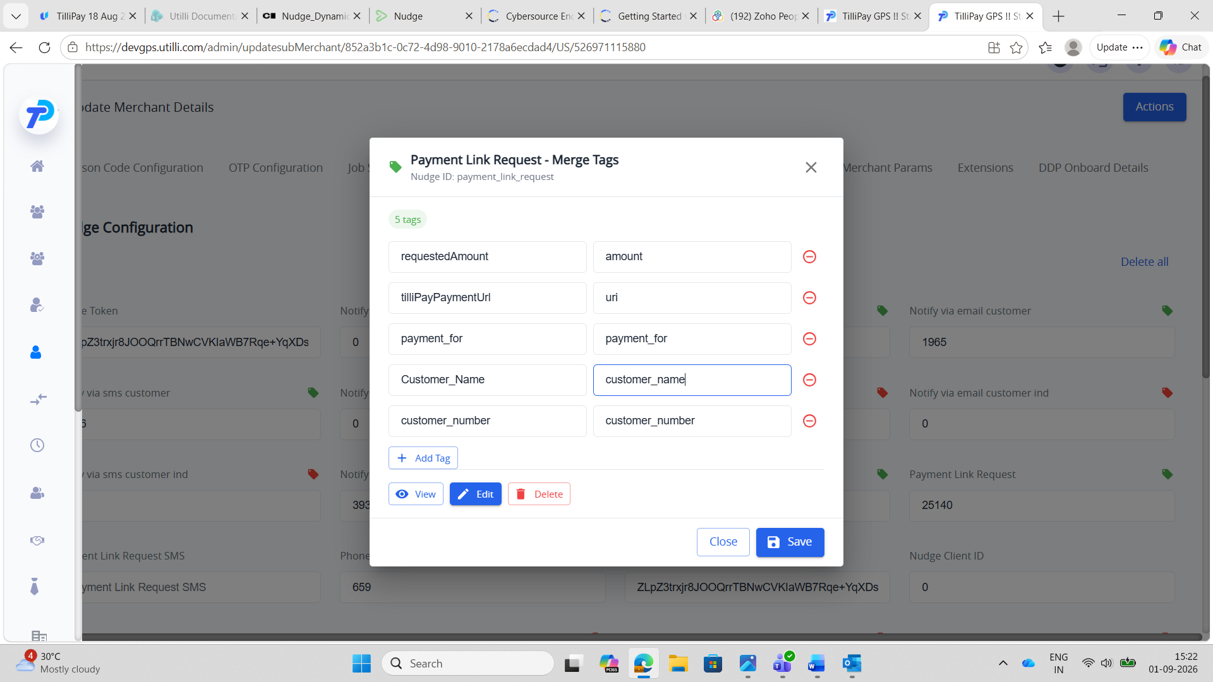
Email — before
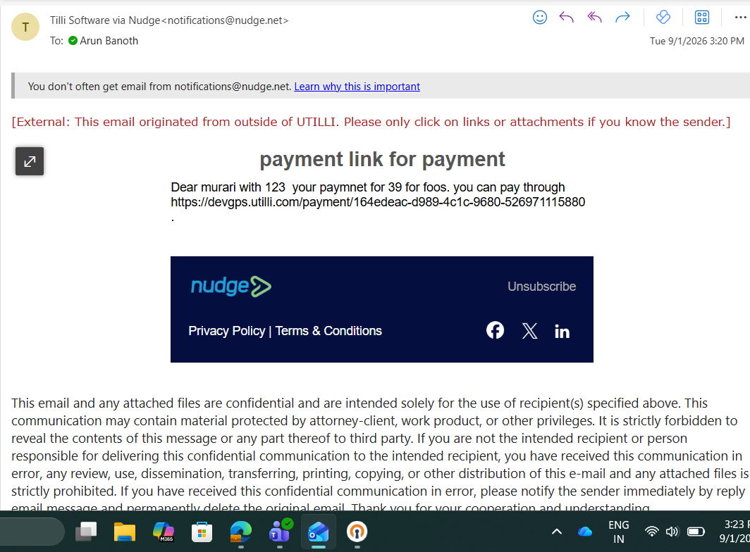
Config — after
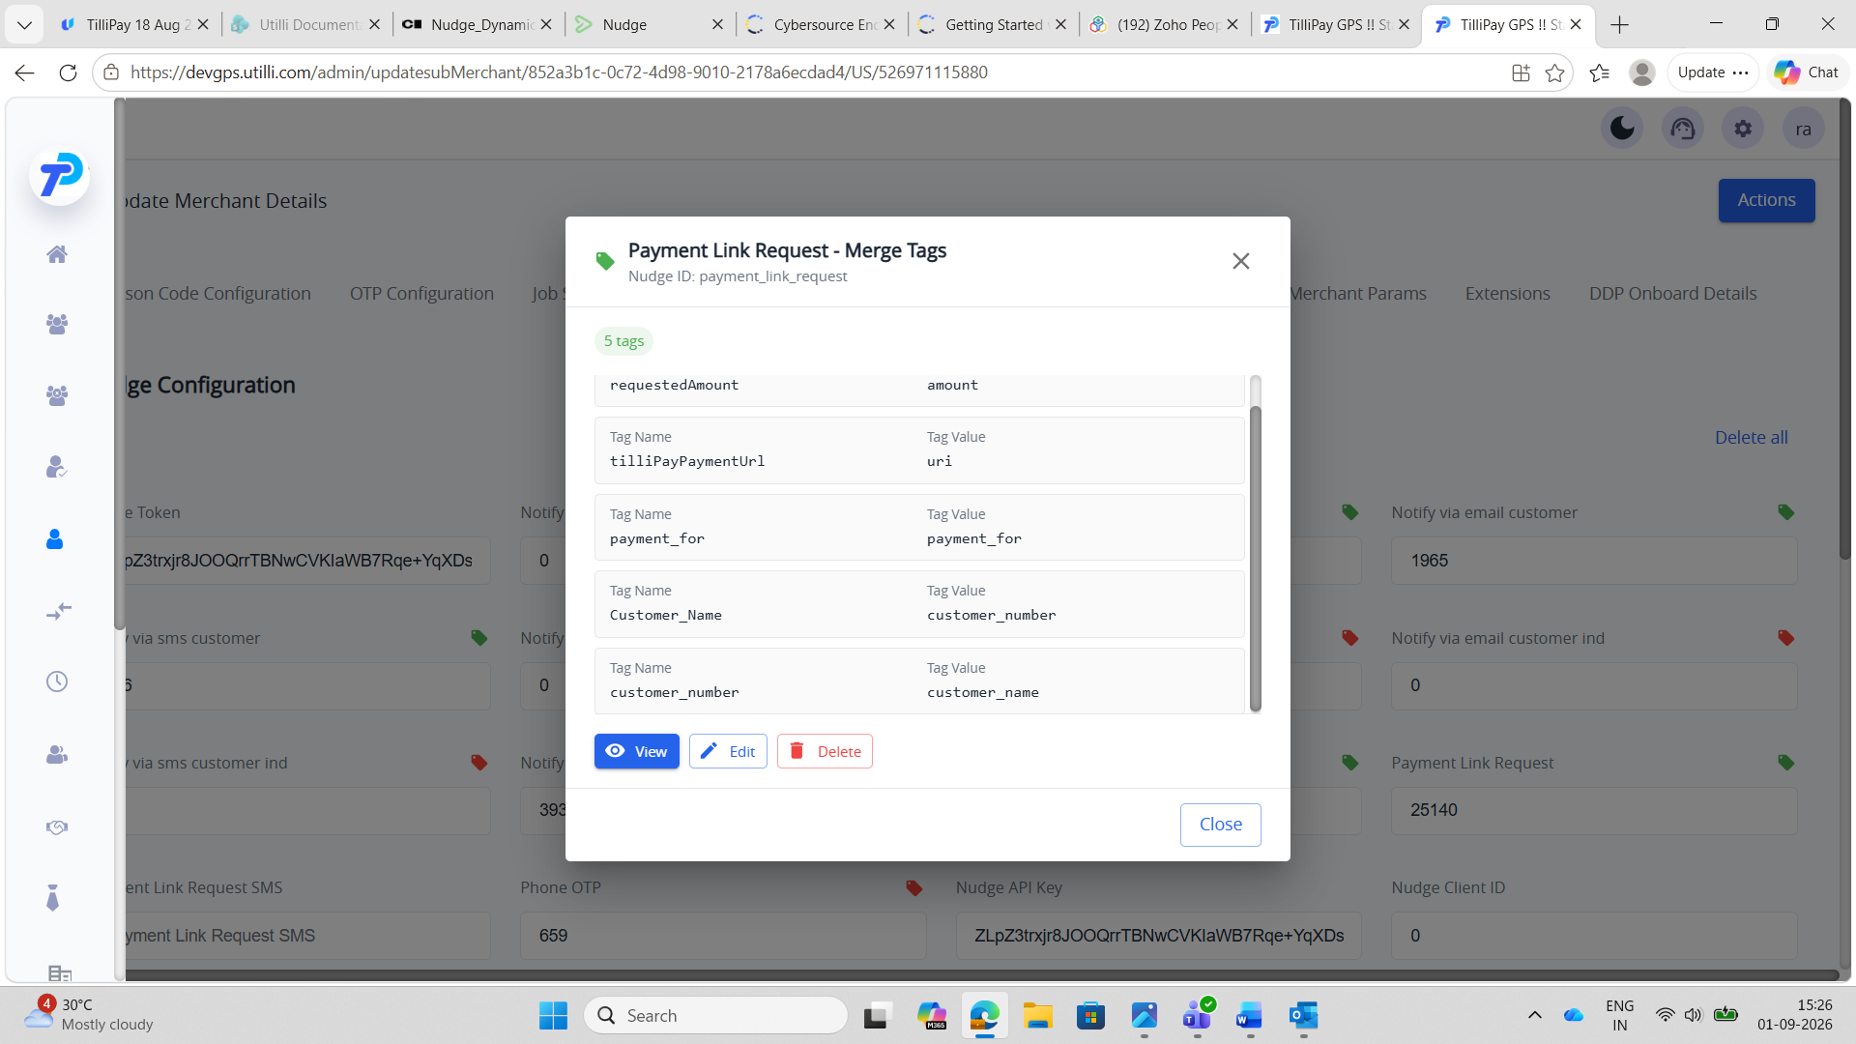
Email — after
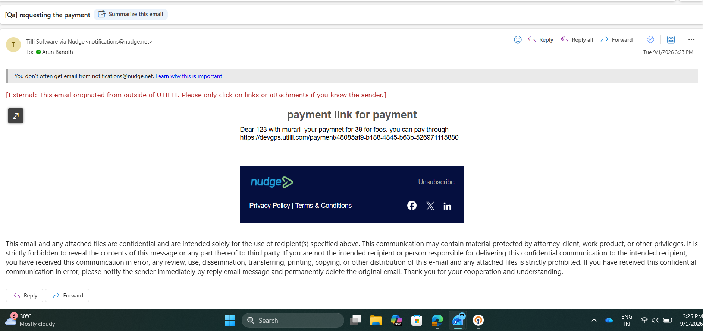

TC-NDT-A2 — SnapPay
Steps: Admin → Merchants → merchant → Update Merchant Details → Nudge Configuration → Payment Link Request tags → Save. Merchant portal → Share Payment → share link (before). Change tag values → Save → share again (after).
Expected: The After email differs from the Before email (same data, changed mapping) → merge tags are dynamic.
Config — before
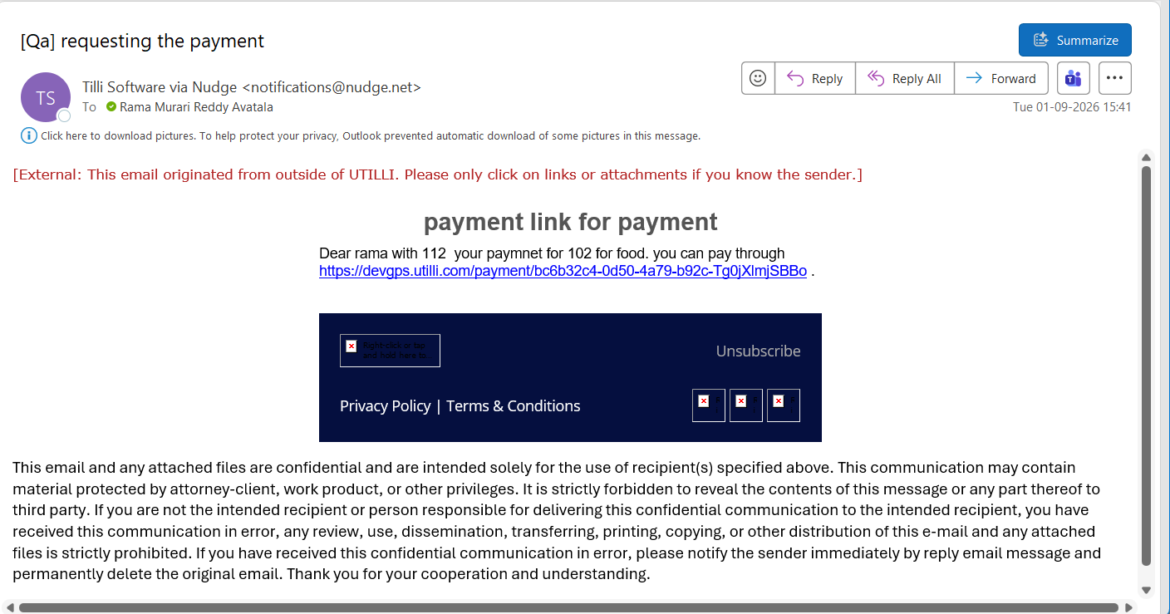
Email — before
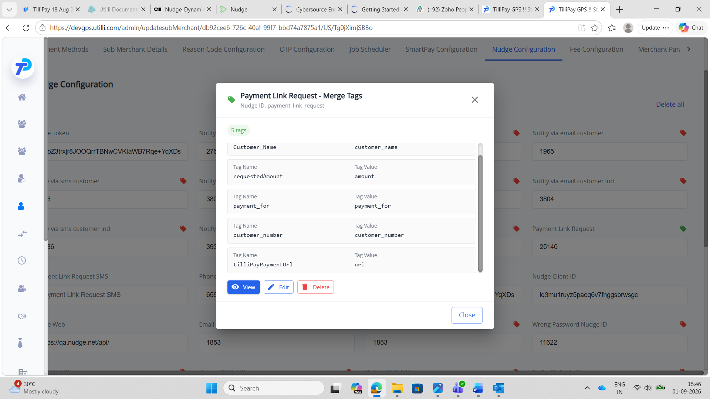
Config — after
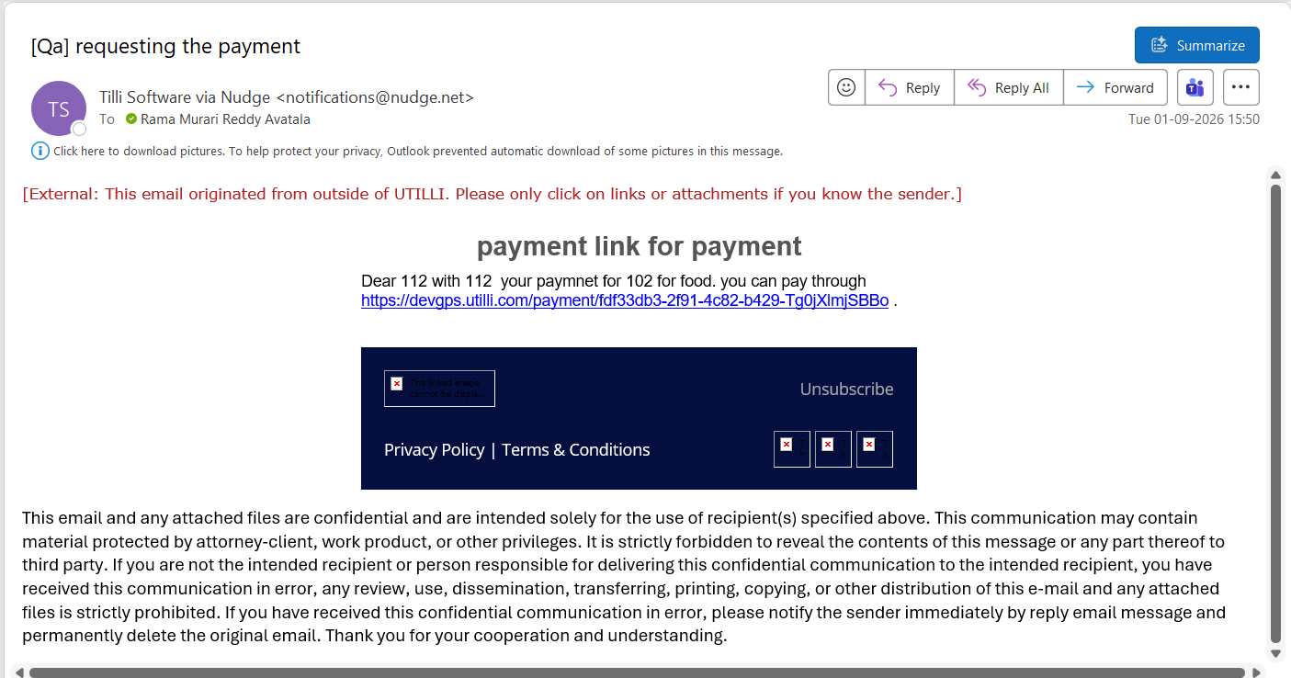
Email — after
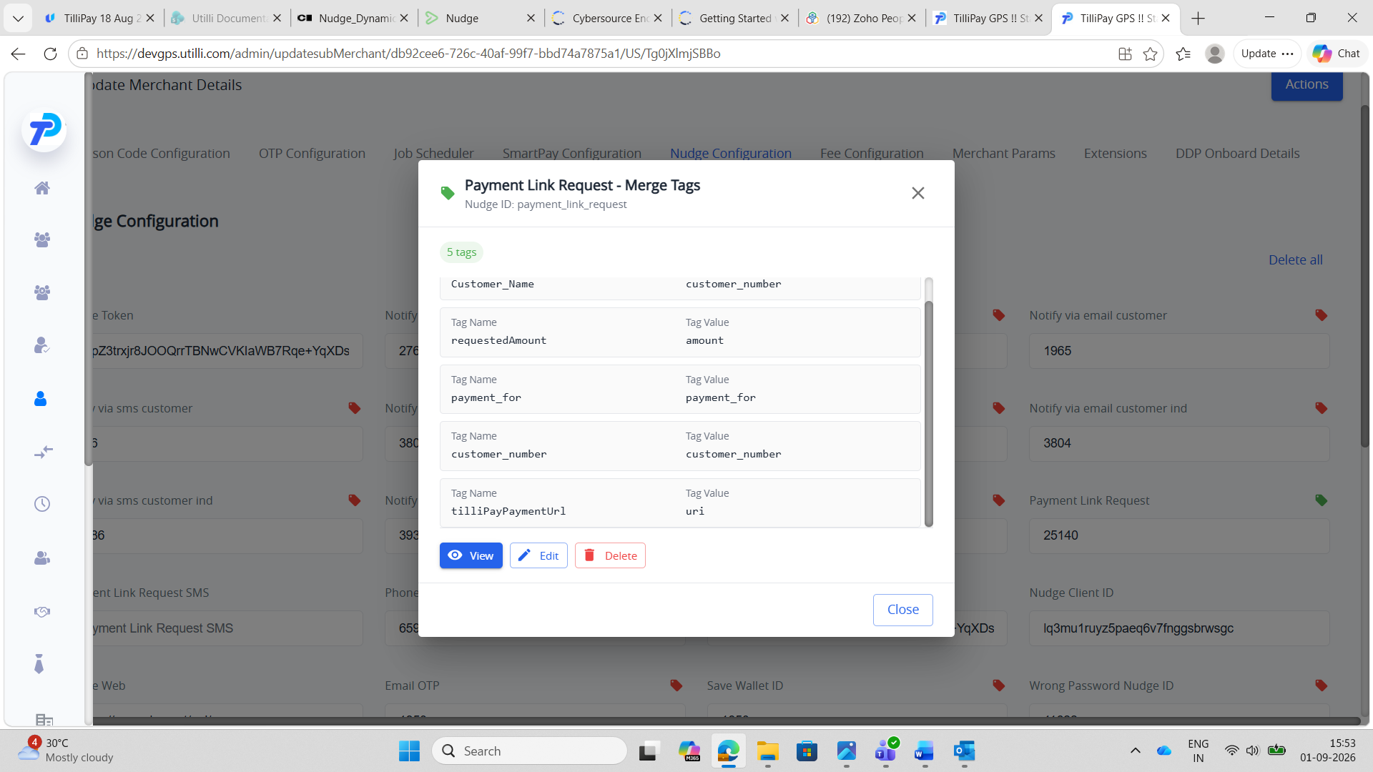

TC-NDT-A3 — Paymentus
Steps: Admin → Merchants → merchant → Update Merchant Details → Nudge Configuration → Payment Link Request tags → Save. Merchant portal → Share Payment → share link (before). Change tag values → Save → share again (after).
Expected: The After email differs from the Before email (same data, changed mapping) → merge tags are dynamic.
Config — before
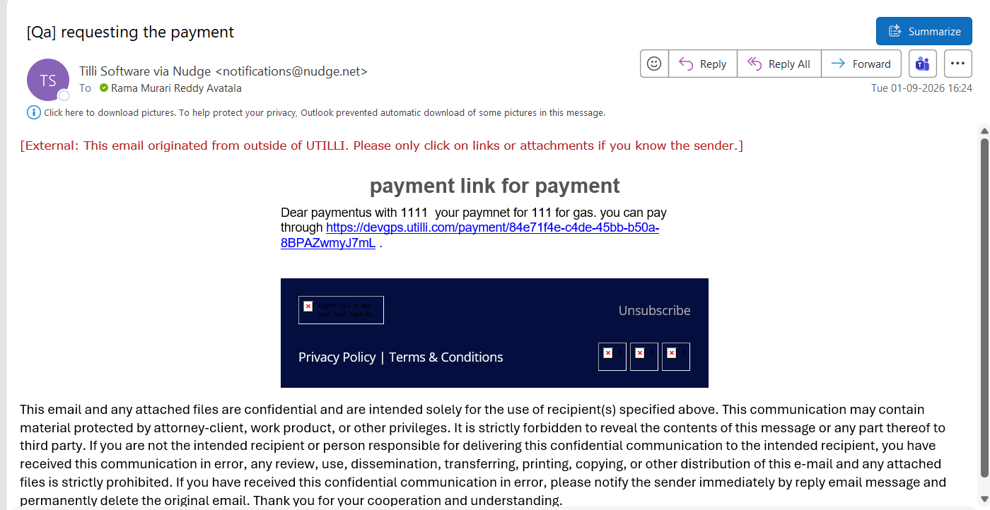
Email — before
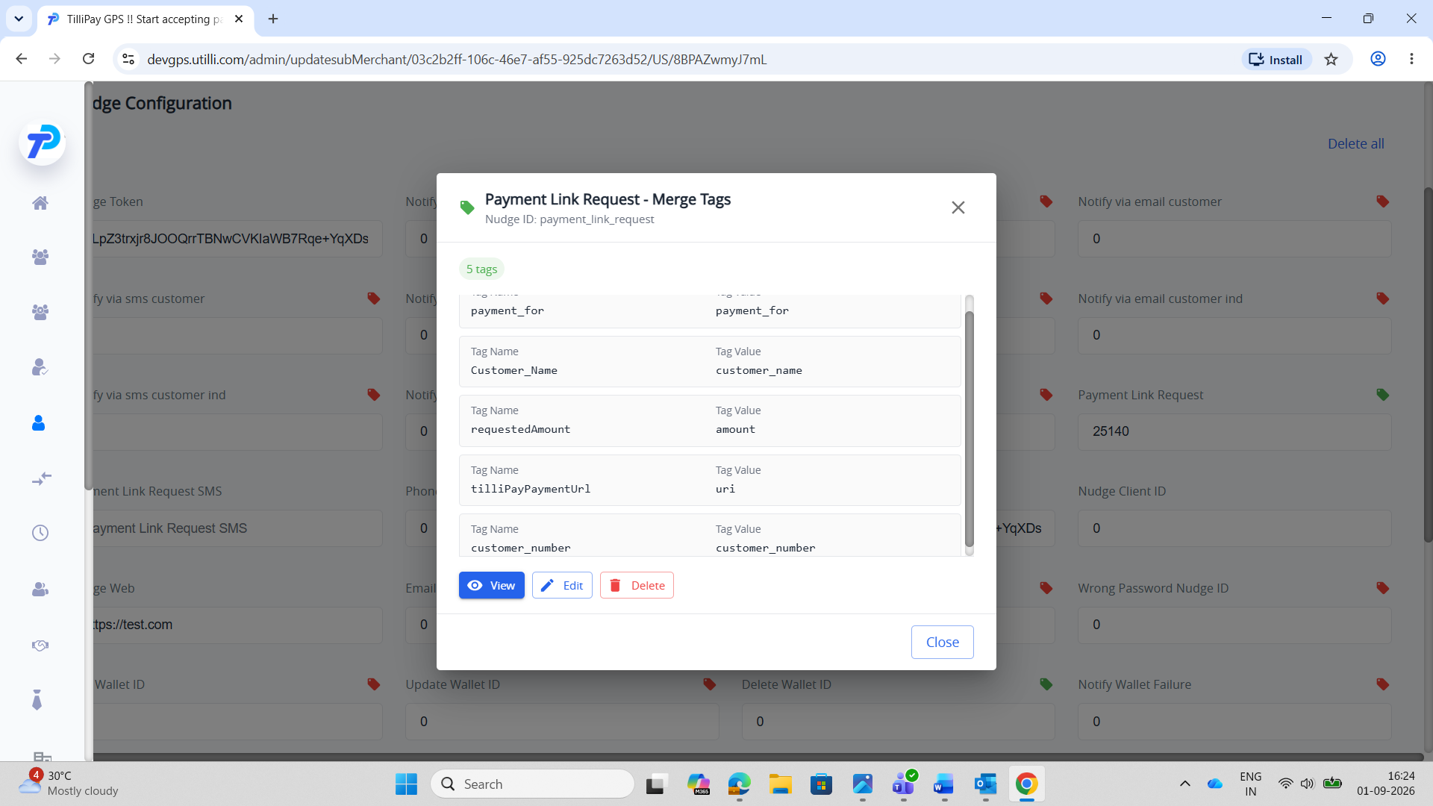
Config — after
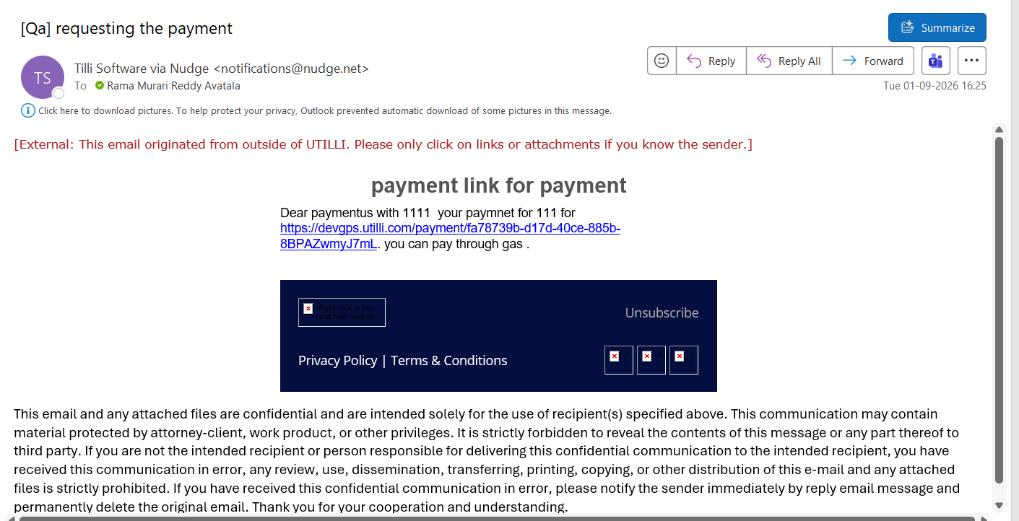
Email — after
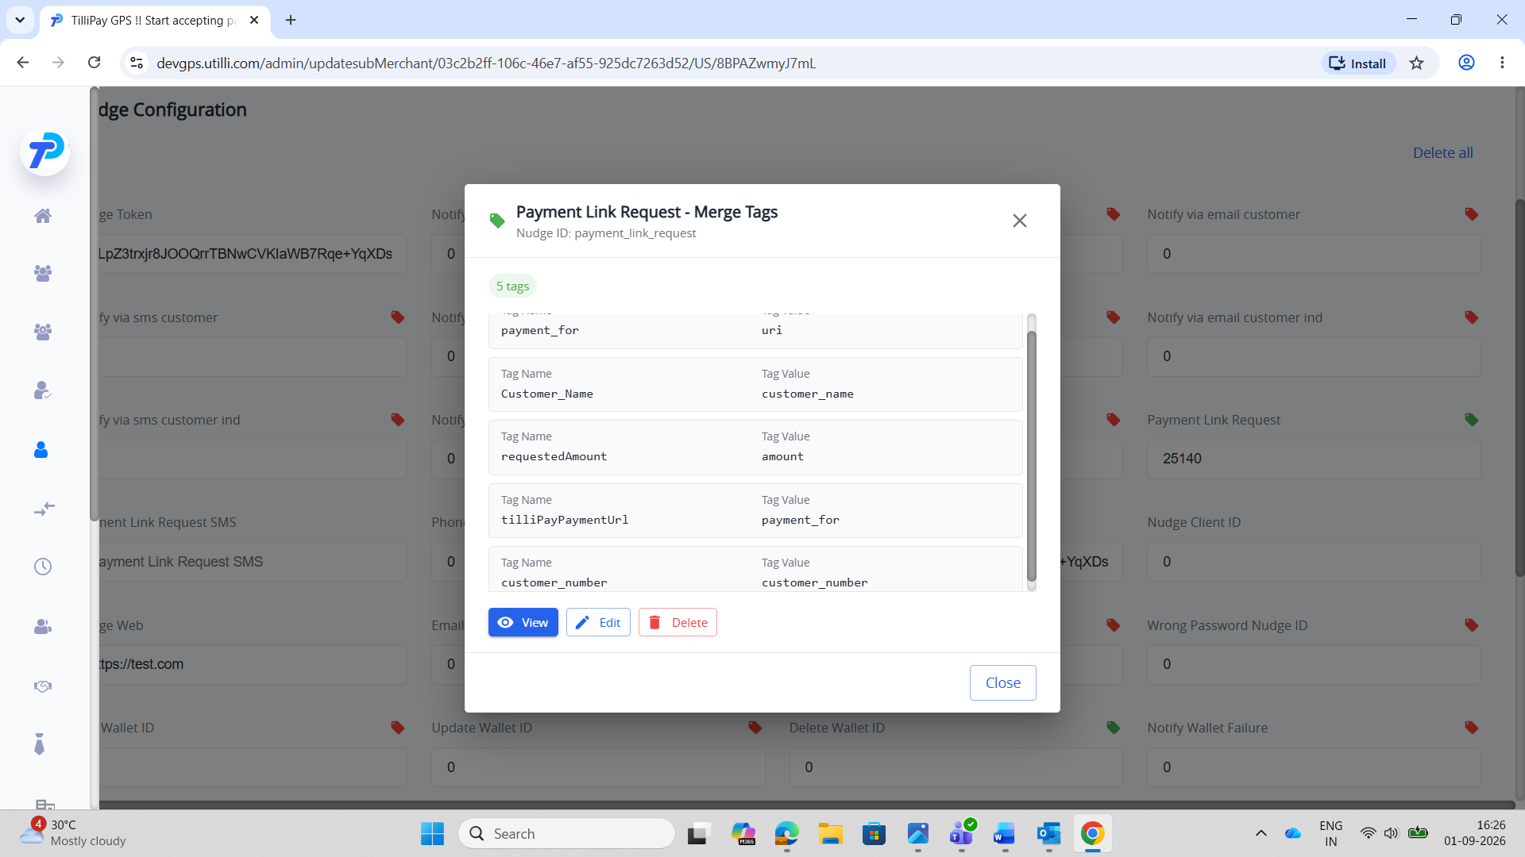

TC-NDT-A4 — MerchantE
Steps: Admin → Merchants → merchant → Update Merchant Details → Nudge Configuration → Payment Link Request tags → Save. Merchant portal → Share Payment → share link (before). Change tag values → Save → share again (after).
Expected: The After email differs from the Before email (same data, changed mapping) → merge tags are dynamic.
Config — before
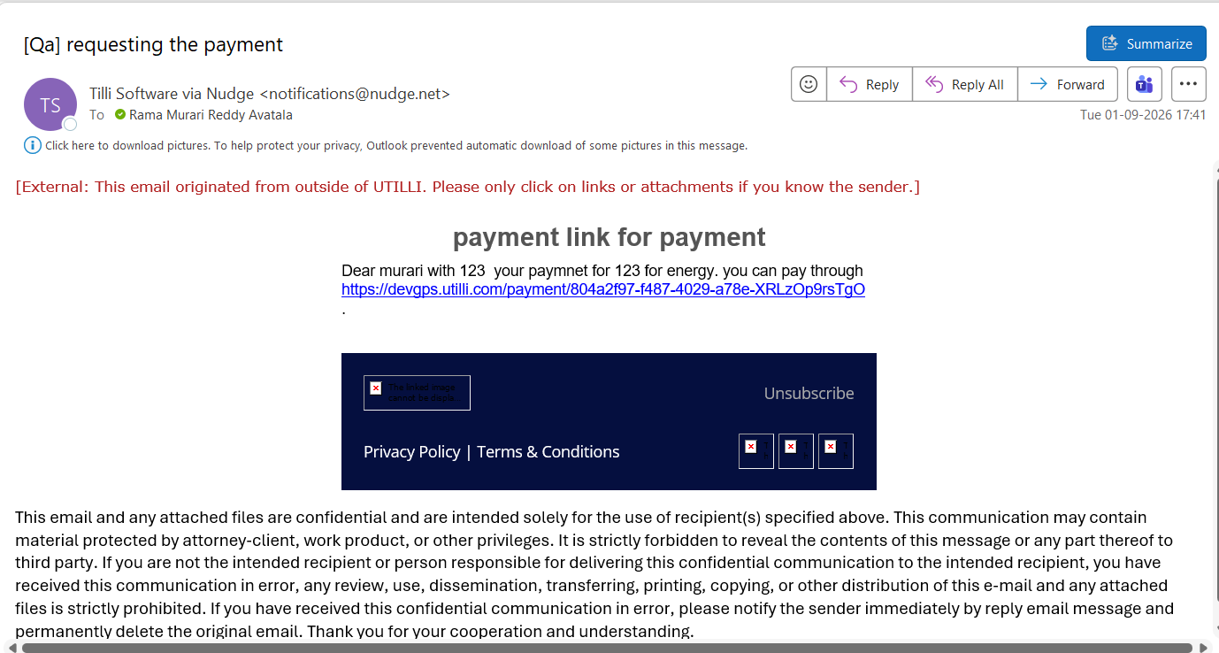
Email — before
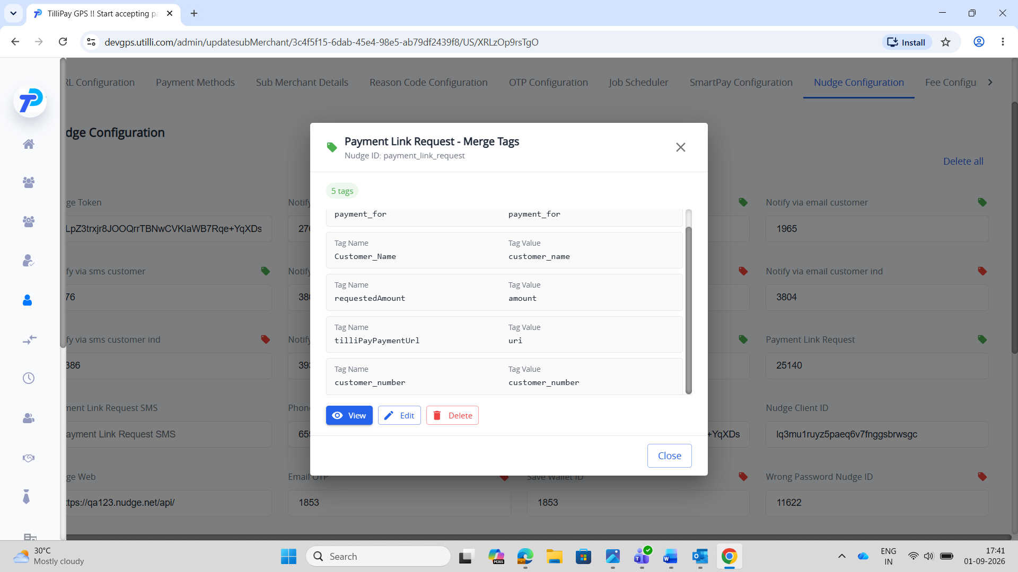
Config — after
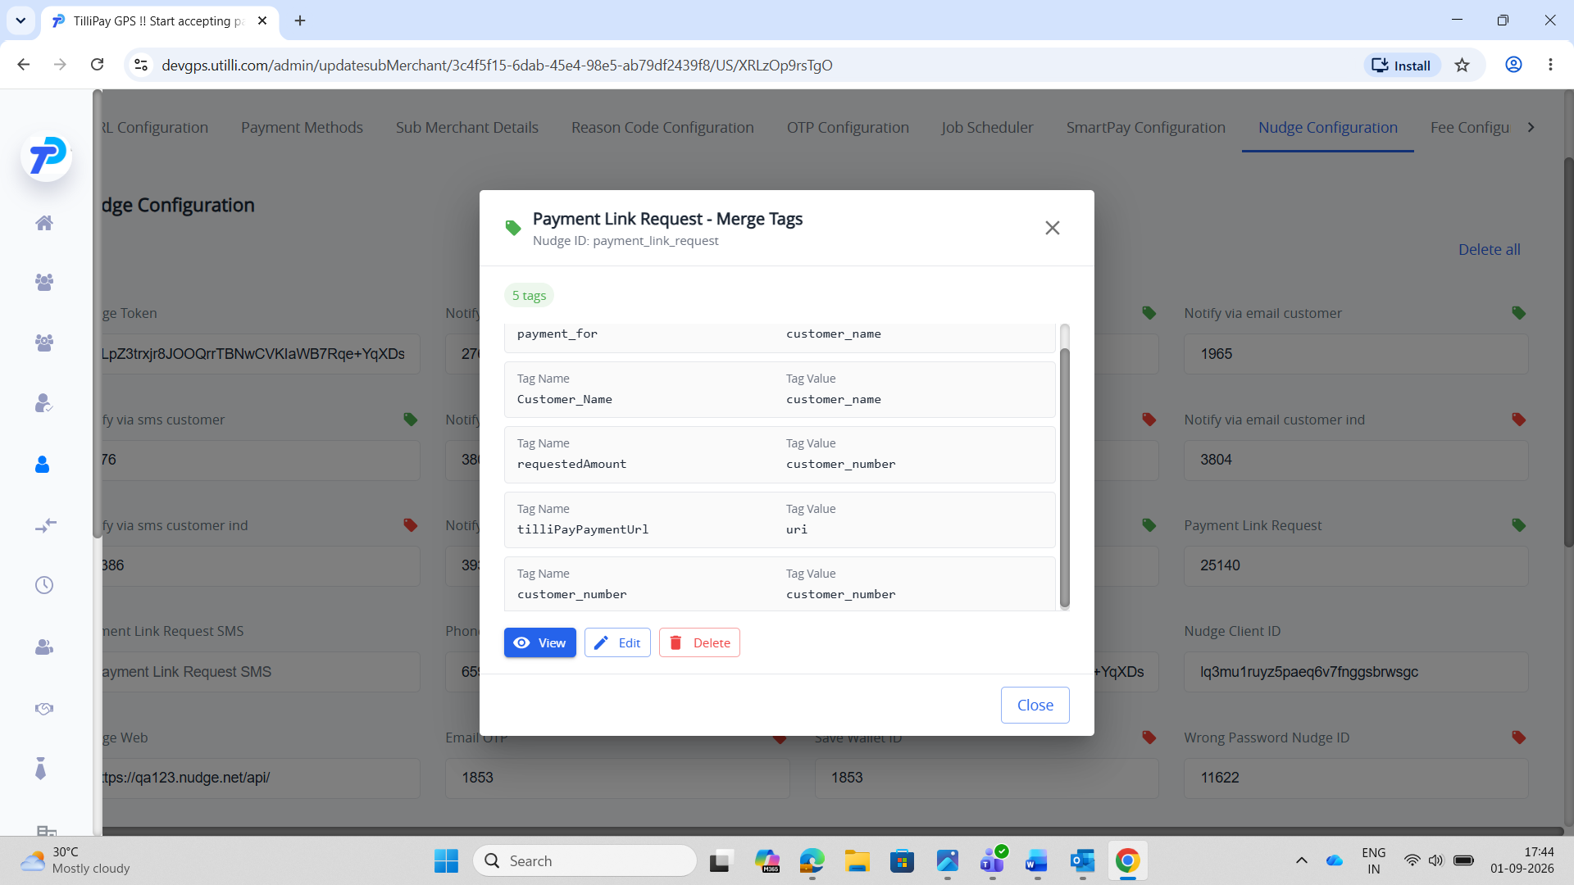
Email — after
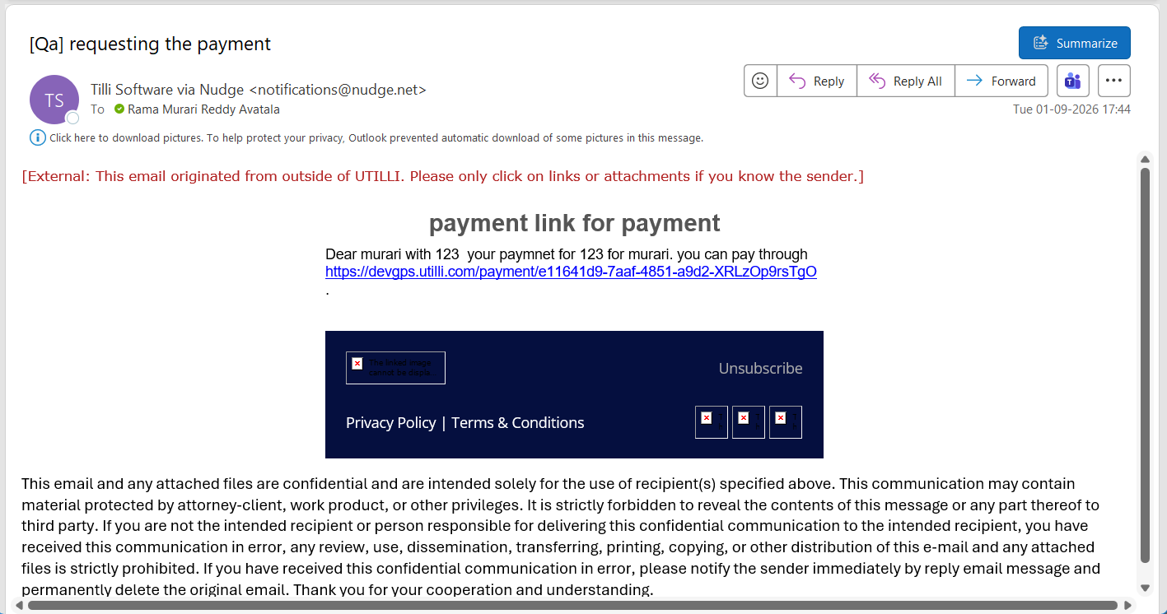

TC-NDT-A5 — Commerce Hub
Steps: Admin → Merchants → merchant → Update Merchant Details → Nudge Configuration → Payment Link Request tags → Save. Merchant portal → Share Payment → share link (before). Change tag values → Save → share again (after).
Expected: The After email differs from the Before email (same data, changed mapping) → merge tags are dynamic.
Config — before
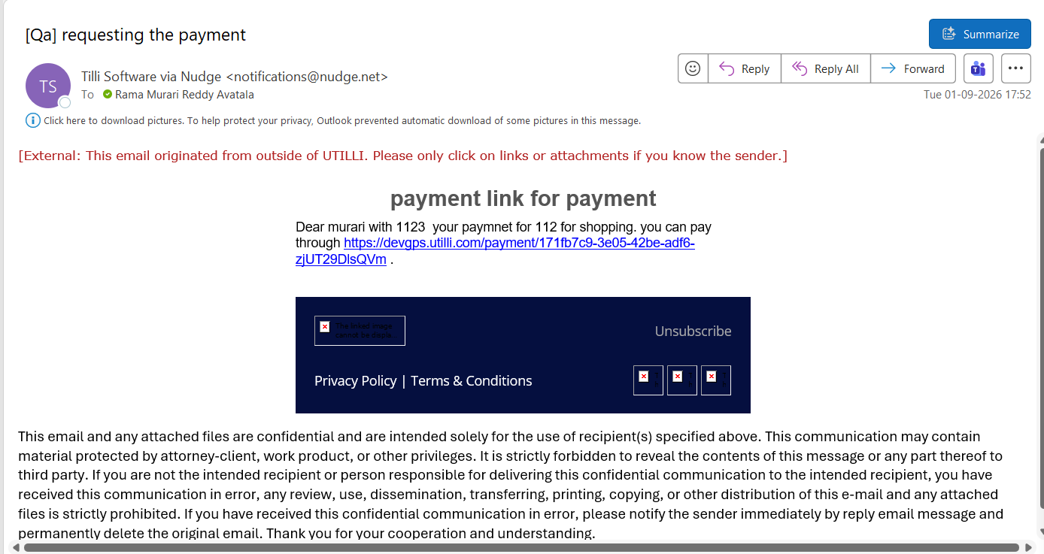
Email — before
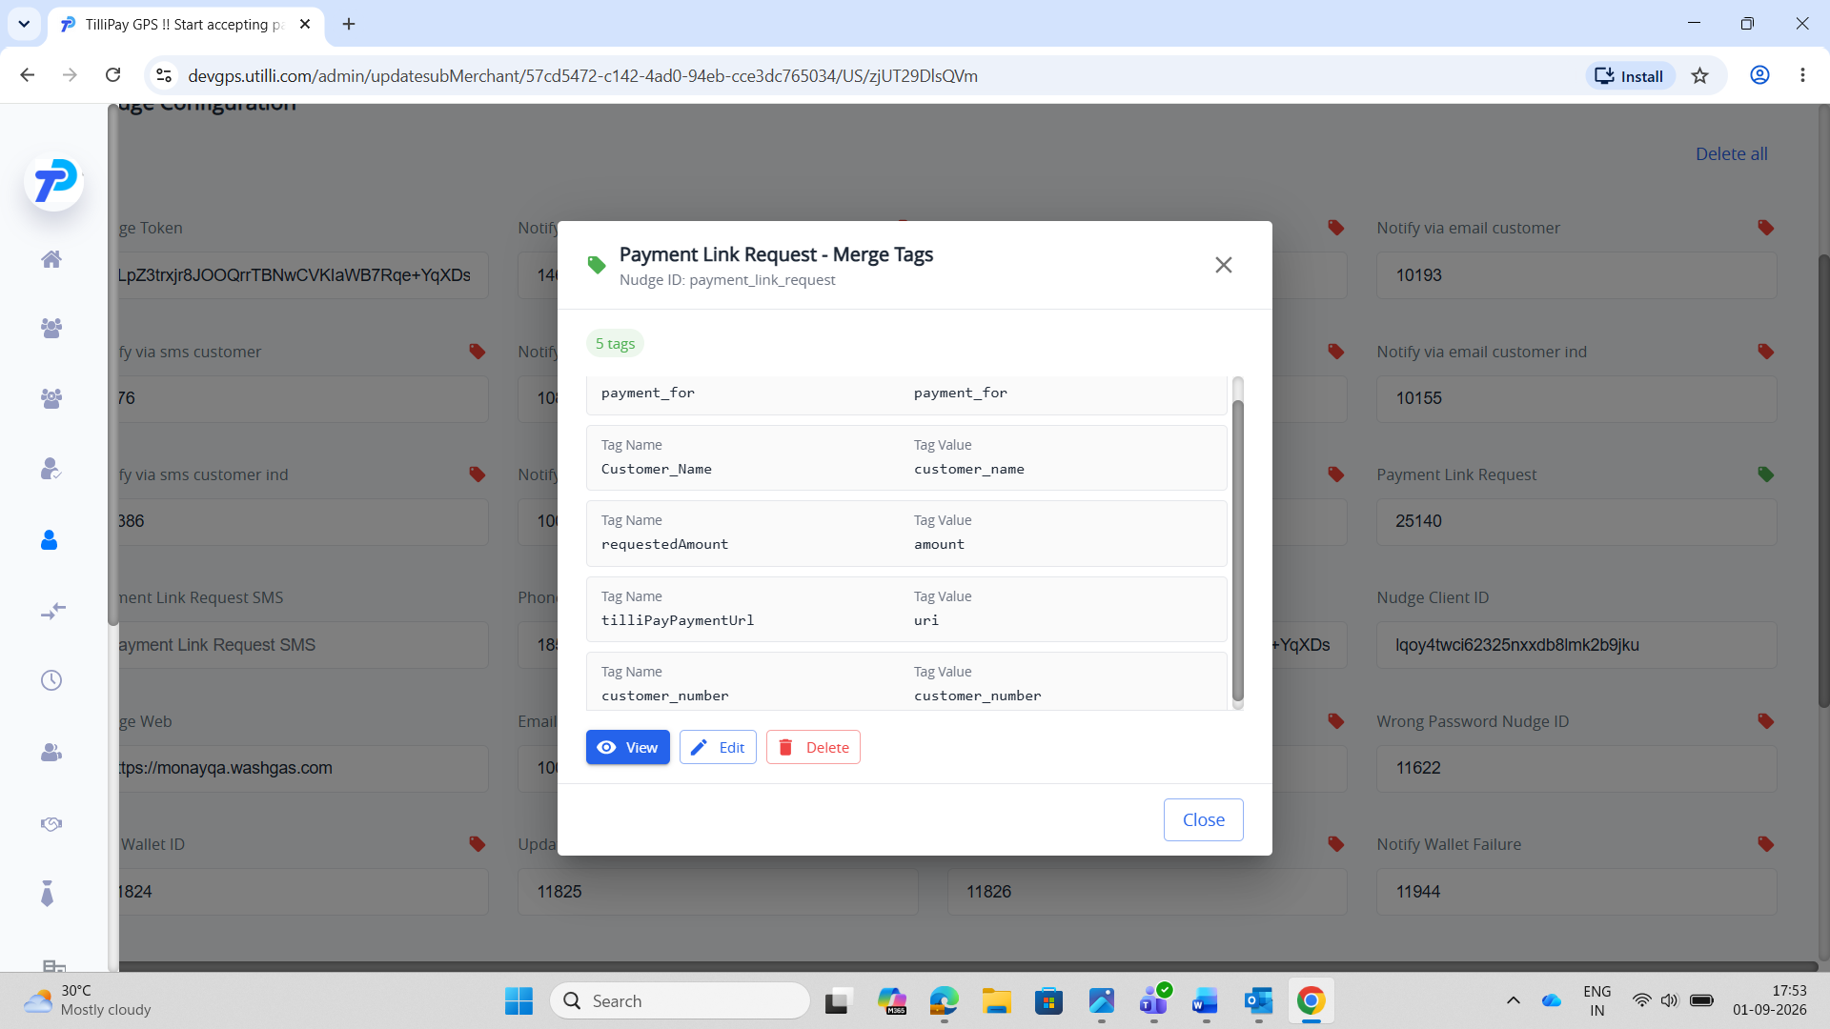
Config — after
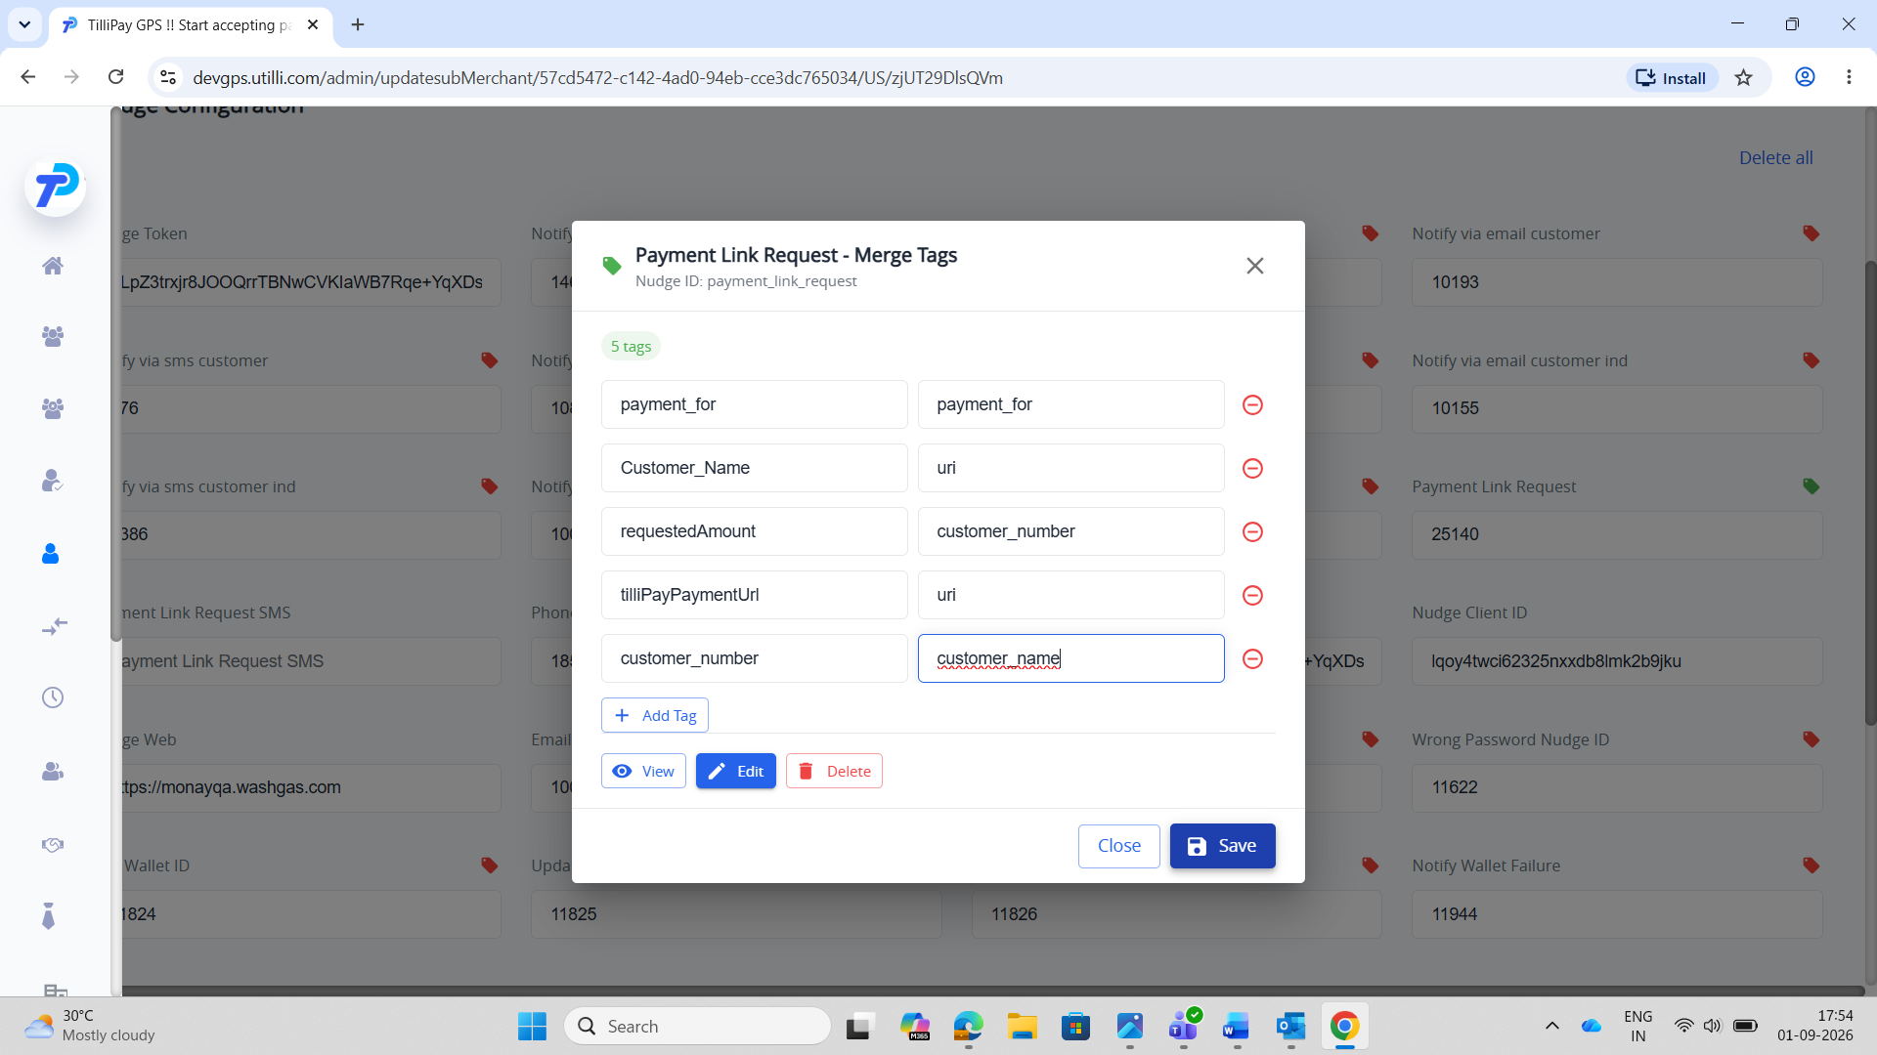
Email — after
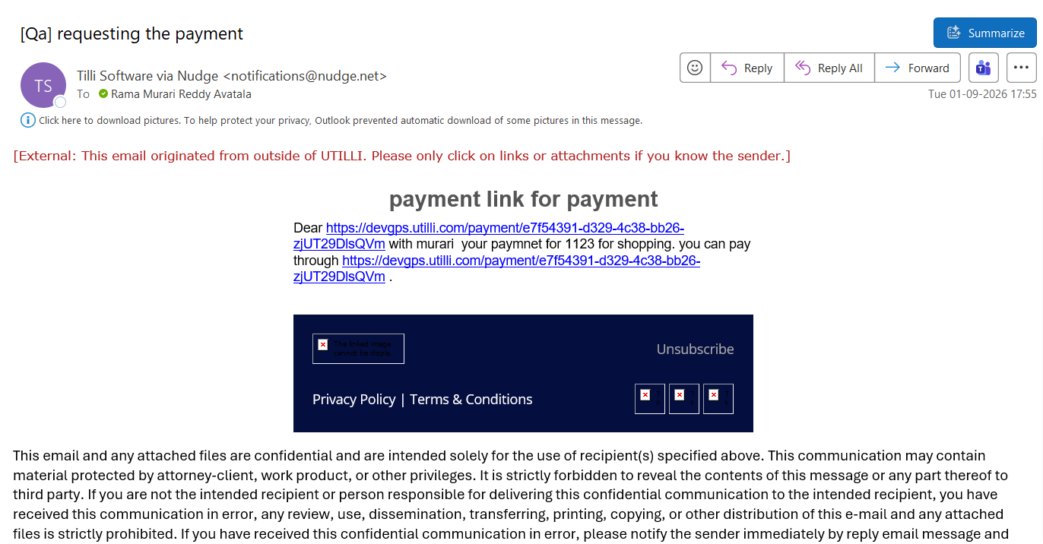

TC-NDT-A6 — BillPay
Steps: Admin → Merchants → merchant → Update Merchant Details → Nudge Configuration → Payment Link Request tags → Save. Merchant portal → Share Payment → share link (before). Change tag values → Save → share again (after).
Expected: The After email differs from the Before email (same data, changed mapping) → merge tags are dynamic.
Config — before
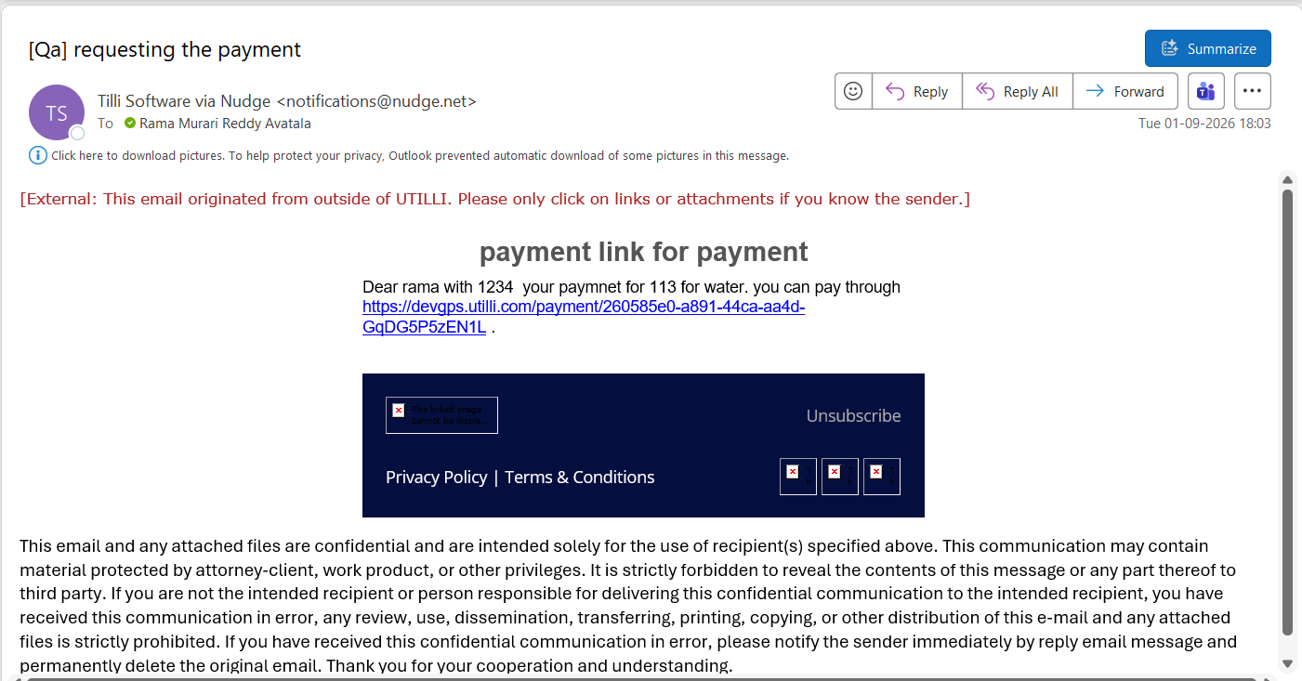
Email — before
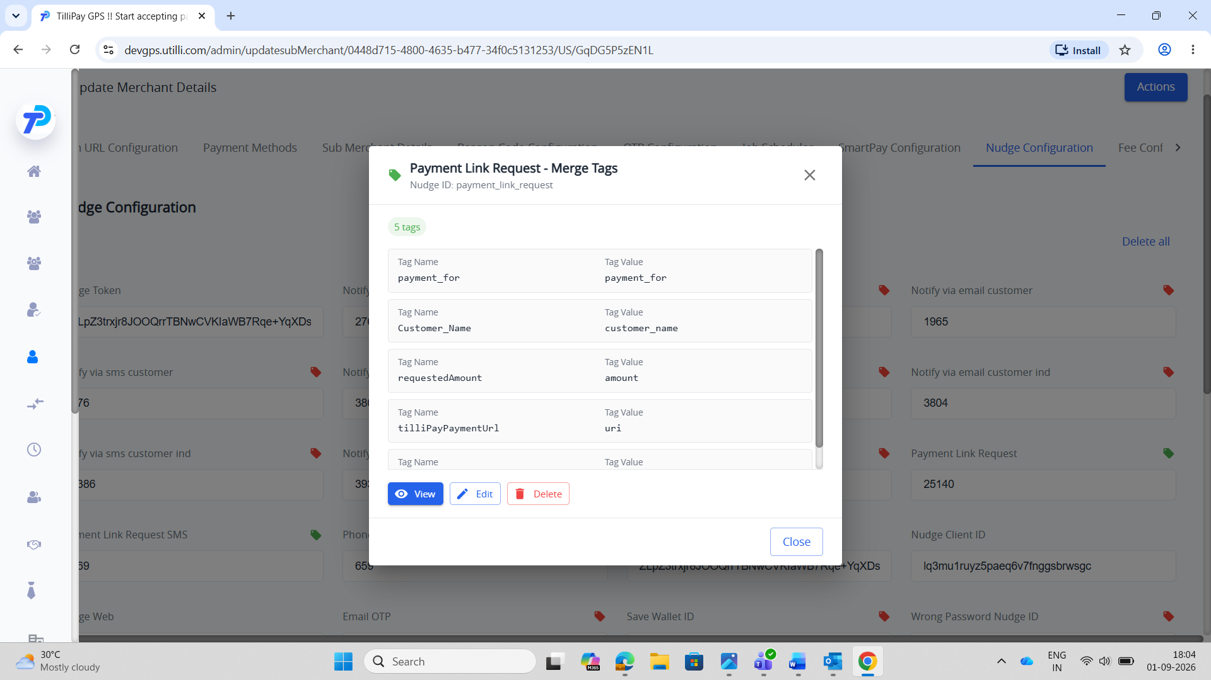
Config — after
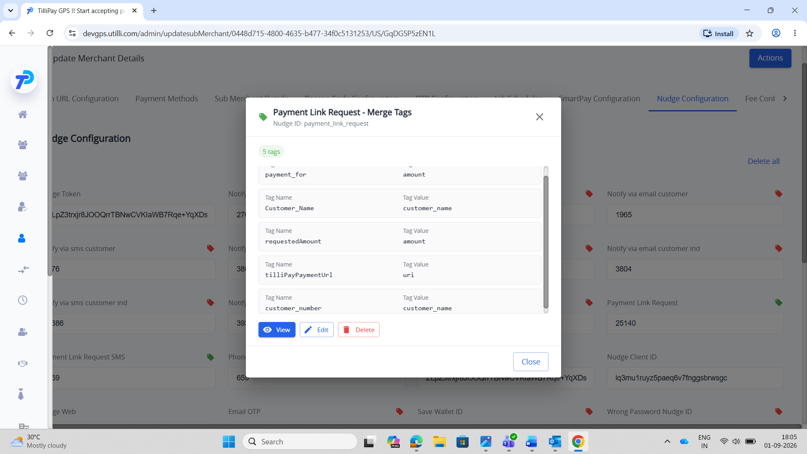
Email — after
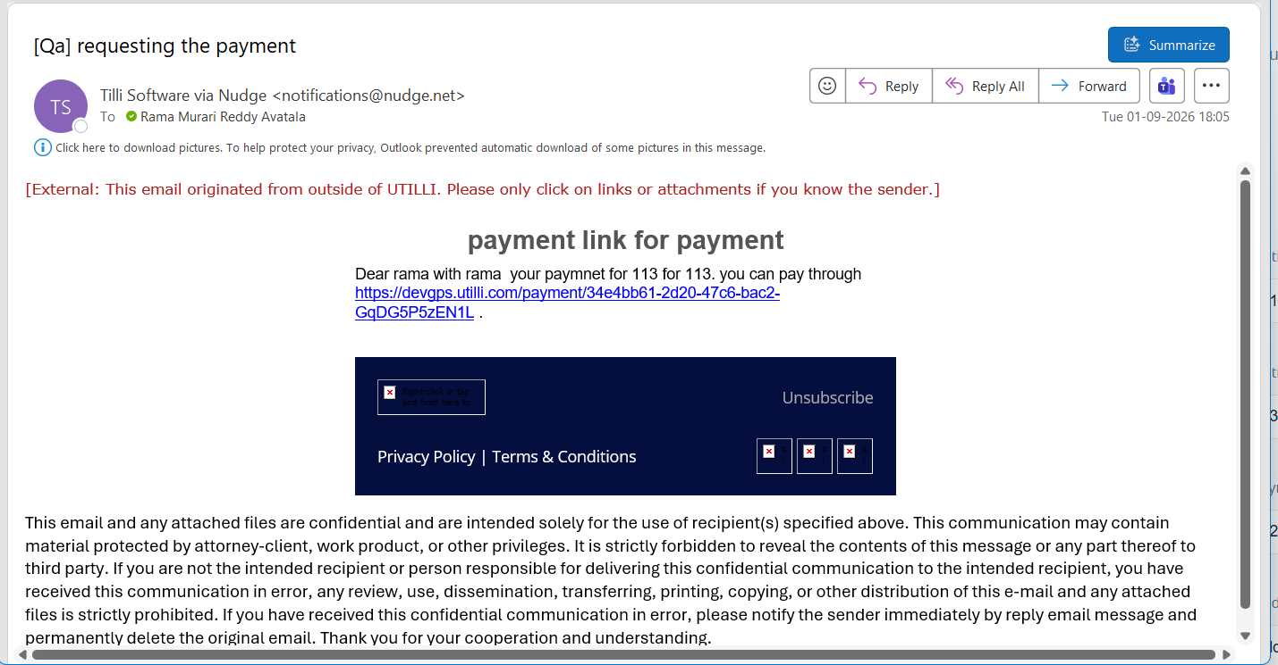

TC-NDT-A7 — NuveiPay
Steps: Admin → Merchants → merchant → Update Merchant Details → Nudge Configuration → Payment Link Request tags → Save. Merchant portal → Share Payment → share link (before). Change tag values → Save → share again (after).
Expected: The After email differs from the Before email (same data, changed mapping) → merge tags are dynamic.
Config — before
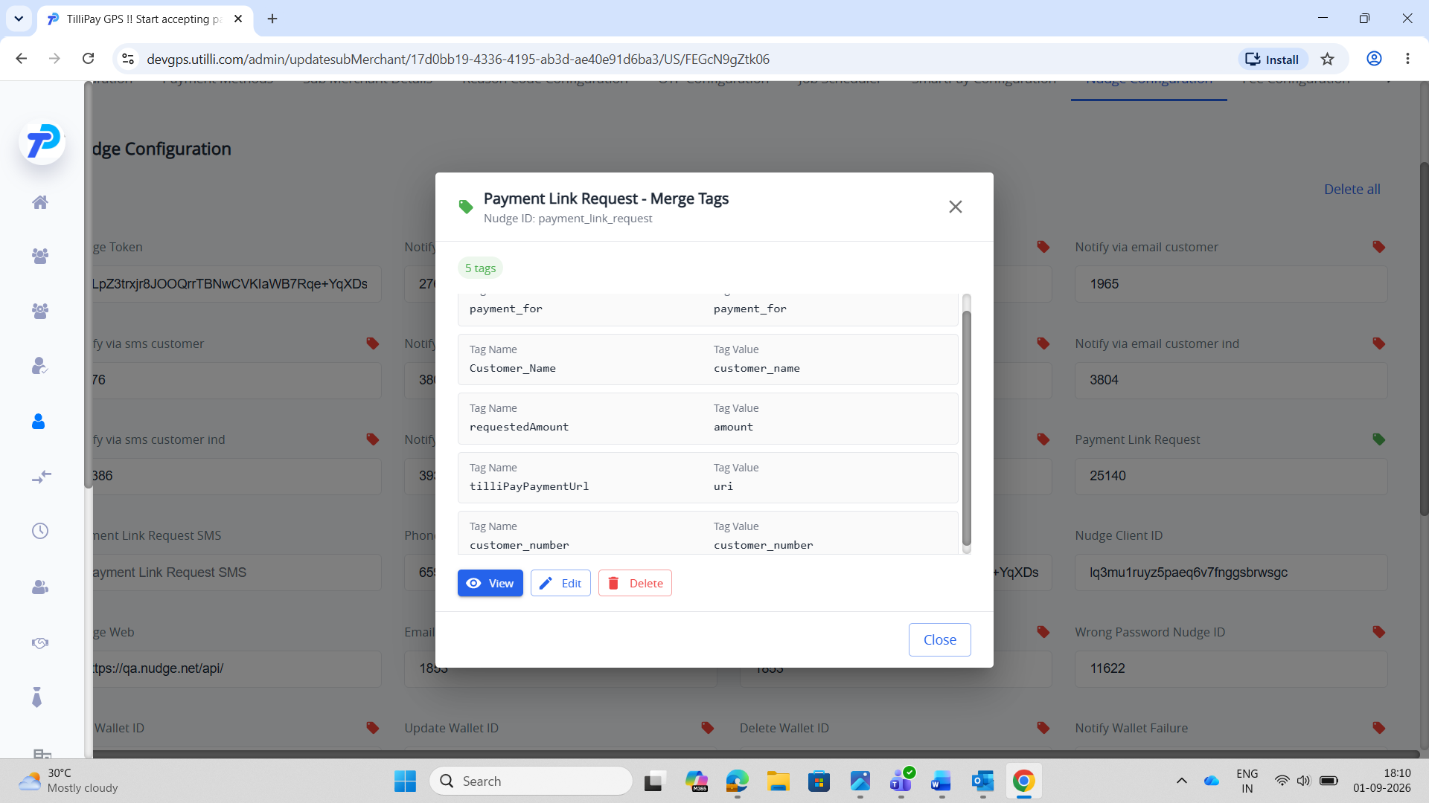
Email — before
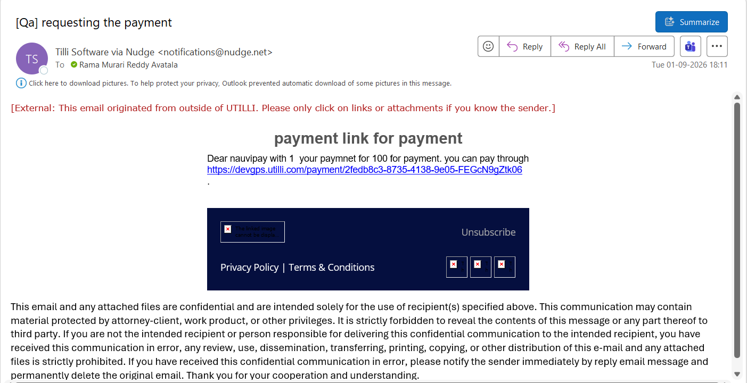
Config — after
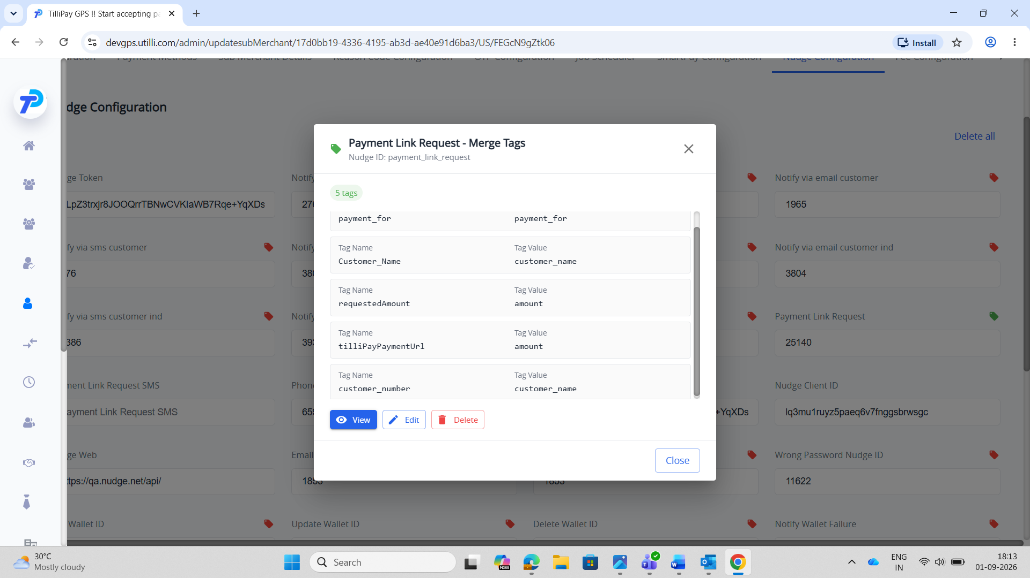
Email — after
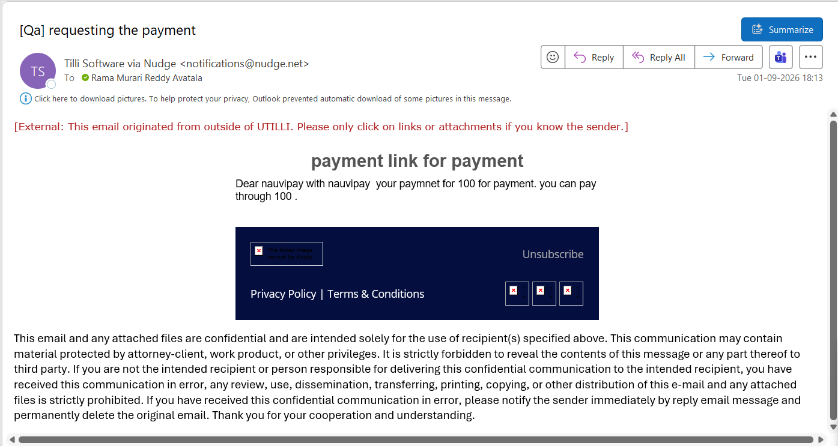

SECTION 2 — Payment Reversal (per-merchant)
Tags (Tag Name → Tag Value): customer_name → customer_name, Refund_amount → amount, Payment_amount → amount.

TC-NDT-B1 — IPG
Steps: Admin → Merchants → merchant → Update Merchant Details → Nudge Configuration → Notify payment reversal tags → Save. Merchant portal → Transactions → refund/reversal (before). Change tag values → Save → reverse again (after).
Expected: The After email differs from the Before email (same data, changed mapping) → merge tags are dynamic.
Config — before
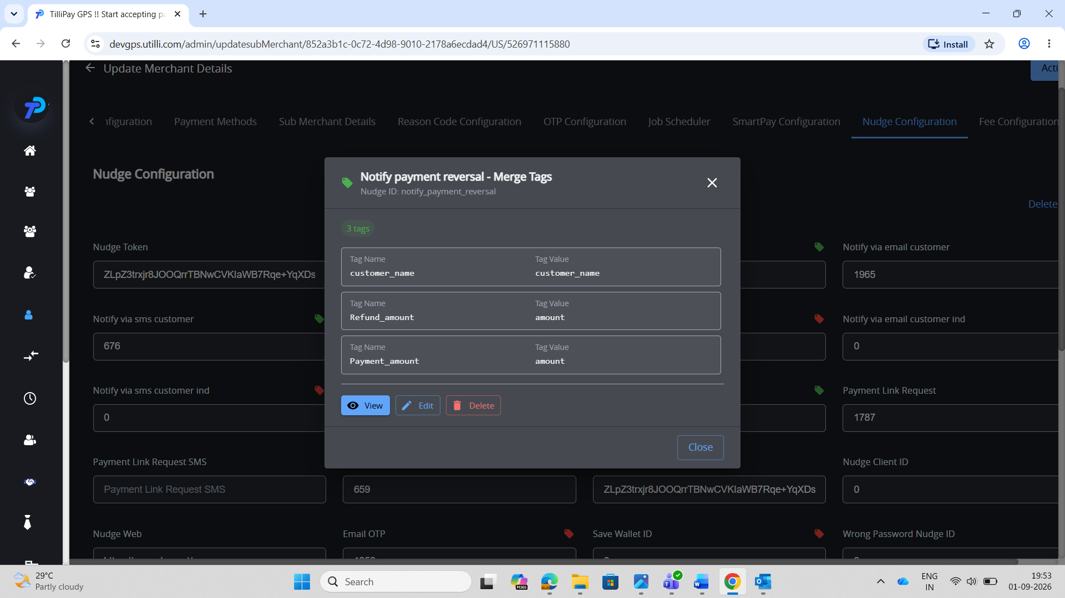
Email — before
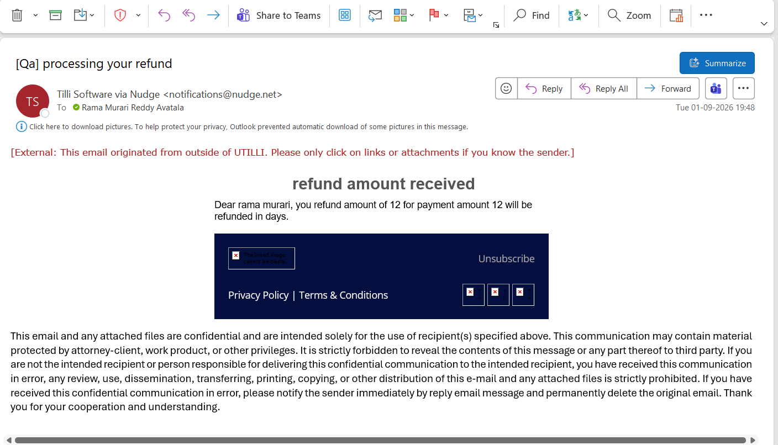
Config — after
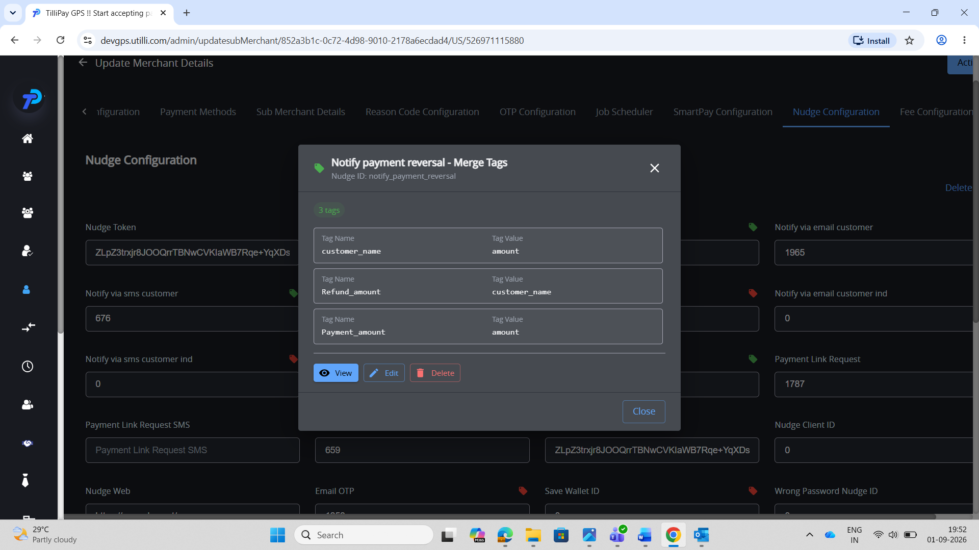
Email — after
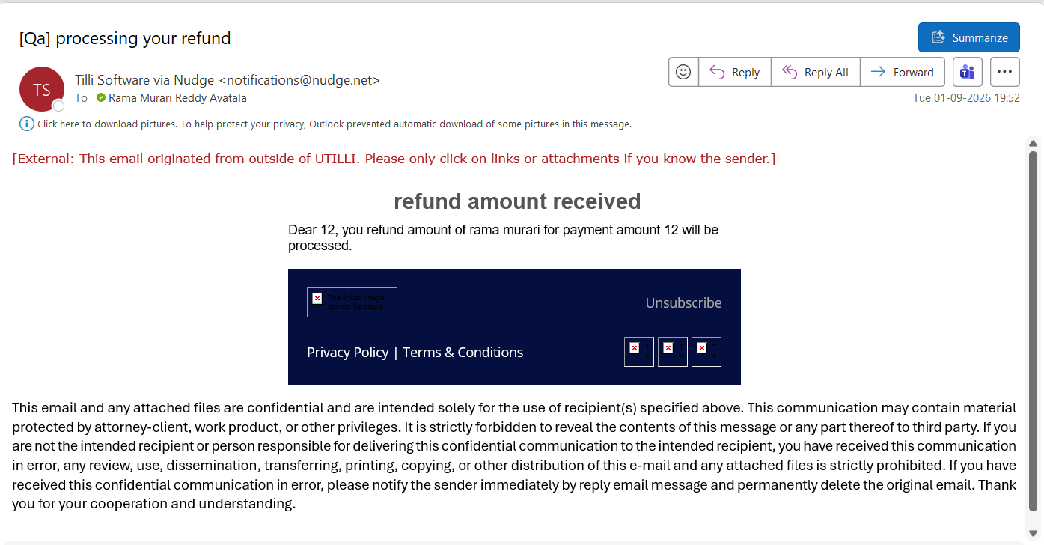

TC-NDT-B2 — NuveiPay
Steps: Admin → Merchants → merchant → Update Merchant Details → Nudge Configuration → Notify payment reversal tags → Save. Merchant portal → Transactions → refund/reversal (before). Change tag values → Save → reverse again (after).
Expected: The After email differs from the Before email (same data, changed mapping) → merge tags are dynamic.
Config — before
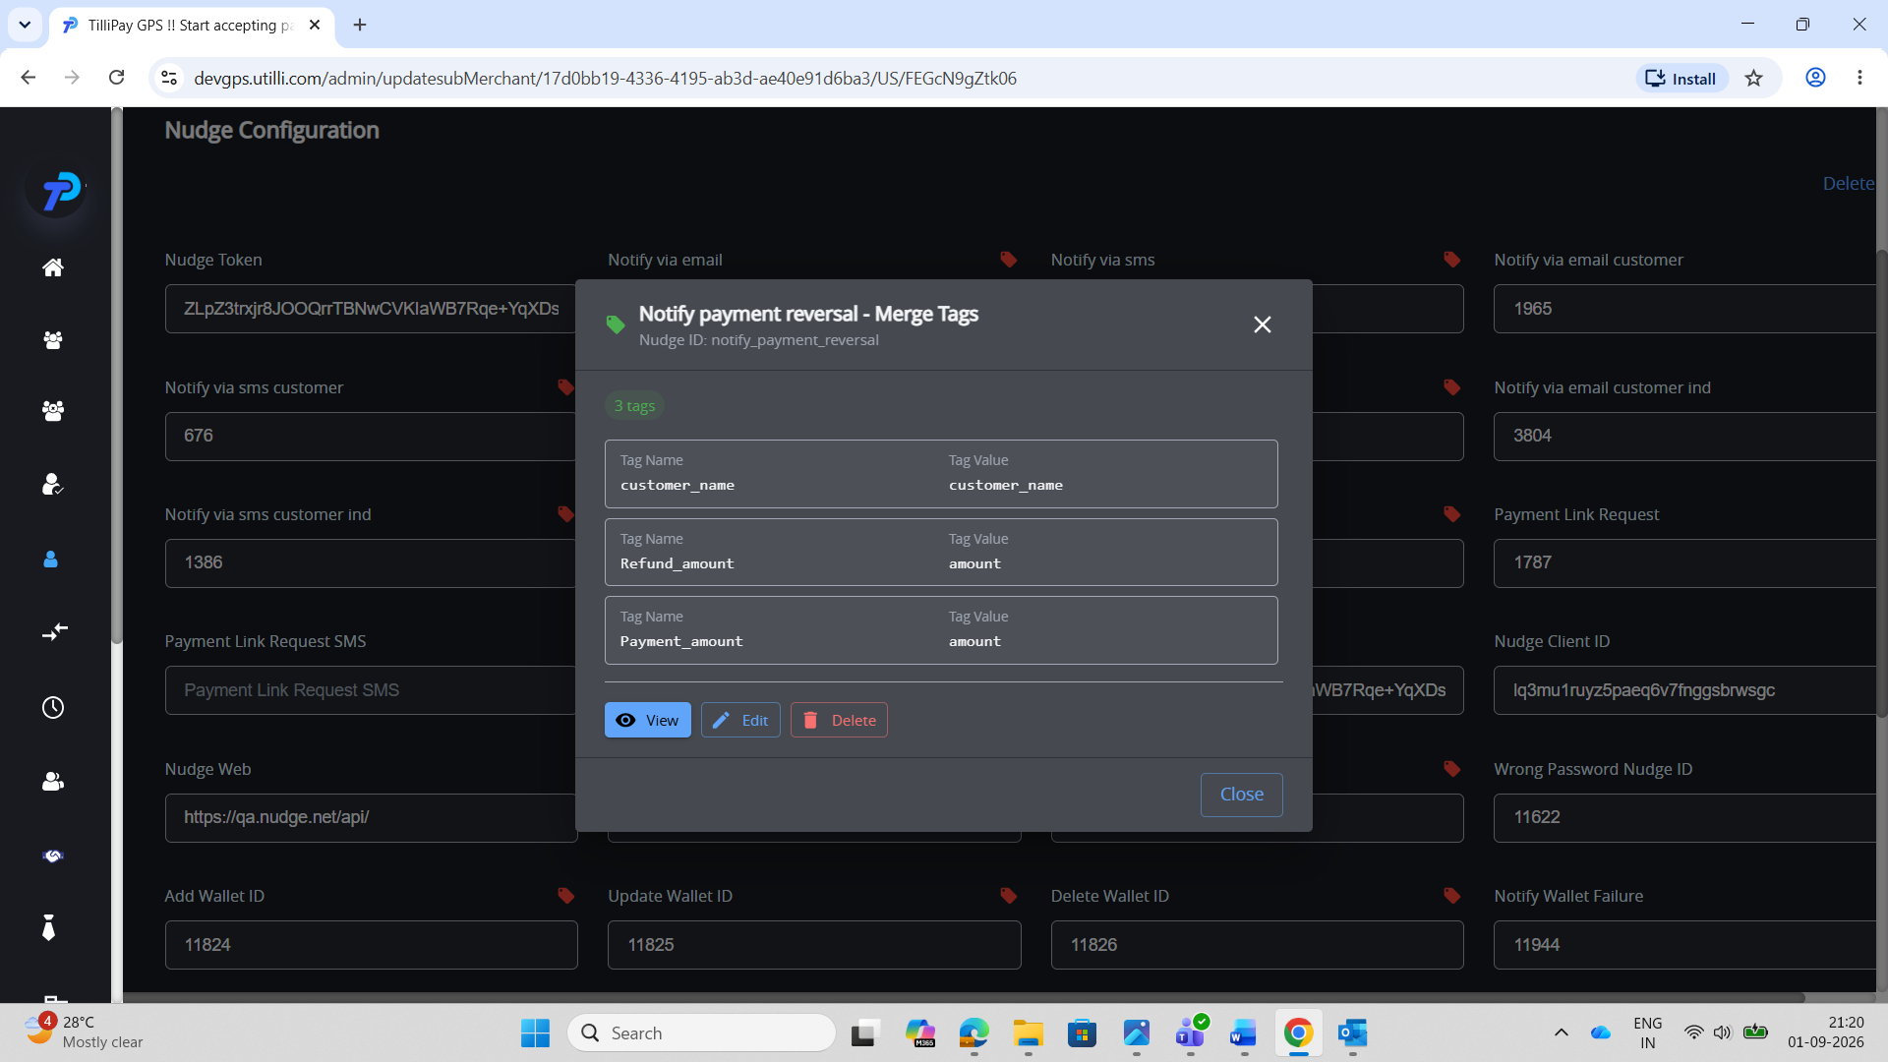
Email — before
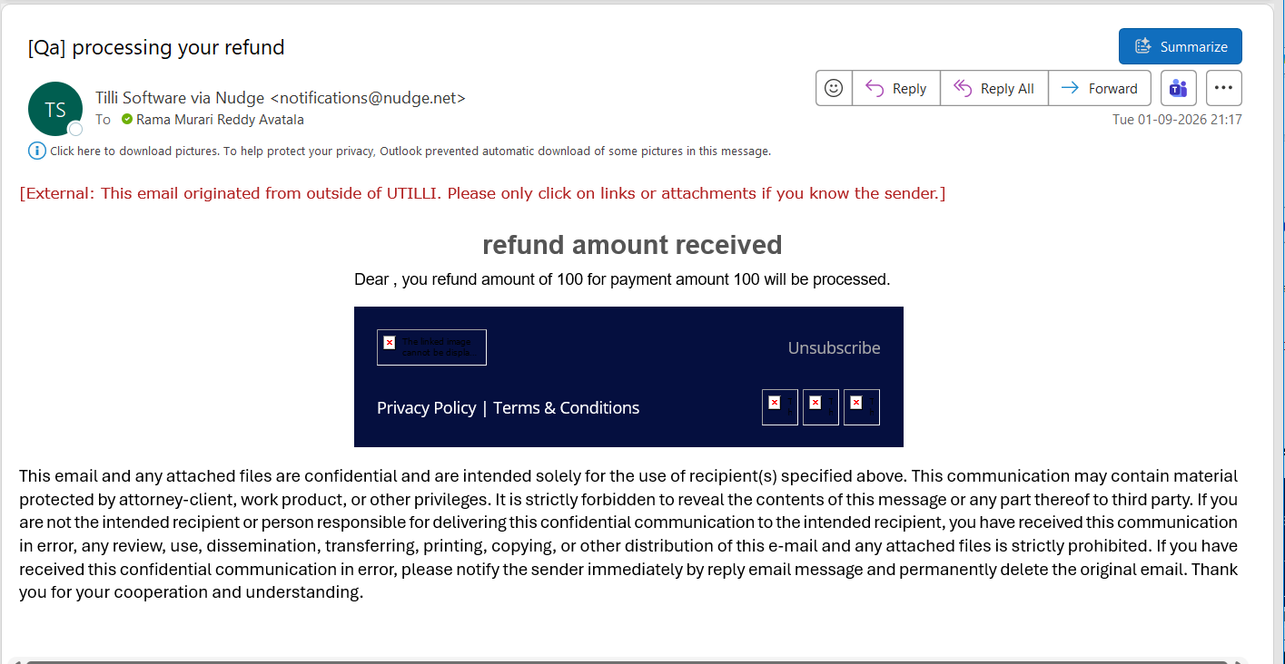
Config — after
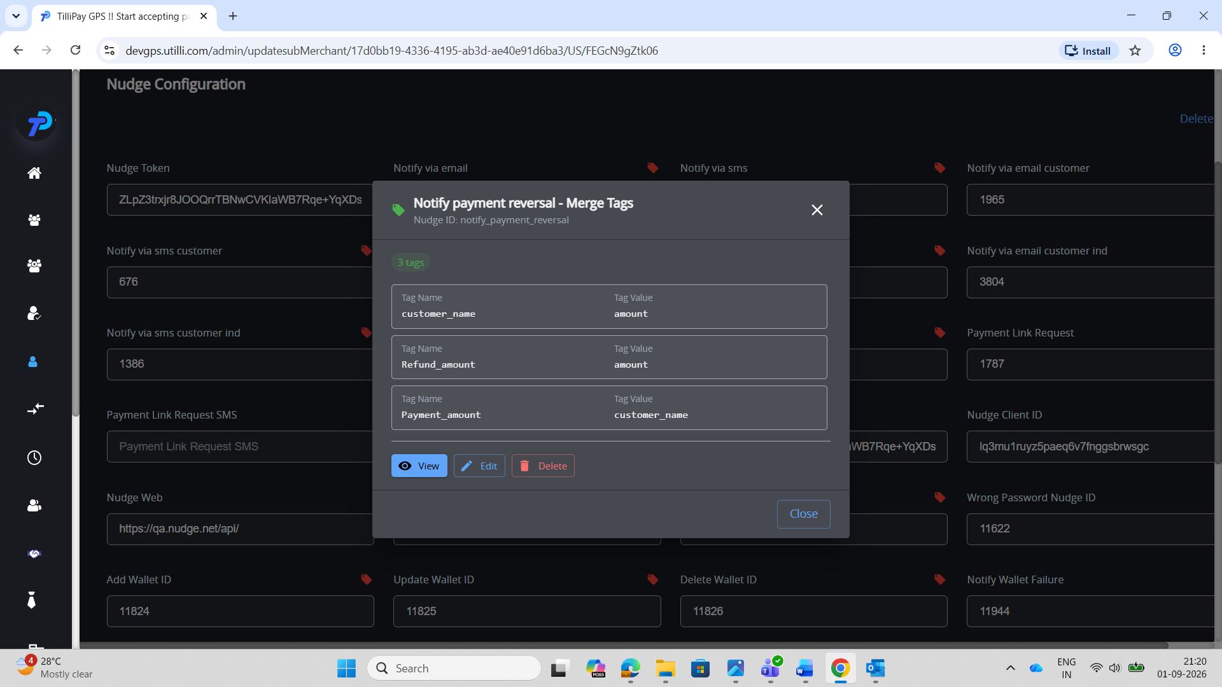
Email — after
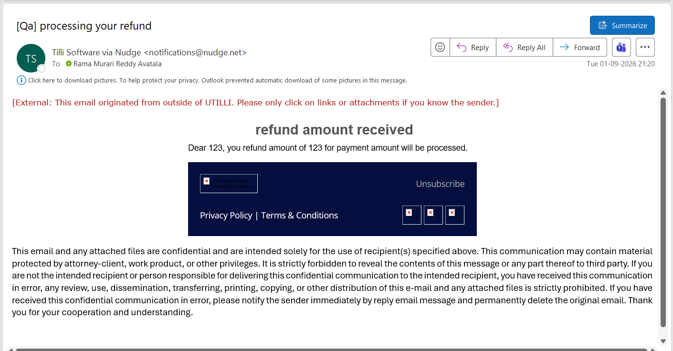

TC-NDT-B3 — SnapPay
Steps: Admin → Merchants → merchant → Update Merchant Details → Nudge Configuration → Notify payment reversal tags → Save. Merchant portal → Transactions → refund/reversal (before). Change tag values → Save → reverse again (after).
Expected: The After email differs from the Before email (same data, changed mapping) → merge tags are dynamic.
Config — before
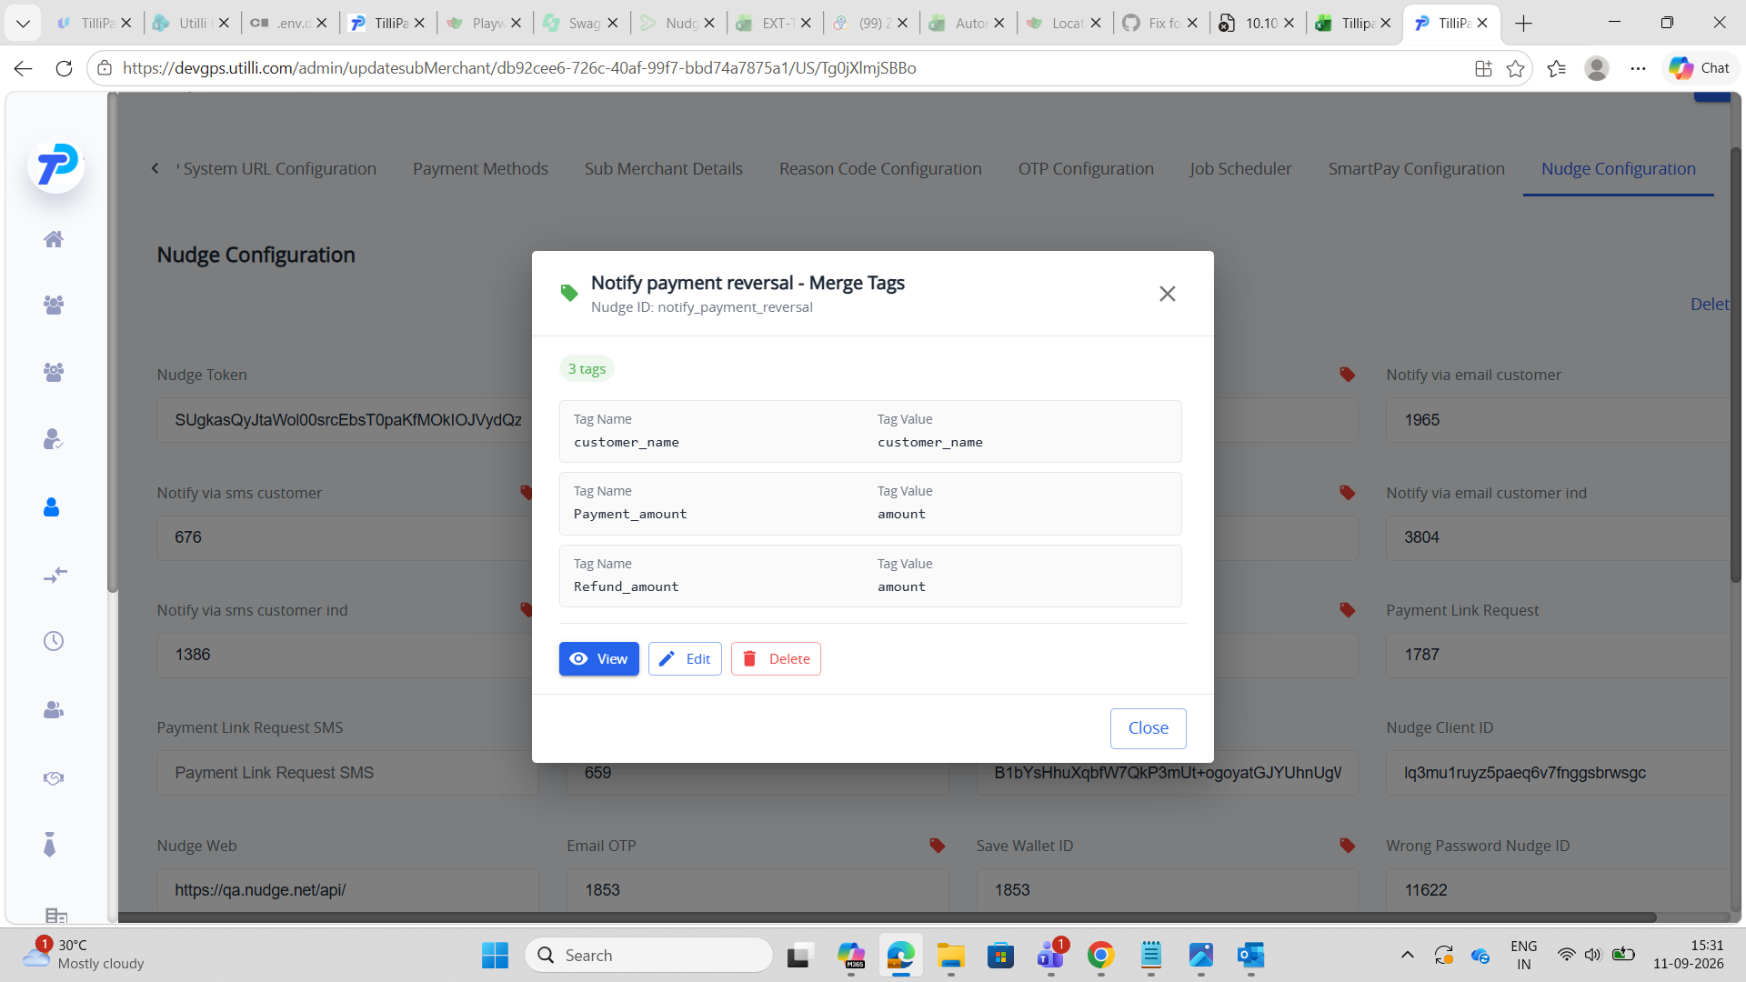
Email — before
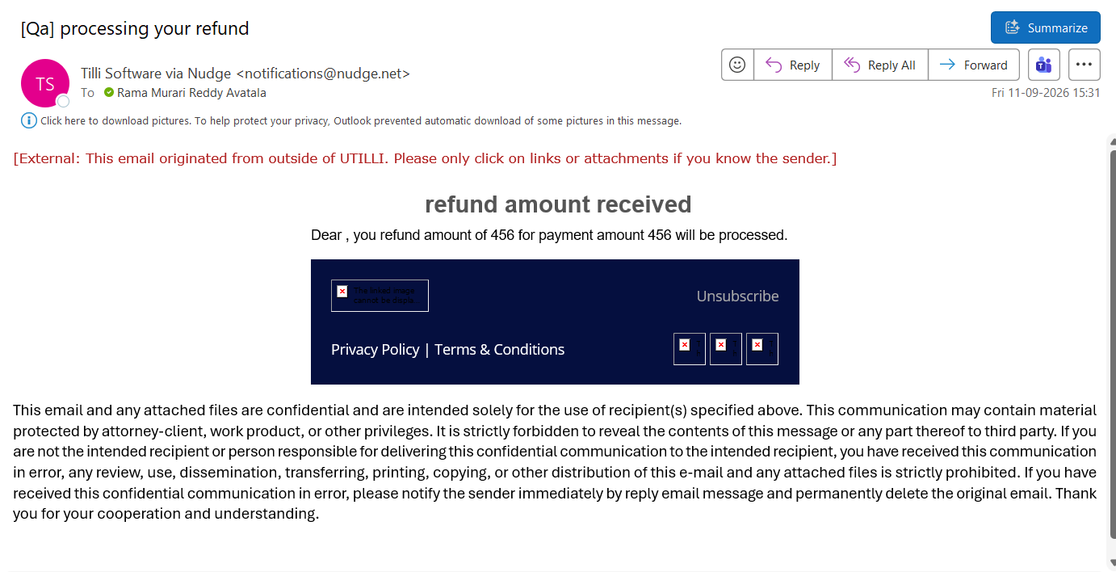
Config — after
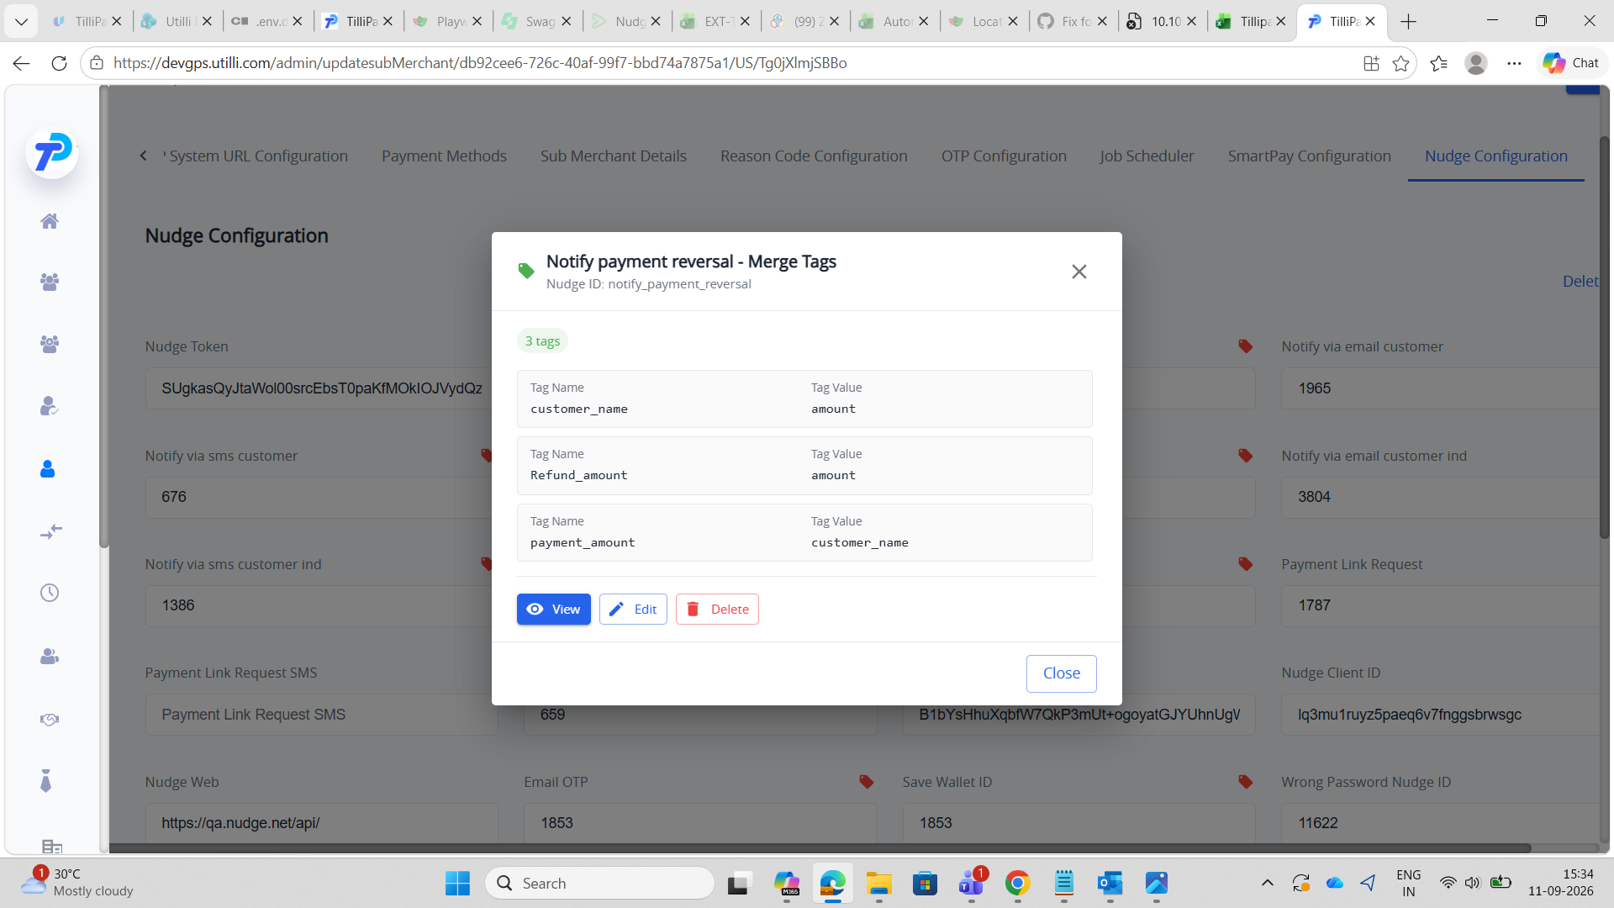
Email — after
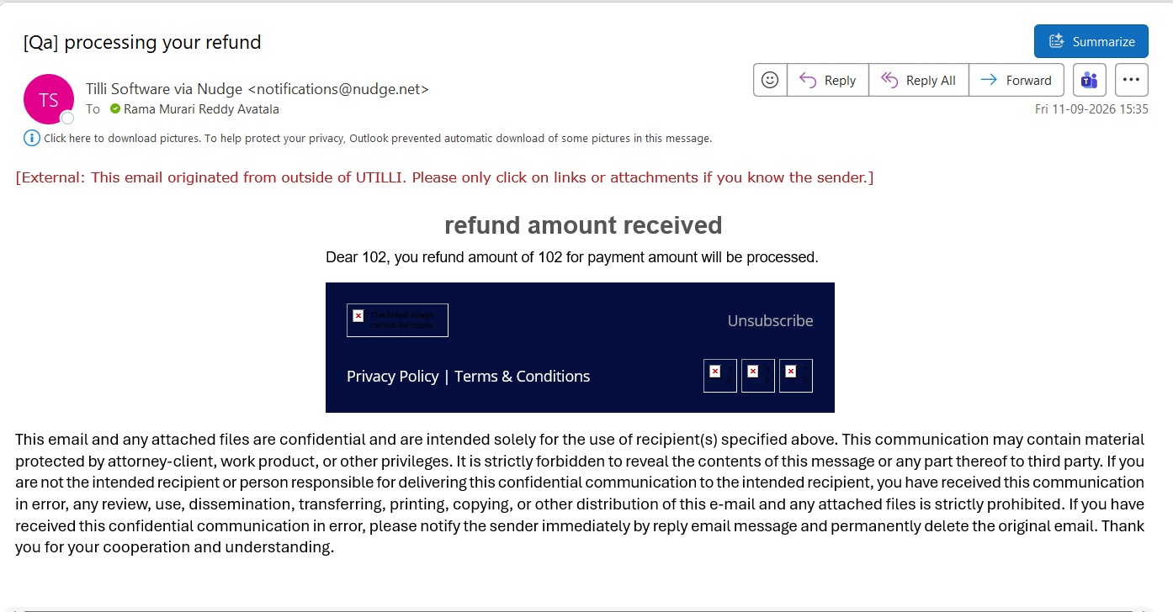

TC-NDT-B4 — Freeman
Steps: Admin → Merchants → merchant → Update Merchant Details → Nudge Configuration → Notify payment reversal tags → Save. Merchant portal → Transactions → refund/reversal (before). Change tag values → Save → reverse again (after).
Expected: The After email differs from the Before email (same data, changed mapping) → merge tags are dynamic.
Config — before
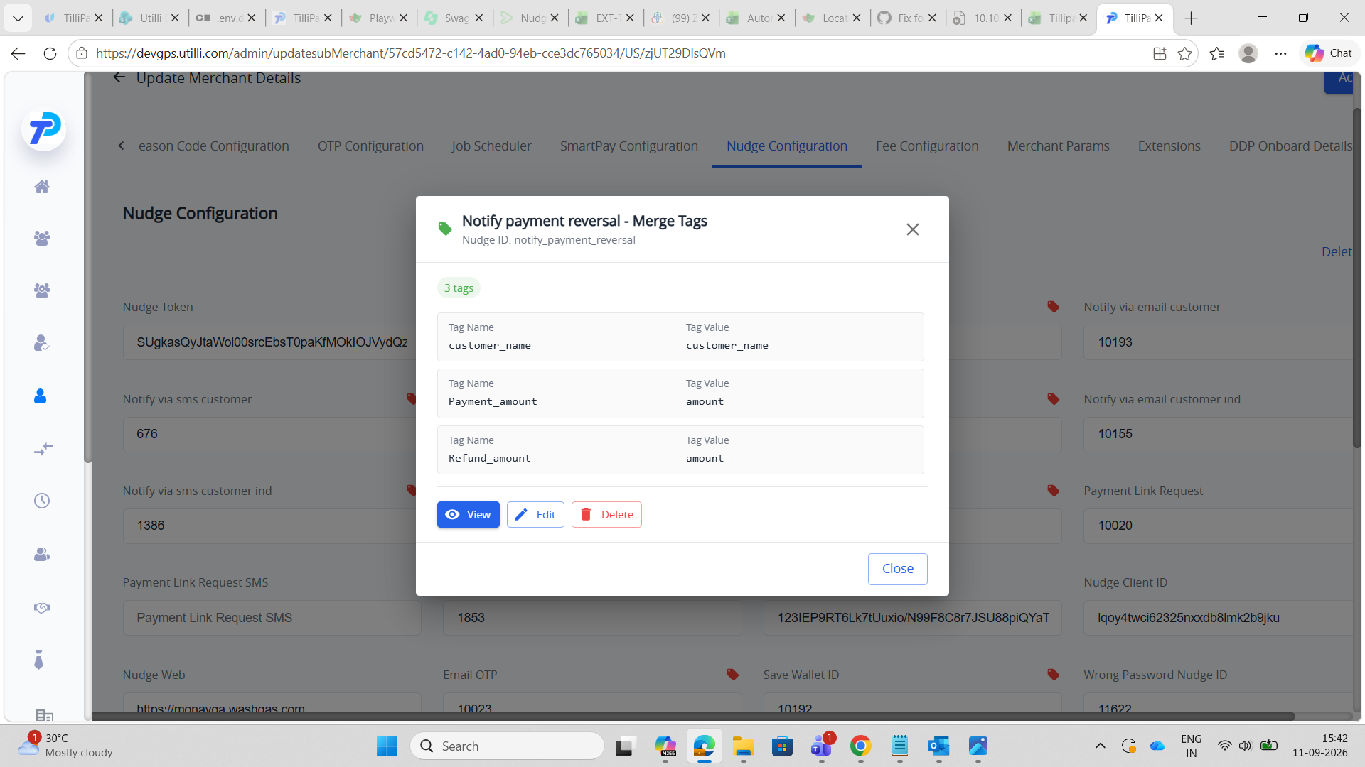
Email — before
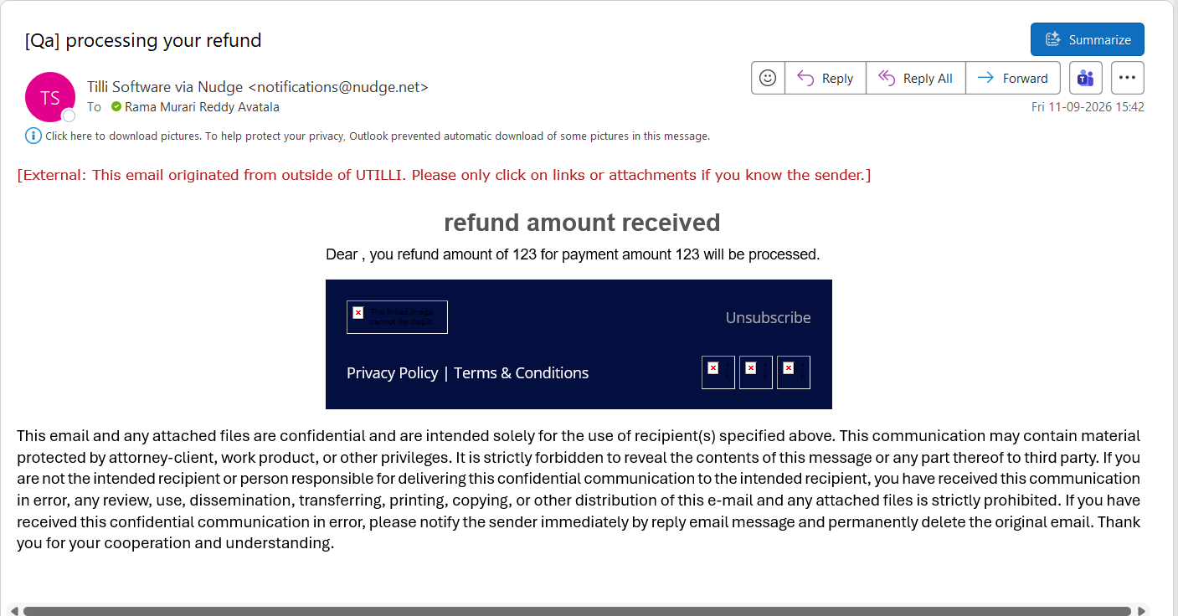
Config — after
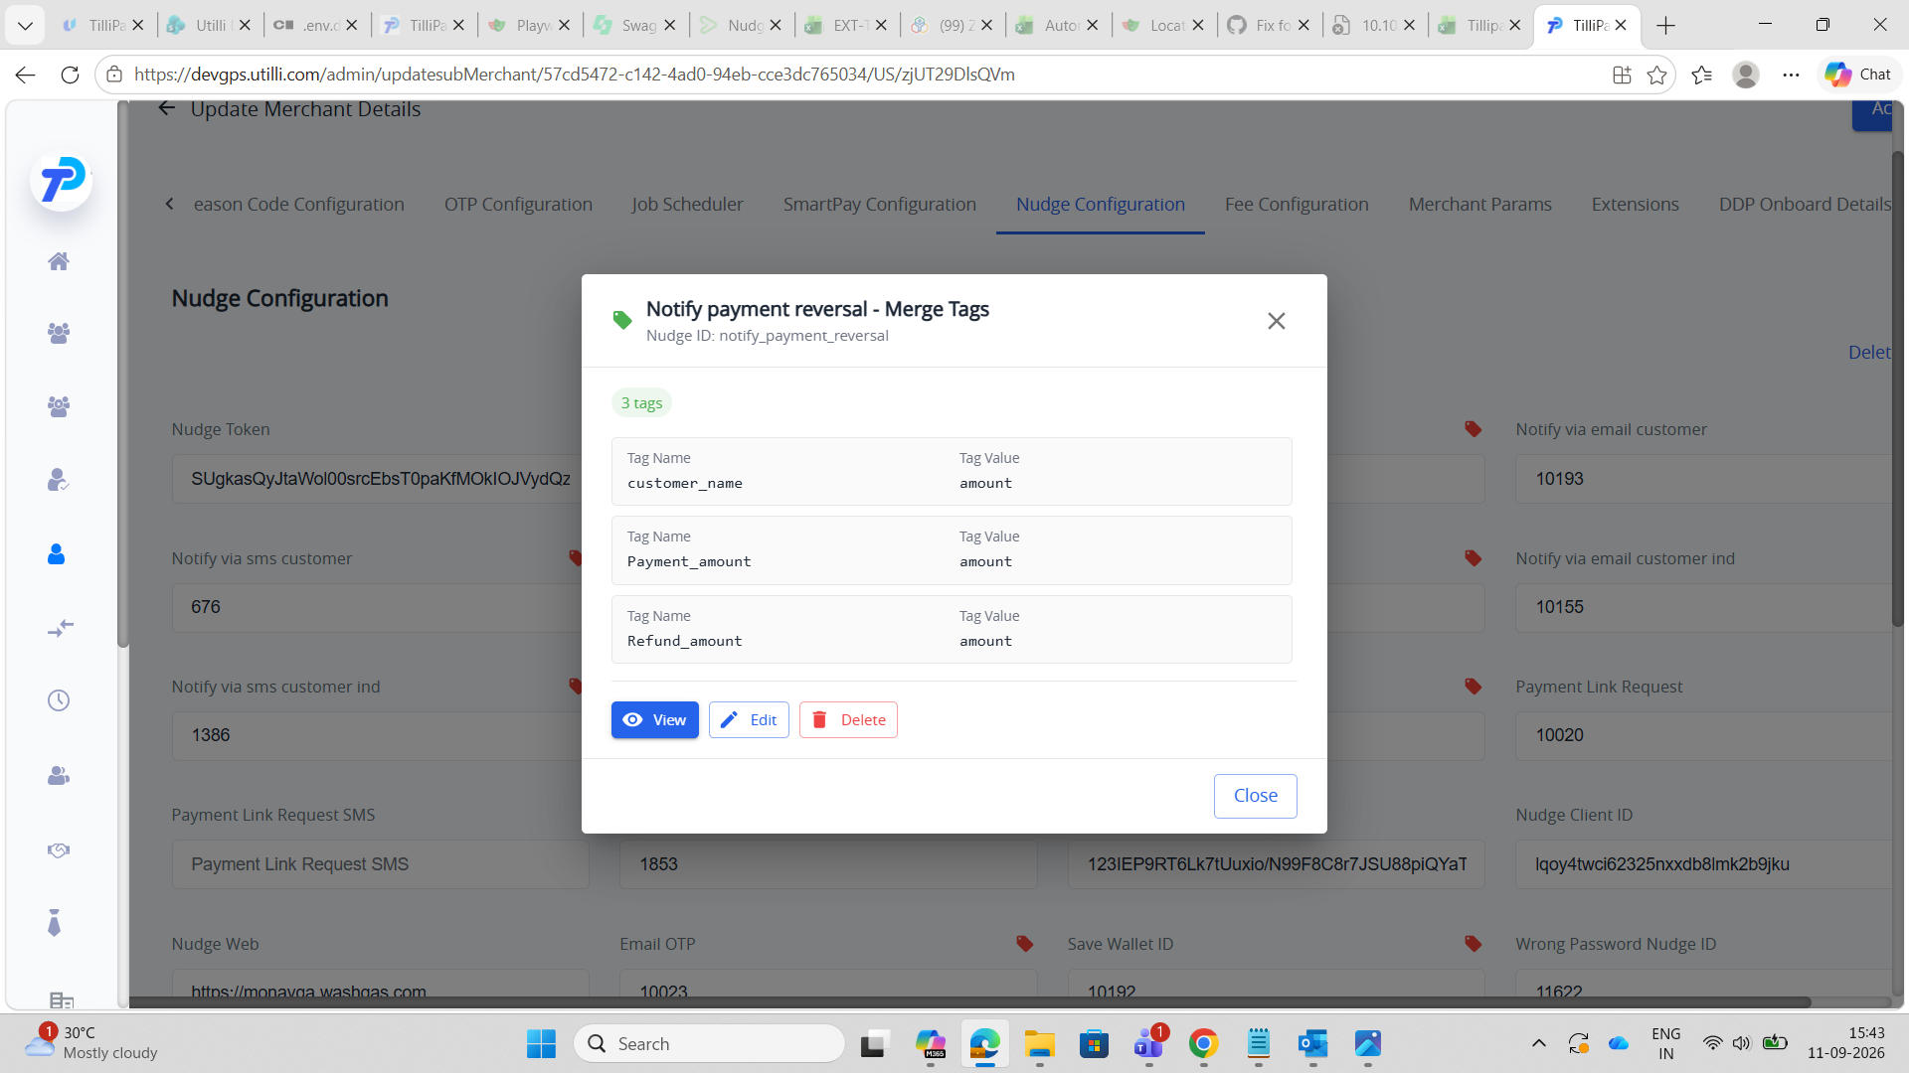
Email — after
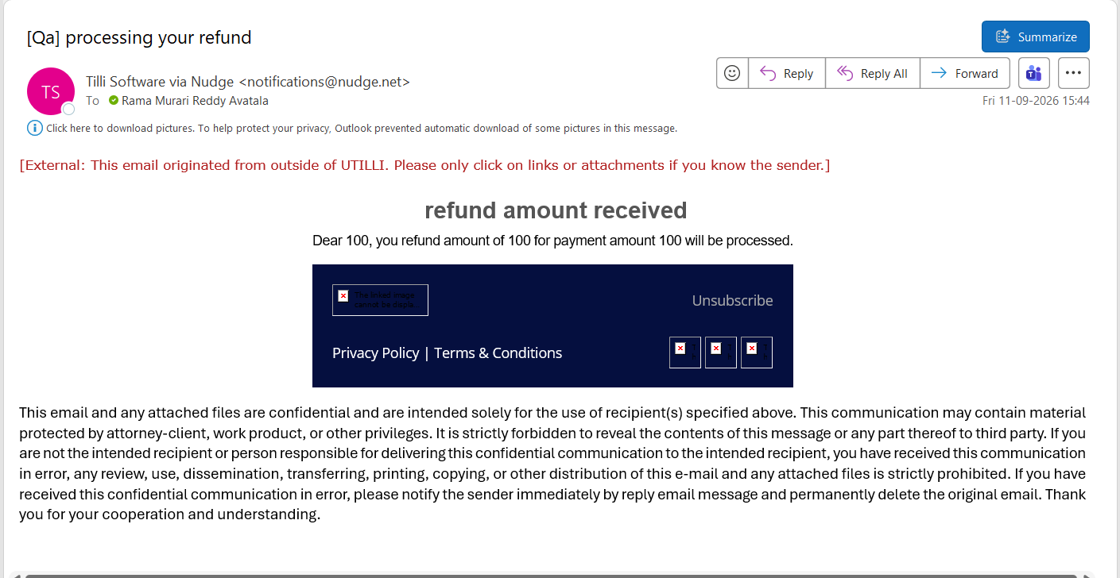

SECTION 3 — Payment Link (default page — For Developers)
Tags (Tag Name → Tag Value): requestedAmount → amount, tilliPayPaymentUrl → uri, payment_for → payment_for, Customer_Name → customer_name, customer_number → customer_number.

TC-NDT-C1 — IPG
Steps: Admin → For Developers → Third Party → Nudge (Nav bar) → US → Payment Link Request tags → Save. Merchant portal → Share Payment → share link (before). Change tag values → Save → share again (after).
Expected: The After email differs from the Before email (same data, changed mapping) → merge tags are dynamic.
Config — before
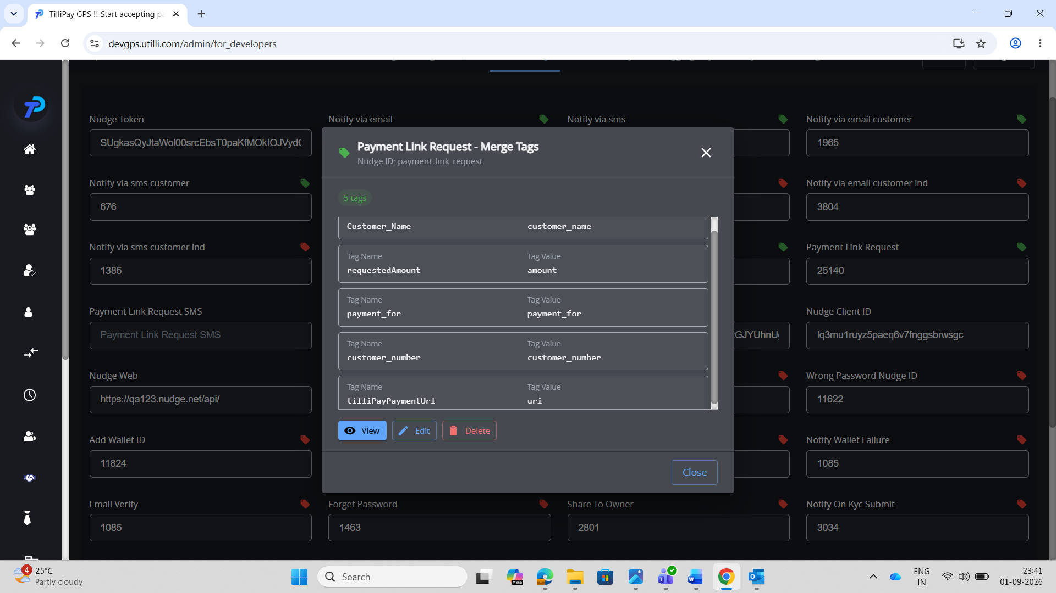
Email — before
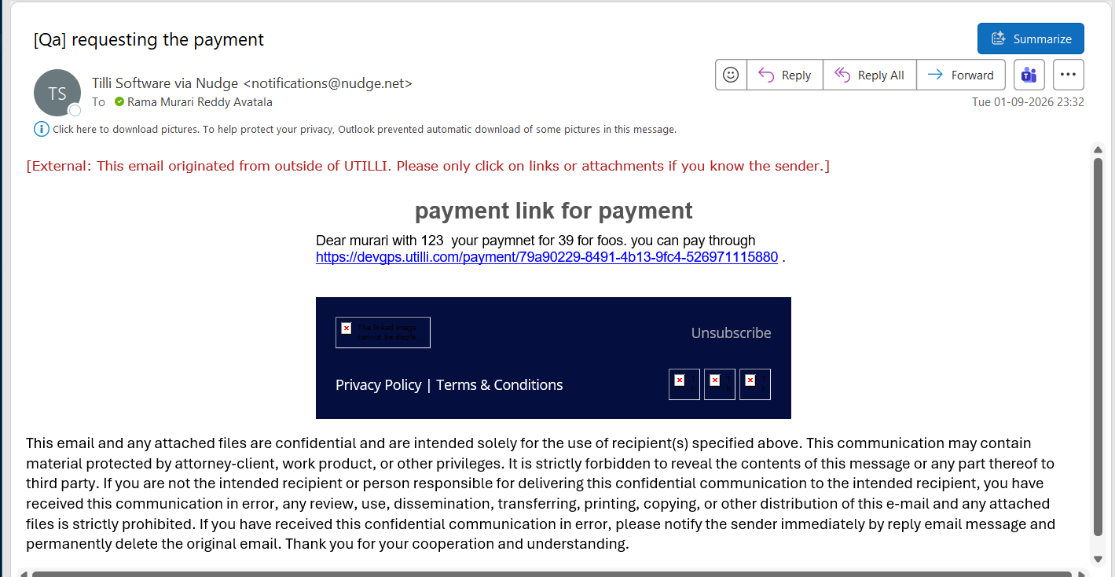
Config — after
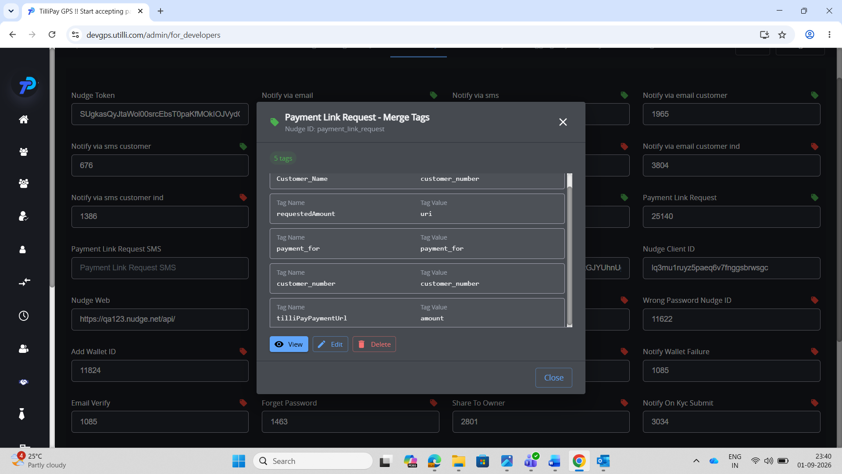
Email — after
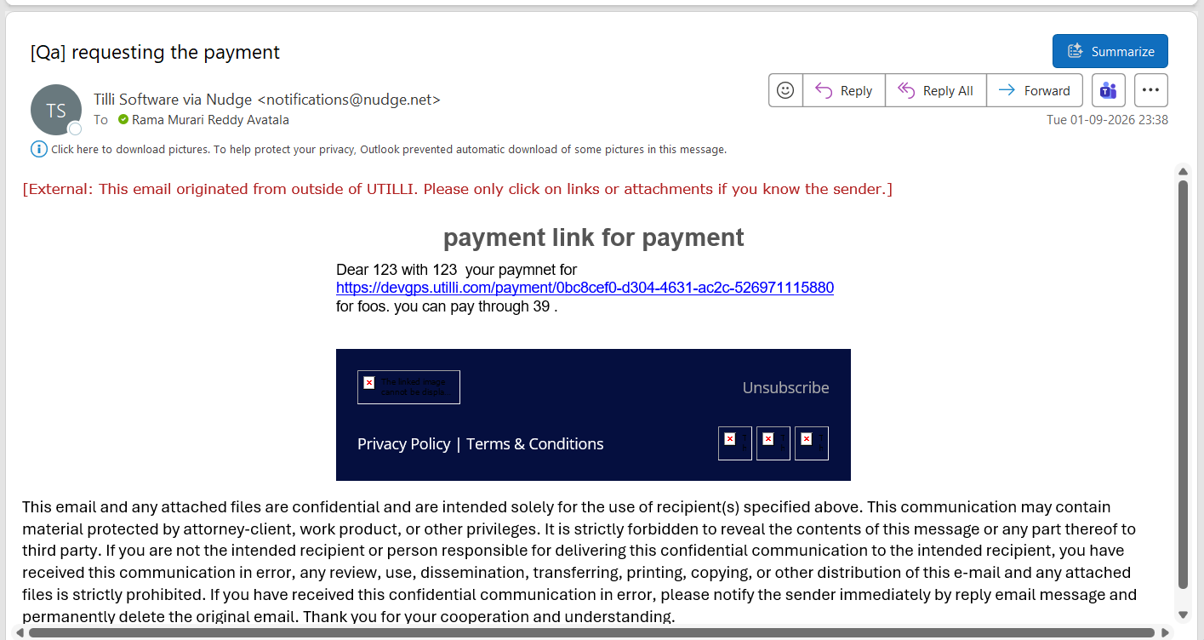

SECTION 4 — Payment Reversal (default page — For Developers)
Tags (Tag Name → Tag Value): customer_name → customer_name, Refund_amount → amount, Payment_amount → amount.

TC-NDT-D1 — IPG
Steps: Admin → For Developers → Third Party → Nudge (Nav bar) → US → Notify payment reversal tags → Save. Merchant portal → Transactions → refund/reversal (before). Change tag values → Save → reverse again (after).
Expected: The After email differs from the Before email (same data, changed mapping) → merge tags are dynamic.
Config — before
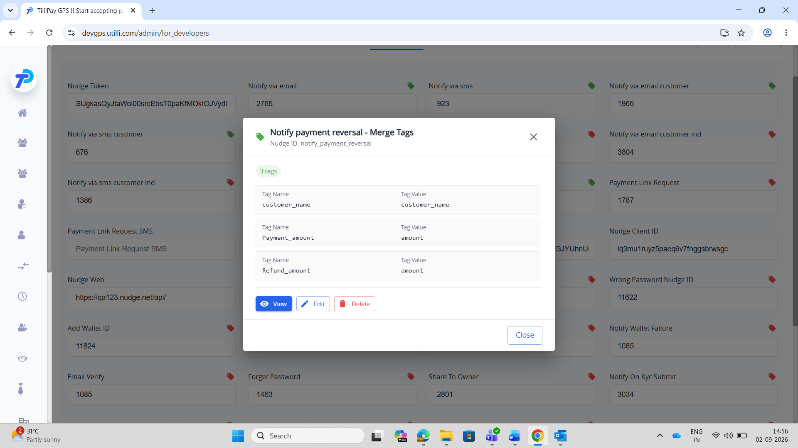
Email — before
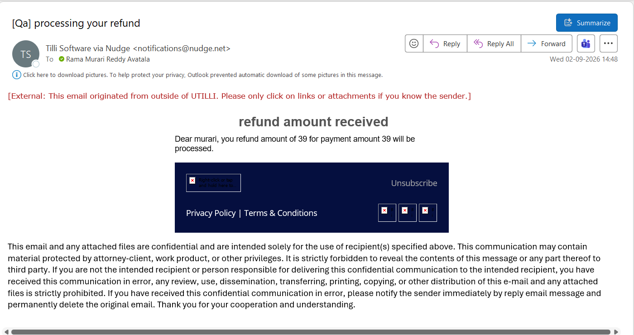
Config — after
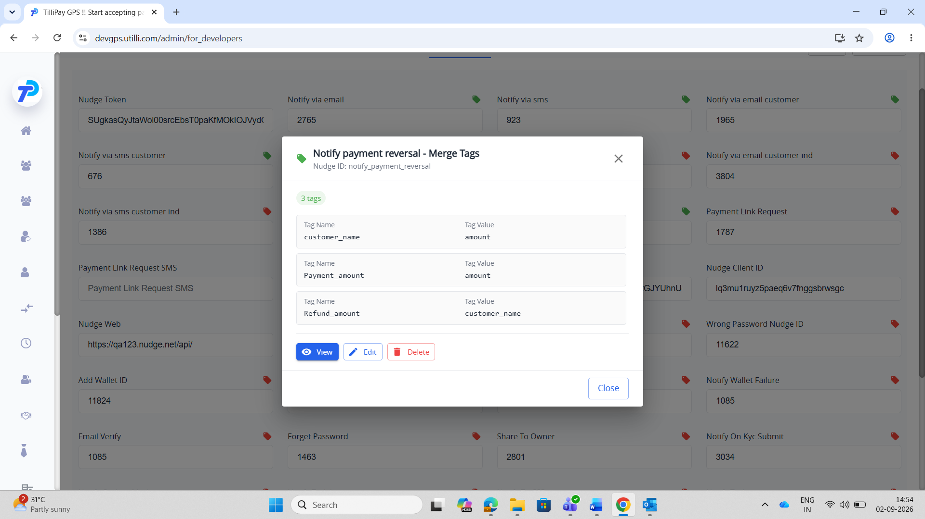
Email — after
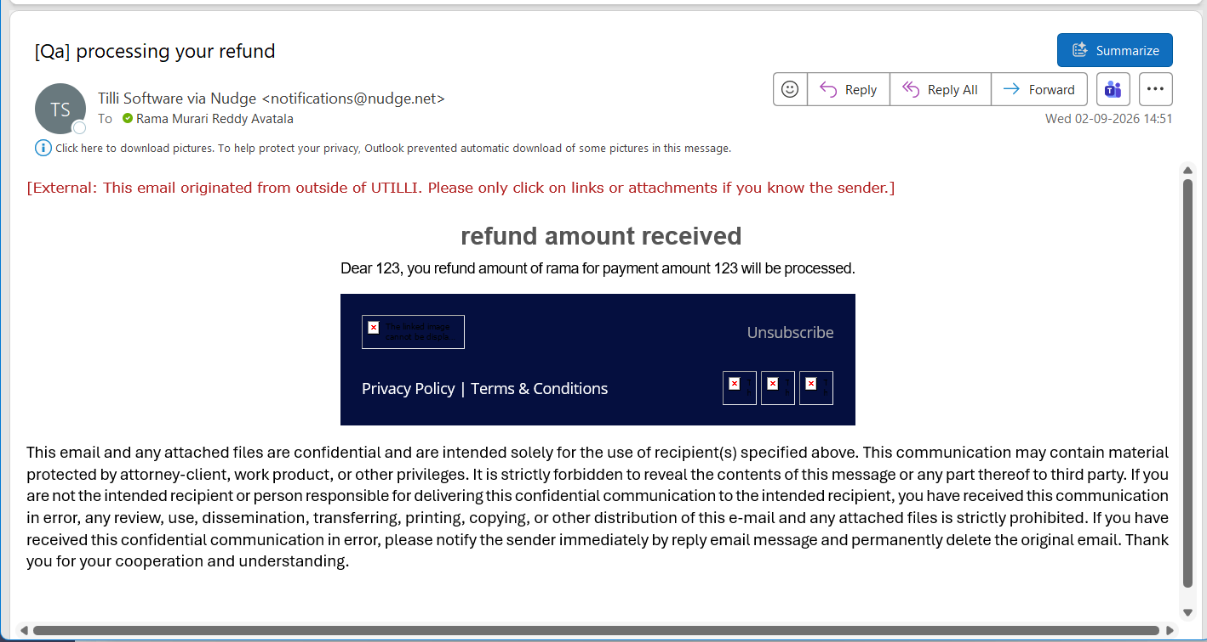

SECTION 5 — Payment Failure (already dynamic)
Tags (Tag Name → Tag Value): customer_name → customerName, Payment_amount → amount, last_four_digits_of_card → last_four_digits_of_card.

TC-NDT-E1 — IPG
Steps: Admin → Nudge Config → Notify payment failure tags → Save. Make a declined/failed payment (before). Change tag values → Save → trigger another failed payment (after).
Expected: The After email differs from the Before email (same data, changed mapping) → merge tags are dynamic.
Config — before
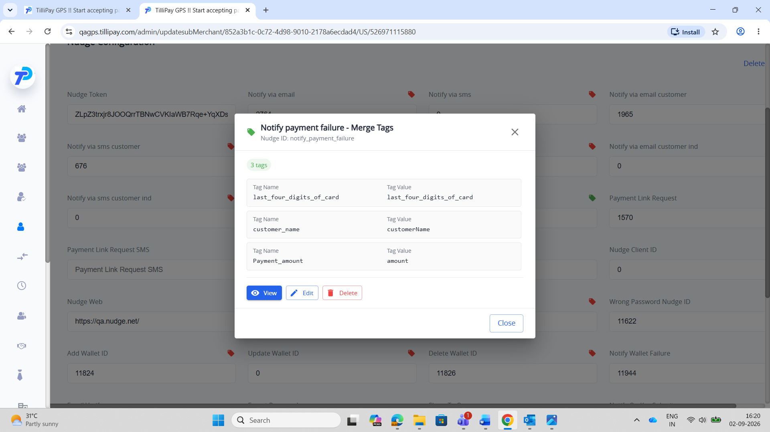
Email — before
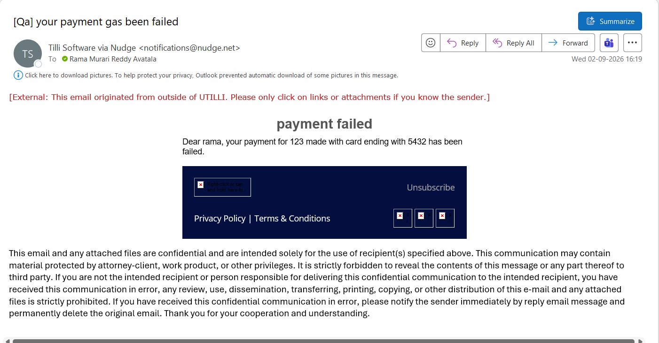
Config — after
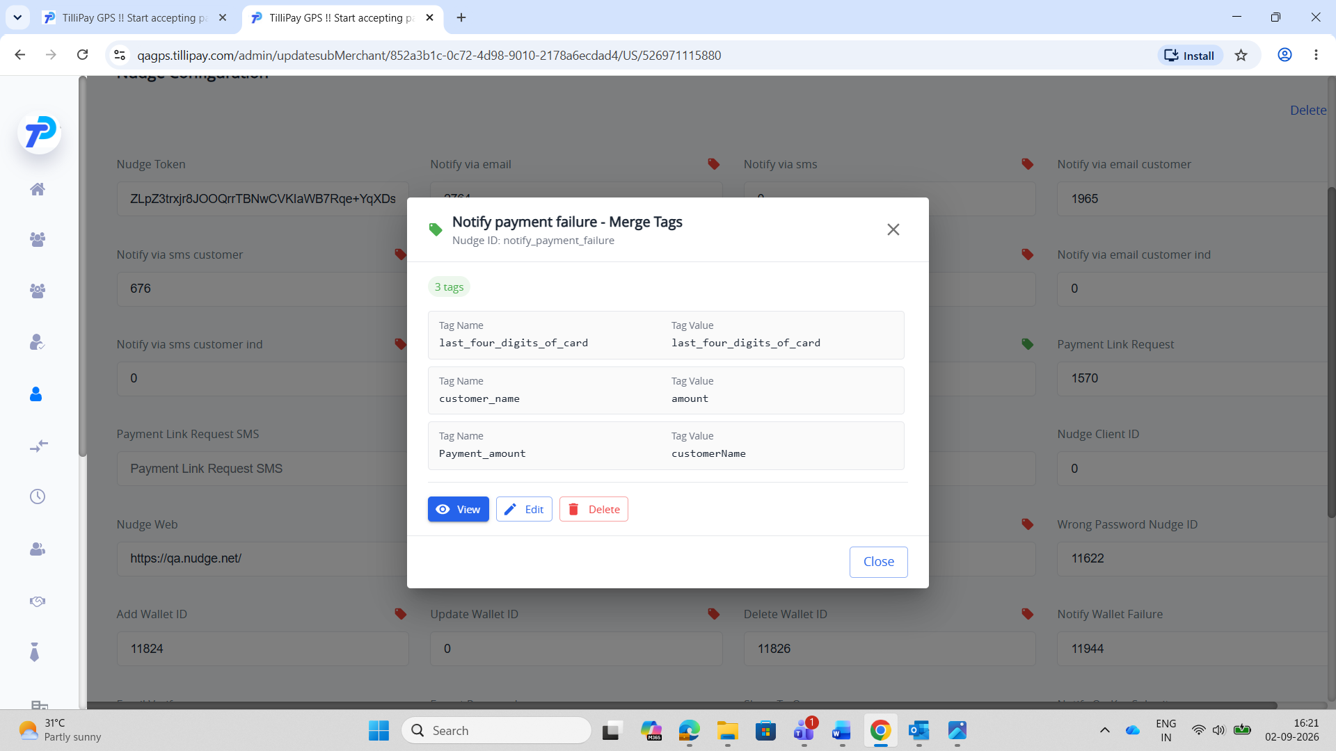
Email — after
