Prepare Query — Having and Execute never recover after Select is emptied
Test case: PS-PQ-05 Module: Payment Analytics → Payment Stats → Prepare Query Priority: High Environment: QA — https://qagps.tillipay.com/portal/paymentstats Gateways seen on: BillPay, MerchantE Date observed: 22 September 2026
Summary
Emptying the Select field correctly disables Group, Having and Execute.
Putting the Select fields back does not bring them all back. Group becomes usable again, but Having stays greyed out and Execute stays disabled. From that point the panel cannot be used at all — there is no way to build or run a query without leaving the page.
Steps to reproduce
1. Sign in to the customer portal. 2. Go to Payment Analytics → Payment Stats from the sidebar. 3. Expand Prepare Query. 4. Note that Select and Group are pre-filled and Execute is enabled. 5. Remove every chip from the Select field, one by one, using the small x on each chip. 6. Observe Group, Having and Execute — all three are now disabled. *(This part is correct.)* 7. Add the Select fields back from the dropdown. 8. Observe Having and Execute.
Expected result
Step 6 of the written case: *"Add one Select field back and verify Group becomes usable again."*
The panel should return to a working state. Once Select has fields again, Group, Having and Execute should all be usable, exactly as they were when the panel was opened.
Actual result
Control | After emptying Select | After adding Select fields back
Group | disabled | usable again — correct
Having (3 dropdowns) | disabled | still disabled — wrong
And/Or | disabled | still disabled — wrong
Execute | disabled | still disabled — wrong

Only Group recovers. Having and Execute stay locked, so the query panel is dead until the page is reloaded or the user navigates away and back.
Evidence
[Image #17] — before anything is removed
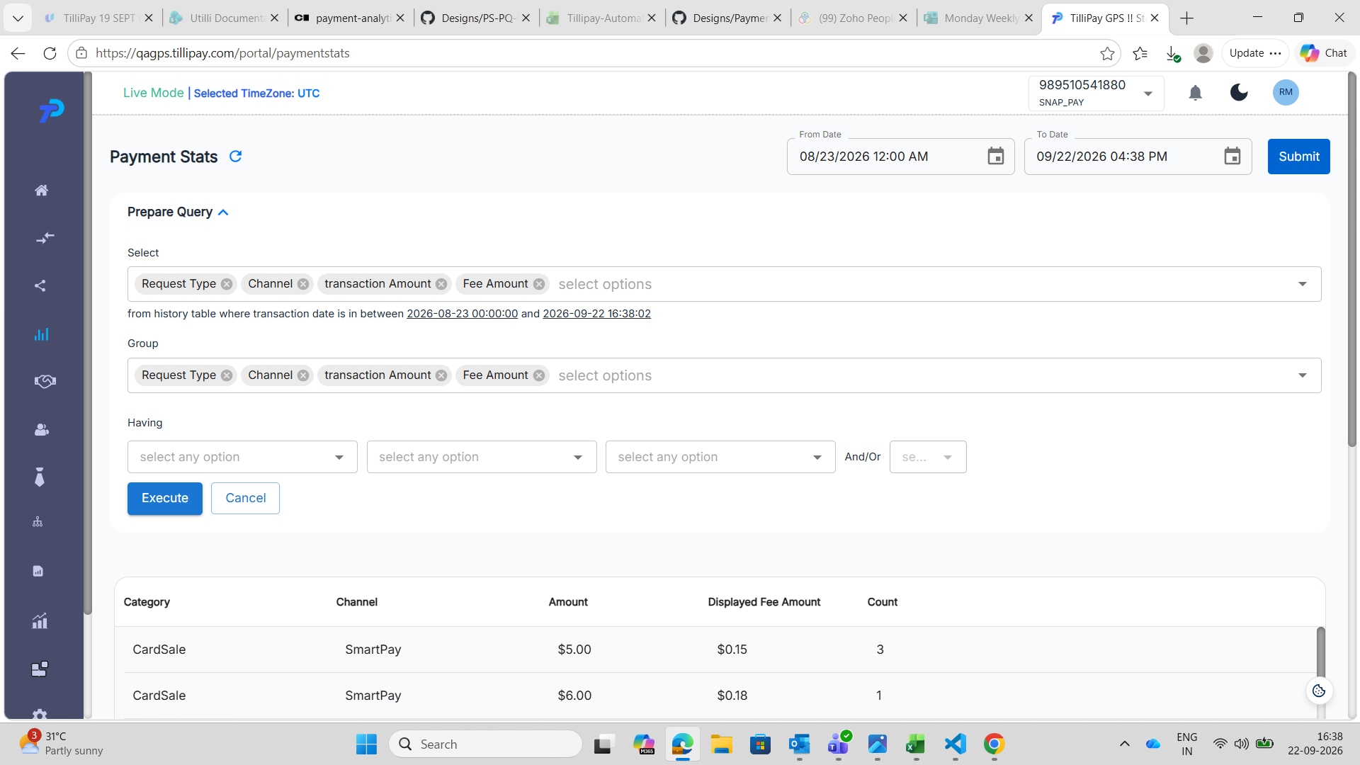
SnapPay (989510541880), 16:38. The panel as it opens. Select and Group each hold all four fields, the three Having dropdowns read "select any option" and are usable, and Execute is blue and clickable. This is the state the panel should return to once Select is refilled.
[Image #15] — the intermediate state, which is correct
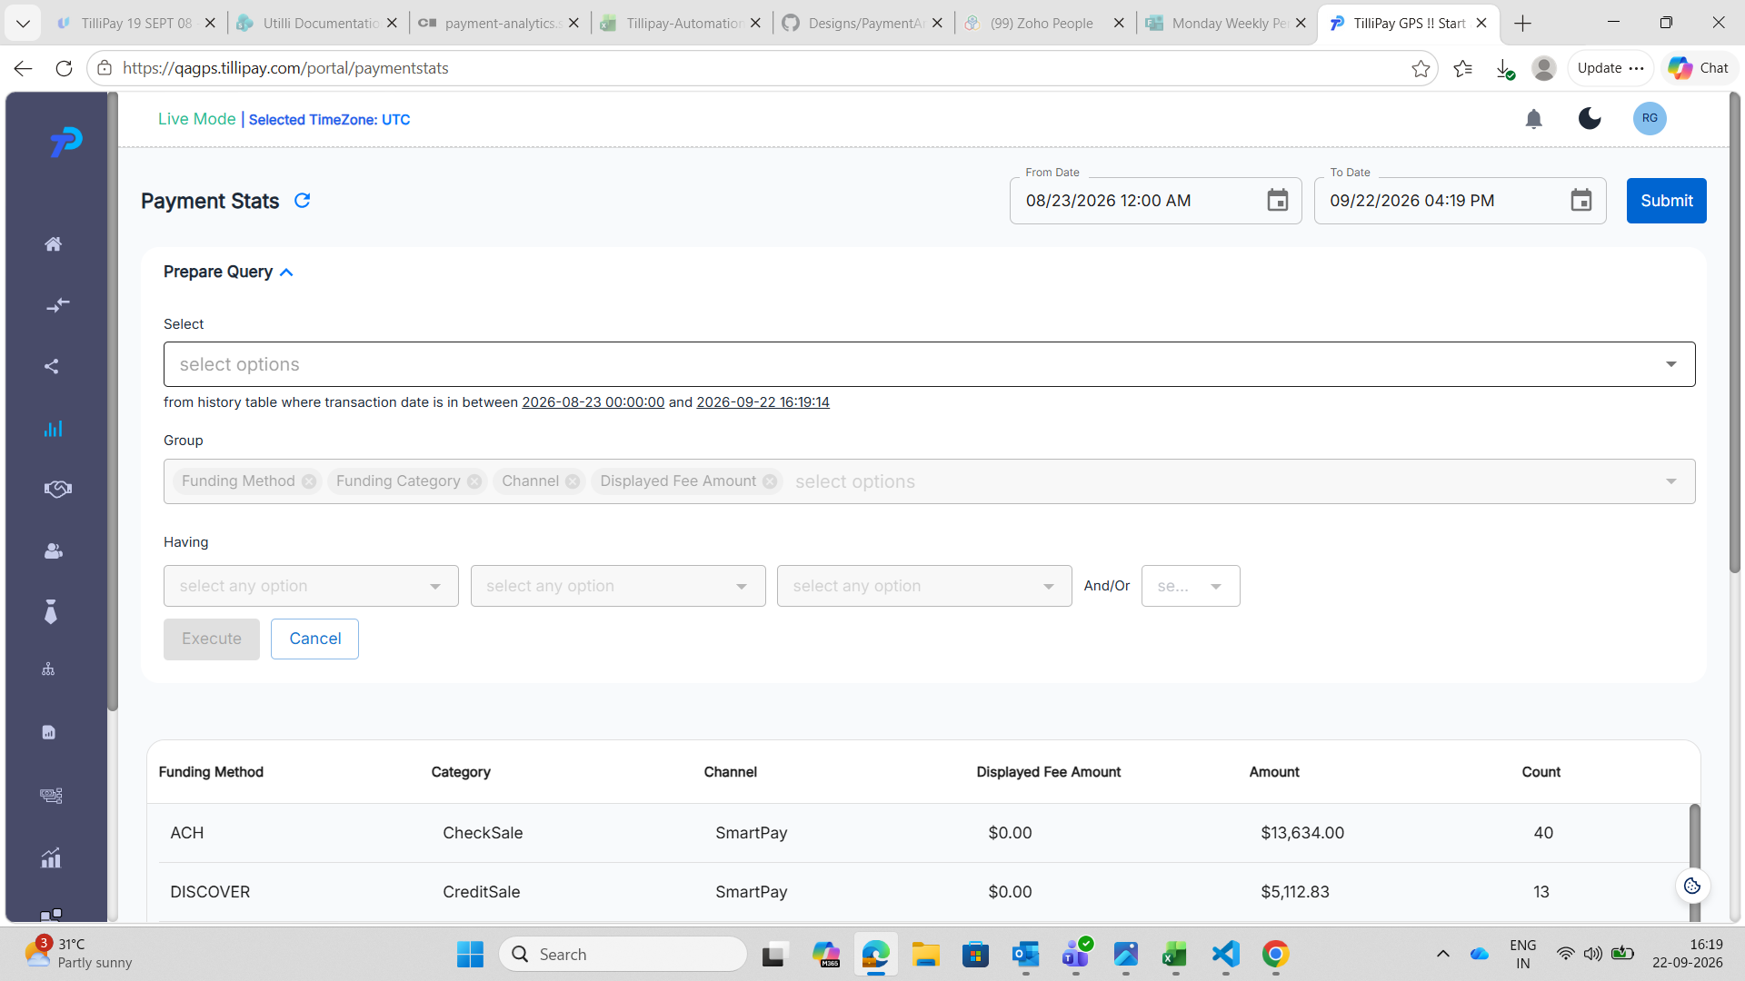
BillPay, 16:19. Select has been emptied and shows only the "select options" placeholder. The Group chips — Funding Method, Funding Category, Channel, Displayed Fee Amount — are greyed, the Having dropdowns are greyed, and Execute is greyed. This is the intermediate state, which is the correct behaviour for an empty Select.
[Image #14] — the broken end state
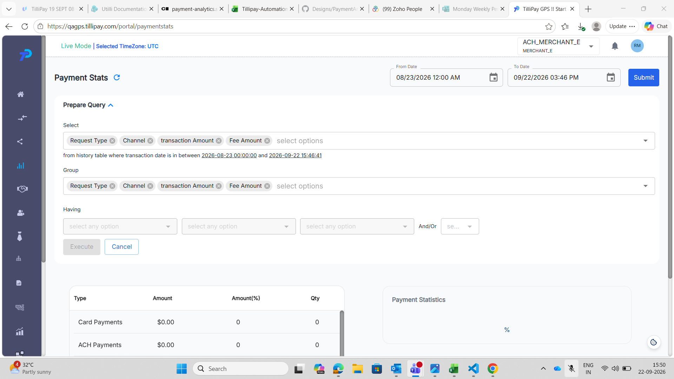
MerchantE (ACH_MERCHANT_E), 15:50. Select holds all four fields — Request Type, Channel, transaction Amount, Fee Amount — and Group holds the same four. Despite the panel being fully populated, all three Having dropdowns and the And/Or dropdown are greyed out, and the Execute button is greyed out while Cancel remains active. This is the state left behind after Select was emptied and refilled.
In all three screenshots the date range and the results table below are unaffected, so the page itself is healthy — only the query controls are stuck.
Impact
The Prepare Query panel is the only way a merchant can group or filter their payment statistics. Once this state is reached the feature is unusable for the rest of the visit, and nothing on screen explains why the buttons are dead or how to get them back.
Clearing a field and changing your mind is ordinary behaviour, so this is easy to hit by accident.
Workaround: reload the page, or navigate away and back through the sidebar. The panel opens fresh and works normally.
Notes for the developer
• Group recovering while Having and Execute do not suggests the enable/disable rules for the three controls are evaluated separately, and only Group's is re-checked when Select changes.
• Having and Execute appear to recover only when Group itself is edited, not when Select is.
• Seen on both BillPay and MerchantE, so it is not specific to one gateway's field set.

