Nudge Dynamic Merge Tags — QA Test Plan
Feature: Dynamic (admin-configurable) merge tags for Payment Reversal, Payment Failure, and Payment Link Request notifications.
Branch: Dev_RamaMurari (PR #1218 → dev). Services: nodejs_gps (backend), gps_admin (Admin Portal → Nudge Configuration), reactjs_gps / gps_payments_app (merchant & payment flows that trigger the notifications).

1. What this feature does
A Nudge notification (email/SMS) is built from a template that has "blanks" called merge tags (e.g. {{customer_name}}). Previously the list of blanks for these notifications was hardcoded in the app (static). Now the blanks can be configured by staff from the Admin → Nudge Configuration page (dynamic) and stored in the nudge_merge_tags table.
Three notifications are covered:
• 1. Payment Reversal (notify_payment_reversal) — refund/reversal email — newly dynamic.
• 2. Payment Failure (notify_payment_failure) — payment-failed email — was already dynamic; verified + a log-label fix.
• 3. Payment Link Request (payment_link_request) — "here's your payment link" email — newly dynamic (all send paths, US + India).
Backward compatible: if a merchant has no merge tags configured, the notification sends the same content as before (a built-in fallback list), so nothing breaks.
Backend change summary (for reference): new helper resolveTagsWithFallback in nudge.helper.js; notifyOnPaymentRevarsal (http.js) → dynamic; payment-link email → dynamic in sendUserPaymentLinkV2, notifyOnSharePaymentLink, sendPayLLink (billinginfo.service.js) and notifyOnSharePaymentLinkIND (billinginfo.service.ind.js); failure log type corrected PAYMENT_REVERSAL → PAYMENT_FAILURE.
Migrations: None required. The nudge_merge_tags table and the notify_payment_reversal / notify_payment_failure / payment_link_request columns already exist.

2. How to use this document
• Execute the test cases in order within each section.
• Each test case has Preconditions → Steps → Expected Result → Screenshot.
• The core check for "is it dynamic": change a tag in Admin → trigger the notification → if the email changes, it is dynamic; if it ignores the config, it is static.
• Test against a backend running this branch, using a merchant where payments actually work.

3. Glossary
• Merge tag — a blank in the Nudge template, e.g. {{customer_name}}.
• Tag Name — the blank's name in the Nudge template (the Nudge side).
• Tag Value — the TilliPay field the blank is filled from (entered in Admin).
• Static — merge tags are hardcoded in the app's code.
• Dynamic — merge tags come from the nudge_merge_tags DB table, edited in the Admin Nudge Config page.
• Fallback — when no tags are configured, the code uses the original hardcoded list, so behaviour is unchanged.

SECTION A — Admin: Nudge Configuration (setup)
Where: Admin Portal → Sub-merchants → select the test merchant → Nudge Configuration.

TC-NDT-A1 — Merge-tag icon appears for a notification
• Preconditions: Logged into Admin Portal; the notification's template ID is filled in.
• Steps:
• 1. Open Nudge Configuration for the test merchant.
• 2. Enter a template ID in the notification field (e.g. Notify payment reversal / Payment link request).
• 3. Look next to that field.
• Expected Result: A tag (🏷️) icon appears next to the field. It is red when no merge tags are configured.
• Screenshot :

TC-NDT-A2 — Add merge tags and Save
• Preconditions: TC-NDT-A1 done for the chosen notification.
• Steps:
• 1. Click the 🏷️ icon → (Edit mode) → click Add Tag.
• 2. Enter a Tag Name and Tag Value row (see the section for the notification).
• 3. Add all required rows, then click Save.
• Expected Result: Tags are saved; the 🏷️ icon turns green (tags configured).
• Screenshot:

TC-NDT-A3 — View saved merge tags
• Steps:
• 1. Click the green 🏷️ icon.
• Expected Result: The dialog opens in View mode and lists each Tag Name / Tag Value pair that was saved.
• Screenshot:

TC-NDT-A4 — Edit / remove merge tags
• Steps:
• 1. Click 🏷️ → Edit → change a Tag Value, or remove a row (⊝), or Add Tag.
• 2. Click Save.
• Expected Result: The change is saved; reopening shows the updated list (icon stays green while any tag exists, turns red when all are removed).
• Screenshot:

SECTION B — Payment Reversal (notify_payment_reversal)
Where: Admin Nudge Config (to set tags) + a refund/reversal on a paid transaction (to trigger).
Merge tags to configure (Tag Name → Tag Value):
• customer_name → customer_name
• Refund_amount → amount
• Payment_amount → amount
• Refund_days → refundDays
• currency → currency
Template must contain: {{customer_name}}, {{Refund_amount}}, {{Payment_amount}}, {{Refund_days}}, {{currency}}

TC-NDT-B1 — Configure reversal merge tags
• Preconditions: Notify payment reversal has a template ID; template contains the placeholders above.
• Steps:
• 1. Admin → Nudge Config → Notify payment reversal → 🏷️ → Add the tags listed above → Save.
• Expected Result: Tags saved; 🏷️ icon green.
• Screenshot:

TC-NDT-B2 — Reversal email uses the configured tags (dynamic)
• Preconditions: TC-NDT-B1 done.
• Steps:
• 1. Process a refund / reversal on a paid transaction for the merchant.
• 2. Check the customer's inbox.
• Expected Result: The reversal email is received and its blanks show the real values (customer name, refund amount, currency).
• Screenshot:

TC-NDT-B3 — Prove it is dynamic
• Steps:
• 1. In Admin, change a Tag Value (e.g. customer_name → customer_number) or add a new tag → Save.
• 2. Process another reversal.
• Expected Result: The email changes to match the new config — no code change / redeploy. (Proves dynamic.)
• Screenshot:

TC-NDT-B4 — Fallback (no tags = old behaviour)
• Steps:
• 1. In Admin, remove all reversal tags → Save (🏷️ turns red).
• 2. Process a reversal.
• Expected Result: The reversal email still sends, using the built-in default content (identical to before). Nothing breaks.
• Screenshot:

SECTION C — Payment Failure (notify_payment_failure)
Where: Admin Nudge Config + a payment that is declined/fails (to trigger).
Merge tags to configure (Tag Name → Tag Value):
• customer_name → customerName
• Payment_amount → Payment_amount
• last_four_digits_of_card → last_four_digits_of_card
• currency → currency
Template must contain: {{customer_name}}, {{Payment_amount}}, {{last_four_digits_of_card}}, {{currency}}

TC-NDT-C1 — Configure failure merge tags
• Preconditions: Notify payment failure has a template ID; template contains the placeholders above.
• Steps:
• 1. Admin → Nudge Config → Notify payment failure → 🏷️ → Add the tags above → Save.
• Expected Result: Tags saved; 🏷️ icon green.
• Executed: notify_payment_failure (Nudge ID 25140) is already dynamic; 3 tags configured, with swaps to prove dynamic — customer_name → amount, Payment_amount → customerName, last_four_digits_of_card → last_four_digits_of_card.
• Screenshot:
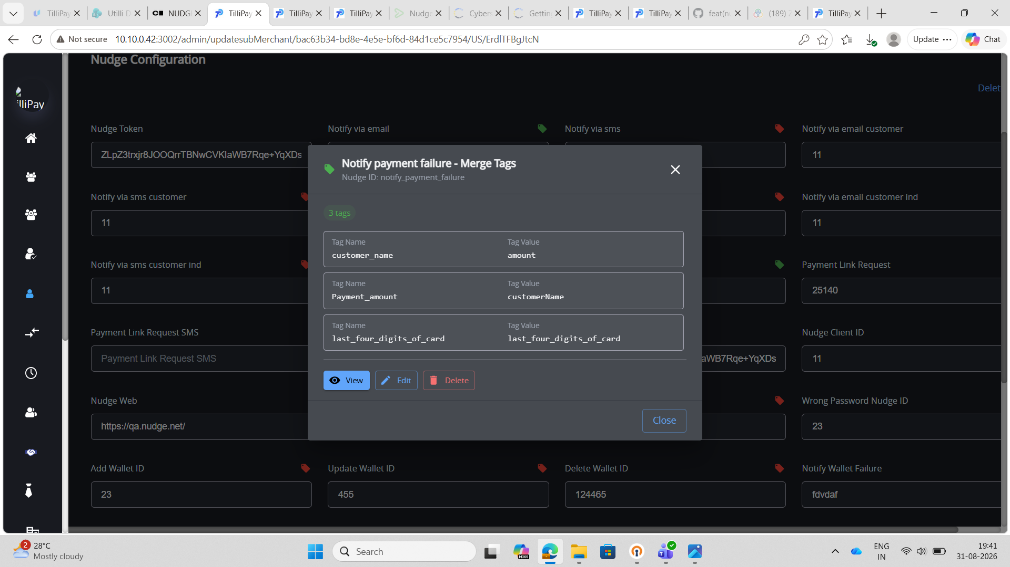

TC-NDT-C2 — Failure email uses the configured tags (dynamic)
• Steps:
• 1. Make a payment that is declined / fails.
• 2. Check the customer's inbox.
• Expected Result: The "payment failed" email is received with the real values (customer name, amount, last 4 digits).
• Screenshot:

TC-NDT-C3 — Prove it is dynamic
• Steps:
• 1. Change/add a tag in Admin → Save.
• 2. Trigger another failed payment.
• Expected Result: The email changes to match the new config (dynamic).
• Screenshot:

TC-NDT-C4 — Log label check
• Steps:
• 1. After a failed payment, inspect the nudge_logs row for this send.
• Expected Result: nudge_logs.type reads PAYMENT_FAILURE (previously mislabeled PAYMENT_REVERSAL).
• Screenshot:

TC-NDT-C5 — Fallback (no tags = old behaviour)
• Steps:
• 1. Remove all failure tags → Save.
• 2. Trigger a failed payment.
• Expected Result: The failure email still sends with the built-in default content.
• Screenshot:

SECTION D — Payment Link Request (payment_link_request)
Where: Admin Nudge Config + the merchant Share Payment page (to trigger).
Merge tags to configure (Tag Name → Tag Value):
• requested → email
• amountUnit → currency
• requestedAmount → amount
• tilliPayPaymentUrl → uri
• customer → business_legal_name
• payment_for → payment_for
• Customer_Name → customer_Name
• customer_number → customer_number
• customField3 → customFieldsObj?.customField3 || ''
• customField4 → customFieldsObj?.customField4 || ''
• customField5 → customFieldsObj?.customField5 || ''
Template must contain the matching {{placeholders}}.

TC-NDT-D1 — Configure payment-link merge tags
• Preconditions: Payment link request has a template ID; template contains the placeholders.
• Steps:
• 1. Admin → Nudge Config → Payment link request → 🏷️ → Add the tags above → Save.
• Expected Result: Tags saved; 🏷️ icon green.
• Executed: 5 tags configured for payment_link_request (Nudge ID 25140), with deliberate swaps to prove dynamic behaviour — Customer_Name → customer_number and customer_number → customer_name.
• Screenshot:
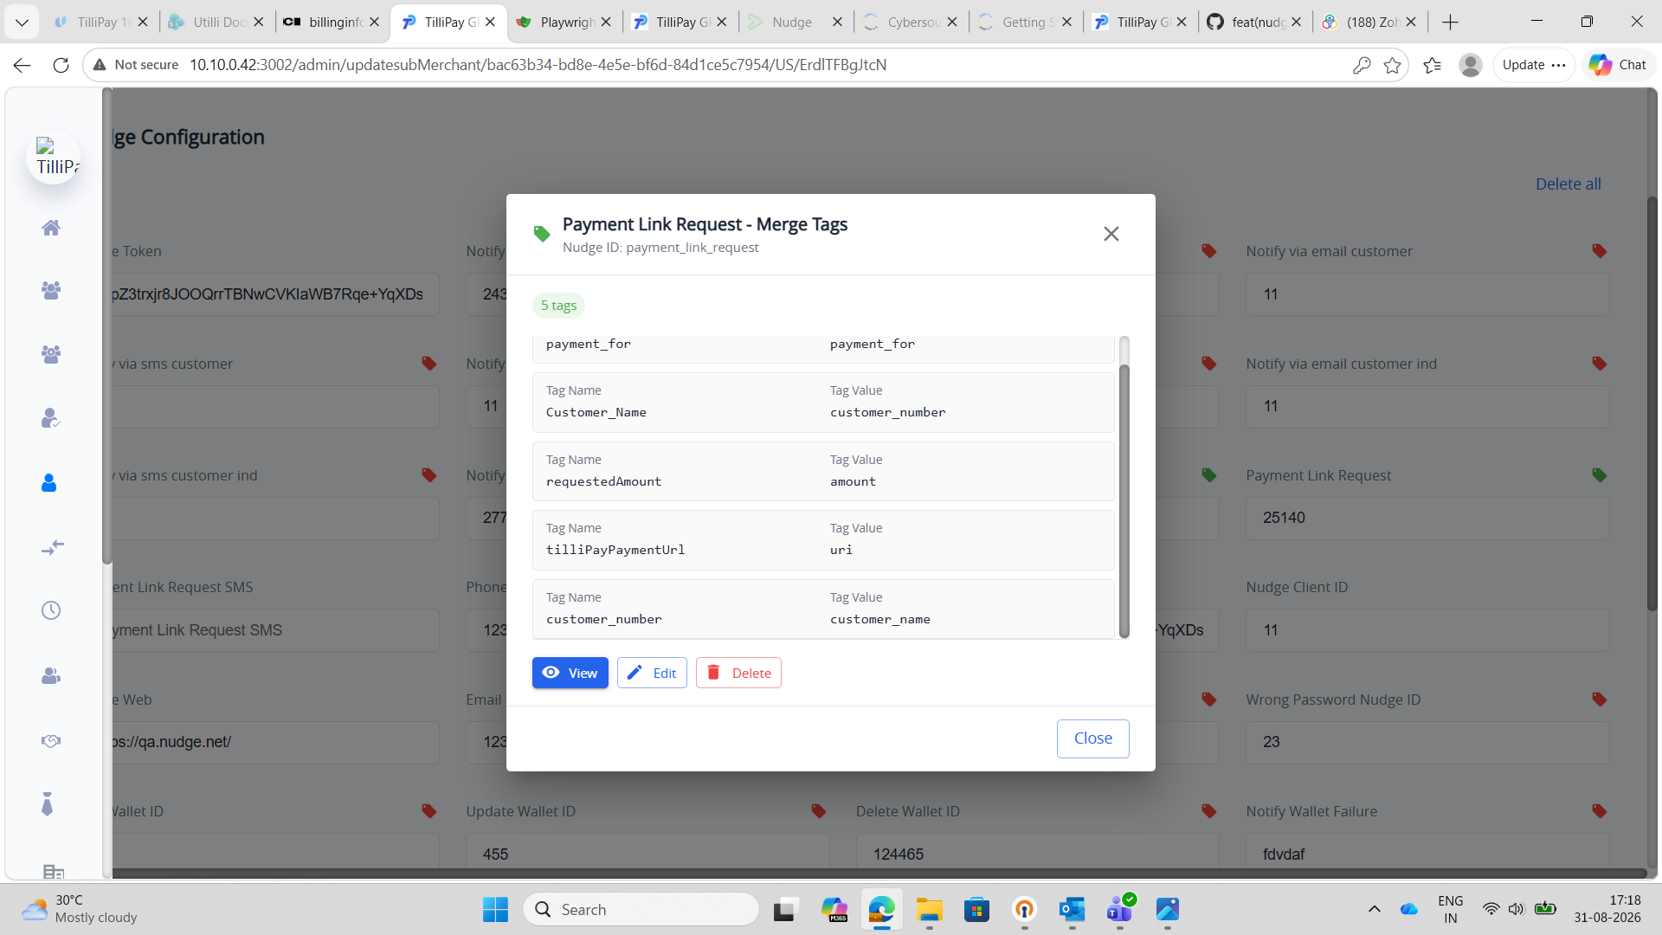

TC-NDT-D2 — Payment-link email uses the configured tags (dynamic)
• Steps:
• 1. Merchant portal → Share Payment → enter a customer email + amount (e.g. 56) → create/share the link.
• 2. Check the customer's inbox.
• Expected Result: The payment-link email is received; the amount blank shows 56 and the link works.
• Screenshot:

TC-NDT-D3 — Prove it is dynamic (local/dynamic vs dev/static)
• Steps:
• 1. Keep the swapped config from TC-NDT-D1 (Customer_Name → customer_number, customer_number → customer_name).
• 2. Share the same payment link from the local backend (dynamic code) and from the dev backend (static code) with the same data (name "manay", number "12222").
• 3. Compare both emails.
• Expected Result: The local (dynamic) email reflects the admin config (swapped), while the dev (static) email ignores the config and uses the hardcoded order.
• Result (PASS ✅):
• Local (dynamic): "Dear 12222 with manay … for 124 …" — name and number are swapped, matching the admin config → the DB tags drove the email.
• Dev (static): "Dear manay with 12222 … for 124.00 …" — normal order, config ignored → uses hardcoded tags.
• Same config, different result per environment → confirms dynamic on local, static on dev.
• Screenshots:
Local — dynamic (reflects the swapped config):
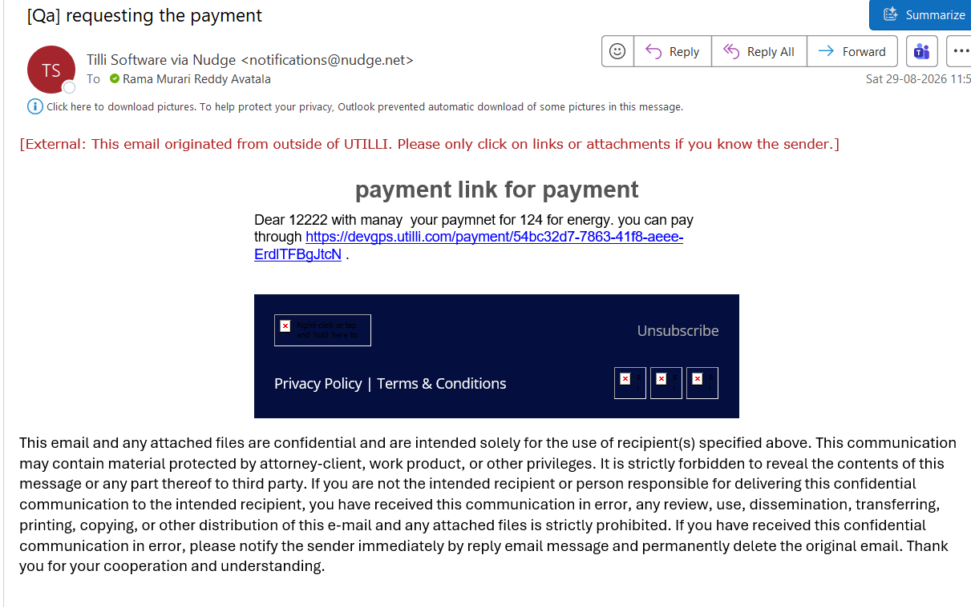
Dev — static (ignores the config):
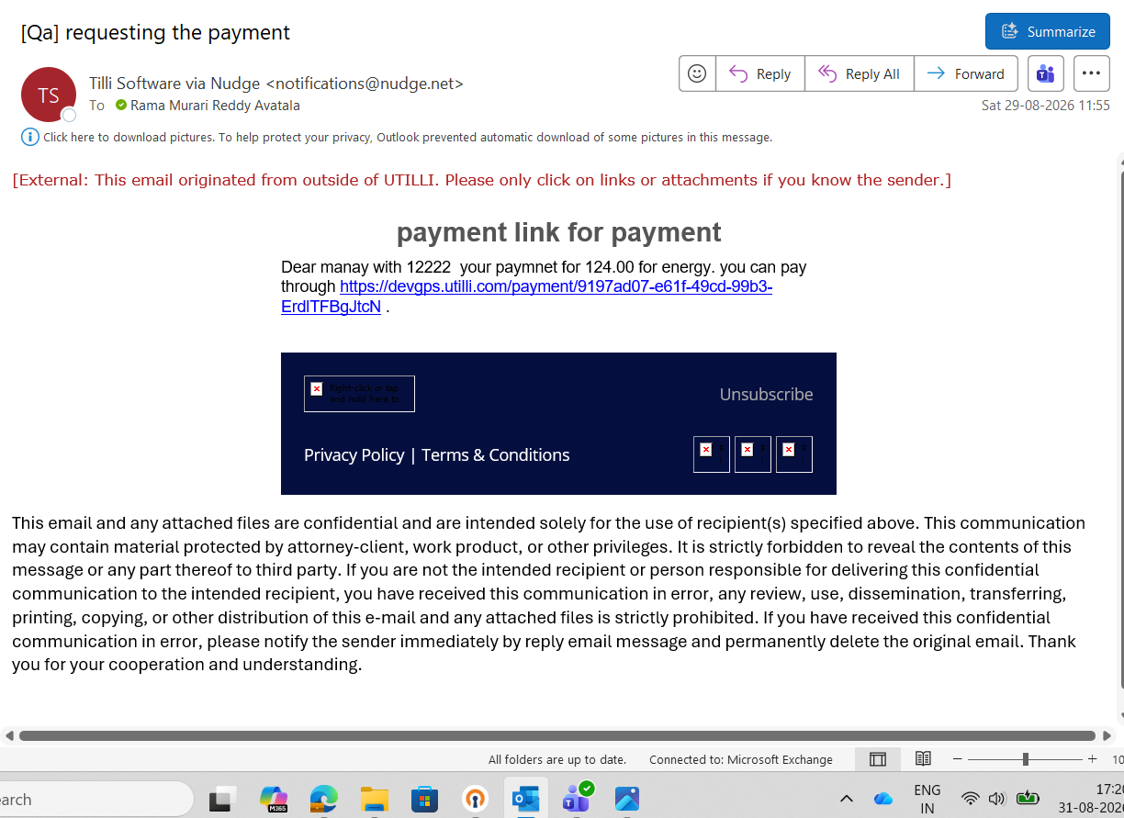

TC-NDT-D4 — Fallback (no tags = old behaviour)
• Steps:
• 1. Remove all payment-link tags → Save.
• 2. Share a payment link.
• Expected Result: The email still sends with the built-in default content.
• Screenshot:

TC-NDT-D5 — Coverage: resend, bulk, India
• Steps:
• 1. Resend an existing payment link (sendPayLLink).
• 2. Bulk share links (sendUserPaymentLinkV2).
• 3. Repeat D1–D2 for an India merchant (notifyOnSharePaymentLinkIND).
• Expected Result: All paths send the payment-link email using the configured tags (or the fallback when none) — behaviour is consistent across all four paths.
• Screenshot:

SECTION E — Backward compatibility / regression

TC-NDT-E1 — Un-configured merchant is unchanged
• Steps:
• 1. Use a merchant with no merge tags configured for these notifications.
• 2. Trigger each of the three notifications.
• Expected Result: All three send exactly the same content as before (fallback). No errors, no visible change.
• Screenshot:

TC-NDT-E2 — No UI / flow breakage
• Steps:
• 1. Exercise the normal payment, refund/reversal, and share-link flows (single, resend, bulk).
• Expected Result: All flows work as before; only the merge tags sent to Nudge differ. No route/screen changes.
• Screenshot:

Sign-off
• [ ] Branch deployed to QA; no new migration run (confirmed not needed).
• [ ] Section A (Admin config) passes.
• [ ] Section B (Reversal) — dynamic proof + fallback pass.
• [ ] Section C (Failure) — dynamic proof + fallback pass; log type = PAYMENT_FAILURE.
• [ ] Section D (Payment Link) — dynamic proof + fallback pass; resend/bulk/India verified.
• [ ] Section E — un-configured merchant unchanged; no UI/flow breakage.

