Payment Stats — defects
Module: Payment Analytics → Payment Stats Environment: QA — https://qagps.tillipay.com/portal/paymentstats Last updated: 23 September 2026
 | Test case | Defect | Priority | Gateways
1 | PS-LOAD-10 | Switching sub-merchant does not reload the stats | High | all gateways
2 | PS-SUB-03 | The first refresh click after page load is swallowed | Medium | all gateways
3 | PS-PQ-05 | Having and Execute never recover after Select is emptied | High | BillPay, MerchantE
4 | PS-PQ-13 | Execute after Cancel queries what the panel no longer shows | High | BillPay
5 | PS-PQ-16 | The Prepare Query panel does not drive the table | High | MerchantE

Each is automated. The tests assert the intended behaviour and are marked expected-fail, so they turn red once the defect is fixed; PS-PQ-05's test records the partial recovery it leaves behind.
1. PS-LOAD-10 — switching sub-merchant does not reload the stats
Test case: PS-LOAD-10 Priority: High Gateways seen on: all gateways — measured on IPG and SnapPay Date observed: 16 and 23 September 2026
Summary
A merchant account can hold several sub-merchants, each with its own payments, chosen from the selector at the top of the portal.
Changing that selector updates the name on screen but does not refetch. The table and the graph keep showing the previous sub-merchant's figures, with nothing to indicate they are stale. The merchant is told they are looking at one sub-merchant while being shown another's numbers.
Steps to reproduce
1. Sign in as a merchant with at least two sub-merchants. 2. Go to Payment Analytics → Payment Stats from the sidebar. 3. Note the figures in the table. 4. Open the sub-merchant selector at the top of the page and choose a different one. 5. Watch the refresh icon beside the Payment Stats heading — it spins while a request is in flight, so it is the on-screen indicator that the page is fetching. 6. Compare the table and the graph against what was noted in step 3.
Expected result
Changing sub-merchant refetches and redraws both the table and the graph for the newly chosen sub-merchant.
Actual result
Nothing reloads. The refresh icon does not spin, the table keeps the previous figures and the graph is unchanged.
Measured on IPG on 16 September, watching the network: switching from 44052731 to 44052728 changed the dropdown and the hidden input behind it, and sent zero payment_stats_us requests.
Evidence
Before the switch — sub-merchant 989510541880
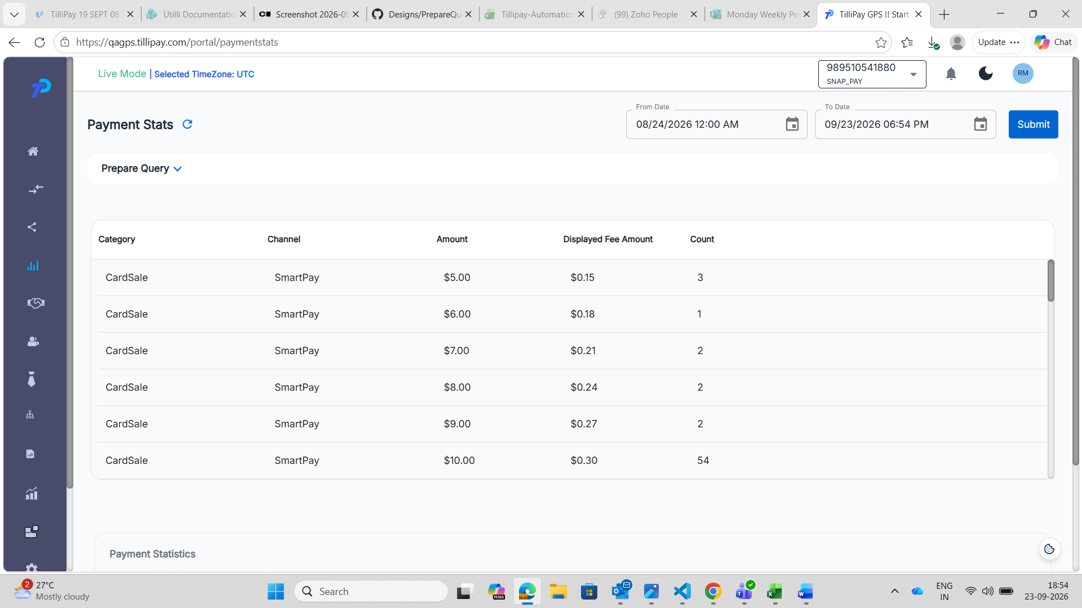
SnapPay, 18:54. The selector reads 989510541880. The table shows six CardSale rows — $5.00/3, $6.00/1, $7.00/2, $8.00/2, $9.00/2 and $10.00/54.
After the switch — sub-merchant SnapPayICADummy
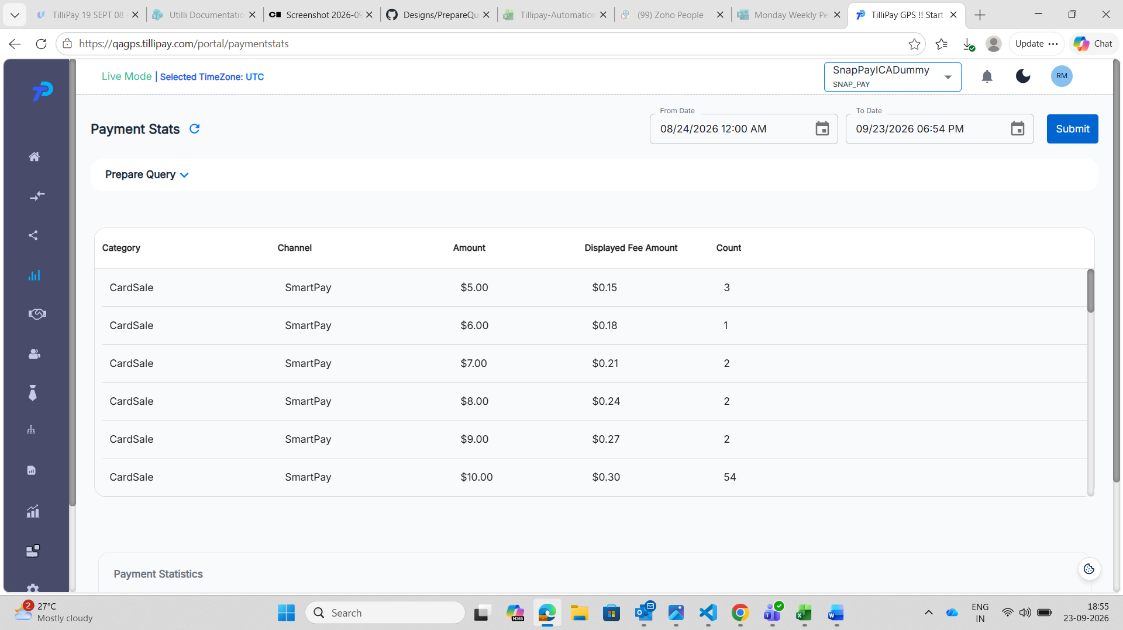
One minute later. The selector now reads SnapPayICADummy, a different sub-merchant entirely. Every row below is identical — the same six amounts, the same fees, the same counts including the 54.
Two different sub-merchants cannot have byte-identical figures by coincidence. The page never went and asked.
What pins the cause
After switching, change a date and press Submit. A request does fire, and it carries the new sub_merchant_id and returns different figures.
That proves the switch stored the new value correctly. The selector writes the id and nothing tells the page to fetch with it, so only the refetch is missing.
Impact
Silently wrong data, which is worse than an obvious failure. A merchant with several sub-merchants can switch, read the table and act on the wrong sub-merchant's figures. There is no error, no empty state and no stale-data warning — just confident, incorrect numbers.
Workaround: after switching, change a date and press Submit, or reload the page.
Notes for the developer
• The store is updated correctly; only the refetch that should follow it is missing.
• The same refetch already happens on Submit and on the refresh icon, so the call exists — it just is not triggered by the sub-merchant change.
• Worth checking the graph as well as the table: both are drawn from the same fetch, so both stay stale.
2. PS-SUB-03 — the first refresh click after page load is swallowed
Test case: PS-SUB-03 Priority: Medium Gateways seen on: all gateways — measured on IPG Date observed: 17 September 2026
Summary
The refresh icon beside the Payment Stats heading ignores exactly one click: the first one after the page loads. Nothing spins, no request goes out, and nothing on screen says so. Click it again and it works normally.
The icon is not dead, and it is not a slow response. It is one click, lost.
Steps to reproduce
1. Sign in on any gateway. 2. Go to Payment Analytics → Payment Stats from the sidebar and let the page settle. 3. Click the refresh icon beside the Payment Stats heading, once. 4. Watch the icon. It should spin while the page fetches. 5. Click it a second time and watch again.
Expected result
Every click on the refresh icon reloads the stats, and the icon spins while the request is in flight.
Actual result
Click | Icon | Request
1st after page load | never spins | none sent
2nd | spins | sent, HTTP 200
3rd | spins | sent, HTTP 200

Measured on IPG by sampling the icon's class every 40 milliseconds, so a spin too brief to see would still have been caught. There was none on the first click.
An earlier note recorded this as "the icon only works once a Submit has run". That is wrong and should not be relied on — a second refresh click is enough on its own, with no Submit involved.
Impact
Minor in effect but easy to hit: the merchant presses refresh, nothing happens, and there is no feedback at all. The natural reading is that the button is broken or the page is frozen.
Workaround: click it twice.
Notes for the developer
The cause is a React state read that happens before the state has been applied. The handler clears the date-set flag and then tests it on the next line:
setDateSet(false); if (!Isdateset) { ...fetch... }
Isdateset still holds the previous value at that point, so the fetch is skipped. On the second click the flag has settled and the branch is taken.
This is the same class of problem as reading a state variable immediately after setting it anywhere else in the page, so it is worth a look for the same pattern nearby.
3. PS-PQ-05 — Having and Execute never recover after Select is emptied
Module: Payment Analytics → Payment Stats → Prepare Query Priority: High Environment: QA — https://qagps.tillipay.com/portal/paymentstats Date observed: 22 September 2026
Summary
Emptying the Select field correctly disables Group, Having and Execute.
Putting the Select fields back does not bring them all back. Group becomes usable again, but Having stays greyed out and Execute stays disabled. From that point the panel cannot be used at all — there is no way to build or run a query without leaving the page.
Steps to reproduce
1. Sign in to the customer portal. 2. Go to Payment Analytics → Payment Stats from the sidebar. 3. Expand Prepare Query. 4. Note that Select and Group are pre-filled and Execute is enabled. 5. Remove every chip from the Select field, one by one, using the small x on each chip. 6. Observe Group, Having and Execute — all three are now disabled. *(This part is correct.)* 7. Add the Select fields back from the dropdown. 8. Observe Having and Execute.
Expected result
Step 6 of the written case: *"Add one Select field back and verify Group becomes usable again."*
The panel should return to a working state. Once Select has fields again, Group, Having and Execute should all be usable, exactly as they were when the panel was opened.
Actual result
Control | After emptying Select | After adding Select fields back
Group | disabled | usable again — correct
Having (3 dropdowns) | disabled | still disabled — wrong
And/Or | disabled | still disabled — wrong
Execute | disabled | still disabled — wrong

Only Group recovers. Having and Execute stay locked, so the query panel is dead until the page is reloaded or the user navigates away and back.
Evidence
Before anything is removed
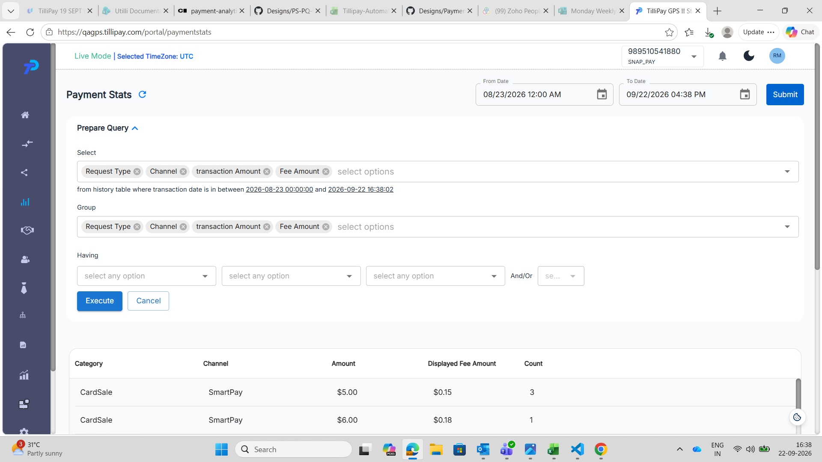
SnapPay (989510541880), 16:38. The panel as it opens. Select and Group each hold all four fields, the three Having dropdowns read "select any option" and are usable, and Execute is blue and clickable. This is the state the panel should return to once Select is refilled.
Select emptied — the intermediate state, which is correct
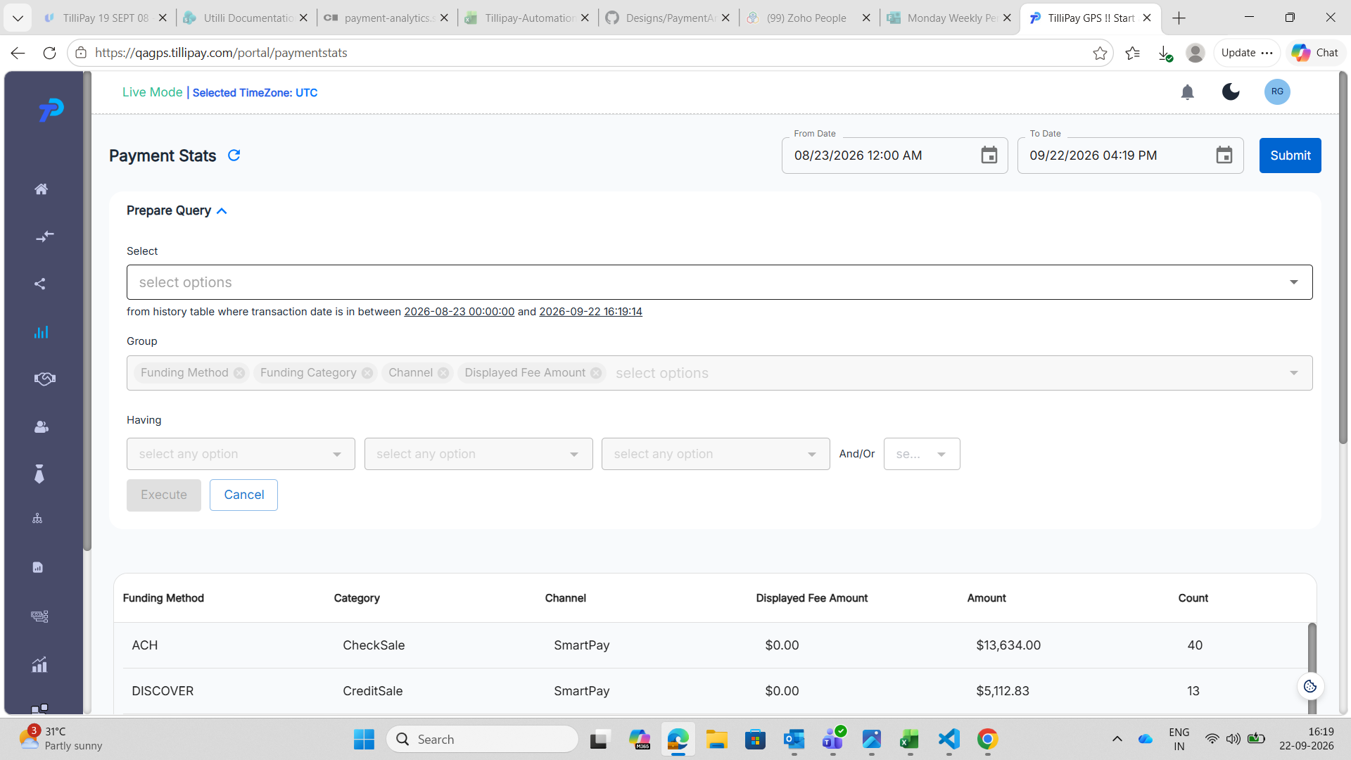
BillPay, 16:19. Select has been emptied and shows only the "select options" placeholder. The Group chips — Funding Method, Funding Category, Channel, Displayed Fee Amount — are greyed, the Having dropdowns are greyed, and Execute is greyed. This is the intermediate state, which is the correct behaviour for an empty Select.
Select refilled — the broken end state
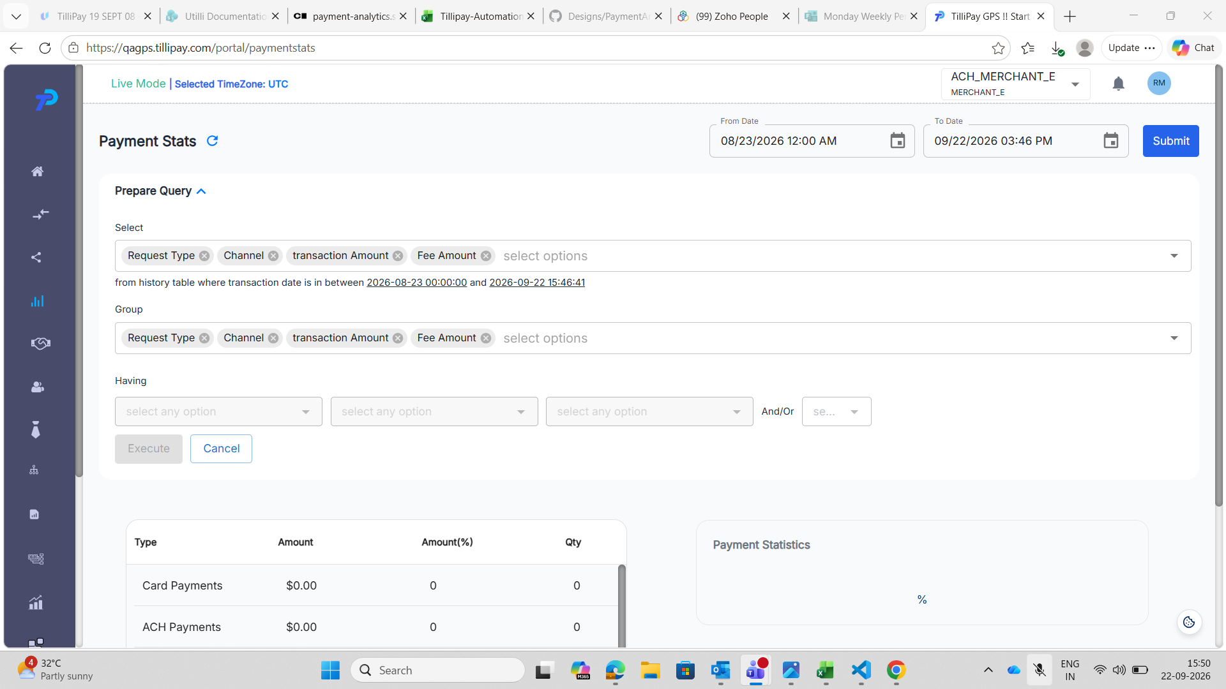
MerchantE (ACH_MERCHANT_E), 15:50. Select holds all four fields — Request Type, Channel, transaction Amount, Fee Amount — and Group holds the same four. Despite the panel being fully populated, all three Having dropdowns and the And/Or dropdown are greyed out, and the Execute button is greyed out while Cancel remains active. This is the state left behind after Select was emptied and refilled.
In every screenshot the date range and the results table below are unaffected, so the page itself is healthy — only the query controls are stuck.
Impact
The Prepare Query panel is the only way a merchant can group or filter their payment statistics. Once this state is reached the feature is unusable for the rest of the visit, and nothing on screen explains why the buttons are dead or how to get them back.
Clearing a field and changing your mind is ordinary behaviour, so this is easy to hit by accident.
Workaround: reload the page, or navigate away and back through the sidebar. The panel opens fresh and works normally.
Notes for the developer
• Group recovering while Having and Execute do not suggests the enable/disable rules for the three controls are evaluated separately, and only Group's is re-checked when Select changes.
• Having and Execute appear to recover only when Group itself is edited, not when Select is.
• Seen on both BillPay and MerchantE, so it is not specific to one gateway's field set.
4. PS-PQ-13 — Execute straight after Cancel queries what the panel no longer shows
Test case: PS-PQ-13 Priority: High Gateway seen on: BillPay Date observed: 23 September 2026
Summary
Cancel restores what is displayed but not the query behind it.
Press Execute straight after Cancel, without touching anything, and the request carries the previous, narrowed field list rather than the one the panel is showing. The table comes back missing a column that the panel still lists as selected.
Steps to reproduce
1. Sign in as the BillPay merchant. 2. Go to Payment Analytics → Payment Stats from the sidebar. 3. Note the column headings in the table. 4. Expand Prepare Query. Select and Group both arrive holding all four fields. 5. Remove one or more chips from Select and press Execute. The table narrows, correctly. 6. Press Cancel. The panel redraws with every field selected again, and the original columns come back. 7. Without changing anything, press Execute.
Expected result
The panel is showing all four fields, so Execute should query all four and the table should match the headings noted in step 3.
Actual result
The request carries only the fields left after step 5. The table drops the column that was removed before Cancel, even though the panel lists it as selected.
 | Select panel shows | select_fields sent
After trimming to two and Execute | 2 chips | funding_method,funding_category — correct
After Cancel | 4 chips | all four — correct
Execute after Cancel | 4 chips | channel,funding_category,funding_method

The last row carries three fields, not four. displayed_fee_amount is missing.
Evidence
Select trimmed — request correct
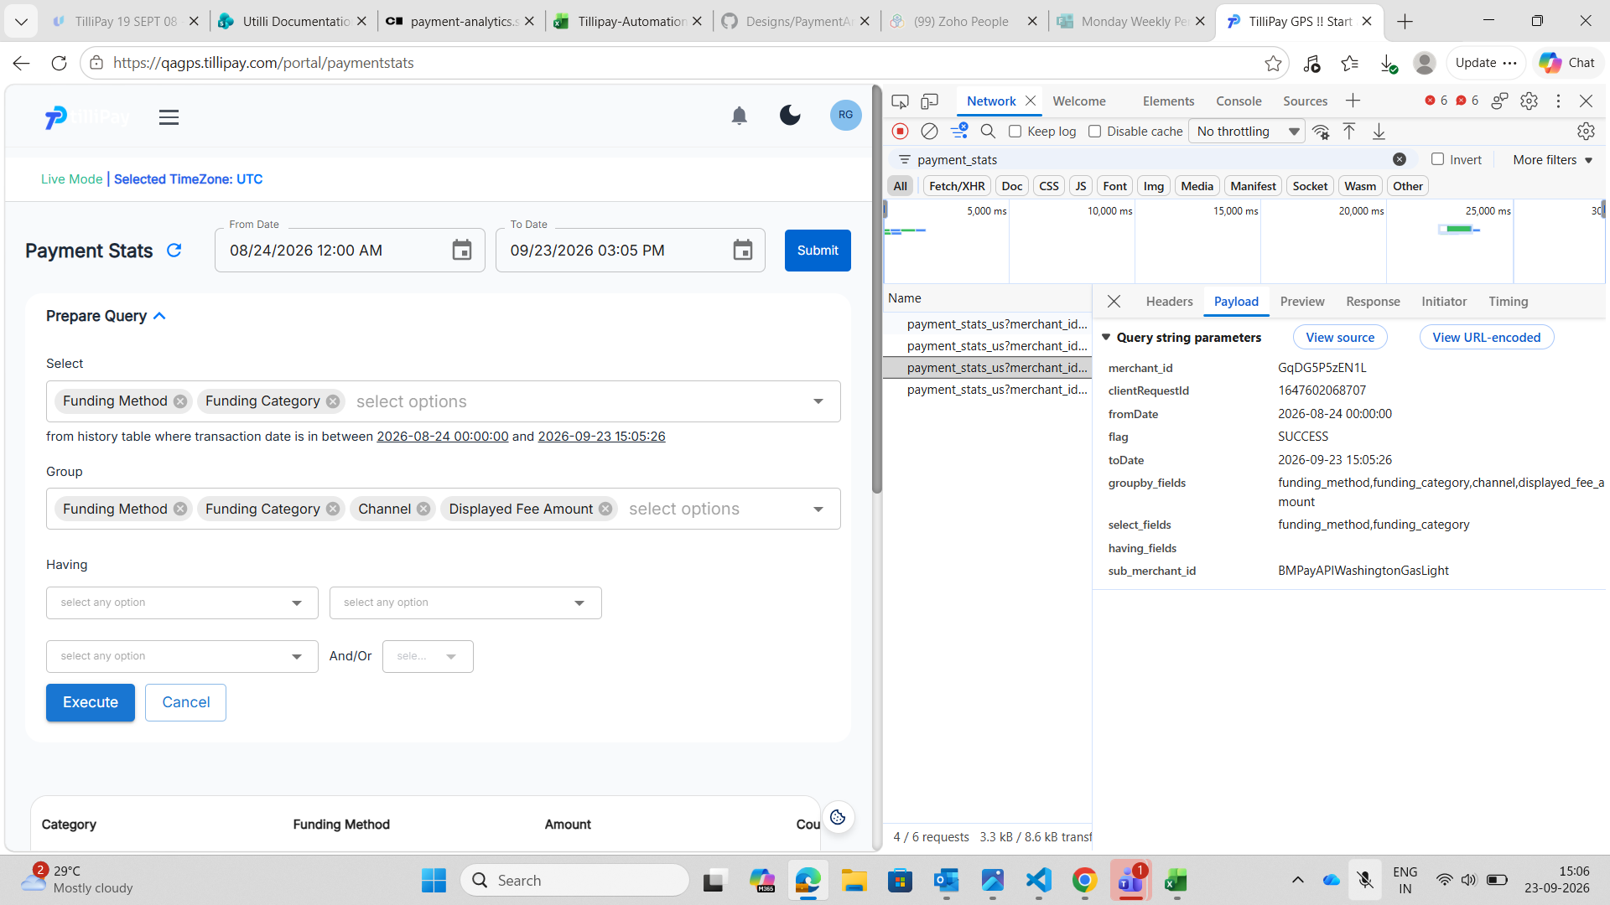
Select trimmed to Funding Method and Funding Category. The request carries exactly those two, and Group still holds four so groupby_fields carries four. Everything matches the panel.
After Cancel — request still correct
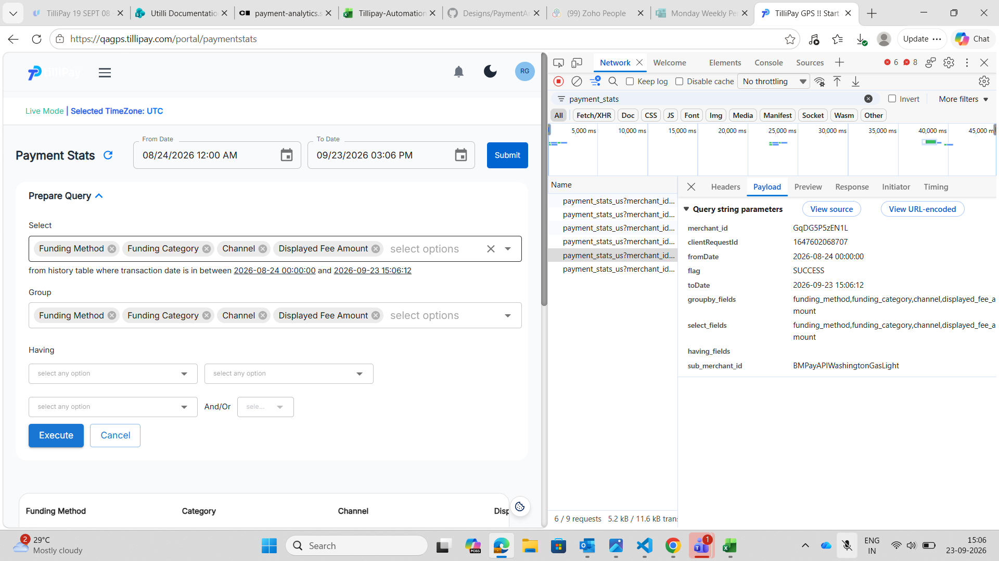
Cancel has restored the panel and the request carries all four fields. Cancel itself is not the problem.
Execute after Cancel — request wrong
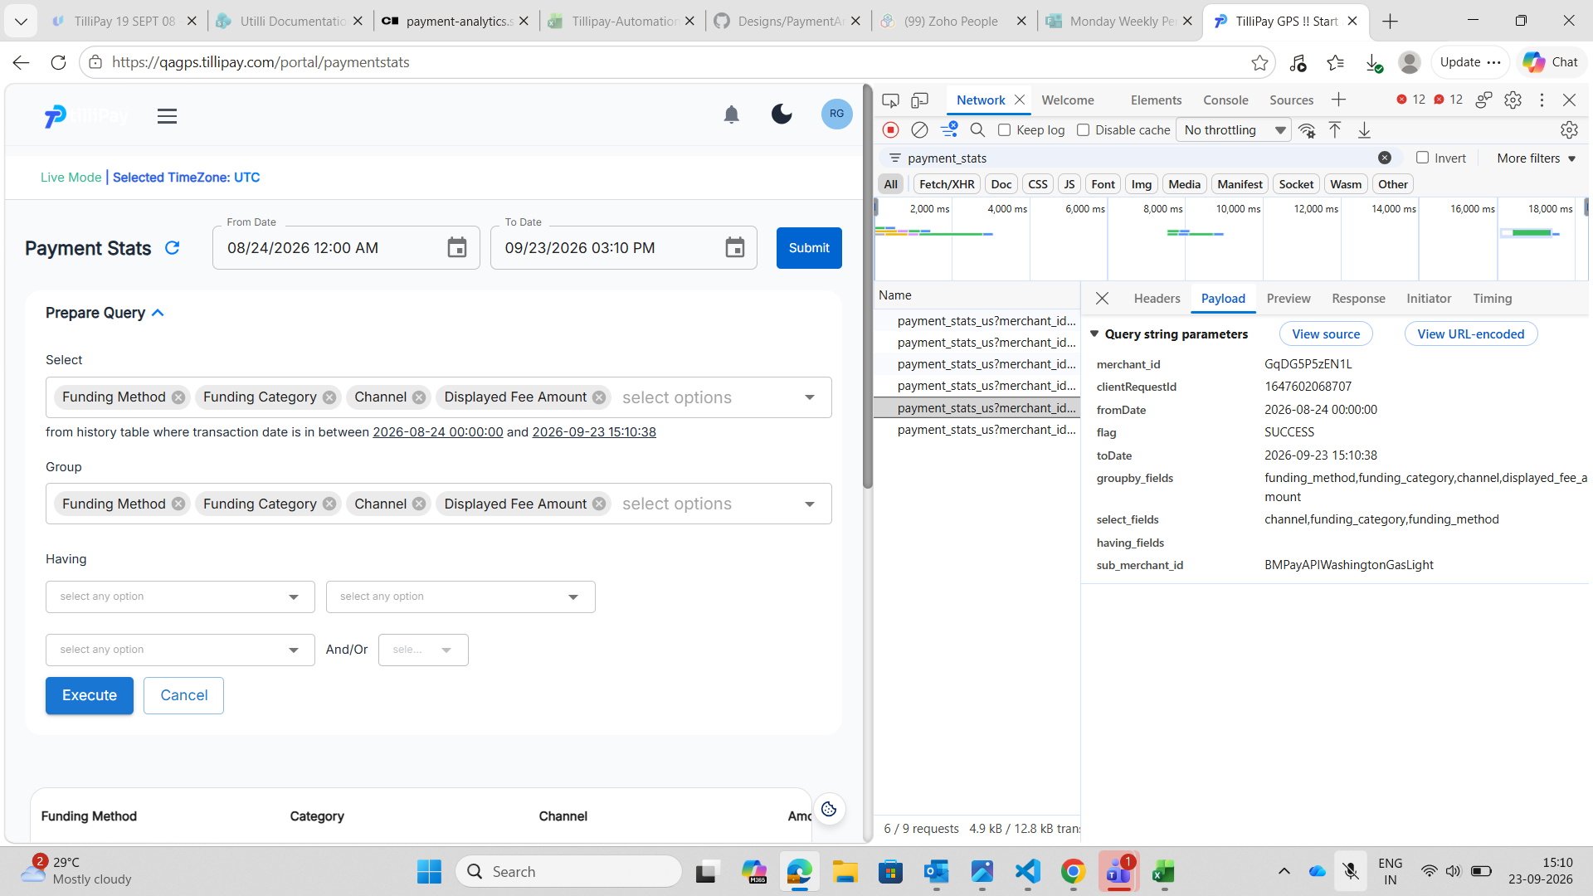
The panel shows all four fields. The request carries three:
select_fields channel,funding_category,funding_method groupby_fields funding_method,funding_category,channel,displayed_fee_amount
displayed_fee_amount is absent from select_fields while still present in groupby_fields, and the table below has lost its Displayed Fee Amount column.
Impact
The merchant is shown a result they did not ask for, with nothing on screen to indicate it. The panel and the table disagree, and the panel is the thing they trust.
Pressing Cancel and then Execute is an ordinary sequence — change your mind, start again — so this is easy to hit without realising.
Workaround: reload the page after Cancel before building a new query.
Notes for the developer
• Cancel redraws the panel and fires a correct default request. The stale state only surfaces on the next Execute, so the fault is in what Execute reads, not in Cancel's own request.
• The returned list is not merely shorter, it is reordered: channel,funding_category,funding_method against the panel's order of Funding Method, Funding Category, Channel, Displayed Fee Amount. A correct request follows the panel order, as the request straight after Cancel does. That points at the field list being rebuilt from some other collection which kept a stale membership and lost the ordering, rather than Cancel failing to clear a flag.
• groupby_fields stays correct throughout. Only select_fields goes stale, which narrows where to look.
5. PS-PQ-16 — the Prepare Query panel does not drive the table
Test case: PS-PQ-16 Priority: High Gateway seen on: MerchantE Date observed: 23 September 2026
Summary
MerchantE is given a Prepare Query panel that does nothing.
The panel is present and fully populated, it accepts every change, the request goes out carrying what was chosen, and the API answers 200. The table never changes. It keeps rendering the fixed payment-type breakdown regardless of the query.
Steps to reproduce
1. Sign in as the MerchantE merchant. 2. Go to Payment Analytics → Payment Stats from the sidebar. 3. Note the column headings in the table: Type, Amount, Amount(%), Qty, Qty(%). 4. Expand Prepare Query. Select and Group both arrive holding four fields — Request Type, Channel, transaction Amount and Fee Amount. 5. Remove transaction Amount and Fee Amount from Select, leaving Request Type and Channel. 6. Press Execute. 7. Read the column headings again.
Expected result
A query over Request Type and Channel should rebuild the table around those two fields plus the totals:
Request Type | Channel | Amount | Count
This is what BillPay and SnapPay do with the same action.
Actual result
The headings do not change. The table still reads:
Type | Amount | Amount(%) | Qty | Qty(%)
with the same payment-type rows — Card Payments, ACH Payments, Card Voids, ACH Returns and the rest. Not one column or row moves.
 | Column headings
Before Execute | Type, Amount, Amount(%), Qty, Qty(%)
After Execute with Select trimmed to two fields | Type, Amount, Amount(%), Qty, Qty(%) — unchanged

Evidence
Select trimmed to two fields, table unchanged after Execute
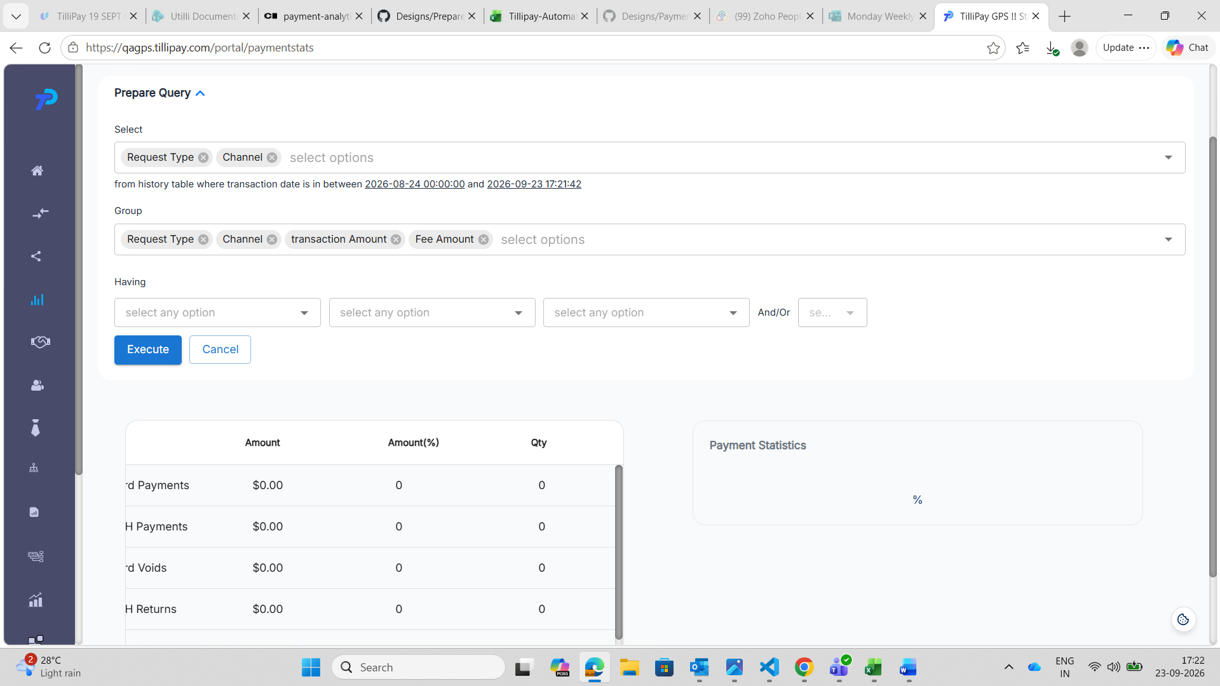
Select holds Request Type and Channel only. Group still holds all four. Execute has been pressed, and the table below is still the payment-type breakdown rather than a query result. The Type column is scrolled out of view in this capture, which is why the rows read "rd Payments" and "H Payments"; all five breakdown headings are present on screen.
Judge this case by the column headings, not the figures. This account has no payments in the window, so every row reads $0.00 whichever table is being displayed.
Impact
The feature is advertised and inert. A merchant can spend as long as they like building a query on this gateway and will always be shown the same fixed breakdown, with nothing to tell them their query was ignored.
There is no workaround — the panel cannot be made to work.
Notes for the developer
• The query is not failing. The request carries the narrowed field list and the API answers 200, so the work happens and the result is discarded on the way to the screen.
• The page appears to render the fixed payment-type breakdown for this gateway regardless of the query response, which suggests the gateway is routed to the wrong renderer rather than the query being broken.
• An earlier note recorded this case as blocked because MerchantE returned an error. That is no longer true and should not be relied on: the request succeeds.

