Nudge Dynamic Merge Tags — QA Test Doc
Verifies that Payment Link, Payment Reversal and Payment Failure notification merge tags are dynamic — edited in Admin, reflected in the email, no code change. Nudge ID = the number (e.g. 25140); keep it the same on the merchant page and the For-Developers default page.

How to use
- Each test case: Steps → Expected → Screenshot.
- Core check: change a tag in Admin → trigger the notification → if the email changes, it is dynamic.
- “Before” = original tags/email; “After” = changed tags/email.

Prerequisites
- Environment: dev / QA running this build; Admin portal access.
- A merchant that can actually take payments, and access to the customer inbox to verify emails.
- Each notification has a valid Nudge ID (template) set.
If no email arrives: check the Nudge ID (template number) is set and is a valid template on the Nudge side — and is the same on the merchant page and the For-Developers default page. A blank/invalid template = no email is sent.

SECTION A — Payment Link (per-merchant)
Where: Admin → Merchants → merchant → Update Merchant Details → Nudge Configuration; trigger from the merchant portal Share Payment. Tags: requestedAmount → amount, tilliPayPaymentUrl → uri, payment_for → payment_for, Customer_Name → customer_name, customer_number → customer_number…………..

TC-NDT-A1 — Configure merge tags
- Steps: Admin → Merchants → merchant → Update Merchant Details → Nudge Configuration → tag icon on Payment Link Request → add/view tags → Save.
- Expected: tags saved (icon green).
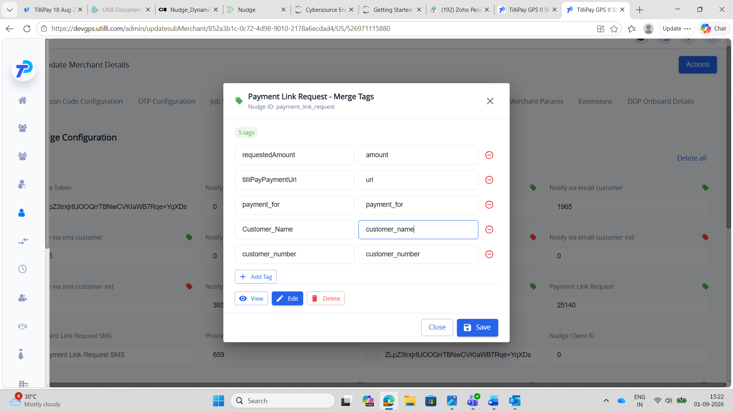

TC-NDT-A2 — Email uses the tags
- Steps: Merchant portal → Share Payment → share link.
- Expected: email received — “Dear murari with 123 … for 39 for foos”.
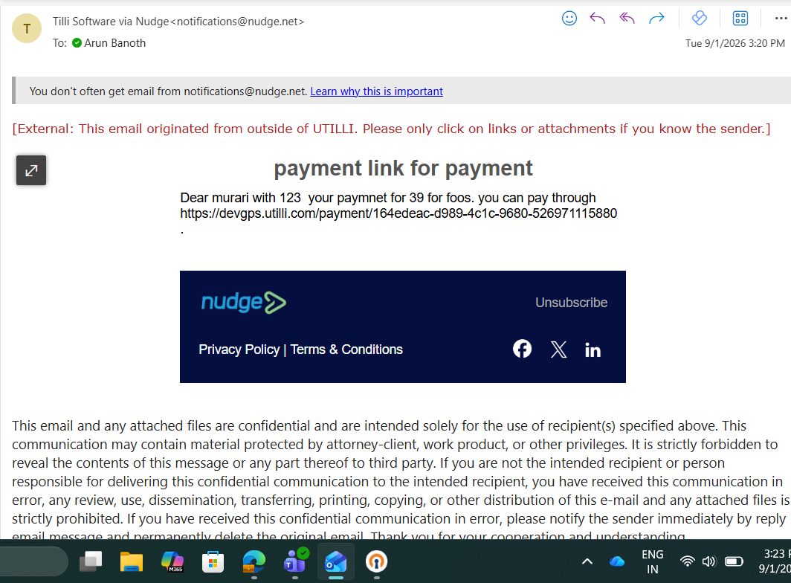

TC-NDT-A3 — Prove dynamic
- Steps: Edit → swap Customer_Name / customer_number → Save → share again(change the tag values).
- Expected: email changes — “Dear 123 with murari …”.
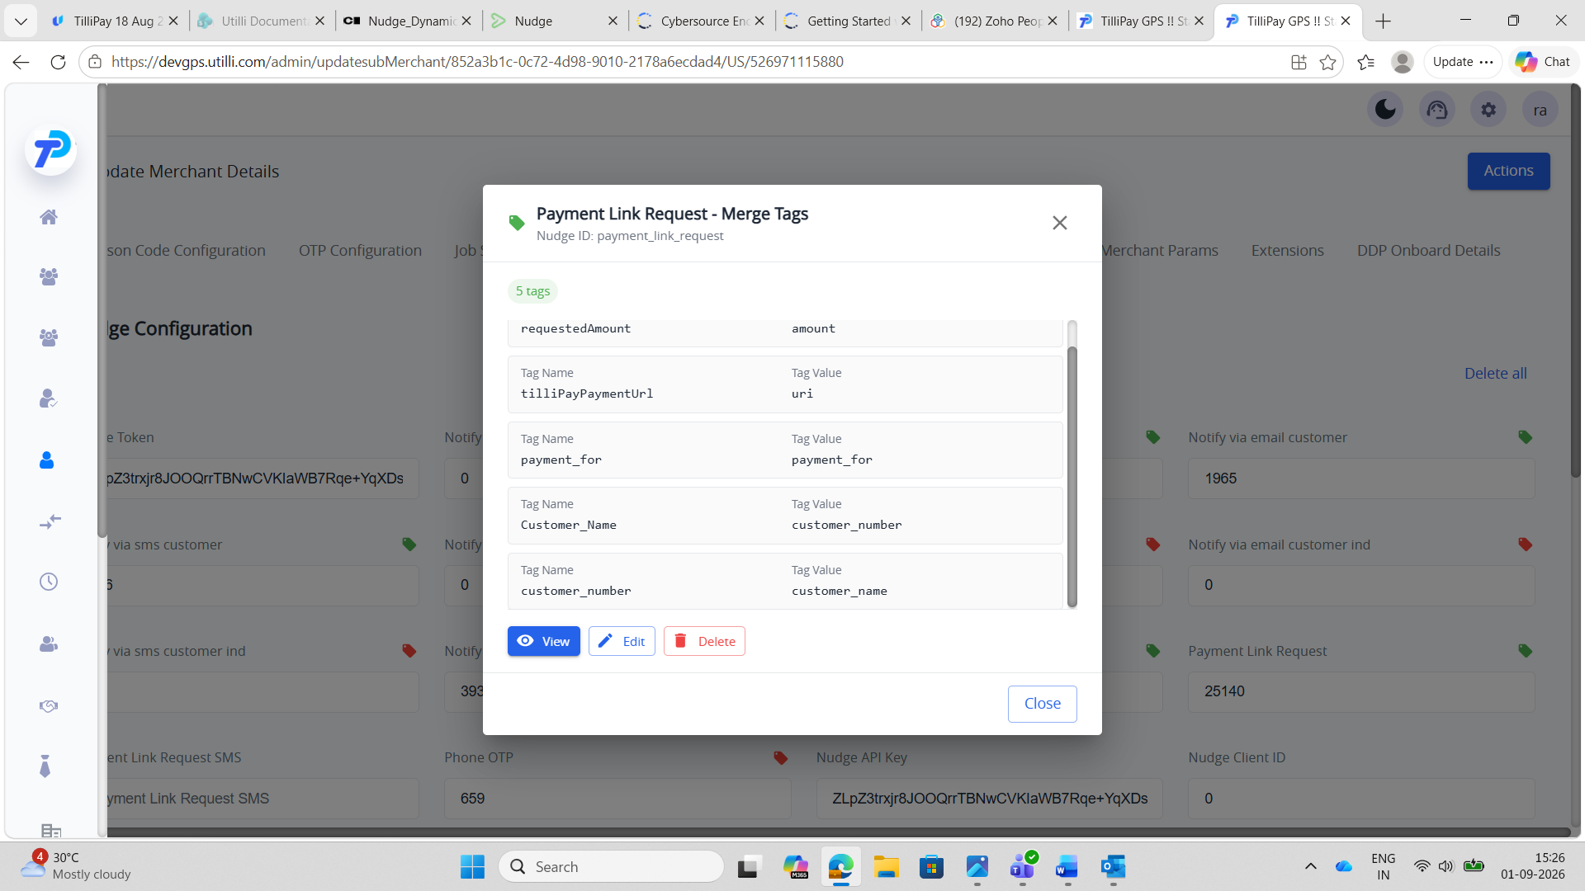
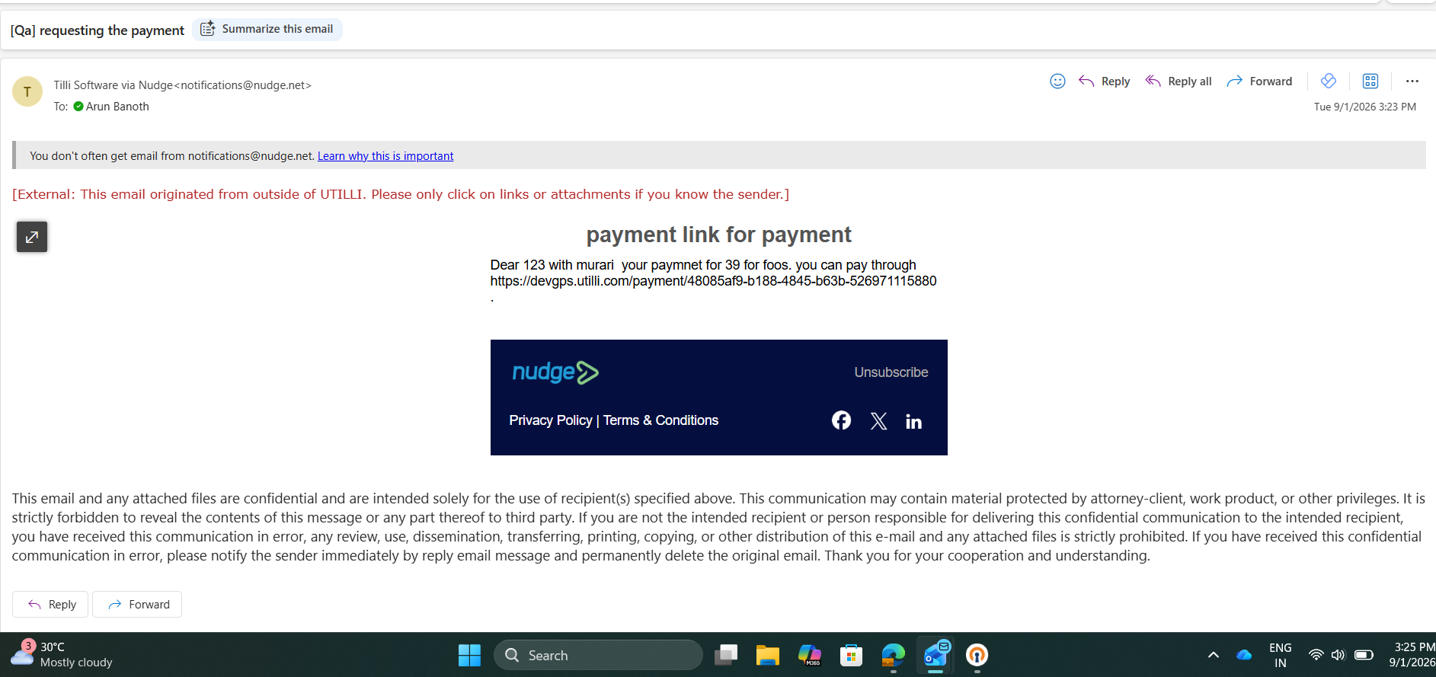

SECTION B — Payment Reversal (per-merchant)
Where: Admin → Merchants → merchant → Update Merchant Details → Nudge Configuration; trigger from the merchant portal Transactions → refund/reversal. Tags: customer_name → customer_name, Refund_amount → amount, Payment_amount → amount,……..

TC-NDT-B1 — Configure merge tags
- Steps: Admin → Merchants → merchant → Update Merchant Details → Nudge Configuration → tag icon on Notify payment reversal → add/view tags → Save.
- Expected: tags saved (icon green).
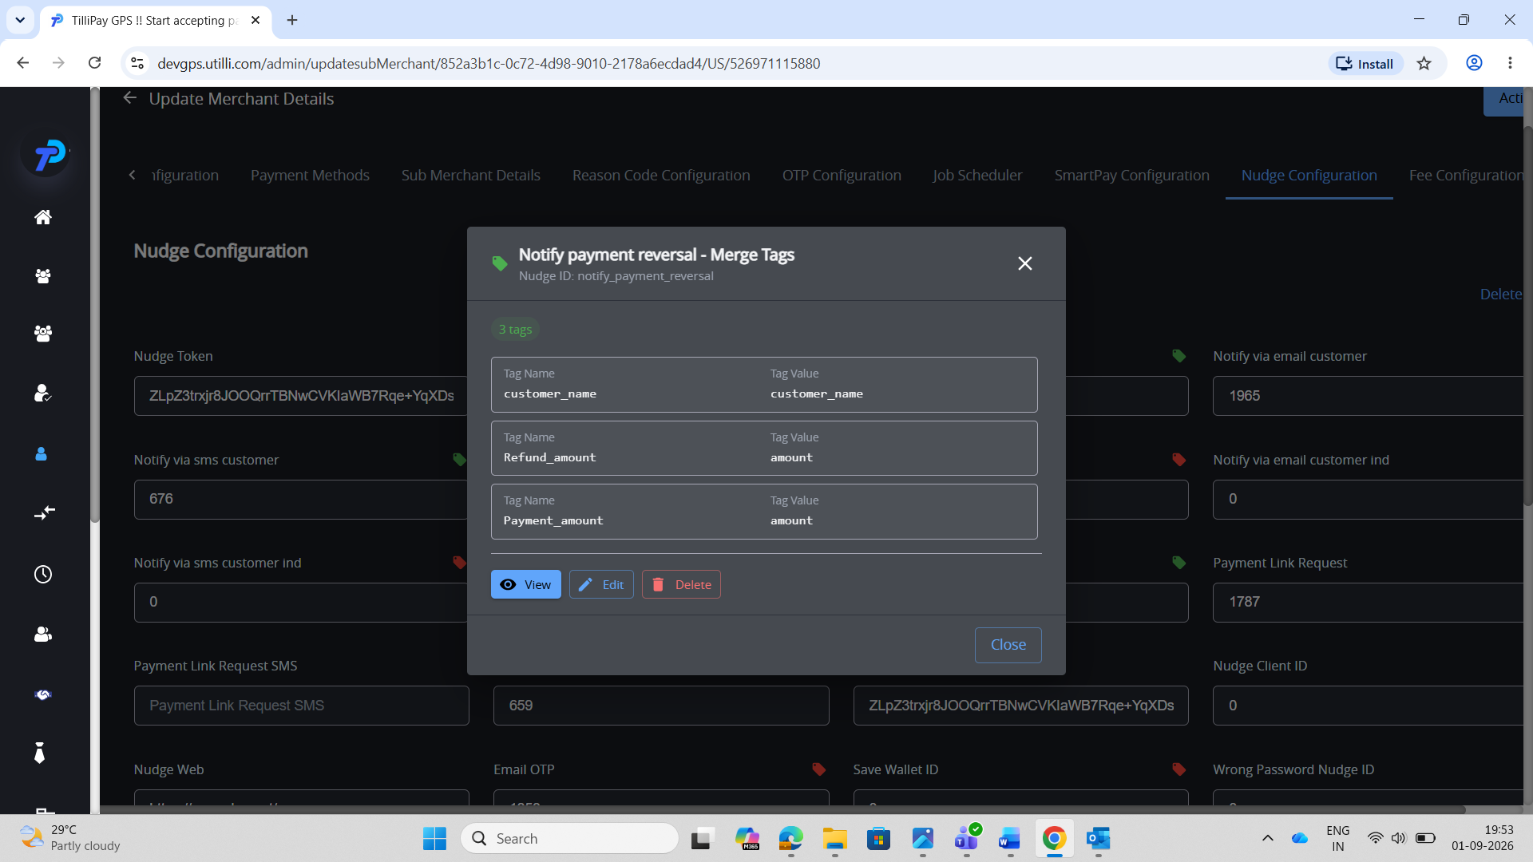

TC-NDT-B2 — Email uses the tags
- Steps: Merchant portal → Transactions → process a refund/reversal.
- Expected: email received — “Dear rama murari, you refund amount of 12 for payment amount 12”.
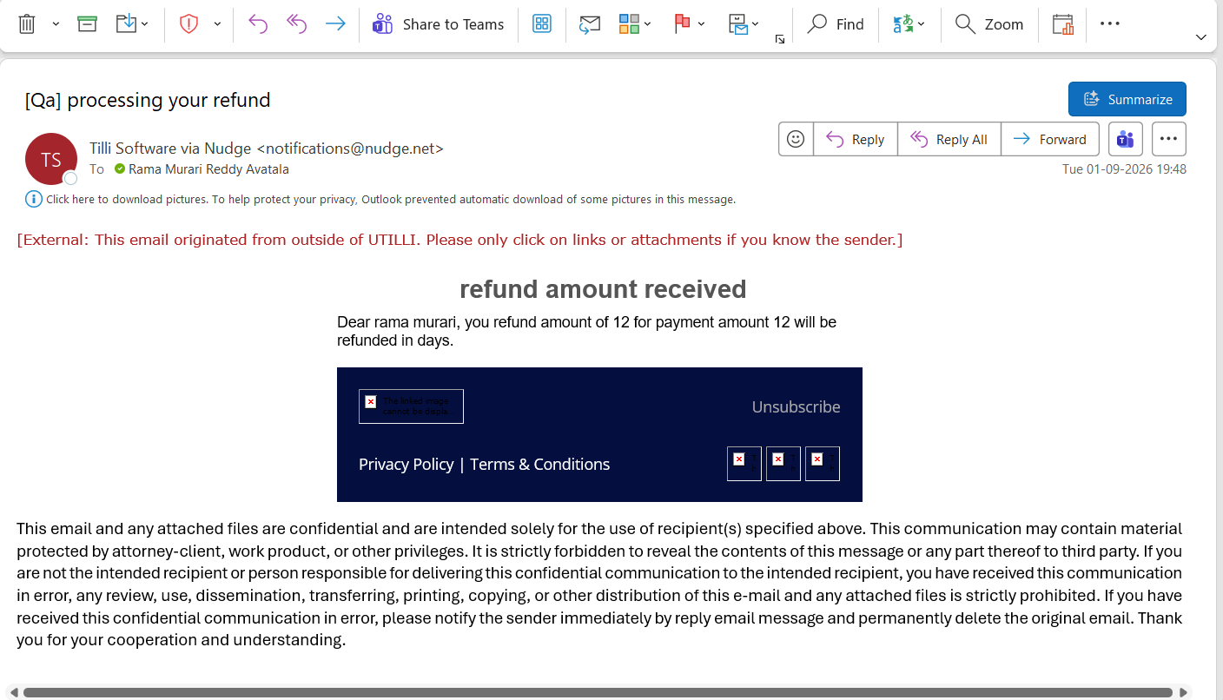

TC-NDT-B3 — Prove dynamic
- Steps: Edit → change tag values → Save → process the reversal again.
- Expected: email changes — “Dear 12, you refund amount of rama murari …”.
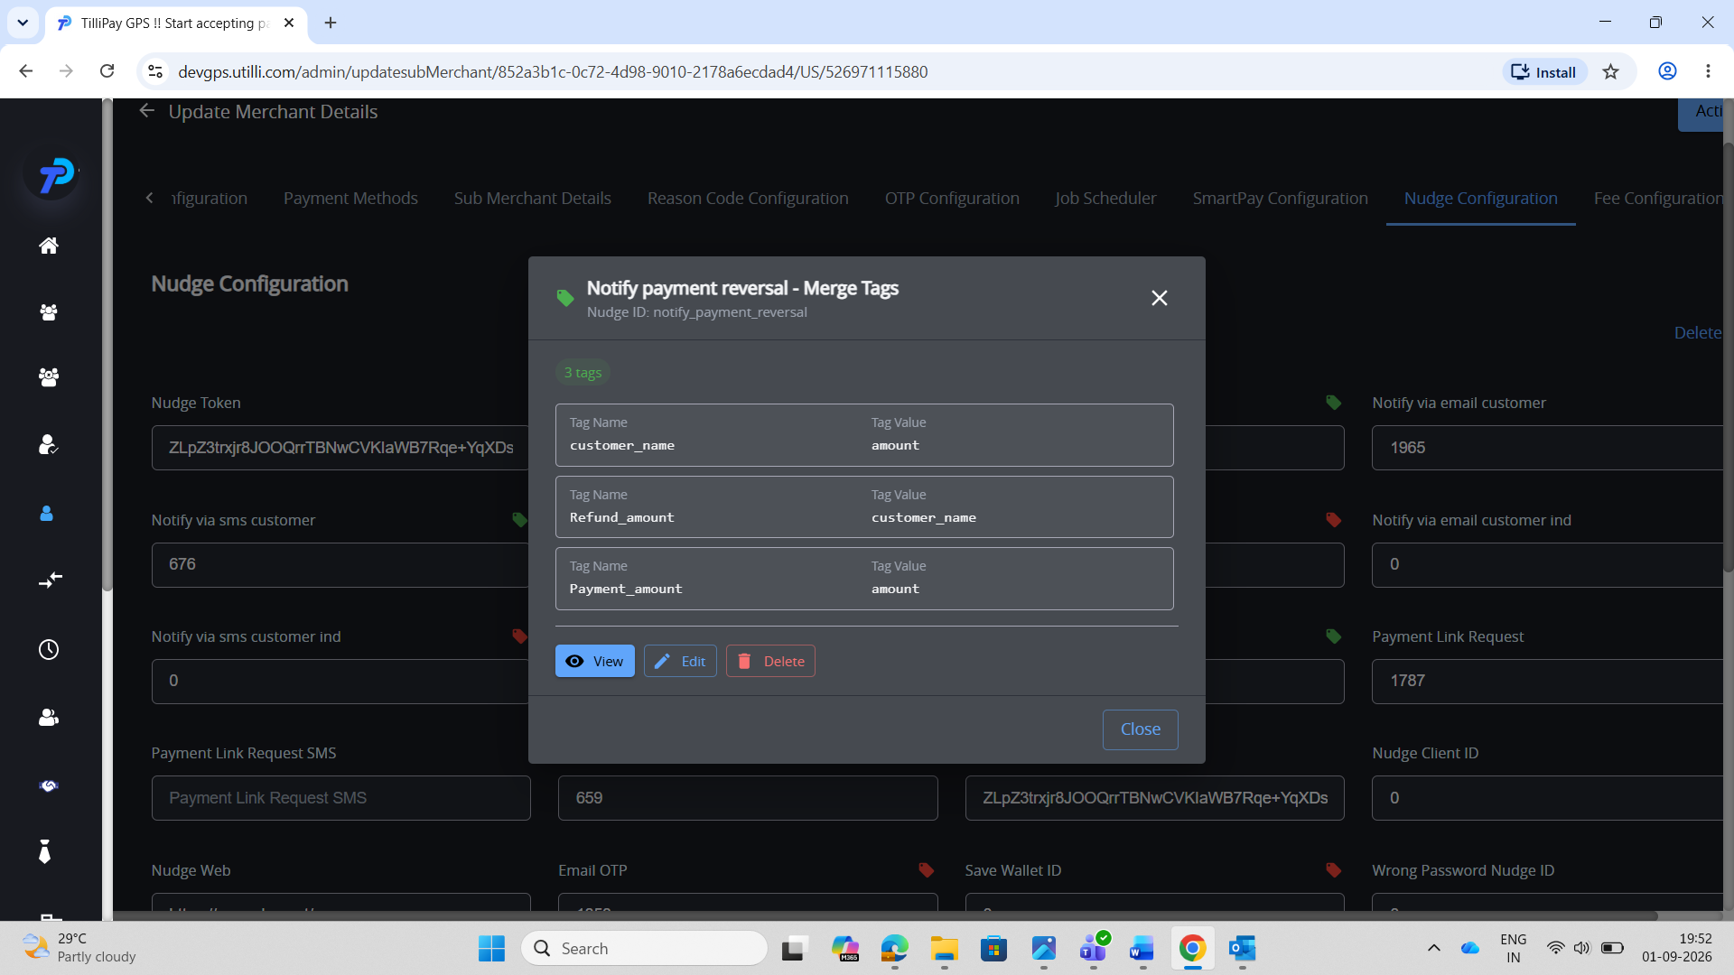
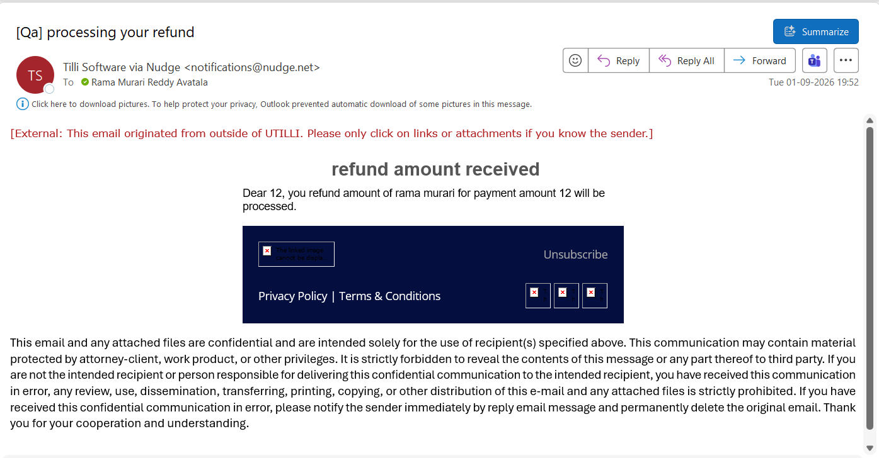

SECTION C — Payment Link (default page — For Developers)
Where: Admin → For Developers → Third Party → Nudge (Nav bar) → US; trigger from the merchant portal Share Payment. Same tags as Section A; used when the merchant has no per-merchant tags. Same Nudge ID as the merchant page.

TC-NDT-C1 — Configure merge tags (default)
- Steps: Admin → For Developers → Third Party → Nudge (Nav bar) → US → tag icon on Payment Link Request → add/view tags → Save.
- Expected: tags saved (icon green).
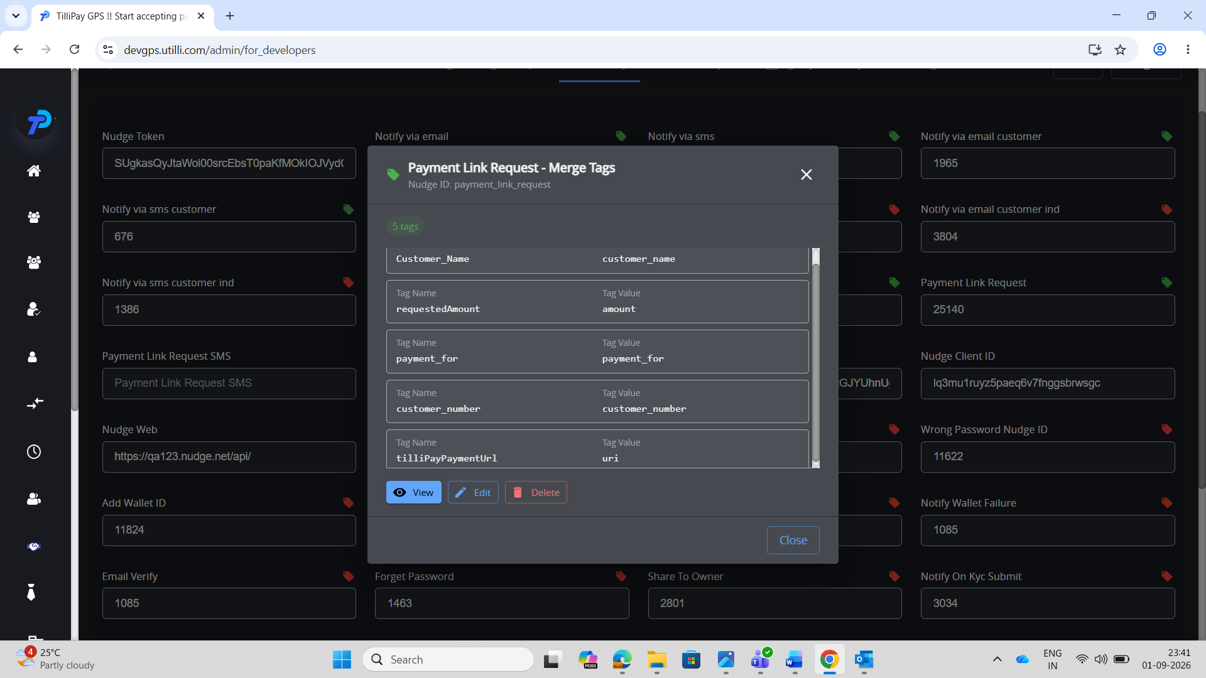

TC-NDT-C2 — Email uses the tags (default)
- Steps: Merchant portal → Share Payment → share link.
- Expected: email received — “Dear murari with 123 … for 39 for foos”.
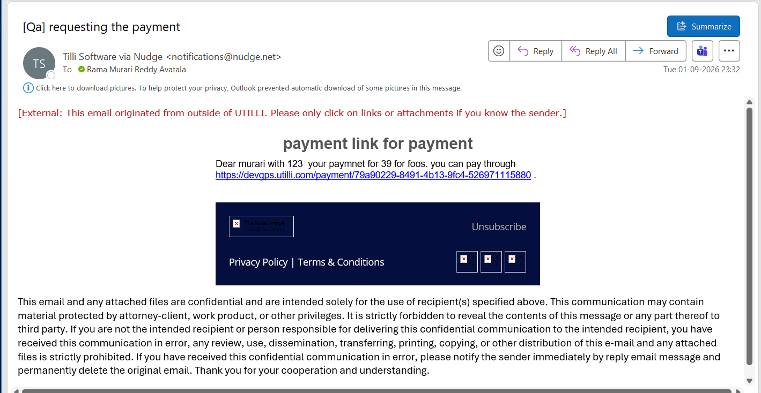

TC-NDT-C3 — Prove dynamic (default)
- Steps: Edit → change tag values → Save → share again.
- Expected: email changes — “Dear 123 with 123 … pay through 39”.
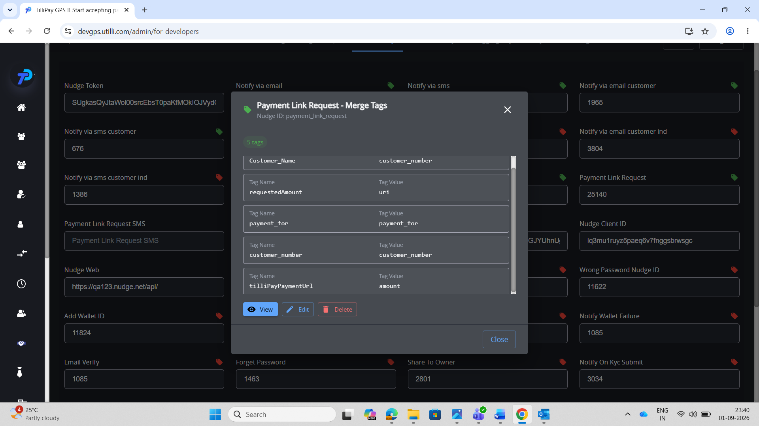
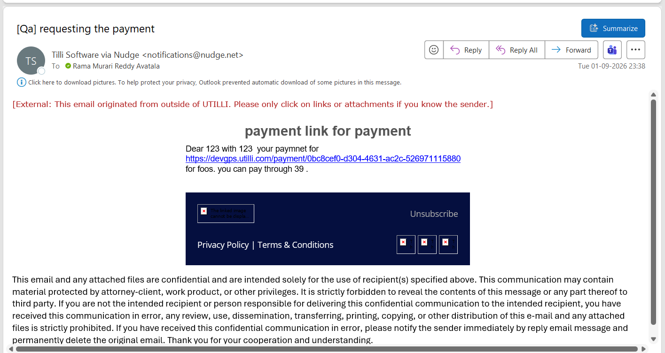

SECTION D — Payment Reversal (default page — For Developers)
Where: Admin → For Developers → Third Party → Nudge (Nav bar) → US; trigger from the merchant portal Transactions → refund/reversal. Same tags as Section B. Same Nudge ID as the merchant page.

TC-NDT-D1 — Configure merge tags (default)
- Steps: Admin → For Developers → Third Party → Nudge (Nav bar) → US → tag icon on Notify payment reversal → add/view tags → Save.
- Expected: tags saved (icon green).
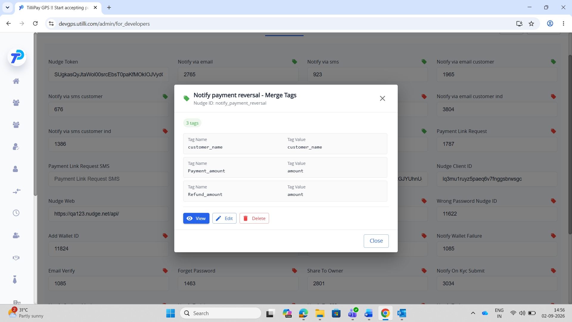

TC-NDT-D2 — Email uses the tags (default)
- Steps: Merchant portal → Transactions → process a refund/reversal.
- Expected: email received — “Dear murari, you refund amount of 39 for payment amount 39”.
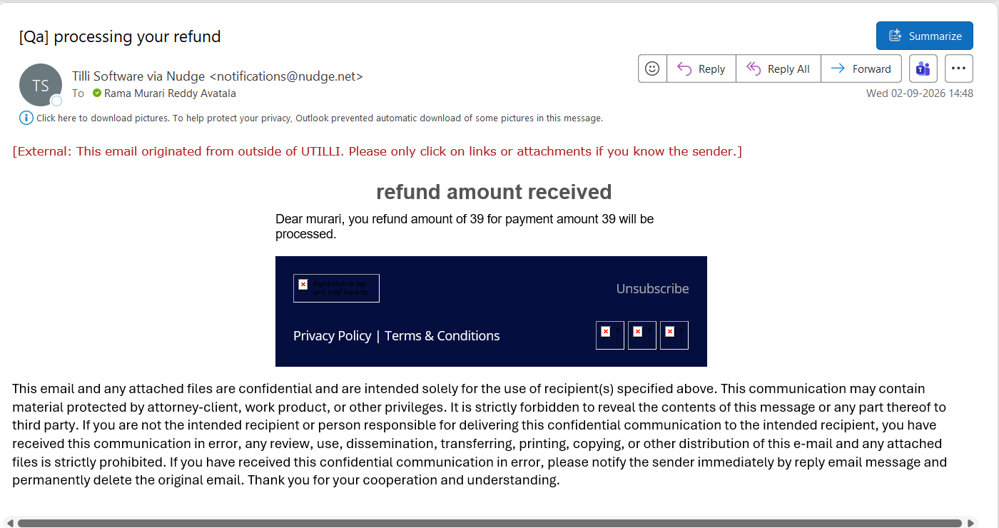

TC-NDT-D3 — Prove dynamic (default)
- Steps: Edit → change tag values → Save → process the reversal again.
- Expected: email changes — “Dear 123, you refund amount of rama …”.
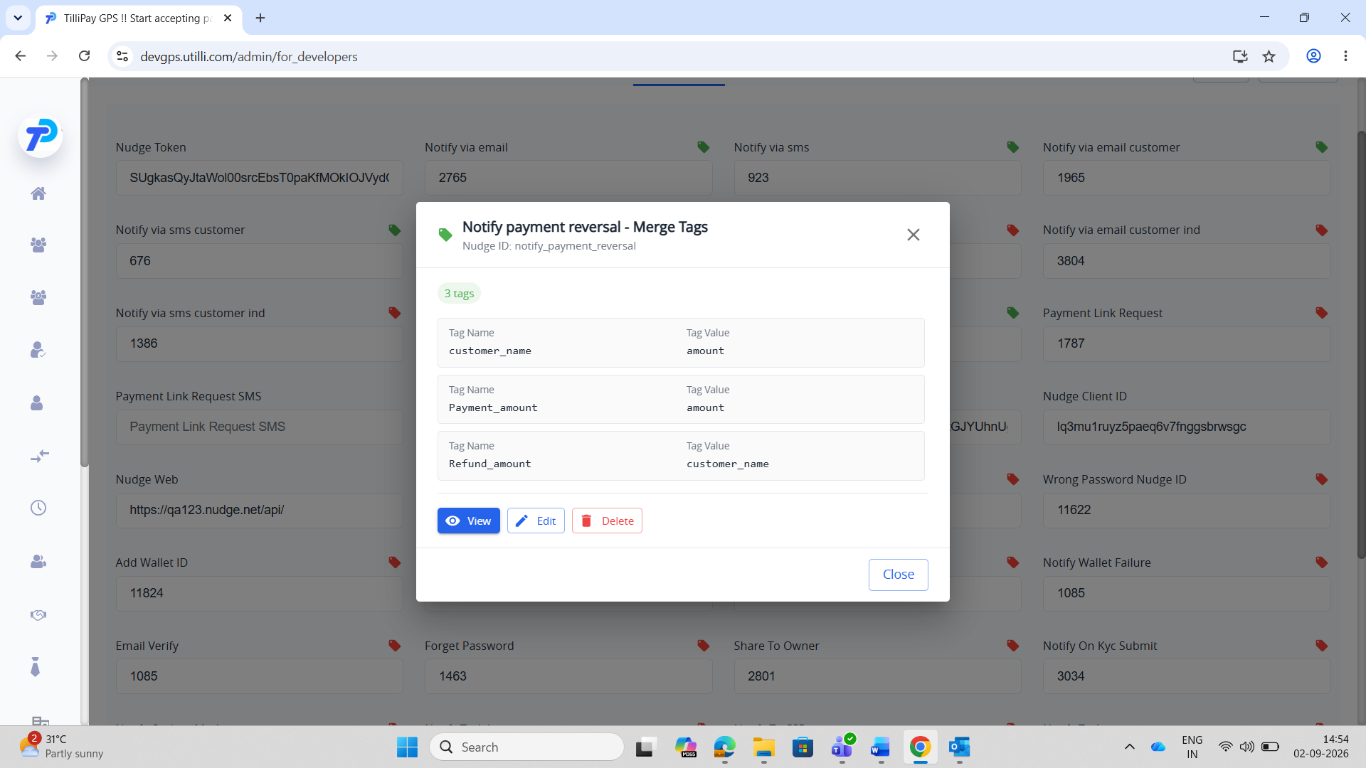
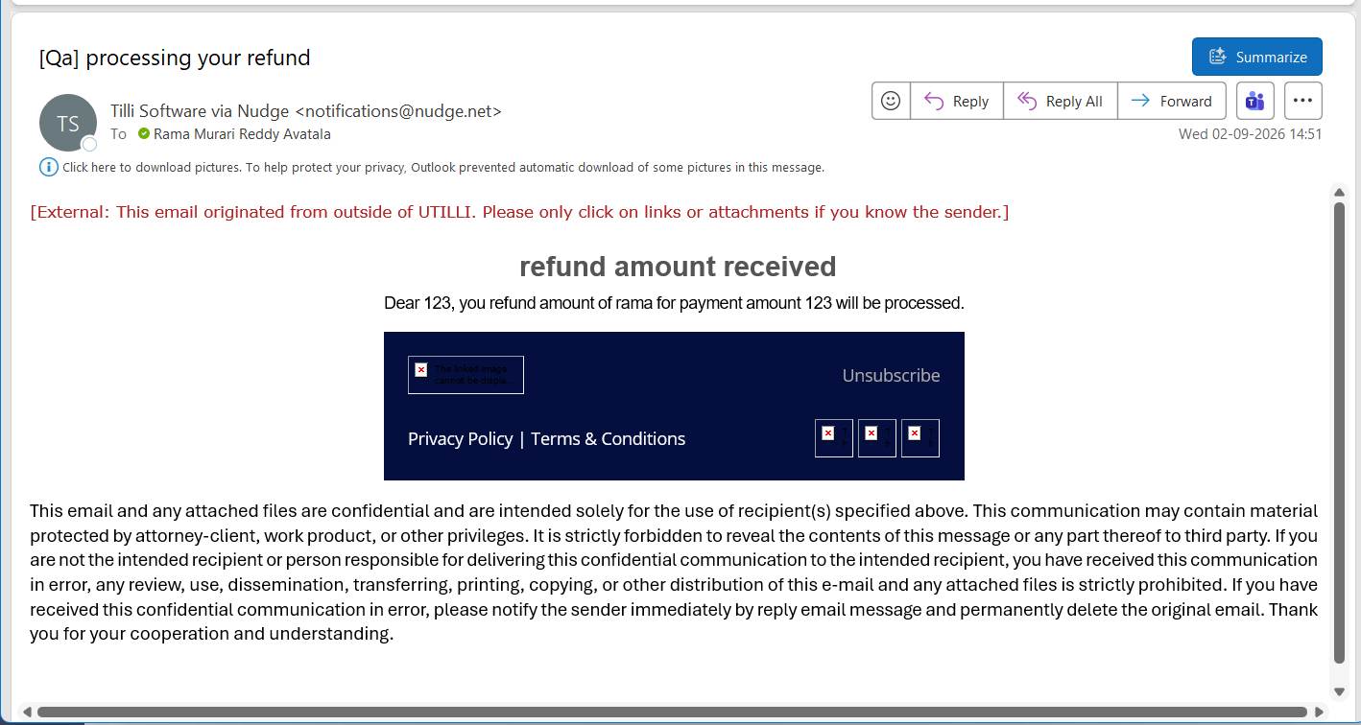

SECTION E — Payment Failure (already dynamic-tested in qa)
Where: Admin → Nudge Config → Notify payment failure; trigger by a declined/failed payment (from the payment page). Tags: customer_name → customerName, Payment_amount → amount, last_four_digits_of_card → last_four_digits_of_card……..

TC-NDT-E1 — Configure merge tags
- Steps: Admin → Nudge Config → Notify payment failure → tag icon → add/view tags → Save.
- Expected: tags saved (icon green).
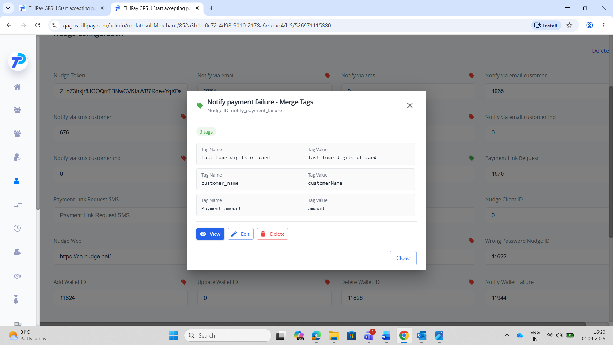

TC-NDT-E2 — Email uses the tags
- Steps: Make a payment that is declined/fails(from payment page).
- Expected: email received — “Dear rama, your payment for 123 made with card ending with 5432 has been failed”.
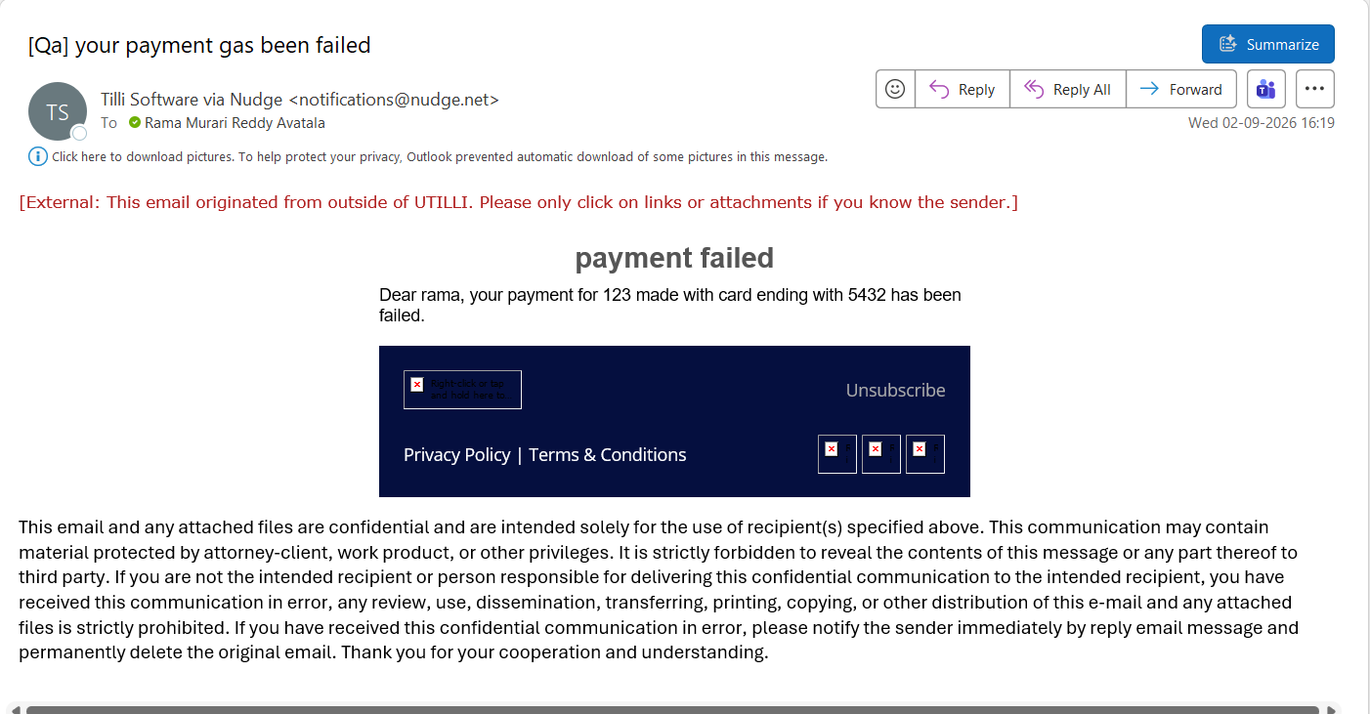

TC-NDT-E3 — Prove dynamic
- Steps: Edit → swap tag values → Save → trigger another failed payment(from payment page).
- Expected: email changes — “Dear 123, your payment for rama …”.
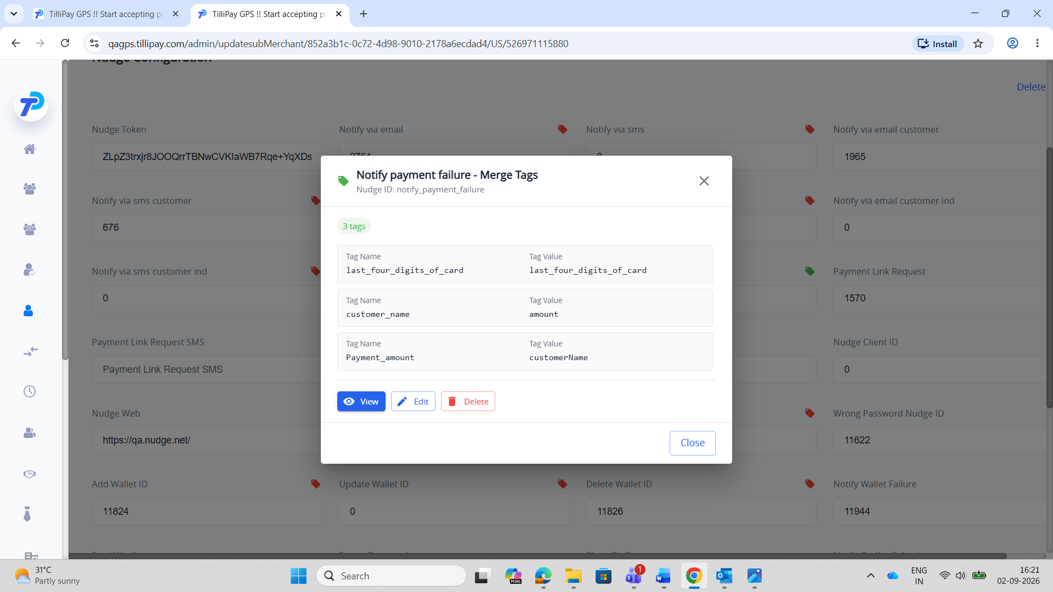
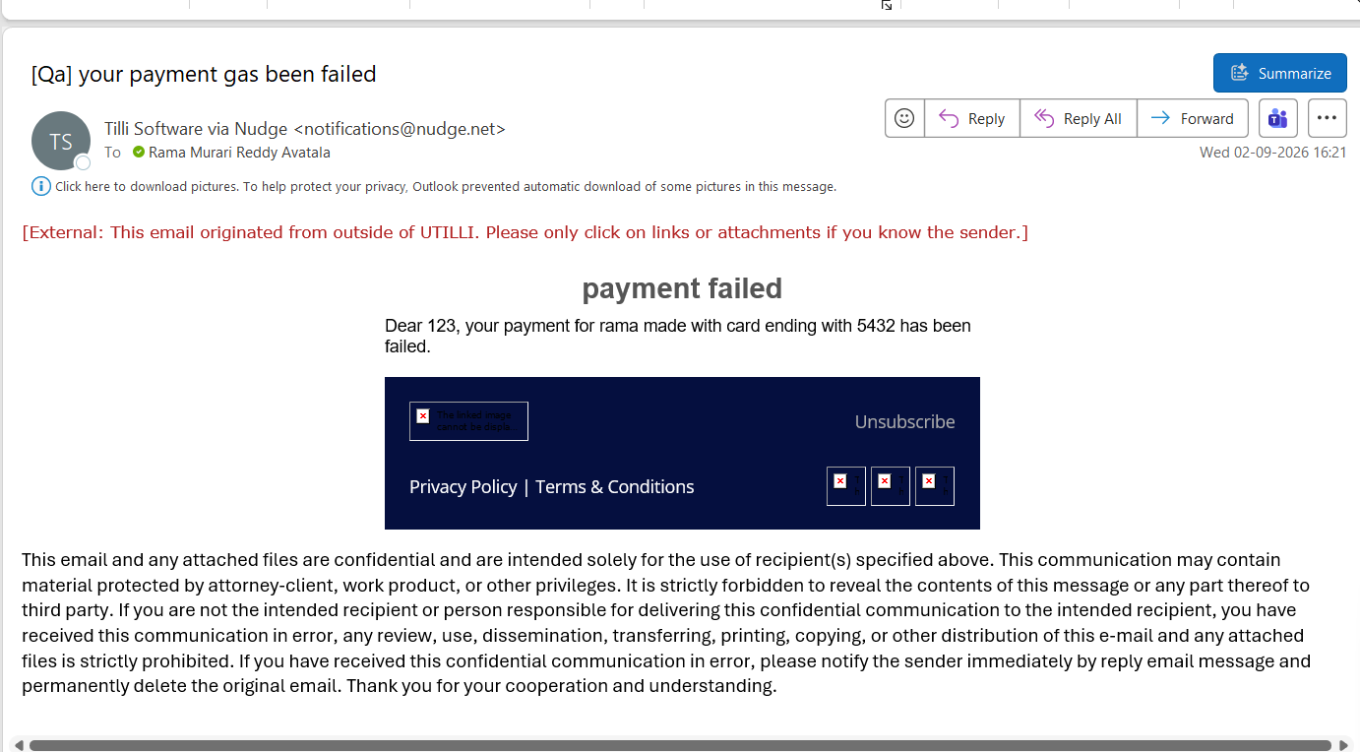

Sign-off
- ☐ A — Payment Link (per-merchant)
- ☐ B — Payment Reversal (per-merchant)
- ☐ C — Payment Link (default page)
- ☐ D — Payment Reversal (default page)
- ☐ E — Payment Failure

