Costco Lead Matching Solution – Technical Documentation
Table of Contents
1. Overview 4
2. Flow Diagram 5
3. Data Sources and Schema 5
3.1 Lead Data 5
3.2 Transaction Data 5
3.3 Matching Attributes 6
4. Data Ingestion Layer 6
4.1 Lead Data Extraction 6
4.2 Transaction Data Extraction 7
5. Data Preprocessing Layer 7
5.1 Data Cleaning and Validation 7
5.2 Feature Engineering 7
5.3 Data Storage Strategy 7
6. Primary Matching Layer 8
6.1 Processing Workflow 8
6.2 Matching Rules 8
6.3 Confidence Assignment 8
6.4 Output 8
7. Vector Conversion Layer 9
7.1 Embedding Infrastructure 9
7.2 Fields Embedded 9
7.3 Model and Configuration 9
7.4 Performance Considerations 9
8. Fuzzy Matching Layer 9
This layer enhances deterministic results using cosine similarity on embeddings. 9
8.1 Data Preparation 9
8.2 Similarity Computation 10
8.3 Weighted Scoring Model 10
8.4 Thresholding 10
8.5 Merge & Update Logic 10
9. Confidence & Status Mapping 10
9.1 Confidence Classification 10
9.2 Lead Status Assignment 11
10. Final Data Preparation 11
11. Cloud SQL Update Layer 11
11.1 POS Table Updates 11
11.2 Lead Table Updates 12
12. ServiceNow Integration 12
12.1 Data Preparation 12
12.2 Payload Construction 12
12.3 API Execution 12
13. Cleanup & Audit Layer 13
13.1 Temporary File Cleanup 13
13.2 Audit Table Update 13
14. Key Design Highlights 13

Overview
The Costco Lead Matching Solution is a hybrid data matching system designed to associate lead records with corresponding Point-of-Sale (PoS) transactions. It combines deterministic (rule-based) and probabilistic (vector-based / fuzzy) matching techniques to achieve high accuracy and scalability.
The system is built on Google Cloud Platform (GCP) and leverages services such as:
- Cloud SQL for structured data storage
- Google Cloud Storage (GCS) for intermediate data persistence
- Vertex AI for embedding generation
- ServiceNow APIs for downstream integration
- Cloud run jobs for pipeline orchestration

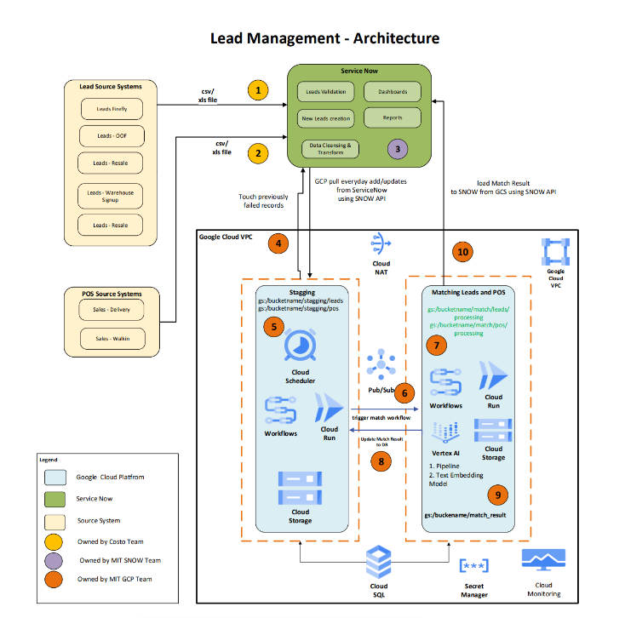

2. Flow Diagram
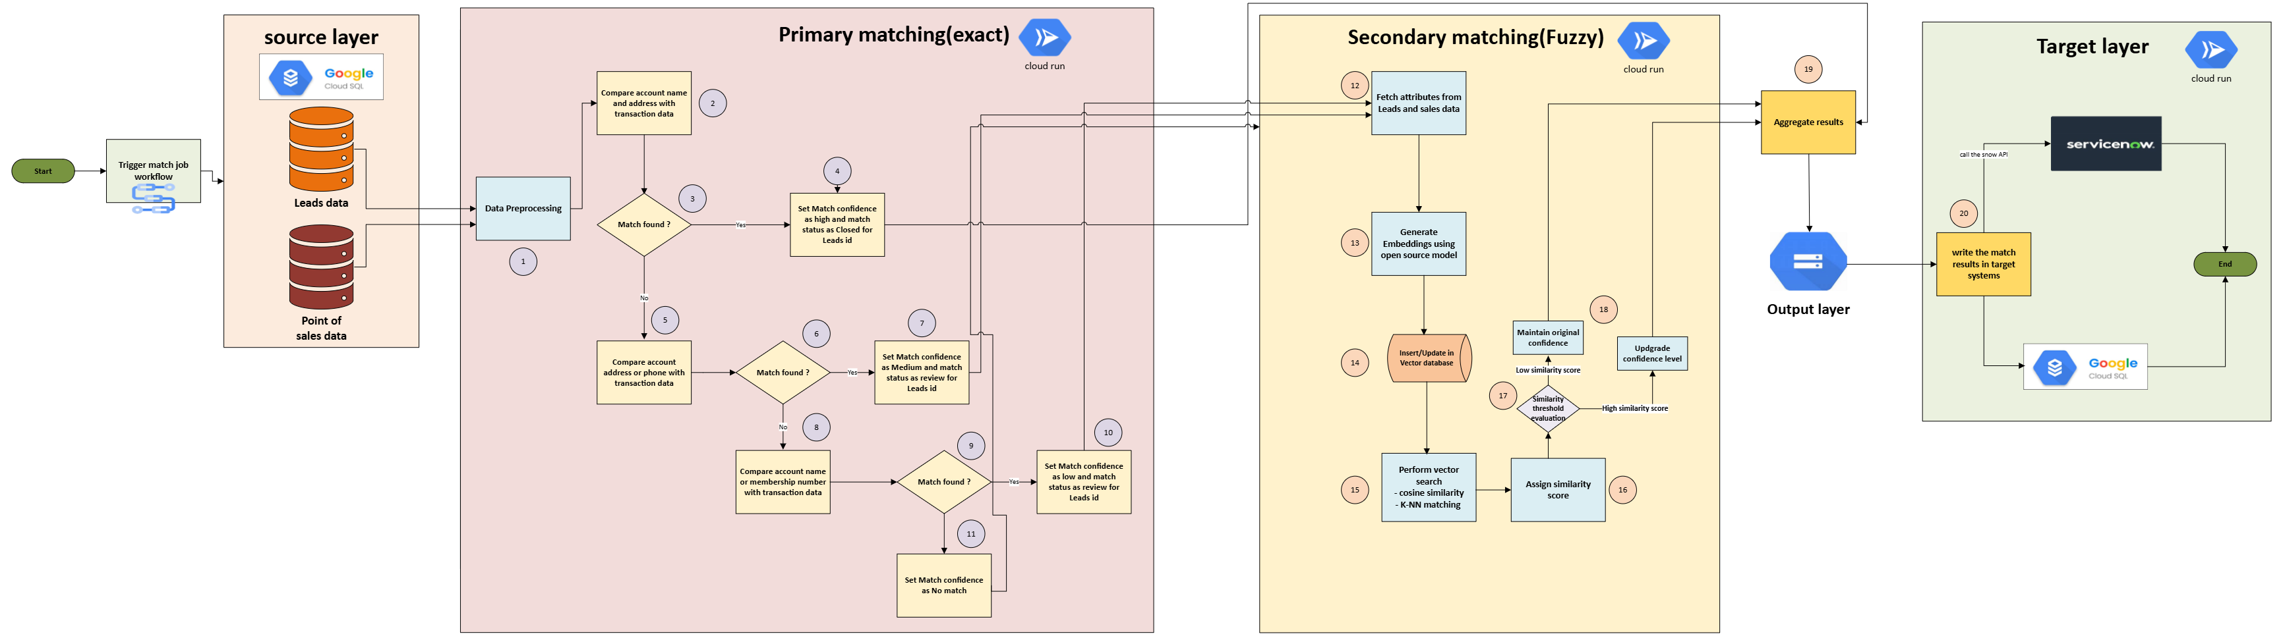
This section should visually represent:
- Data ingestion from Cloud SQL
- Preprocessing and GCS storage
- Primary matching flow
- Parallel embedding generation
- Fuzzy matching layer
- Final output updates (Cloud SQL + ServiceNow)
- Audit and cleanup process

3. Data Sources and Schema

3.1 Lead Data
Lead data is distributed across three relational tables in Cloud SQL:
- lead
- account
- contact
These tables are joined to construct a unified dataset required for matching.

3.2 Transaction Data
Transaction data is stored in:
- transaction
This table contains PoS-level information used for mapping leads to actual purchases.

3.3 Matching Attributes
The following attributes are used across all matching layers:
- Identification Fields:
  - membership_number
  - warehouse_number
- Business Information:
  - business_name
- Customer Information:
  - first_name, last_name
  - phone, email
- Address Information:
  - address_line_one, address_line_two
  - city, state, zip_code

4. Data Ingestion Layer
This layer is responsible for extracting relevant datasets from Cloud SQL and applying initial filtering rules.

4.1 Lead Data Extraction
Data is retrieved by joining the lead, account, and contact tables.
Filtering Rules
The following records are excluded:
- Lead statuses:
  - Closed – Do not contact
  - Closed – Duplicate
- Leads older than two fiscal years
This ensures only active and relevant leads are processed.

4.2 Transaction Data Extraction
Transaction records are derived by joining the lead and transaction tables.
Filtering Rules
- Records with lead match status as “Complete” are excluded to prevent redundant processing of already confidently matched records.

5. Data Preprocessing Layer
This layer standardizes and prepares data for downstream matching processes.

5.1 Data Cleaning and Validation
- Replace NULL values with empty strings
- Validate presence of mandatory matching fields
- Normalize text data:
- Trim leading/trailing whitespace
- Remove redundant spaces
- Convert all text to lowercase

5.2 Feature Engineering
To improve matching effectiveness, the following derived fields are created:
- CUSTOMER_NAME
Concatenation of first_name and last_name
- FULL_ADDRESS
Concatenation of address_line_one + address_line_two + city + state + zip_code
- COMBINED_FIELD
A comprehensive representation combining:
CUSTOMER_NAME + FULL_ADDRESS + business_name + phone + email
These composite fields significantly enhance both deterministic and semantic matching.

5.3 Data Storage Strategy
- Raw Data → Stored in GCS (raw bucket)
- Processed Data → Stored in GCS (pre-processed bucket)
This separation ensures:
- Traceability
- Reprocessing capability
- Debugging support

6. Primary Matching Layer
This layer performs rule-based matching using exact and partial comparisons.

6.1 Processing Workflow
- Data is read from GCS
- Converted into DataFrames
- Matching rules are applied sequentially

6.2 Matching Rules

Field | Points awarded | Conditions
Full Address | 60 | Exact match on normalized address string
Business Name | 40 | Exact match on normalized business name
Email | 30 | Exact match on normalized email address
Phone | 20 | Exact match on normalized phone number

Note: Matching is strictly scoped to the same warehouse. Records where warehouse numbers are null or blank are excluded from the matching process entirely and are classified as No Match. A lead can only be matched to a sales record belonging to the same warehouse cross-warehouse matching is not permitted.

6.3 Confidence Assignment
Category | Score
Complete | 100-150
Potential | 80-99
No Match | 0-79

All records are labelled match_type = "Exact"

6.4 Output
Results are stored in the GCS pre-processed bucket and passed to the fuzzy matching layer.

7. Vector Conversion Layer
This layer enables semantic similarity matching using embeddings.

7.1 Embedding Infrastructure
- Separate embedding tables in Cloud SQL for:
  - Lead data
  - Transaction data

7.2 Fields Embedded
- COMBINED_FIELD
- FULL_ADDRESS
- BUSINESS_NAME

7.3 Model and Configuration
- Model: Vertex AI – text-embedding-005
- Batch size: 250
- Processing mode: Parallel execution

7.4 Performance Considerations
- Batch processing reduces API overhead
- Parallel execution minimizes pipeline latency
- Incremental updates support scalability

8. Fuzzy Matching Layer

This layer enhances deterministic results using cosine similarity on embeddings.

Data Preparation
- Load primary matching results from GCS
- Extract Leads with warehouse number

8.2 Similarity Computation
Similarity scores are computed for:
- COMBINED_FIELD
- FULL_ADDRESS
- BUSINESS_NAME
A pre-filter is applied:
- COMBINED_FIELD similarity ≥ 80%

Vector search
Index: HNSW (Hierarchical Navigable Small World)
Metric: Cosine similarity

8.4 Weighted Scoring Model
$$\text{Similarity Score}=\frac{\left(\text{combined}\text{_field_score}+4×\text{address}\text{_score}+3×\text{business}\text{_name_score}\right)}{8}$$
This weighting prioritizes address and business name over other fields.

8.5 Thresholding
- Only records with:
  - Similarity Score ≥ 80
are retained

8.5 Merge & Update Logic
- Merge fuzzy results with primary matches using lead_id
- If fuzzy score exceeds primary score:
  - Update:
    - pos_id
    - account_number
    - similarity_score
    - match_type = "Fuzzy"
    - match result

9. Confidence & Status Mapping
Similarity scores are mapped to confidence levels and lead statuses.

9.1 Confidence Classification
Match result | Score Range | Level
Complete | 90 – 100 | High
Potential | 85 – 89.999 | Medium
Potential | 80 – 84.999 | Low
No Match | < 80 | -

10. Final Data Preparation
- Select required columns
- Add updated_date timestamp
- Handle No Match cases:
  - pos_id = NULL
  - account_number = 0
- Remove duplicates (lead_id, pos_id)
- Final dataset is stored in GCS.

11. Cloud SQL Update Layer
Lead and POS tables are updated using processed results.

11.1 POS Table Updates
- Apply filter on match result column: Complete, Potential
- Deduplicate on pos_id (highest score retained)
- Update fields:
  - pos_id, lead_id, match_type, match_score, updated_by, updated_date

11.2 Lead Table Updates
- Apply similar filtering
- Update lead match status and related attributes

12. ServiceNow Integration
Results are sent via REST API in batches with error handling and retries.

12.1 Data Preparation
- Load results from GCS
- Filter:
  - Match result – Complete, Potential

12.2 Payload Construction
Fields included:
- lead_id
- pos_id
- match_result
- account_number
- similarity_score

12.3 API Execution
- Convert to JSON
- Send in batches
- Parse response:
  - status
  - message
  - successcount

13. Cleanup & Audit Layer
Temporary files are removed and audit logs are updated with execution metrics.

13.1 Temporary File Cleanup
- Remove intermediate files from GCS
- Retain only final outputs

13.2 Audit Table Update
Each execution is tracked using a unique match_id.
Audit Fields
- match_count
- no_match_count
- stats
- status = "completed"
- end_date
- match_id

14. Key Design Highlights
- Hybrid matching approach:
  - Deterministic + Semantic
- Parallel processing for performance optimization
- Weighted scoring for improved accuracy
- Scalable GCP-based architecture
- End-to-end traceability via audit logging

