EECS 3421 PROJECT 3

Ramandeep Kullar

Tools Used for Program

I used Eclipse which is an IDE for java to write the code. It makes writing code much easier since the IDE is able to remember your variable names and has autocompletion. It also helps spots errors in your code and can format the code to help with readability.

I also used Sublime Text which is another great editor for various programming languages. Although it is inferior to eclipse since it doesn’t have many features that help to write better code. Once I was done writing my code in eclipse I transferred the same code to sublime text because from sublime you can easily save your code anywhere. For instance, on your Desktop, so whenever you need to access it to make quick changes, you don’t need to open up eclipse every time.

The following was used to set up the connection to the database (JDBC). Also, to process queries, updates, and catch SQL exceptions

* Java.sql.Connection
* Java.sql.DriverManager
* java.sql.SQLException
* java.sql.PreparedStatement
* java.sql.ResultSet

I also imported java.util.treemap and java.util.map which was used for the selection of books/categories and I of course used java.util.scanner for user input.

I used the scripts provided for the YRB database yrb-create and yrb-drop. yrb-create to create the schema and drop I used in case I messed things up or wanted to recreate the original schema without any modifications.

User-Manual

The application is quite straightforward to use. When the application first starts I provide instructions for using it which are as followed. So, the word **exit** is a key word and can be used at any point to terminate the application. Any previous changes you may have made to database will be committed. You will see an example of this later in the screenshots of the application. Furthermore, books and categories are case sensitive, so you don’t have to worry about capitalizing the first letter or anything. For yes/no questions you can either enter ‘yes’ or ‘y’ for yes and anything else is considered as no. The application also allows you to go back to previous stages (backtracking), so you will be asked questions such as ‘Do you want to try again’ or ‘Would you like to go back to cid selection’ and other cases such as this which will be showcased in screenshots.

Setting up the application

Again, setting up the application is straightforward. Follow these steps.

Open the terminal and go to the directory which contains yrb-create and yrb-drop. Then proceed with the following commands

* db2 connect to c3421a
* db2 -tf yrb-drop
* db2 -tf yrb-create

This is to access the database (db2) and to insure there are no previous yrb schema created just to ensure that no mistakes happen when running the program

Now go to where yrbapp3.java and book3.java are located make sure they are in the same folder, and execute the following commands

* source ~db2leduc/cshrc.runtime
* javac yrbapp3.java
* java yrbapp3

and this should get the application running.

Screenshots of different scenarios

**First Scenario**

* The following scenario showcased is when the user enters a valid cid, chooses not to update customer info
* The key word **exit** is also showcased which terminates the application

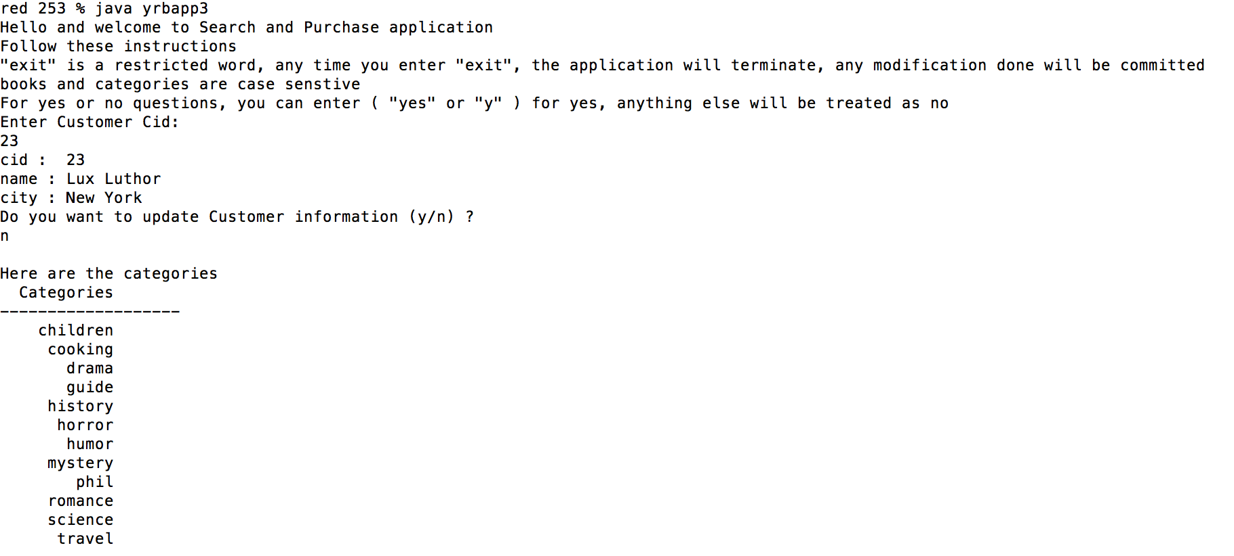

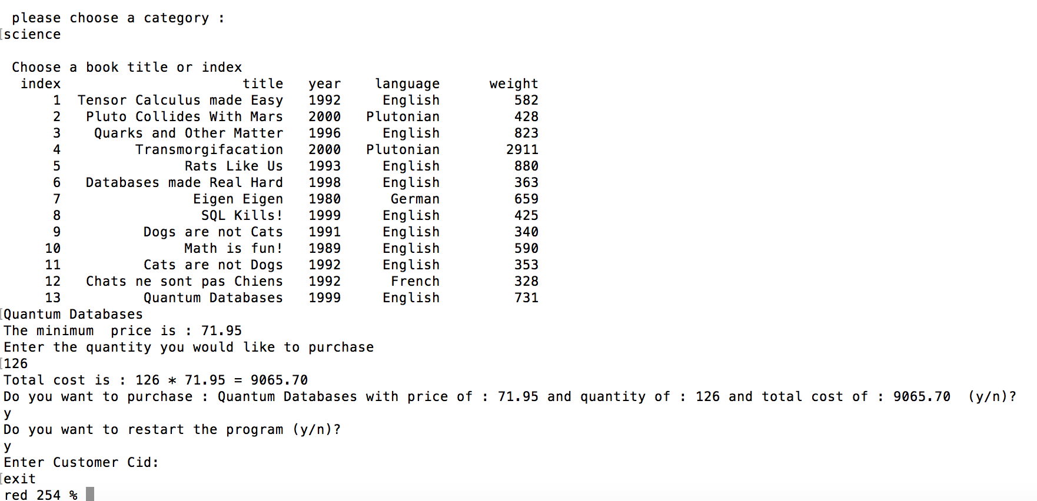

**Second Scenario**

* In this scenario the user updates information about the customer. You can notice this when I choose to restart the program and enter the same cid as I did initially, it showcases the updated information I had entered.

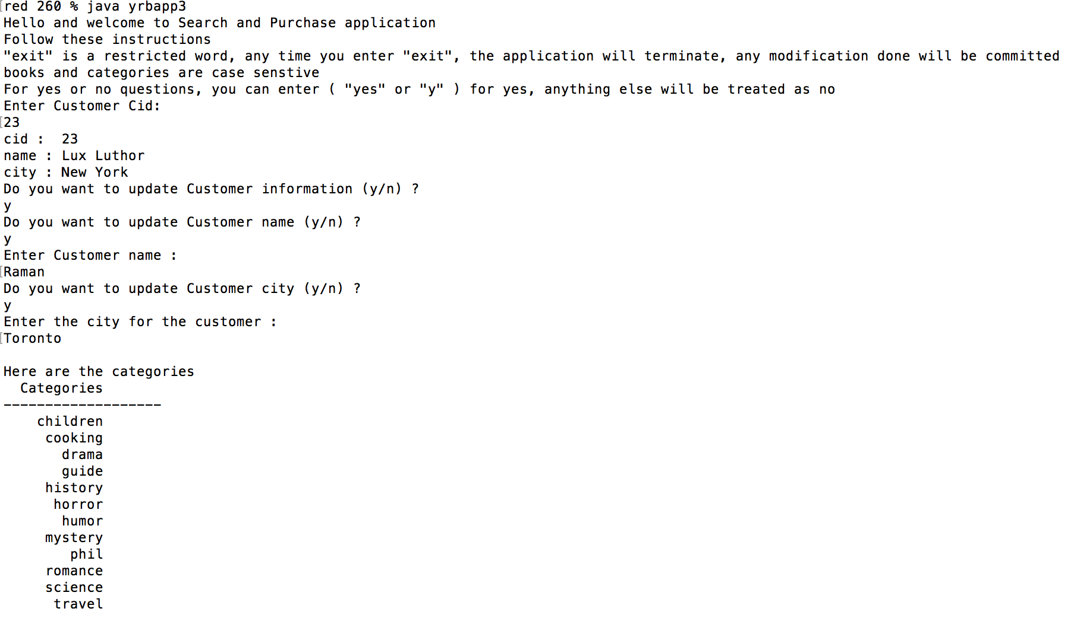

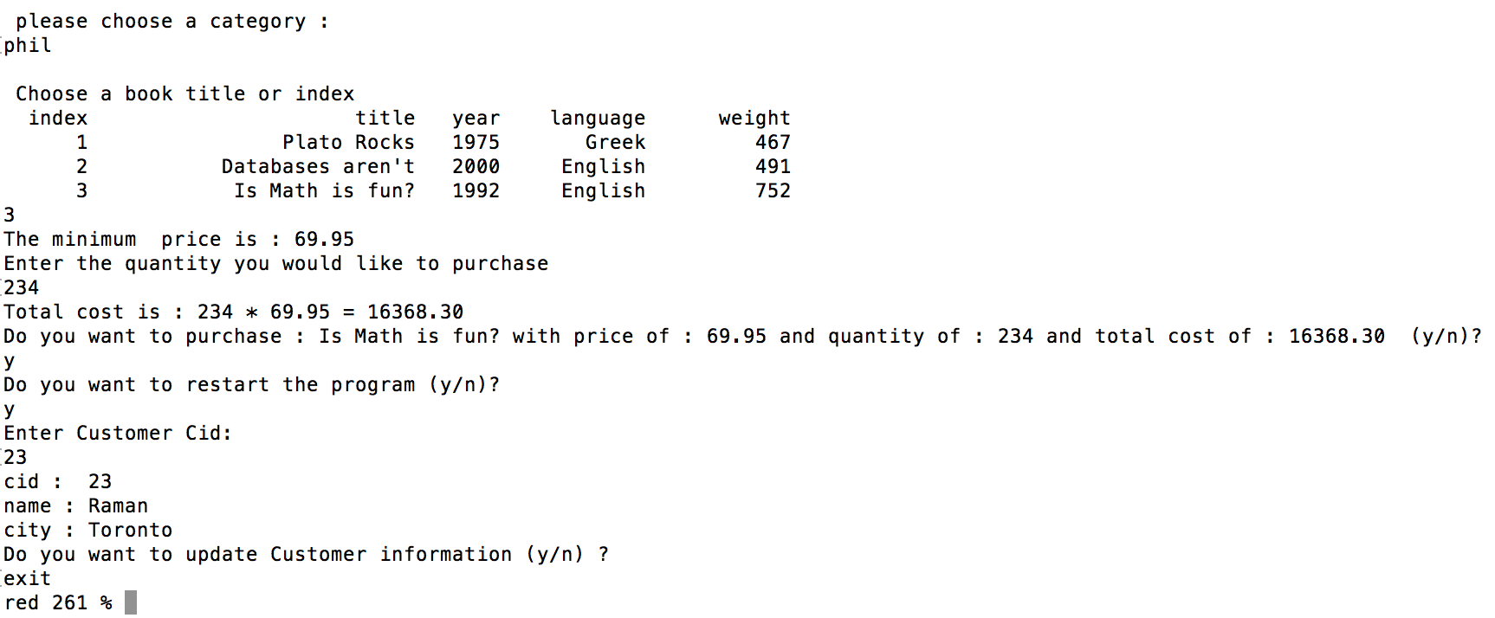

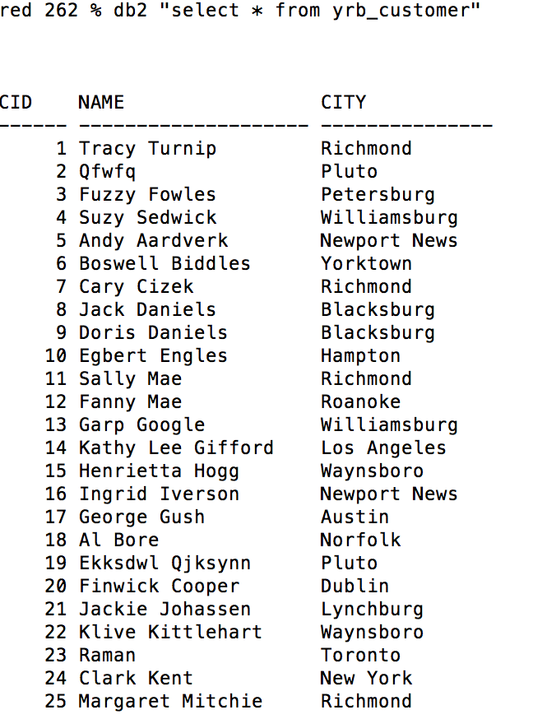As you can see CID (23) has been updated w/ the info I had entered

**Third Scenario**

* This scenario will showcase various outputs of the program responding to invalid inputs

This screenshot shows outputs for invalid cid (both cid that doesn’t exist and a string), also there is max range for customer name

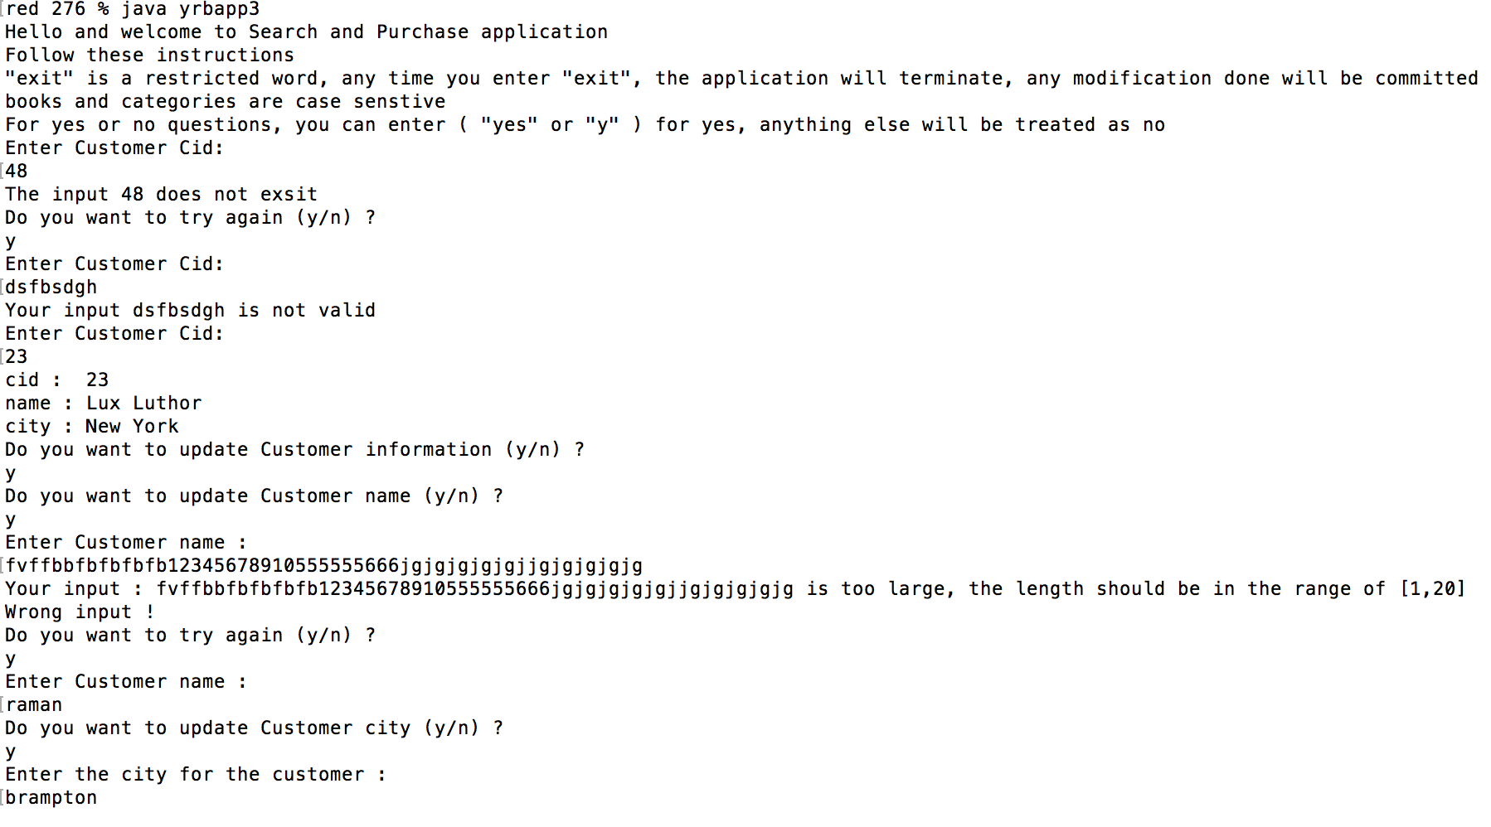

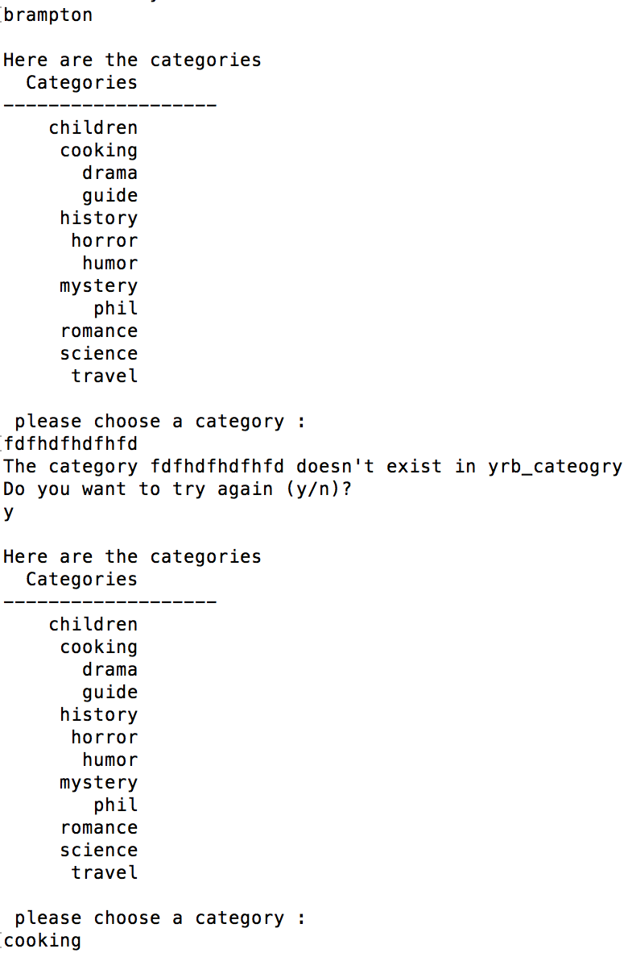Continuation from previous screenshot, showcases invalid category

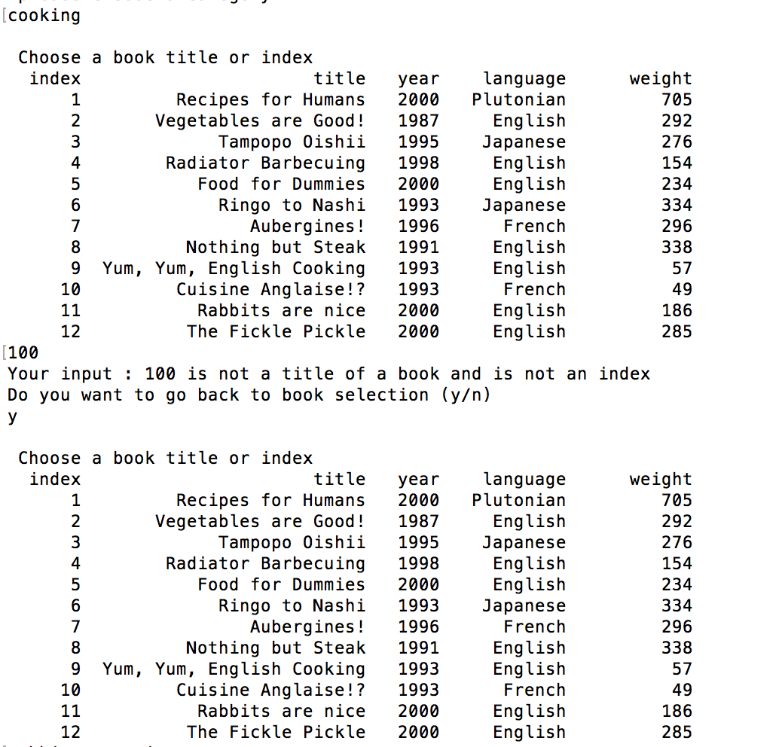Continuation of output, showcases invalid book tittle(index) also showing how you can backtrack and go make to book selection

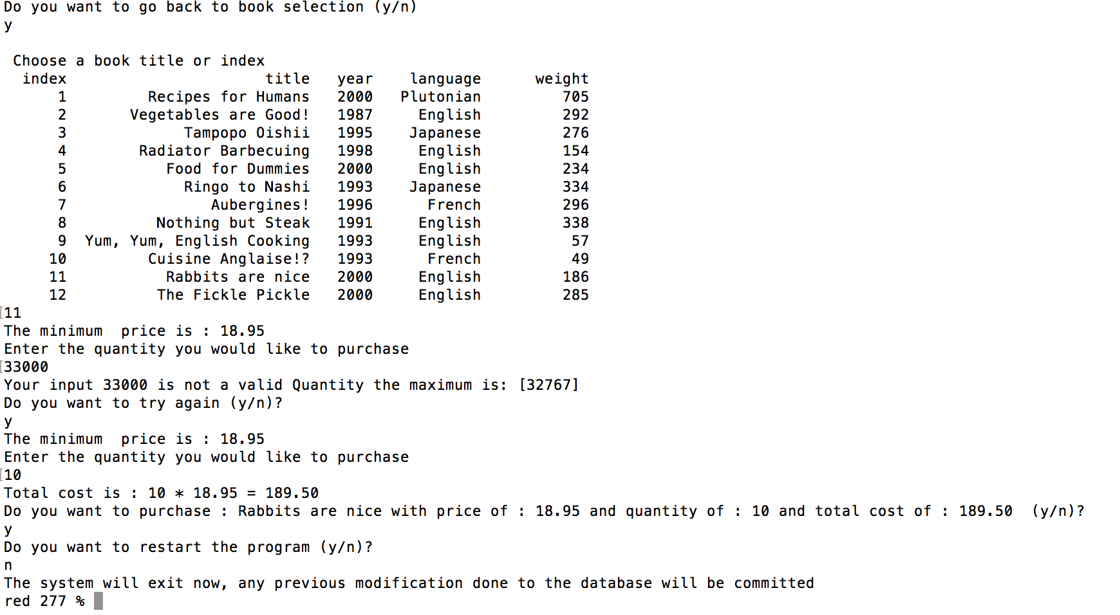showcases invalid quantity since I made it type short which has max range 32767.

**Fourth Scenario**

* This scenario showcases how you can go to previous stages throughout the program

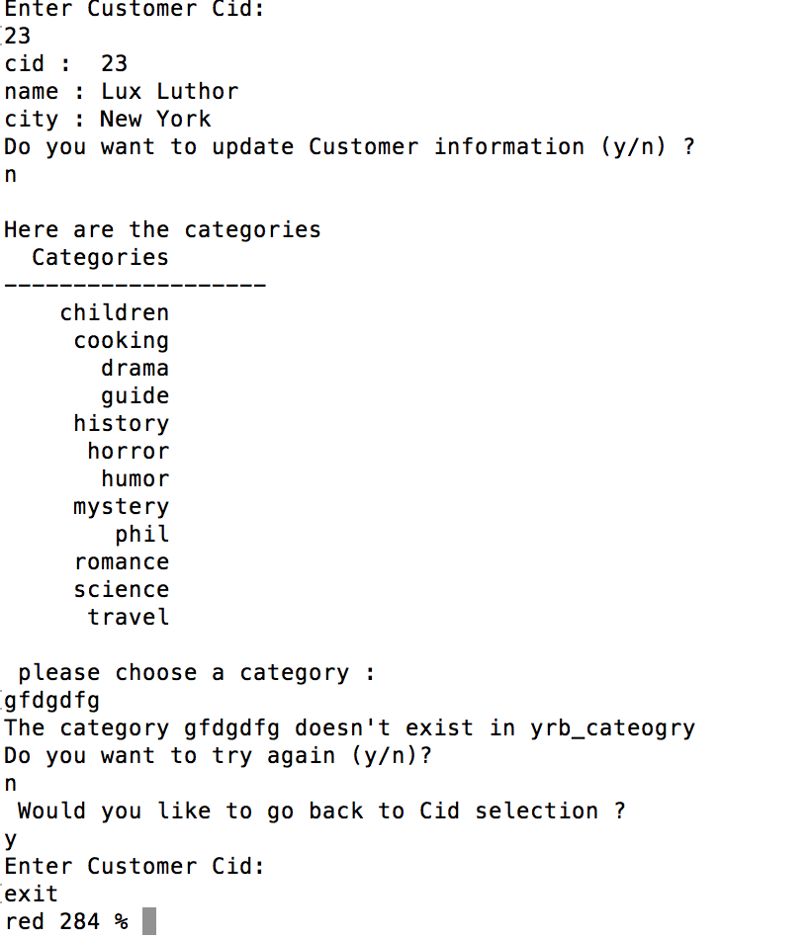showcases how you can go back to cid selection from categories.

* Also note you can go back to category selection and cid selection from book selection stage as following screenshot shows

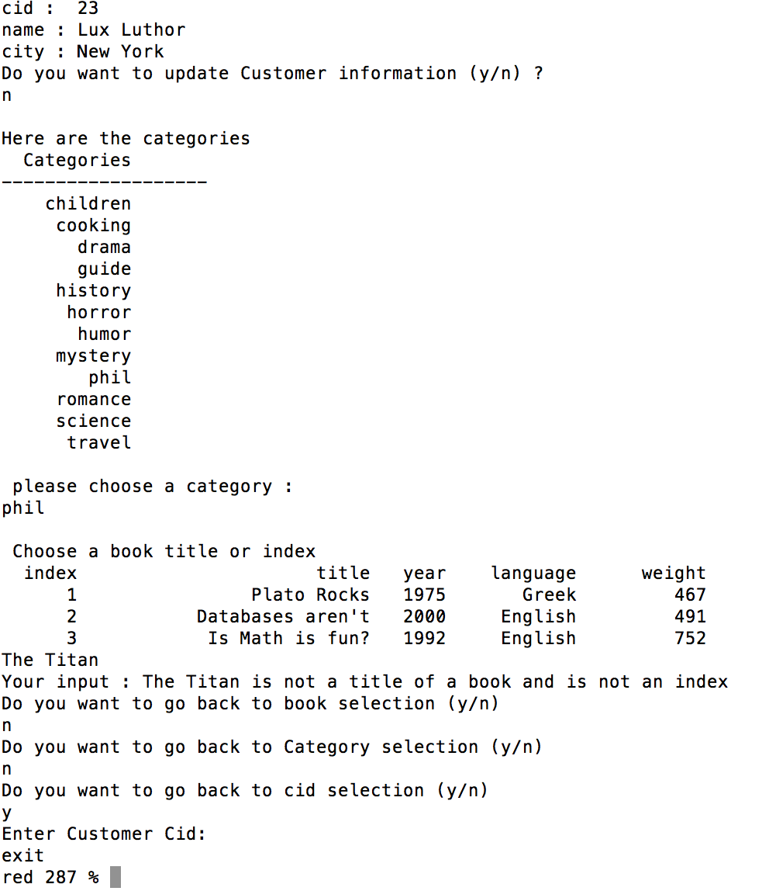

* Similarly, just like this you could go back to book selection, category selection, and cid selection when you are at the quantity stage. If you enter an invalid quantity, will ask you if you want to try again. Enter ‘n’. it will ask if you want to go to book selection keep selecting ‘no’ and you can go back till the cid selection stage.