Smart Intrusion Detection System

# Aim

To develop a smart intrusion detection system using ESP32 and PIR sensor that sends real-time alerts to security personnel via the Blynk IoT cloud platform.

# Problem Statement

Simulate a smart intrusion detection system that:  
(a) Continuously detects human movement in a restricted area using a PIR sensor.  
(b) Provides real-time alerts to security personnel via the cloud when motion is detected, indicating unauthorized access.

# Scope of the Solution

This system can be applied in:  
- Homes  
- Banks  
- Server rooms  
- Warehouses  
- Any area requiring intrusion monitoring  
  
It helps reduce response time in the event of a security breach by sending immediate notifications to the user.

# Required Components

Hardware:  
- ESP32 Dev Module  
- PIR Motion Sensor  
- USB Cable  
- Jumper Wires  
- Breadboard (optional)  
  
Software:  
- Arduino IDE  
- Blynk IoT Platform (New Blynk 2.0)  
- Wokwi Simulator (for virtual circuit demo)  
  
Cloud Services:  
- Blynk Cloud (for notifications and device management)

# Flowchart of the Code

# 

# Simulated Circuit (Wokwi)

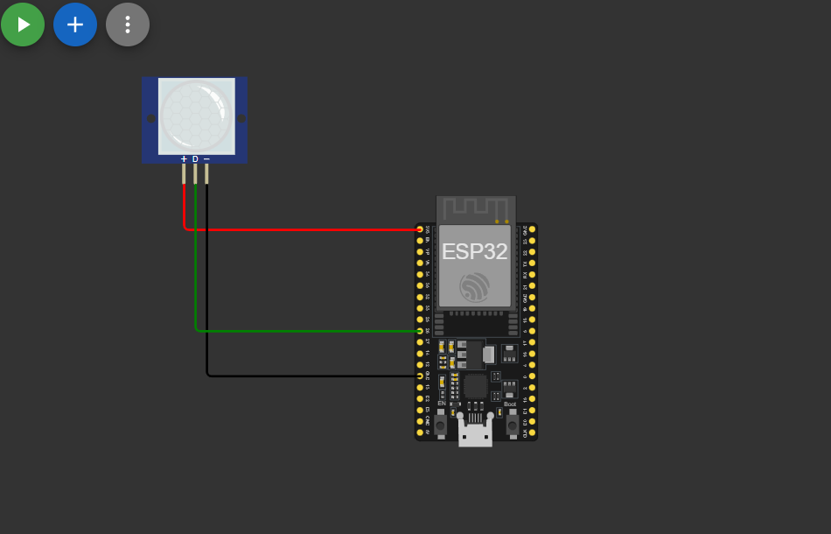

# Video of the Demo

A demonstration video and pictures showing the motion detection and push notification has been recorded. Please find the link below:  
<https://drive.google.com/drive/folders/1Owp309f28uXxkbrCc3BLODs6RrDtVJNM>